NHSRC
Meghalaya-Ri Bhoi
Analysis: Apr 2009 – Mar 2010

MEGHALAYA- RI BHOI DIST.- Summary-Apr'09 to Mar'10
ANC
ANC Registration against Expected Pregnancies | 126% | TT1 given to Pregnant women against ANC Registraion | 46%
3 ANC Check ups against ANC Reigtrations | 48% | 100 IFA Tablets given to Pregnant women against ANC Registraion | 40%
Deliveries
Unreported Deliveries against Estimated Deliveries | 8.1% | HOME Deliveries( SBA& Non SBA) against Estimated Deliveries | 77.8%
Institutional Deliveries against Estimated Deliveries | 14.1% | HOME Deliveries( SBA& Non SBA) against Reported Deliveries | 84.7%
Institutional Deliveries against Reported Deliveries | 15.3% | C Section Deliveries against Institutional Deliveries( Pvt & Pub) | 0%
Births & Neonates Care
Live Births Reported against Estimated Live Births | 94% | New borns weighed against Reported Live Births | 39%
Still Births (Reported) | 47 | New borns weighed less than 2.5 kgs against newborns weighed | 6%
Sex Ratio at Birh | 963 | New borns breastfed within one hr of Birth against Reported live Births | 77%
Child Immunisation( 0 to 11 mnths)
BCG given against Expected Live Births | 107% | Measles given against Expected Live Births | 85%
OPV3 given against Expected Live Births | 96% | Fully Immunised Children against Expected Live Births | 80%
DPT3 given against Expected Live Births | 96%
Family Planning
Family Plannig Methods Users ( Sterilisations(Male &Female)+IUD+ Condom pieces/72 + OCP Cycles/13) | 1,168 | IUD Insertions against reported FP Methods | 7%
Sterilisation against reported FP Methods | 2% | Condom Users against reported FP Methods | 25%
 |  | OCP Users against reported FP Methods | 66%
Other Services
OPD | 2,34,355 | Major Operations | 19
IPD | 15,930 | Minor Operations | 138

MEGHALAYA- RI BHOI DIST.- Deliveries Apr'09 to Mar'10
Total Population | 2,35,614 | Expected Deliveries |  | 6,110
Home SBA | Home Non SBA | Institutional | Total Deliveries Reported | Unreported Deliveries
500 | 4,253 | 861 | 5,614 | 496
Home SBA % | Home Non SBA% | Institutional % | Total Deliveries Reported % | Unreported Deliveries %
8% | 70% | 14% | 92% | 8%
`

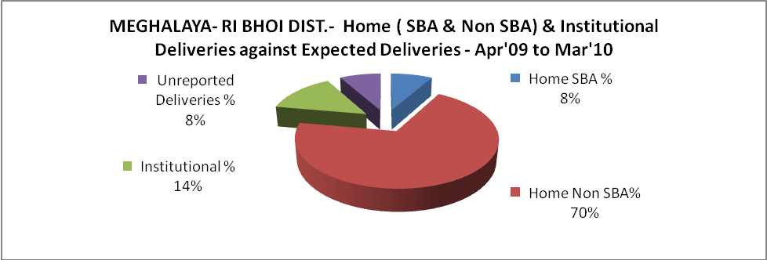

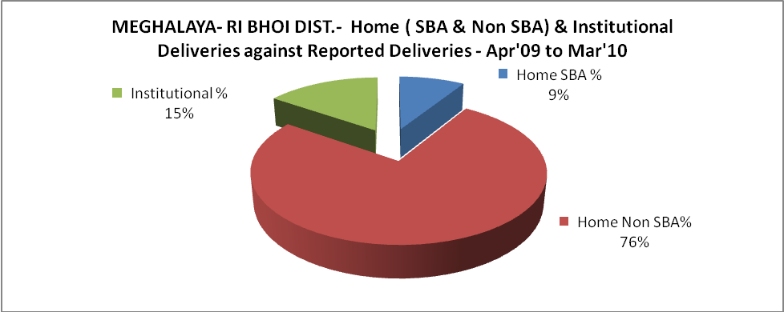

MEGHALAYA- RI BHOI DIST.- C sections & Complicated Deliveries Apr'09 to Mar'10
 | Institutional Deliveries (Public) | Institutional Deliveries (Pvt)
 | 861 | -
C Section | - | -
C Section% | 0% | 0%
Complicated Pregnacies attended | 149 | -
Complicated Pregnacies attended % | 17% | 0%

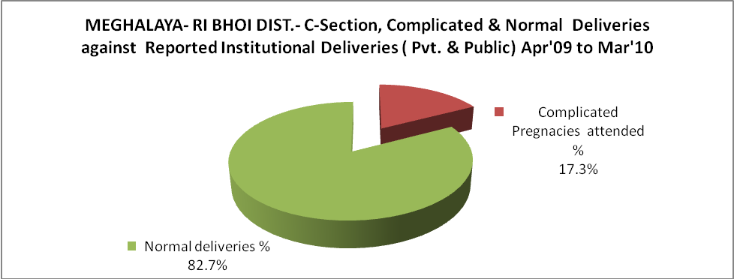

MEGHALAYA- RI BHOI DIST.- Complicated Pregnancies & Deliveries Treated - Apr'09 to Mar'10
Reported Deliveries |  |  | Reported ANC Reigtration
5,614 |  |  | 8,258
Complicated Pregnancies attended | Complicated Pregnancies Rate | C - Section Deliveries | PNC Maternal Complications | Abortions | Still Births
149 | 2% | - | 13 | 43 | 47
Complicated Deliveries Treated with |  |  |  | No Of Eclampsia cases Treated | No Of severe anemia cases treated
IV Antibiotics | IV antihypertensive/Magsulph injection | IV Oxytocis | Blood Transfusion | No Of Eclampsia cases Treated | No Of severe anemia cases treated
83 | 2 | 82 | - | 3 | 136

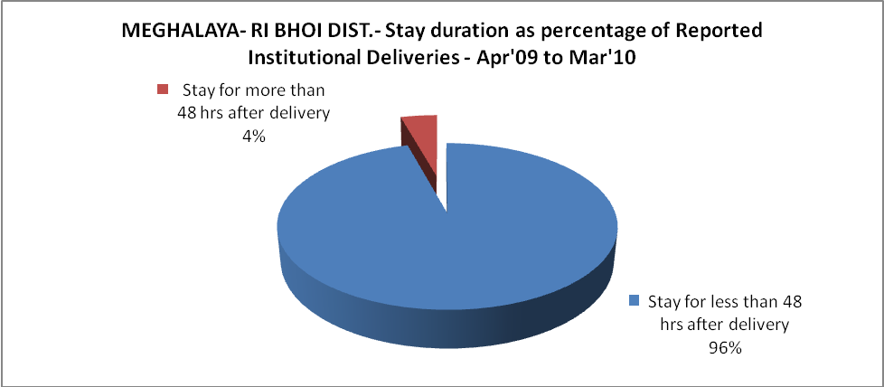

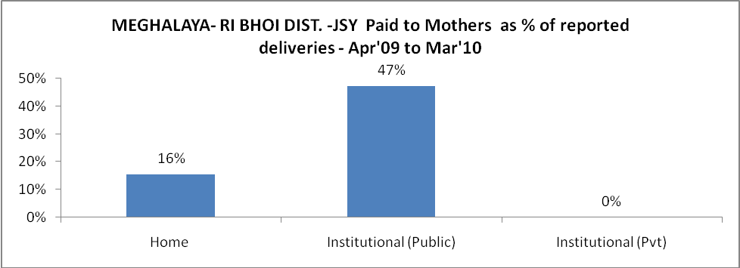

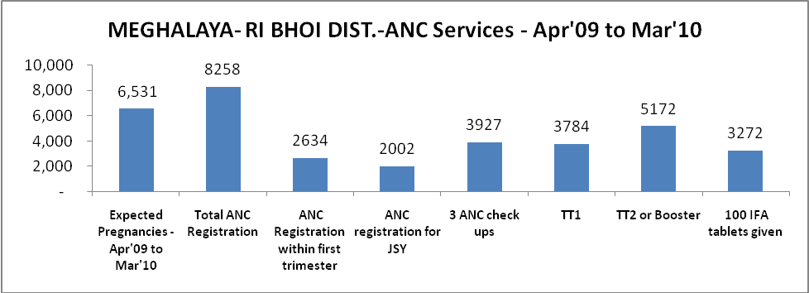

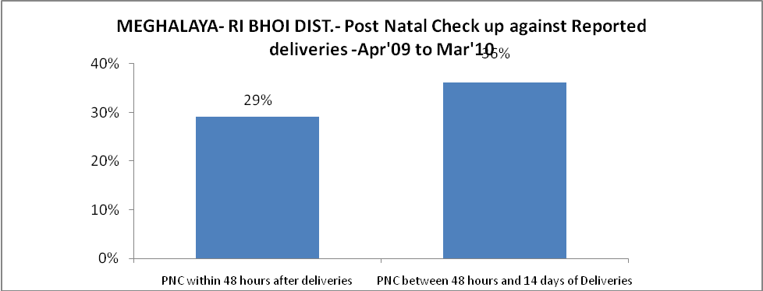

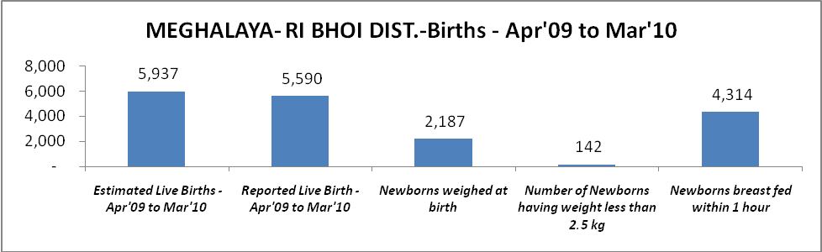

MEGHALAYA- RI BHOI DIST. - Births - Apr'09 to Mar'10
Live Birth - Males | Live Birth - females | Live Birth - Total | Sex Ratio at birth | Still Birth | Abortion( Induced/Spontaneous
2,848 | 2,742 | 5,590 | 963 | 47 | 43

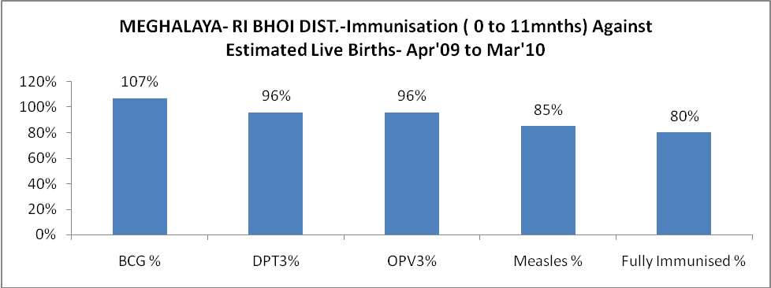

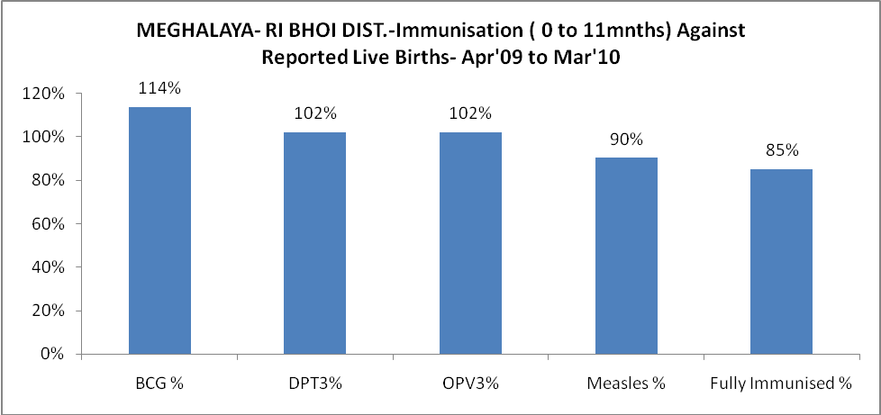

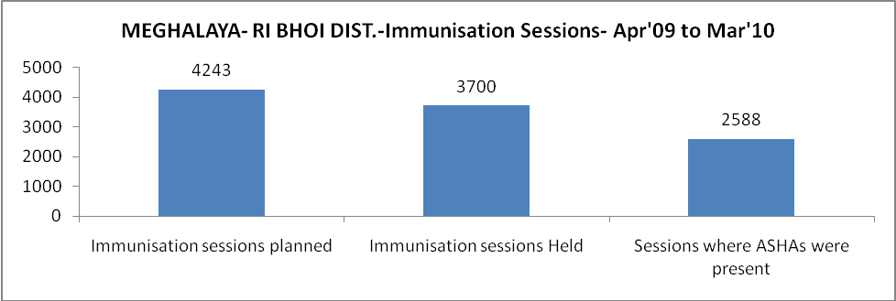

MEGHALAYA- RI BHOI DIST.- Apr'09 to Mar'10
Total Abortions | Abortion Rate
43 | 0.7%

MEGHALAYA- RI BHOI DIST.- Apr'09 to Mar'10
Total OPD | Total RTI/STI cases
2,34,355 | 553

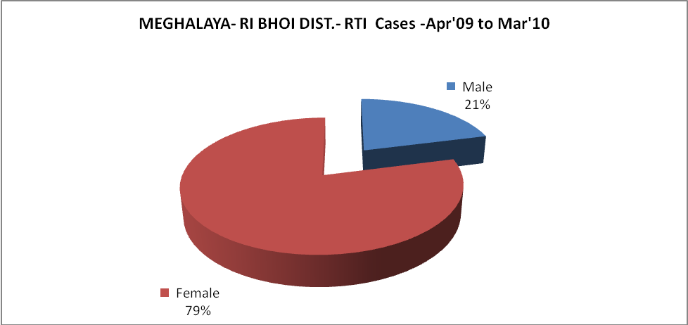

MEGHALAYA- RI BHOI DIST.-Sterilisations - Apr'09 to Mar'10
 | Reported | %age of Reported Sterilisation
Total Sterilisation | 23 | -
NSV | - | 0%
Laproscopic | 6 | 26%
MiniLap | - | 0%
Post Partum | 17 | 74%
Male Sterilisation | - | 0%
Female Sterilisation | 23 | 100%

MEGHALAYA- RI BHOI DIST.-FP Methods - Apr'09 to Mar'10
 | Reported | %age of All Reported FP Methods
Total Reported FP Methodd (All types) Users | 1,168 | -
Sterilisations | 23 | 2%
IUD | 85 | 7%
Condom Users | 290 | 25%
OCP Users | 771 | 66%
Limiting Methods | 23 | 2%
Spacing Methods | 1,145 | 98%

MEGHALAYA- RI BHOI DIST.- Service Delivery - Apr'09 to Mar'10
Operation major (General and spinal anaesthesia) | Operation minor (No or local anaesthesia) | AYUSH | Dental Procedures | Adolescent counselling services | Total OPD | Total IPD
19 | 138 | 11,874 | 4,435 | 151 | 2,34,355 | 15,930
Operation major (General and spinal anaesthesia) as %ge of OPD | Operation minor (No or local anaesthesia)as %ge of OPD | AYUSH as %ge of OPD | Dental Procedures as %ge of OPD | Adolescent counselling services as %ge of OPD | IPD as percentage of OPD
0.0% | 0.1% | 5.1% | 1.9% | 0.1% | 7%

MEGHALAYA- RI BHOI DIST.- Lab Services - Apr'09 to Mar'10
Total OPD | Total HB tested | Total HIV Tested | Total Population
2,34,355 | 3,968 | 124 | 2,35,614
HB test conducted as %age of OPD | HB<7gm as %age of HB tested | HIV test conducted as %age of OPD | HIV positive as %age of HIV tested | Blood Smear Examined as % of Population
1.7% | 14.5% | 0.1% | 34.7% | 19.1%

MEGHALAYA- RI BHOI DIST.- Childhood Disease - Vaccine Preventable -Apr'09 to Mar'10
Diphtheria | Pertussis | Tetanus Neonatorum | Tetanus others | Polio | Measles
0 | 0 | 0 | 0 | 0 | 122
MEGHALAYA- RI BHOI DIST.-Childhood Disease - Others - Apr'09 to Mar'10
Diarrhoea and dehydration | Malaria | Number admitted with Respiratory Infections
9,200 | 639 | 2,031

MEGHALAYA- RI BHOI DIST.- Infant & Child Deaths - Apr'09 to Mar'10
Infant Deaths within 24 hrs of birth | Infant Deaths between 24hrs & under 1 week | Infant Deaths between 1 week & under 1 month | Child Deaths between 1 month & under 1 year | Child Deaths between 1yr under 5years | Total Deaths
1 | 14 | 18 | 44 | 49 | 126

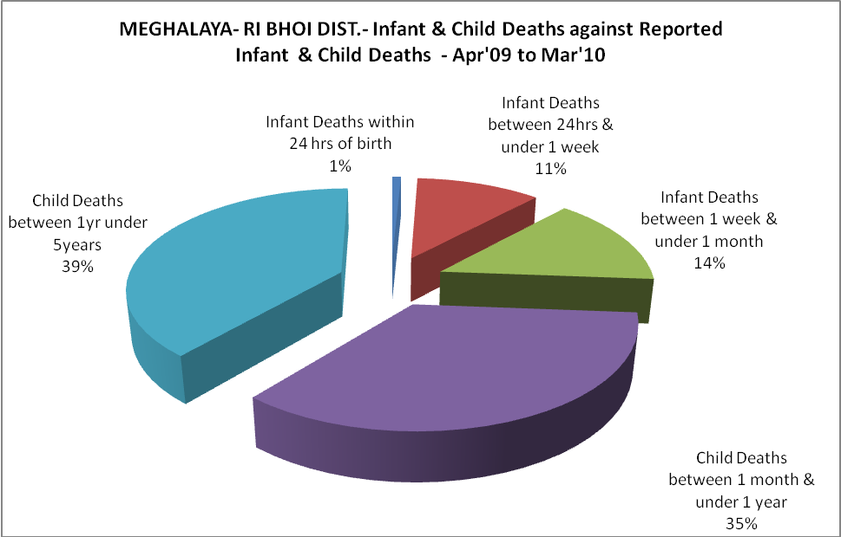

MEGHALAYA- RI BHOI DIST.- Causes of Infant & Child Deaths - Apr'09 to Mar'10
Sepsis |  |  | Asphyxia |  |  | LBW
Up to 1 Weeks of Birth | Between 1 week & 4 weeks of birth | Total | Up to 1 Weeks of Birth | Between 1 week & 4 weeks of birth | Total | Up to 1 Weeks of Birth | Between 1 week & 4 weeks of birth | Total
1 | 2 | 3 | 4 | 8 | 12 | 3 | 1 | 4
Pneumonia |  |  | Diarrhoea |  |  | Fever related
Between 1 month and 11 months | Between 1 year & 5 years | Total | Between 1 month and 11 months | Between 1 year & 5 years | Total | Between 1 month and 11 months | Between 1 year & 5 years | Total
4 | 2 | 6 | 10 | 12 | 22 | 13 | 16 | 29
Others |  |  | Measles |  |  | Others
Up to 1 Weeks of Birth | Between 1 week & 4 weeks of birth | Total | Between 1 month and 11 months | Between 1 year & 5 years | Total | Between 1 month and 11 months | Between 1 year & 5 years | Total
6 | 7 | 13 | 1 | 0 | 1 | 16 | 19 | 35
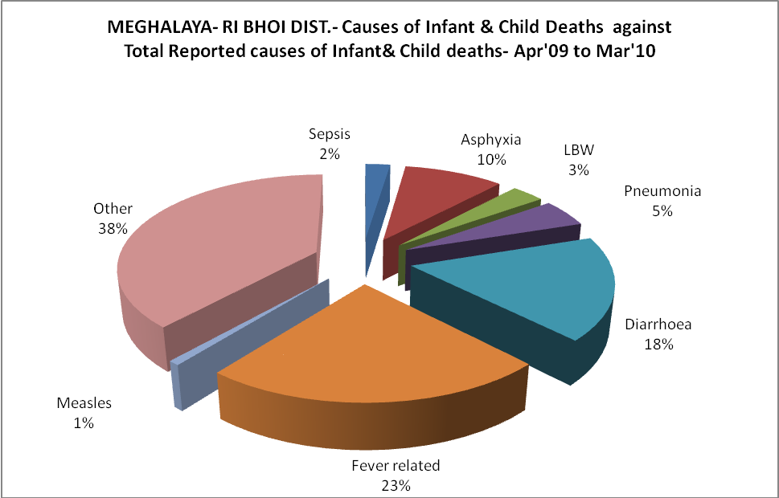

MEGHALAYA- RI BHOI DIST.- Maternal Deaths & Causes - Apr'09 to Mar'10
Abortion |  |  | Obstructed/prolonged labour |  |  | Severe hypertesnion/fits
6-14 yrs | 15-55 yrs. | Total | 6-14 yrs | 15-55 yrs. | Total | 6-14 yrs | 15-55 yrs. | Total
0 | 0 | 0 | 0 | 0 | 0 | 0 | 0 | 0
Bleeding |  |  | High Fever |  |  | Other Causes
6-14 yrs | 15-55 yrs. | Total | 6-14 yrs | 15-55 yrs. | Total | 6-14 yrs | 15-55 yrs. | Total
0 | 2 | 2 | 0 | 1 | 1 | 0 | 4 | 4

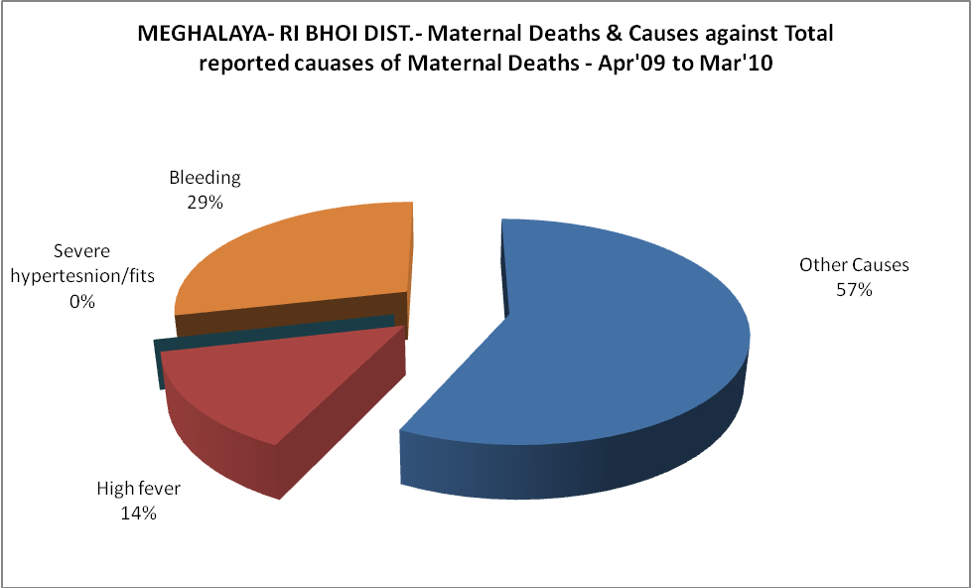

MEGHALAYA- RI BHOI DIST.-Causes of Deaths in 6 to 55yrs age group - Apr'09 to Mar'10
Diarrhoel Diseases |  |  |  | Tuberculosis |  |  |  | Respiratory Diseases( Other than TB)
6-14 yrs | 15-55 yrs. | Above 55yrs | Total | 6-14 yrs | 15-55 yrs. | Above 55yrs | Total | 6-14 yrs | 15-55 yrs. | Above 55yrs | Total
7 | 10 | 8 | 25 | 1 | 3 | 3 | 7 | 3 | 7 | 3 | 13
Malaria |  |  |  | Other fever Related |  |  |  | HIV/Aids
6-14 yrs | 15-55 yrs. | Above 55yrs | Total | 6-14 yrs | 15-55 yrs. | Above 55yrs | Total | 6-14 yrs | 15-55 yrs. | Above 55yrs | Total
4 | 0 | 0 | 4 | 9 | 17 | 11 | 37 | 0 | 0 | 0 | 0
Heart Disease/Hypertenion related |  |  |  | Neurological Disease including strokes |  |  |  | Trauma/Accidents/ Burn Cases
6-14 yrs | 15-55 yrs. | Above 55yrs | Total | 6-14 yrs | 15-55 yrs. | Above 55yrs | Total | 6-14 yrs | 15-55 yrs. | Above 55yrs | Total
0 | 1 | 5 | 6 | 0 | 3 | 5 | 8 | 0 | 5 | 3 | 8
Suicide |  |  |  | Animal Bites & Stings
6-14 yrs | 15-55 yrs. | Above 55yrs | Total | 6-14 yrs | 15-55 yrs. | Above 55yrs | Total
1 | 9 | 1 | 11 | 0 | 1 | 0 | 1

