NHSRC
Himachal Pradesh- Shimla District
Analysis 2009-10

7/22/2010

Shimla Dist.- Summary-Apr'09 to Mar'10
ANC
ANC Registration against Expected Pregnancies | 193% | TT1 given to Pregnant women against ANC Registration | 40%
3 ANC Check ups against ANC Registrations | 65% | 100 IFA Tablets given to Pregnant women against ANC Registration | 57%
Deliveries
Unreported Deliveries against Estimated Deliveries | 1.3% | HOME Deliveries( SBA& Non SBA) against Estimated Deliveries | 17.1%
Institutional Deliveries against Estimated Deliveries | 81.6% | HOME Deliveries( SBA& Non SBA) against Reported Deliveries | 17.3%
Institutional Deliveries against Reported Deliveries | 82.7% | C Section Deliveries against Institutional Deliveries( Pvt & Pub) | 10%
Births & Neonates Care
Live Births Reported against Estimated Live Births | 100% | New borns weighed against Reported Live Births | 77%
Still Births (Reported) | 232 | New borns weighed less than 2.5 kgs against newborns weighed | 10%
Sex Ratio at Birth | 895 | New borns breastfed within one hr of Birth against Reported live Births | 26%
Child Immunization( 0 to 11 months)
BCG given against Expected Live Births | 123% | Measles given against Expected Live Births | 100%
OPV3 given against Expected Live Births | 99% | Fully Immunized Children against Expected Live Births | 100%
DPT3 given against Expected Live Births | 100%
Family Planning
Family Planning Methods Users ( Sterilizations(Male &Female)+IUD+ Condom pieces/72 + OCP Cycles/13) | 21,934 | IUD Insertions against reported FP Methods | 12%
Sterilization against reported FP Methods | 17% | Condom Users against reported FP Methods | 54%
 |  | OCP Users against reported FP Methods | 18%
Other Services
OPD | 272,113 | Major Operations | 1,146
IPD | 11,153 | Minor Operations | 663

Shimla Dist.- Deliveries Apr'09 to Mar'10
Total Population | 796,691 | Expected Deliveries |  | 14,412
Home SBA | Home Non SBA | Institutional | Total Deliveries Reported | Unreported Deliveries
888 | 1,572 | 11,766 | 14,226 | 186
Home SBA % | Home Non SBA% | Institutional % | Total Deliveries Reported % | Unreported Deliveries %
6% | 11% | 82% | 99% | 1%

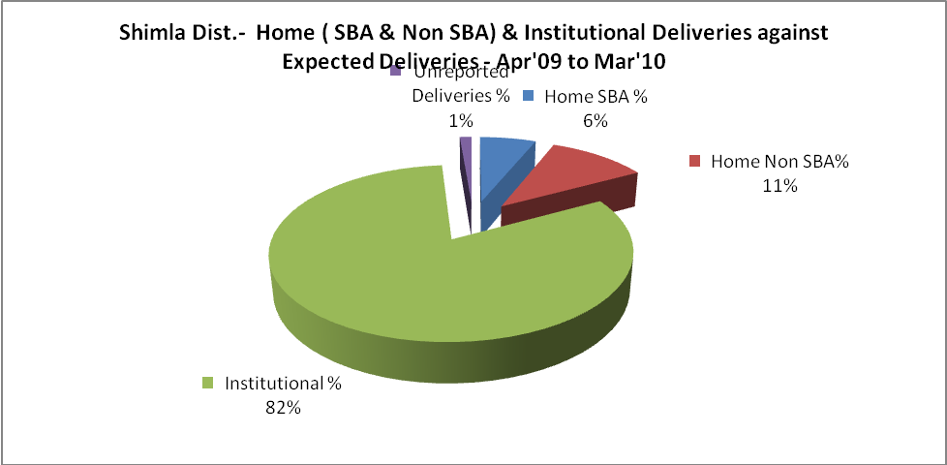
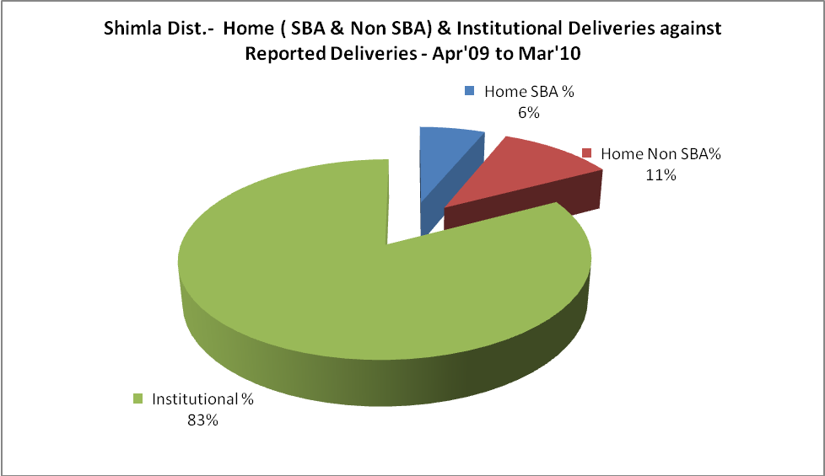

Shimla Dist.- C sections & Complicated Deliveries Apr'09 to Mar'10
 | Institutional Deliveries (Public) | Institutional Deliveries (Pvt)
 | 11,445 | 321
C Section | 1,154 | -
C Section% | 10% | 0%
Complicated Pregnancies attended | 59 | -
Complicated Pregnancies attended % | 1% | 0%

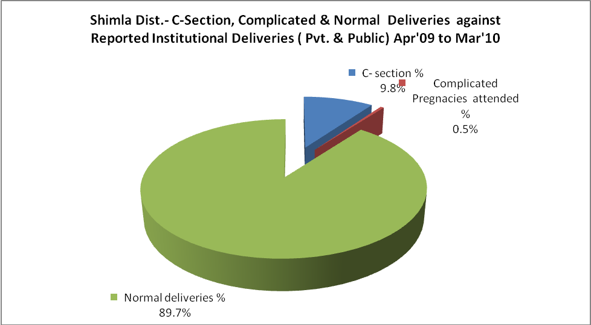

Shimla Dist.- Complicated Pregnancies & Deliveries Treated - Apr'09 to Mar'10
Reported Deliveries |  |  | Reported ANC Registration
14,226 |  |  | 29,870
Complicated Pregnancies attended | Complicated Pregnancies Rate | C - Section Deliveries | PNC Maternal Complications | Abortions | Still Births
59 | 0% | 1,154 | 15 | 567 | 232
Complicated Deliveries Treated with |  |  |  | No Of Eclampsia cases Treated | No Of severe anemia cases treated
IV Antibiotics | IV antihypertensive/Magsulph injection | IV Oxytocis | Blood Transfusion | No Of Eclampsia cases Treated | No Of severe anemia cases treated
156 | 1 | - | 40 | 13 | 102

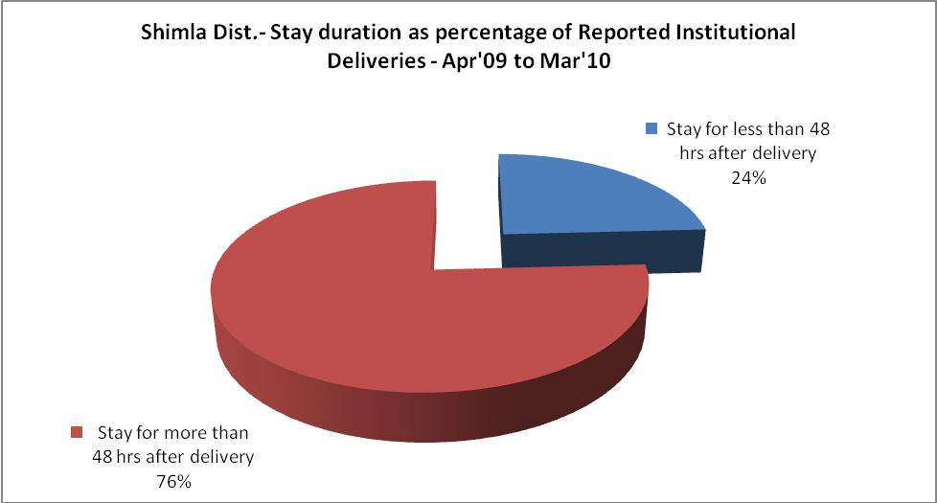

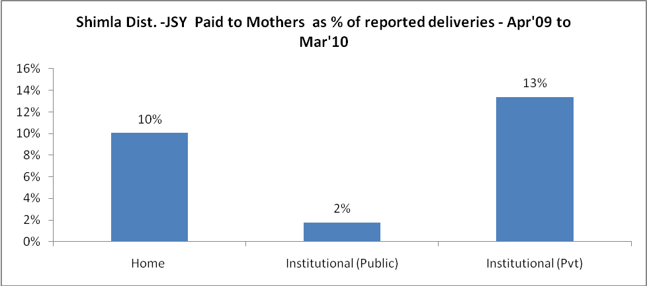
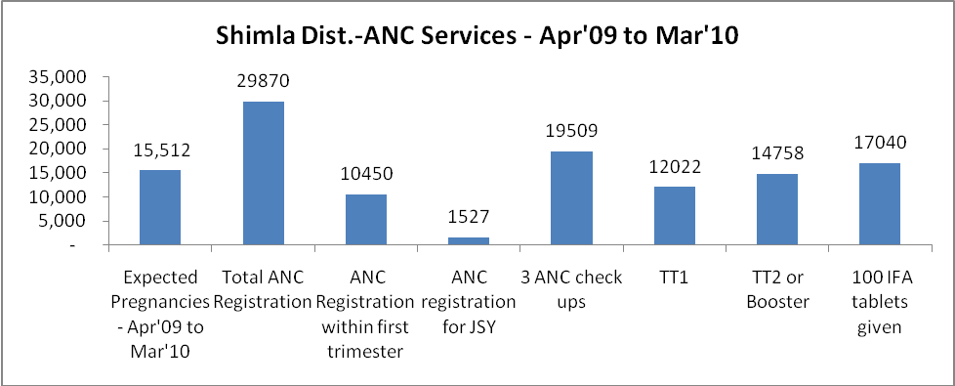

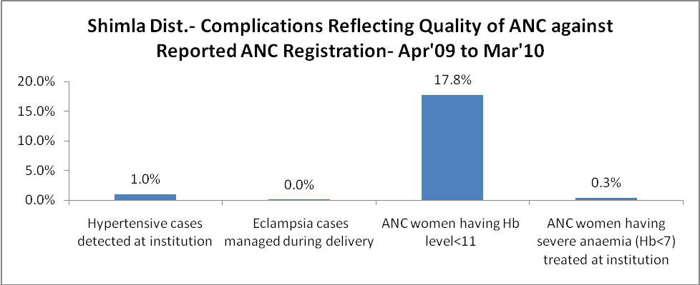
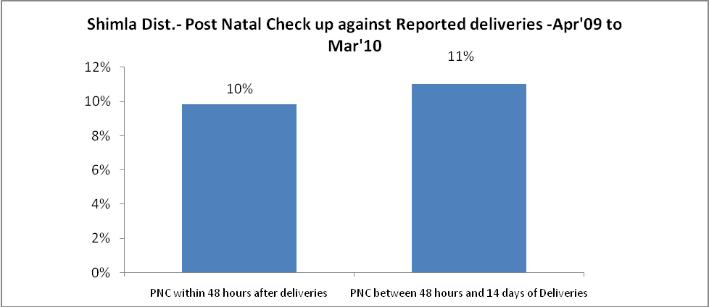

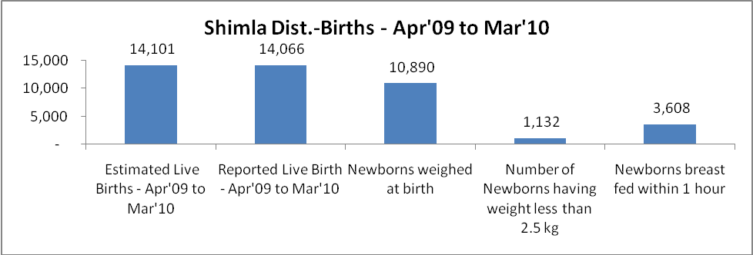

Shimla Dist. - Births - Apr'09 to Mar'10
Live Birth - Males | Live Birth - females | Live Birth - Total | Sex Ratio at birth | Still Birth | Abortion( Induced/Spontaneous
7,424 | 6,642 | 14,066 | 895 | 232 | 567

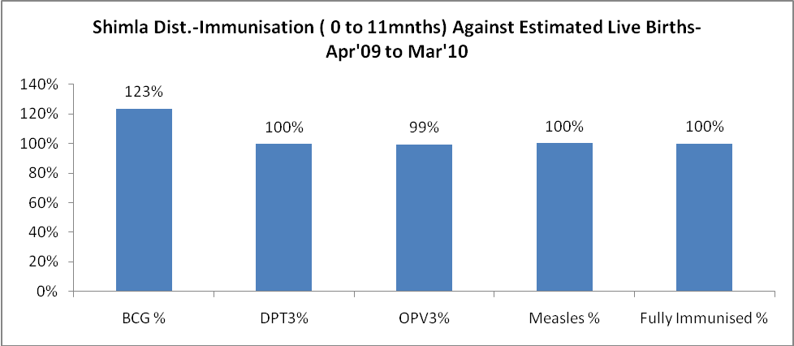
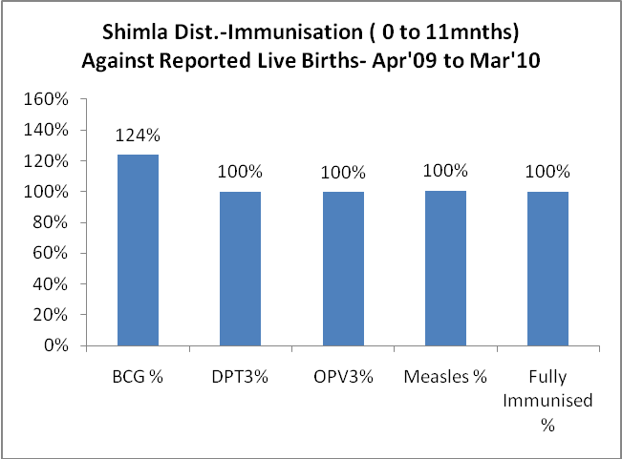
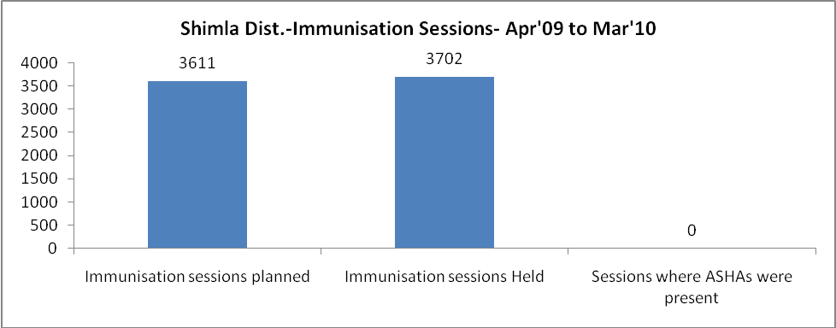
Shimla Dist.- Apr'09 to Mar'10
Total Abortions | Abortion Rate
1,359 | 8.8%

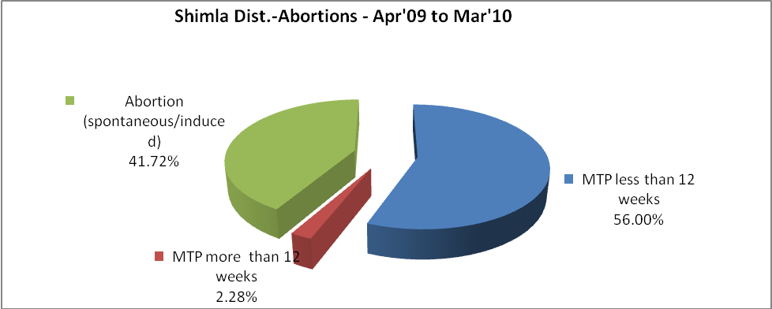
Shimla Dist.- Apr'09 to Mar'10
Total OPD | Total RTI/STI cases
272,113 | 3,527

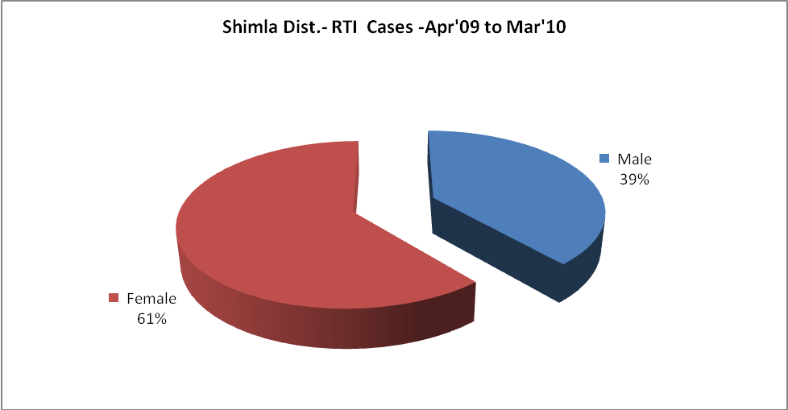
Shimla Dist.-Sterilizations - Apr'09 to Mar'10
 | Reported | %age of Reported Sterilization
Total Sterilization | 3,669 | -
NSV | 356 | 10%
Laproscopic | 2,833 | 77%
MiniLap | 38 | 1%
Post Partum | 442 | 12%
Male Sterilization | 356 | 10%
Female Sterilization | 3,313 | 90%

Shimla Dist.-FP Methods - Apr'09 to Mar'10
 | Reported | %age of All Reported FP Methods
Total Reported FP Method (All types) Users | 21,934 | -
Sterilizations | 3,669 | 17%
IUD | 2,560 | 12%
Condom Users | 11,822 | 54%
OCP Users | 3,884 | 18%
Limiting Methods | 3,669 | 17%
Spacing Methods | 18,265 | 83%

Shimla Dist.- Service Delivery - Apr'09 to Mar'10
Operation major (General and spinal anaesthesia) | Operation minor (No or local anaesthesia) | AYUSH | Dental Procedures | Adolescent counseling services | Total OPD | Total IPD
1,146 | 663 | 450 | 11,518 | 533 | 272,113 | 11,153
Operation major (General and spinal anaesthesia) as %ge of OPD | Operation minor (No or local anaesthesia)as %ge of OPD | AYUSH as %ge of OPD | Dental Procedures as %ge of OPD | Adolescent counseling services as %ge of OPD | IPD as percentage of OPD
0.4% | 0.2% | 0.2% | 4.2% | 0.2% | 4%

Shimla Dist.- Lab Services - Apr'09 to Mar'10
Total OPD | Total HB tested | Total HIV Tested | Total Population
272,113 | 32,802 | 3,429 | 796,691
HB test conducted as %age of OPD | HB<7gm as %age of HB tested | HIV test conducted as %age of OPD | HIV positive as %age of HIV tested | Blood Smear Examined as % of Population
12.1% | 1.5% | 1.3% | 0.0% | 1.5%

Shimla Dist.- Childhood Disease - Vaccine Preventable -Apr'09 to Mar'10
Diphtheria | Pertussis | Tetanus Neonatorum | Tetanus others | Polio | Measles
0 | 0 | 0 | 0 | 0 | 15
Shimla Dist.-Childhood Disease - Others - Apr'09 to Mar'10
Diarrhoea and dehydration | Malaria | Number admitted with Respiratory Infections
3,793 | 20 | 2,363
Shimla Dist.- Infant & Child Deaths - Apr'09 to Mar'10
Infant Deaths within 24 hrs of birth | Infant Deaths under 1 week | Infant Deaths under 1 month | Child Deaths under 1 year | Child Deaths under 5years | Total Deaths
0 | 8 | 16 | 31 | 39 | 94

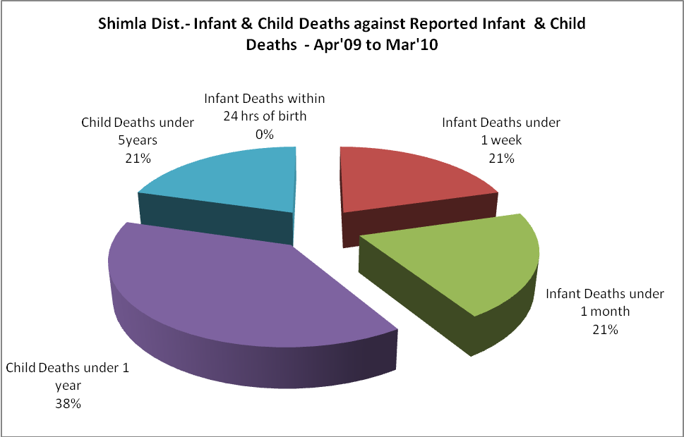

Shimla Dist.- Causes of Infant & Child Deaths - Apr'09 to Mar'10
Sepsis |  |  | Asphyxia |  |  | LBW
Up to 1 Weeks of Birth | Between 1 week & 4 weeks of birth | Total | Up to 1 Weeks of Birth | Between 1 week & 4 weeks of birth | Total | Up to 1 Weeks of Birth | Between 1 week & 4 weeks of birth | Total
0 | 0 | 0 | 0 | 0 | 0 | 5 | 4 | 9
Pneumonia |  |  | Diarrhoea |  |  | Fever related
Between 1 month and 11 months | Between 1 year & 5 years | Total | Between 1 month and 11 months | Between 1 year & 5 years | Total | Between 1 month and 11 months | Between 1 year & 5 years | Total
2 | 1 | 3 | 0 | 2 | 2 | 1 | 0 | 1
Others |  |  | Measles |  |  | Others
Up to 1 Weeks of Birth | Between 1 week & 4 weeks of birth | Total | Between 1 month and 11 months | Between 1 year & 5 years | Total | Between 1 month and 11 months | Between 1 year & 5 years | Total
3 | 4 | 7 | 0 | 0 | 0 | 12 | 5 | 17

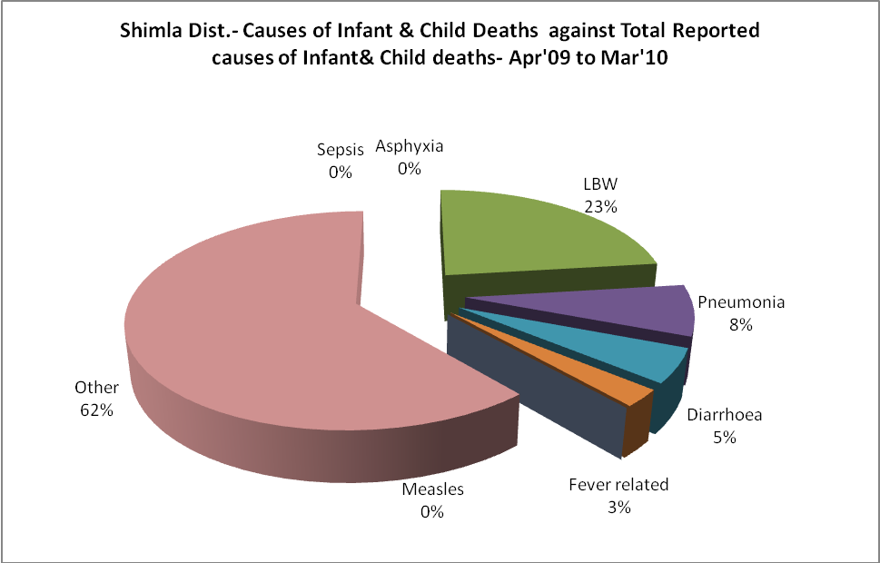

Shimla Dist.- Maternal Deaths & Causes - Apr'09 to Mar'10
Abortion |  |  | Obstructed/prolonged labour |  |  | Severe hypertension/fits
6-14 yrs | 15-55 yrs. | Total | 6-14 yrs | 15-55 yrs. | Total | 6-14 yrs | 15-55 yrs. | Total
0 | 0 | 0 | 0 | 0 | 0 | 0 | 0 | 0
Bleeding |  |  | High Fever |  |  | Other Causes
6-14 yrs | 15-55 yrs. | Total | 6-14 yrs | 15-55 yrs. | Total | 6-14 yrs | 15-55 yrs. | Total
0 | 0 | 0 | 0 | 0 | 0 | 0 | 0 | 0

Shimla Dist.-Causes of Deaths in 6 to 55yrs age group - Apr'09 to Mar'10
Diarrhoel Diseases |  |  |  | Tuberculosis |  |  |  | Respiratory Diseases( Other than TB)
6-14 yrs | 15-55 yrs. | Above 55yrs | Total | 6-14 yrs | 15-55 yrs. | Above 55yrs | Total | 6-14 yrs | 15-55 yrs. | Above 55yrs | Total
2 | 1 | 0 | 3 | 0 | 4 | 1 | 5 | 1 | 6 | 3 | 10
Malaria |  |  |  | Other fever Related |  |  |  | HIV/Aids
6-14 yrs | 15-55 yrs. | Above 55yrs | Total | 6-14 yrs | 15-55 yrs. | Above 55yrs | Total | 6-14 yrs | 15-55 yrs. | Above 55yrs | Total
0 | 0 | 0 | 0 | 2 | 2 | 3 | 7 | 0 | 0 | 0 | 0
Heart Disease/Hypertension related |  |  |  | Neurological Disease including strokes |  |  |  | Trauma/Accidents/ Burn Cases
6-14 yrs | 15-55 yrs. | Above 55yrs | Total | 6-14 yrs | 15-55 yrs. | Above 55yrs | Total | 6-14 yrs | 15-55 yrs. | Above 55yrs | Total
8 | 19 | 0 | 27 | 0 | 0 | 0 | 0 | 22 | 19 | 1 | 42
Suicide |  |  |  | Animal Bites & Stings
6-14 yrs | 15-55 yrs. | Above 55yrs | Total | 6-14 yrs | 15-55 yrs. | Above 55yrs | Total
16 | 11 | 0 | 27 | 1 | 1 | 0 | 2

