NHSRC
Himachal Pradesh- Sirmaur District
Analysis 2009-10

7/22/2010

Sirmaur Dist.- Summary-Apr'09 to Mar'10
ANC
ANC Registration against Expected Pregnancies | 118% | TT1 given to Pregnant women against ANC Registration | 52%
3 ANC Check ups against ANC Registrations | 79% | 100 IFA Tablets given to Pregnant women against ANC Registration | 85%
Deliveries
Unreported Deliveries against Estimated Deliveries | 16.7% | HOME Deliveries( SBA& Non SBA) against Estimated Deliveries | 45.7%
Institutional Deliveries against Estimated Deliveries | 37.6% | HOME Deliveries( SBA& Non SBA) against Reported Deliveries | 54.8%
Institutional Deliveries against Reported Deliveries | 45.2% | C Section Deliveries against Institutional Deliveries( Pvt & Pub) | 18%
Births & Neonates Care
Live Births Reported against Estimated Live Births | 85% | New borns weighed against Reported Live Births | 90%
Still Births (Reported) | 76 | New borns weighed less than 2.5 kgs against newborns weighed | 6%
Sex Ratio at Birth | 886 | New borns breastfed within one hr of Birth against Reported live Births | 74%
Child Immunization( 0 to 11 months)
BCG given against Expected Live Births | 109% | Measles given against Expected Live Births | 112%
OPV3 given against Expected Live Births | 115% | Fully Immunized Children against Expected Live Births | 112%
DPT3 given against Expected Live Births | 115%
Family Planning
Family Planning Methods Users ( Sterilizations(Male &Female)+IUD+ Condom pieces/72 + OCP Cycles/13) | 10,093 | IUD Insertions against reported FP Methods | 10%
Sterilization against reported FP Methods | 21% | Condom Users against reported FP Methods | 55%
 |  | OCP Users against reported FP Methods | 14%
Other Services
OPD | 243,559 | Major Operations | 275
IPD | 4,353 | Minor Operations | 436

Sirmaur Dist.- Deliveries Apr'09 to Mar'10
Total Population | 505,683 | Expected Deliveries |  | 9,148
Home SBA | Home Non SBA | Institutional | Total Deliveries Reported | Unreported Deliveries
103 | 4,076 | 3,442 | 7,621 | 1,527
Home SBA % | Home Non SBA% | Institutional % | Total Deliveries Reported % | Unreported Deliveries %
1% | 45% | 38% | 83% | 17%

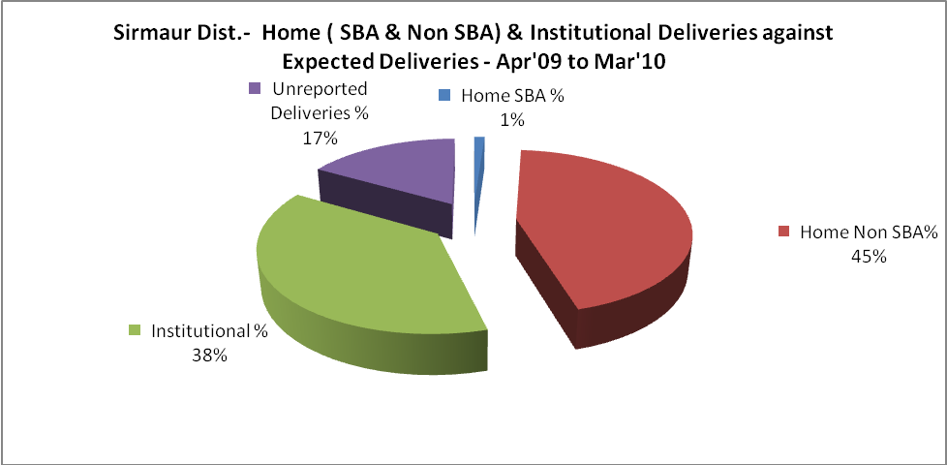
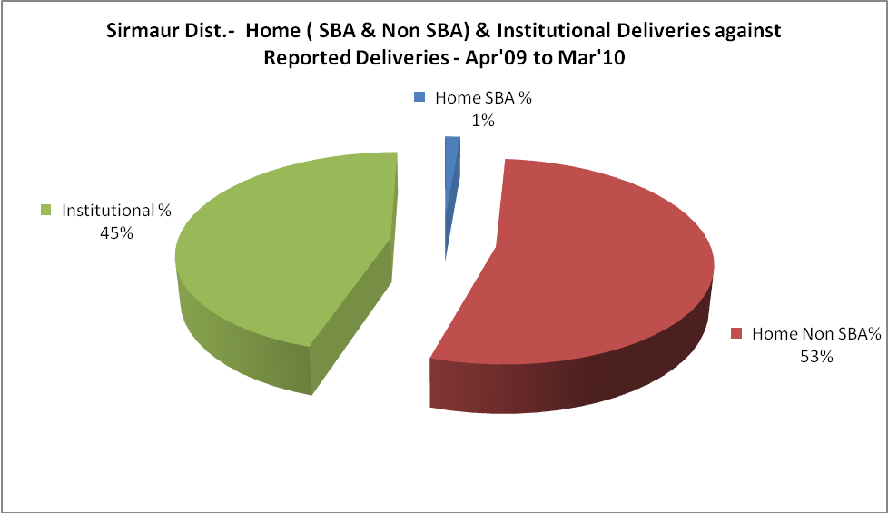

Sirmaur Dist.- Complicated Pregnancies & Deliveries Treated - Apr'09 to Mar'10
Reported Deliveries |  |  | Reported ANC Registration
7,621 |  |  | 11,579
Complicated Pregnancies attended | Complicated Pregnancies Rate | C - Section Deliveries | PNC Maternal Complications | Abortions | Still Births
109 | 1% | 76 | 9 | 94 | 76
Complicated Deliveries Treated with |  |  |  | No Of Eclampsia cases Treated | No Of severe anemia cases treated
IV Antibiotics | IV antihypertensive/Magsulph injection | IV Oxytocis | Blood Transfusion | No Of Eclampsia cases Treated | No Of severe anemia cases treated
256 | 19 | 176 | 2 | - | 56

Sirmaur Dist.- C sections & Complicated Deliveries Apr'09 to Mar'10
 | Institutional Deliveries (Public) | Institutional Deliveries (Pvt)
 | 3,302 | 140
C Section | 53 | 23
C Section% | 2% | 16%
Complicated Pregnancies attended | 109 | -
Complicated Pregnancies attended % | 3% | 0%

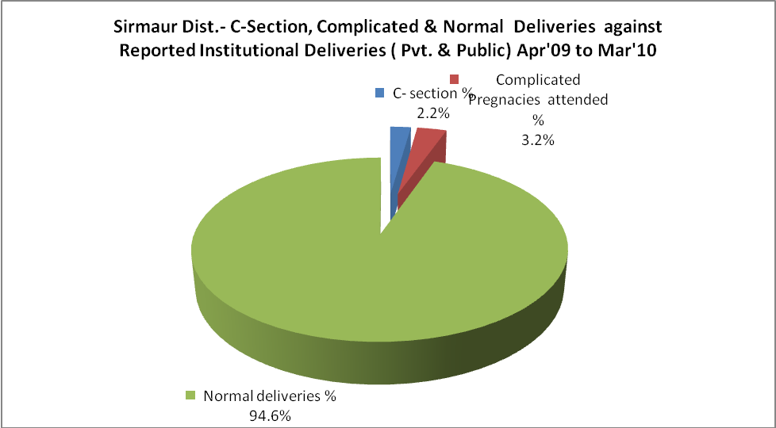

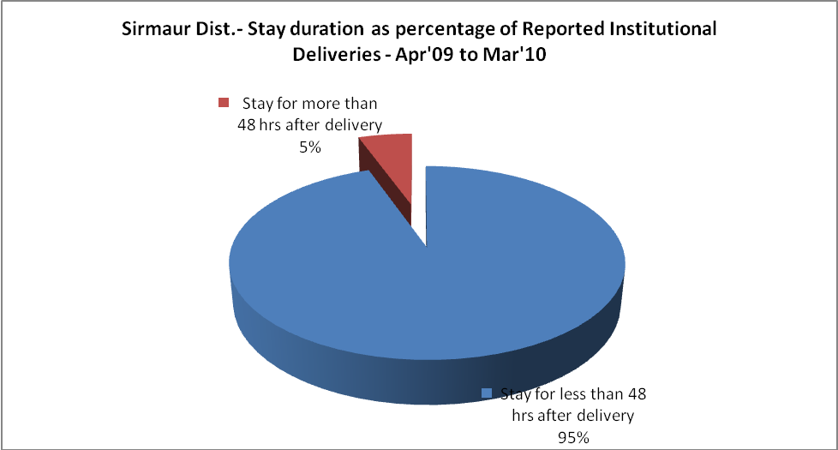

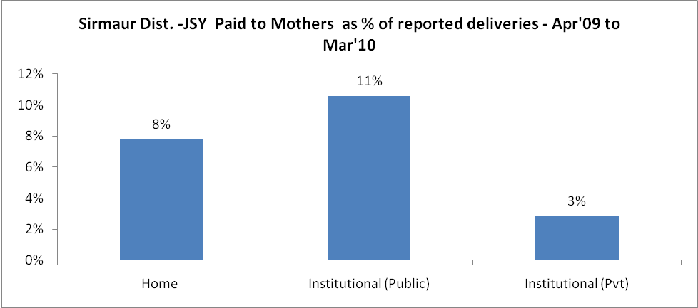
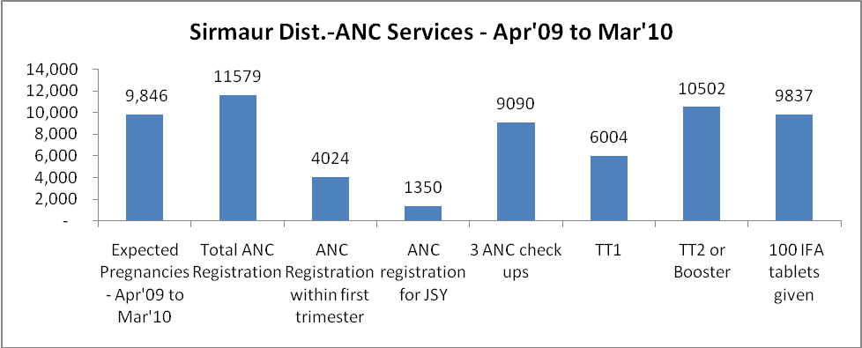

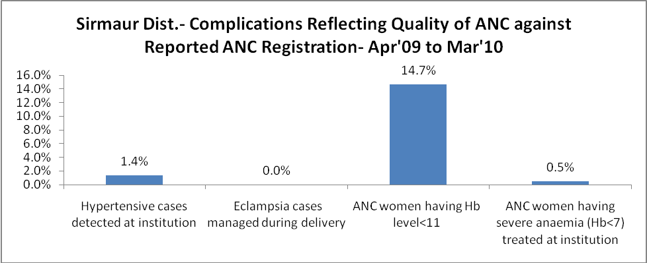
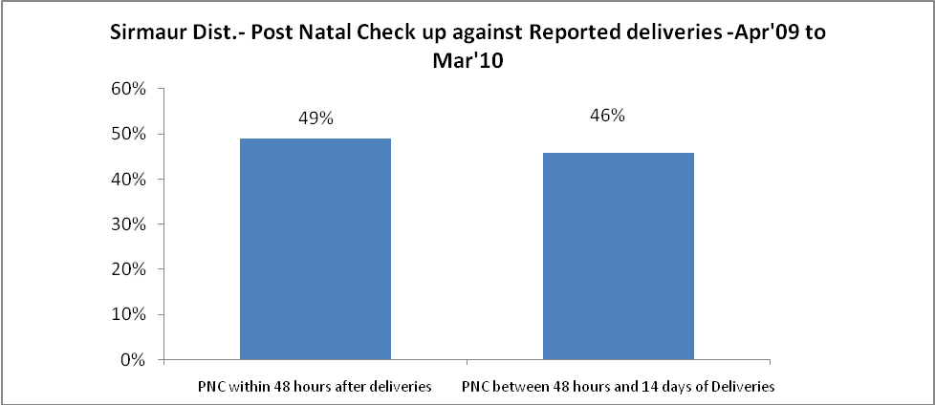

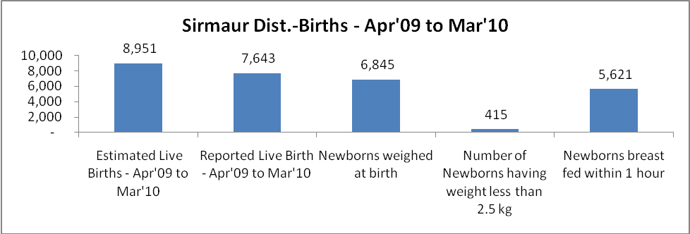

Sirmaur Dist. - Births - Apr'09 to Mar'10
Live Birth - Males | Live Birth - females | Live Birth - Total | Sex Ratio at birth | Still Birth | Abortion( Induced/Spontaneous
4,053 | 3,590 | 7,643 | 886 | 76 | 94

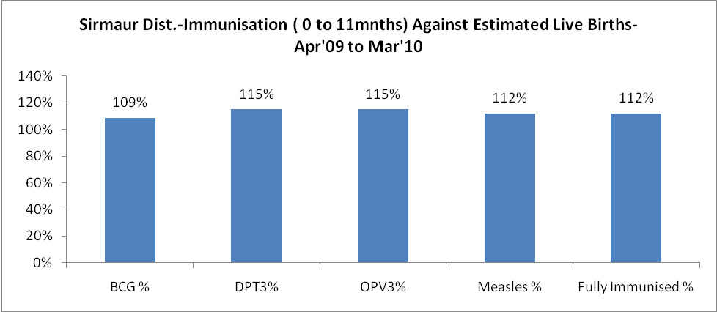
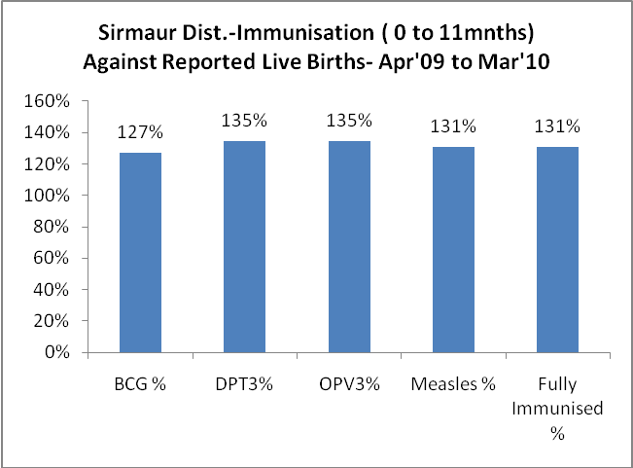
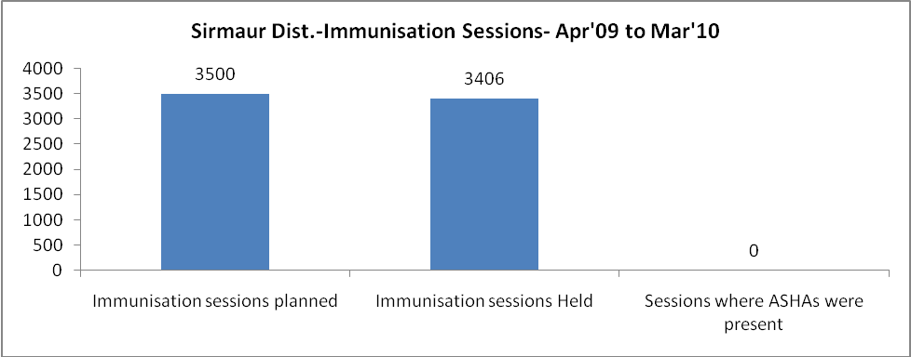
Sirmaur Dist.- Apr'09 to Mar'10
Total Abortions | Abortion Rate
593 | 6.0%

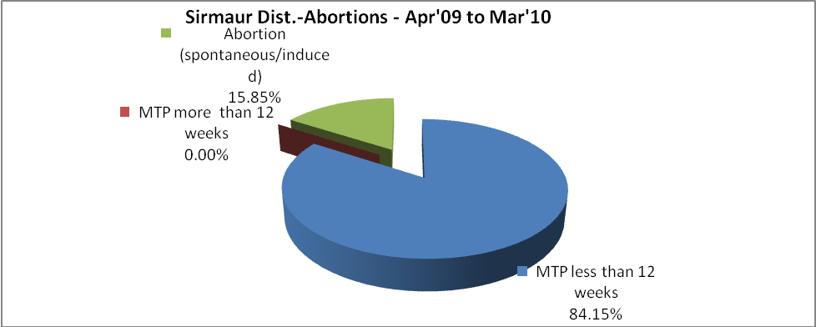
Sirmaur Dist.- Apr'09 to Mar'10
Total OPD | Total RTI/STI cases
243,559 | 2,623

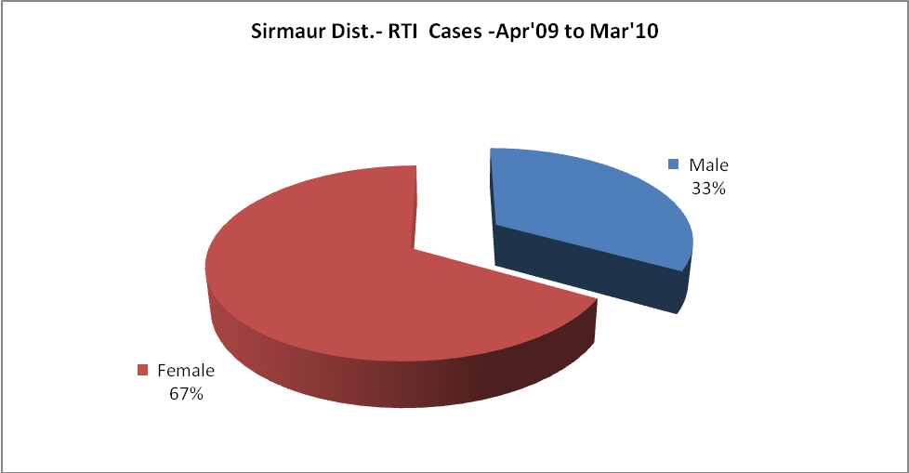
Sirmaur Dist.-Sterilizations - Apr'09 to Mar'10
 | Reported | %age of Reported Sterilization
Total Sterilization | 2,128 | -
NSV | 25 | 1%
Laproscopic | 2,078 | 98%
MiniLap | 14 | 1%
Post Partum | 11 | 1%
Male Sterilization | 25 | 1%
Female Sterilization | 2,103 | 99%

Sirmaur Dist.-FP Methods - Apr'09 to Mar'10
 | Reported | %age of All Reported FP Methods
Total Reported FP Method (All types) Users | 10,093 | -
Sterilizations | 2,128 | 21%
IUD | 981 | 10%
Condom Users | 5,558 | 55%
OCP Users | 1,427 | 14%
Limiting Methods | 2,128 | 21%
Spacing Methods | 7,965 | 79%

Sirmaur Dist.- Service Delivery - Apr'09 to Mar'10
Operation major (General and spinal anaesthesia) | Operation minor (No or local anaesthesia) | AYUSH | Dental Procedures | Adolescent counseling services | Total OPD | Total IPD
275 | 436 | - | 12,795 | 830 | 243,559 | 4,353
Operation major (General and spinal anaesthesia) as %ge of OPD | Operation minor (No or local anaesthesia)as %ge of OPD | AYUSH as %ge of OPD | Dental Procedures as %ge of OPD | Adolescent counseling services as %ge of OPD | IPD as percentage of OPD
0.1% | 0.2% | 0.0% | 5.3% | 0.3% | 2%

Sirmaur Dist.- Lab Services - Apr'09 to Mar'10
Total OPD | Total HB tested | Total HIV Tested | Total Population
243,559 | 11,146 | 826 | 505,683
HB test conducted as %age of OPD | HB<7gm as %age of HB tested | HIV test conducted as %age of OPD | HIV positive as %age of HIV tested | Blood Smear Examined as % of Population
4.6% | 2.1% | 0.3% | 0.6% | 6.6%

Sirmaur Dist.- Childhood Disease - Vaccine Preventable -Apr'09 to Mar'10
Diphtheria | Pertussis | Tetanus Neonatorum | Tetanus others | Polio | Measles
0 | 0 | 0 | 0 | 0 | 77
Sirmaur Dist.-Childhood Disease - Others - Apr'09 to Mar'10
Diarrhoea and dehydration | Malaria | Number admitted with Respiratory Infections
3,377 | - | 2,262
Sirmaur Dist.- Infant & Child Deaths - Apr'09 to Mar'10
Infant Deaths within 24 hrs of birth | Infant Deaths under 1 week | Infant Deaths under 1 month | Child Deaths under 1 year | Child Deaths under 5years | Total Deaths
11 | 18 | 32 | 49 | 61 | 171

Sirmaur Dist.- Causes of Infant & Child Deaths - Apr'09 to Mar'10
Sepsis |  |  | Asphyxia |  |  | LBW
Up to 1 Weeks of Birth | Between 1 week & 4 weeks of birth | Total | Up to 1 Weeks of Birth | Between 1 week & 4 weeks of birth | Total | Up to 1 Weeks of Birth | Between 1 week & 4 weeks of birth | Total
0 | 0 | 0 | 0 | 0 | 0 | 1 | 5 | 6
Pneumonia |  |  | Diarrhoea |  |  | Fever related
Between 1 month and 11 months | Between 1 year & 5 years | Total | Between 1 month and 11 months | Between 1 year & 5 years | Total | Between 1 month and 11 months | Between 1 year & 5 years | Total
6 | 0 | 6 | 0 | 0 | 0 | 3 | 1 | 4
Others |  |  | Measles |  |  | Others
Up to 1 Weeks of Birth | Between 1 week & 4 weeks of birth | Total | Between 1 month and 11 months | Between 1 year & 5 years | Total | Between 1 month and 11 months | Between 1 year & 5 years | Total
6 | 20 | 26 | 0 | 0 | 0 | 8 | 11 | 19

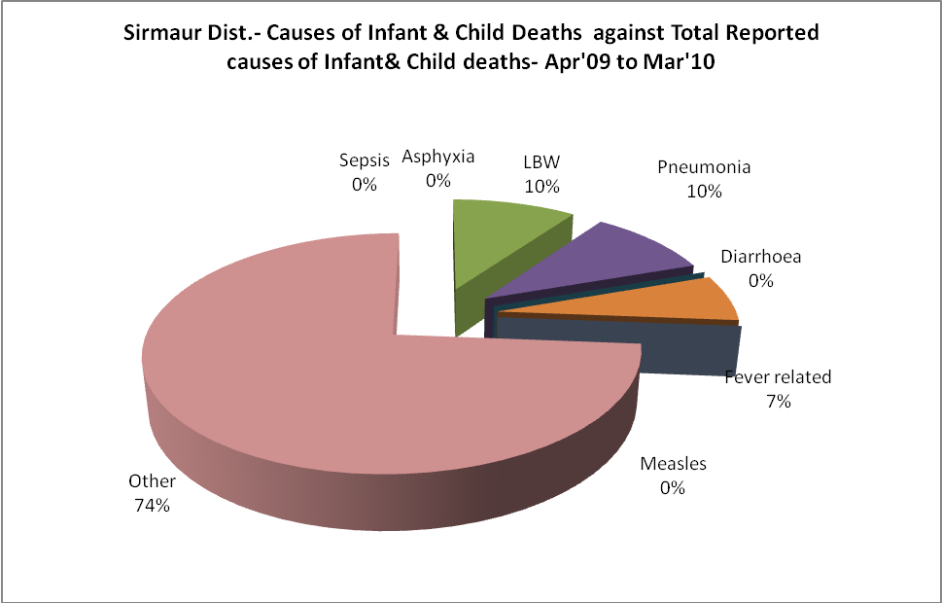

Sirmaur Dist.- Maternal Deaths & Causes - Apr'09 to Mar'10
Abortion |  |  | Obstructed/prolonged labour |  |  | Severe hypertension/fits
6-14 yrs | 15-55 yrs. | Total | 6-14 yrs | 15-55 yrs. | Total | 6-14 yrs | 15-55 yrs. | Total
0 | 0 | 0 | 0 | 0 | 0 | 0 | 0 | 0
Bleeding |  |  | High Fever |  |  | Other Causes
6-14 yrs | 15-55 yrs. | Total | 6-14 yrs | 15-55 yrs. | Total | 6-14 yrs | 15-55 yrs. | Total
0 | 0 | 0 | 0 | 1 | 1 | 0 | 3 | 3

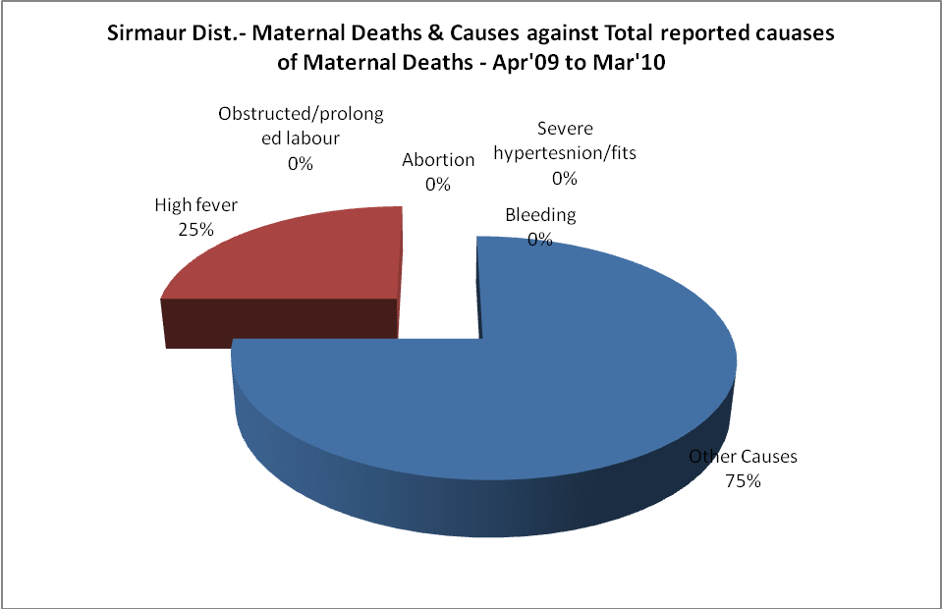

Sirmaur Dist.-Causes of Deaths in 6 to 55yrs age group - Apr'09 to Mar'10
Diarrhoel Diseases |  |  |  | Tuberculosis |  |  |  | Respiratory Diseases( Other than TB)
6-14 yrs | 15-55 yrs. | Above 55yrs | Total | 6-14 yrs | 15-55 yrs. | Above 55yrs | Total | 6-14 yrs | 15-55 yrs. | Above 55yrs | Total
0 | 0 | 0 | 0 | 0 | 3 | 0 | 3 | 0 | 1 | 3 | 4
Malaria |  |  |  | Other fever Related |  |  |  | HIV/Aids
6-14 yrs | 15-55 yrs. | Above 55yrs | Total | 6-14 yrs | 15-55 yrs. | Above 55yrs | Total | 6-14 yrs | 15-55 yrs. | Above 55yrs | Total
0 | 0 | 0 | 0 | 1 | 9 | 2 | 12 | 0 | 0 | 0 | 0
Heart Disease/Hypertenion related |  |  |  | Neurological Disease including strokes |  |  |  | Trauma/Accidents/ Burn Cases
6-14 yrs | 15-55 yrs. | Above 55yrs | Total | 6-14 yrs | 15-55 yrs. | Above 55yrs | Total | 6-14 yrs | 15-55 yrs. | Above 55yrs | Total
0 | 10 | 5 | 15 | 1 | 0 | 0 | 1 | 0 | 12 | 2 | 14
Suicide |  |  |  | Animal Bites & Stings
6-14 yrs | 15-55 yrs. | Above 55yrs | Total | 6-14 yrs | 15-55 yrs. | Above 55yrs | Total
0 | 5 | 0 | 5 | 0 | 0 | 0 | 0

