NHSRC
Rajasthan-Sirohi
Analysis: Apr 2009 – Mar 2010

Rajasthan- Sirohi- Summary-Apr'09 to Mar'10
ANC
ANC Registration against Expected Pregnancies | 111% | TT1 given to Pregnant women against ANC Registration | 61%
3 ANC Checkups against ANC Registrations | 72% | 100 IFA Tablets given to Pregnant women against ANC Registration | 95%
Deliveries
Unreported Deliveries against Estimated Deliveries | 16.1% | HOME Deliveries( SBA& Non SBA) against Estimated Deliveries | 10.0%
Institutional Deliveries against Estimated Deliveries | 73.9% | HOME Deliveries( SBA& Non SBA) against Reported Deliveries | 11.9%
Institutional Deliveries against Reported Deliveries | 88.1% | C Section Deliveries against Institutional Deliveries( Pvt & Pub) | 1%
Births & Neonates Care
Live Births Reported against Estimated Live Births | 86% | New borns weighed against Reported Live Births | 100%
Still Births (Reported) | 341 | New borns weighed less than 2.5 kgs against newborns weighed | 15%
Sex Ratio at Birth | 909 | New borns breastfed within one hr of Birth against Reported live Births | 92%
Child Immunisation( 0 to 11 months)
BCG given against Expected Live Births | 116% | Measles given against Expected Live Births | 114%
OPV3 given against Expected Live Births | 116% | Fully Immunised Children against Expected Live Births | 103%
DPT3 given against Expected Live Births | 116%
Family Planning
Family Plannig Methods Users ( Sterilisations(Male &Female)+IUD+ Condom pieces/72 + OCP Cycles/13) | 69,329 | IUD Insertions against reported FP Methods | 20%
Sterilisation against reported FP Methods | 4% | Condom Users against reported FP Methods | 49%
 |  | OCP Users against reported FP Methods | 26%
Other Services
OPD | 567,162 | Major Operations | 1,146
IPD | 25,550 | Minor Operations | 4,463

Rajasthan- Sirohi- Deliveries Apr'09 to Mar'10
Total Population | 1,012,900 | Expected Deliveries |  | 28,732
Home SBA | Home Non SBA | Institutional | Total Deliveries Reported | Unreported Deliveries
2,047 | 812 | 21,235 | 24,094 | 4,638
Home SBA % | Home Non SBA% | Institutional % | Total Deliveries Reported % | Unreported Deliveries %
7% | 3% | 74% | 84% | 16%
`

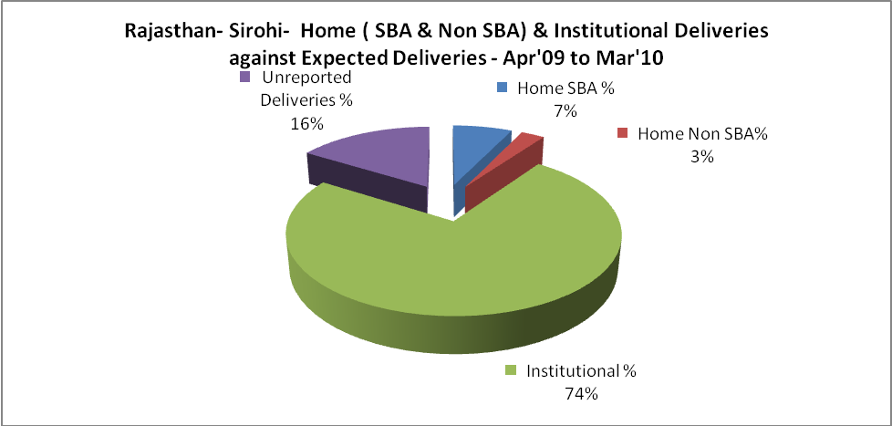

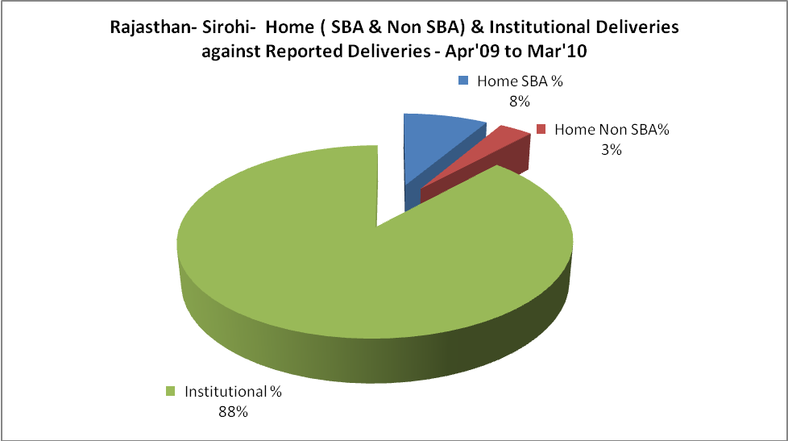

Rajasthan- Sirohi- C sections & Complicated Deliveries Apr'09 to Mar'10
 | Institutional Deliveries (Public) | Institutional Deliveries (Pvt)
 | 14,639 | 6,596
C Section | 128 | 117
C Section% | 1% | 2%
Complicated Pregnacies attended | 285 | 182
Complicated Pregnacies attended % | 2% | 3%

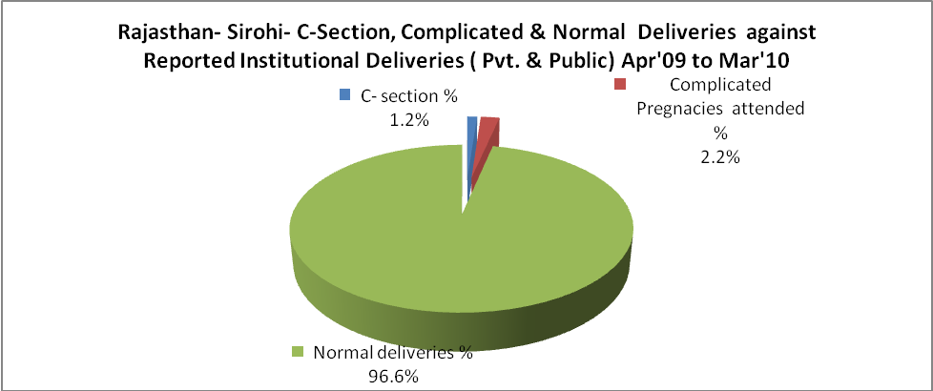

Rajasthan- Sirohi- Complicated Pregnancies & Deliveries Treated - Apr'09 to Mar'10
Reported Deliveries |  |  | Reported ANC Reigtration
24,094 |  |  | 33,858
Complicated Pregnancies attended | Complicated Pregnancies Rate | C - Section Deliveries | PNC Maternal Complications | Abortions | Still Births
467 | 2% | 245 | 169 | 179 | 341
Complicated Deliveries Treated with |  |  |  | No Of Eclampsia cases Treated | No Of severe anemia cases treated
IV Antibiotics | IV antihypertensive/Magsulph injection | IV Oxytocis | Blood Transfusion | No Of Eclampsia cases Treated | No Of severe anemia cases treated
421 | 68 | 640 | 79 | 6 | 220

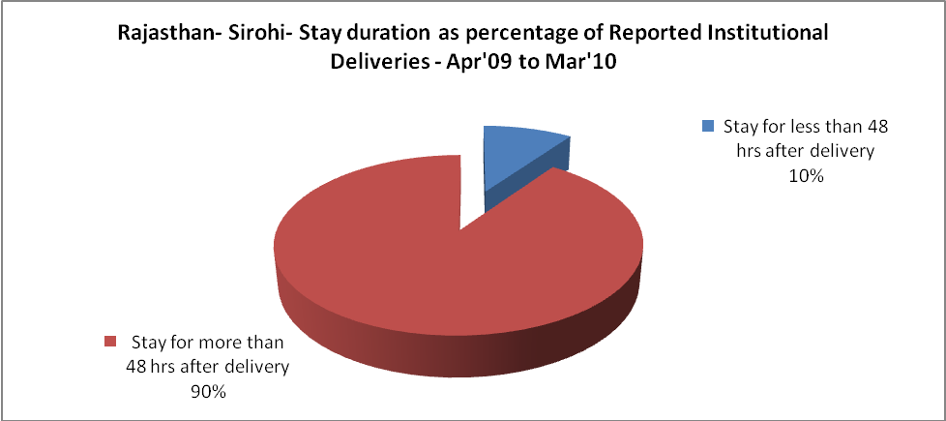

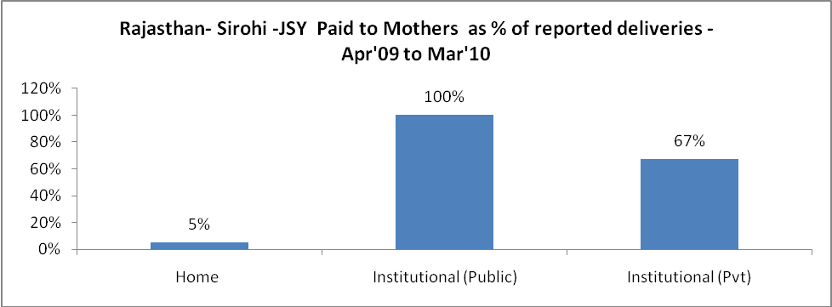

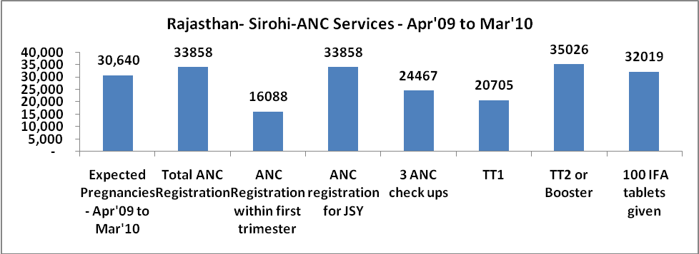

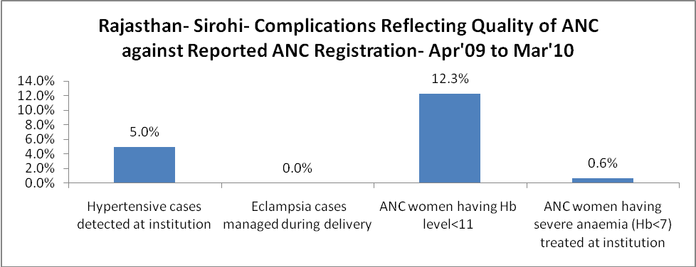

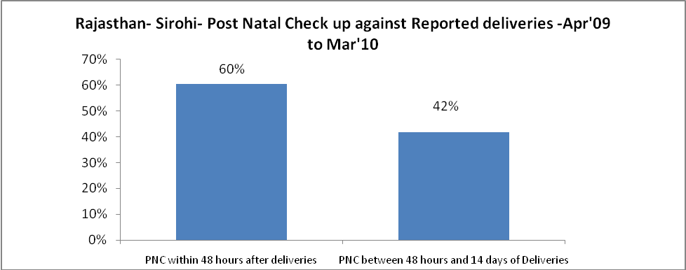

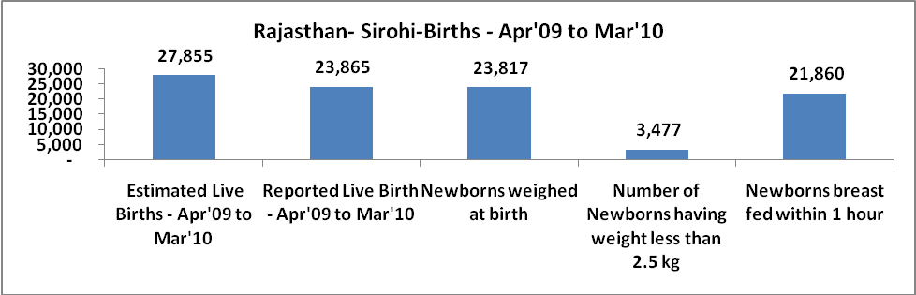

Rajasthan- Sirohi - Births - Apr'09 to Mar'10
Live Birth - Males | Live Birth - females | Live Birth - Total | Sex Ratio at birth | Still Birth | Abortion( Induced/Spontaneous
12,503 | 11,362 | 23,865 | 909 | 341 | 179

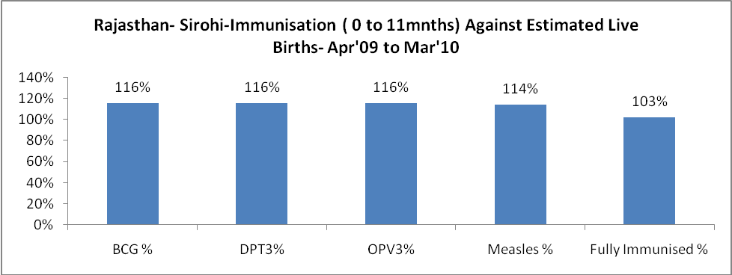

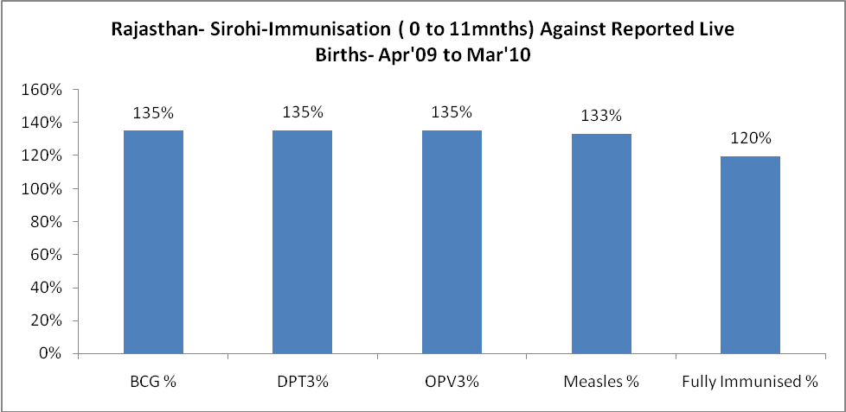

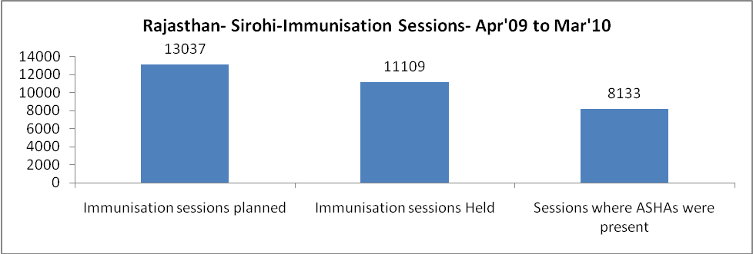

Rajasthan- Sirohi- Apr'09 to Mar'10
Total Abortions | Abortion Rate
582 | 1.9%

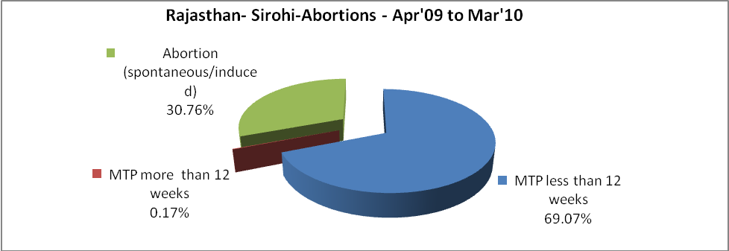

Rajasthan- Sirohi- Apr'09 to Mar'10
Total OPD | Total RTI/STI cases
567,162 | 1,350

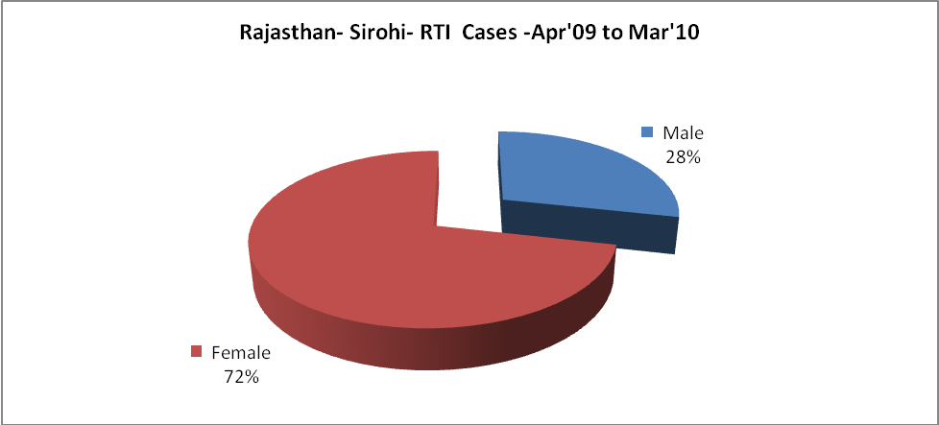

Rajasthan- Sirohi-Sterilisations - Apr'09 to Mar'10
 | Reported | %age of Reported Sterilisation
Total Sterilisation | 3,117 | -
NSV | 64 | 2%
Laproscopic | 2,866 | 92%
MiniLap | - | 0%
Post Partum | 187 | 6%
Male Sterilisation | 64 | 2%
Female Sterilisation | 3,053 | 98%

Rajasthan- Sirohi-FP Methods - Apr'09 to Mar'10
 | Reported | %age of All Reported FP Methods
Total Reported FP Methodd (All types) Users | 69,329 | -
Sterilisations | 3,117 | 4%
IUD | 13,834 | 20%
Condom Users | 34,274 | 49%
OCP Users | 18,104 | 26%
Limiting Methods | 3,117 | 4%
Spacing Methods | 66,212 | 96%

Rajasthan- Sirohi- Service Delivery - Apr'09 to Mar'10
Operation major (General and spinal anaesthesia) | Operation minor (No or local anaesthesia) | AYUSH | Dental Procedures | Adolescent counselling services | Total OPD | Total IPD
1,146 | 4,463 | 24,572 | 10,162 | 1,226 | 567,162 | 25,550
Operation major (General and spinal anaesthesia) as %ge of OPD | Operation minor (No or local anaesthesia)as %ge of OPD | AYUSH as %ge of OPD | Dental Procedures as %ge of OPD | Adolescent counselling services as %ge of OPD | IPD as percentage of OPD
0.2% | 0.8% | 4.3% | 1.8% | 0.2% | 5%

Rajasthan- Sirohi- Lab Services - Apr'09 to Mar'10
Total OPD | Total HB tested | Total HIV Tested | Total Population
567,162 | 15,137 | 3,341 | 1,012,900
HB test conducted as %age of OPD | HB<7gm as %age of HB tested | HIV test conducted as %age of OPD | HIV positive as %age of HIV tested | Blood Smear Examined as % of Population
2.7% | 15.0% | 0.6% | 3.1% | 11.9%

Rajasthan- Sirohi- Childhood Disease - Vaccine Preventable -Apr'09 to Mar'10
Diphtheria | Pertussis | Tetanus Neonatorum | Tetanus others | Polio | Measles
0 | 0 | 0 | 0 | 0 | 10
Rajasthan- Sirohi-Childhood Disease - Others - Apr'09 to Mar'10
Diarrhoea and dehydration | Malaria | Number admitted with Respiratory Infections
3,114 | 7 | 308

Rajasthan- Sirohi- Infant & Child Deaths - Apr'09 to Mar'10
Infant Deaths within 24 hrs of birth | Infant Deaths between 24hrs & under 1 week | Infant Deaths between 1 week & under 1 month | Child Deaths between 1 month & under 1 year | Child Deaths between 1yr under 5years | Total Deaths
45 | 131 | 39 | 55 | 64 | 334

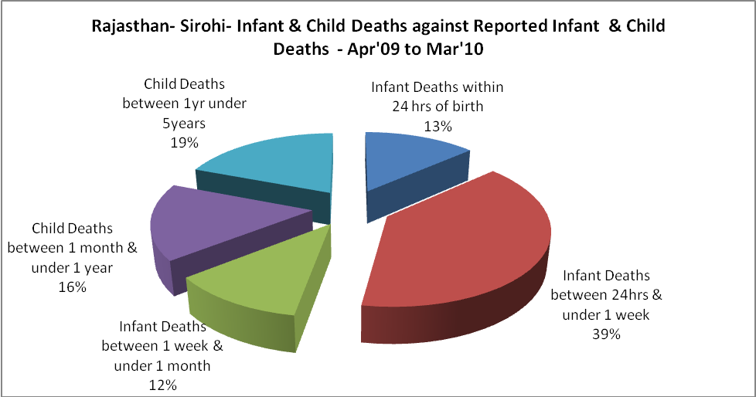

Rajasthan- Sirohi- Causes of Infant & Child Deaths - Apr'09 to Mar'10
Sepsis |  |  | Asphyxia |  |  | LBW
Up to 1 Weeks of Birth | Between 1 week & 4 weeks of birth | Total | Up to 1 Weeks of Birth | Between 1 week & 4 weeks of birth | Total | Up to 1 Weeks of Birth | Between 1 week & 4 weeks of birth | Total
12 | 2 | 14 | 14 | 1 | 15 | 50 | 6 | 56
Pneumonia |  |  | Diarrhoea |  |  | Fever related
Between 1 month and 11 months | Between 1 year & 5 years | Total | Between 1 month and 11 months | Between 1 year & 5 years | Total | Between 1 month and 11 months | Between 1 year & 5 years | Total
9 | 4 | 13 | 3 | 5 | 8 | 4 | 6 | 10
Others |  |  | Measles |  |  | Others
Up to 1 Weeks of Birth | Between 1 week & 4 weeks of birth | Total | Between 1 month and 11 months | Between 1 year & 5 years | Total | Between 1 month and 11 months | Between 1 year & 5 years | Total
55 | 30 | 85 | 0 | 0 | 0 | 39 | 49 | 88

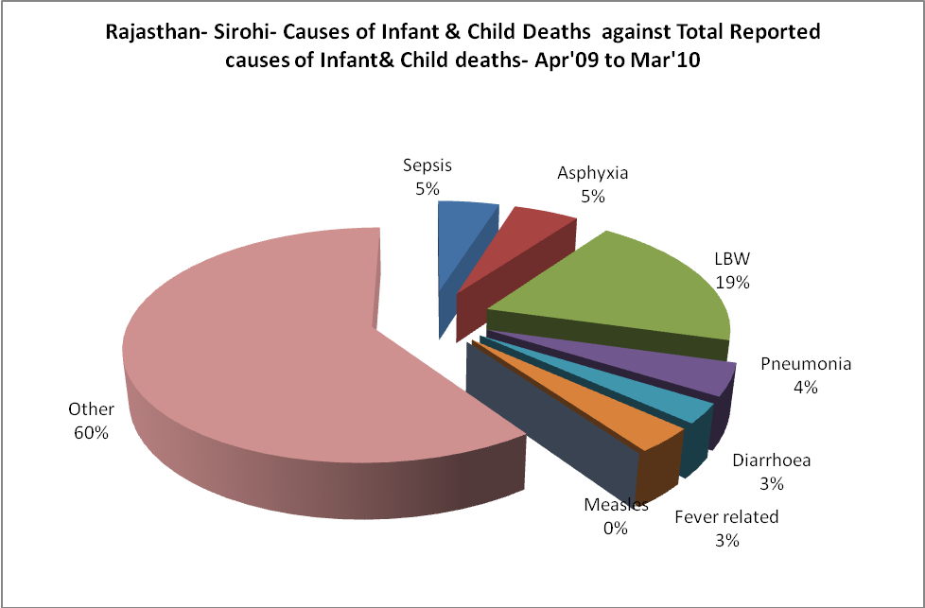
Rajasthan- Sirohi- Maternal Deaths & Causes - Apr'09 to Mar'10
Abortion |  |  | Obstructed/prolonged labour |  |  | Severe hypertesnion/fits
6-14 yrs | 15-55 yrs. | Total | 6-14 yrs | 15-55 yrs. | Total | 6-14 yrs | 15-55 yrs. | Total
0 | 3 | 3 | 0 | 2 | 2 | 0 | 1 | 1
Bleeding |  |  | High Fever |  |  | Other Causes
6-14 yrs | 15-55 yrs. | Total | 6-14 yrs | 15-55 yrs. | Total | 6-14 yrs | 15-55 yrs. | Total
0 | 2 | 2 | 0 | 0 | 0 | 0 | 6 | 6

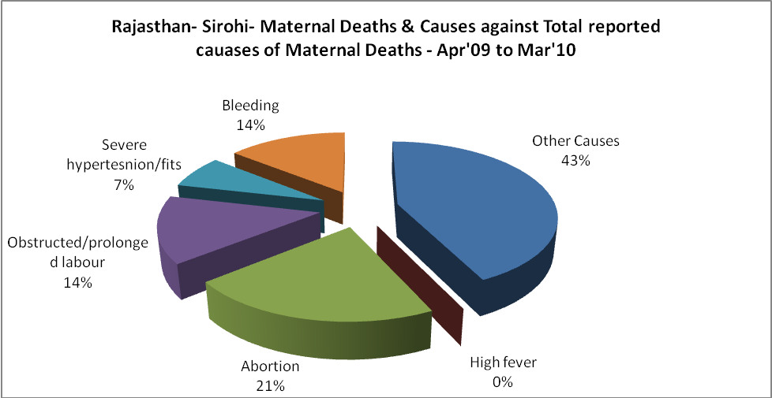

Rajasthan- Sirohi-Causes of Deaths in 6 to 55yrs age group - Apr'09 to Mar'10
Diarrhoel Diseases |  |  |  | Tuberculosis |  |  |  | Respiratory Diseases( Other than TB)
6-14 yrs | 15-55 yrs. | Above 55yrs | Total | 6-14 yrs | 15-55 yrs. | Above 55yrs | Total | 6-14 yrs | 15-55 yrs. | Above 55yrs | Total
7 | 8 | 0 | 15 | 2 | 5 | 3 | 10 | 0 | 17 | 20 | 37
Malaria |  |  |  | Other fever Related |  |  |  | HIV/Aids
6-14 yrs | 15-55 yrs. | Above 55yrs | Total | 6-14 yrs | 15-55 yrs. | Above 55yrs | Total | 6-14 yrs | 15-55 yrs. | Above 55yrs | Total
0 | 0 | 0 | 0 | 1 | 2 | 1 | 4 | 0 | 2 | 0 | 2
Heart Disease/Hypertenion related |  |  |  | Neurological Disease including strokes |  |  |  | Trauma/Accidents/ Burn Cases
6-14 yrs | 15-55 yrs. | Above 55yrs | Total | 6-14 yrs | 15-55 yrs. | Above 55yrs | Total | 6-14 yrs | 15-55 yrs. | Above 55yrs | Total
0 | 22 | 4 | 26 | 23 | 3 | 5 | 31 | 3 | 57 | 40 | 100
Suicide |  |  |  | Animal Bites & Stings
6-14 yrs | 15-55 yrs. | Above 55yrs | Total | 6-14 yrs | 15-55 yrs. | Above 55yrs | Total
0 | 14 | 1 | 15 | 3 | 8 | 4 | 15

