NHSRC
Himachal Pradesh- Solan District
Analysis 2009-10

7/22/2010

Solan Dist.- Summary-Apr'09 to Mar'10
ANC
ANC Registration against Expected Pregnancies | 114% | TT1 given to Pregnant women against ANC Registration | 59%
3 ANC Check ups against ANC Registrations | 57% | 100 IFA Tablets given to Pregnant women against ANC Registration | 89%
Deliveries
Unreported Deliveries against Estimated Deliveries | 11.2% | HOME Deliveries( SBA& Non SBA) against Estimated Deliveries | 37.6%
Institutional Deliveries against Estimated Deliveries | 51.2% | HOME Deliveries( SBA& Non SBA) against Reported Deliveries | 42.3%
Institutional Deliveries against Reported Deliveries | 57.7% | C Section Deliveries against Institutional Deliveries( Pvt & Pub) | 23%
Births & Neonates Care
Live Births Reported against Estimated Live Births | 91% | New borns weighed against Reported Live Births | 94%
Still Births (Reported) | 104 | New borns weighed less than 2.5 kgs against newborns weighed | 3%
Sex Ratio at Birth | 904 | New borns breastfed within one hr of Birth against Reported live Births | 75%
Child Immunization( 0 to 11 months)
BCG given against Expected Live Births | 112% | Measles given against Expected Live Births | 108%
OPV3 given against Expected Live Births | 112% | Fully Immunized Children against Expected Live Births | 108%
DPT3 given against Expected Live Births | 112%
Family Planning
Family Planning Methods Users ( Sterilizations(Male &Female)+IUD+ Condom pieces/72 + OCP Cycles/13) | 13,779 | IUD Insertions against reported FP Methods | 12%
Sterilization against reported FP Methods | 18% | Condom Users against reported FP Methods | 58%
 |  | OCP Users against reported FP Methods | 12%
Other Services
OPD | 431,298 | Major Operations | 1,176
IPD | 17,304 | Minor Operations | 1,035

Solan Dist.- Deliveries Apr'09 to Mar'10
Total Population | 551,956 | Expected Deliveries |  | 9,985
Home SBA | Home Non SBA | Institutional | Total Deliveries Reported | Unreported Deliveries
1,634 | 2,120 | 5,116 | 8,870 | 1,115
Home SBA % | Home Non SBA% | Institutional % | Total Deliveries Reported % | Unreported Deliveries %
16% | 21% | 51% | 89% | 11%

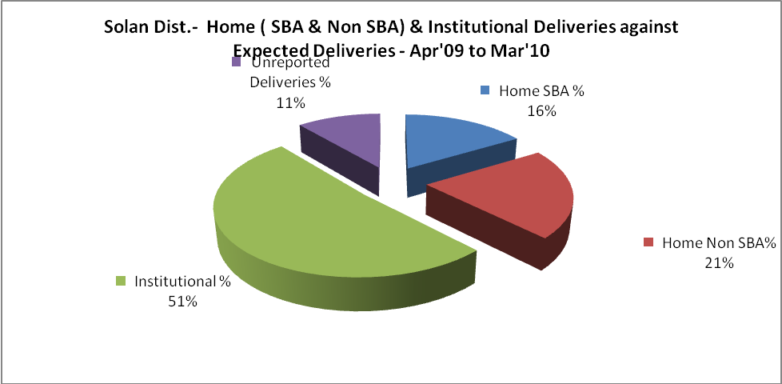
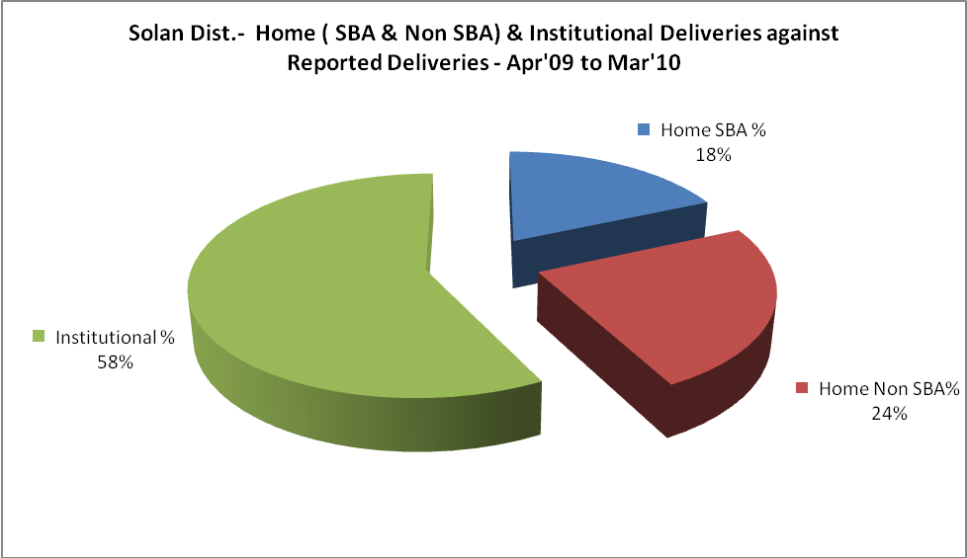

Solan Dist.- C sections & Complicated Deliveries Apr'09 to Mar'10
 | Institutional Deliveries (Public) | Institutional Deliveries (Pvt)
 | 3,870 | 1,246
C Section | 263 | 207
C Section% | 7% | 17%
Complicated Pregnancies attended | 75 | 151
Complicated Pregnancies attended % | 2% | 12%

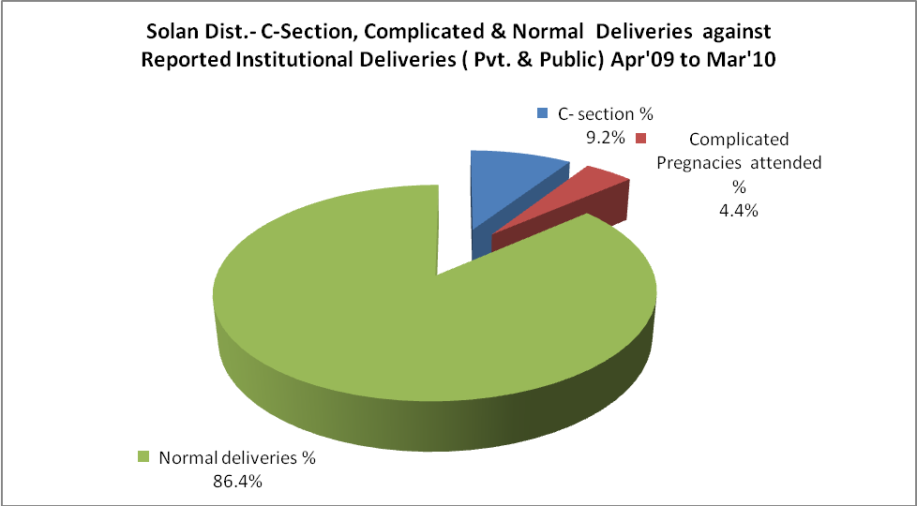

Solan Dist.- Complicated Pregnancies & Deliveries Treated - Apr'09 to Mar'10
Reported Deliveries |  |  | Reported ANC Registration
8,870 |  |  | 12,239
Complicated Pregnancies attended | Complicated Pregnancies Rate | C - Section Deliveries | PNC Maternal Complications | Abortions | Still Births
226 | 2% | 470 | 34 | 111 | 104
Complicated Deliveries Treated with |  |  |  | No Of Eclampsia cases Treated | No Of severe anemia cases treated
IV Antibiotics | IV antihypertensive/Magsulph injection | IV Oxytocis | Blood Transfusion | No Of Eclampsia cases Treated | No Of severe anemia cases treated
78 | 5 | 4 | 6 | 1 | 106

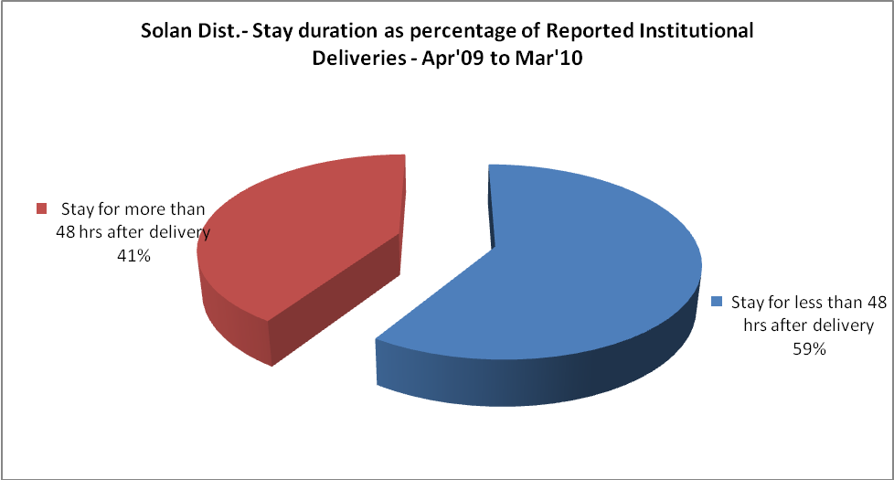

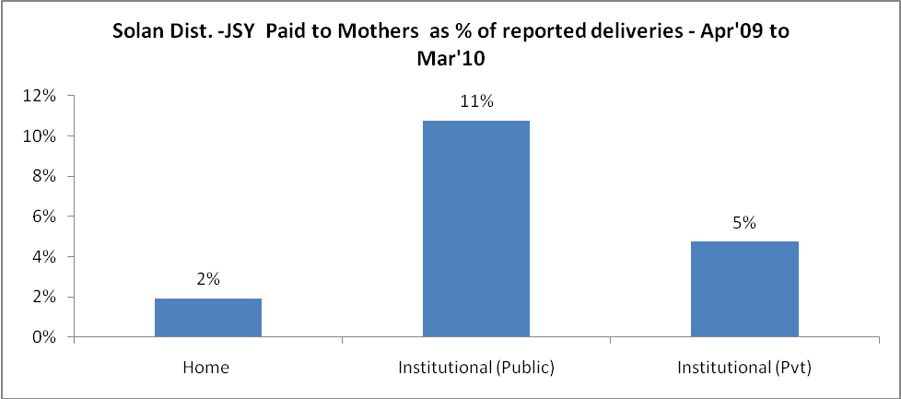
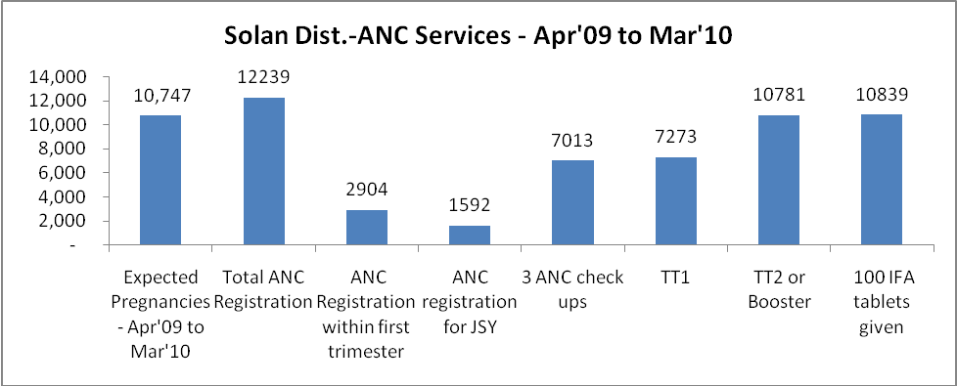

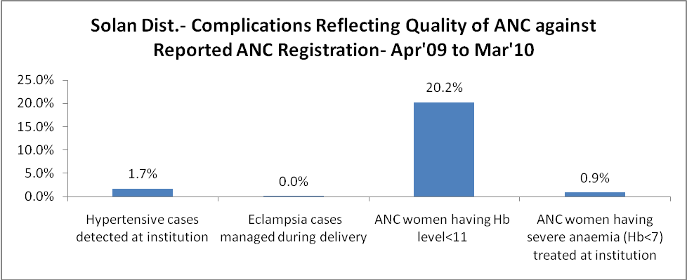
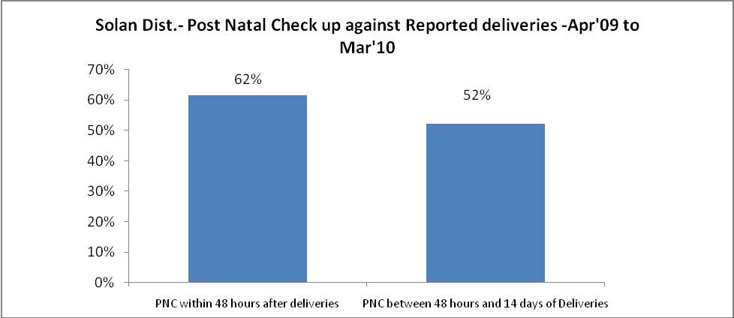

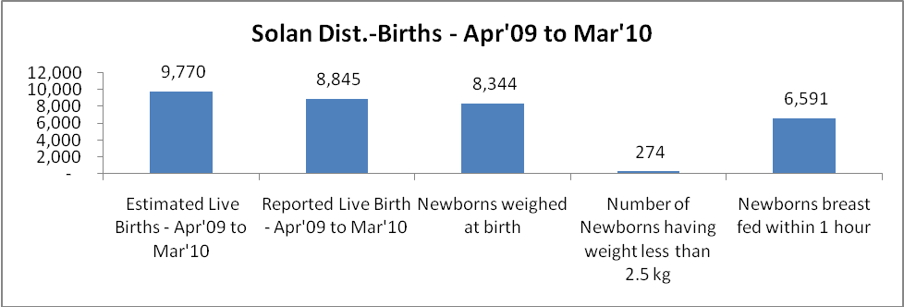

Solan Dist. - Births - Apr'09 to Mar'10
Live Birth - Males | Live Birth - females | Live Birth - Total | Sex Ratio at birth | Still Birth | Abortion( Induced/Spontaneous
4,646 | 4,199 | 8,845 | 904 | 104 | 111

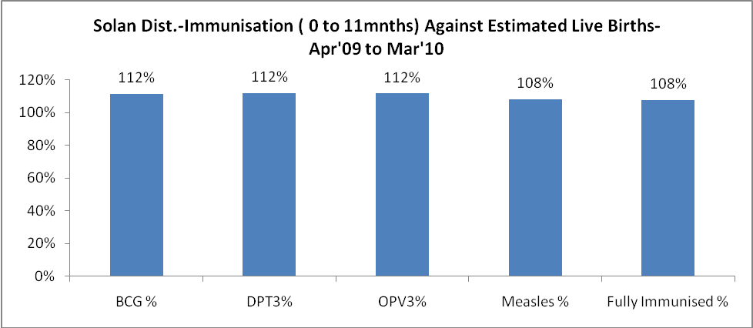
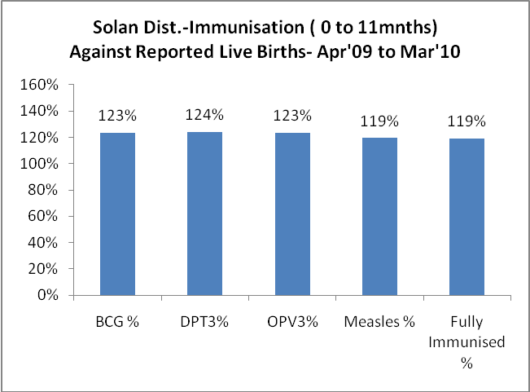
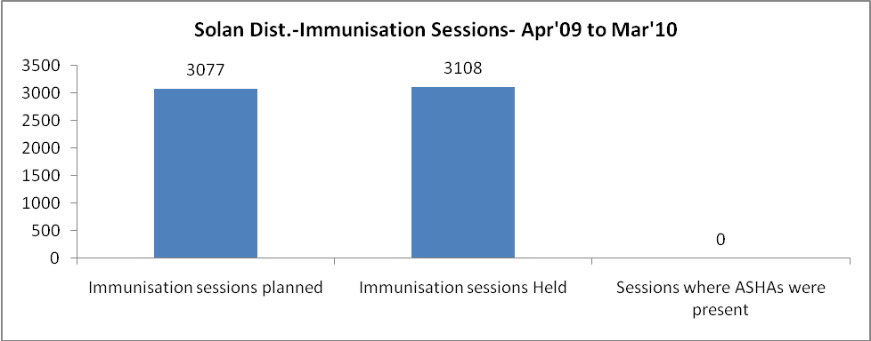
Solan Dist.- Apr'09 to Mar'10
Total Abortions | Abortion Rate
275 | 2.6%

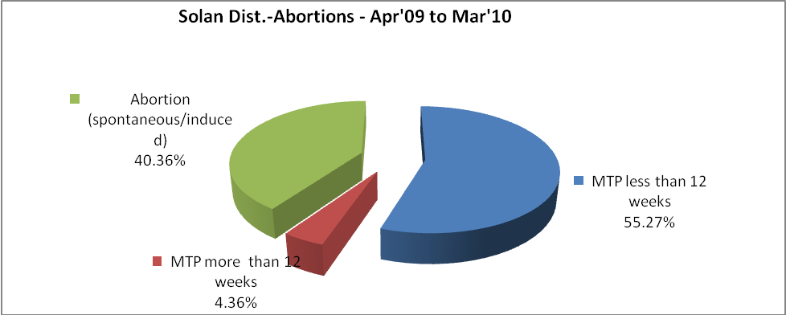
Solan Dist.- Apr'09 to Mar'10
Total OPD | Total RTI/STI cases
431,298 | 3,371

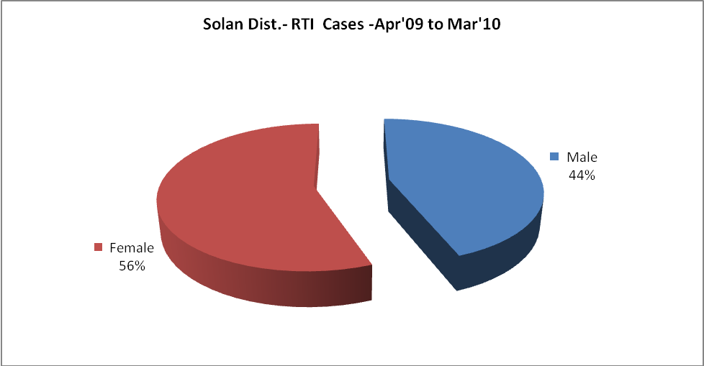
Solan Dist.-Sterilizations - Apr'09 to Mar'10
 | Reported | %age of Reported Sterilization
Total Sterilization | 2,500 | -
NSV | 171 | 7%
Laproscopic | 2,290 | 92%
MiniLap | 34 | 1%
Post Partum | 5 | 0%
Male Sterilization | 171 | 7%
Female Sterilization | 2,329 | 93%

Solan Dist.-FP Methods - Apr'09 to Mar'10
 | Reported | %age of All Reported FP Methods
Total Reported FP Method (All types) Users | 13,779 | -
Sterilizations | 2,500 | 18%
IUD | 1,608 | 12%
Condom Users | 7,977 | 58%
OCP Users | 1,693 | 12%
Limiting Methods | 2,500 | 18%
Spacing Methods | 11,279 | 82%

Solan Dist.- Service Delivery - Apr'09 to Mar'10
Operation major (General and spinal anaesthesia) | Operation minor (No or local anaesthesia) | AYUSH | Dental Procedures | Adolescent counseling services | Total OPD | Total IPD
1,176 | 1,035 | 700 | 5,843 | - | 431,298 | 17,304
Operation major (General and spinal anaesthesia) as %ge of OPD | Operation minor (No or local anaesthesia)as %ge of OPD | AYUSH as %ge of OPD | Dental Procedures as %ge of OPD | Adolescent counseling services as %ge of OPD | IPD as percentage of OPD
0.3% | 0.2% | 0.2% | 1.4% | 0.0% | 4%

Solan Dist.- Lab Services - Apr'09 to Mar'10
Total OPD | Total HB tested | Total HIV Tested | Total Population
431,298 | 14,199 | 3,515 | 551,956
HB test conducted as %age of OPD | HB<7gm as %age of HB tested | HIV test conducted as %age of OPD | HIV positive as %age of HIV tested | Blood Smear Examined as % of Population
3.3% | 2.4% | 0.8% | 0.7% | 2.8%

Solan Dist.- Childhood Disease - Vaccine Preventable -Apr'09 to Mar'10
Diphtheria | Pertussis | Tetanus Neonatorum | Tetanus others | Polio | Measles
0 | 0 | 0 | 0 | 0 | 1
Solan Dist.-Childhood Disease - Others - Apr'09 to Mar'10
Diarrhoea and dehydration | Malaria | Number admitted with Respiratory Infections
1,236 | 6 | 844
Solan Dist.- Infant & Child Deaths - Apr'09 to Mar'10
Infant Deaths within 24 hrs of birth | Infant Deaths under 1 week | Infant Deaths under 1 month | Child Deaths under 1 year | Child Deaths under 5years | Total Deaths
2 | 11 | 12 | 16 | 18 | 59

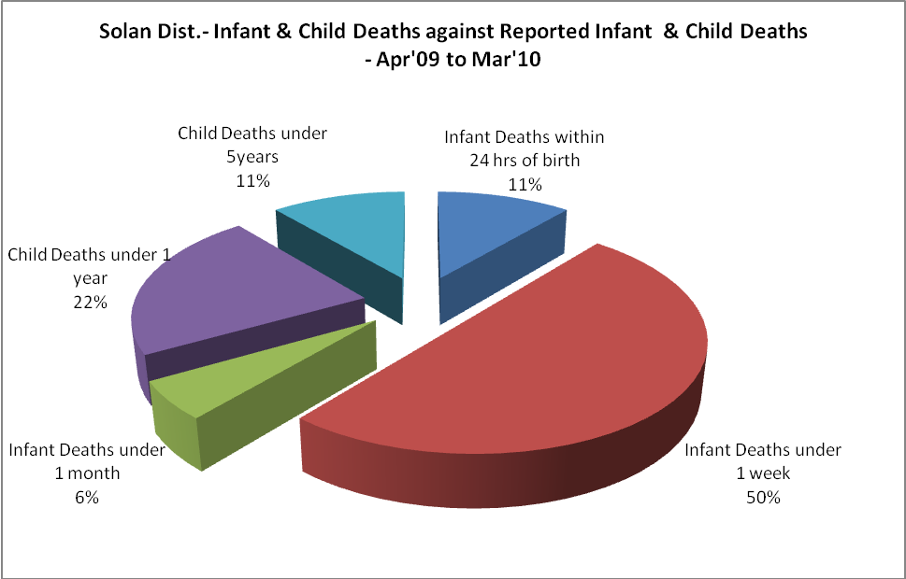

Solan Dist.- Causes of Infant & Child Deaths - Apr'09 to Mar'10
Sepsis |  |  | Asphyxia |  |  | LBW
Up to 1 Weeks of Birth | Between 1 week & 4 weeks of birth | Total | Up to 1 Weeks of Birth | Between 1 week & 4 weeks of birth | Total | Up to 1 Weeks of Birth | Between 1 week & 4 weeks of birth | Total
0 | 0 | 0 | 1 | 0 | 1 | 2 | 1 | 3
Pneumonia |  |  | Diarrhoea |  |  | Fever related
Between 1 month and 11 months | Between 1 year & 5 years | Total | Between 1 month and 11 months | Between 1 year & 5 years | Total | Between 1 month and 11 months | Between 1 year & 5 years | Total
2 | 2 | 4 | 0 | 0 | 0 | 0 | 0 | 0
Others |  |  | Measles |  |  | Others
Up to 1 Weeks of Birth | Between 1 week & 4 weeks of birth | Total | Between 1 month and 11 months | Between 1 year & 5 years | Total | Between 1 month and 11 months | Between 1 year & 5 years | Total
6 | 2 | 8 | 0 | 0 | 0 | 2 | 0 | 2

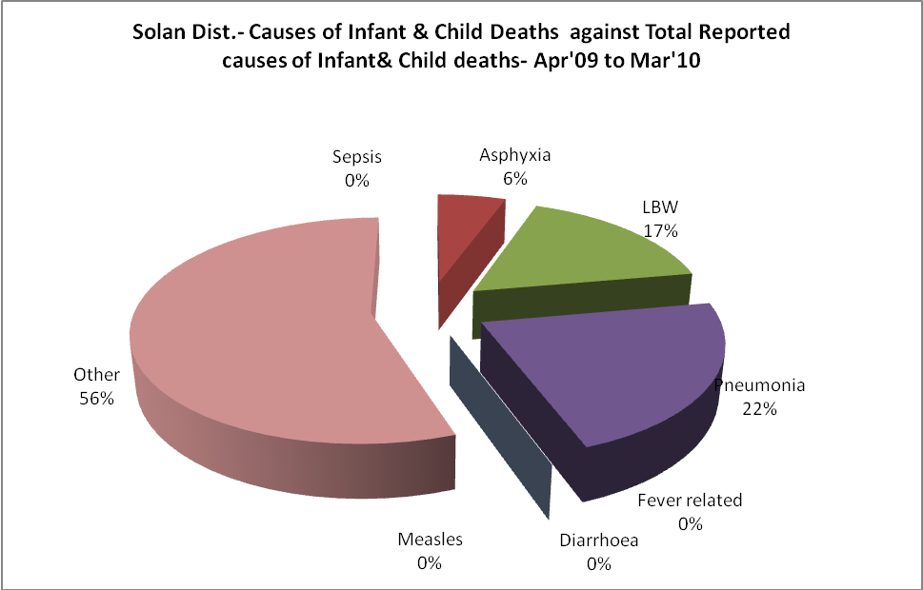

Solan Dist.- Maternal Deaths & Causes - Apr'09 to Mar'10
Abortion |  |  | Obstructed/prolonged labour |  |  | Severe hypertension/fits
6-14 yrs | 15-55 yrs. | Total | 6-14 yrs | 15-55 yrs. | Total | 6-14 yrs | 15-55 yrs. | Total
0 | 0 | 0 | 0 | 0 | 0 | 0 | 0 | 0
Bleeding |  |  | High Fever |  |  | Other Causes
6-14 yrs | 15-55 yrs. | Total | 6-14 yrs | 15-55 yrs. | Total | 6-14 yrs | 15-55 yrs. | Total
0 | 0 | 0 | 0 | 0 | 0 | 0 | 0 | 0

Solan Dist.-Causes of Deaths in 6 to 55yrs age group - Apr'09 to Mar'10
Diarrhoel Diseases |  |  |  | Tuberculosis |  |  |  | Respiratory Diseases( Other than TB)
6-14 yrs | 15-55 yrs. | Above 55yrs | Total | 6-14 yrs | 15-55 yrs. | Above 55yrs | Total | 6-14 yrs | 15-55 yrs. | Above 55yrs | Total
0 | 0 | 0 | 0 | 0 | 1 | 3 | 4 | 0 | 7 | 2 | 9
Malaria |  |  |  | Other fever Related |  |  |  | HIV/Aids
6-14 yrs | 15-55 yrs. | Above 55yrs | Total | 6-14 yrs | 15-55 yrs. | Above 55yrs | Total | 6-14 yrs | 15-55 yrs. | Above 55yrs | Total
0 | 0 | 0 | 0 | 0 | 0 | 1 | 1 | 0 | 0 | 0 | 0
Heart Disease/Hypertenion related |  |  |  | Neurological Disease including strokes |  |  |  | Trauma/Accidents/ Burn Cases
6-14 yrs | 15-55 yrs. | Above 55yrs | Total | 6-14 yrs | 15-55 yrs. | Above 55yrs | Total | 6-14 yrs | 15-55 yrs. | Above 55yrs | Total
0 | 9 | 16 | 25 | 0 | 2 | 0 | 2 | 1 | 10 | 3 | 14
Suicide |  |  |  | Animal Bites & Stings
6-14 yrs | 15-55 yrs. | Above 55yrs | Total | 6-14 yrs | 15-55 yrs. | Above 55yrs | Total
0 | 2 | 0 | 2 | 0 | 0 | 0 | 0

