NHSRC
Himachal Pradesh- Una District
Analysis 2009-10

7/22/2010

Una Dist.- Summary-Apr'09 to Mar'10
ANC
ANC Registration against Expected Pregnancies | 132% | TT1 given to Pregnant women against ANC Registration | 53%
3 ANC Check ups against ANC Registrations | 81% | 100 IFA Tablets given to Pregnant women against ANC Registration | 64%
Deliveries
Unreported Deliveries against Estimated Deliveries | -0.4% | HOME Deliveries( SBA& Non SBA) against Estimated Deliveries | 44.3%
Institutional Deliveries against Estimated Deliveries | 56.1% | HOME Deliveries( SBA& Non SBA) against Reported Deliveries | 44.2%
Institutional Deliveries against Reported Deliveries | 55.8% | C Section Deliveries against Institutional Deliveries( Pvt & Pub) | 50%
Births & Neonates Care
Live Births Reported against Estimated Live Births | 103% | New borns weighed against Reported Live Births | 81%
Still Births (Reported) | 82 | New borns weighed less than 2.5 kgs against newborns weighed | 7%
Sex Ratio at Birth | 878 | New borns breastfed within one hr of Birth against Reported live Births | 62%
Child Immunization( 0 to 11 months)
BCG given against Expected Live Births | 113% | Measles given against Expected Live Births | 107%
OPV3 given against Expected Live Births | 111% | Fully Immunized Children against Expected Live Births | 105%
DPT3 given against Expected Live Births | 111%
Family Planning
Family Planning Methods Users ( Sterilizations(Male &Female)+IUD+ Condom pieces/72 + OCP Cycles/13) | 10,027 | IUD Insertions against reported FP Methods | 12%
Sterilization against reported FP Methods | 16% | Condom Users against reported FP Methods | 51%
 |  | OCP Users against reported FP Methods | 20%
Other Services
OPD | 475,851 | Major Operations | 1,259
IPD | 17,026 | Minor Operations | 1,260

Una Dist.- Deliveries Apr'09 to Mar'10
Total Population | 494,303 | Expected Deliveries |  | 8,942
Home SBA | Home Non SBA | Institutional | Total Deliveries Reported | Unreported Deliveries
535 | 3,428 | 5,013 | 8,976 | (34)
Home SBA % | Home Non SBA% | Institutional % | Total Deliveries Reported % | Unreported Deliveries %
6% | 38% | 56% | 100% | 0%

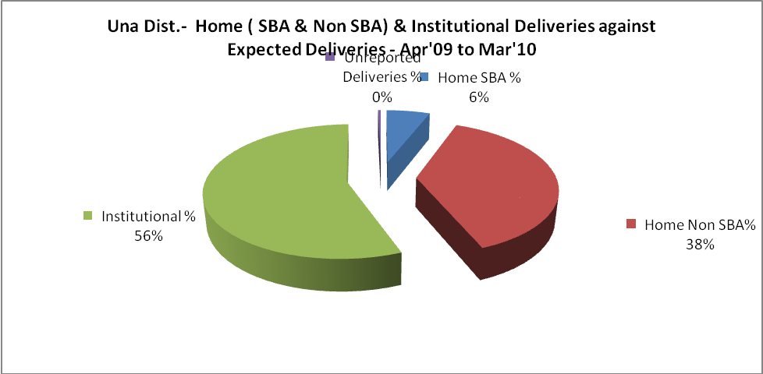
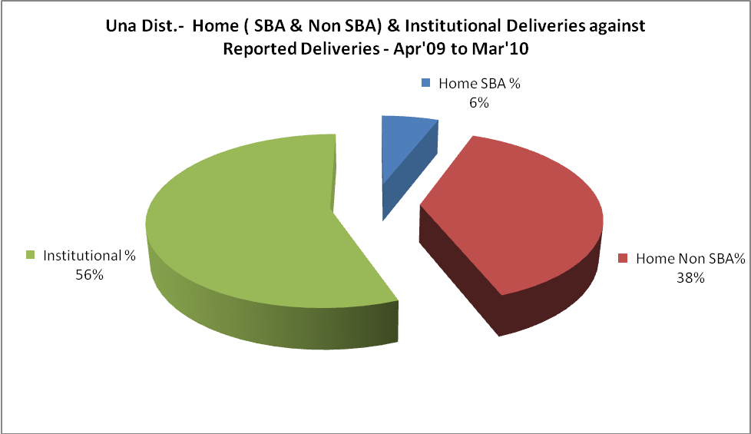

Una Dist.- C sections & Complicated Deliveries Apr'09 to Mar'10
 | Institutional Deliveries (Public) | Institutional Deliveries (Pvt)
 | 2,854 | 2,159
C Section | 695 | 546
C Section% | 24% | 25%
Complicated Pregnancies attended | 920 | 310
Complicated Pregnancies attended % | 32% | 14%

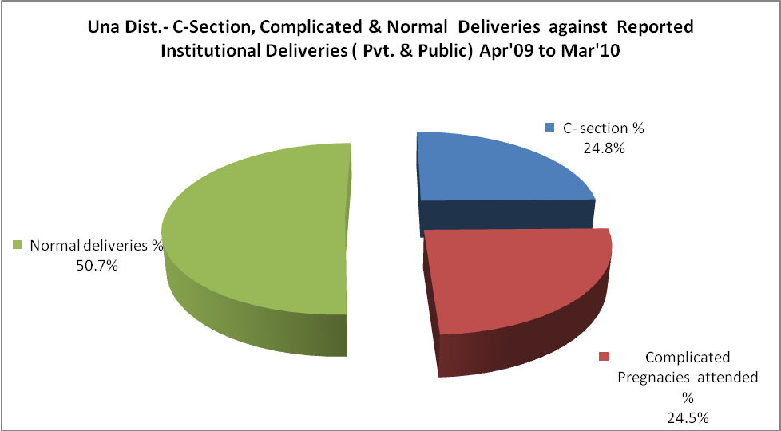

Una Dist.- Complicated Pregnancies & Deliveries Treated - Apr'09 to Mar'10
Reported Deliveries |  |  | Reported ANC Registration
8,976 |  |  | 12,722
Complicated Pregnancies attended | Complicated Pregnancies Rate | C - Section Deliveries | PNC Maternal Complications | Abortions | Still Births
1,230 | 13% | 1,241 | - | 120 | 82
Complicated Deliveries Treated with |  |  |  | No Of Eclampsia cases Treated | No Of severe anemia cases treated
IV Antibiotics | IV antihypertensive/Magsulph injection | IV Oxytocis | Blood Transfusion | No Of Eclampsia cases Treated | No Of severe anemia cases treated
847 | 41 | 546 | 143 | - | 125

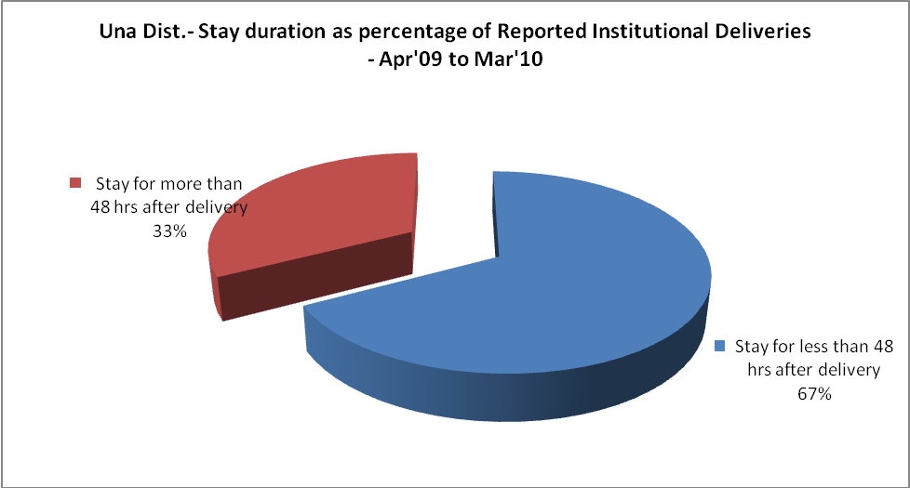

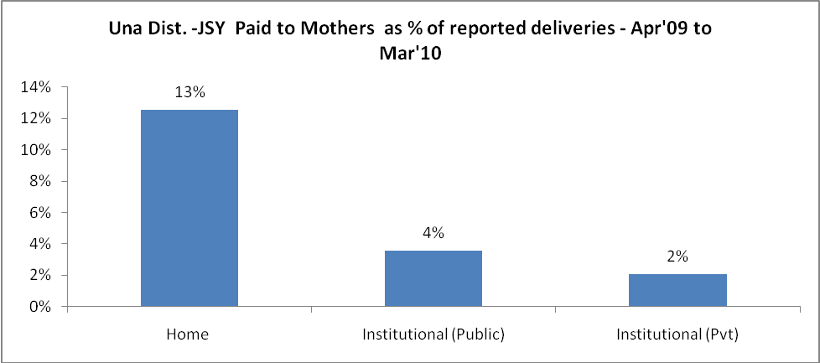
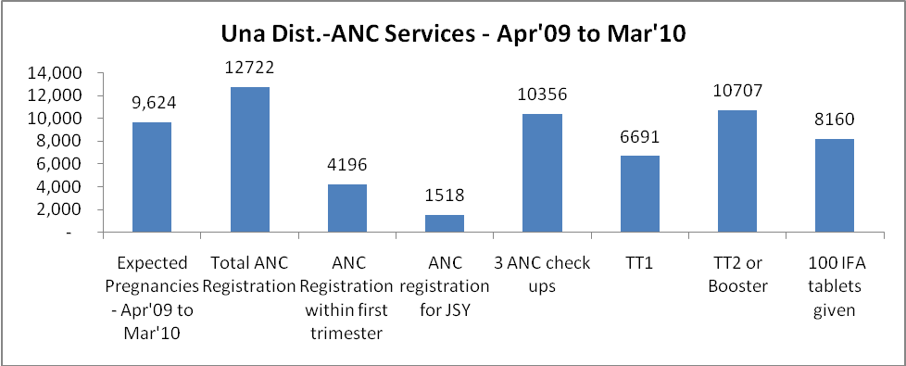

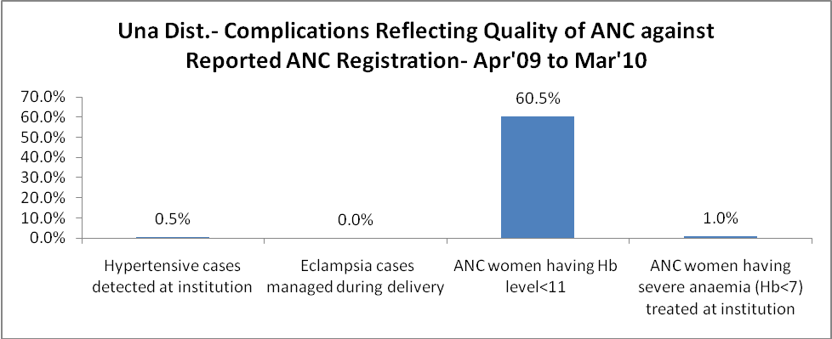
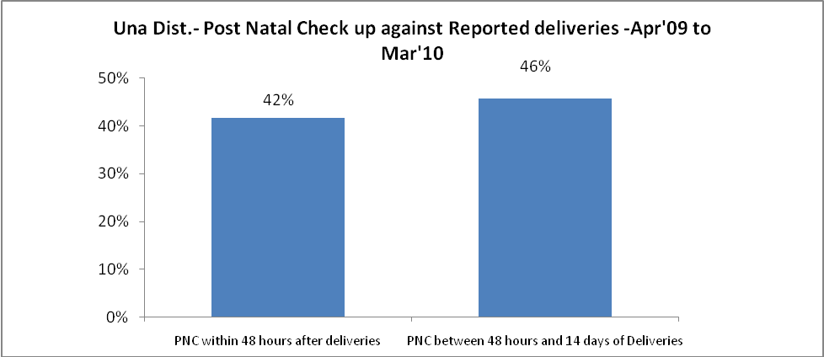

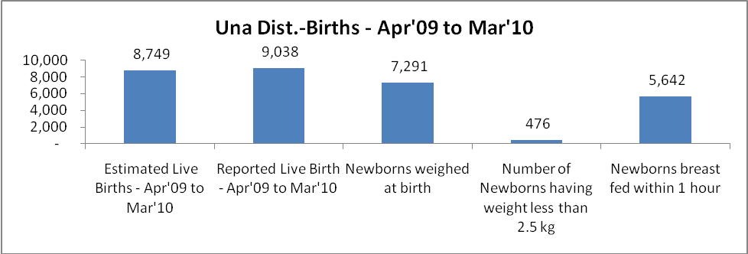

Una Dist. - Births - Apr'09 to Mar'10
Live Birth - Males | Live Birth - females | Live Birth - Total | Sex Ratio at birth | Still Birth | Abortion( Induced/Spontaneous
4,812 | 4,226 | 9,038 | 878 | 82 | 120

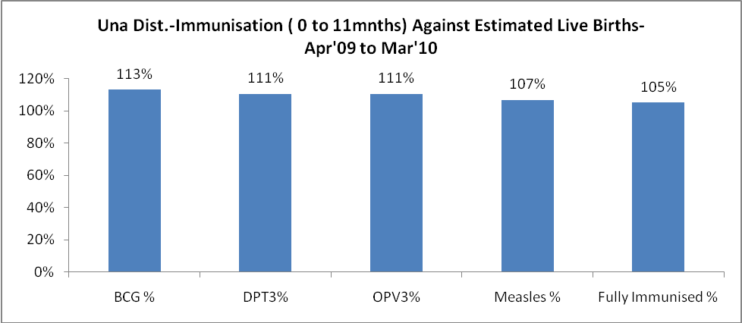
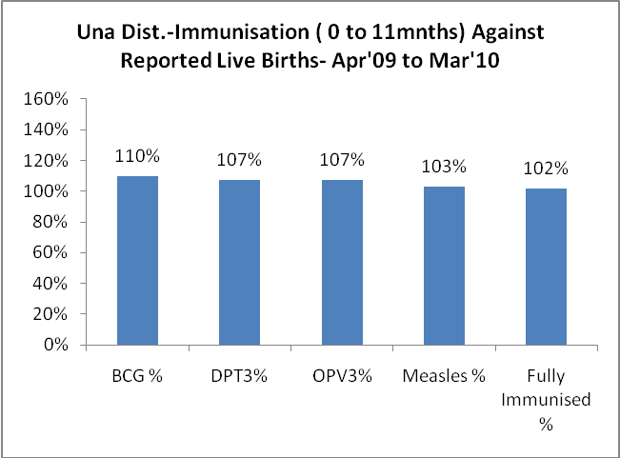
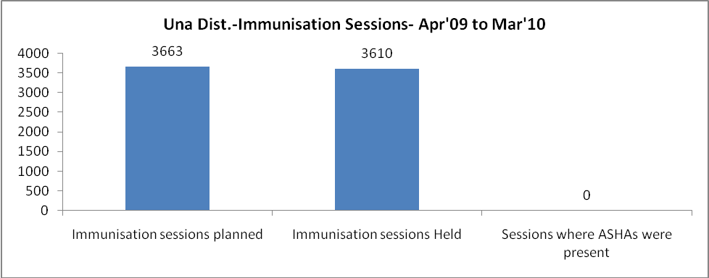
Una Dist.- Apr'09 to Mar'10
Total Abortions | Abortion Rate
351 | 3.6%

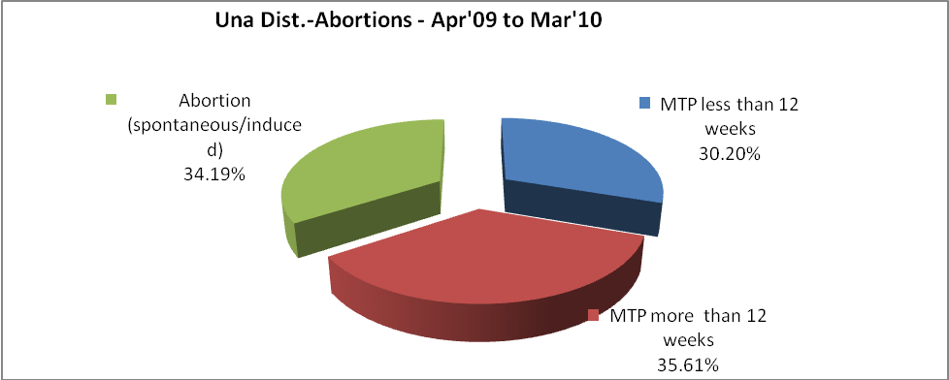
Una Dist.- Apr'09 to Mar'10
Total OPD | Total RTI/STI cases
475,851 | 4,091

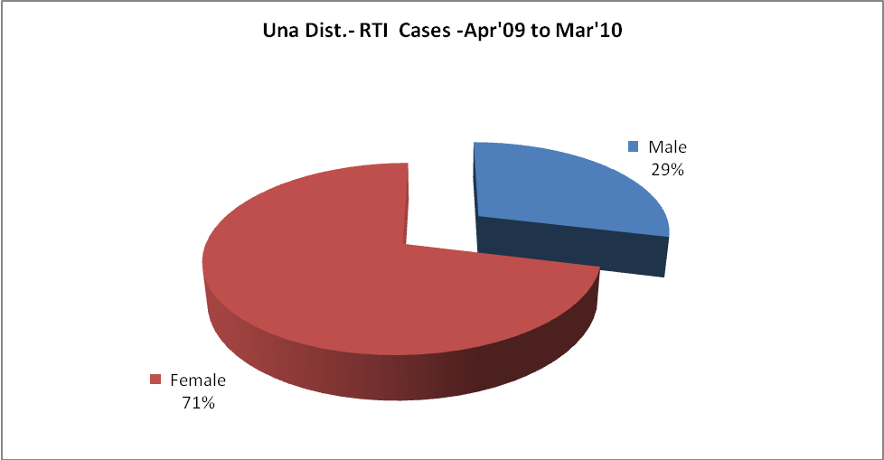
Una Dist.-Sterilizations - Apr'09 to Mar'10
 | Reported | %age of Reported Sterilization
Total Sterilization | 1,600 | -
NSV | 35 | 2%
Laproscopic | 1,448 | 91%
MiniLap | 1 | 0%
Post Partum | 116 | 7%
Male Sterilization | 35 | 2%
Female Sterilization | 1,565 | 98%

Una Dist.-FP Methods - Apr'09 to Mar'10
 | Reported | %age of All Reported FP Methods
Total Reported FP Method (All types) Users | 10,027 | -
Sterilizations | 1,600 | 16%
IUD | 1,244 | 12%
Condom Users | 5,134 | 51%
OCP Users | 2,049 | 20%
Limiting Methods | 1,600 | 16%
Spacing Methods | 8,427 | 84%

Una Dist.- Service Delivery - Apr'09 to Mar'10
Operation major (General and spinal anaesthesia) | Operation minor (No or local anaesthesia) | AYUSH | Dental Procedures | Adolescent counseling services | Total OPD | Total IPD
1,259 | 1,260 | - | 15,942 | 2,943 | 475,851 | 17,026
Operation major (General and spinal anaesthesia) as %ge of OPD | Operation minor (No or local anaesthesia)as %ge of OPD | AYUSH as %ge of OPD | Dental Procedures as %ge of OPD | Adolescent counseling services as %ge of OPD | IPD as percentage of OPD
0.3% | 0.3% | 0.0% | 3.4% | 0.6% | 4%

Una Dist.- Lab Services - Apr'09 to Mar'10
Total OPD | Total HB tested | Total HIV Tested | Total Population
475,851 | 21,491 | 4,517 | 494,303
HB test conducted as %age of OPD | HB<7gm as %age of HB tested | HIV test conducted as %age of OPD | HIV positive as %age of HIV tested | Blood Smear Examined as % of Population
4.5% | 8.0% | 0.9% | 2.4% | 2.3%

Una Dist.- Childhood Disease - Vaccine Preventable -Apr'09 to Mar'10
Diphtheria | Pertussis | Tetanus Neonatorum | Tetanus others | Polio | Measles
0 | 0 | 0 | 0 | 0 | 0
Una Dist.-Childhood Disease - Others - Apr'09 to Mar'10
Diarrhoea and dehydration | Malaria | Number admitted with Respiratory Infections
1,848 | - | 486
Una Dist.- Infant & Child Deaths - Apr'09 to Mar'10
Infant Deaths within 24 hrs of birth | Infant Deaths under 1 week | Infant Deaths under 1 month | Child Deaths under 1 year | Child Deaths under 5years | Total Deaths
17 | 37 | 23 | 29 | 31 | 137

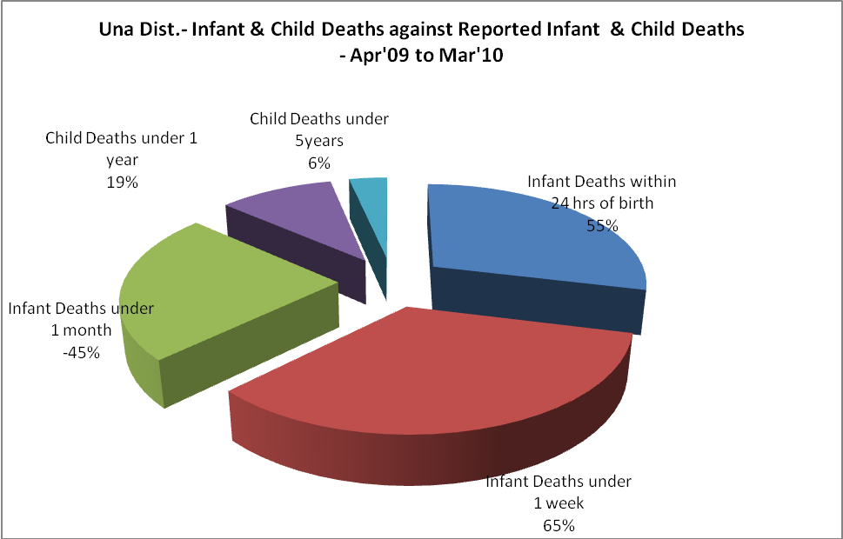

Una Dist.- Causes of Infant & Child Deaths - Apr'09 to Mar'10
Sepsis |  |  | Asphyxia |  |  | LBW
Up to 1 Weeks of Birth | Between 1 week & 4 weeks of birth | Total | Up to 1 Weeks of Birth | Between 1 week & 4 weeks of birth | Total | Up to 1 Weeks of Birth | Between 1 week & 4 weeks of birth | Total
2 | 2 | 4 | 5 | 0 | 5 | 11 | 1 | 12
Pneumonia |  |  | Diarrhoea |  |  | Fever related
Between 1 month and 11 months | Between 1 year & 5 years | Total | Between 1 month and 11 months | Between 1 year & 5 years | Total | Between 1 month and 11 months | Between 1 year & 5 years | Total
0 | 1 | 1 | 1 | 0 | 1 | 0 | 0 | 0
Others |  |  | Measles |  |  | Others
Up to 1 Weeks of Birth | Between 1 week & 4 weeks of birth | Total | Between 1 month and 11 months | Between 1 year & 5 years | Total | Between 1 month and 11 months | Between 1 year & 5 years | Total
2 | 0 | 2 | 0 | 0 | 0 | 5 | 1 | 6

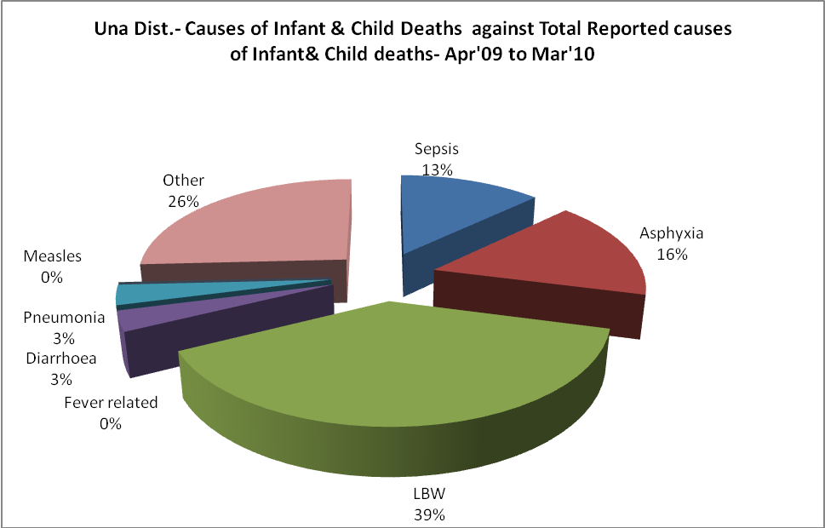

Una Dist.- Maternal Deaths & Causes - Apr'09 to Mar'10
Abortion |  |  | Obstructed/prolonged labour |  |  | Severe hypertension/fits
6-14 yrs | 15-55 yrs. | Total | 6-14 yrs | 15-55 yrs. | Total | 6-14 yrs | 15-55 yrs. | Total
0 | 0 | 0 | 0 | 0 | 0 | 0 | 0 | 0
Bleeding |  |  | High Fever |  |  | Other Causes
6-14 yrs | 15-55 yrs. | Total | 6-14 yrs | 15-55 yrs. | Total | 6-14 yrs | 15-55 yrs. | Total
0 | 1 | 1 | 0 | 0 | 0 | 0 | 0 | 0

Una Dist.-Causes of Deaths in 6 to 55yrs age group - Apr'09 to Mar'10
Diarrhoel Diseases |  |  |  | Tuberculosis |  |  |  | Respiratory Diseases( Other than TB)
6-14 yrs | 15-55 yrs. | Above 55yrs | Total | 6-14 yrs | 15-55 yrs. | Above 55yrs | Total | 6-14 yrs | 15-55 yrs. | Above 55yrs | Total
5 | 5 | 1 | 11 | 0 | 9 | 13 | 22 | 1 | 31 | 132 | 164
Malaria |  |  |  | Other fever Related |  |  |  | HIV/Aids
6-14 yrs | 15-55 yrs. | Above 55yrs | Total | 6-14 yrs | 15-55 yrs. | Above 55yrs | Total | 6-14 yrs | 15-55 yrs. | Above 55yrs | Total
0 | 1 | 3 | 4 | 0 | 2 | 8 | 10 | 2 | 3 | 0 | 5
Heart Disease/Hypertension related |  |  |  | Neurological Disease including strokes |  |  |  | Trauma/Accidents/ Burn Cases
6-14 yrs | 15-55 yrs. | Above 55yrs | Total | 6-14 yrs | 15-55 yrs. | Above 55yrs | Total | 6-14 yrs | 15-55 yrs. | Above 55yrs | Total
1 | 109 | 178 | 288 | 1 | 9 | 21 | 31 | 3 | 31 | 6 | 40
Suicide |  |  |  | Animal Bites & Stings
6-14 yrs | 15-55 yrs. | Above 55yrs | Total | 6-14 yrs | 15-55 yrs. | Above 55yrs | Total
2 | 10 | 0 | 12 | 3 | 5 | 1 | 9

