NHSRC
Meghalaya-West Khasi Hills
Analysis: Apr 2009 – Mar 2010

MEGHALAYA- WEST KHASI HILLS DIST.- Summary-Apr'09 to Mar'10
ANC
ANC Registration against Expected Pregnancies | 102% | TT1 given to Pregnant women against ANC Registraion | 47%
3 ANC Check ups against ANC Reigtrations | 38% | 100 IFA Tablets given to Pregnant women against ANC Registraion | 24%
Deliveries
Unreported Deliveries against Estimated Deliveries | 23.8% | HOME Deliveries( SBA& Non SBA) against Estimated Deliveries | 58.0%
Institutional Deliveries against Estimated Deliveries | 18.3% | HOME Deliveries( SBA& Non SBA) against Reported Deliveries | 76.0%
Institutional Deliveries against Reported Deliveries | 24.0% | C Section Deliveries against Institutional Deliveries( Pvt & Pub) | 1%
Births & Neonates Care
Live Births Reported against Estimated Live Births | 83% | New borns weighed against Reported Live Births | 52%
Still Births (Reported) | 130 | New borns weighed less than 2.5 kgs against newborns weighed | 3%
Sex Ratio at Birh | 950 | New borns breastfed within one hr of Birth against Reported live Births | 36%
Child Immunisation( 0 to 11 months)
BCG given against Expected Live Births | 114% | Measles given against Expected Live Births | 84%
OPV3 given against Expected Live Births | 97% | Fully Immunised Children against Expected Live Births | 78%
DPT3 given against Expected Live Births | 97%
Family Planning
Family Plannig Methods Users ( Sterilisations(Male &Female)+IUD+ Condom pieces/72 + OCP Cycles/13) | 218 | IUD Insertions against reported FP Methods | 2%
Sterilisation against reported FP Methods | 4% | Condom Users against reported FP Methods | 75%
 |  | OCP Users against reported FP Methods | 19%
Other Services
OPD | 2,99,103 | Major Operations | -
IPD | 11,989 | Minor Operations | 10

MEGHALAYA- WEST KHASI HILLS DIST.- Deliveries Apr'09 to Mar'10
Total Population | 3,62,150 | Expected Deliveries |  | 9,391
Home SBA | Home Non SBA | Institutional | Total Deliveries Reported | Unreported Deliveries
930 | 4,512 | 1,714 | 7,156 | 2,235
Home SBA % | Home Non SBA% | Institutional % | Total Deliveries Reported % | Unreported Deliveries %
10% | 48% | 18% | 76% | 24%
`

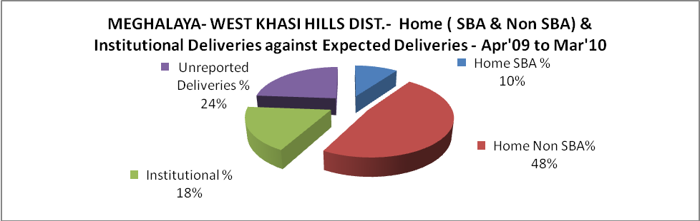

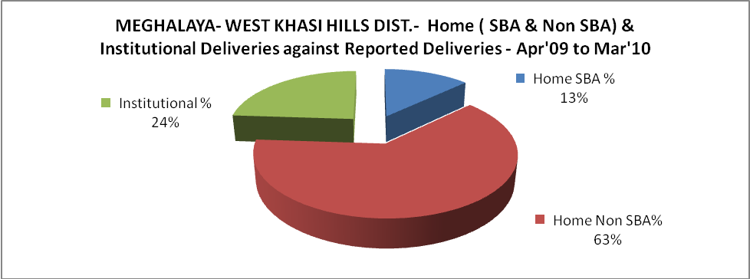

MEGHALAYA- WEST KHASI HILLS DIST.- C sections & Complicated Deliveries Apr'09 to Mar'10
 | Institutional Deliveries (Public) | Institutional Deliveries (Pvt)
 | 1,400 | 314
C Section | 13 | 9
C Section% | 1% | 3%
Complicated Pregnacies attended | 72 | 2
Complicated Pregnacies attended % | 5% | 1%

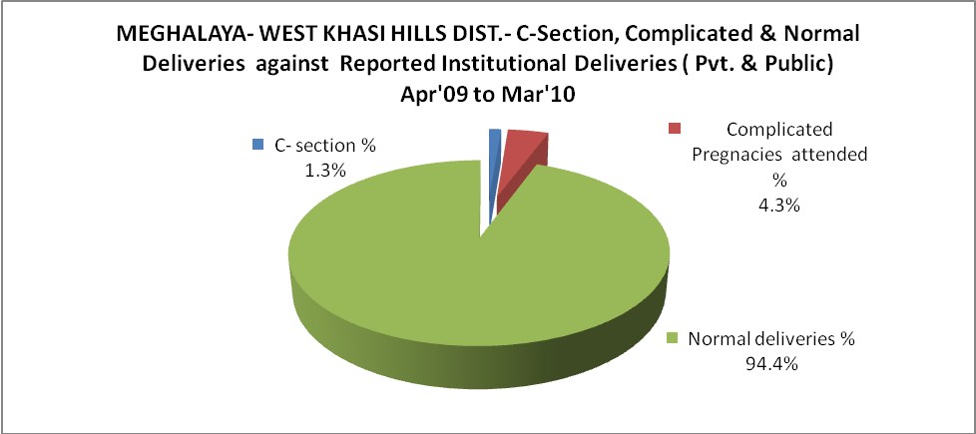

MEGHALAYA- WEST KHASI HILLS DIST.- Complicated Pregnancies & Deliveries Treated - Apr'09 to Mar'10
Reported Deliveries |  |  | Reported ANC Reigtration
7,156 |  |  | 10,275
Complicated Pregnancies attended | Complicated Pregnancies Rate | C - Section Deliveries | PNC Maternal Complications | Abortions | Still Births
74 | 1% | 22 | 21 | 131 | 130
Complicated Deliveries Treated with |  |  |  | No Of Eclampsia cases Treated | No Of severe anemia cases treated
IV Antibiotics | IV antihypertensive/Magsulph injection | IV Oxytocis | Blood Transfusion | No Of Eclampsia cases Treated | No Of severe anemia cases treated
50 | 4 | 112 | - | 13 | 18

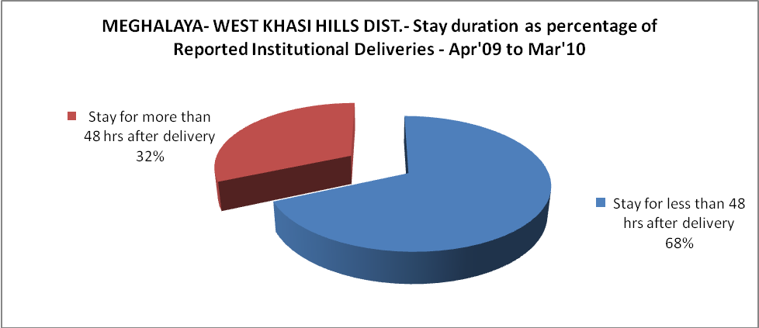

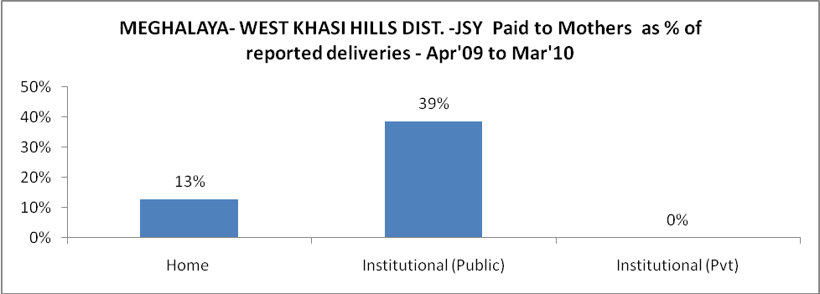

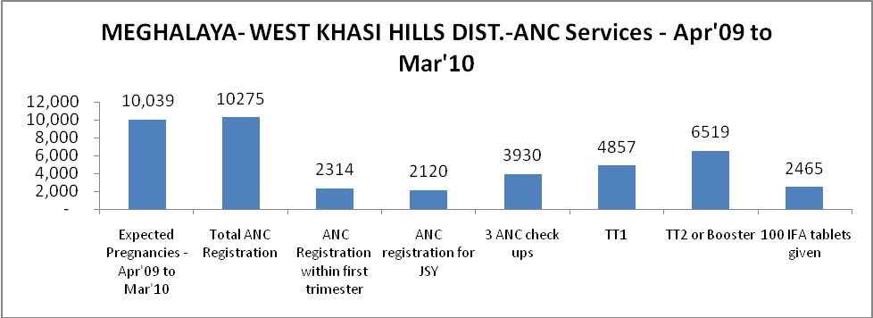

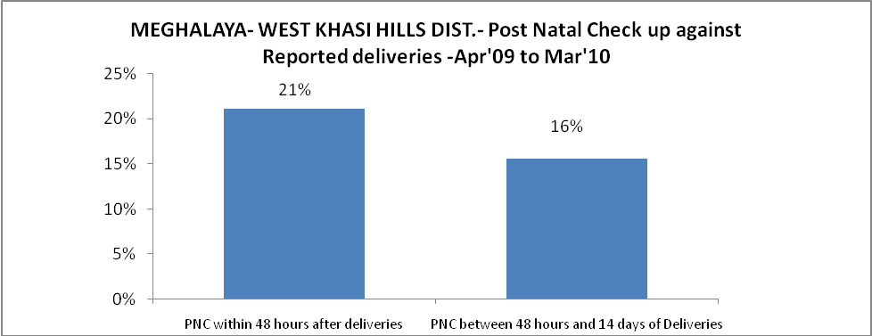

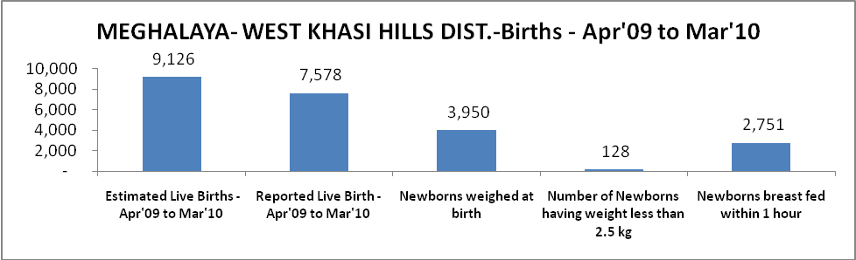

MEGHALAYA- WEST KHASI HILLS DIST. - Births - Apr'09 to Mar'10
Live Birth - Males | Live Birth - females | Live Birth - Total | Sex Ratio at birth | Still Birth | Abortion( Induced/Spontaneous
3,887 | 3,691 | 7,578 | 950 | 130 | 131

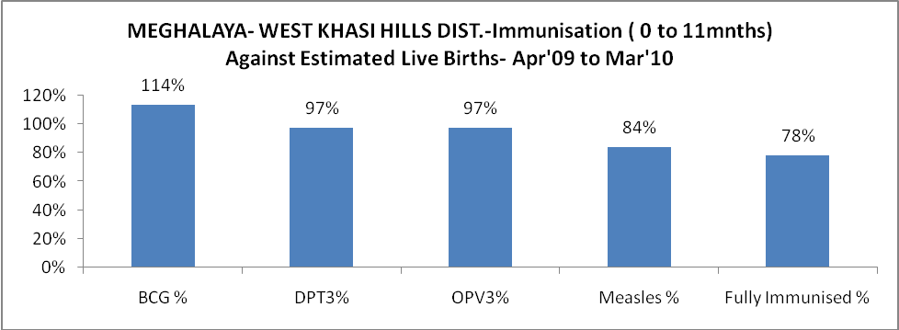

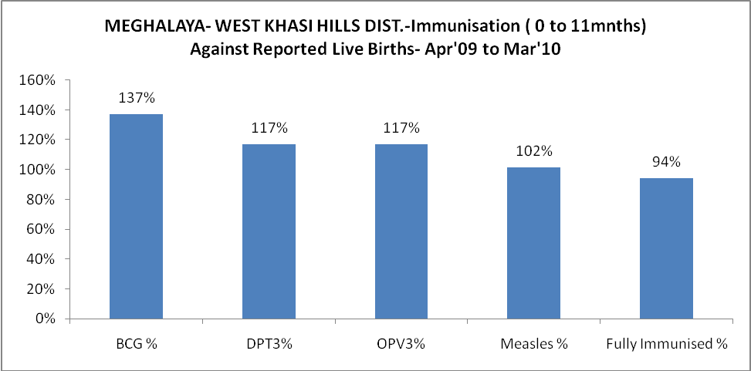

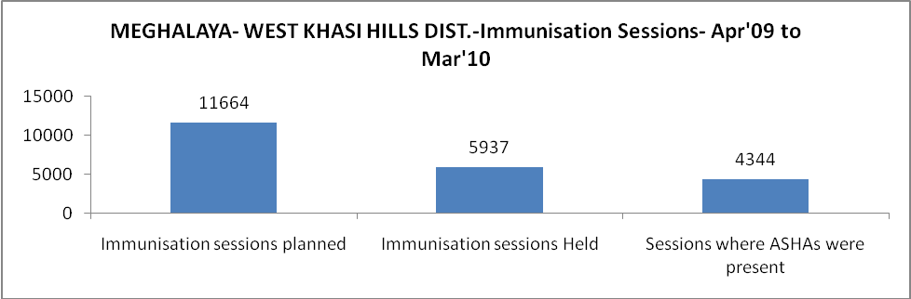

MEGHALAYA- WEST KHASI HILLS DIST.- Apr'09 to Mar'10
Total Abortions | Abortion Rate
138 | 1.4%

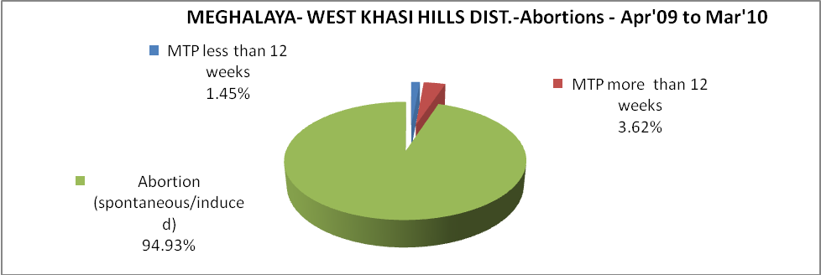

MEGHALAYA- WEST KHASI HILLS DIST.- Apr'09 to Mar'10
Total OPD | Total RTI/STI cases
2,99,103 | 378

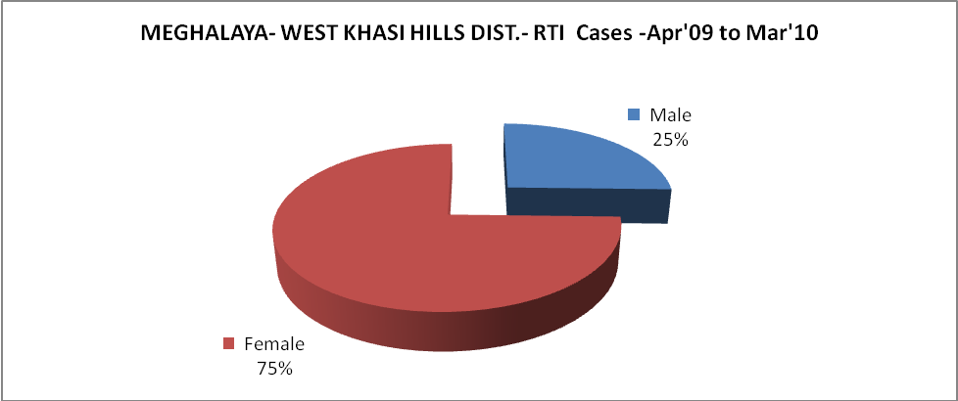

MEGHALAYA- WEST KHASI HILLS DIST.-Sterilisations - Apr'09 to Mar'10
 | Reported | %age of Reported Sterilisation
Total Sterilisation | 8 | -
NSV | - | 0%
Laproscopic | - | 0%
MiniLap | - | 0%
Post Partum | 8 | 100%
Male Sterilisation | - | 0%
Female Sterilisation | 8 | 100%

MEGHALAYA- WEST KHASI HILLS DIST.-FP Methods - Apr'09 to Mar'10
 | Reported | %age of All Reported FP Methods
Total Reported FP Methodd (All types) Users | 218 | -
Sterilisations | 8 | 4%
IUD | 4 | 2%
Condom Users | 164 | 75%
OCP Users | 42 | 19%
Limiting Methods | 8 | 4%
Spacing Methods | 210 | 96%

MEGHALAYA- WEST KHASI HILLS DIST.- Service Delivery - Apr'09 to Mar'10
Operation major (General and spinal anaesthesia) | Operation minor (No or local anaesthesia) | AYUSH | Dental Procedures | Adolescent counselling services | Total OPD | Total IPD
- | 10 | 33,833 | 6,527 | 101 | 2,99,103 | 11,989
Operation major (General and spinal anaesthesia) as %ge of OPD | Operation minor (No or local anaesthesia)as %ge of OPD | AYUSH as %ge of OPD | Dental Procedures as %ge of OPD | Adolescent counselling services as %ge of OPD | IPD as percentage of OPD
0.0% | 0.0% | 11.3% | 2.2% | 0.0% | 4%

MEGHALAYA- WEST KHASI HILLS DIST.- Lab Services - Apr'09 to Mar'10
Total OPD | Total HB tested | Total HIV Tested | Total Population
2,99,103 | 243 | 929 | 3,62,150
HB test conducted as %age of OPD | HB<7gm as %age of HB tested | HIV test conducted as %age of OPD | HIV positive as %age of HIV tested | Blood Smear Examined as % of Population
0.1% | 16.0% | 0.3% | 0.0% | 3.9%

MEGHALAYA- WEST KHASI HILLS DIST.- Childhood Disease - Vaccine Preventable -Apr'09 to Mar'10
Diphtheria | Pertussis | Tetanus Neonatorum | Tetanus others | Polio | Measles
0 | 0 | 0 | 0 | 0 | 167
MEGHALAYA- WEST KHASI HILLS DIST.-Childhood Disease - Others - Apr'09 to Mar'10
Diarrhoea and dehydration | Malaria | Number admitted with Respiratory Infections
11,590 | 1,034 | 728

MEGHALAYA- WEST KHASI HILLS DIST.- Infant & Child Deaths - Apr'09 to Mar'10
Infant Deaths within 24 hrs of birth | Infant Deaths between 24hrs & under 1 week | Infant Deaths between 1 week & under 1 month | Child Deaths between 1 month & under 1 year | Child Deaths between 1yr under 5years | Total Deaths
7 | 14 | 5 | 35 | 44 | 105

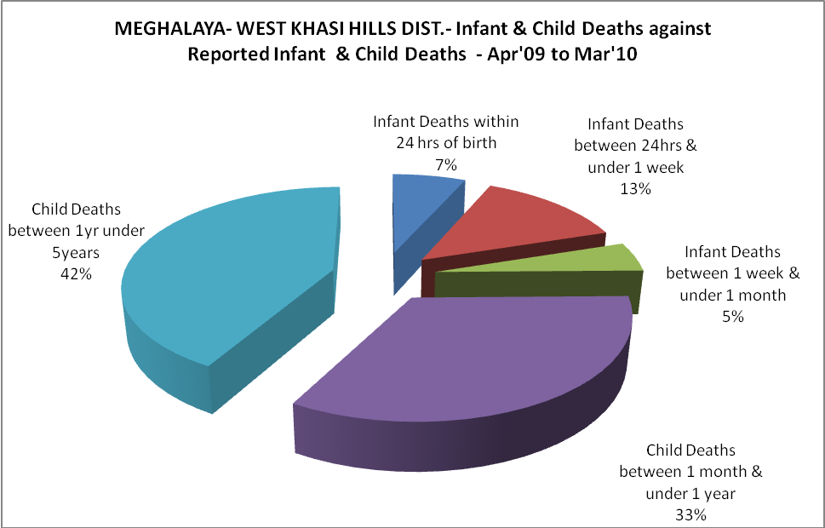

MEGHALAYA- WEST KHASI HILLS DIST.- Causes of Infant & Child Deaths - Apr'09 to Mar'10
Sepsis |  |  | Asphyxia |  |  | LBW
Up to 1 Weeks of Birth | Between 1 week & 4 weeks of birth | Total | Up to 1 Weeks of Birth | Between 1 week & 4 weeks of birth | Total | Up to 1 Weeks of Birth | Between 1 week & 4 weeks of birth | Total
4 | 1 | 5 | 6 | 1 | 7 | 0 | 0 | 0
Pneumonia |  |  | Diarrhoea |  |  | Fever related
Between 1 month and 11 months | Between 1 year & 5 years | Total | Between 1 month and 11 months | Between 1 year & 5 years | Total | Between 1 month and 11 months | Between 1 year & 5 years | Total
3 | 5 | 8 | 9 | 5 | 14 | 5 | 12 | 17
Others |  |  | Measles |  |  | Others
Up to 1 Weeks of Birth | Between 1 week & 4 weeks of birth | Total | Between 1 month and 11 months | Between 1 year & 5 years | Total | Between 1 month and 11 months | Between 1 year & 5 years | Total
4 | 3 | 7 | 0 | 0 | 0 | 18 | 22 | 40

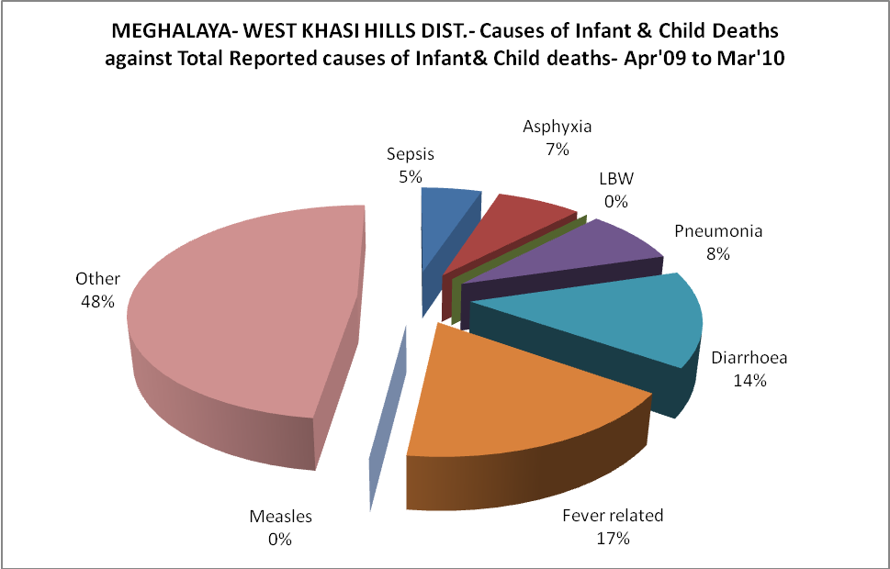

MEGHALAYA- WEST KHASI HILLS DIST.- Maternal Deaths & Causes - Apr'09 to Mar'10
Abortion |  |  | Obstructed/prolonged labour |  |  | Severe hypertesnion/fits
6-14 yrs | 15-55 yrs. | Total | 6-14 yrs | 15-55 yrs. | Total | 6-14 yrs | 15-55 yrs. | Total
0 | 0 | 0 | 0 | 0 | 0 | 0 | 0 | 0
Bleeding |  |  | High Fever |  |  | Other Causes
6-14 yrs | 15-55 yrs. | Total | 6-14 yrs | 15-55 yrs. | Total | 6-14 yrs | 15-55 yrs. | Total
0 | 4 | 4 | 0 | 0 | 0 | 2 | 4 | 6

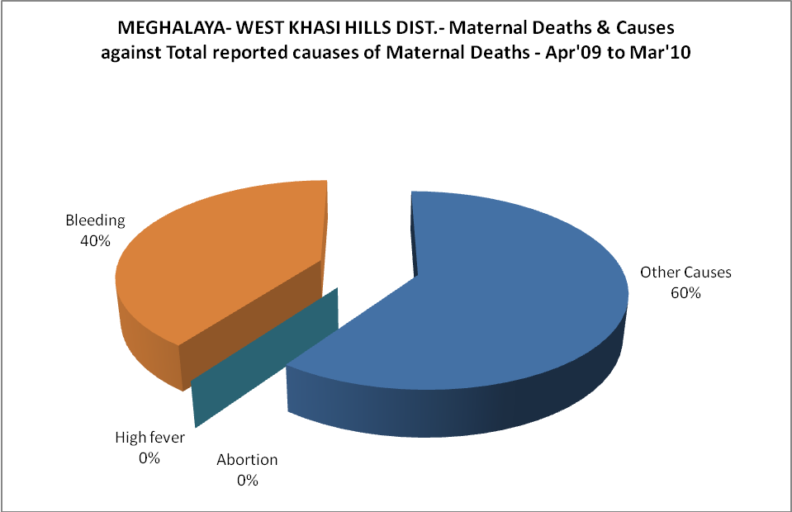

MEGHALAYA- WEST KHASI HILLS DIST.-Causes of Deaths in 6 to 55yrs age group - Apr'09 to Mar'10
Diarrhoel Diseases |  |  |  | Tuberculosis |  |  |  | Respiratory Diseases( Other than TB)
6-14 yrs | 15-55 yrs. | Above 55yrs | Total | 6-14 yrs | 15-55 yrs. | Above 55yrs | Total | 6-14 yrs | 15-55 yrs. | Above 55yrs | Total
1 | 5 | 0 | 6 | 2 | 3 | 0 | 5 | 1 | 2 | 1 | 4
Malaria |  |  |  | Other fever Related |  |  |  | HIV/Aids
6-14 yrs | 15-55 yrs. | Above 55yrs | Total | 6-14 yrs | 15-55 yrs. | Above 55yrs | Total | 6-14 yrs | 15-55 yrs. | Above 55yrs | Total
8 | 21 | 1 | 30 | 7 | 10 | 0 | 17 | 0 | 0 | 0 | 0
Heart Disease/Hypertenion related |  |  |  | Neurological Disease including strokes |  |  |  | Trauma/Accidents/ Burn Cases
6-14 yrs | 15-55 yrs. | Above 55yrs | Total | 6-14 yrs | 15-55 yrs. | Above 55yrs | Total | 6-14 yrs | 15-55 yrs. | Above 55yrs | Total
0 | 3 | 0 | 3 | 0 | 1 | 0 | 1 | 0 | 1 | 0 | 1
Suicide |  |  |  | Animal Bites & Stings
6-14 yrs | 15-55 yrs. | Above 55yrs | Total | 6-14 yrs | 15-55 yrs. | Above 55yrs | Total
0 | 2 | 0 | 2 | 0 | 0 | 0 | 0

