NHSRC
Rajasthan-Ajmer
Analysis: Apr 2009 – Mar 2010

Rajasthan- Ajmer- Summary-Apr'09 to Mar'10
ANC
ANC Registration against Expected Pregnancies | 105% | TT1 given to Pregnant women against ANC Registration | 56%
3 ANC Checkups against ANC Registrations | 52% | 100 IFA Tablets given to Pregnant women against ANC Registration | 76%
Deliveries
Unreported Deliveries against Estimated Deliveries | 15.1% | HOME Deliveries( SBA& Non SBA) against Estimated Deliveries | 8.7%
Institutional Deliveries against Estimated Deliveries | 76.2% | HOME Deliveries( SBA& Non SBA) against Reported Deliveries | 10.3%
Institutional Deliveries against Reported Deliveries | 89.7% | C Section Deliveries against Institutional Deliveries( Pvt & Pub) | 10%
Births & Neonates Care
Live Births Reported against Estimated Live Births | 71% | New borns weighed against Reported Live Births | 92%
Still Births (Reported) | 957 | New borns weighed less than 2.5 kgs against newborns weighed | 8%
Sex Ratio at Birh | 952 | New borns breastfed within one hr of Birth against Reported live Births | 92%
Child Immunization( 0 to 11 months)
BCG given against Expected Live Births | 95% | Measles given against Expected Live Births | 90%
OPV3 given against Expected Live Births | 93% | Fully Immunised Children against Expected Live Births | 83%
DPT3 given against Expected Live Births | 93%
Family Planning
Family Plannig Methods Users ( Sterilisations(Male &Female)+IUD+ Condom pieces/72 + OCP Cycles/13) | 108,290 | IUD Insertions against reported FP Methods | 9%
Sterilisation against reported FP Methods | 11% | Condom Users against reported FP Methods | 51%
 |  | OCP Users against reported FP Methods | 29%
Other Services
OPD | 793,787 | Major Operations | 2,898
IPD | 55,570 | Minor Operations | 6,277

`
Rajasthan- Ajmer- Deliveries Apr'09 to Mar'10
Total Population | 2,606,800 | Expected Deliveries |  | 73,945
Home SBA | Home Non SBA | Institutional | Total Deliveries Reported | Unreported Deliveries
2,335 | 4,109 | 56,343 | 62,787 | 11,158
Home SBA % | Home Non SBA% | Institutional % | Total Deliveries Reported % | Unreported Deliveries %
3% | 6% | 76% | 85% | 15%

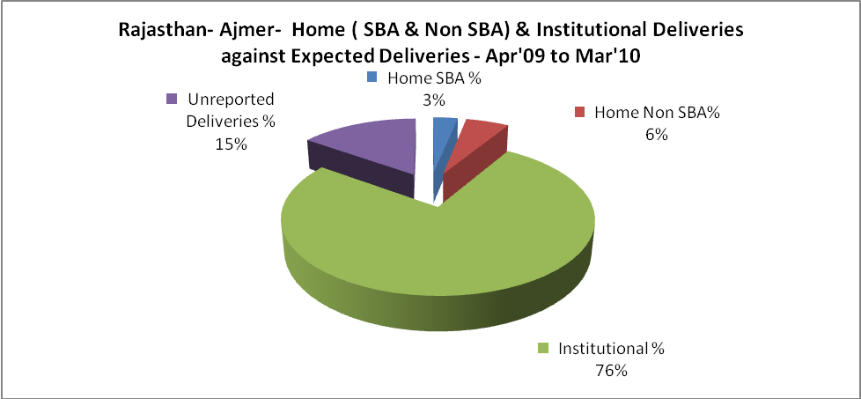

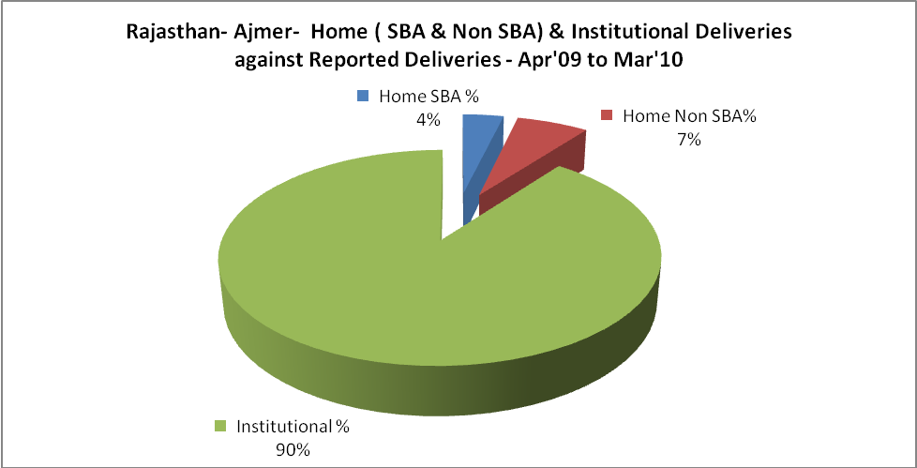

Rajasthan- Ajmer- C sections & Complicated Deliveries Apr'09 to Mar'10
 | Institutional Deliveries (Public) | Institutional Deliveries (Pvt)
 | 37,161 | 19,182
C Section | 3,224 | 2,513
C Section% | 9% | 13%
Complicated Pregnacies attended | 4,574 | 110
Complicated Pregnacies attended % | 12% | 1%

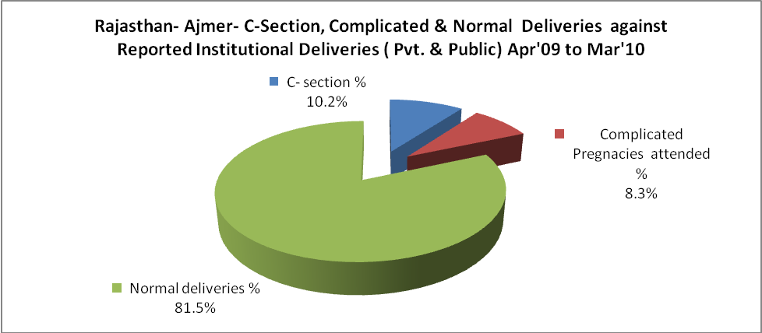

Rajasthan- Ajmer- Complicated Pregnancies & Deliveries Treated - Apr'09 to Mar'10
Reported Deliveries |  |  | Reported ANC Reigtration
62,787 |  |  | 83,127
Complicated Pregnancies attended | Complicated Pregnancies Rate | C - Section Deliveries | PNC Maternal Complications | Abortions | Still Births
4,684 | 6% | 5,737 | 1,294 | 799 | 957
Complicated Deliveries Treated with |  |  |  | No Of Eclampsia cases Treated | No Of severe anemia cases treated
IV Antibiotics | IV antihypertensive/Magsulph injection | IV Oxytocis | Blood Transfusion | No Of Eclampsia cases Treated | No Of severe anemia cases treated
3,683 | 273 | 2,159 | 558 | 451 | 3,544

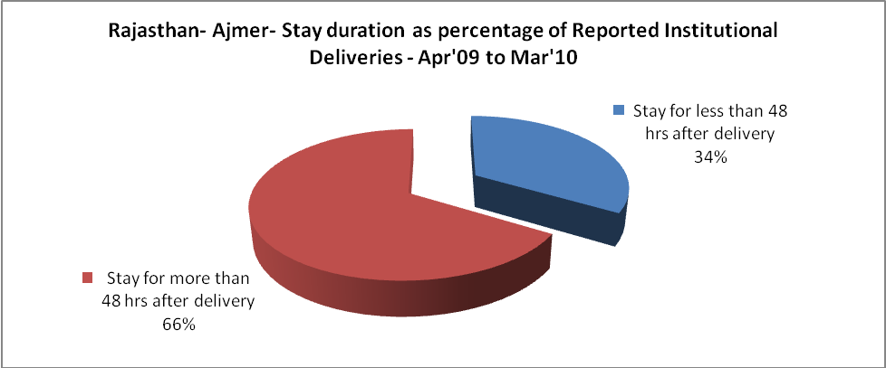

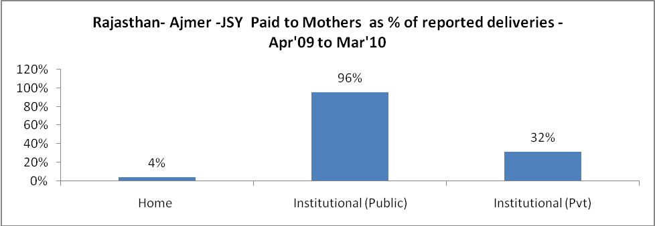

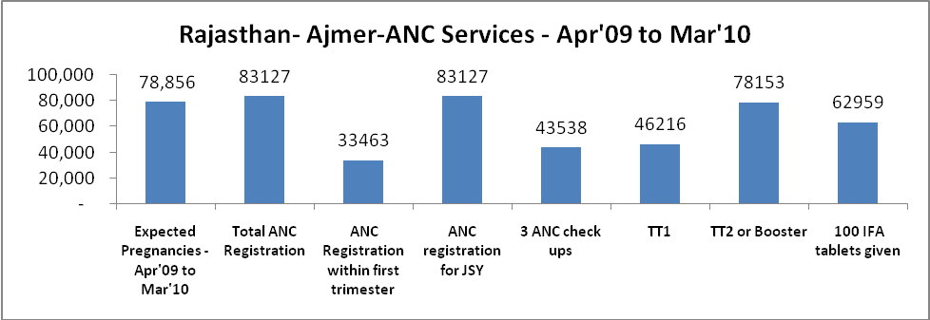

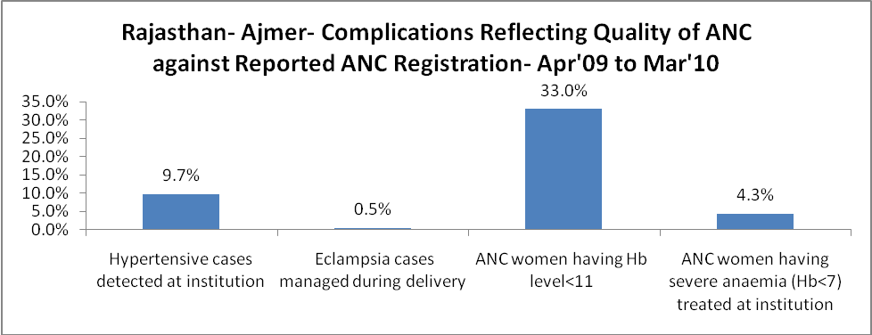

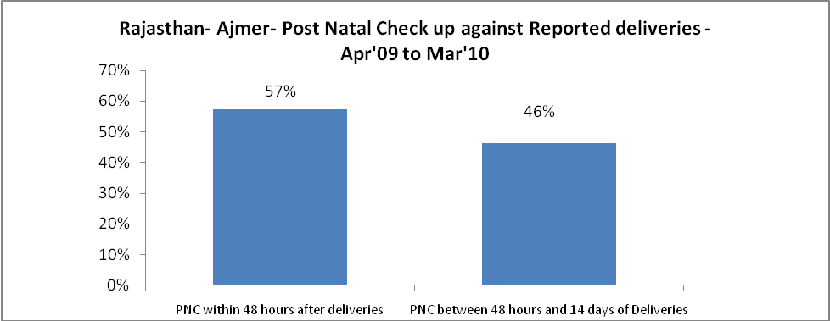

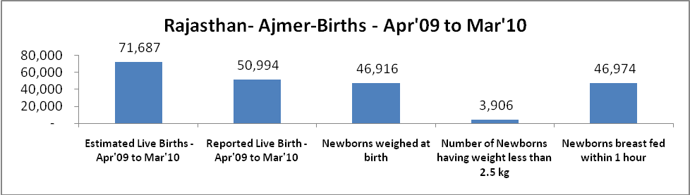

Rajasthan- Ajmer - Births - Apr'09 to Mar'10
Live Birth - Males | Live Birth - females | Live Birth - Total | Sex Ratio at birth | Still Birth | Abortion( Induced/Spontaneous
26,129 | 24,865 | 50,994 | 952 | 957 | 799

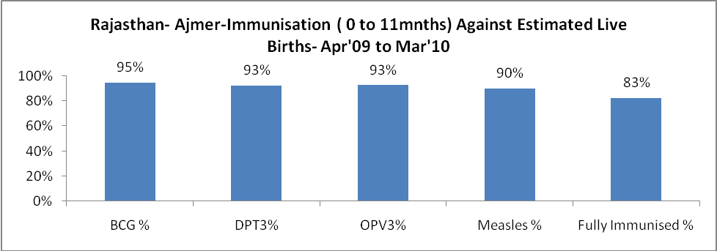

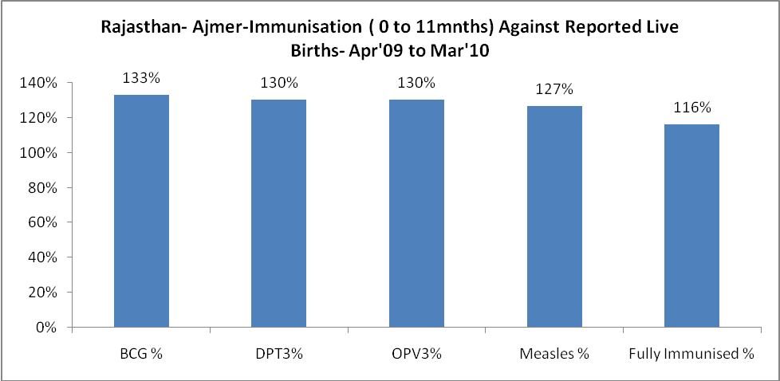

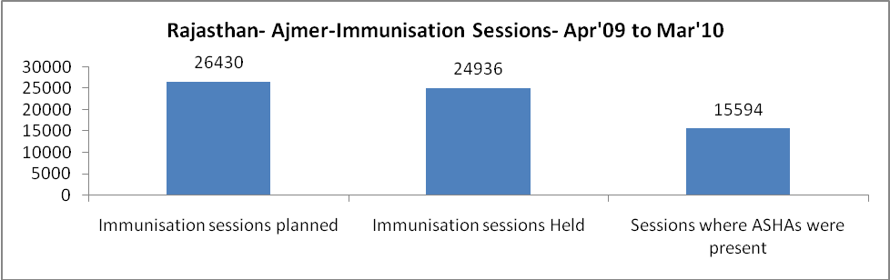

Rajasthan- Ajmer- Apr'09 to Mar'10
Total Abortions | Abortion Rate
2,925 | 3.7%

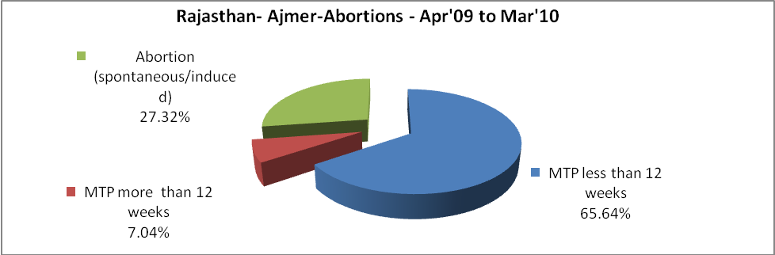

Rajasthan- Ajmer- Apr'09 to Mar'10
Total OPD | Total RTI/STI cases
793,787 | 7,706

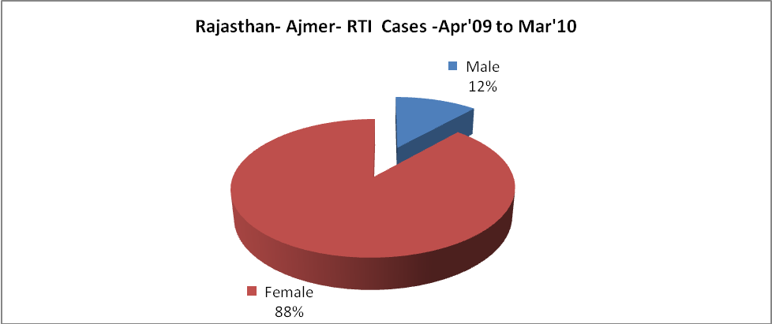
Rajasthan- Ajmer-Sterilisations - Apr'09 to Mar'10
 | Reported | %age of Reported Sterilisation
Total Sterilisation | 11,514 | -
NSV | 444 | 4%
Laproscopic | 10,182 | 88%
MiniLap | - | 0%
Post Partum | 888 | 8%
Male Sterilisation | 444 | 4%
Female Sterilisation | 11,070 | 96%

Rajasthan- Ajmer-FP Methods - Apr'09 to Mar'10
 | Reported | %age of All Reported FP Methods
Total Reported FP Methodd (All types) Users | 108,290 | -
Sterilisations | 11,514 | 11%
IUD | 9,930 | 9%
Condom Users | 55,356 | 51%
OCP Users | 31,490 | 29%
Limiting Methods | 11,514 | 11%
Spacing Methods | 96,776 | 89%

Rajasthan- Ajmer- Service Delivery - Apr'09 to Mar'10
Operation major (General and spinal anaesthesia) | Operation minor (No or local anaesthesia) | AYUSH | Dental Procedures | Adolescent counselling services | Total OPD | Total IPD
2,898 | 6,277 | 52,733 | 899 | 2,787 | 793,787 | 55,570
Operation major (General and spinal anaesthesia) as %ge of OPD | Operation minor (No or local anaesthesia)as %ge of OPD | AYUSH as %ge of OPD | Dental Procedures as %ge of OPD | Adolescent counselling services as %ge of OPD | IPD as percentage of OPD
0.4% | 0.8% | 6.6% | 0.1% | 0.4% | 7%

Rajasthan- Ajmer- Lab Services - Apr'09 to Mar'10
Total OPD | Total HB tested | Total HIV Tested | Total Population
793,787 | 27,034 | 13,239 | 2,606,800
HB test conducted as %age of OPD | HB<7gm as %age of HB tested | HIV test conducted as %age of OPD | HIV positive as %age of HIV tested | Blood Smear Examined as % of Population
3.4% | 10.7% | 1.7% | 0.7% | 4.4%

Rajasthan- Ajmer- Childhood Disease - Vaccine Preventable -Apr'09 to Mar'10
Diphtheria | Pertussis | Tetanus Neonatorum | Tetanus others | Polio | Measles
0 | 0 | 0 | 20 | 0 | 48
Rajasthan- Ajmer-Childhood Disease - Others - Apr'09 to Mar'10
Diarrhoea and dehydration | Malaria | Number admitted with Respiratory Infections
1,945 | 187 | 323

Rajasthan- Ajmer- Infant & Child Deaths - Apr'09 to Mar'10
Infant Deaths within 24 hrs of birth | Infant Deaths between 24hrs & under 1 week | Infant Deaths between 1 week & under 1 month | Child Deaths between 1 month & under 1 year | Child Deaths between 1yr under 5years | Total Deaths
124 | 127 | 47 | 60 | 44 | 402

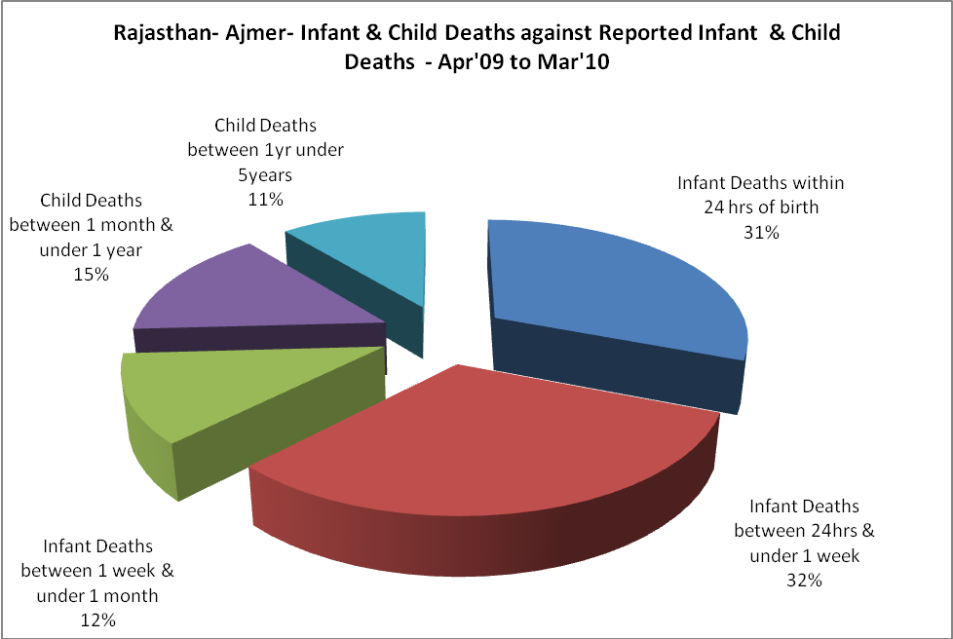

Rajasthan- Ajmer- Causes of Infant & Child Deaths - Apr'09 to Mar'10
Sepsis |  |  | Asphyxia |  |  | LBW
Up to 1 Weeks of Birth | Between 1 week & 4 weeks of birth | Total | Up to 1 Weeks of Birth | Between 1 week & 4 weeks of birth | Total | Up to 1 Weeks of Birth | Between 1 week & 4 weeks of birth | Total
12 | 3 | 15 | 33 | 12 | 45 | 37 | 11 | 48
Pneumonia |  |  | Diarrhoea |  |  | Fever related
Between 1 month and 11 months | Between 1 year & 5 years | Total | Between 1 month and 11 months | Between 1 year & 5 years | Total | Between 1 month and 11 months | Between 1 year & 5 years | Total
7 | 3 | 10 | 7 | 7 | 14 | 15 | 7 | 22
Others |  |  | Measles |  |  | Others
Up to 1 Weeks of Birth | Between 1 week & 4 weeks of birth | Total | Between 1 month and 11 months | Between 1 year & 5 years | Total | Between 1 month and 11 months | Between 1 year & 5 years | Total
45 | 21 | 66 | 0 | 0 | 0 | 31 | 27 | 58

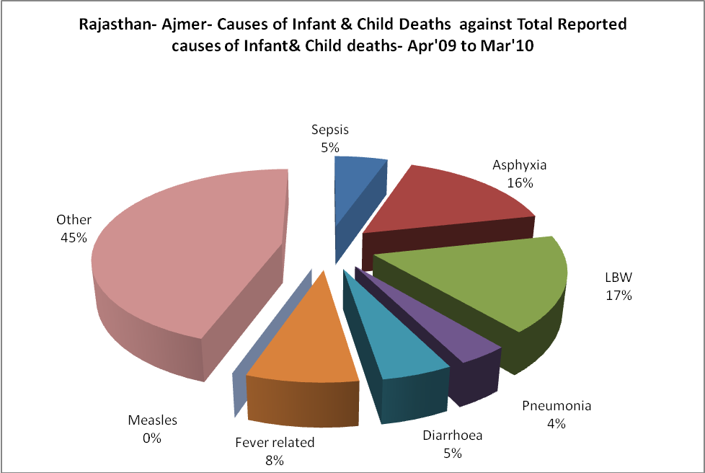

Rajasthan- Ajmer- Maternal Deaths & Causes - Apr'09 to Mar'10
Abortion |  |  | Obstructed/prolonged labour |  |  | Severe hypertesnion/fits
6-14 yrs | 15-55 yrs. | Total | 6-14 yrs | 15-55 yrs. | Total | 6-14 yrs | 15-55 yrs. | Total
0 | 0 | 0 | 0 | 0 | 0 | 0 | 0 | 0
Bleeding |  |  | High Fever |  |  | Other Causes
6-14 yrs | 15-55 yrs. | Total | 6-14 yrs | 15-55 yrs. | Total | 6-14 yrs | 15-55 yrs. | Total
0 | 1 | 1 | 0 | 0 | 0 | 0 | 21 | 21

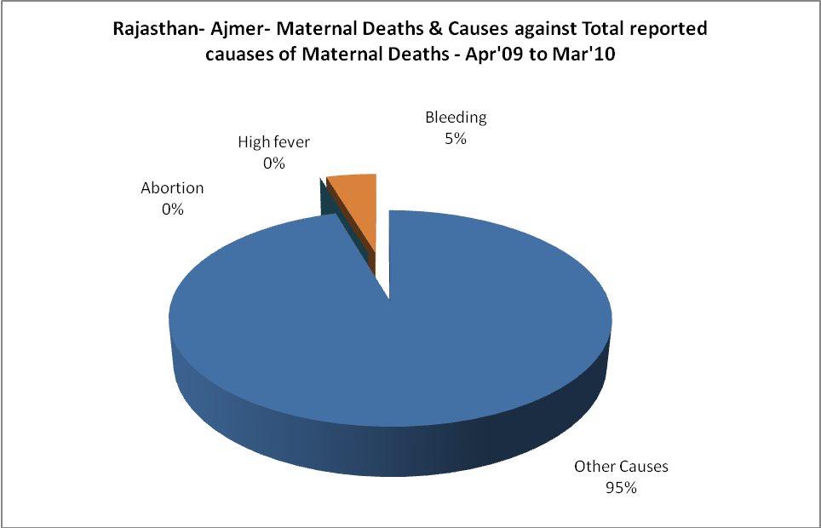

Rajasthan- Ajmer-Causes of Deaths in 6 to 55yrs age group - Apr'09 to Mar'10
Diarrhoel Diseases |  |  |  | Tuberculosis |  |  |  | Respiratory Diseases( Other than TB)
6-14 yrs | 15-55 yrs. | Above 55yrs | Total | 6-14 yrs | 15-55 yrs. | Above 55yrs | Total | 6-14 yrs | 15-55 yrs. | Above 55yrs | Total
10 | 25 | 10 | 45 | 10 | 83 | 18 | 111 | 100 | 462 | 171 | 733
Malaria |  |  |  | Other fever Related |  |  |  | HIV/Aids
6-14 yrs | 15-55 yrs. | Above 55yrs | Total | 6-14 yrs | 15-55 yrs. | Above 55yrs | Total | 6-14 yrs | 15-55 yrs. | Above 55yrs | Total
0 | 0 | 0 | 0 | 9 | 9 | 3 | 21 | 0 | 0 | 0 | 0
Heart Disease/Hypertenion related |  |  |  | Neurological Disease including strokes |  |  |  | Trauma/Accidents/ Burn Cases
6-14 yrs | 15-55 yrs. | Above 55yrs | Total | 6-14 yrs | 15-55 yrs. | Above 55yrs | Total | 6-14 yrs | 15-55 yrs. | Above 55yrs | Total
0 | 122 | 27 | 149 | 12 | 72 | 24 | 108 | 12 | 50 | 18 | 80
Suicide |  |  |  | Animal Bites & Stings
6-14 yrs | 15-55 yrs. | Above 55yrs | Total | 6-14 yrs | 15-55 yrs. | Above 55yrs | Total
1 | 14 | 3 | 18 | 2 | 8 | 4 | 14

