NHSRC
Rajasthan-Alwar
Analysis: Apr 2009 – Mar 2010

Rajasthan- Alwar- Summary-Apr'09 to Mar'10
ANC
ANC Registration against Expected Pregnancies | 115% | TT1 given to Pregnant women against ANC Registration | 57%
3 ANC Checkups against ANC Registrations | 64% | 100 IFA Tablets given to Pregnant women against ANC Registration | 73%
Deliveries
Unreported Deliveries against Estimated Deliveries | 28.0% | HOME Deliveries( SBA& Non SBA) against Estimated Deliveries | 12.7%
Institutional Deliveries against Estimated Deliveries | 59.2% | HOME Deliveries( SBA& Non SBA) against Reported Deliveries | 17.7%
Institutional Deliveries against Reported Deliveries | 82.3% | C Section Deliveries against Institutional Deliveries( Pvt & Pub) | 7%
Births & Neonates Care
Live Births Reported against Estimated Live Births | 73% | New borns weighed against Reported Live Births | 73%
Still Births (Reported) | 1,613 | New borns weighed less than 2.5 kgs against newborns weighed | 19%
Sex Ratio at Birh | 888 | New borns breastfed within one hr of Birth against Reported live Births | 69%
Child Immunisation( 0 to 11 months)
BCG given against Expected Live Births | 97% | Measles given against Expected Live Births | 84%
OPV3 given against Expected Live Births | 87% | Fully Immunised Children against Expected Live Births | 80%
DPT3 given against Expected Live Births | 88%
Family Planning
Family Plannig Methods Users ( Sterilisations(Male &Female)+IUD+ Condom pieces/72 + OCP Cycles/13) | 141,840 | IUD Insertions against reported FP Methods | 12%
Sterilisation against reported FP Methods | 12% | Condom Users against reported FP Methods | 52%
 |  | OCP Users against reported FP Methods | 24%
Other Services
OPD | 1,266,742 | Major Operations | 4,245
IPD | 91,864 | Minor Operations | 2,570

`

Rajasthan- Alwar- Deliveries Apr'09 to Mar'10
Total Population | 3,605,100 | Expected Deliveries |  | 102,263
Home SBA | Home Non SBA | Institutional | Total Deliveries Reported | Unreported Deliveries
6,920 | 6,116 | 60,562 | 73,598 | 28,665
Home SBA % | Home Non SBA% | Institutional % | Total Deliveries Reported % | Unreported Deliveries %
7% | 6% | 59% | 72% | 28%

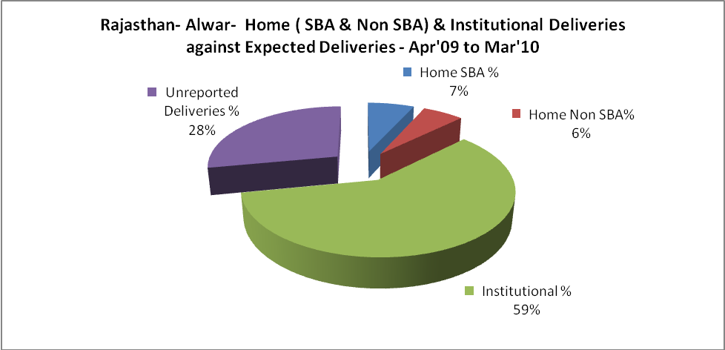

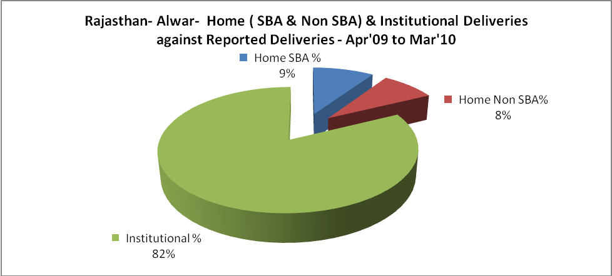

Rajasthan- Alwar- C sections & Complicated Deliveries Apr'09 to Mar'10
 | Institutional Deliveries (Public) | Institutional Deliveries (Pvt)
 | 44,352 | 16,210
C Section | 1,504 | 2,989
C Section% | 3% | 18%
Complicated Pregnacies attended | 3,569 | 2,185
Complicated Pregnacies attended % | 8% | 13%

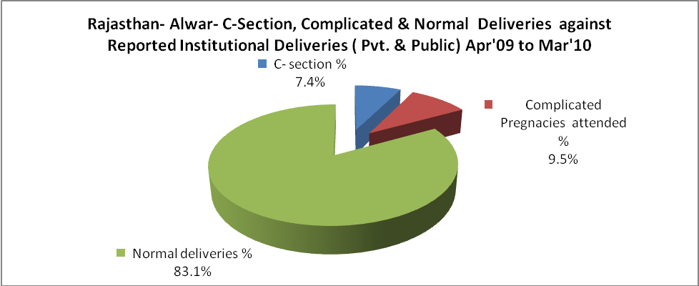

Rajasthan- Alwar- Complicated Pregnancies & Deliveries Treated - Apr'09 to Mar'10
Reported Deliveries |  |  | Reported ANC Reigtration
73,598 |  |  | 125,004
Complicated Pregnancies attended | Complicated Pregnancies Rate | C - Section Deliveries | PNC Maternal Complications | Abortions | Still Births
5,754 | 5% | 4,493 | 665 | 2,040 | 1,613
Complicated Deliveries Treated with |  |  |  | No Of Eclampsia cases Treated | No Of severe anemia cases treated
IV Antibiotics | IV antihypertensive/Magsulph injection | IV Oxytocis | Blood Transfusion | No Of Eclampsia cases Treated | No Of severe anemia cases treated
10,227 | 2,051 | 11,730 | 1,092 | 256 | 1,631

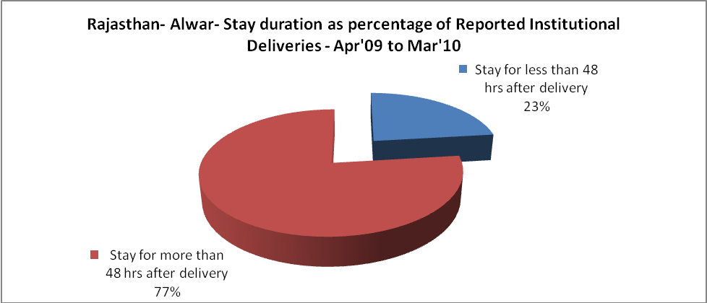

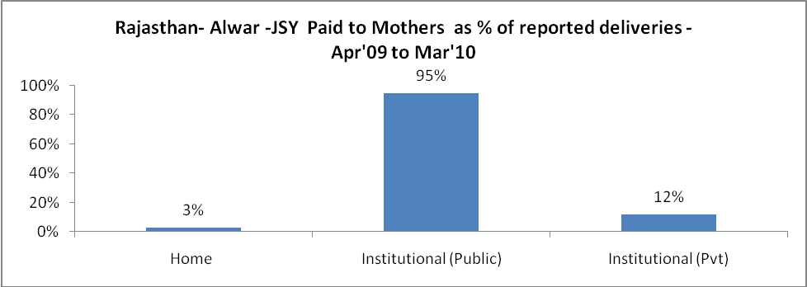

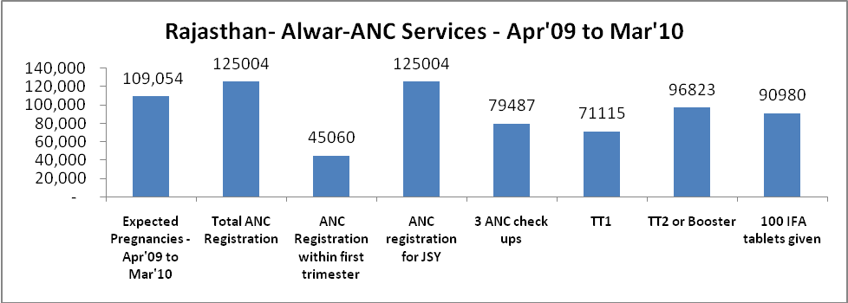

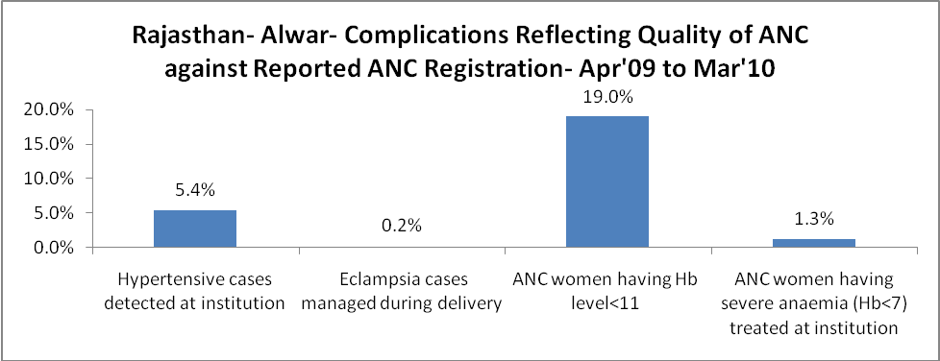

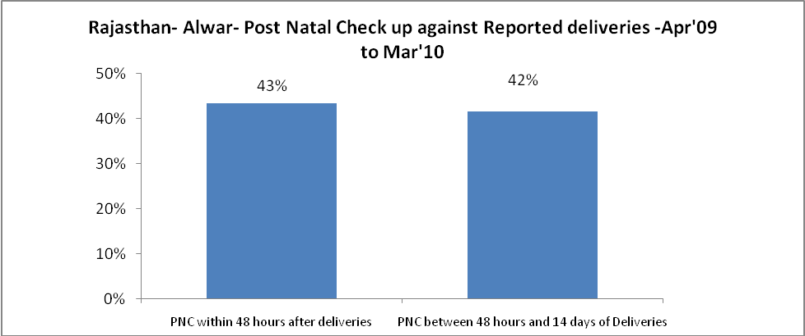

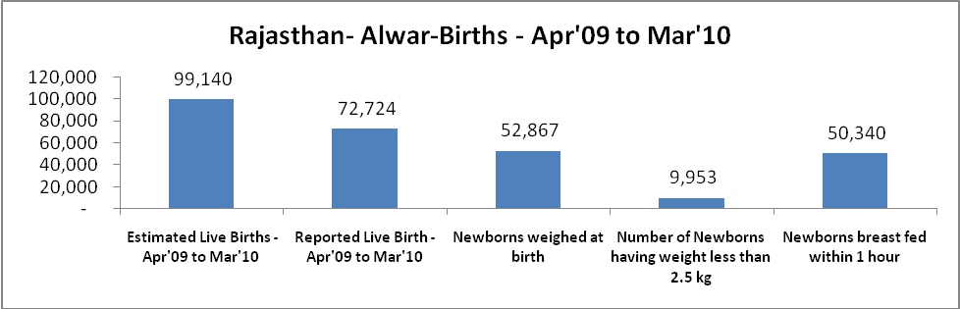

Rajasthan- Alwar - Births - Apr'09 to Mar'10
Live Birth - Males | Live Birth - females | Live Birth - Total | Sex Ratio at birth | Still Birth | Abortion( Induced/Spontaneous
38,527 | 34,197 | 72,724 | 888 | 1,613 | 2,040

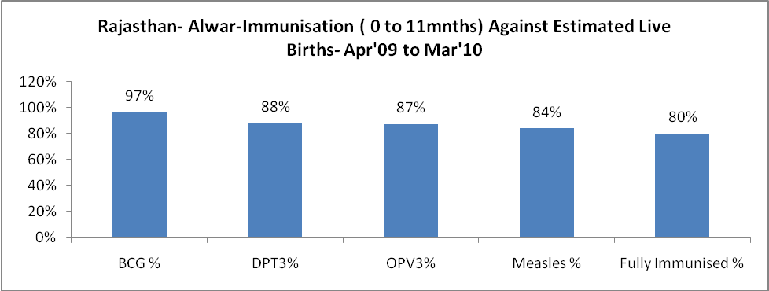

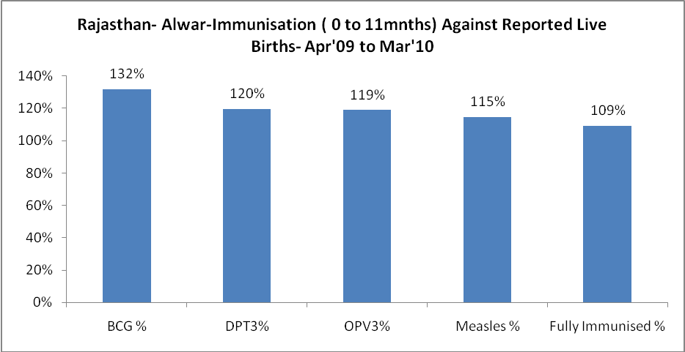

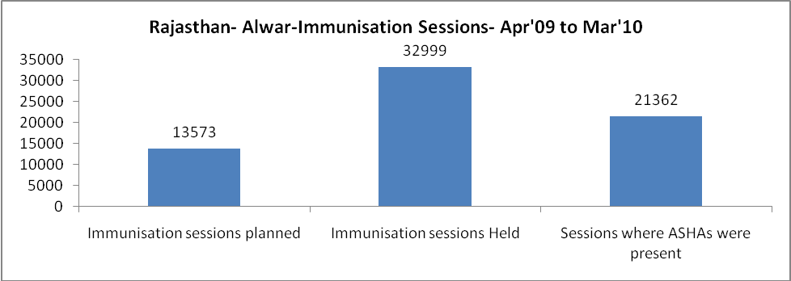

Rajasthan- Alwar- Apr'09 to Mar'10
Total Abortions | Abortion Rate
2,502 | 2.3%

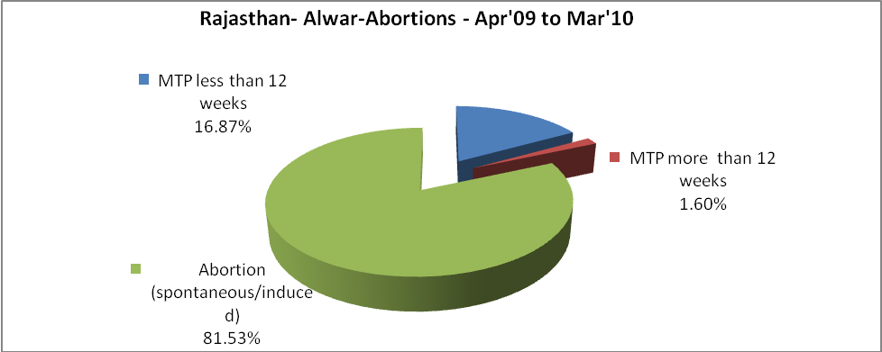

Rajasthan- Alwar- Apr'09 to Mar'10
Total OPD | Total RTI/STI cases
1,266,742 | 5,393

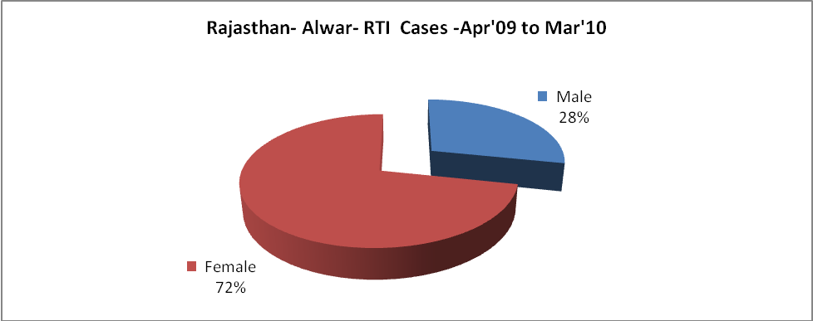
Rajasthan- Alwar-Sterilisations - Apr'09 to Mar'10
 | Reported | %age of Reported Sterilisation
Total Sterilisation | 16,695 | -
NSV | 627 | 4%
Laproscopic | 15,727 | 94%
MiniLap | 185 | 1%
Post Partum | 156 | 1%
Male Sterilisation | 627 | 4%
Female Sterilisation | 16,068 | 96%

Rajasthan- Alwar-FP Methods - Apr'09 to Mar'10
 | Reported | %age of All Reported FP Methods
Total Reported FP Methodd (All types) Users | 141,840 | -
Sterilisations | 16,695 | 12%
IUD | 16,488 | 12%
Condom Users | 74,319 | 52%
OCP Users | 34,338 | 24%
Limiting Methods | 16,695 | 12%
Spacing Methods | 125,145 | 88%

Rajasthan- Alwar- Lab Services - Apr'09 to Mar'10
Total OPD | Total HB tested | Total HIV Tested | Total Population
1,266,742 | 49,976 | 22,989 | 3,605,100
HB test conducted as %age of OPD | HB<7gm as %age of HB tested | HIV test conducted as %age of OPD | HIV positive as %age of HIV tested | Blood Smear Examined as % of Population
3.9% | 5.4% | 1.8% | 1.6% | 6.1%

Rajasthan- Alwar- Childhood Disease - Vaccine Preventable -Apr'09 to Mar'10
Diphtheria | Pertussis | Tetanus Neonatorum | Tetanus others | Polio | Measles
0 | 0 | 0 | 0 | 0 | 178
Rajasthan- Alwar-Childhood Disease - Others - Apr'09 to Mar'10
Diarrhoea and dehydration | Malaria | Number admitted with Respiratory Infections
5,987 | 1,072 | 4,641

Rajasthan- Alwar- Infant & Child Deaths - Apr'09 to Mar'10
Infant Deaths within 24 hrs of birth | Infant Deaths between 24hrs & under 1 week | Infant Deaths between 1 week & under 1 month | Child Deaths between 1 month & under 1 year | Child Deaths between 1yr under 5years | Total Deaths
73 | 362 | 148 | 529 | 416 | 1528

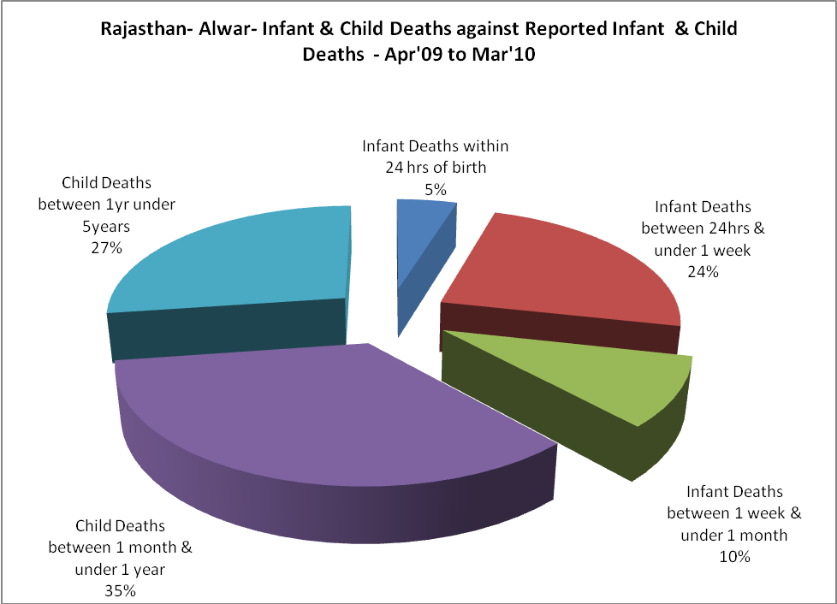

Rajasthan- Alwar- Causes of Infant & Child Deaths - Apr'09 to Mar'10
Sepsis |  |  | Asphyxia |  |  | LBW
Up to 1 Weeks of Birth | Between 1 week & 4 weeks of birth | Total | Up to 1 Weeks of Birth | Between 1 week & 4 weeks of birth | Total | Up to 1 Weeks of Birth | Between 1 week & 4 weeks of birth | Total
11 | 24 | 35 | 36 | 17 | 53 | 47 | 24 | 71
Pneumonia |  |  | Diarrhoea |  |  | Fever related
Between 1 month and 11 months | Between 1 year & 5 years | Total | Between 1 month and 11 months | Between 1 year & 5 years | Total | Between 1 month and 11 months | Between 1 year & 5 years | Total
92 | 49 | 141 | 86 | 116 | 202 | 190 | 128 | 318
Others |  |  | Measles |  |  | Others
Up to 1 Weeks of Birth | Between 1 week & 4 weeks of birth | Total | Between 1 month and 11 months | Between 1 year & 5 years | Total | Between 1 month and 11 months | Between 1 year & 5 years | Total
268 | 83 | 351 | 0 | 0 | 0 | 161 | 123 | 284

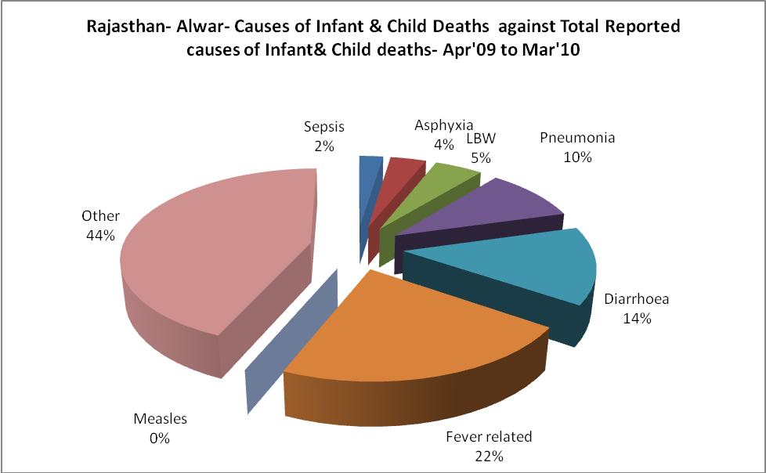

Rajasthan- Alwar- Maternal Deaths & Causes - Apr'09 to Mar'10
Abortion |  |  | Obstructed/prolonged labour |  |  | Severe hypertesnion/fits
6-14 yrs | 15-55 yrs. | Total | 6-14 yrs | 15-55 yrs. | Total | 6-14 yrs | 15-55 yrs. | Total
1 | 17 | 18 | 0 | 10 | 10 | 3 | 6 | 9
Bleeding |  |  | High Fever |  |  | Other Causes
6-14 yrs | 15-55 yrs. | Total | 6-14 yrs | 15-55 yrs. | Total | 6-14 yrs | 15-55 yrs. | Total
2 | 7 | 9 | 0 | 5 | 5 | 10 | 18 | 28

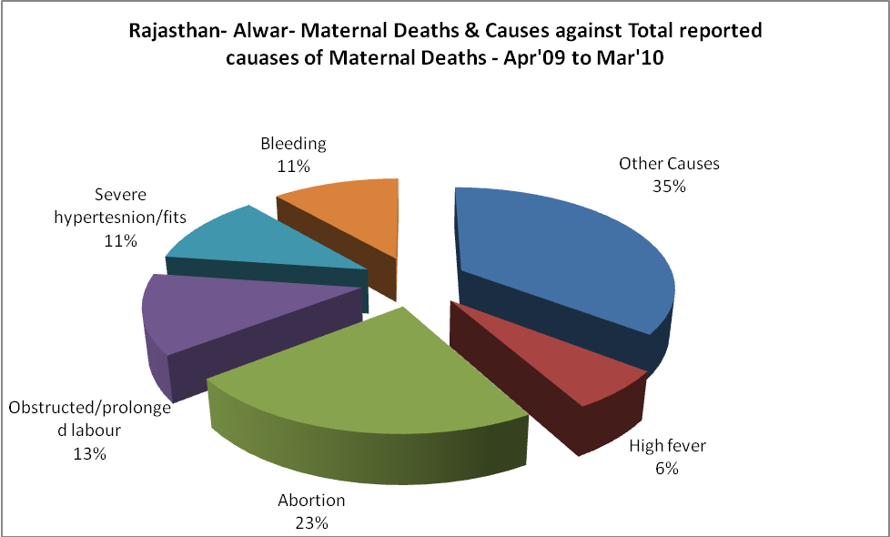

Rajasthan- Alwar-Causes of Deaths in 6 to 55yrs age group - Apr'09 to Mar'10
Diarrhoel Diseases |  |  |  | Tuberculosis |  |  |  | Respiratory Diseases( Other than TB)
6-14 yrs | 15-55 yrs. | Above 55yrs | Total | 6-14 yrs | 15-55 yrs. | Above 55yrs | Total | 6-14 yrs | 15-55 yrs. | Above 55yrs | Total
192 | 128 | 72 | 392 | 23 | 118 | 70 | 211 | 16 | 48 | 145 | 209
Malaria |  |  |  | Other fever Related |  |  |  | HIV/Aids
6-14 yrs | 15-55 yrs. | Above 55yrs | Total | 6-14 yrs | 15-55 yrs. | Above 55yrs | Total | 6-14 yrs | 15-55 yrs. | Above 55yrs | Total
31 | 193 | 16 | 240 | 28 | 70 | 52 | 150 | 0 | 7 | 4 | 11
Heart Disease/Hypertenion related |  |  |  | Neurological Disease including strokes |  |  |  | Trauma/Accidents/ Burn Cases
6-14 yrs | 15-55 yrs. | Above 55yrs | Total | 6-14 yrs | 15-55 yrs. | Above 55yrs | Total | 6-14 yrs | 15-55 yrs. | Above 55yrs | Total
1 | 80 | 120 | 201 | 143 | 20 | 38 | 201 | 9 | 56 | 30 | 95
Suicide |  |  |  | Animal Bites & Stings
6-14 yrs | 15-55 yrs. | Above 55yrs | Total | 6-14 yrs | 15-55 yrs. | Above 55yrs | Total
3 | 64 | 8 | 75 | 5 | 12 | 4 | 21

