NHSRC
Maharashtra – Aurangabad
Analysis: Apr 2009 – Mar 2010

Maharashtra-Ahmadnagar- Summary-Apr'09 to Mar'10
ANC
ANC Registration against Expected Pregnancies | 87% | TT1 given to Pregnant women against ANC Registration | 65%
3 ANC Check ups against ANC Registrations | 90% | 100 IFA Tablets given to Pregnant women against ANC Registration | 83%
Deliveries
Unreported Deliveries against Estimated Deliveries | 22.0% | HOME Deliveries( SBA& Non SBA) against Estimated Deliveries | 3.6%
Institutional Deliveries against Estimated Deliveries | 74.4% | HOME Deliveries( SBA& Non SBA) against Reported Deliveries | 4.7%
Institutional Deliveries against Reported Deliveries | 95.3% | C Section Deliveries against Institutional Deliveries( Pvt & Pub) | 5%
Births & Neonates Care
Live Births Reported against Estimated Live Births | 78% | New borns weighed against Reported Live Births | 91%
Still Births (Reported) | 900 | New borns weighed less than 2.5 kgs against newborns weighed | 7%
Sex Ratio at Birth | 813 | New borns breastfed within one hr of Birth against Reported live Births | 0%
Child Immunization( 0 to 11 months)
BCG given against Expected Live Births | 92% | Measles given against Expected Live Births | 89%
OPV3 given against Expected Live Births | 91% | Fully Immunized Children against Expected Live Births | 88%
DPT3 given against Expected Live Births | 92%
Family Planning
Family Planning Methods Users ( Sterilizations(Male &Female)+IUD+ Condom pieces/72 + OCP Cycles/13) | 57,911 | IUD Insertions against reported FP Methods | 27%
Sterilization against reported FP Methods | 29% | Condom Users against reported FP Methods | 27%
 |  | OCP Users against reported FP Methods | 18%
Other Services
OPD | 325,934 | Major Operations | 560
IPD | - | Minor Operations | 659

Maharashtra-Aurangabad- Deliveries Apr'09 to Mar'10
Total Population | 3,395,972 | Expected Deliveries |  | 61,791
Home SBA | Home Non SBA | Institutional | Total Deliveries Reported | Unreported Deliveries
13,759 | 687 | 45,574 | 60,020 | 1,771
Home SBA % | Home Non SBA% | Institutional % | Total Deliveries Reported % | Unreported Deliveries %
22% | 1% | 74% | 97% | 3%

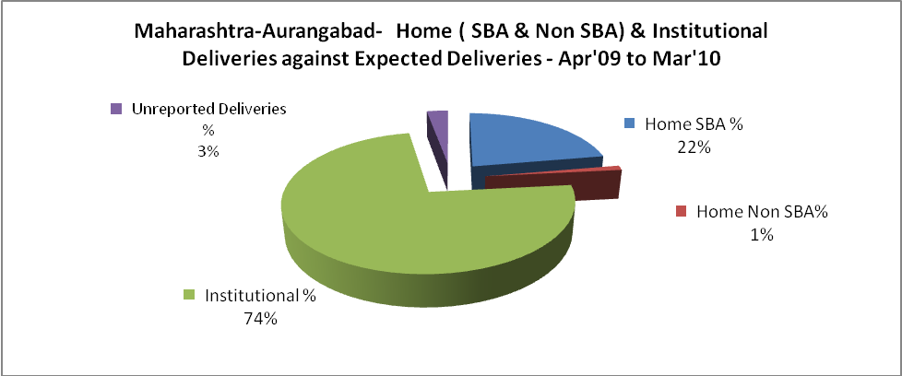`

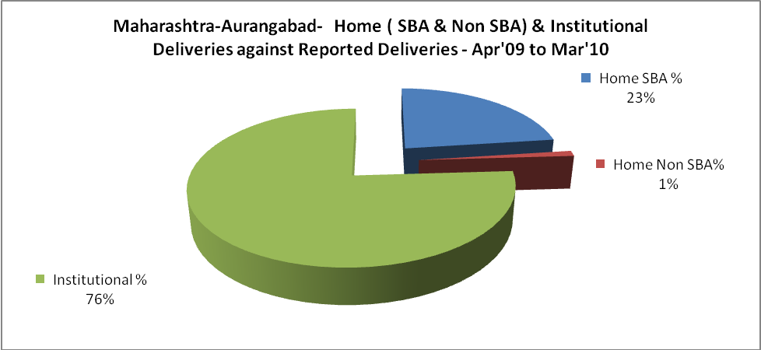

Maharashtra-Aurangabad- C sections & Complicated Deliveries Apr'09 to Mar'10
 | Institutional Deliveries (Public) | Institutional Deliveries (Pvt)
 | 17,586 | 27,988
C Section | 17 | 1,178
C Section% | 0% | 4%
Complicated Pregnancies attended | 770 | 549
Complicated Pregnancies attended % | 4% | 2%

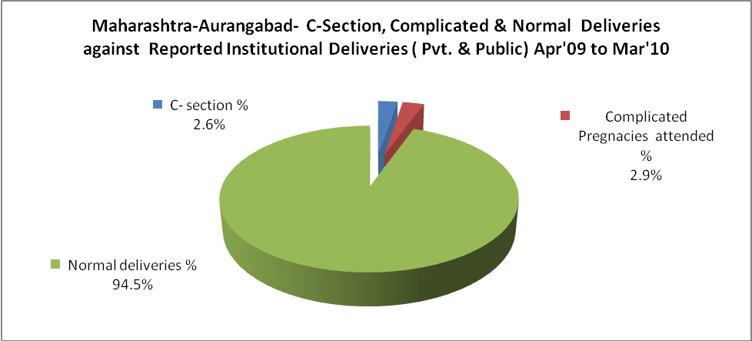

Maharashtra-Aurangabad- Complicated Pregnancies & Deliveries Treated - Apr'09 to Mar'10
Reported Deliveries |  |  | Reported ANC Registration
60,020 |  |  | 89,637
Complicated Pregnancies attended | Complicated Pregnancies Rate | C - Section Deliveries | PNC Maternal Complications | Abortions | Still Births
1,319 | 2% | 1,195 | - | 4,806 | 500
Complicated Deliveries Treated with |  |  |  | No Of Eclampsia cases Treated | No Of severe anemia cases treated
IV Antibiotics | IV antihypertensive/Magsulph injection | IV Oxytocis | Blood Transfusion | No Of Eclampsia cases Treated | No Of severe anemia cases treated
- | - | - | - | - | -

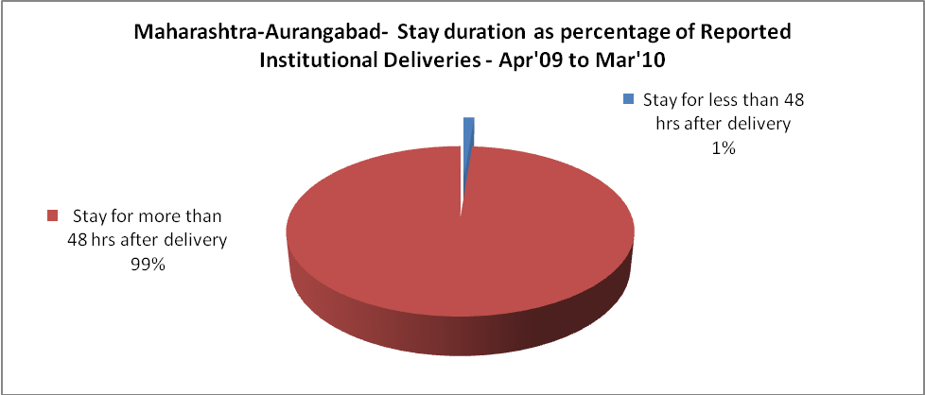

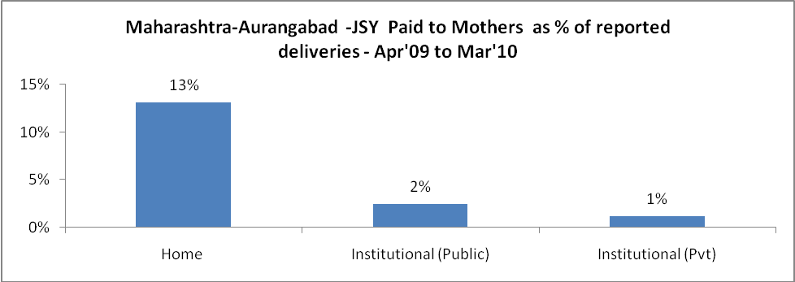

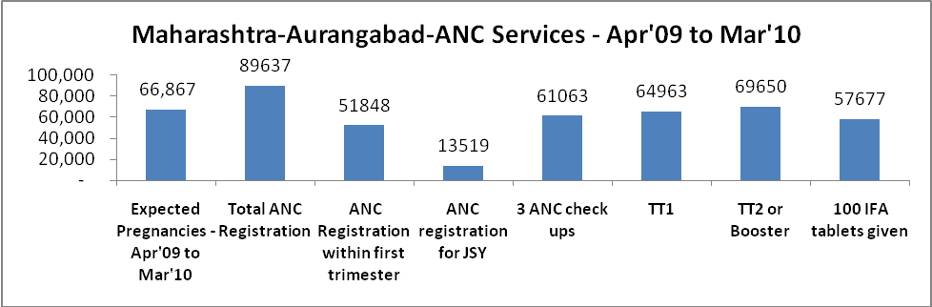

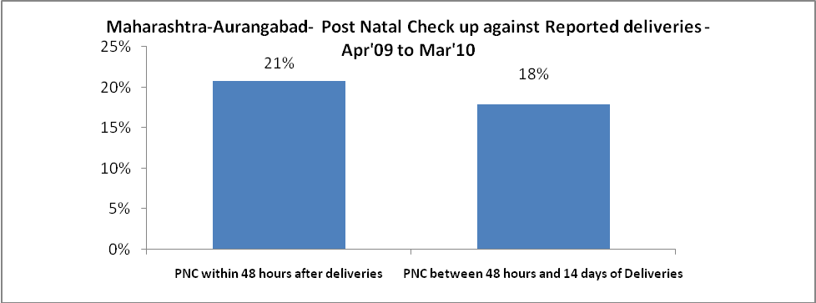

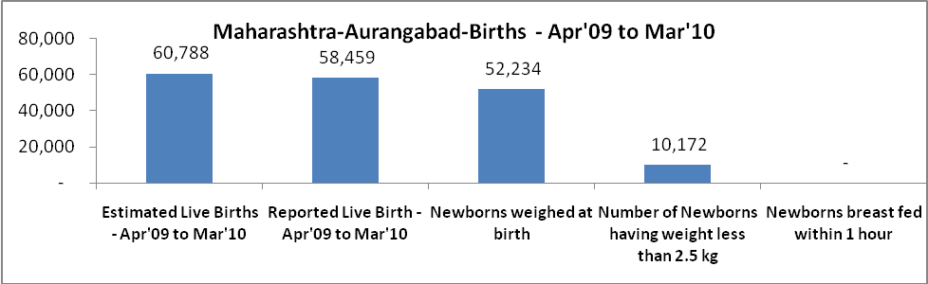

Maharashtra-Aurangabad - Births - Apr'09 to Mar'10
Live Birth - Males | Live Birth - females | Live Birth - Total | Sex Ratio at birth | Still Birth | Abortion( Induced/Spontaneous
32,078 | 26,381 | 58,459 | 822 | 500 | 4,806

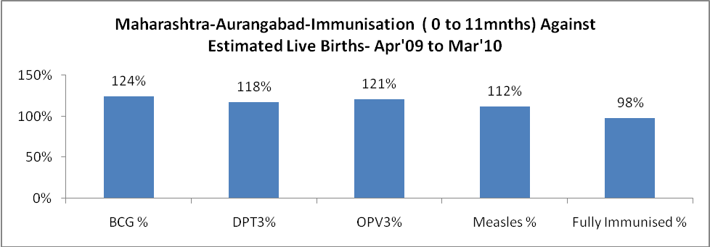

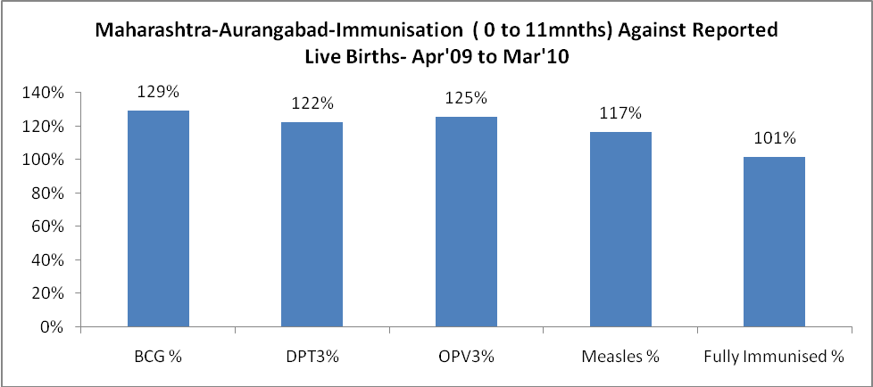

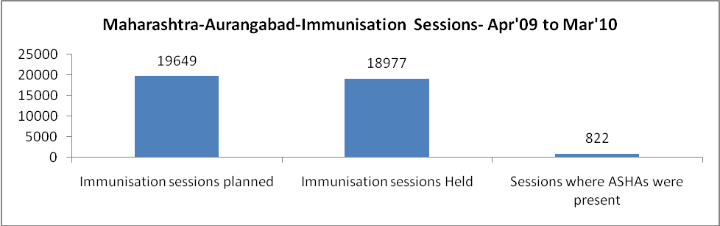

Maharashtra-Aurangabad- Apr'09 to Mar'10
Total Abortions | Abortion Rate
9,338 | 14.0%

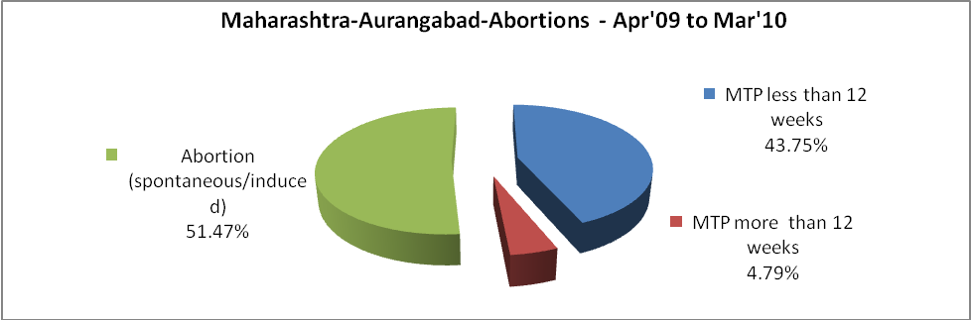

Maharashtra-Aurangabad- Apr'09 to Mar'10
Total OPD | Total RTI/STI cases
325,934 | 7,434

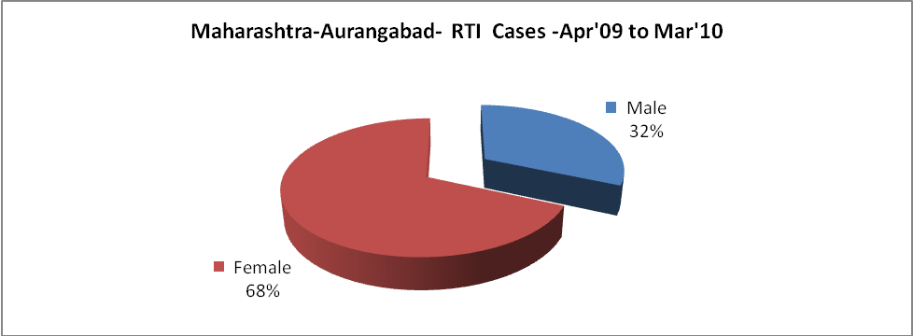

Maharashtra-Aurangabad-Sterilizations - Apr'09 to Mar'10
 | Reported | %age of Reported Sterilization
Total Sterilization | 15,124 | -
NSV | 484 | 3%
Laparoscopic | 2,084 | 14%
Mini Lap | 10,934 | 72%
Post Partum | 1,622 | 11%
Male Sterilization | 484 | 3%
Female Sterilization | 14,640 | 97%

Maharashtra-Aurangabad-FP Methods - Apr'09 to Mar'10
 | Reported | %age of All Reported FP Methods
Total Reported FP Method (All types) Users | 57,911 | -
Sterilizations | 15,124 | 26%
IUD | 12,527 | 22%
Condom Users | 20,764 | 36%
OCP Users | 9,497 | 16%
Limiting Methods | 15,124 | 26%
Spacing Methods | 42,787 | 74%

Maharashtra-Aurangabad- Service Delivery - Apr'09 to Mar'10
Operation major (General and spinal anaesthesia) | Operation minor (No or local anaesthesia) | AYUSH | Dental Procedures | Adolescent counselling services | Total OPD | Total IPD
202 | 493 | - | - | - | 325,934 | -
Operation major (General and spinal anaesthesia) as %ge of OPD | Operation minor (No or local anaesthesia)as %ge of OPD | AYUSH as %ge of OPD | Dental Procedures as %ge of OPD | Adolescent counselling services as %ge of OPD | IPD as percentage of OPD
0.1% | 0.2% | 0.0% | 0.0% | 0.0% | 0%

Maharashtra-Aurangabad- Lab Services - Apr'09 to Mar'10
Total OPD | Total HB tested | Total HIV Tested | Total Population
325,934 | - | -
HB test conducted as %age of OPD | HB<7gm as %age of HB tested | HIV test conducted as %age of OPD | HIV positive as %age of HIV tested | Blood Smear Examined as % of Population
0.0% | - | 0.0% | - | 5.9%

Maharashtra-Aurangabad- Childhood Disease - Vaccine Preventable -Apr'09 to Mar'10
Diphtheria | Pertussis | Tetanus Neonatorum | Tetanus others | Polio | Measles
0 | 0 | 0 | 0 | 0 | 8
Maharashtra-Aurangabad-Childhood Disease - Others - Apr'09 to Mar'10
Diarrhoea and dehydration | Malaria | Number admitted with Respiratory Infections
3,266 | 22 | 17

Maharashtra-Aurangabad- Infant & Child Deaths - Apr'09 to Mar'10
Infant Deaths within 24 hrs of birth | Infant Deaths between 24hrs & under 1 week | Infant Deaths between 1 week & under 1 month | Child Deaths between 1 month & under 1 year | Child Deaths between 1yr under 5years | Total Deaths
161 | 184 | 74 | 147 | 112 | 678

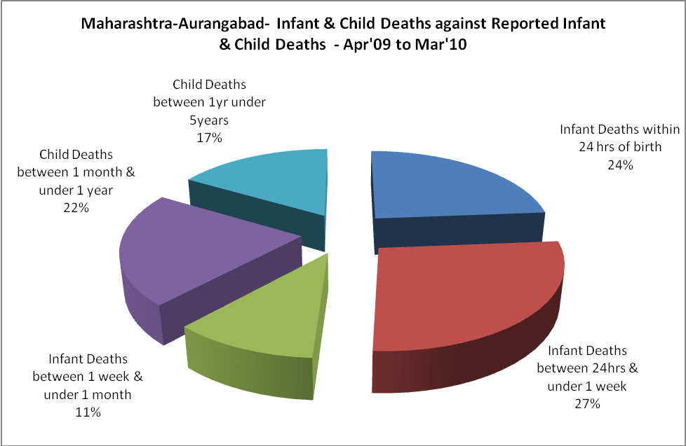

Maharashtra-Aurangabad- Causes of Infant & Child Deaths - Apr'09 to Mar'10
Sepsis |  |  | Asphyxia |  |  | LBW
Up to 1 Weeks of Birth | Between 1 week & 4 weeks of birth | Total | Up to 1 Weeks of Birth | Between 1 week & 4 weeks of birth | Total | Up to 1 Weeks of Birth | Between 1 week & 4 weeks of birth | Total
0 | 0 | 0 | 0 | 0 | 0 | 0 | 0 | 0
Pneumonia |  |  | Diarrhoea |  |  | Fever related
Between 1 month and 11 months | Between 1 year & 5 years | Total | Between 1 month and 11 months | Between 1 year & 5 years | Total | Between 1 month and 11 months | Between 1 year & 5 years | Total
0 | 0 | 0 | 0 | 0 | 0 | 0 | 0 | 0
Others |  |  | Measles |  |  | Others
Up to 1 Weeks of Birth | Between 1 week & 4 weeks of birth | Total | Between 1 month and 11 months | Between 1 year & 5 years | Total | Between 1 month and 11 months | Between 1 year & 5 years | Total
184 | 74 | 258 | 0 | 0 | 0 | 147 | 112 | 259

Maharashtra-Aurangabad- Maternal Deaths & Causes - Apr'09 to Mar'10
Abortion |  |  | Obstructed/prolonged labour |  |  | Severe hypertension/fits
6-14 yrs | 15-55 yrs. | Total | 6-14 yrs | 15-55 yrs. | Total | 6-14 yrs | 15-55 yrs. | Total
0 | 0 | 0 | 0 | 0 | 0 | 0 | 0 | 0
Bleeding |  |  | High Fever |  |  | Other Causes
6-14 yrs | 15-55 yrs. | Total | 6-14 yrs | 15-55 yrs. | Total | 6-14 yrs | 15-55 yrs. | Total
0 | 0 | 0 | 0 | 0 | 0 | 0 | 0 | 0

Maharashtra-Aurangabad-Causes of Deaths in 6 to 55yrs age group - Apr'09 to Mar'10
Diarrhoel Diseases |  |  |  | Tuberculosis |  |  |  | Respiratory Diseases( Other than TB)
6-14 yrs | 15-55 yrs. | Above 55yrs | Total | 6-14 yrs | 15-55 yrs. | Above 55yrs | Total | 6-14 yrs | 15-55 yrs. | Above 55yrs | Total
0 | 545 | 0 | 545 | 0 | 0 | 0 | 0 | 0 | 0 | 0 | 0
Malaria |  |  |  | Other fever Related |  |  |  | HIV/Aids
6-14 yrs | 15-55 yrs. | Above 55yrs | Total | 6-14 yrs | 15-55 yrs. | Above 55yrs | Total | 6-14 yrs | 15-55 yrs. | Above 55yrs | Total
0 | 0 | 0 | 0 | 0 | 0 | 0 | 0 | 0 | 0 | 0 | 0
Heart Disease/Hypertension related |  |  |  | Neurological Disease including strokes |  |  |  | Trauma/Accidents/ Burn Cases
6-14 yrs | 15-55 yrs. | Above 55yrs | Total | 6-14 yrs | 15-55 yrs. | Above 55yrs | Total | 6-14 yrs | 15-55 yrs. | Above 55yrs | Total
0 | 0 | 0 | 0 | 0 | 0 | 0 | 0 | 0 | 0 | 0 | 0
Suicide |  |  |  | Animal Bites & Stings
6-14 yrs | 15-55 yrs. | Above 55yrs | Total | 6-14 yrs | 15-55 yrs. | Above 55yrs | Total
0 | 0 | 0 | 0 | 0 | 0 | 0 | 0

0
Total
0
Total
259

