NHSRC
Bihar-Banka

KUNAL
8/14/2010

Bihar- Banka- Summary-Apr'09 to Mar'10
ANC
ANC Registration against Expected Pregnancies | 70% | TT1 given to Pregnant women against ANC Registraion | 83%
3 ANC Check ups against ANC Reigtrations | 56% | 100 IFA Tablets given to Pregnant women against ANC Registraion | 86%
Deliveries
Unreported Deliveries against Estimated Deliveries | 51.5% | HOME Deliveries( SBA& Non SBA) against Estimated Deliveries | 6.4%
Institutional Deliveries against Estimated Deliveries | 42.1% | HOME Deliveries( SBA& Non SBA) against Reported Deliveries | 13.1%
Institutional Deliveries against Reported Deliveries | 86.9% | C Section Deliveries against Institutional Deliveries( Pvt & Pub) | 0%
Births & Neonates Care
Live Births Reported against Estimated Live Births | 48% | New borns weighed against Reported Live Births | 90%
Still Births (Reported) | 746 | New borns weighed less than 2.5 kgs against newborns weighed | 15%
Sex Ratio at Birh | 908 | New borns breastfed within one hr of Birth against Reported live Births | 81%
Child Immunisation( 0 to 11 mnths)
BCG given against Expected Live Births | 83% | Measles given against Expected Live Births | 71%
OPV3 given against Expected Live Births | 69% | Fully Immunised Children against Expected Live Births | 89%
DPT3 given against Expected Live Births | 88%
Family Plannng
Family Plannig Methods Users ( Sterilisations(Male &Female)+IUD+ Condom pieces/72 + OCP Cycles/13) | 11,141 | IUD Insertions against reported FP Methods | 20%
Sterilisation against reported FP Methods | 59% | Condom Users against reported FP Methods | 13%
 |  | OCP Users against reported FP Methods | 8%
Other Services
OPD | 5,91,963 | Major Operations | 4,219
IPD | 1,599 | Minor Operations | 5,079

Bihar- Banka- Deliveries Apr'09 to Mar'10
Total Population | 18,49,520 | Expected Deliveries |  | 56,053
Home SBA | Home Non SBA | Institutional | Total Deliveries Reported | Unreported Deliveries
1,342 | 2,227 | 23,610 | 27,179 | 28,874
Home SBA % | Home Non SBA% | Institutional % | Total Deliveries Reported % | Unreported Deliveries %
2% | 4% | 42% | 48% | 52%
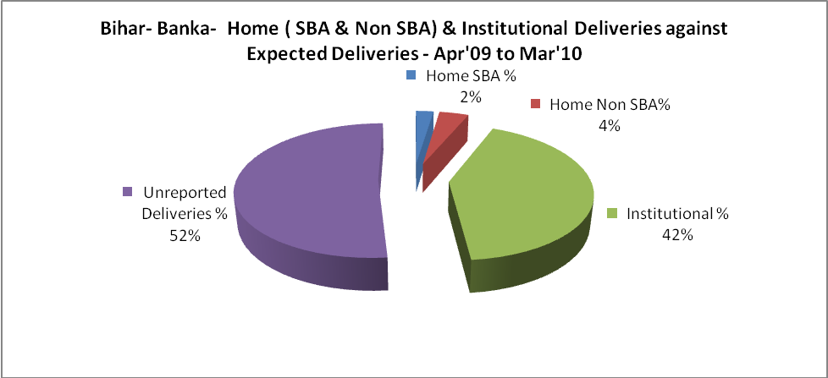
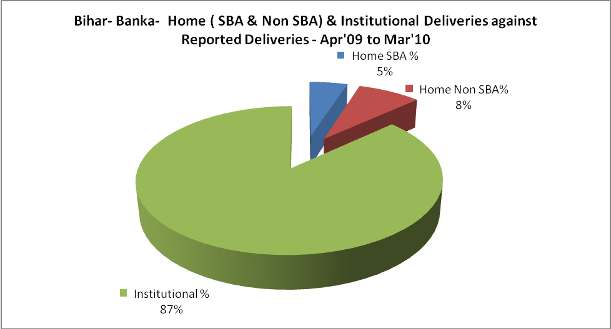

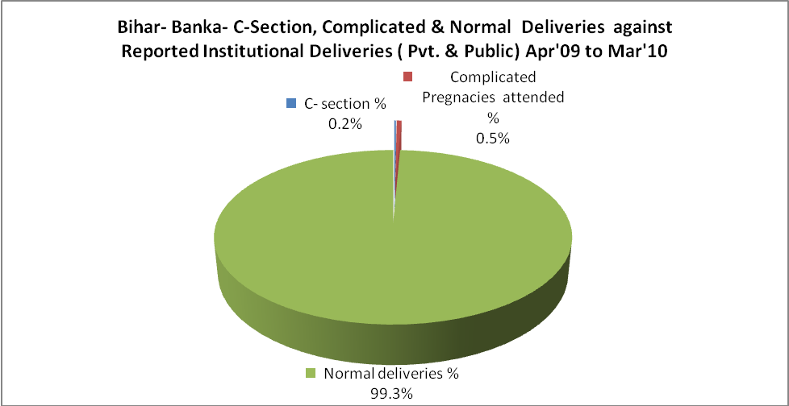

Bihar- Banka- Complicated Pregnancies & Deliveries Treated - Apr'09 to Mar'10
Reported Deliveries |  |  | Reported ANC Reigtration
27,179 |  |  | 42,047
Complicated Pregnancies attended | Complicated Pregnancies Rate | C - Section Deliveries | PNC Maternal Complications | Abortions | Still Births
126 | 0% | 43 | - | 58 | 746
Complicated Deliveries Treated with |  |  |  | No Of Eclampsia cases Treated | No Of severe anemia cases treated
IV Antibiotics | IV antihypertensive/Magsulph injection | IV Oxytocis | Blood Transfusion | No Of Eclampsia cases Treated | No Of severe anemia cases treated
7,971 | 200 | 7,427 | - | 78 | 216

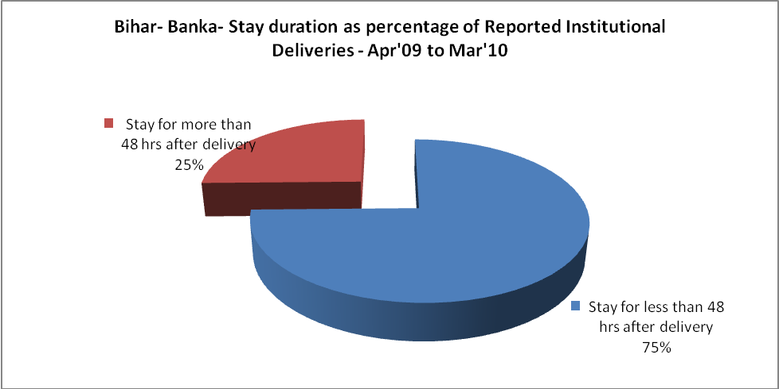

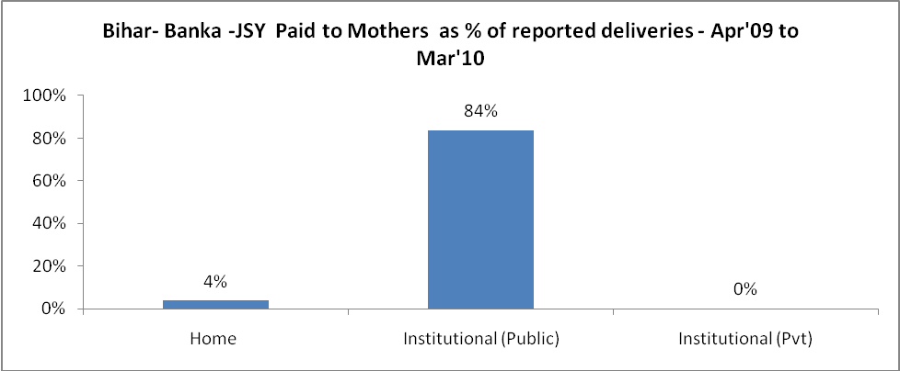
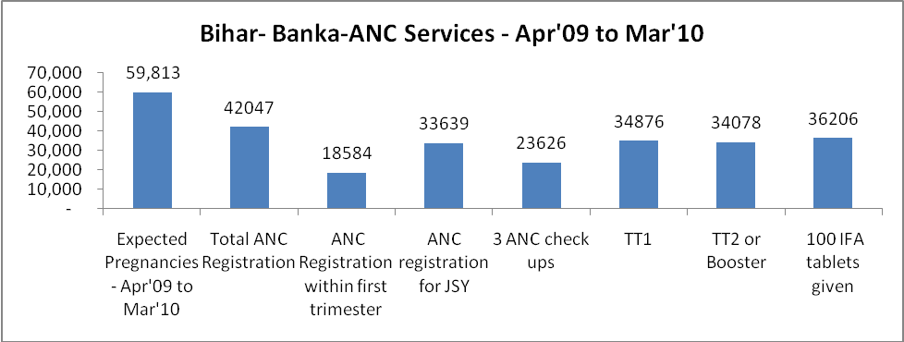

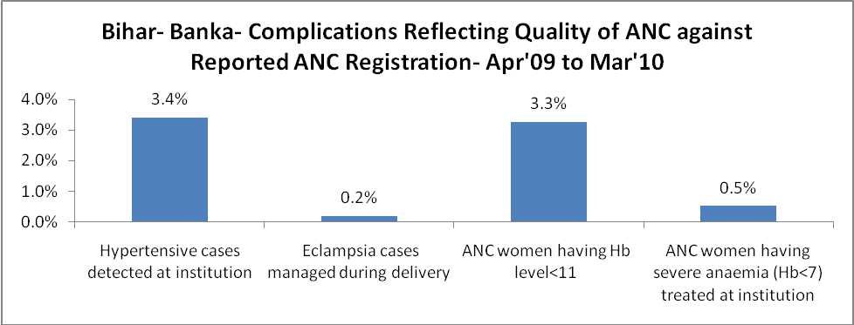
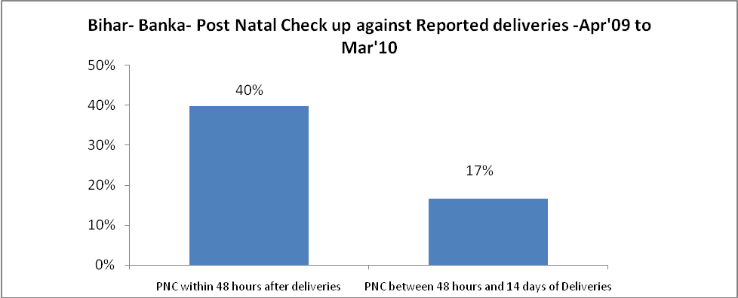
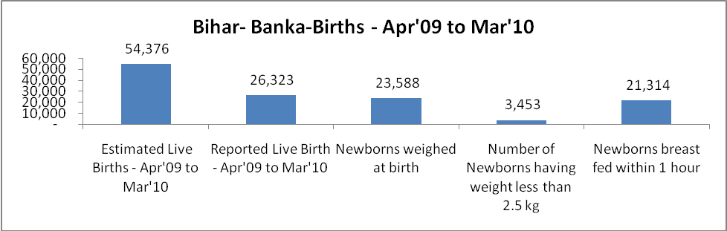

Bihar- Banka - Births - Apr'09 to Mar'10
Live Birth - Males | Live Birth - females | Live Birth - Total | Sex Ratio at birth | Still Birth | Abortion( Induced/Spontaneous
13,798 | 12,525 | 26,323 | 908 | 746 | 58

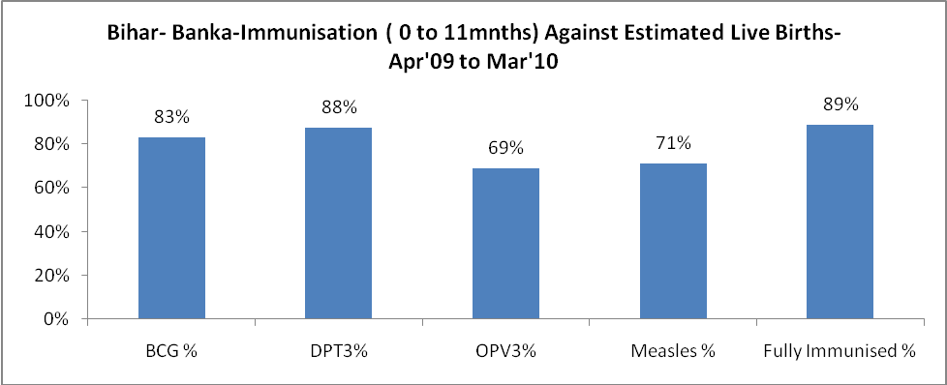
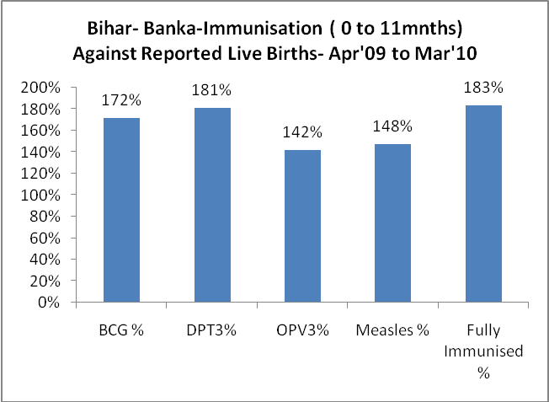
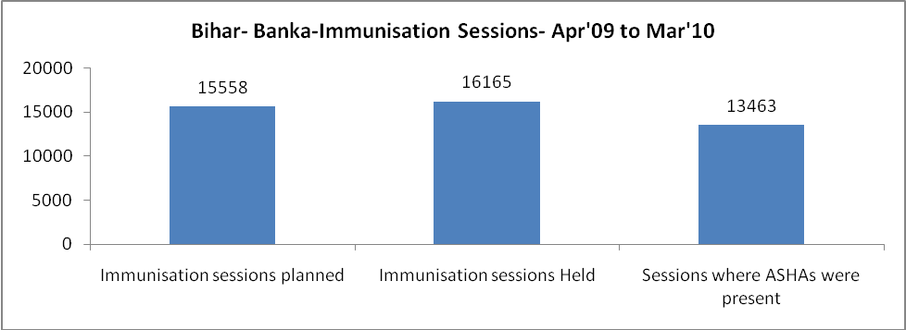
Bihar- Banka- Apr'09 to Mar'10
Total Abortions | Abortion Rate
59 | 0.1%

Bihar- Banka- Apr'09 to Mar'10
Total OPD | Total RTI/STI cases
5,91,963 | 210

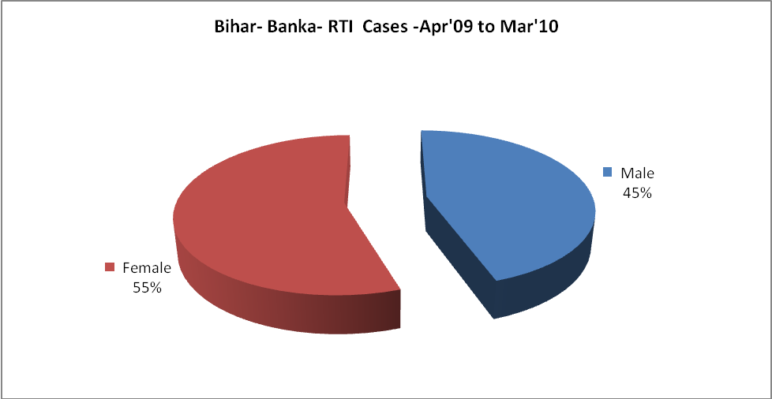
Bihar- Banka-Sterilisations - Apr'09 to Mar'10
 | Reported | %age of Reported Sterilisation
Total Sterilisation | 6,560 | -
NSV | 471 | 7%
Laproscopic | 318 | 5%
MiniLap | 5,768 | 88%
Post Partum | 3 | 0%
Male Sterilisation | 471 | 7%
Female Sterilisation | 6,089 | 93%

Bihar- Banka-FP Methods - Apr'09 to Mar'10
 | Reported | %age of All Reported FP Methods
Total Reported FP Methodd (All types) Users | 11,141 | -
Sterilisations | 6,560 | 59%
IUD | 2,239 | 20%
Condom Users | 1,458 | 13%
OCP Users | 884 | 8%
Limiting Methods | 6,560 | 59%
Spacing Methods | 4,581 | 41%

Bihar- Banka- Service Delivery - Apr'09 to Mar'10
Operation major (General and spinal anaesthesia) | Operation minor (No or local anaesthesia) | AYUSH | Dental Procedures | Adolescent counselling services | Total OPD | Total IPD
4,219 | 5,079 | - | - | 54 | 5,91,963 | 1,599
Operation major (General and spinal anaesthesia) as %ge of OPD | Operation minor (No or local anaesthesia)as %ge of OPD | AYUSH as %ge of OPD | Dental Procedures as %ge of OPD | Adolescent counselling services as %ge of OPD | IPD as percentage of OPD
0.7% | 0.9% | 0.0% | 0.0% | 0.0% | 0%

Bihar- Banka- Lab Services - Apr'09 to Mar'10
Total OPD | Total HB tested | Total HIV Tested | Total Population
5,91,963 | 2,585 | - | 18,49,520
HB test conducted as %age of OPD | HB<7gm as %age of HB tested | HIV test conducted as %age of OPD | HIV positive as %age of HIV tested | Blood Smear Examined as % of Population
0.4% | 10.8% | 0.0% | - | 0.1%

Bihar- Banka- Childhood Disease - Vaccine Preventable -Apr'09 to Mar'10
Diphtheria | Pertussis | Tetanus Neonatorum | Tetanus others | Polio | Measles
0 | 0 | 0 | 0 | 0 | 432
Bihar- Banka-Childhood Disease - Others - Apr'09 to Mar'10
Diarrhoea and dehydration | Malaria | Number admitted with Respiratory Infections
459 | 44 | 5

Bihar- Banka- Infant & Child Deaths - Apr'09 to Mar'10
Infant Deaths within 24 hrs of birth | Infant Deaths between 24hrs & under 1 week | Infant Deaths between 1 week & under 1 month | Child Deaths between 1 month & under 1 year | Child Deaths between 1yr under 5years | Total Deaths
1 | 0 | 0 | 0 | 0 | 1

Bihar- Banka- Causes of Infant & Child Deaths - Apr'09 to Mar'10
Sepsis |  |  | Asphyxia |  |  | LBW
Up to 1 Weeks of Birth | Between 1 week & 4 weeks of birth | Total | Up to 1 Weeks of Birth | Between 1 week & 4 weeks of birth | Total | Up to 1 Weeks of Birth | Between 1 week & 4 weeks of birth | Total
0 | 0 | 0 | 0 | 0 | 0 | 0 | 0 | 0
Pneumonia |  |  | Diarrhoea |  |  | Fever related
Between 1 month and 11 months | Between 1 year & 5 years | Total | Between 1 month and 11 months | Between 1 year & 5 years | Total | Between 1 month and 11 months | Between 1 year & 5 years | Total
0 | 0 | 0 | 0 | 0 | 0 | 0 | 0 | 0
Others |  |  | Measles |  |  | Others
Up to 1 Weeks of Birth | Between 1 week & 4 weeks of birth | Total | Between 1 month and 11 months | Between 1 year & 5 years | Total | Between 1 month and 11 months | Between 1 year & 5 years | Total
0 | 0 | 0 | 0 | 0 | 0 | 0 | 0 | 0

Bihar- Banka- Maternal Deaths & Causes - Apr'09 to Mar'10
Abortion |  |  | Obstructed/prolonged labour |  |  | Severe hypertesnion/fits
6-14 yrs | 15-55 yrs. | Total | 6-14 yrs | 15-55 yrs. | Total | 6-14 yrs | 15-55 yrs. | Total
0 | 0 | 0 | 0 | 0 | 0 | 0 | 0 | 0
Bleeding |  |  | High Fever |  |  | Other Causes
6-14 yrs | 15-55 yrs. | Total | 6-14 yrs | 15-55 yrs. | Total | 6-14 yrs | 15-55 yrs. | Total
0 | 0 | 0 | 0 | 0 | 0 | 0 | 0 | 0

Bihar- Banka-Causes of Deaths in 6 to 55yrs age group - Apr'09 to Mar'10
Diarrhoel Diseases |  |  |  | Tuberculosis |  |  |  | Respiratory Diseases( Other than TB)
6-14 yrs | 15-55 yrs. | Above 55yrs | Total | 6-14 yrs | 15-55 yrs. | Above 55yrs | Total | 6-14 yrs | 15-55 yrs. | Above 55yrs | Total
0 | 0 | 0 | 0 | 0 | 0 | 0 | 0 | 0 | 0 | 0 | 0
Malaria |  |  |  | Other fever Related |  |  |  | HIV/Aids
6-14 yrs | 15-55 yrs. | Above 55yrs | Total | 6-14 yrs | 15-55 yrs. | Above 55yrs | Total | 6-14 yrs | 15-55 yrs. | Above 55yrs | Total
0 | 0 | 0 | 0 | 0 | 0 | 0 | 0 | 0 | 0 | 0 | 0
Heart Disease/Hypertenion related |  |  |  | Neurological Disease including strokes |  |  |  | Trauma/Accidents/ Burn Cases
6-14 yrs | 15-55 yrs. | Above 55yrs | Total | 6-14 yrs | 15-55 yrs. | Above 55yrs | Total | 6-14 yrs | 15-55 yrs. | Above 55yrs | Total
0 | 1 | 0 | 1 | 0 | 0 | 0 | 0 | 0 | 0 | 0 | 0
Suicide |  |  |  | Animal Bites & Stings
6-14 yrs | 15-55 yrs. | Above 55yrs | Total | 6-14 yrs | 15-55 yrs. | Above 55yrs | Total
0 | 0 | 0 | 0 | 0 | 0 | 0 | 0

