NHSRC
Rajasthan-Banswara
Analysis: Apr 2009 – Mar 2010

Rajasthan- Banswara- Summary-Apr'09 to Mar'10
ANC
ANC Registration against Expected Pregnancies | 116% | TT1 given to Pregnant women against ANC Registration | 47%
3 ANC Checkups against ANC Registrations | 60% | 100 IFA Tablets given to Pregnant women against ANC Registration | 65%
Deliveries
Unreported Deliveries against Estimated Deliveries | 20.1% | HOME Deliveries( SBA& Non SBA) against Estimated Deliveries | 7.0%
Institutional Deliveries against Estimated Deliveries | 72.8% | HOME Deliveries( SBA& Non SBA) against Reported Deliveries | 8.8%
Institutional Deliveries against Reported Deliveries | 91.2% | C Section Deliveries against Institutional Deliveries( Pvt & Pub) | 3%
Births & Neonates Care
Live Births Reported against Estimated Live Births | 83% | New borns weighed against Reported Live Births | 96%
Still Births (Reported) | 1,379 | New borns weighed less than 2.5 kgs against newborns weighed | 15%
Sex Ratio at Birh | 905 | New borns breastfed within one hr of Birth against Reported live Births | 87%
Child Immunisation( 0 to 11 months)
BCG given against Expected Live Births | 101% | Measles given against Expected Live Births | 86%
OPV3 given against Expected Live Births | 86% | Fully Immunised Children against Expected Live Births | 86%
DPT3 given against Expected Live Births | 90%
Family Planning
Family Plannig Methods Users ( Sterilisations(Male &Female)+IUD+ Condom pieces/72 + OCP Cycles/13) | 76,912 | IUD Insertions against reported FP Methods | 19%
Sterilisation against reported FP Methods | 9% | Condom Users against reported FP Methods | 48%
 |  | OCP Users against reported FP Methods | 24%
Other Services
OPD | 777,891 | Major Operations | 2,633
IPD | 124,074 | Minor Operations | 7,345

`
Rajasthan- Banswara- Deliveries Apr'09 to Mar'10
Total Population | 1,707,600 | Expected Deliveries |  | 48,438
Home SBA | Home Non SBA | Institutional | Total Deliveries Reported | Unreported Deliveries
2,214 | 1,183 | 35,284 | 38,681 | 9,757
Home SBA % | Home Non SBA% | Institutional % | Total Deliveries Reported % | Unreported Deliveries %
5% | 2% | 73% | 80% | 20%

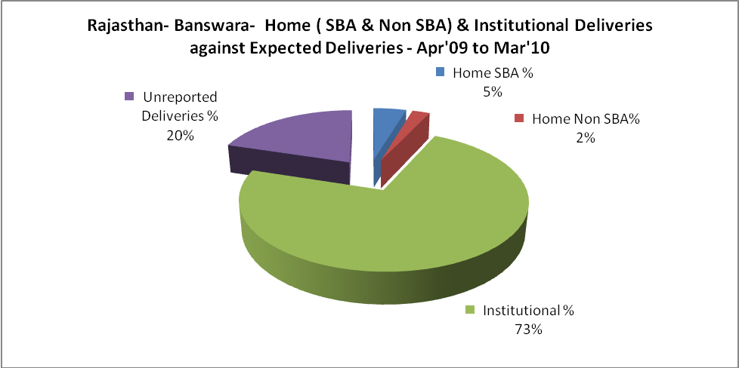

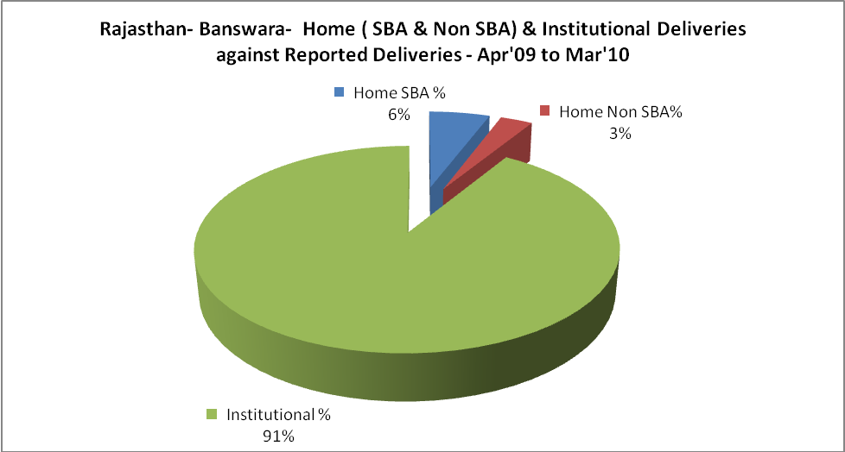

Rajasthan- Banswara- C sections & Complicated Deliveries Apr'09 to Mar'10
 | Institutional Deliveries (Public) | Institutional Deliveries (Pvt)
 | 35,176 | 108
C Section | 1,070 | -
C Section% | 3% | 0%
Complicated Pregnacies attended | 2,004 | -
Complicated Pregnacies attended % | 6% | 0%

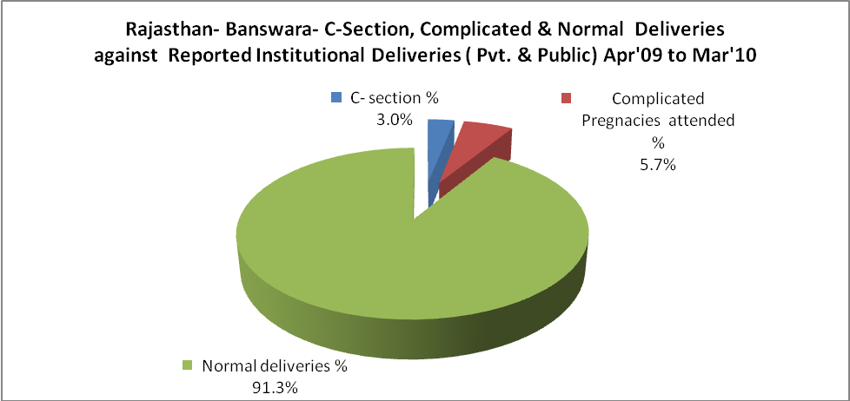

Rajasthan- Banswara- Complicated Pregnancies & Deliveries Treated - Apr'09 to Mar'10
Reported Deliveries |  |  | Reported ANC Reigtration
38,681 |  |  | 60,095
Complicated Pregnancies attended | Complicated Pregnancies Rate | C - Section Deliveries | PNC Maternal Complications | Abortions | Still Births
2,004 | 4% | 1,070 | 245 | 556 | 1,379
Complicated Deliveries Treated with |  |  |  | No Of Eclampsia cases Treated | No Of severe anemia cases treated
IV Antibiotics | IV antihypertensive/Magsulph injection | IV Oxytocis | Blood Transfusion | No Of Eclampsia cases Treated | No Of severe anemia cases treated
3,612 | 732 | 6,866 | 143 | 60 | 1,616

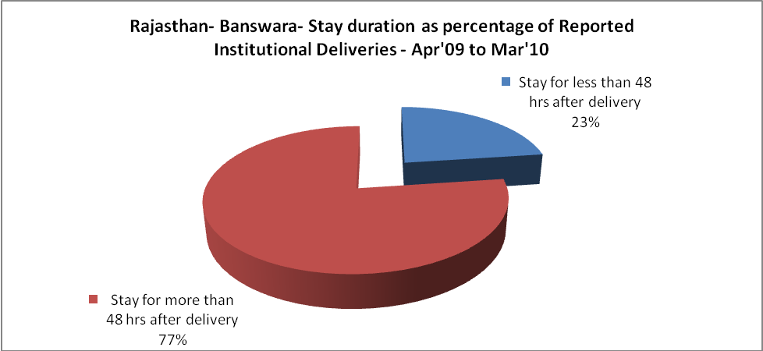

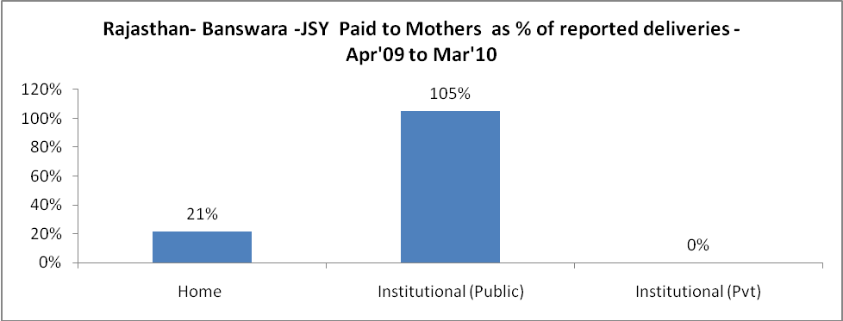

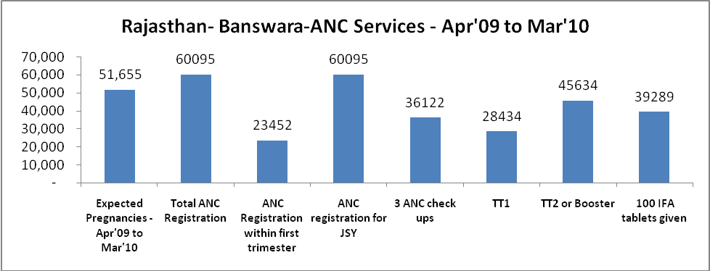

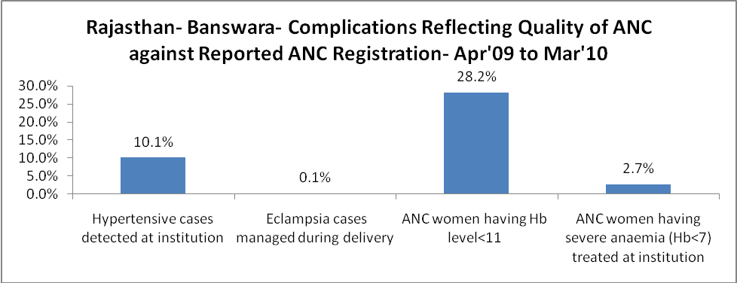

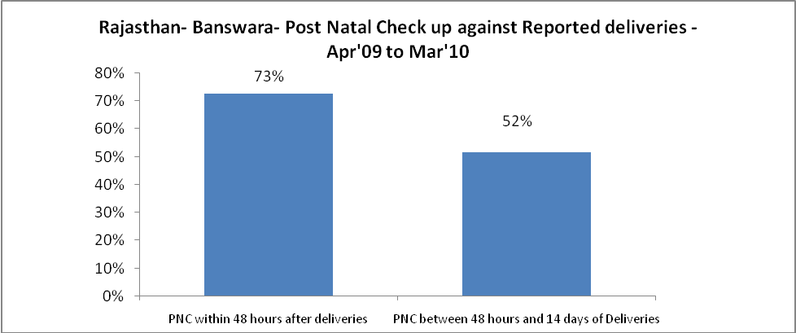

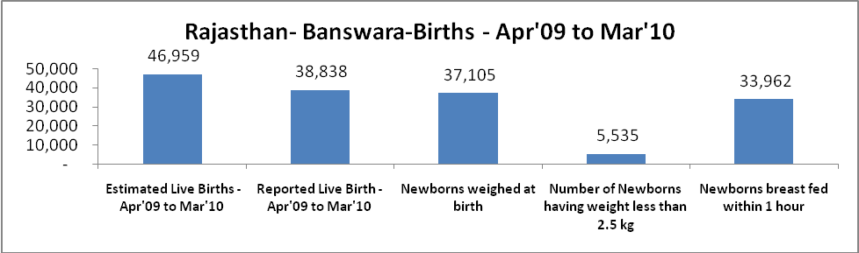

Rajasthan- Banswara - Births - Apr'09 to Mar'10
Live Birth - Males | Live Birth - females | Live Birth - Total | Sex Ratio at birth | Still Birth | Abortion( Induced/Spontaneous
20,385 | 18,453 | 38,838 | 905 | 1,379 | 556

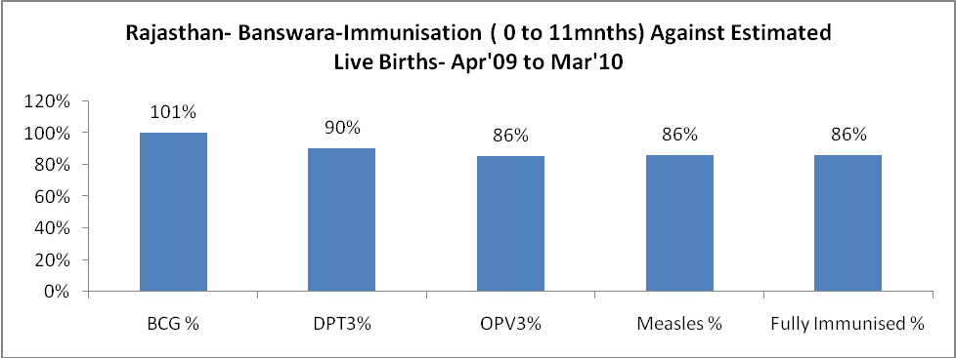

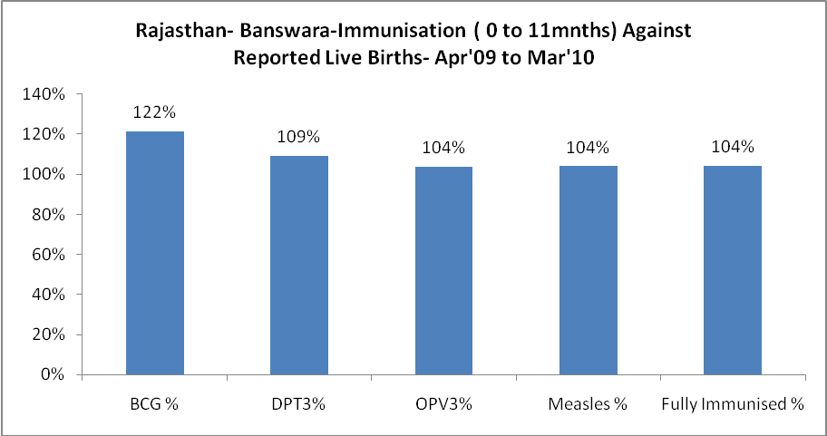
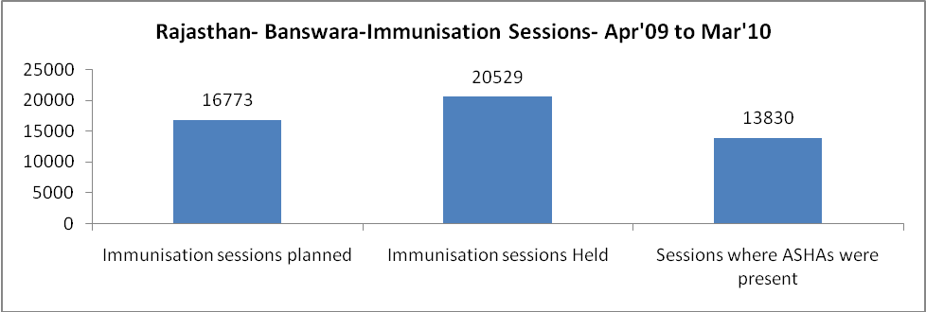

Rajasthan- Banswara- Apr'09 to Mar'10
Total Abortions | Abortion Rate
876 | 1.7%

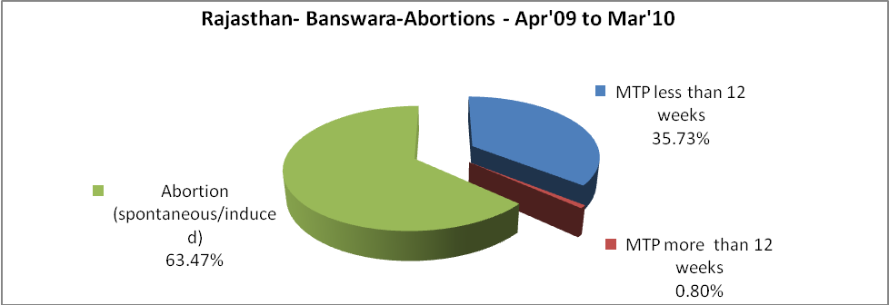

Rajasthan- Banswara- Apr'09 to Mar'10
Total OPD | Total RTI/STI cases
777,891 | 3,213

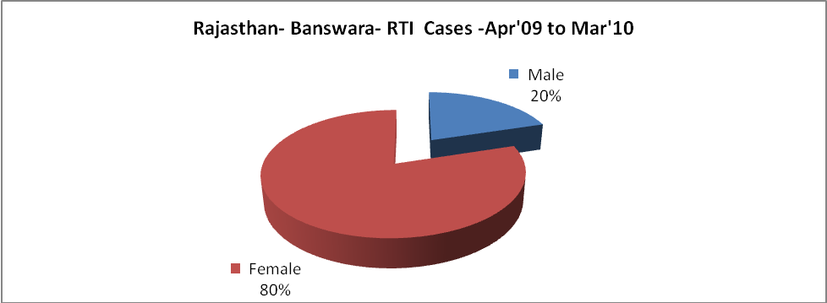

Rajasthan- Banswara- Sterilisations - Apr'09 to Mar'10
 | Reported | %age of Reported Sterilisation
Total Sterilisation | 7,029 | -
NSV | 87 | 1%
Laproscopic | 560 | 8%
MiniLap | 299 | 4%
Post Partum | 6,083 | 87%
Male Sterilisation | 87 | 1%
Female Sterilisation | 6,942 | 99%

 |  | Rajasthan- Banswara-FP Methods - Apr'09 to Mar'10
 |  |  | Reported |  | %age of All Reported FP Methods
 |  | Total Reported FP Methodd (All types) Users | 76,912 |  | -
 |  | Sterilisations | 7,029 |  | 9%
 |  | IUD | 14,399 |  | 19%
 |  | Condom Users | 37,230 |  | 48%
 |  | OCP Users | 18,254 |  | 24%
 |  | Limiting Methods | 7,029 |  | 9%
 |  | Spacing Methods | 69,883 |  | 91%
Rajasthan- Banswara- Lab Services - Apr'09 to Mar'10
Total OPD | Total HB tested |  |  | Total HIV Tested |  | Total Population
777,891 | 36,121 |  |  | 8,404 |  | 1,707,600
HB test conducted as %age of OPD | HB<7gm as %age of HB tested |  |  | HIV test conducted as %age of OPD |  | HIV positive as %age of HIV tested |  | Blood Smear Examined as % of Population
4.6% | 15.6% |  |  | 1.1% |  | 0.6% |  | 5.5%

Rajasthan- Banswara- Childhood Disease - Vaccine Preventable -Apr'09 to Mar'10
Diphtheria | Pertussis | Tetanus Neonatorum | Tetanus others | Polio | Measles
0 | 0 | 0 | 1 | 0 | 30
Rajasthan- Banswara-Childhood Disease - Others - Apr'09 to Mar'10
Diarrhoea and dehydration | Malaria | Number admitted with Respiratory Infections
8,573 | 458 | 1,981

Rajasthan- Banswara- Infant & Child Deaths - Apr'09 to Mar'10
Infant Deaths within 24 hrs of birth | Infant Deaths between 24hrs & under 1 week | Infant Deaths between 1 week & under 1 month | Child Deaths between 1 month & under 1 year | Child Deaths between 1yr under 5years | Total Deaths
74 | 322 | 175 | 220 | 303 | 1094

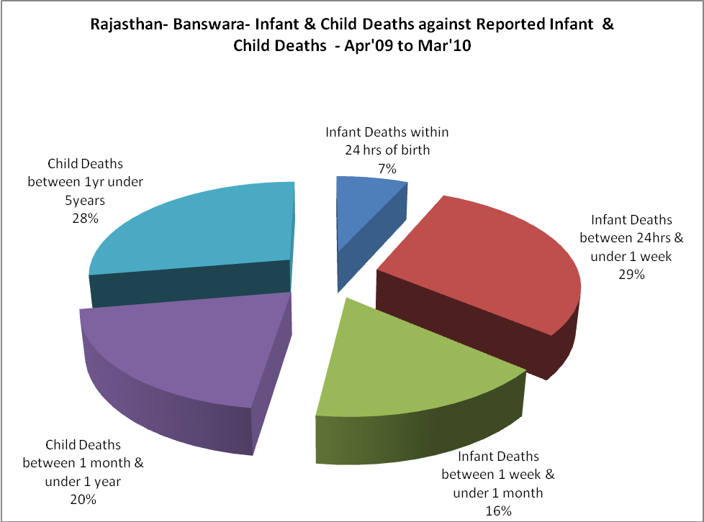

Rajasthan- Banswara- Causes of Infant & Child Deaths - Apr'09 to Mar'10
Sepsis |  |  | Asphyxia |  |  | LBW
Up to 1 Weeks of Birth | Between 1 week & 4 weeks of birth | Total | Up to 1 Weeks of Birth | Between 1 week & 4 weeks of birth | Total | Up to 1 Weeks of Birth | Between 1 week & 4 weeks of birth | Total
38 | 34 | 72 | 58 | 28 | 86 | 135 | 46 | 181
Pneumonia |  |  | Diarrhoea |  |  | Fever related
Between 1 month and 11 months | Between 1 year & 5 years | Total | Between 1 month and 11 months | Between 1 year & 5 years | Total | Between 1 month and 11 months | Between 1 year & 5 years | Total
55 | 36 | 91 | 9 | 21 | 30 | 17 | 25 | 42
Others |  |  | Measles |  |  | Others
Up to 1 Weeks of Birth | Between 1 week & 4 weeks of birth | Total | Between 1 month and 11 months | Between 1 year & 5 years | Total | Between 1 month and 11 months | Between 1 year & 5 years | Total
91 | 67 | 158 | 2 | 0 | 2 | 137 | 221 | 358

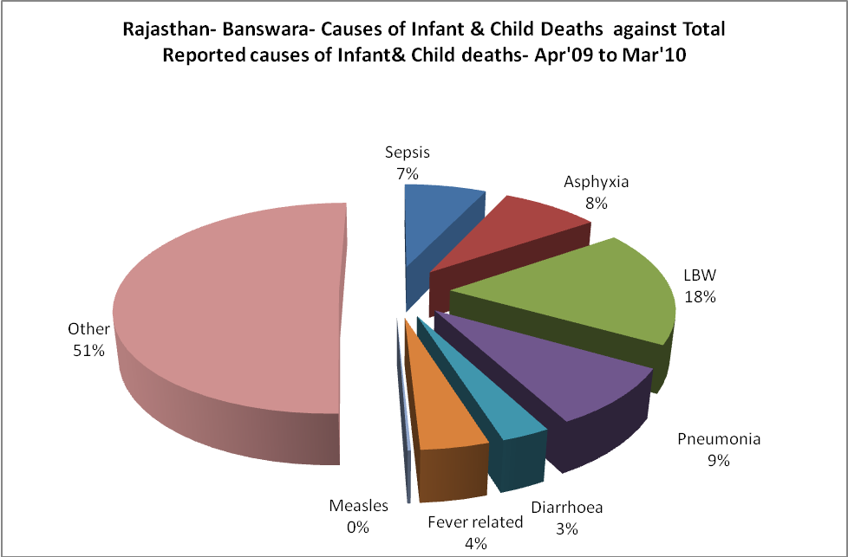

Rajasthan- Banswara- Maternal Deaths & Causes - Apr'09 to Mar'10
Abortion |  |  | Obstructed/prolonged labour |  |  | Severe hypertesnion/fits
6-14 yrs | 15-55 yrs. | Total | 6-14 yrs | 15-55 yrs. | Total | 6-14 yrs | 15-55 yrs. | Total
0 | 7 | 7 | 0 | 4 | 4 | 0 | 0 | 0
Bleeding |  |  | High Fever |  |  | Other Causes
6-14 yrs | 15-55 yrs. | Total | 6-14 yrs | 15-55 yrs. | Total | 6-14 yrs | 15-55 yrs. | Total
1 | 8 | 9 | 0 | 0 | 0 | 3 | 15 | 18

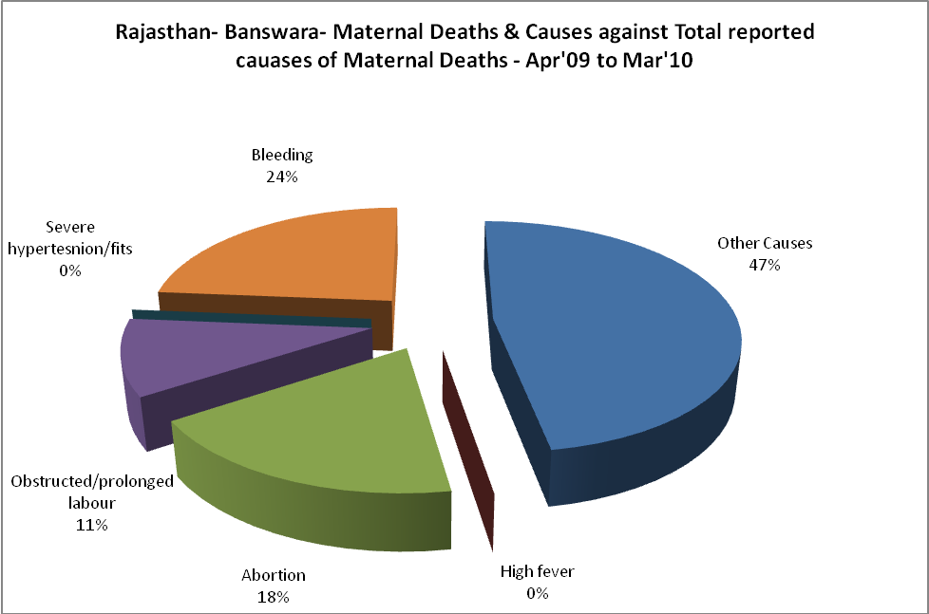

Rajasthan- Banswara-Causes of Deaths in 6 to 55yrs age group - Apr'09 to Mar'10
Diarrhoel Diseases |  |  |  | Tuberculosis |  |  |  | Respiratory Diseases( Other than TB)
6-14 yrs | 15-55 yrs. | Above 55yrs | Total | 6-14 yrs | 15-55 yrs. | Above 55yrs | Total | 6-14 yrs | 15-55 yrs. | Above 55yrs | Total
16 | 19 | 3 | 38 | 6 | 55 | 16 | 77 | 15 | 51 | 47 | 113
Malaria |  |  |  | Other fever Related |  |  |  | HIV/Aids
6-14 yrs | 15-55 yrs. | Above 55yrs | Total | 6-14 yrs | 15-55 yrs. | Above 55yrs | Total | 6-14 yrs | 15-55 yrs. | Above 55yrs | Total
0 | 0 | 3 | 3 | 25 | 37 | 17 | 79 | 1 | 3 | 2 | 6
Heart Disease/Hypertenion related |  |  |  | Neurological Disease including strokes |  |  |  | Trauma/Accidents/ Burn Cases
6-14 yrs | 15-55 yrs. | Above 55yrs | Total | 6-14 yrs | 15-55 yrs. | Above 55yrs | Total | 6-14 yrs | 15-55 yrs. | Above 55yrs | Total
1 | 69 | 64 | 134 | 103 | 26 | 11 | 140 | 17 | 76 | 30 | 123
Suicide |  |  |  | Animal Bites & Stings
6-14 yrs | 15-55 yrs. | Above 55yrs | Total | 6-14 yrs | 15-55 yrs. | Above 55yrs | Total
0 | 64 | 8 | 72 | 10 | 25 | 12 | 47

