NHSRC
Rajasthan-Baran
Analysis: Apr 2009 – Mar 2010

Rajasthan- Baran- Summary-Apr'09 to Mar'10
ANC
ANC Registration against Expected Pregnancies | 91% | TT1 given to Pregnant women against ANC Registration | 88%
3 ANC Checkups against ANC Registrations | 62% | 100 IFA Tablets given to Pregnant women against ANC Registration | 91%
Deliveries
Unreported Deliveries against Estimated Deliveries | 27.4% | HOME Deliveries( SBA& Non SBA) against Estimated Deliveries | 3.2%
Institutional Deliveries against Estimated Deliveries | 69.4% | HOME Deliveries( SBA& Non SBA) against Reported Deliveries | 4.4%
Institutional Deliveries against Reported Deliveries | 95.6% | C Section Deliveries against Institutional Deliveries( Pvt & Pub) | 2%
Births & Neonates Care
Live Births Reported against Estimated Live Births | 72% | New borns weighed against Reported Live Births | 89%
Still Births (Reported) | 386 | New borns weighed less than 2.5 kgs against newborns weighed | 22%
Sex Ratio at Birth | 828 | New borns breastfed within one hr of Birth against Reported live Births | 90%
Child Immunization( 0 to 11 months)
BCG given against Expected Live Births | 93% | Measles given against Expected Live Births | 94%
OPV3 given against Expected Live Births | 95% | Fully Immunized Children against Expected Live Births | 94%
DPT3 given against Expected Live Births | 95%
Family Planning
Family Plannig Methods Users ( Sterilisations(Male &Female)+IUD+ Condom pieces/72 + OCP Cycles/13) | 79,191 | IUD Insertions against reported FP Methods | 10%
Sterilisation against reported FP Methods | 7% | Condom Users against reported FP Methods | 57%
 |  | OCP Users against reported FP Methods | 27%
Other Services
OPD | 916,305 | Major Operations | 398
IPD | 53,783 | Minor Operations | 424

Rajasthan- Baran- Deliveries Apr'09 to Mar'10
Total Population | 1,218,700 | Expected Deliveries |  | 34,570
Home SBA | Home Non SBA | Institutional | Total Deliveries Reported | Unreported Deliveries
665 | 430 | 23,991 | 25,086 | 9,484
Home SBA % | Home Non SBA% | Institutional % | Total Deliveries Reported % | Unreported Deliveries %
2% | 1% | 69% | 73% | 27%
`

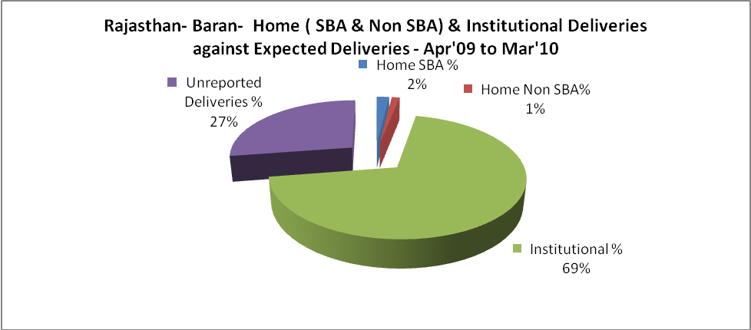

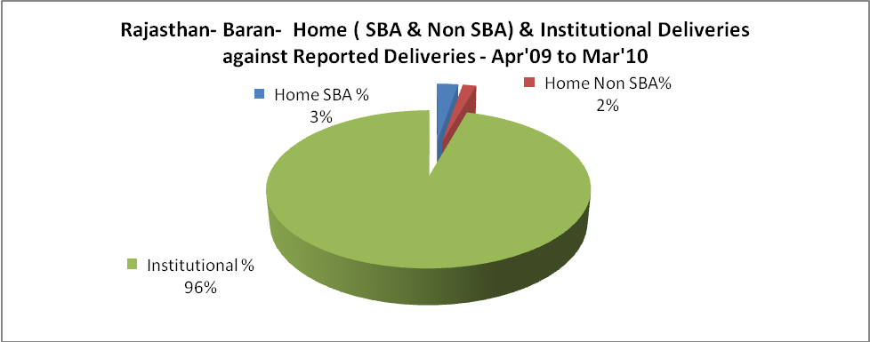

Rajasthan- Baran- C sections & Complicated Deliveries Apr'09 to Mar'10
 | Institutional Deliveries (Public) | Institutional Deliveries (Pvt)
 | 22,590 | 1,401
C Section | 228 | 178
C Section% | 1% | 13%
Complicated Pregnacies attended | 173 | 1
Complicated Pregnacies attended % | 1% | 0%

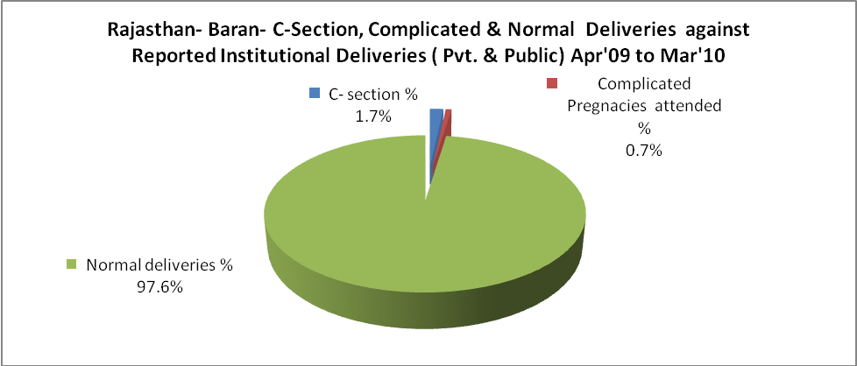

Rajasthan- Baran- Complicated Pregnancies & Deliveries Treated - Apr'09 to Mar'10
Reported Deliveries |  |  | Reported ANC Reigtration
25,086 |  |  | 33,615
Complicated Pregnancies attended | Complicated Pregnancies Rate | C - Section Deliveries | PNC Maternal Complications | Abortions | Still Births
174 | 0% | 406 | 1,834 | 273 | 386
Complicated Deliveries Treated with |  |  |  | No Of Eclampsia cases Treated | No Of severe anemia cases treated
IV Antibiotics | IV antihypertensive/Magsulph injection | IV Oxytocis | Blood Transfusion | No Of Eclampsia cases Treated | No Of severe anemia cases treated
605 | 149 | 419 | 154 | 66 | 308

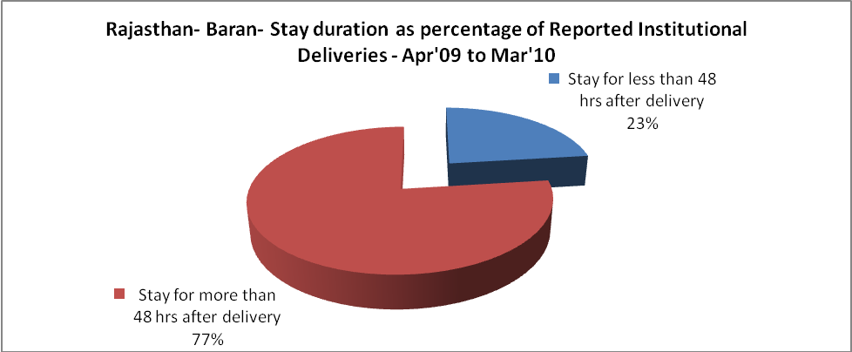

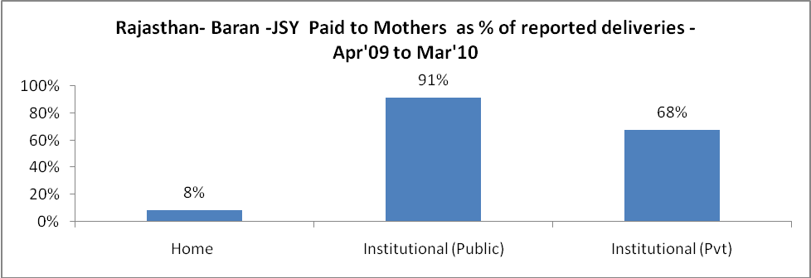

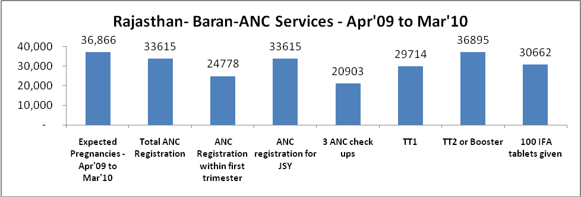

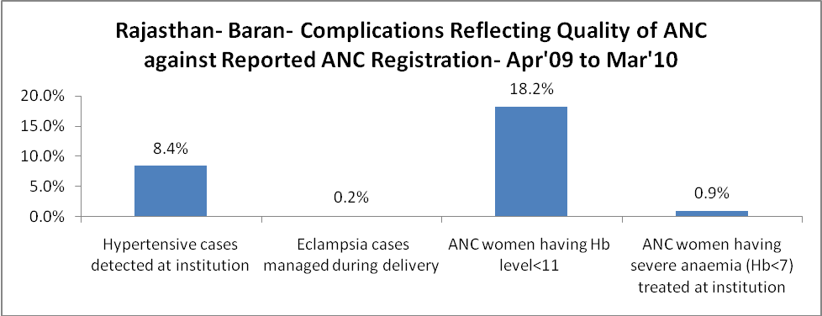

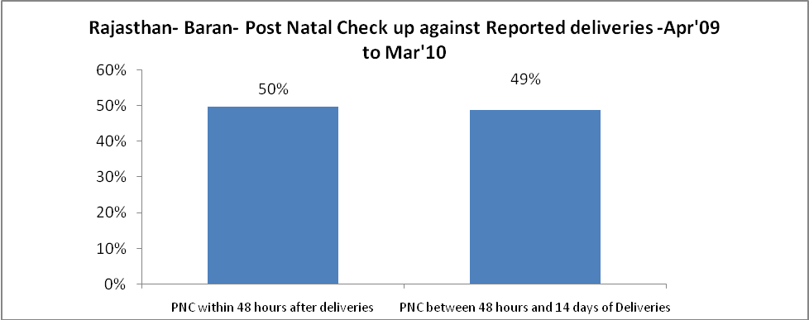

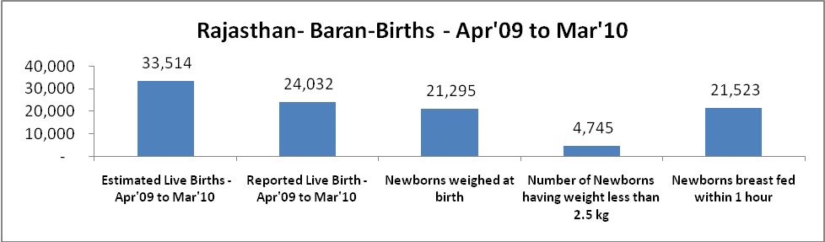

Rajasthan- Baran - Births - Apr'09 to Mar'10
Live Birth - Males | Live Birth - females | Live Birth - Total | Sex Ratio at birth | Still Birth | Abortion( Induced/Spontaneous
13,144 | 10,888 | 24,032 | 828 | 386 | 273

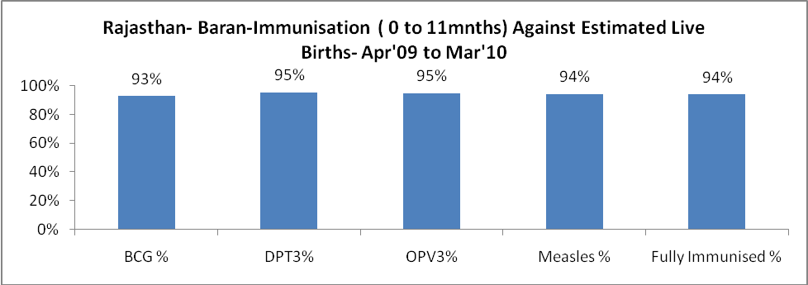

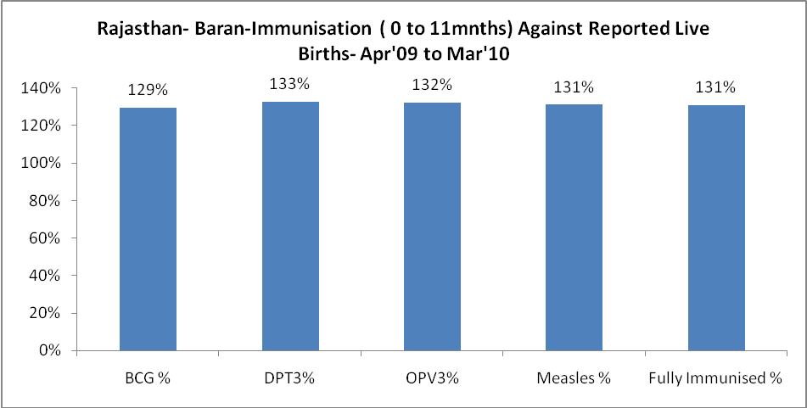

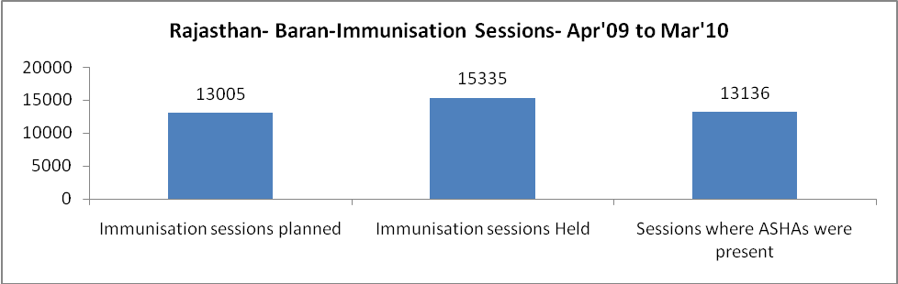

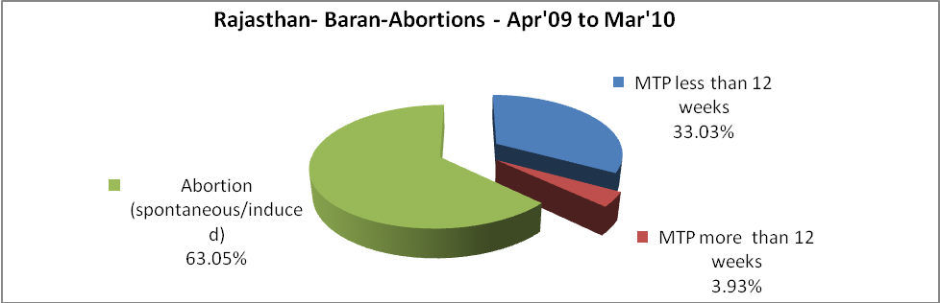

Rajasthan- Baran- Apr'09 to Mar'10
Total Abortions | Abortion Rate
433 | 1.2%

Rajasthan- Baran- Apr'09 to Mar'10
Total OPD | Total RTI/STI cases
916,305 | 4,218

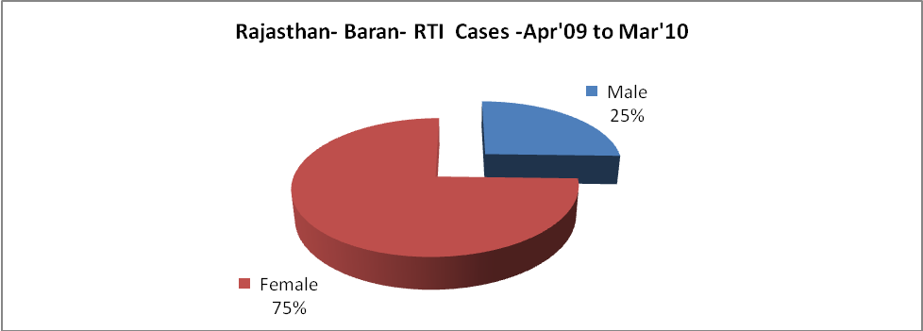

Rajasthan- Baran-Sterilisations - Apr'09 to Mar'10
 | Reported | %age of Reported Sterilisation
Total Sterilisation | 5,487 | -
NSV | 385 | 7%
Laproscopic | 4,395 | 80%
MiniLap | - | 0%
Post Partum | 707 | 13%
Male Sterilisation | 385 | 7%
Female Sterilisation | 5,102 | 93%

Rajasthan- Baran-FP Methods - Apr'09 to Mar'10
 | Reported | %age of All Reported FP Methods
Total Reported FP Methodd (All types) Users | 79,191 | -
Sterilisations | 5,487 | 7%
IUD | 7,616 | 10%
Condom Users | 45,003 | 57%
OCP Users | 21,085 | 27%
Limiting Methods | 5,487 | 7%
Spacing Methods | 73,704 | 93%

Rajasthan- Baran- Service Delivery - Apr'09 to Mar'10
Operation major (General and spinal anaesthesia) | Operation minor (No or local anaesthesia) | AYUSH | Dental Procedures | Adolescent counselling services | Total OPD | Total IPD
398 | 424 | 54,757 | 2,251 | 1,179 | 916,305 | 53,783
Operation major (General and spinal anaesthesia) as %ge of OPD | Operation minor (No or local anaesthesia)as %ge of OPD | AYUSH as %ge of OPD | Dental Procedures as %ge of OPD | Adolescent counselling services as %ge of OPD | IPD as percentage of OPD
0.0% | 0.0% | 6.0% | 0.2% | 0.1% | 6%

Rajasthan- Baran- Lab Services - Apr'09 to Mar'10
Total OPD | Total HB tested | Total HIV Tested | Total Population
916,305 | 18,820 | 562 | 1,218,700
HB test conducted as %age of OPD | HB<7gm as %age of HB tested | HIV test conducted as %age of OPD | HIV positive as %age of HIV tested | Blood Smear Examined as % of Population
2.1% | 5.0% | 0.1% | 0.0% | 8.8%

Rajasthan- Baran- Childhood Disease - Vaccine Preventable -Apr'09 to Mar'10
Diphtheria | Pertussis | Tetanus Neonatorum | Tetanus others | Polio | Measles
0 | 0 | 0 | 2 | 0 | 8
Rajasthan- Baran-Childhood Disease - Others - Apr'09 to Mar'10
Diarrhoea and dehydration | Malaria | Number admitted with Respiratory Infections
1,615 | 216 | 1,242

Rajasthan- Baran- Infant & Child Deaths - Apr'09 to Mar'10
Infant Deaths within 24 hrs of birth | Infant Deaths between 24hrs & under 1 week | Infant Deaths between 1 week & under 1 month | Child Deaths between 1 month & under 1 year | Child Deaths between 1yr under 5years | Total Deaths
23 | 85 | 27 | 90 | 186 | 411

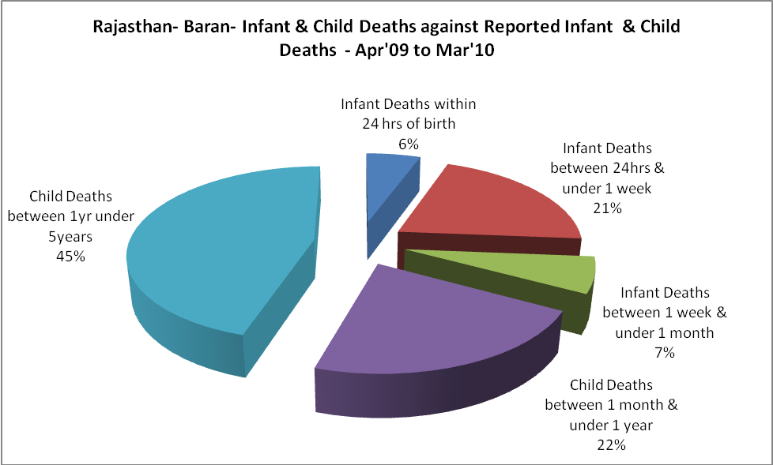

Rajasthan- Baran- Causes of Infant & Child Deaths - Apr'09 to Mar'10
Sepsis |  |  | Asphyxia |  |  | LBW
Up to 1 Weeks of Birth | Between 1 week & 4 weeks of birth | Total | Up to 1 Weeks of Birth | Between 1 week & 4 weeks of birth | Total | Up to 1 Weeks of Birth | Between 1 week & 4 weeks of birth | Total
9 | 1 | 10 | 20 | 5 | 25 | 29 | 12 | 41
Pneumonia |  |  | Diarrhoea |  |  | Fever related
Between 1 month and 11 months | Between 1 year & 5 years | Total | Between 1 month and 11 months | Between 1 year & 5 years | Total | Between 1 month and 11 months | Between 1 year & 5 years | Total
24 | 34 | 58 | 15 | 30 | 45 | 15 | 42 | 57
Others |  |  | Measles |  |  | Others
Up to 1 Weeks of Birth | Between 1 week & 4 weeks of birth | Total | Between 1 month and 11 months | Between 1 year & 5 years | Total | Between 1 month and 11 months | Between 1 year & 5 years | Total
27 | 9 | 36 | 0 | 2 | 2 | 36 | 78 | 114

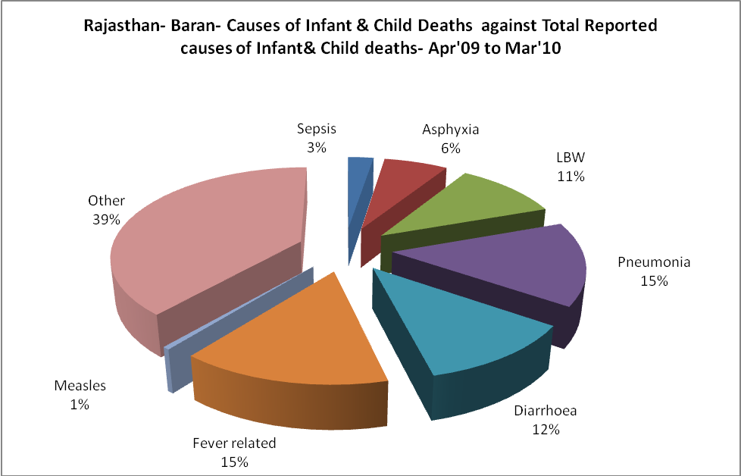

Rajasthan- Baran- Maternal Deaths & Causes - Apr'09 to Mar'10
Abortion |  |  | Obstructed/prolonged labour |  |  | Severe hypertesnion/fits
6-14 yrs | 15-55 yrs. | Total | 6-14 yrs | 15-55 yrs. | Total | 6-14 yrs | 15-55 yrs. | Total
0 | 1 | 1 | 0 | 0 | 0 | 0 | 1 | 1
Bleeding |  |  | High Fever |  |  | Other Causes
6-14 yrs | 15-55 yrs. | Total | 6-14 yrs | 15-55 yrs. | Total | 6-14 yrs | 15-55 yrs. | Total
0 | 0 | 0 | 0 | 2 | 2 | 1 | 19 | 20

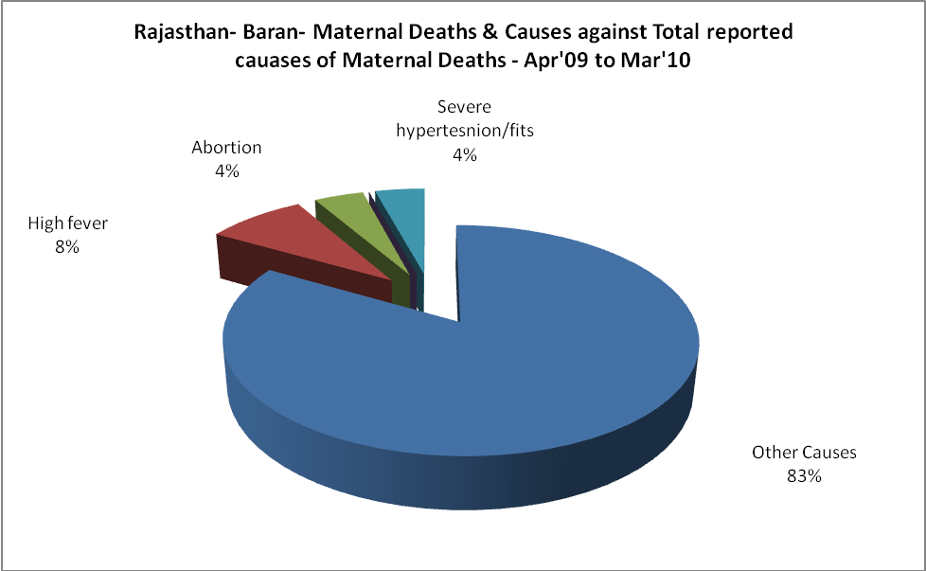

Rajasthan- Baran-Causes of Deaths in 6 to 55yrs age group - Apr'09 to Mar'10
Diarrhoel Diseases |  |  |  | Tuberculosis |  |  |  | Respiratory Diseases( Other than TB)
6-14 yrs | 15-55 yrs. | Above 55yrs | Total | 6-14 yrs | 15-55 yrs. | Above 55yrs | Total | 6-14 yrs | 15-55 yrs. | Above 55yrs | Total
17 | 6 | 0 | 23 | 6 | 17 | 8 | 31 | 16 | 20 | 25 | 61
Malaria |  |  |  | Other fever Related |  |  |  | HIV/Aids
6-14 yrs | 15-55 yrs. | Above 55yrs | Total | 6-14 yrs | 15-55 yrs. | Above 55yrs | Total | 6-14 yrs | 15-55 yrs. | Above 55yrs | Total
4 | 2 | 0 | 6 | 27 | 10 | 6 | 43 | 0 | 0 | 0 | 0
Heart Disease/Hypertenion related |  |  |  | Neurological Disease including strokes |  |  |  | Trauma/Accidents/ Burn Cases
6-14 yrs | 15-55 yrs. | Above 55yrs | Total | 6-14 yrs | 15-55 yrs. | Above 55yrs | Total | 6-14 yrs | 15-55 yrs. | Above 55yrs | Total
3 | 17 | 15 | 35 | 20 | 34 | 16 | 70 | 7 | 21 | 4 | 32
Suicide |  |  |  | Animal Bites & Stings
6-14 yrs | 15-55 yrs. | Above 55yrs | Total | 6-14 yrs | 15-55 yrs. | Above 55yrs | Total
4 | 19 | 2 | 25 | 4 | 4 | 2 | 10

