NHSRC
Rajasthan-Barmer
Analysis: Apr 2009 – Mar 2010

Rajasthan- Barmer- Summary-Apr'09 to Mar'10
ANC
ANC Registration against Expected Pregnancies | 94% | TT1 given to Pregnant women against ANC Registration | 60%
3 ANC Checkups against ANC Registrations | 63% | 100 IFA Tablets given to Pregnant women against ANC Registration | 85%
Deliveries
Unreported Deliveries against Estimated Deliveries | 23.5% | HOME Deliveries( SBA& Non SBA) against Estimated Deliveries | 23.0%
Institutional Deliveries against Estimated Deliveries | 53.5% | HOME Deliveries( SBA& Non SBA) against Reported Deliveries | 30.1%
Institutional Deliveries against Reported Deliveries | 69.9% | C Section Deliveries against Institutional Deliveries( Pvt & Pub) | 0%
Births & Neonates Care
Live Births Reported against Estimated Live Births | 78% | New borns weighed against Reported Live Births | 86%
Still Births (Reported) | 812 | New borns weighed less than 2.5 kgs against newborns weighed | 16%
Sex Ratio at Birth | 876 | New borns breastfed within one hr of Birth against Reported live Births | 76%
Child Immunization( 0 to 11 months)
BCG given against Expected Live Births | 97% | Measles given against Expected Live Births | 90%
OPV3 given against Expected Live Births | 88% | Fully Immunised Children against Expected Live Births | 84%
DPT3 given against Expected Live Births | 89%
Family Planning
Family Plannig Methods Users ( Sterilisations(Male &Female)+IUD+ Condom pieces/72 + OCP Cycles/13) | 121,825 | IUD Insertions against reported FP Methods | 9%
Sterilisation against reported FP Methods | 9% | Condom Users against reported FP Methods | 55%
 |  | OCP Users against reported FP Methods | 27%
Other Services
OPD | 786,825 | Major Operations | 1,063
IPD | 34,283 | Minor Operations | 2,324

Rajasthan- Barmer- Deliveries Apr'09 to Mar'10
Total Population | 2,352,400 | Expected Deliveries |  | 66,729
Home SBA | Home Non SBA | Institutional | Total Deliveries Reported | Unreported Deliveries
5,873 | 9,481 | 35,679 | 51,033 | 15,696
Home SBA % | Home Non SBA% | Institutional % | Total Deliveries Reported % | Unreported Deliveries %
9% | 14% | 53% | 76% | 24%
`

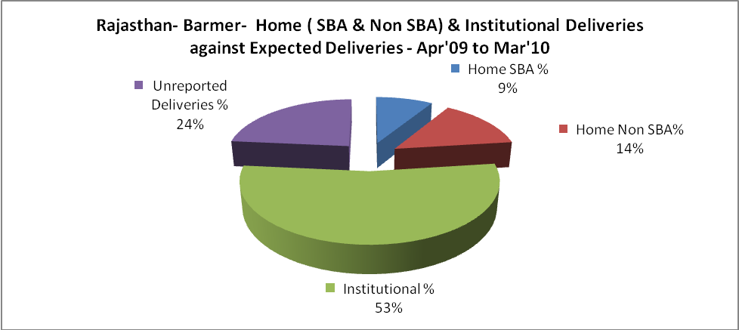

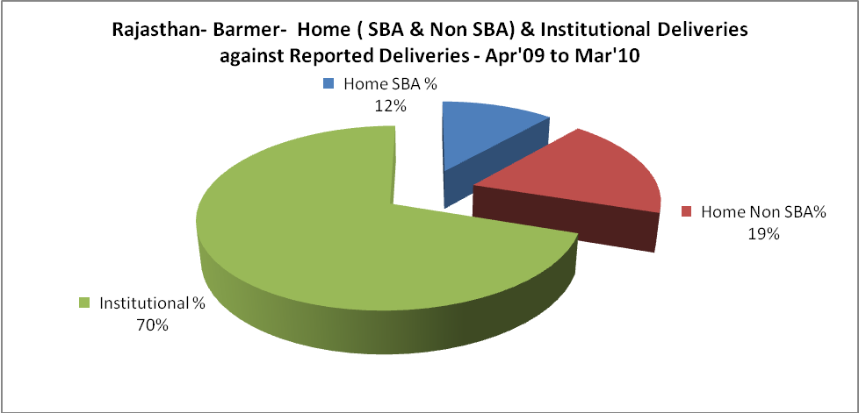

Rajasthan- Barmer- C sections & Complicated Deliveries Apr'09 to Mar'10
 | Institutional Deliveries (Public) | Institutional Deliveries (Pvt)
 | 35,200 | 479
C Section | 109 | -
C Section% | 0% | 0%
Complicated Pregnacies attended | 935 | -
Complicated Pregnacies attended % | 3% | 0%

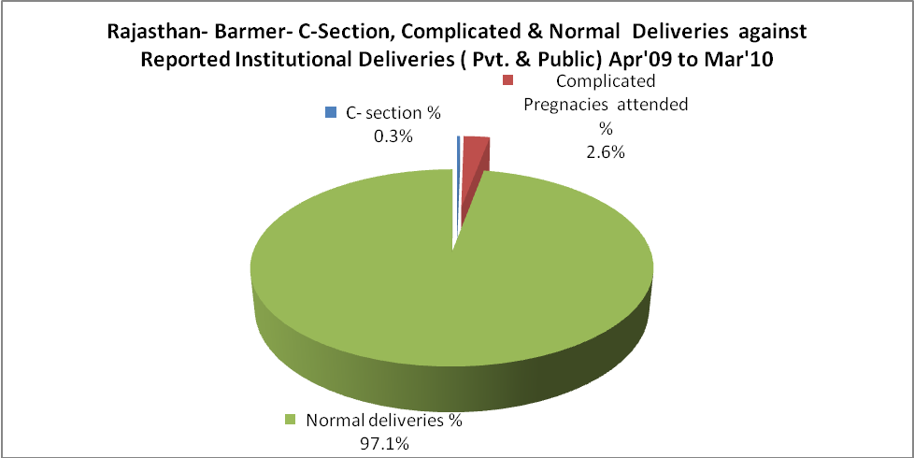

Rajasthan- Barmer- Complicated Pregnancies & Deliveries Treated - Apr'09 to Mar'10
Reported Deliveries |  |  | Reported ANC Reigtration
51,033 |  |  | 67,115
Complicated Pregnancies attended | Complicated Pregnancies Rate | C - Section Deliveries | PNC Maternal Complications | Abortions | Still Births
935 | 1% | 109 | 407 | 573 | 812
Complicated Deliveries Treated with |  |  |  | No Of Eclampsia cases Treated | No Of severe anemia cases treated
IV Antibiotics | IV antihypertensive/Magsulph injection | IV Oxytocis | Blood Transfusion | No Of Eclampsia cases Treated | No Of severe anemia cases treated
3,809 | 299 | 3,910 | 190 | 168 | 1,153

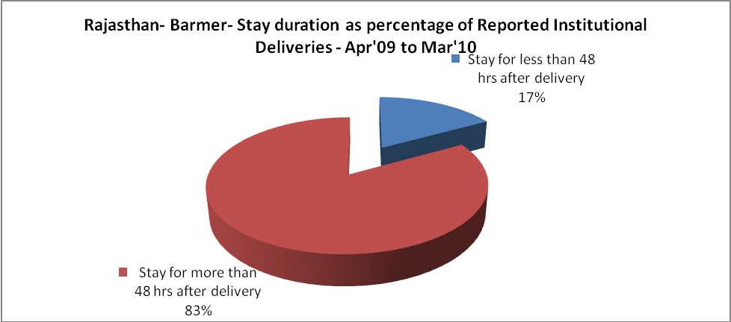

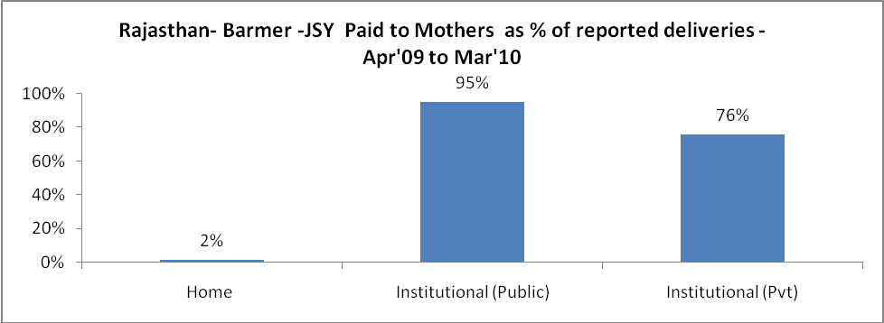

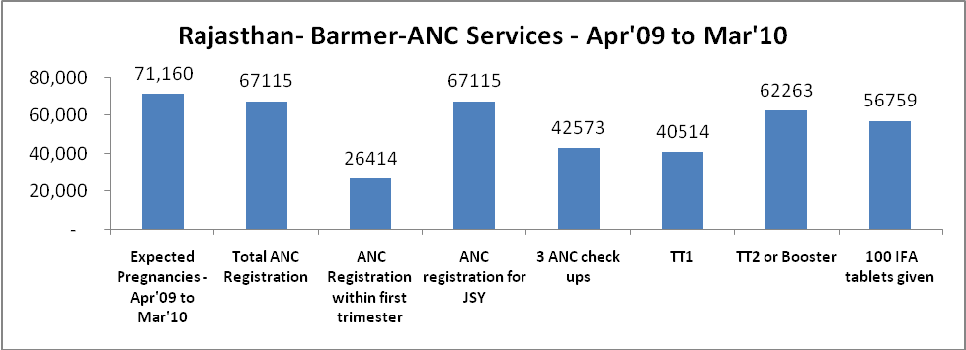
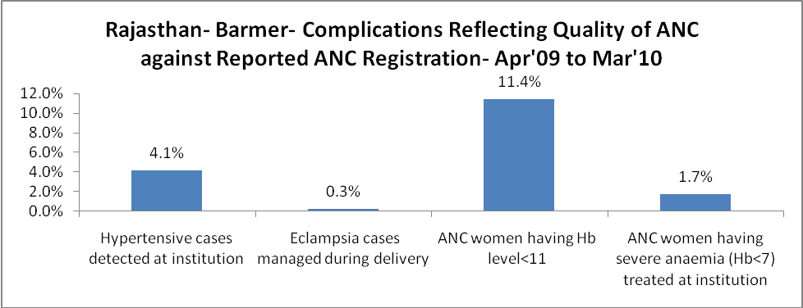
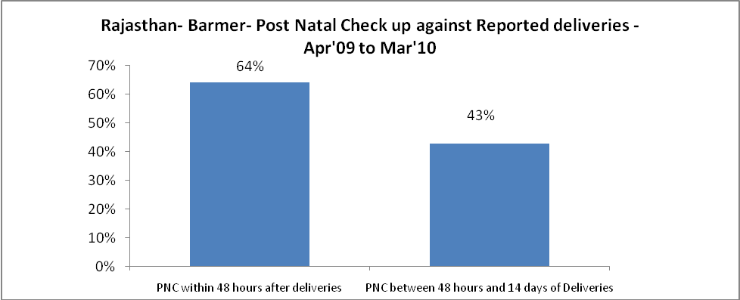
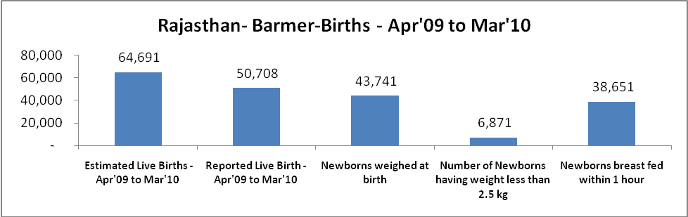

Rajasthan- Barmer - Births - Apr'09 to Mar'10
Live Birth - Males | Live Birth - females | Live Birth - Total | Sex Ratio at birth | Still Birth | Abortion( Induced/Spontaneous
27,028 | 23,680 | 50,708 | 876 | 812 | 573

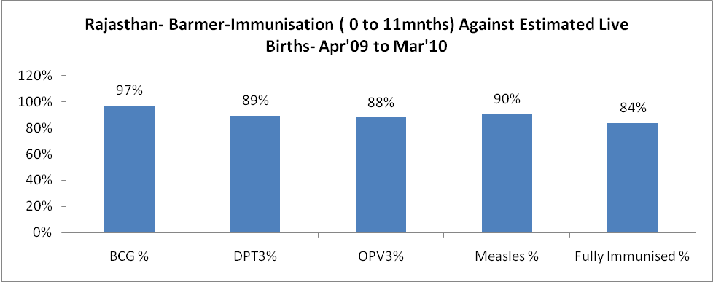

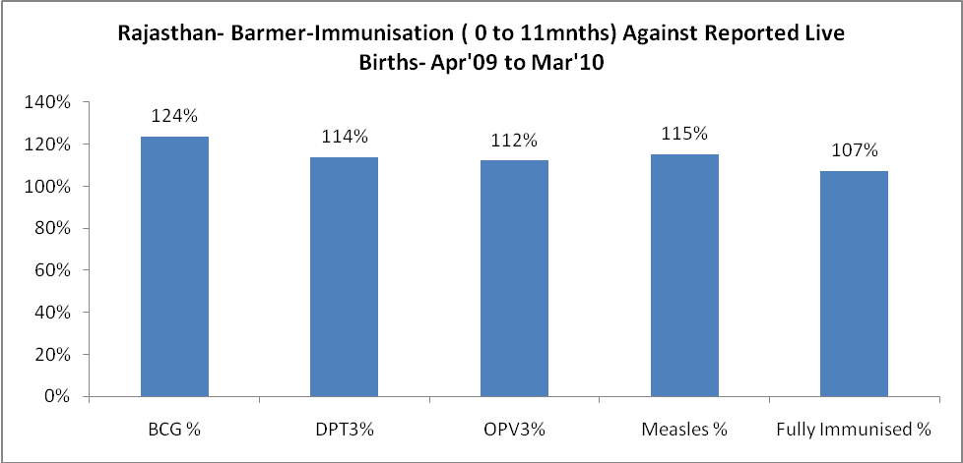

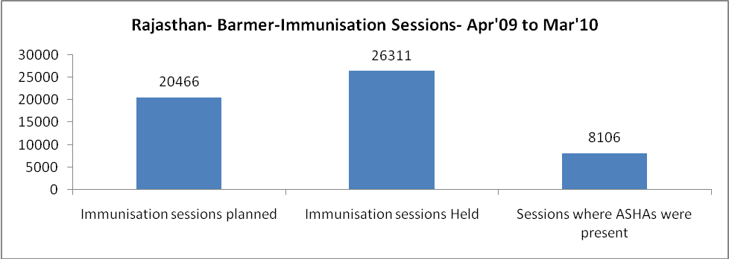

Rajasthan- Barmer- Apr'09 to Mar'10
Total Abortions | Abortion Rate
629 | 0.9%

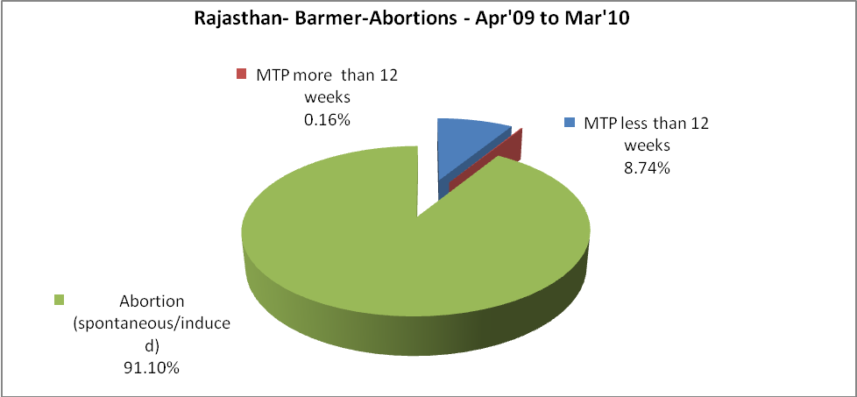

Rajasthan- Barmer- Apr'09 to Mar'10
Total OPD | Total RTI/STI cases
786,825 | 2,106

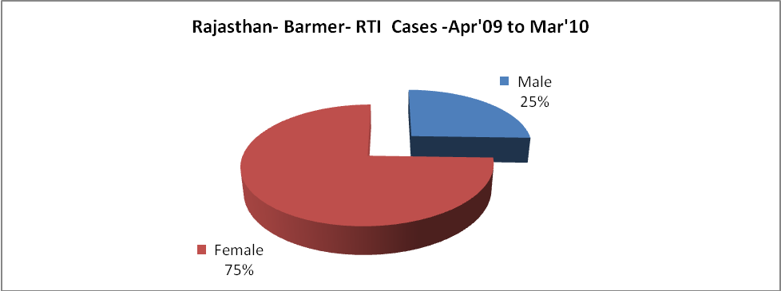
Rajasthan- Barmer-Sterilisations - Apr'09 to Mar'10
 | Reported | %age of Reported Sterilisation
Total Sterilisation | 11,081 | -
NSV | 83 | 1%
Laproscopic | 10,861 | 98%
MiniLap | - | 0%
Post Partum | 137 | 1%
Male Sterilisation | 83 | 1%
Female Sterilisation | 10,998 | 99%

Rajasthan- Barmer-FP Methods - Apr'09 to Mar'10
 | Reported | %age of All Reported FP Methods
Total Reported FP Methodd (All types) Users | 121,825 | -
Sterilisations | 11,081 | 9%
IUD | 11,159 | 9%
Condom Users | 66,780 | 55%
OCP Users | 32,805 | 27%
Limiting Methods | 11,081 | 9%
Spacing Methods | 110,744 | 91%

Rajasthan- Barmer- Service Delivery - Apr'09 to Mar'10
Operation major (General and spinal anaesthesia) | Operation minor (No or local anaesthesia) | AYUSH | Dental Procedures | Adolescent counselling services | Total OPD | Total IPD
1,063 | 2,324 | 31,140 | 1,617 | 316 | 786,825 | 34,283
Operation major (General and spinal anaesthesia) as %ge of OPD | Operation minor (No or local anaesthesia)as %ge of OPD | AYUSH as %ge of OPD | Dental Procedures as %ge of OPD | Adolescent counselling services as %ge of OPD | IPD as percentage of OPD
0.1% | 0.3% | 4.0% | 0.2% | 0.0% | 4%

Rajasthan- Barmer- Lab Services - Apr'09 to Mar'10
Total OPD | Total HB tested | Total HIV Tested | Total Population
786,825 | 22,295 | 17,667 | 2,352,400
HB test conducted as %age of OPD | HB<7gm as %age of HB tested | HIV test conducted as %age of OPD | HIV positive as %age of HIV tested | Blood Smear Examined as % of Population
2.8% | 7.7% | 2.2% | 0.9% | 3.9%

Rajasthan- Barmer- Childhood Disease - Vaccine Preventable -Apr'09 to Mar'10
Diphtheria | Pertussis | Tetanus Neonatorum | Tetanus others | Polio | Measles
0 | 0 | 1 | 0 | 0 | 35
Rajasthan- Barmer-Childhood Disease - Others - Apr'09 to Mar'10
Diarrhoea and dehydration | Malaria | Number admitted with Respiratory Infections
1,375 | 86 | 1,216

Rajasthan- Barmer- Infant & Child Deaths - Apr'09 to Mar'10
Infant Deaths within 24 hrs of birth | Infant Deaths between 24hrs & under 1 week | Infant Deaths between 1 week & under 1 month | Child Deaths between 1 month & under 1 year | Child Deaths between 1yr under 5years | Total Deaths
17 | 60 | 34 | 32 | 39 | 182

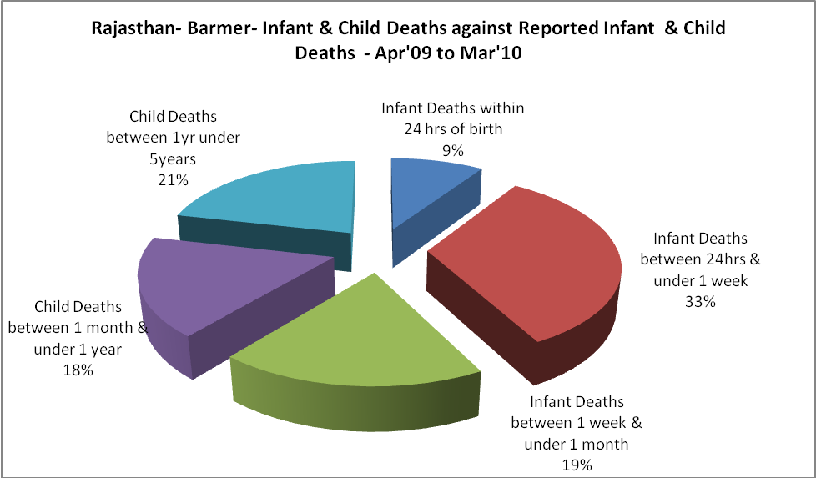

Rajasthan- Barmer- Causes of Infant & Child Deaths - Apr'09 to Mar'10
Sepsis |  |  | Asphyxia |  |  | LBW
Up to 1 Weeks of Birth | Between 1 week & 4 weeks of birth | Total | Up to 1 Weeks of Birth | Between 1 week & 4 weeks of birth | Total | Up to 1 Weeks of Birth | Between 1 week & 4 weeks of birth | Total
13 | 14 | 27 | 2 | 6 | 8 | 19 | 4 | 23
Pneumonia |  |  | Diarrhoea |  |  | Fever related
Between 1 month and 11 months | Between 1 year & 5 years | Total | Between 1 month and 11 months | Between 1 year & 5 years | Total | Between 1 month and 11 months | Between 1 year & 5 years | Total
8 | 10 | 18 | 2 | 2 | 4 | 8 | 7 | 15
Others |  |  | Measles |  |  | Others
Up to 1 Weeks of Birth | Between 1 week & 4 weeks of birth | Total | Between 1 month and 11 months | Between 1 year & 5 years | Total | Between 1 month and 11 months | Between 1 year & 5 years | Total
26 | 10 | 36 | 0 | 0 | 0 | 14 | 20 | 34

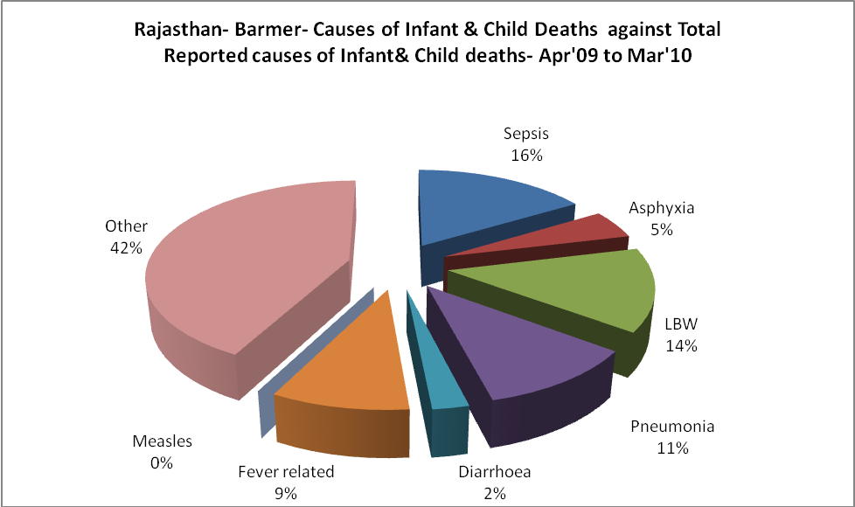

Rajasthan- Barmer- Maternal Deaths & Causes - Apr'09 to Mar'10
Abortion |  |  | Obstructed/prolonged labour |  |  | Severe hypertesnion/fits
6-14 yrs | 15-55 yrs. | Total | 6-14 yrs | 15-55 yrs. | Total | 6-14 yrs | 15-55 yrs. | Total
0 | 3 | 3 | 0 | 1 | 1 | 0 | 0 | 0
Bleeding |  |  | High Fever |  |  | Other Causes
6-14 yrs | 15-55 yrs. | Total | 6-14 yrs | 15-55 yrs. | Total | 6-14 yrs | 15-55 yrs. | Total
0 | 3 | 3 | 0 | 0 | 0 | 1 | 1 | 2

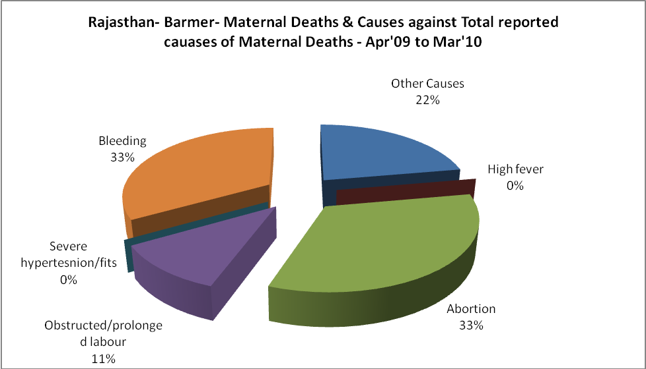

Rajasthan- Barmer-Causes of Deaths in 6 to 55yrs age group - Apr'09 to Mar'10
Diarrhoel Diseases |  |  |  | Tuberculosis |  |  |  | Respiratory Diseases( Other than TB)
6-14 yrs | 15-55 yrs. | Above 55yrs | Total | 6-14 yrs | 15-55 yrs. | Above 55yrs | Total | 6-14 yrs | 15-55 yrs. | Above 55yrs | Total
0 | 0 | 0 | 0 | 0 | 1 | 2 | 3 | 4 | 24 | 14 | 42
Malaria |  |  |  | Other fever Related |  |  |  | HIV/Aids
6-14 yrs | 15-55 yrs. | Above 55yrs | Total | 6-14 yrs | 15-55 yrs. | Above 55yrs | Total | 6-14 yrs | 15-55 yrs. | Above 55yrs | Total
3 | 0 | 0 | 3 | 3 | 9 | 2 | 14 | 1 | 2 | 3 | 6
Heart Disease/Hypertenion related |  |  |  | Neurological Disease including strokes |  |  |  | Trauma/Accidents/ Burn Cases
6-14 yrs | 15-55 yrs. | Above 55yrs | Total | 6-14 yrs | 15-55 yrs. | Above 55yrs | Total | 6-14 yrs | 15-55 yrs. | Above 55yrs | Total
1 | 14 | 38 | 53 | 11 | 4 | 9 | 24 | 1 | 4 | 0 | 5
Suicide |  |  |  | Animal Bites & Stings
6-14 yrs | 15-55 yrs. | Above 55yrs | Total | 6-14 yrs | 15-55 yrs. | Above 55yrs | Total
0 | 2 | 2 | 4 | 0 | 0 | 0 | 0

