NHSRC
Bihar- Bhagalpur
HMIS DATA ANALYSIS 2009-10

KUNAL
8/15/2010

Bihar-Bhagalpur- Summary-Apr'09 to Mar'10
ANC
ANC Registration against Expected Pregnancies | 49% | TT1 given to Pregnant women against ANC Registraion | 104%
3 ANC Check ups against ANC Reigtrations | 23% | 100 IFA Tablets given to Pregnant women against ANC Registraion | 141%
Deliveries
Unreported Deliveries against Estimated Deliveries | 66.7% | HOME Deliveries( SBA& Non SBA) against Estimated Deliveries | 0.2%
Institutional Deliveries against Estimated Deliveries | 33.1% | HOME Deliveries( SBA& Non SBA) against Reported Deliveries | 0.6%
Institutional Deliveries against Reported Deliveries | 99.4% | C Section Deliveries against Institutional Deliveries( Pvt & Pub) | 1%
Births & Neonates Care
Live Births Reported against Estimated Live Births | 34% | New borns weighed against Reported Live Births | 67%
Still Births (Reported) | 627 | New borns weighed less than 2.5 kgs against newborns weighed | 6%
Sex Ratio at Birh | 944 | New borns breastfed within one hr of Birth against Reported live Births | 66%
Child Immunisation( 0 to 11 mnths)
BCG given against Expected Live Births | 71% | Measles given against Expected Live Births | 68%
OPV3 given against Expected Live Births | 71% | Fully Immunised Children against Expected Live Births | 94%
DPT3 given against Expected Live Births | 71%
Family Plannng
Family Plannig Methods Users ( Sterilisations(Male &Female)+IUD+ Condom pieces/72 + OCP Cycles/13) | 15,607 | IUD Insertions against reported FP Methods | 61%
Sterilisation against reported FP Methods | 21% | Condom Users against reported FP Methods | 11%
 |  | OCP Users against reported FP Methods | 7%
Other Services
OPD | 10,23,186 | Major Operations | 800
IPD | 18 | Minor Operations | 712

Bihar-Bhagalpur- Deliveries Apr'09 to Mar'10
Total Population | 27,94,012 | Expected Deliveries |  | 84,678
Home SBA | Home Non SBA | Institutional | Total Deliveries Reported | Unreported Deliveries
162 | 4 | 28,022 | 28,188 | 56,490
Home SBA % | Home Non SBA% | Institutional % | Total Deliveries Reported % | Unreported Deliveries %
0% | 0% | 33% | 33% | 67%

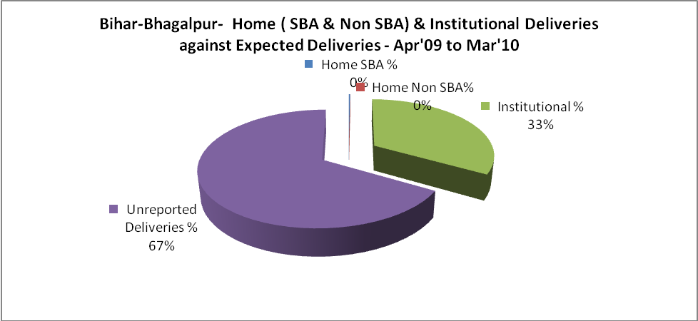
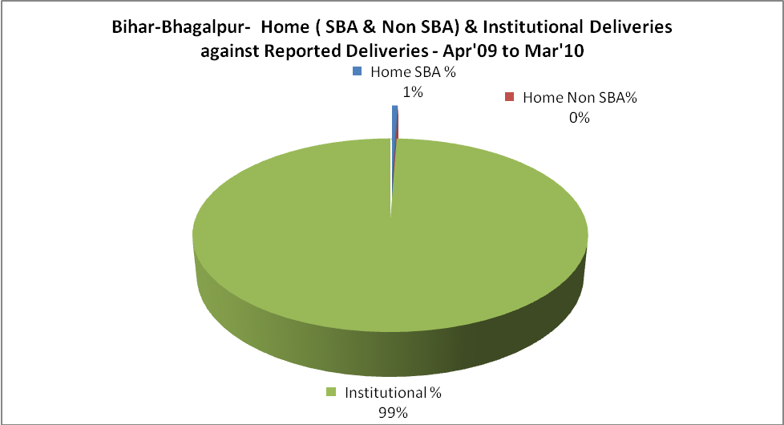
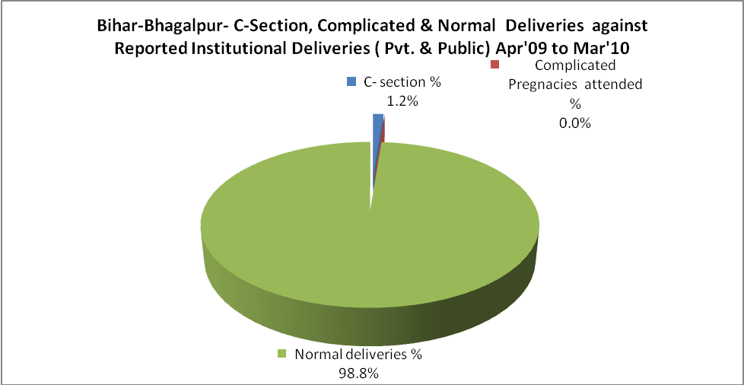
Bihar-Bhagalpur- Complicated Pregnancies & Deliveries Treated - Apr'09 to Mar'10
Reported Deliveries |  |  | Reported ANC Reigtration
28,188 |  |  | 44,015
Complicated Pregnancies attended | Complicated Pregnancies Rate | C - Section Deliveries | PNC Maternal Complications | Abortions | Still Births
1 | 0% | 349 | 448 | 13 | 627
Complicated Deliveries Treated with |  |  |  | No Of Eclampsia cases Treated | No Of severe anemia cases treated
IV Antibiotics | IV antihypertensive/Magsulph injection | IV Oxytocis | Blood Transfusion | No Of Eclampsia cases Treated | No Of severe anemia cases treated
1,366 | 1,366 | 1,366 | - | 13 | 3

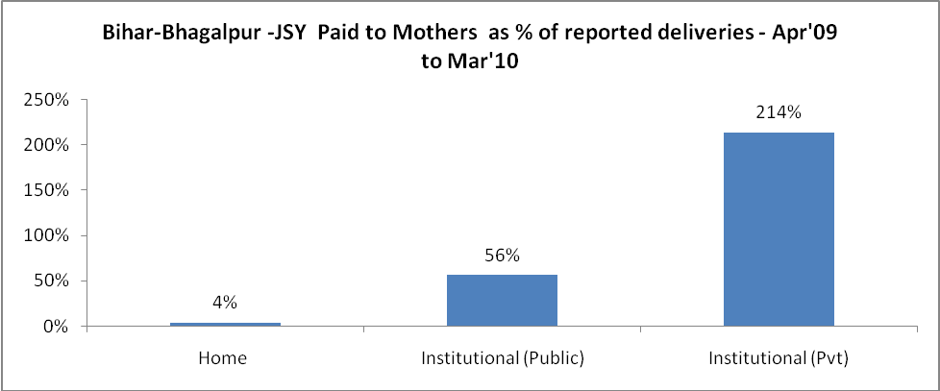
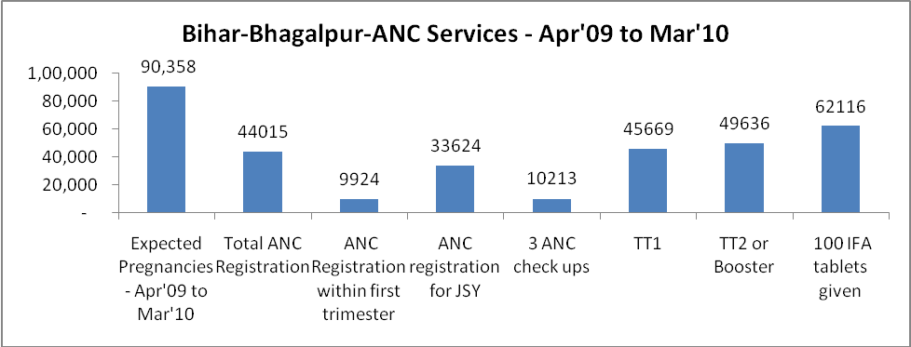
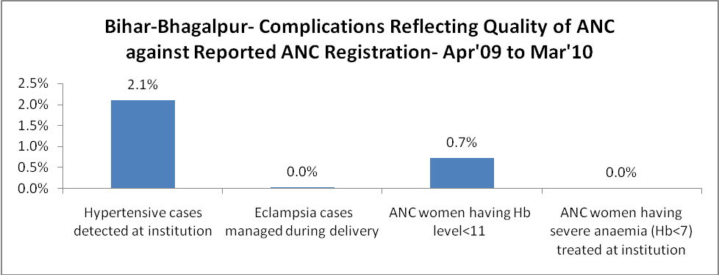
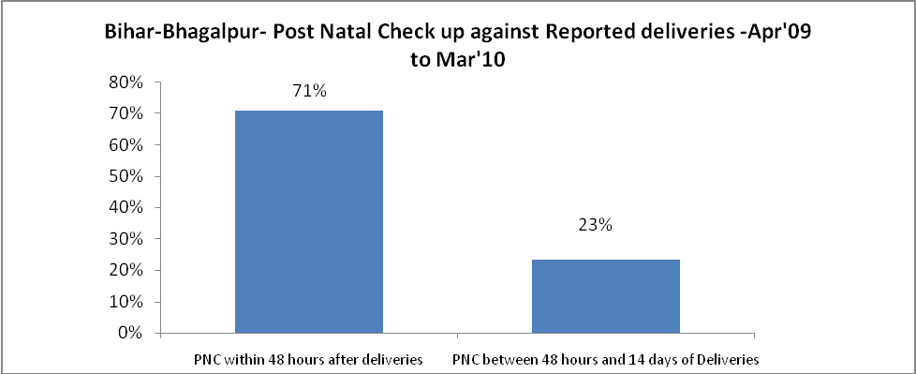
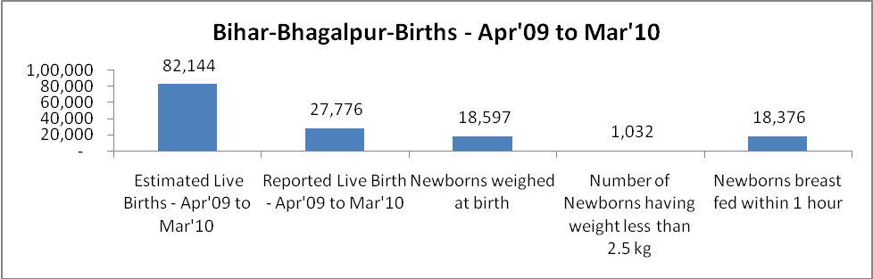
Bihar-Bhagalpur - Births - Apr'09 to Mar'10
Live Birth - Males | Live Birth - females | Live Birth - Total | Sex Ratio at birth | Still Birth | Abortion( Induced/Spontaneous
14,289 | 13,487 | 27,776 | 944 | 627 | 13

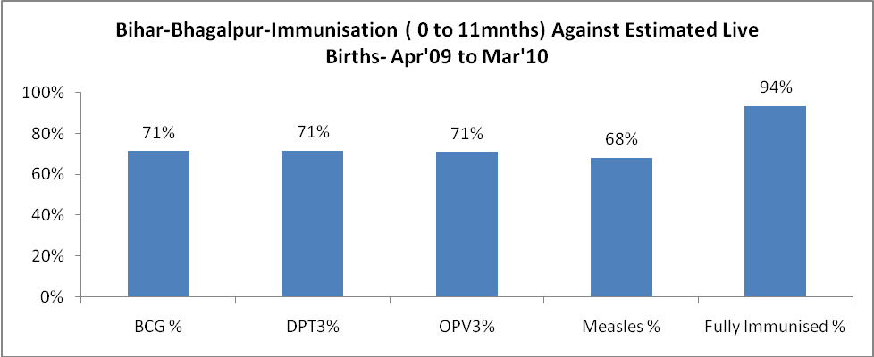
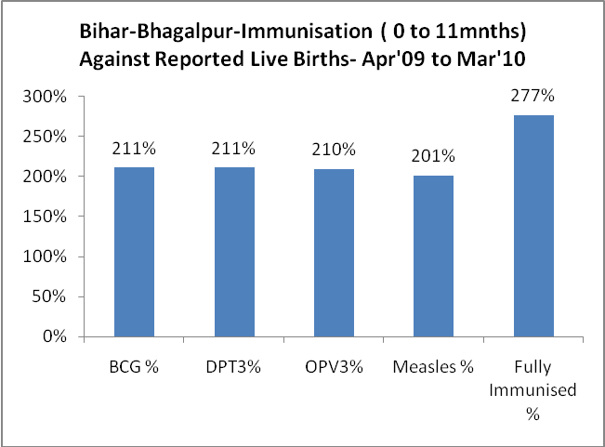
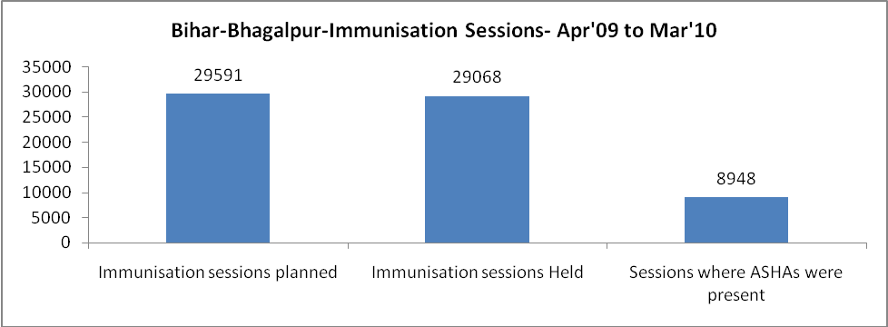

Bihar-Bhagalpur- Apr'09 to Mar'10
Total Abortions | Abortion Rate
13 | 0.0%

Bihar-Bhagalpur- Apr'09 to Mar'10
Total OPD | Total RTI/STI cases
10,23,186 | 5,228

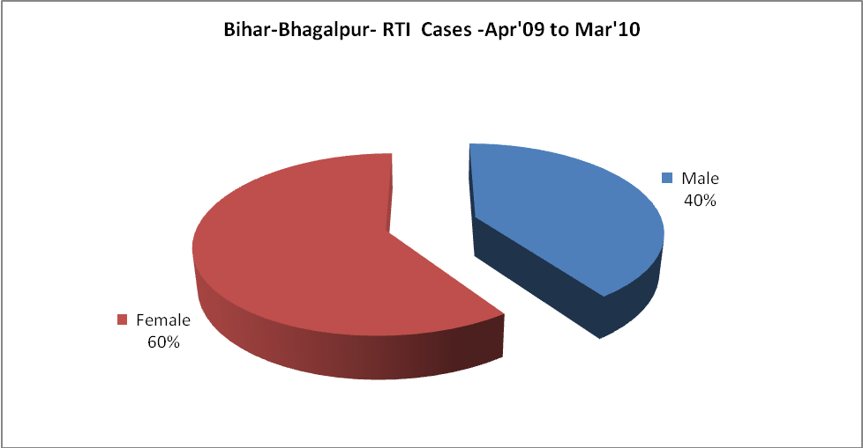
Bihar-Bhagalpur-Sterilisations - Apr'09 to Mar'10
 | Reported | %age of Reported Sterilisation
Total Sterilisation | 3,250 | -
NSV | 184 | 6%
Laproscopic | 14 | 0%
MiniLap | 3,037 | 93%
Post Partum | 15 | 0%
Male Sterilisation | 184 | 6%
Female Sterilisation | 3,066 | 94%

Bihar-Bhagalpur-FP Methods - Apr'09 to Mar'10
 | Reported | %age of All Reported FP Methods
Total Reported FP Methodd (All types) Users | 15,607 | -
Sterilisations | 3,250 | 21%
IUD | 9,581 | 61%
Condom Users | 1,743 | 11%
OCP Users | 1,032 | 7%
Limiting Methods | 3,250 | 21%
Spacing Methods | 12,357 | 79%

Bihar-Bhagalpur- Service Delivery - Apr'09 to Mar'10
Operation major (General and spinal anaesthesia) | Operation minor (No or local anaesthesia) | AYUSH | Dental Procedures | Adolescent counselling services | Total OPD | Total IPD
800 | 712 | 2,678 | 3,631 | 31,100 | 10,23,186 | 18
Operation major (General and spinal anaesthesia) as %ge of OPD | Operation minor (No or local anaesthesia)as %ge of OPD | AYUSH as %ge of OPD | Dental Procedures as %ge of OPD | Adolescent counselling services as %ge of OPD | IPD as percentage of OPD
0.1% | 0.1% | 0.3% | 0.4% | 3.0% | 0%

Bihar-Bhagalpur- Lab Services - Apr'09 to Mar'10
Total OPD | Total HB tested | Total HIV Tested | Total Population
10,23,186 | 774 | - | 27,94,012
HB test conducted as %age of OPD | HB<7gm as %age of HB tested | HIV test conducted as %age of OPD | HIV positive as %age of HIV tested | Blood Smear Examined as % of Population
0.1% | 0.0% | 0.0% | 0 | 0.2%

Bihar-Bhagalpur- Childhood Disease - Vaccine Preventable -Apr'09 to Mar'10
Diphtheria | Pertussis | Tetanus Neonatorum | Tetanus others | Polio | Measles
0 | 0 | 0 | 0 | 0 | 567
Bihar-Bhagalpur-Childhood Disease - Others - Apr'09 to Mar'10
Diarrhoea and dehydration | Malaria | Number admitted with Respiratory Infections
150 | 84 | -

Bihar-Bhagalpur- Infant & Child Deaths - Apr'09 to Mar'10
Infant Deaths within 24 hrs of birth | Infant Deaths between 24hrs & under 1 week | Infant Deaths between 1 week & under 1 month | Child Deaths between 1 month & under 1 year | Child Deaths between 1yr under 5years | Total Deaths
0 | 0 | 0 | 0 | 0 | 0

Bihar-Bhagalpur- Causes of Infant & Child Deaths - Apr'09 to Mar'10
Sepsis |  |  | Asphyxia |  |  | LBW
Up to 1 Weeks of Birth | Between 1 week & 4 weeks of birth | Total | Up to 1 Weeks of Birth | Between 1 week & 4 weeks of birth | Total | Up to 1 Weeks of Birth | Between 1 week & 4 weeks of birth | Total
0 | 0 | 0 | 0 | 0 | 0 | 0 | 0 | 0
Pneumonia |  |  | Diarrhoea |  |  | Fever related
Between 1 month and 11 months | Between 1 year & 5 years | Total | Between 1 month and 11 months | Between 1 year & 5 years | Total | Between 1 month and 11 months | Between 1 year & 5 years | Total
0 | 0 | 0 | 0 | 0 | 0 | 0 | 0 | 0
Others |  |  | Measles |  |  | Others
Up to 1 Weeks of Birth | Between 1 week & 4 weeks of birth | Total | Between 1 month and 11 months | Between 1 year & 5 years | Total | Between 1 month and 11 months | Between 1 year & 5 years | Total
0 | 0 | 0 | 0 | 0 | 0 | 0 | 0 | 0

Bihar-Bhagalpur-Causes of Deaths in 6 to 55yrs age group - Apr'09 to Mar'10
Diarrhoeal Diseases |  |  |  | Tuberculosis |  |  |  | Respiratory Diseases( Other than TB)
6-14 yrs | 15-55 yrs. | Above 55yrs | Total | 6-14 yrs | 15-55 yrs. | Above 55yrs | Total | 6-14 yrs | 15-55 yrs. | Above 55yrs | Total
0 | 0 | 0 | 0 | 0 | 0 | 0 | 0 | 0 | 0 | 0 | 0
Malaria |  |  |  | Other fever Related |  |  |  | HIV/Aids
6-14 yrs | 15-55 yrs. | Above 55yrs | Total | 6-14 yrs | 15-55 yrs. | Above 55yrs | Total | 6-14 yrs | 15-55 yrs. | Above 55yrs | Total
0 | 0 | 0 | 0 | 0 | 0 | 0 | 0 | 0 | 0 | 0 | 0
Heart Disease/Hypertenion related |  |  |  | Neurological Disease including strokes |  |  |  | Trauma/Accidents/ Burn Cases
6-14 yrs | 15-55 yrs. | Above 55yrs | Total | 6-14 yrs | 15-55 yrs. | Above 55yrs | Total | 6-14 yrs | 15-55 yrs. | Above 55yrs | Total
0 | 0 | 0 | 0 | 0 | 0 | 0 | 0 | 0 | 0 | 0 | 0
Suicide |  |  |  | Animal Bites & Stings
6-14 yrs | 15-55 yrs. | Above 55yrs | Total | 6-14 yrs | 15-55 yrs. | Above 55yrs | Total
0 | 0 | 0 | 0 | 0 | 0 | 0 | 0

