NHSRC
Maharashtra – Bid
Analysis: Apr 2009 – Mar 2010

Maharashtra-Bid- Summary-Apr'09 to Mar'10
ANC
ANC Registration against Expected Pregnancies | 93% | TT1 given to Pregnant women against ANC Registration | 62%
3 ANC Check ups against ANC Registrations | 69% | 100 IFA Tablets given to Pregnant women against ANC Registration | 74%
Deliveries
Unreported Deliveries against Estimated Deliveries | 15.2% | HOME Deliveries( SBA& Non SBA) against Estimated Deliveries | 7.1%
Institutional Deliveries against Estimated Deliveries | 77.6% | HOME Deliveries( SBA& Non SBA) against Reported Deliveries | 8.4%
Institutional Deliveries against Reported Deliveries | 91.6% | C Section Deliveries against Institutional Deliveries( Pvt & Pub) | 3%
Births & Neonates Care
Live Births Reported against Estimated Live Births | 83% | New borns weighed against Reported Live Births | 61%
Still Births (Reported) | 517 | New borns weighed less than 2.5 kgs against newborns weighed | 10%
Sex Ratio at Birth | 827 | New borns breastfed within one hr of Birth against Reported live Births | 0%
Child Immunization( 0 to 11 months)
BCG given against Expected Live Births | 88% | Measles given against Expected Live Births | 88%
OPV3 given against Expected Live Births | 88% | Fully Immunized Children against Expected Live Births | 90%
DPT3 given against Expected Live Births | 85%
Family Planning
Family Plannig Methods Users ( Sterilizations(Male &Female)+IUD+ Condom pieces/72 + OCP Cycles/13) | 42,132 | IUD Insertions against reported FP Methods | 25%
Sterilization against reported FP Methods | 26% | Condom Users against reported FP Methods | 28%
 |  | OCP Users against reported FP Methods | 21%
Other Services
OPD | - | Major Operations | -
IPD | - | Minor Operations | -

Maharashtra-Bid- Deliveries Apr'09 to Mar'10
Total Population | 2,536,654 | Expected Deliveries |  | 46,155
Home SBA | Home Non SBA | Institutional | Total Deliveries Reported | Unreported Deliveries
2,691 | 593 | 35,838 | 39,122 | 7,033
Home SBA % | Home Non SBA% | Institutional % | Total Deliveries Reported % | Unreported Deliveries %
6% | 1% | 78% | 85% | 15%

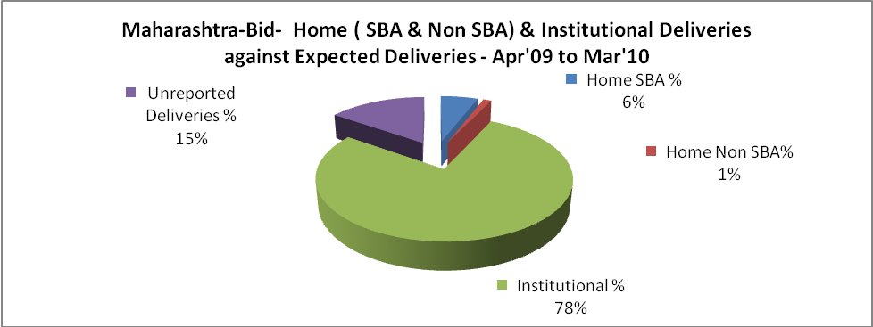

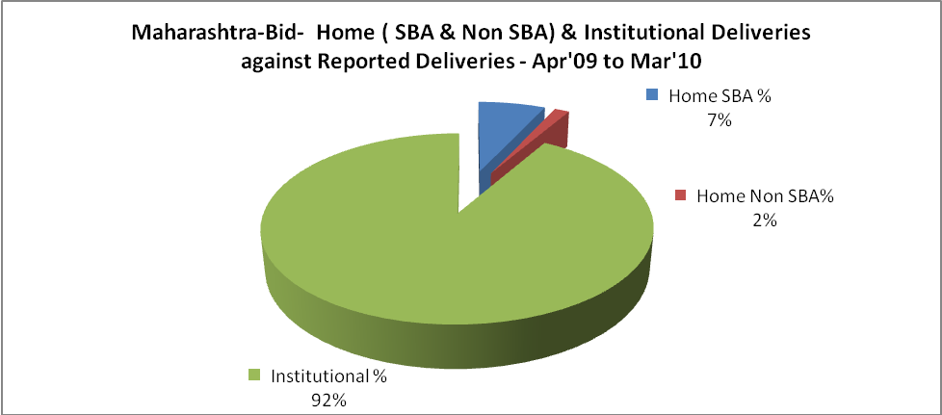

Maharashtra-Bid- C sections & Complicated Deliveries Apr'09 to Mar'10
 | Institutional Deliveries (Public) | Institutional Deliveries (Pvt)
 | 17,527 | 18,311
C Section | 748 | 388
C Section% | 4% | 2%
Complicated Pregnancies attended | 1,149 | 946
Complicated Pregnancies attended % | 7% | 5%

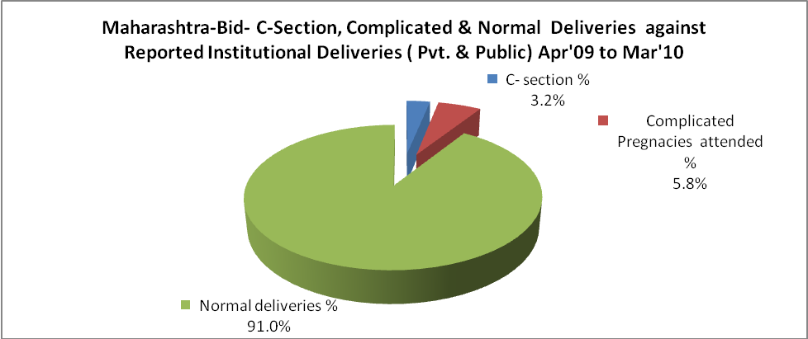

Maharashtra-Bid- Complicated Pregnancies & Deliveries Treated - Apr'09 to Mar'10
Reported Deliveries |  |  | Reported ANC Reigtration
39,122 |  |  | 46,558
Complicated Pregnancies attended | Complicated Pregnancies Rate | C - Section Deliveries | PNC Maternal Complications | Abortions | Still Births
2,095 | 4% | 1,136 | - | 1,917 | 517
Complicated Deliveries Treated with |  |  |  | No Of Eclampsia cases Treated | No Of severe anemia cases treated
IV Antibiotics | IV antihypertensive/Magsulph injection | IV Oxytocis | Blood Transfusion | No Of Eclampsia cases Treated | No Of severe anemia cases treated
- | - | - | - | - | -

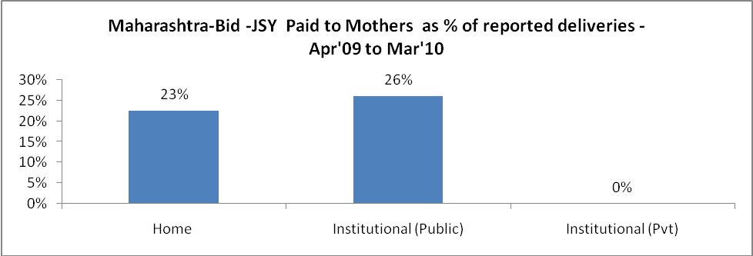

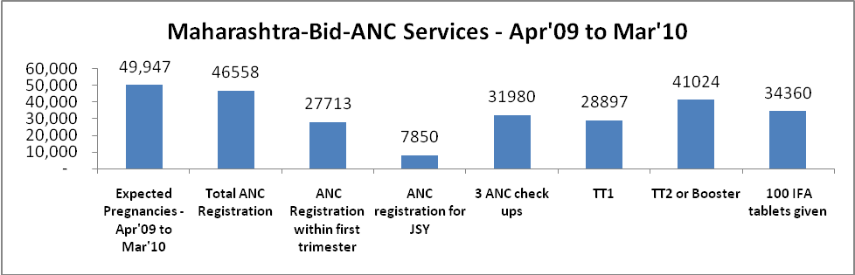

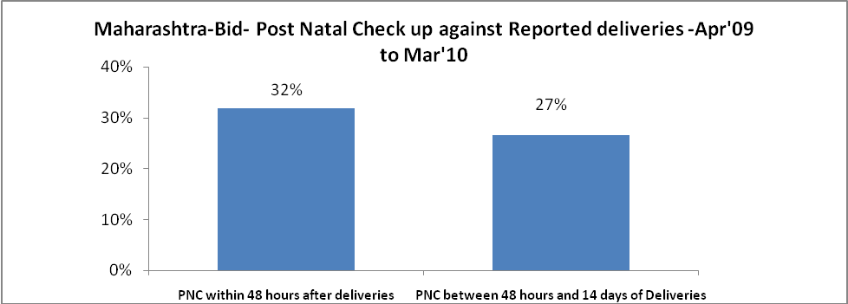

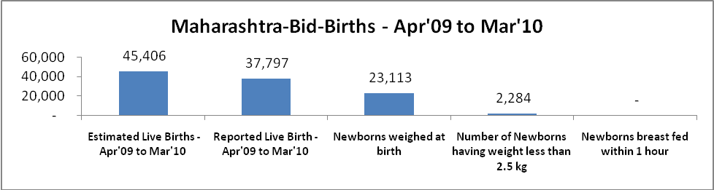

Maharashtra-Bid - Births - Apr'09 to Mar'10
Live Birth - Males | Live Birth - females | Live Birth - Total | Sex Ratio at birth | Still Birth | Abortion( Induced/Spontaneous
20,692 | 17,105 | 37,797 | 827 | 517 | 1,917

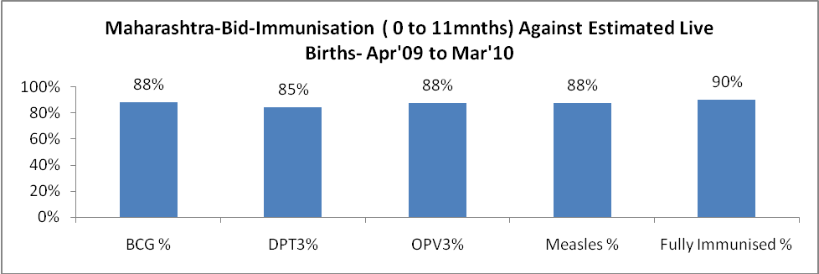

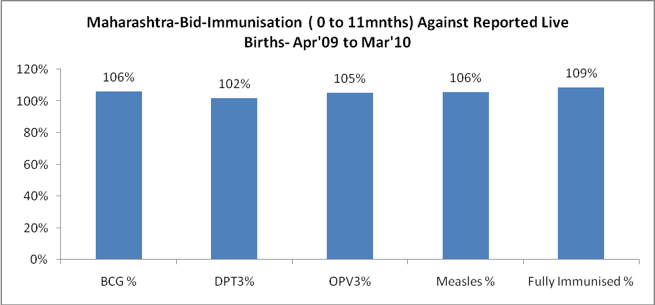

Maharashtra-Bid- Apr'09 to Mar'10
Total Abortions | Abortion Rate
3,024 | 6.1%

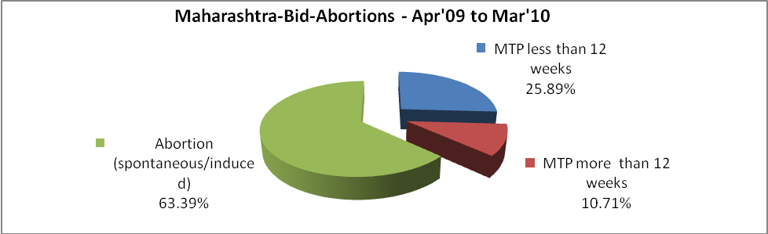

Maharashtra-Bid- Apr'09 to Mar'10
Total OPD | Total RTI/STI cases
- | 6,950

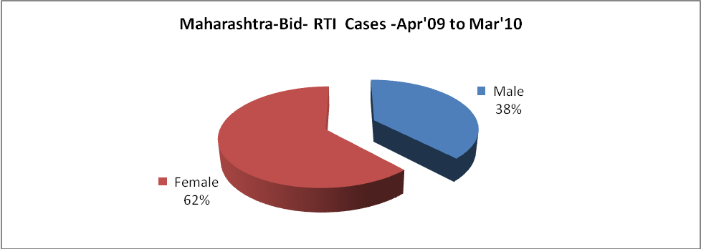

Maharashtra-Bid-Sterilizations - Apr'09 to Mar'10
 | Reported | %age of Reported Sterilization
Total Sterilization | 10,879 | -
NSV | 182 | 2%
Laproscopic | 6,143 | 56%
MiniLap | 3,881 | 36%
Post Partum | 673 | 6%
Male Sterilization | 182 | 2%
Female Sterilization | 10,697 | 98%

Maharashtra-Bid-FP Methods - Apr'09 to Mar'10
 | Reported | %age of All Reported FP Methods
Total Reported FP Methodd (All types) Users | 42,132 | -
Sterilizations | 10,879 | 26%
IUD | 10,517 | 25%
Condom Users | 11,904 | 28%
OCP Users | 8,832 | 21%
Limiting Methods | 10,879 | 26%
Spacing Methods | 31,253 | 74%

Maharashtra-Bid- Lab Services - Apr'09 to Mar'10
Total OPD | Total HB tested | Total HIV Tested | Total Population
- | - | - | 2,536,654
HB test conducted as %age of OPD | HB<7gm as %age of HB tested | HIV test conducted as %age of OPD | HIV positive as %age of HIV tested | Blood Smear Examined as % of Population
0.0% | 0.0% | 0.0% | 0.0% | 0.0%

Maharashtra-Bid- Childhood Disease - Vaccine Preventable -Apr'09 to Mar'10
Diphtheria | Pertussis | Tetanus Neonatorum | Tetanus others | Polio | Measles
1 | 0 | 0 | 0 | 0 | 26
Maharashtra-Bid-Childhood Disease - Others - Apr'09 to Mar'10
Diarrhoea and dehydration | Malaria | Number admitted with Respiratory Infections
3,921 | 590 | -

Maharashtra-Bid- Infant & Child Deaths - Apr'09 to Mar'10
Infant Deaths within 24 hrs of birth | Infant Deaths between 24hrs & under 1 week | Infant Deaths between 1 week & under 1 month | Child Deaths between 1 month & under 1 year | Child Deaths between 1yr under 5years | Total Deaths
0 | 0 | 0 | 21 | 16 | 37
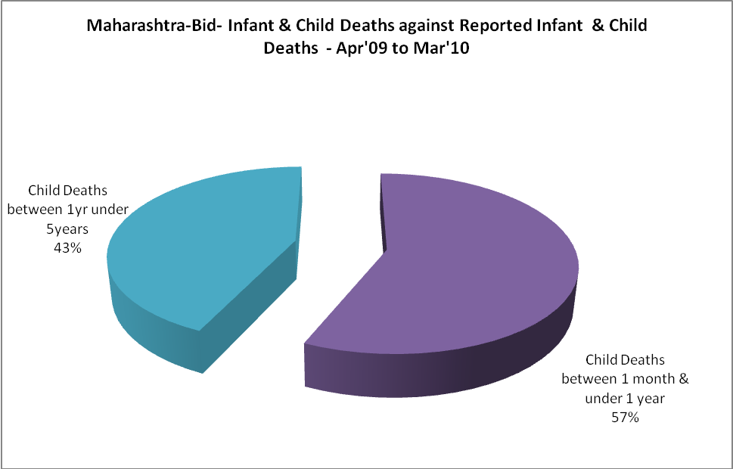

Maharashtra-Bid- Causes of Infant & Child Deaths - Apr'09 to Mar'10
Sepsis |  |  | Asphyxia |  |  | LBW
Up to 1 Weeks of Birth | Between 1 week & 4 weeks of birth | Total | Up to 1 Weeks of Birth | Between 1 week & 4 weeks of birth | Total | Up to 1 Weeks of Birth | Between 1 week & 4 weeks of birth | Total
0 | 0 | 0 | 0 | 0 | 0 | 0 | 0 | 0
Pneumonia |  |  | Diarrhoea |  |  | Fever related
Between 1 month and 11 months | Between 1 year & 5 years | Total | Between 1 month and 11 months | Between 1 year & 5 years | Total | Between 1 month and 11 months | Between 1 year & 5 years | Total
21 | 16 | 37 | 0 | 0 | 0 | 0 | 0 | 0
Others |  |  | Measles |  |  | Others
Up to 1 Weeks of Birth | Between 1 week & 4 weeks of birth | Total | Between 1 month and 11 months | Between 1 year & 5 years | Total | Between 1 month and 11 months | Between 1 year & 5 years | Total
0 | 0 | 0 | 0 | 0 | 0 | 0 | 0 | 0

Maharashtra-Bid- Maternal Deaths & Causes - Apr'09 to Mar'10
Abortion |  |  | Obstructed/prolonged labour |  |  | Severe hypertesnion/fits
6-14 yrs | 15-55 yrs. | Total | 6-14 yrs | 15-55 yrs. | Total | 6-14 yrs | 15-55 yrs. | Total
0 | 0 | 0 | 0 | 0 | 0 | 0 | 0 | 0
Bleeding |  |  | High Fever |  |  | Other Causes
6-14 yrs | 15-55 yrs. | Total | 6-14 yrs | 15-55 yrs. | Total | 6-14 yrs | 15-55 yrs. | Total
0 | 0 | 0 | 0 | 0 | 0 | 0 | 0 | 0

Maharashtra-Bid-Causes of Deaths in 6 to 55yrs age group - Apr'09 to Mar'10
Diarrhoel Diseases |  |  |  | Tuberculosis |  |  |  | Respiratory Diseases( Other than TB)
6-14 yrs | 15-55 yrs. | Above 55yrs | Total | 6-14 yrs | 15-55 yrs. | Above 55yrs | Total | 6-14 yrs | 15-55 yrs. | Above 55yrs | Total
0 | 0 | 0 | 0 | 0 | 0 | 0 | 0 | 0 | 0 | 0 | 0
Malaria |  |  |  | Other fever Related |  |  |  | HIV/Aids
6-14 yrs | 15-55 yrs. | Above 55yrs | Total | 6-14 yrs | 15-55 yrs. | Above 55yrs | Total | 6-14 yrs | 15-55 yrs. | Above 55yrs | Total
0 | 0 | 0 | 0 | 0 | 0 | 0 | 0 | 0 | 0 | 0 | 0
Heart Disease/Hypertension related |  |  |  | Neurological Disease including strokes |  |  |  | Trauma/Accidents/ Burn Cases
6-14 yrs | 15-55 yrs. | Above 55yrs | Total | 6-14 yrs | 15-55 yrs. | Above 55yrs | Total | 6-14 yrs | 15-55 yrs. | Above 55yrs | Total
0 | 0 | 0 | 0 | 0 | 0 | 0 | 0 | 0 | 0 | 0 | 0
Suicide |  |  |  | Animal Bites & Stings
6-14 yrs | 15-55 yrs. | Above 55yrs | Total | 6-14 yrs | 15-55 yrs. | Above 55yrs | Total
0 | 0 | 0 | 0 | 0 | 0 | 0 | 0

