NHSRC
Maharashtra – Chandrapur
Analysis: Apr 2009 – Mar 2010

Maharashtra-Chandrapur- Summary-Apr'09 to Mar'10
ANC
ANC Registration against Expected Pregnancies | 84% | TT1 given to Pregnant women against ANC Registration | 66%
3 ANC Check ups against ANC Registrations | 86% | 100 IFA Tablets given to Pregnant women against ANC Registration | 78%
Deliveries
Unreported Deliveries against Estimated Deliveries | 22.9% | HOME Deliveries( SBA& Non SBA) against Estimated Deliveries | 11.3%
Institutional Deliveries against Estimated Deliveries | 65.8% | HOME Deliveries( SBA& Non SBA) against Reported Deliveries | 14.7%
Institutional Deliveries against Reported Deliveries | 85.3% | C Section Deliveries against Institutional Deliveries( Pvt & Pub) | 13%
Births & Neonates Care
Live Births Reported against Estimated Live Births | 85% | New borns weighed against Reported Live Births | 87%
Still Births (Reported) | 1,616 | New borns weighed less than 2.5 kgs against newborns weighed | 20%
Sex Ratio at Birth | 881 | New borns breastfed within one hr of Birth against Reported live Births | 0%
Child Immunization( 0 to 11 months)
BCG given against Expected Live Births | 87% | Measles given against Expected Live Births | 82%
OPV3 given against Expected Live Births | 78% | Fully Immunized Children against Expected Live Births | 140%
DPT3 given against Expected Live Births | 85%
Family Planning
Family Planning Methods Users ( Sterilizations(Male &Female)+IUD+ Condom pieces/72 + OCP Cycles/13) | 38,297 | IUD Insertions against reported FP Methods | 22%
Sterilization against reported FP Methods | 31% | Condom Users against reported FP Methods | 29%
 |  | OCP Users against reported FP Methods | 18%
Other Services
OPD | 335,578 | Major Operations | 1,803
IPD | - | Minor Operations | 1,313

Maharashtra-Chandrapur- Deliveries Apr'09 to Mar'10
Total Population | 2,429,480 | Expected Deliveries |  | 44,205
Home SBA | Home Non SBA | Institutional | Total Deliveries Reported | Unreported Deliveries
1,816 | 3,186 | 29,071 | 34,073 | 10,132
Home SBA % | Home Non SBA% | Institutional % | Total Deliveries Reported % | Unreported Deliveries %
4% | 7% | 66% | 77% | 23%
`

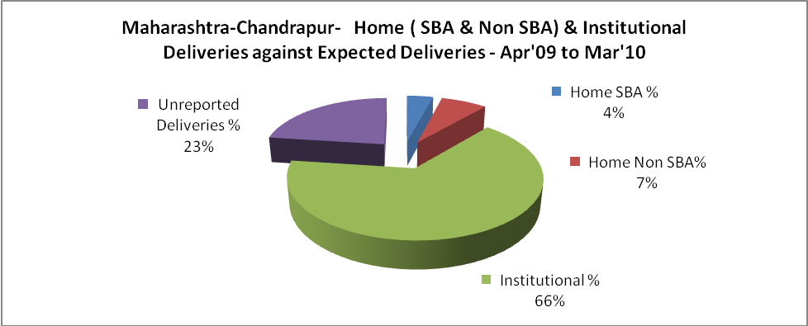

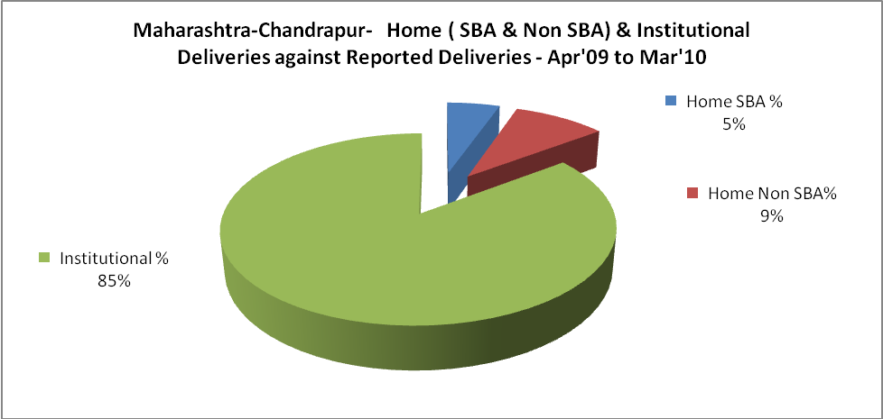

Maharashtra-Chandrapur- C sections & Complicated Deliveries Apr'09 to Mar'10
 | Institutional Deliveries (Public) | Institutional Deliveries (Pvt)
 | 16,362 | 12,709
C Section | 1,068 | 2,790
C Section% | 7% | 22%
Complicated Pregnancies attended | 2,415 | 424
Complicated Pregnancies attended % | 15% | 3%

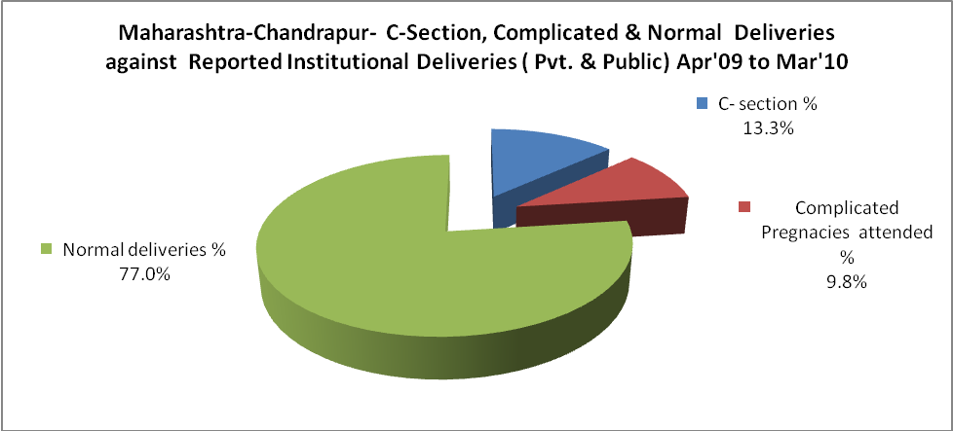

Maharashtra-Chandrapur- Complicated Pregnancies & Deliveries Treated - Apr'09 to Mar'10
Reported Deliveries |  |  | Reported ANC Reigtration
34,073 |  |  | 39,961
Complicated Pregnancies attended | Complicated Pregnancies Rate | C - Section Deliveries | PNC Maternal Complications | Abortions | Still Births
2,839 | 6% | 3,858 | - | 2,024 | 1,616
Complicated Deliveries Treated with |  |  |  | No Of Eclampsia cases Treated | No Of severe anemia cases treated
IV Antibiotics | IV antihypertensive/Magsulph injection | IV Oxytocis | Blood Transfusion | No Of Eclampsia cases Treated | No Of severe anemia cases treated
- | - | - | - | - | -

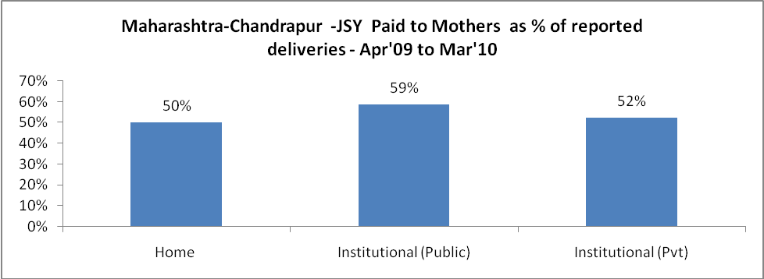

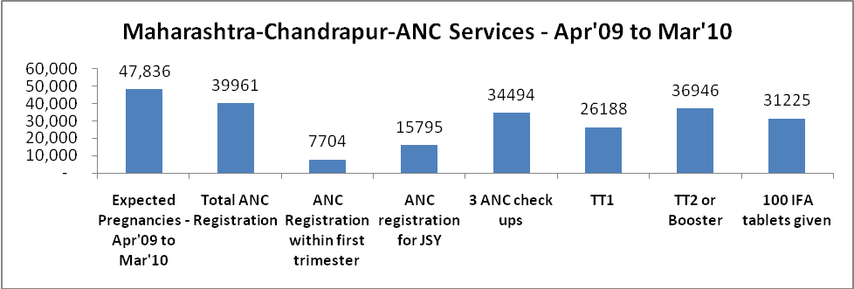

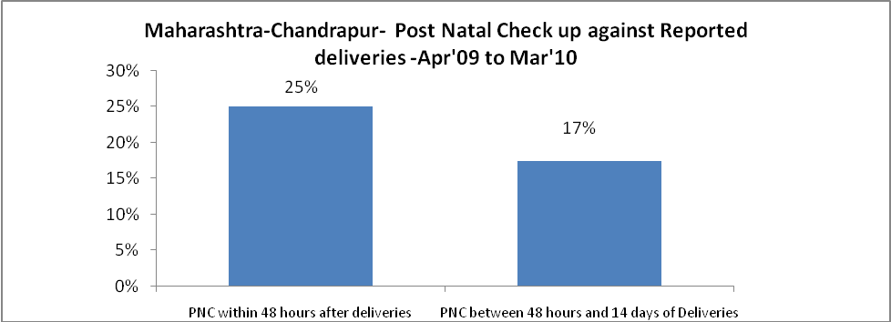

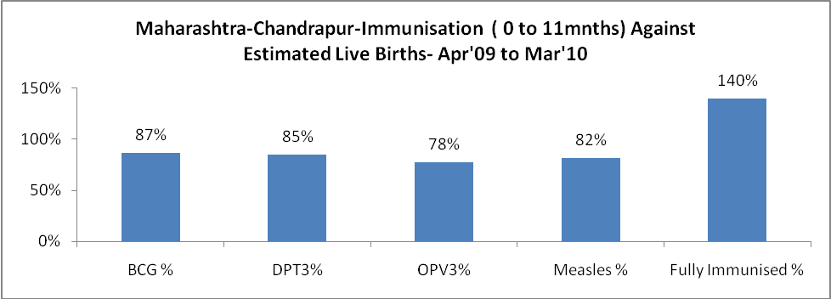

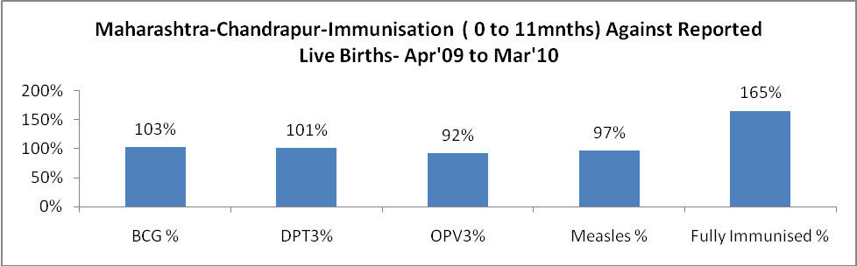

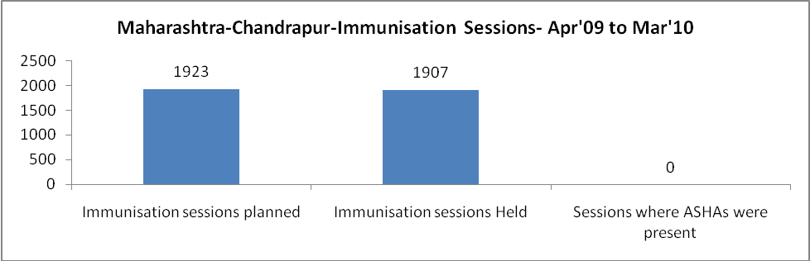

Maharashtra-Chandrapur- Apr'09 to Mar'10
Total Abortions | Abortion Rate
3,470 | 7.3%

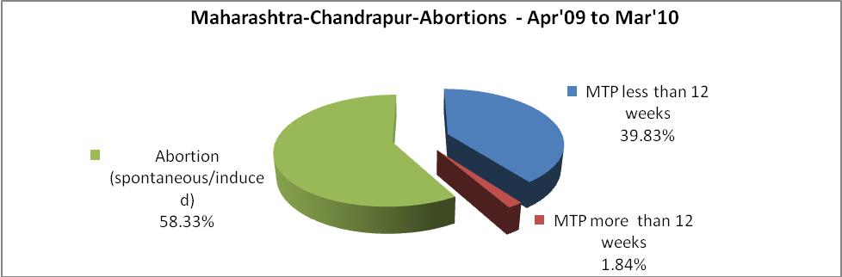

Maharashtra-Chandrapur- Apr'09 to Mar'10
Total OPD | Total RTI/STI cases
335,578 | 5,233

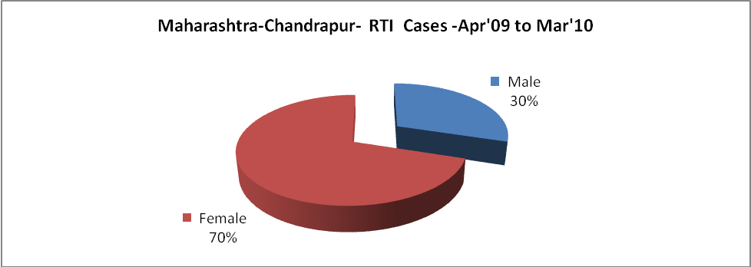
Maharashtra-Chandrapur-Sterilizations - Apr'09 to Mar'10
 | Reported | %age of Reported Sterilization
Total Sterilization | 11,932 | -
NSV | 2,779 | 23%
Laproscopic | 1,210 | 10%
MiniLap | 5,488 | 46%
Post Partum | 2,455 | 21%
Male Sterilization | 2,779 | 23%
Female Sterilization | 9,153 | 77%

Maharashtra-Chandrapur-FP Methods - Apr'09 to Mar'10
 | Reported | %age of All Reported FP Methods
Total Reported FP Methodd (All types) Users | 38,297 | -
Sterilizations | 11,932 | 31%
IUD | 8,573 | 22%
Condom Users | 11,016 | 29%
OCP Users | 6,776 | 18%
Limiting Methods | 11,932 | 31%
Spacing Methods | 26,365 | 69%

Maharashtra-Chandrapur- Service Delivery - Apr'09 to Mar'10
Operation major (General and spinal anaesthesia) | Operation minor (No or local anaesthesia) | AYUSH | Dental Procedures | Adolescent counselling services | Total OPD | Total IPD
1,803 | 1,313 | - | - | - | 335,578 | -
Operation major (General and spinal anaesthesia) as %ge of OPD | Operation minor (No or local anaesthesia)as %ge of OPD | AYUSH as %ge of OPD | Dental Procedures as %ge of OPD | Adolescent counselling services as %ge of OPD | IPD as percentage of OPD
0.5% | 0.4% | 0.0% | 0.0% | 0.0% | 0%

Maharashtra-Chandrapur- Lab Services - Apr'09 to Mar'10
Total OPD | Total HB tested | Total HIV Tested | Total Population
335,578 | - | - | 2,429,480
HB test conducted as %age of OPD | HB<7gm as %age of HB tested | HIV test conducted as %age of OPD | HIV positive as %age of HIV tested | Blood Smear Examined as % of Population
0.0% | 0.0% | 0.0% | 0.0% | 14.3%

Maharashtra-Chandrapur- Infant & Child Deaths - Apr'09 to Mar'10
Infant Deaths within 24 hrs of birth | Infant Deaths between 24hrs & under 1 week | Infant Deaths between 1 week & under 1 month | Child Deaths between 1 month & under 1 year | Child Deaths between 1yr under 5years | Total Deaths
267 | 285 | 96 | 128 | 160 | 936

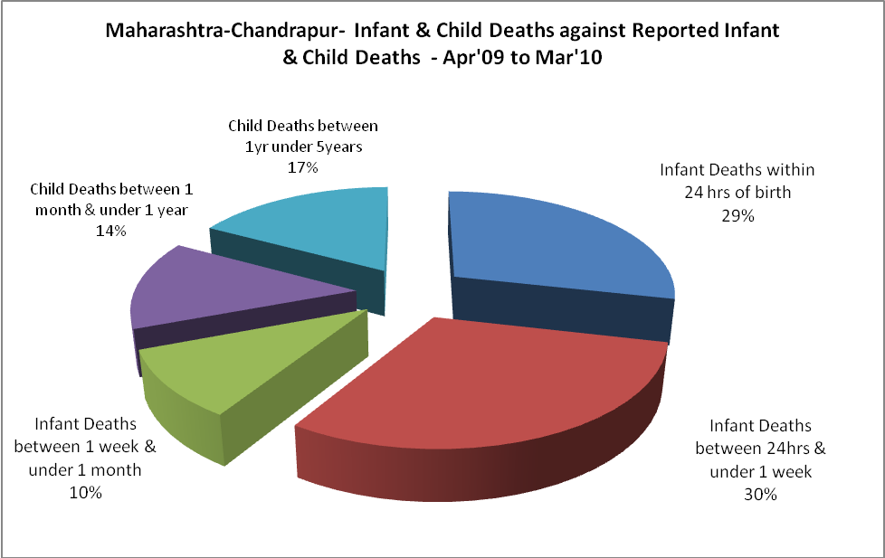

Maharashtra-Chandrapur- Causes of Infant & Child Deaths - Apr'09 to Mar'10
Sepsis |  |  | Asphyxia |  |  | LBW
Up to 1 Weeks of Birth | Between 1 week & 4 weeks of birth | Total | Up to 1 Weeks of Birth | Between 1 week & 4 weeks of birth | Total | Up to 1 Weeks of Birth | Between 1 week & 4 weeks of birth | Total
0 | 0 | 0 | 0 | 0 | 0 | 0 | 0 | 0
Pneumonia |  |  | Diarrhoea |  |  | Fever related
Between 1 month and 11 months | Between 1 year & 5 years | Total | Between 1 month and 11 months | Between 1 year & 5 years | Total | Between 1 month and 11 months | Between 1 year & 5 years | Total
0 | 0 | 0 | 0 | 0 | 0 | 0 | 0 | 0
Others |  |  | Measles |  |  | Others
Up to 1 Weeks of Birth | Between 1 week & 4 weeks of birth | Total | Between 1 month and 11 months | Between 1 year & 5 years | Total | Between 1 month and 11 months | Between 1 year & 5 years | Total
285 | 96 | 381 | 0 | 0 | 0 | 128 | 160 | 288

Maharashtra-Chandrapur- Maternal Deaths & Causes - Apr'09 to Mar'10
Abortion |  |  | Obstructed/prolonged labour |  |  | Severe hypertesnion/fits
6-14 yrs | 15-55 yrs. | Total | 6-14 yrs | 15-55 yrs. | Total | 6-14 yrs | 15-55 yrs. | Total
0 | 0 | 0 | 0 | 0 | 0 | 0 | 0 | 0
Bleeding |  |  | High Fever |  |  | Other Causes
6-14 yrs | 15-55 yrs. | Total | 6-14 yrs | 15-55 yrs. | Total | 6-14 yrs | 15-55 yrs. | Total
0 | 0 | 0 | 0 | 0 | 0 | 0 | 0 | 0

Maharashtra-Chandrapur-Causes of Deaths in 6 to 55yrs age group - Apr'09 to Mar'10
Diarrhoel Diseases |  |  |  | Tuberculosis |  |  |  | Respiratory Diseases( Other than TB)
6-14 yrs | 15-55 yrs. | Above 55yrs | Total | 6-14 yrs | 15-55 yrs. | Above 55yrs | Total | 6-14 yrs | 15-55 yrs. | Above 55yrs | Total
0 | 0 | 0 | 0 | 0 | 0 | 0 | 0 | 0 | 0 | 0 | 0
Malaria |  |  |  | Other fever Related |  |  |  | HIV/Aids
6-14 yrs | 15-55 yrs. | Above 55yrs | Total | 6-14 yrs | 15-55 yrs. | Above 55yrs | Total | 6-14 yrs | 15-55 yrs. | Above 55yrs | Total
0 | 0 | 0 | 0 | 0 | 0 | 0 | 0 | 0 | 0 | 0 | 0
Heart Disease/Hypertension related |  |  |  | Neurological Disease including strokes |  |  |  | Trauma/Accidents/ Burn Cases
6-14 yrs | 15-55 yrs. | Above 55yrs | Total | 6-14 yrs | 15-55 yrs. | Above 55yrs | Total | 6-14 yrs | 15-55 yrs. | Above 55yrs | Total
0 | 0 | 0 | 0 | 0 | 0 | 0 | 0 | 0 | 0 | 0 | 0
Suicide |  |  |  | Animal Bites & Stings
6-14 yrs | 15-55 yrs. | Above 55yrs | Total | 6-14 yrs | 15-55 yrs. | Above 55yrs | Total
0 | 0 | 0 | 0 | 0 | 0 | 0 | 0

