NHSRC
Arunachal Pradesh-Changleng
Analysis: Apr 2009 – Mar 2010

Arunachal Pradesh-CHANGLENG Dist.- Summary-Apr'09 to Mar'10
ANC
ANC Registration against Expected Pregnancies | 76% | TT1 given to Pregnant women against ANC Registraion | 65%
3 ANC Check ups against ANC Reigtrations | 37% | 100 IFA Tablets given to Pregnant women against ANC Registraion | 52%
Deliveries
Unreported Deliveries against Estimated Deliveries | 69.5% | HOME Deliveries( SBA& Non SBA) against Estimated Deliveries | 0.6%
Institutional Deliveries against Estimated Deliveries | 29.9% | HOME Deliveries( SBA& Non SBA) against Reported Deliveries | 1.9%
Institutional Deliveries against Reported Deliveries | 98.1% | C Section Deliveries against Institutional Deliveries( Pvt & Pub) | 0%
Births & Neonates Care
Live Births Reported against Estimated Live Births | 30% | New borns weighed against Reported Live Births | 94%
Still Births (Reported) | 18 | New borns weighed less than 2.5 kgs against newborns weighed | 11%
Sex Ratio at Birh | 947 | New borns breastfed within one hr of Birth against Reported live Births | 92%
Child Immunisation( 0 to 11 months)
BCG given against Expected Live Births | 71% | Measles given against Expected Live Births | 46%
OPV3 given against Expected Live Births | 46% | Fully Immunised Children against Expected Live Births | 42%
DPT3 given against Expected Live Births | 46%
Family Planning
Family Plannig Methods Users ( Sterilisations(Male &Female)+IUD+ Condom pieces/72 + OCP Cycles/13) | 318 | IUD Insertions against reported FP Methods | 44%
Sterilisation against reported FP Methods | 5% | Condom Users against reported FP Methods | 20%
 |  | OCP Users against reported FP Methods | 30%
Other Services
OPD | 104,303 | Major Operations | -
IPD | 4,656 | Minor Operations | -

Arunachal Pradesh-CHANGLENG Dist.- Deliveries Apr'09 to Mar'10
Total Population | 149,797 | Expected Deliveries |  | 3,318
Home SBA | Home Non SBA | Institutional | Total Deliveries Reported | Unreported Deliveries
19 | - | 992 | 1,011 | 2,307
Home SBA % | Home Non SBA% | Institutional % | Total Deliveries Reported % | Unreported Deliveries %
1% | 0% | 30% | 30% | 70%
`

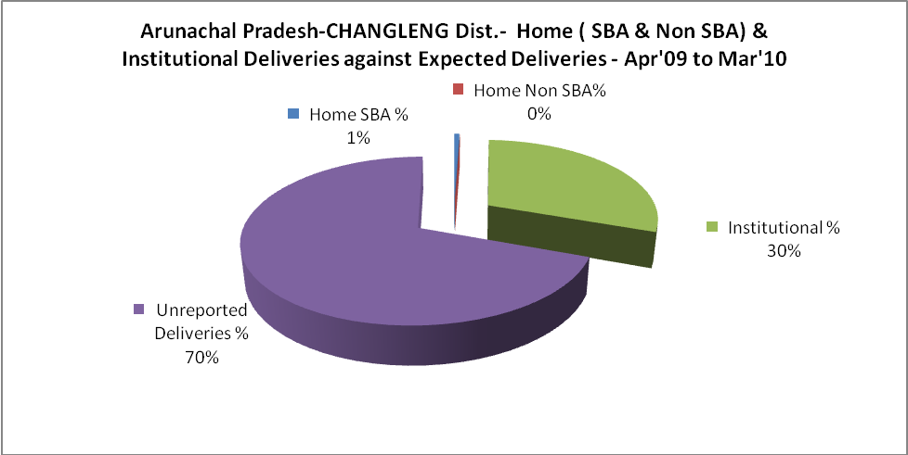

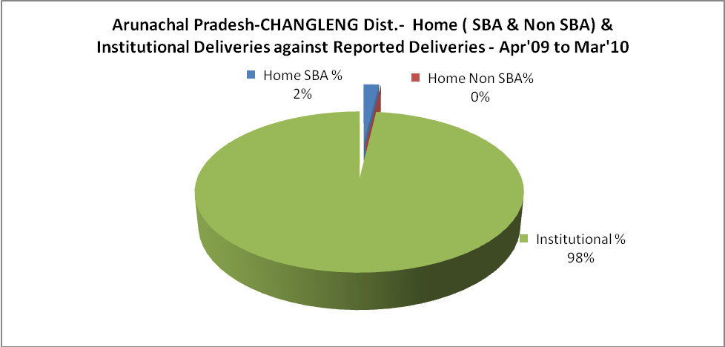

Arunachal Pradesh-CHANGLENG Dist.- C sections & Complicated Deliveries Apr'09 to Mar'10
 | Institutional Deliveries (Public) | Institutional Deliveries (Pvt)
 | 992 | -
C Section | - | -
C Section% | 0% | 0%
Complicated Pregnacies attended | - | -
Complicated Pregnacies attended % | 0% | 0%

Arunachal Pradesh-CHANGLENG Dist.- Complicated Pregnancies & Deliveries Treated - Apr'09 to Mar'10
Reported Deliveries |  |  | Reported ANC Reigtration
1,011 |  |  | 2,716
Complicated Pregnancies attended | Complicated Pregnancies Rate | C - Section Deliveries | PNC Maternal Complications | Abortions | Still Births
- | 0% | - | - | 7 | 18
Complicated Deliveries Treated with |  |  |  | No Of Eclampsia cases Treated | No Of severe anemia cases treated
IV Antibiotics | IV antihypertensive/Magsulph injection | IV Oxytocis | Blood Transfusion | No Of Eclampsia cases Treated | No Of severe anemia cases treated
- | - | - | - | 5 | 19

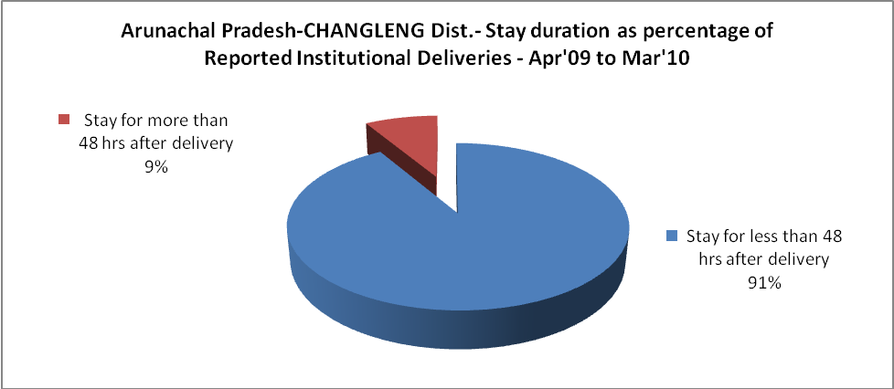

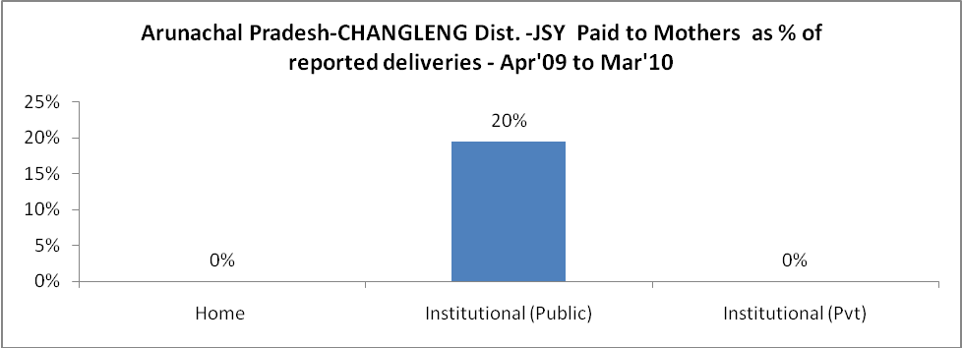

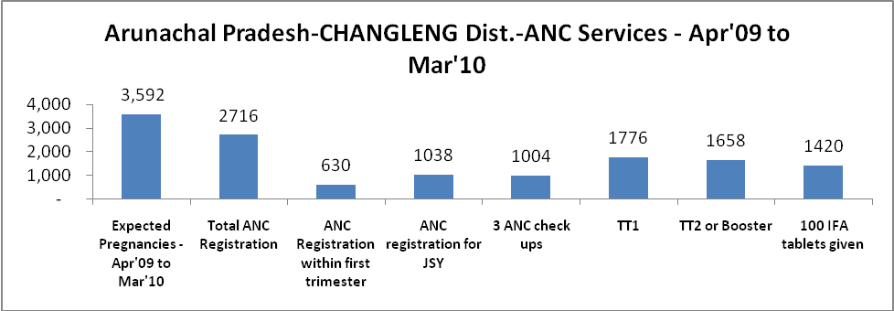

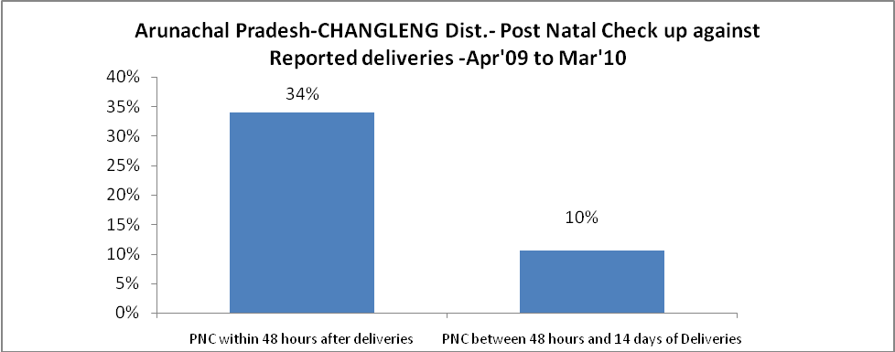

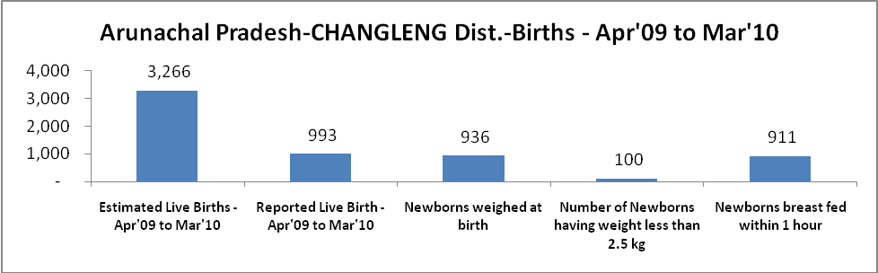

Arunachal Pradesh-CHANGLENG Dist. - Births - Apr'09 to Mar'10
Live Birth - Males | Live Birth - females | Live Birth - Total | Sex Ratio at birth | Still Birth | Abortion( Induced/Spontaneous
510 | 483 | 993 | 947 | 18 | 7

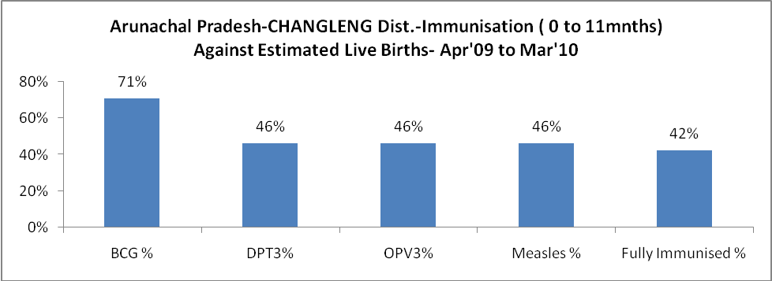

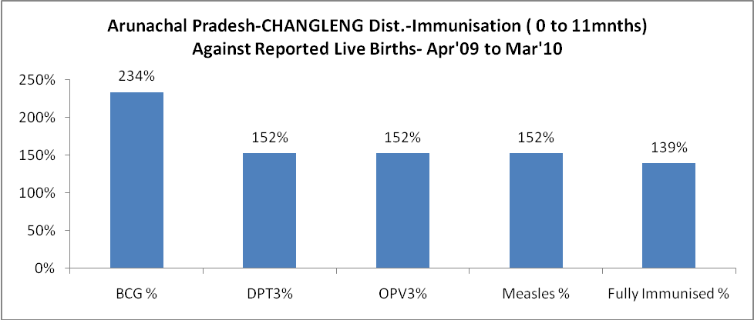

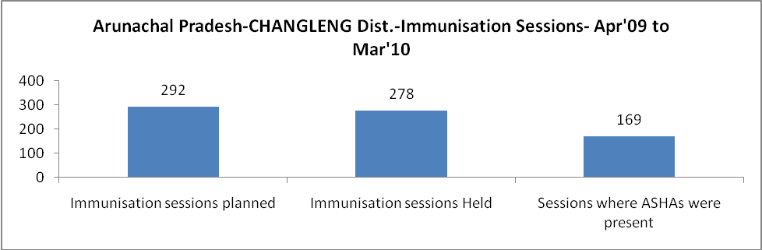

Arunachal Pradesh-CHANGLENG Dist.- Apr'09 to Mar'10
Total Abortions | Abortion Rate
27 | 0.8%

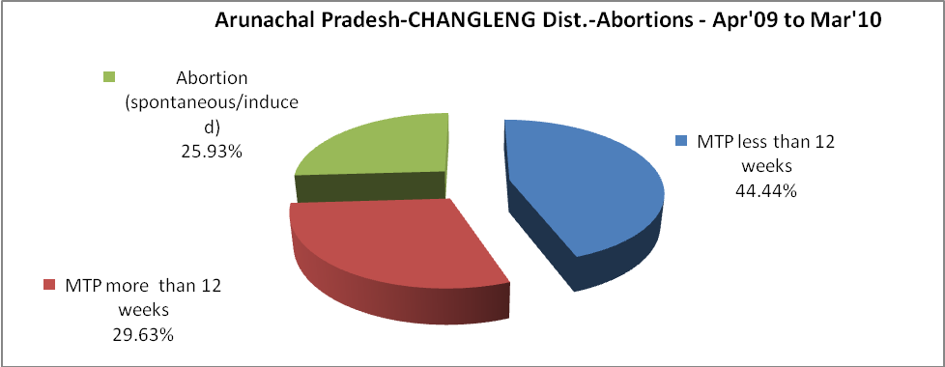

Arunachal Pradesh-CHANGLENG Dist.- Apr'09 to Mar'10
Total OPD | Total RTI/STI cases
104,303 | 570

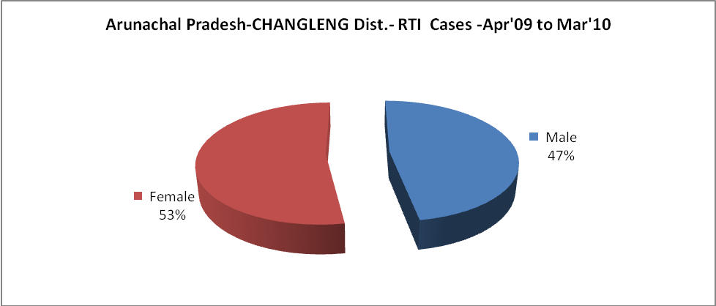

Arunachal Pradesh-CHANGLENG Dist.-Sterilisations - Apr'09 to Mar'10
 | Reported | %age of Reported Sterilisation
Total Sterilisation | 16 | -
NSV | - | 0%
Laproscopic | - | 0%
MiniLap | 16 | 100%
Post Partum | - | 0%
Male Sterilisation | - | 0%
Female Sterilisation | 16 | 100%

Arunachal Pradesh-CHANGLENG Dist.-FP Methods - Apr'09 to Mar'10
 | Reported | %age of All Reported FP Methods
Total Reported FP Methodd (All types) Users | 318 | -
Sterilisations | 16 | 5%
IUD | 141 | 44%
Condom Users | 65 | 20%
OCP Users | 97 | 30%
Limiting Methods | 16 | 5%
Spacing Methods | 302 | 95%

Arunachal Pradesh-CHANGLENG Dist.- Service Delivery - Apr'09 to Mar'10
Operation major (General and spinal anaesthesia) | Operation minor (No or local anaesthesia) | AYUSH | Dental Procedures | Adolescent counselling services | Total OPD | Total IPD
- | - | 5,263 | 3,382 | 189 | 104,303 | 4,656
Operation major (General and spinal anaesthesia) as %ge of OPD | Operation minor (No or local anaesthesia)as %ge of OPD | AYUSH as %ge of OPD | Dental Procedures as %ge of OPD | Adolescent counselling services as %ge of OPD | IPD as percentage of OPD
0.0% | 0.0% | 5.0% | 3.2% | 0.2% | 4%

Arunachal Pradesh-CHANGLENG Dist.- Lab Services - Apr'09 to Mar'10
Total OPD | Total HB tested | Total HIV Tested | Total Population
104,303 | 1,052 | 1,477 | 149,797
HB test conducted as %age of OPD | HB<7gm as %age of HB tested | HIV test conducted as %age of OPD | HIV positive as %age of HIV tested | Blood Smear Examined as % of Population
1.0% | 9.7% | 1.4% | 0.0% | 17.9%

Arunachal Pradesh-CHANGLENG Dist.- Childhood Disease - Vaccine Preventable -Apr'09 to Mar'10
Diphtheria | Pertussis | Tetanus Neonatorum | Tetanus others | Polio | Measles
4 | 0 | 0 | 0 | 0 | 124
Arunachal Pradesh-CHANGLENG Dist.-Childhood Disease - Others - Apr'09 to Mar'10
Diarrhoea and dehydration | Malaria | Number admitted with Respiratory Infections
1,033 | 325 | 389

Arunachal Pradesh-CHANGLENG Dist.- Causes of Infant & Child Deaths - Apr'09 to Mar'10
Sepsis |  |  | Asphyxia |  |  | LBW
Up to 1 Weeks of Birth | Between 1 week & 4 weeks of birth | Total | Up to 1 Weeks of Birth | Between 1 week & 4 weeks of birth | Total | Up to 1 Weeks of Birth | Between 1 week & 4 weeks of birth | Total
0 | 0 | 0 | 0 | 0 | 0 | 0 | 0 | 0
Pneumonia |  |  | Diarrhoea |  |  | Fever related
Between 1 month and 11 months | Between 1 year & 5 years | Total | Between 1 month and 11 months | Between 1 year & 5 years | Total | Between 1 month and 11 months | Between 1 year & 5 years | Total
0 | 0 | 0 | 0 | 0 | 0 | 0 | 0 | 0
Others |  |  | Measles |  |  | Others
Up to 1 Weeks of Birth | Between 1 week & 4 weeks of birth | Total | Between 1 month and 11 months | Between 1 year & 5 years | Total | Between 1 month and 11 months | Between 1 year & 5 years | Total
0 | 0 | 0 | 0 | 0 | 0 | 0 | 0 | 0

Arunachal Pradesh-CHANGLENG Dist.- Maternal Deaths & Causes - Apr'09 to Mar'10
Abortion |  |  | Obstructed/prolonged labour |  |  | Severe hypertesnion/fits
6-14 yrs | 15-55 yrs. | Total | 6-14 yrs | 15-55 yrs. | Total | 6-14 yrs | 15-55 yrs. | Total
0 | 0 | 0 | 0 | 0 | 0 | 0 | 0 | 0
Bleeding |  |  | High Fever |  |  | Other Causes
6-14 yrs | 15-55 yrs. | Total | 6-14 yrs | 15-55 yrs. | Total | 6-14 yrs | 15-55 yrs. | Total
0 | 0 | 0 | 0 | 0 | 0 | 0 | 0 | 0

Arunachal Pradesh-CHANGLENG Dist.-Causes of Deaths in 6 to 55yrs age group - Apr'09 to Mar'10
Diarrhoel Diseases |  |  |  | Tuberculosis |  |  |  | Respiratory Diseases( Other than TB)
6-14 yrs | 15-55 yrs. | Above 55yrs | Total | 6-14 yrs | 15-55 yrs. | Above 55yrs | Total | 6-14 yrs | 15-55 yrs. | Above 55yrs | Total
0 | 0 | 0 | 0 | 0 | 0 | 0 | 0 | 0 | 0 | 0 | 0
Malaria |  |  |  | Other fever Related |  |  |  | HIV/Aids
6-14 yrs | 15-55 yrs. | Above 55yrs | Total | 6-14 yrs | 15-55 yrs. | Above 55yrs | Total | 6-14 yrs | 15-55 yrs. | Above 55yrs | Total
0 | 0 | 0 | 0 | 0 | 0 | 0 | 0 | 0 | 0 | 0 | 0
Heart Disease/Hypertenion related |  |  |  | Neurological Disease including strokes |  |  |  | Trauma/Accidents/ Burn Cases
6-14 yrs | 15-55 yrs. | Above 55yrs | Total | 6-14 yrs | 15-55 yrs. | Above 55yrs | Total | 6-14 yrs | 15-55 yrs. | Above 55yrs | Total
0 | 0 | 0 | 0 | 0 | 0 | 0 | 0 | 0 | 0 | 0 | 0
Suicide |  |  |  | Animal Bites & Stings
6-14 yrs | 15-55 yrs. | Above 55yrs | Total | 6-14 yrs | 15-55 yrs. | Above 55yrs | Total
0 | 0 | 0 | 0 | 0 | 0 | 0 | 0

