NHSRC
Rajasthan-Chittorgarh
Analysis: Apr 2009 – Mar 2010

Rajasthan- Chittorgarh- Summary-Apr'09 to Mar'10
ANC
ANC Registration against Expected Pregnancies | 82% | TT1 given to Pregnant women against ANC Registration | 81%
3 ANC Checkups against ANC Registrations | 82% | 100 IFA Tablets given to Pregnant women against ANC Registration | 90%
Deliveries
Unreported Deliveries against Estimated Deliveries | 38.4% | HOME Deliveries( SBA& Non SBA) against Estimated Deliveries | 9.6%
Institutional Deliveries against Estimated Deliveries | 52.0% | HOME Deliveries( SBA& Non SBA) against Reported Deliveries | 15.6%
Institutional Deliveries against Reported Deliveries | 84.4% | C Section Deliveries against Institutional Deliveries( Pvt & Pub) | 5%
Births & Neonates Care
Live Births Reported against Estimated Live Births | 59% | New borns weighed against Reported Live Births | 90%
Still Births (Reported) | 631 | New borns weighed less than 2.5 kgs against newborns weighed | 12%
Sex Ratio at Birth | 893 | New borns breastfed within one hr of Birth against Reported live Births | 90%
Child Immunization( 0 to 11 months)
BCG given against Expected Live Births | 91% | Measles given against Expected Live Births | 88%
OPV3 given against Expected Live Births | 88% | Fully Immunised Children against Expected Live Births | 87%
DPT3 given against Expected Live Births | 88%
Family Planning
Family Plannig Methods Users ( Sterilisations(Male &Female)+IUD+ Condom pieces/72 + OCP Cycles/13) | 100,432 | IUD Insertions against reported FP Methods | 13%
Sterilisation against reported FP Methods | 10% | Condom Users against reported FP Methods | 51%
 |  | OCP Users against reported FP Methods | 26%
Other Services
OPD | 1,712,335 | Major Operations | 1,475
IPD | 32,504 | Minor Operations | 21,180

Rajasthan- Chittorgarh- Deliveries Apr'09 to Mar'10
Total Population | 1,595,300 | Expected Deliveries |  | 45,253
Home SBA | Home Non SBA | Institutional | Total Deliveries Reported | Unreported Deliveries
2,495 | 1,847 | 23,538 | 27,880 | 17,373
Home SBA % | Home Non SBA% | Institutional % | Total Deliveries Reported % | Unreported Deliveries %
6% | 4% | 52% | 62% | 38%
`

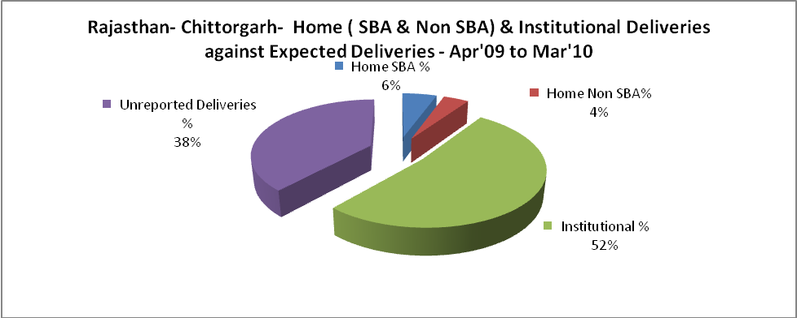

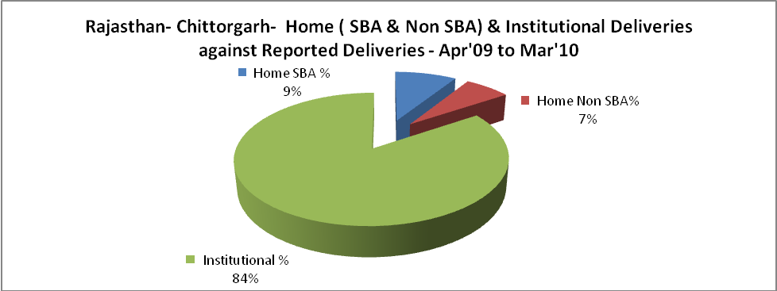

Rajasthan- Chittorgarh- C sections & Complicated Deliveries Apr'09 to Mar'10
 | Institutional Deliveries (Public) | Institutional Deliveries (Pvt)
 | 21,730 | 1,808
C Section | 1,210 | 64
C Section% | 6% | 4%
Complicated Pregnacies attended | 492 | 68
Complicated Pregnacies attended % | 2% | 4%

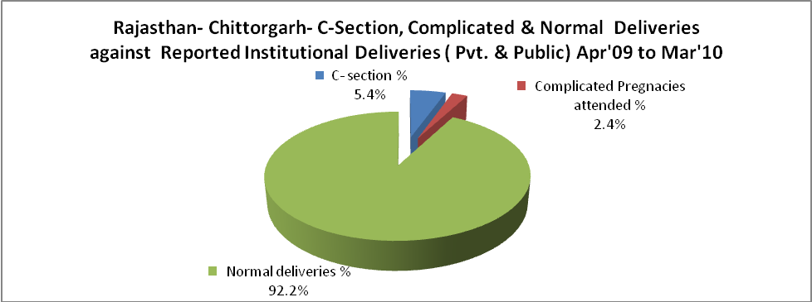

Rajasthan- Chittorgarh- Complicated Pregnancies & Deliveries Treated - Apr'09 to Mar'10
Reported Deliveries |  |  | Reported ANC Reigtration
27,880 |  |  | 39,654
Complicated Pregnancies attended | Complicated Pregnancies Rate | C - Section Deliveries | PNC Maternal Complications | Abortions | Still Births
560 | 1% | 1,274 | 125 | 671 | 631
Complicated Deliveries Treated with |  |  |  | No Of Eclampsia cases Treated | No Of severe anemia cases treated
IV Antibiotics | IV antihypertensive/Magsulph injection | IV Oxytocis | Blood Transfusion | No Of Eclampsia cases Treated | No Of severe anemia cases treated
807 | 96 | 503 | 22 | 14 | 1,104

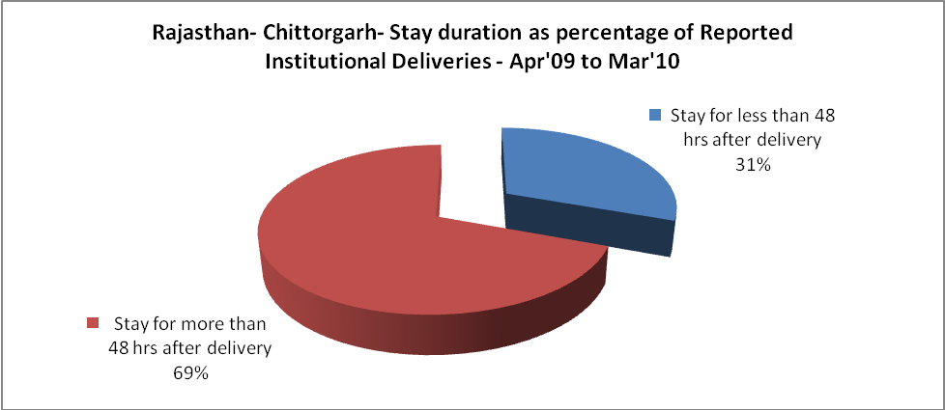

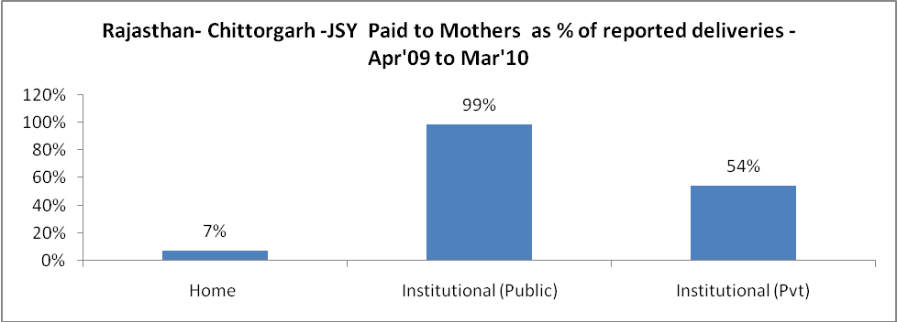

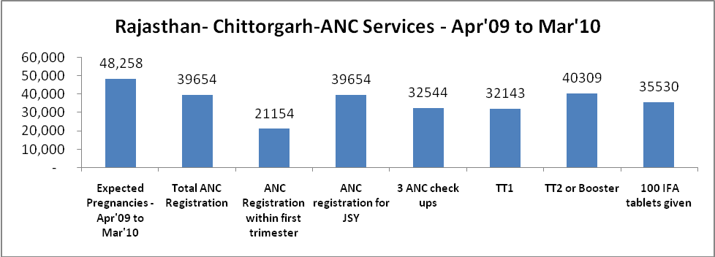

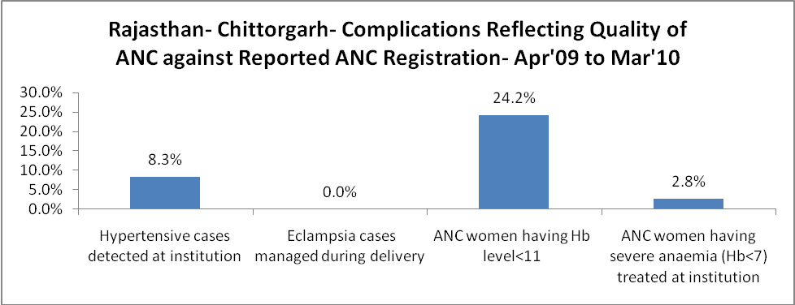

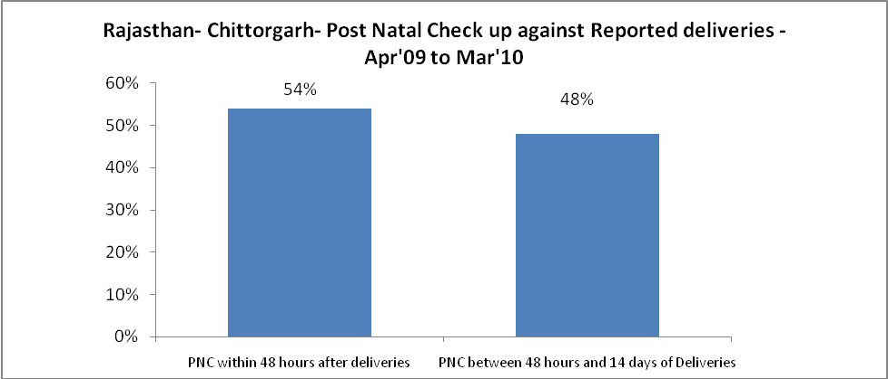

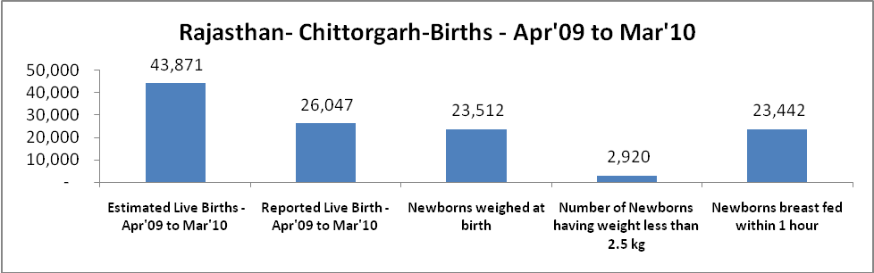

Rajasthan- Chittorgarh - Births - Apr'09 to Mar'10
Live Birth - Males | Live Birth - females | Live Birth - Total | Sex Ratio at birth | Still Birth | Abortion( Induced/Spontaneous
13,763 | 12,284 | 26,047 | 893 | 631 | 671

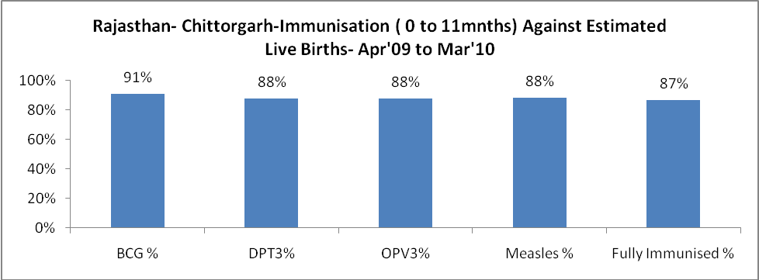

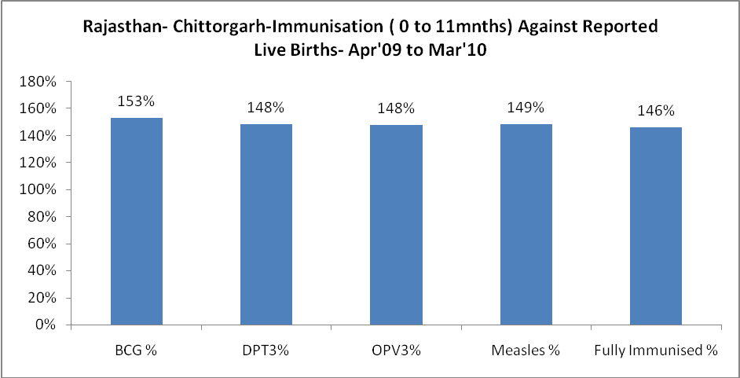

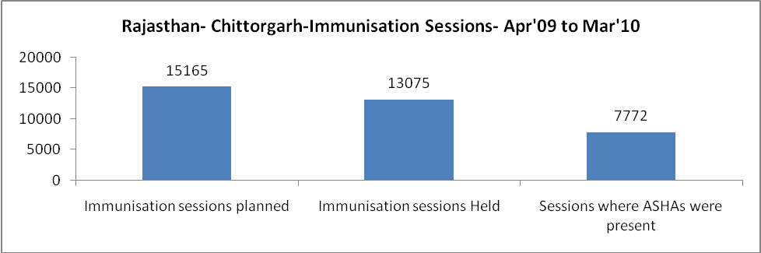

Rajasthan- Chittorgarh- Apr'09 to Mar'10
Total Abortions | Abortion Rate
2,263 | 4.7%

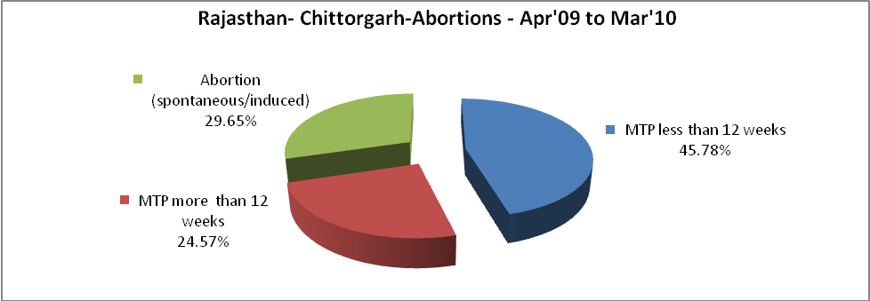

Rajasthan- Chittorgarh- Apr'09 to Mar'10
Total OPD | Total RTI/STI cases
1,712,335 | 3,539

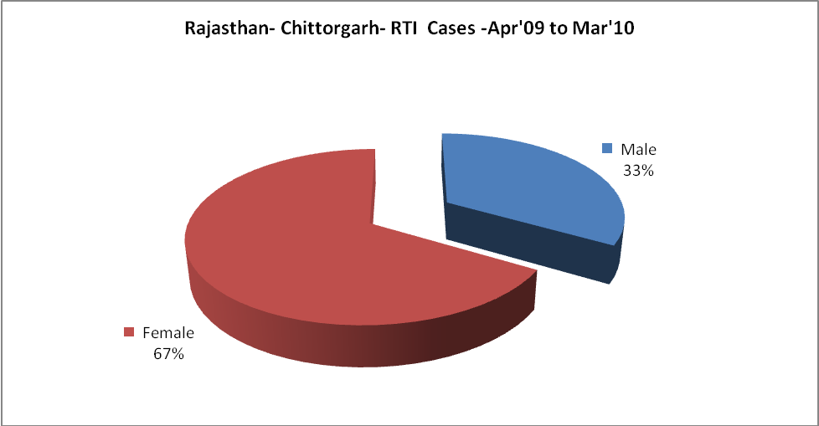

Rajasthan- Chittorgarh-Sterilisations - Apr'09 to Mar'10
 | Reported | %age of Reported Sterilisation
Total Sterilisation | 10,420 | -
NSV | 339 | 3%
Laproscopic | 5,090 | 49%
MiniLap | 2,576 | 25%
Post Partum | 2,415 | 23%
Male Sterilisation | 339 | 3%
Female Sterilisation | 10,081 | 97%

Rajasthan- Chittorgarh-FP Methods - Apr'09 to Mar'10
 | Reported | %age of All Reported FP Methods
Total Reported FP Methodd (All types) Users | 100,432 | -
Sterilisations | 10,420 | 10%
IUD | 12,868 | 13%
Condom Users | 51,054 | 51%
OCP Users | 26,090 | 26%
Limiting Methods | 10,420 | 10%
Spacing Methods | 90,012 | 90%

Rajasthan- Chittorgarh- Service Delivery - Apr'09 to Mar'10
Operation major (General and spinal anaesthesia) | Operation minor (No or local anaesthesia) | AYUSH | Dental Procedures | Adolescent counselling services | Total OPD | Total IPD
1,475 | 21,180 | 34,529 | 1,120 | 2,688 | 1,712,335 | 32,504
Operation major (General and spinal anaesthesia) as %ge of OPD | Operation minor (No or local anaesthesia)as %ge of OPD | AYUSH as %ge of OPD | Dental Procedures as %ge of OPD | Adolescent counselling services as %ge of OPD | IPD as percentage of OPD
0.1% | 1.2% | 2.0% | 0.1% | 0.2% | 2%

Rajasthan- Chittorgarh- Childhood Disease - Vaccine Preventable -Apr'09 to Mar'10
Diphtheria | Pertussis | Tetanus Neonatorum | Tetanus others | Polio | Measles
0 | 0 | 0 | 1 | 0 | 90
Rajasthan- Chittorgarh-Childhood Disease - Others - Apr'09 to Mar'10
Diarrhoea and dehydration | Malaria | Number admitted with Respiratory Infections
1,280 | 78 | 1,237

Rajasthan- Chittorgarh- Infant & Child Deaths - Apr'09 to Mar'10
Infant Deaths within 24 hrs of birth | Infant Deaths between 24hrs & under 1 week | Infant Deaths between 1 week & under 1 month | Child Deaths between 1 month & under 1 year | Child Deaths between 1yr under 5years | Total Deaths
56 | 66 | 23 | 78 | 58 | 281

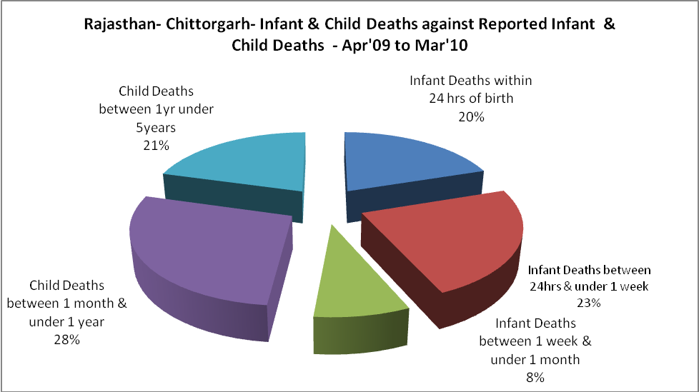

Rajasthan- Chittorgarh- Causes of Infant & Child Deaths - Apr'09 to Mar'10
Sepsis |  |  | Asphyxia |  |  | LBW
Up to 1 Weeks of Birth | Between 1 week & 4 weeks of birth | Total | Up to 1 Weeks of Birth | Between 1 week & 4 weeks of birth | Total | Up to 1 Weeks of Birth | Between 1 week & 4 weeks of birth | Total
14 | 2 | 16 | 10 | 9 | 19 | 22 | 6 | 28
Pneumonia |  |  | Diarrhoea |  |  | Fever related
Between 1 month and 11 months | Between 1 year & 5 years | Total | Between 1 month and 11 months | Between 1 year & 5 years | Total | Between 1 month and 11 months | Between 1 year & 5 years | Total
16 | 6 | 22 | 26 | 18 | 44 | 13 | 14 | 27
Others |  |  | Measles |  |  | Others
Up to 1 Weeks of Birth | Between 1 week & 4 weeks of birth | Total | Between 1 month and 11 months | Between 1 year & 5 years | Total | Between 1 month and 11 months | Between 1 year & 5 years | Total
20 | 6 | 26 | 5 | 1 | 6 | 18 | 19 | 37

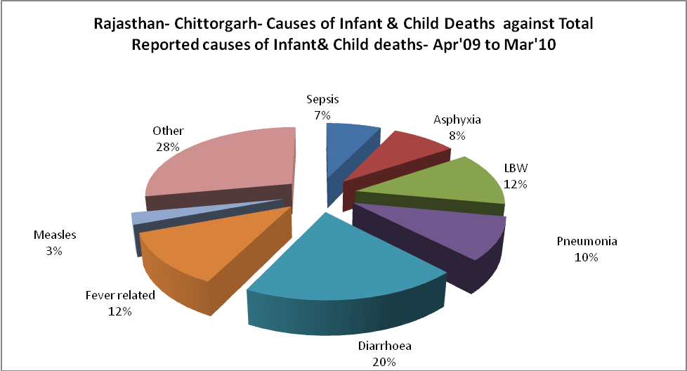

Rajasthan- Chittorgarh- Maternal Deaths & Causes - Apr'09 to Mar'10
Abortion |  |  | Obstructed/prolonged labour |  |  | Severe hypertesnion/fits
6-14 yrs | 15-55 yrs. | Total | 6-14 yrs | 15-55 yrs. | Total | 6-14 yrs | 15-55 yrs. | Total
0 | 8 | 8 | 0 | 0 | 0 | 0 | 1 | 1
Bleeding |  |  | High Fever |  |  | Other Causes
6-14 yrs | 15-55 yrs. | Total | 6-14 yrs | 15-55 yrs. | Total | 6-14 yrs | 15-55 yrs. | Total
0 | 1 | 1 | 0 | 1 | 1 | 2 | 7 | 9

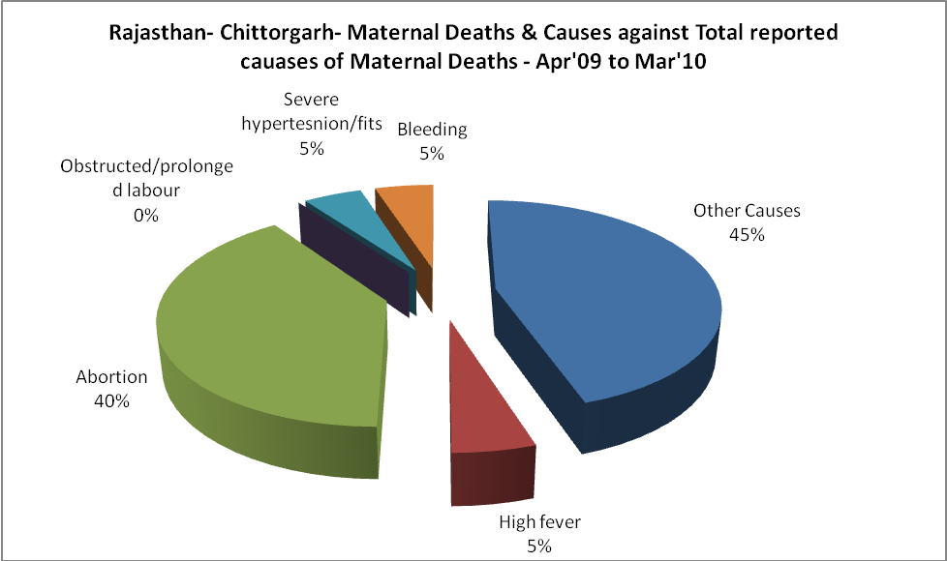

Rajasthan- Chittorgarh-Causes of Deaths in 6 to 55yrs age group - Apr'09 to Mar'10
Diarrhoel Diseases |  |  |  | Tuberculosis |  |  |  | Respiratory Diseases( Other than TB)
6-14 yrs | 15-55 yrs. | Above 55yrs | Total | 6-14 yrs | 15-55 yrs. | Above 55yrs | Total | 6-14 yrs | 15-55 yrs. | Above 55yrs | Total
3 | 10 | 14 | 27 | 2 | 44 | 26 | 72 | 0 | 21 | 46 | 67
Malaria |  |  |  | Other fever Related |  |  |  | HIV/Aids
6-14 yrs | 15-55 yrs. | Above 55yrs | Total | 6-14 yrs | 15-55 yrs. | Above 55yrs | Total | 6-14 yrs | 15-55 yrs. | Above 55yrs | Total
2 | 5 | 5 | 12 | 8 | 13 | 7 | 28 | 2 | 3 | 6 | 11
Heart Disease/Hypertenion related |  |  |  | Neurological Disease including strokes |  |  |  | Trauma/Accidents/ Burn Cases
6-14 yrs | 15-55 yrs. | Above 55yrs | Total | 6-14 yrs | 15-55 yrs. | Above 55yrs | Total | 6-14 yrs | 15-55 yrs. | Above 55yrs | Total
0 | 6 | 12 | 18 | 8 | 7 | 21 | 36 | 5 | 14 | 7 | 26
Suicide |  |  |  | Animal Bites & Stings
6-14 yrs | 15-55 yrs. | Above 55yrs | Total | 6-14 yrs | 15-55 yrs. | Above 55yrs | Total
0 | 1 | 1 | 2 | 1 | 2 | 0 | 3

