NHSRC
Rajasthan-Churu
Analysis: Apr 2009 – Mar 2010

Rajasthan- Churu- Summary-Apr'09 to Mar'10
ANC
ANC Registration against Expected Pregnancies | 103% | TT1 given to Pregnant women against ANC Registraion | 68%
3 ANC Check ups against ANC Reigtrations | 82% | 100 IFA Tablets given to Pregnant women against ANC Registraion | 88%
Deliveries
Unreported Deliveries against Estimated Deliveries | 36.4% | HOME Deliveries( SBA& Non SBA) against Estimated Deliveries | 6.8%
Institutional Deliveries against Estimated Deliveries | 56.8% | HOME Deliveries( SBA& Non SBA) against Reported Deliveries | 10.7%
Institutional Deliveries against Reported Deliveries | 89.3% | C Section Deliveries against Institutional Deliveries( Pvt & Pub) | 1%
Births & Neonates Care
Live Births Reported against Estimated Live Births | 65% | New borns weighed against Reported Live Births | 98%
Still Births (Reported) | 520 | New borns weighed less than 2.5 kgs against newborns weighed | 11%
Sex Ratio at Birh | 878 | New borns breastfed within one hr of Birth against Reported live Births | 95%
Child Immunisation( 0 to 11 months)
BCG given against Expected Live Births | 101% | Measles given against Expected Live Births | 97%
OPV3 given against Expected Live Births | 99% | Fully Immunised Children against Expected Live Births | 96%
DPT3 given against Expected Live Births | 99%
Family Planning
Family Plannig Methods Users ( Sterilisations(Male &Female)+IUD+ Condom pieces/72 + OCP Cycles/13) | 104,246 | IUD Insertions against reported FP Methods | 12%
Sterilisation against reported FP Methods | 9% | Condom Users against reported FP Methods | 50%
 |  | OCP Users against reported FP Methods | 29%
Other Services
OPD | 1,087,480 | Major Operations | 2,098
IPD | 58,927 | Minor Operations | 4,801

`
Rajasthan- Churu- Deliveries Apr'09 to Mar'10
Total Population | 2,015,600 | Expected Deliveries |  | 57,175
Home SBA | Home Non SBA | Institutional | Total Deliveries Reported | Unreported Deliveries
1,770 | 2,121 | 32,467 | 36,358 | 20,817
Home SBA % | Home Non SBA% | Institutional % | Total Deliveries Reported % | Unreported Deliveries %
3% | 4% | 57% | 64% | 36%

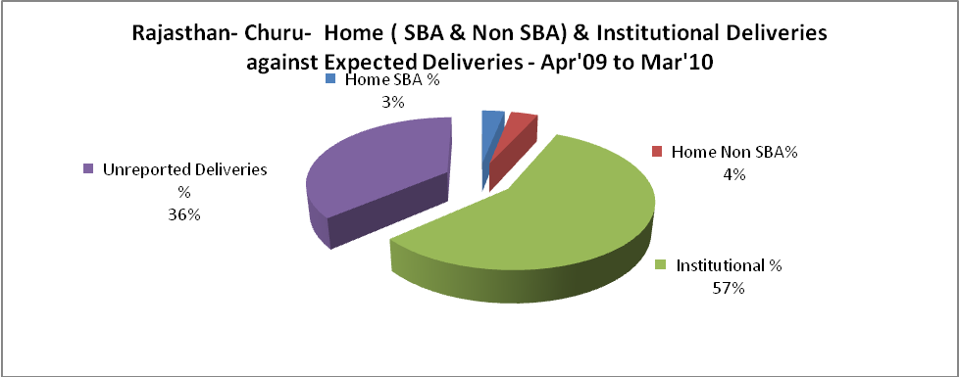

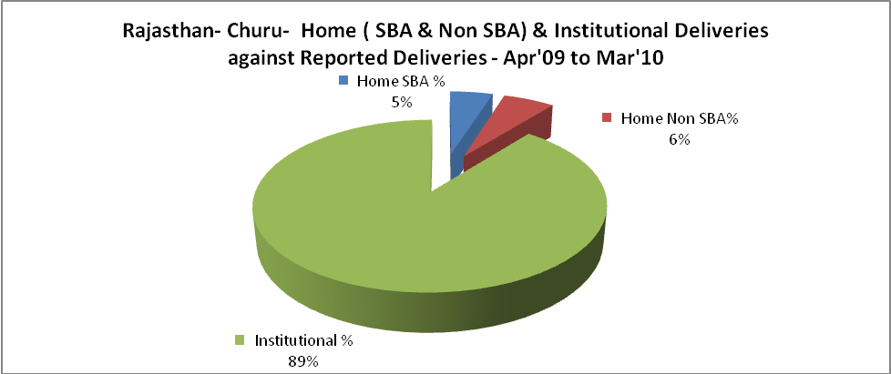

Rajasthan- Churu- C sections & Complicated Deliveries Apr'09 to Mar'10
 | Institutional Deliveries (Public) | Institutional Deliveries (Pvt)
 | 28,816 | 3,651
C Section | 395 | 62
C Section% | 1% | 2%
Complicated Pregnacies attended | 860 | -
Complicated Pregnacies attended % | 3% | 0%

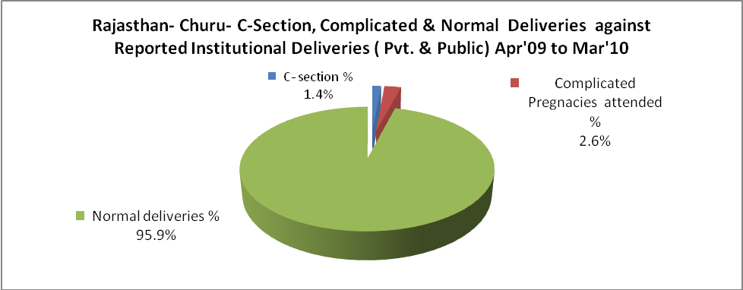

Rajasthan- Churu- Complicated Pregnancies & Deliveries Treated - Apr'09 to Mar'10
Reported Deliveries |  |  | Reported ANC Reigtration
36,358 |  |  | 62,796
Complicated Pregnancies attended | Complicated Pregnancies Rate | C - Section Deliveries | PNC Maternal Complications | Abortions | Still Births
860 | 1% | 457 | 114 | 333 | 520
Complicated Deliveries Treated with |  |  |  | No Of Eclampsia cases Treated | No Of severe anemia cases treated
IV Antibiotics | IV antihypertensive/Magsulph injection | IV Oxytocis | Blood Transfusion | No Of Eclampsia cases Treated | No Of severe anemia cases treated
2,900 | 49 | 1,432 | 357 | 26 | 1,037

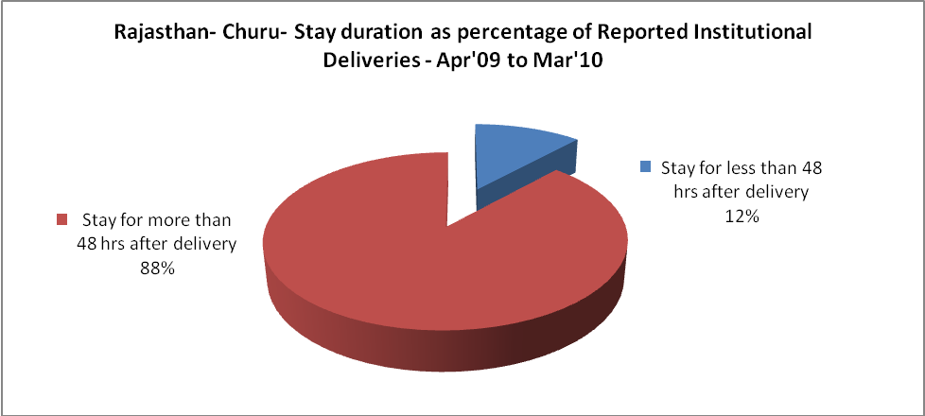

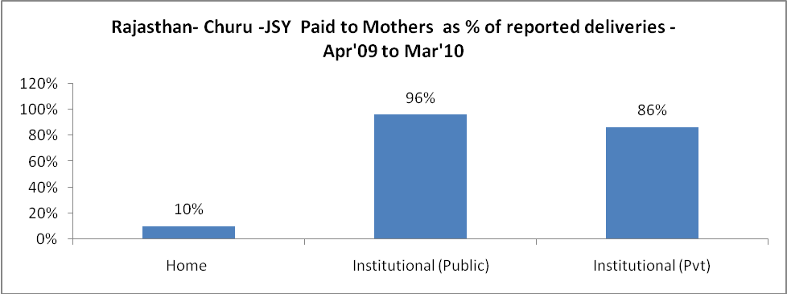

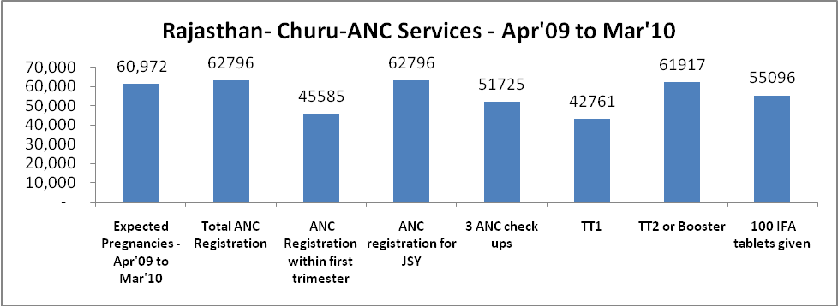
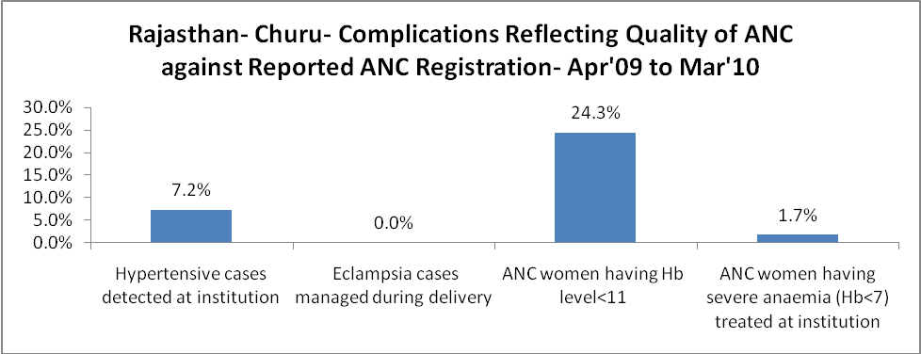

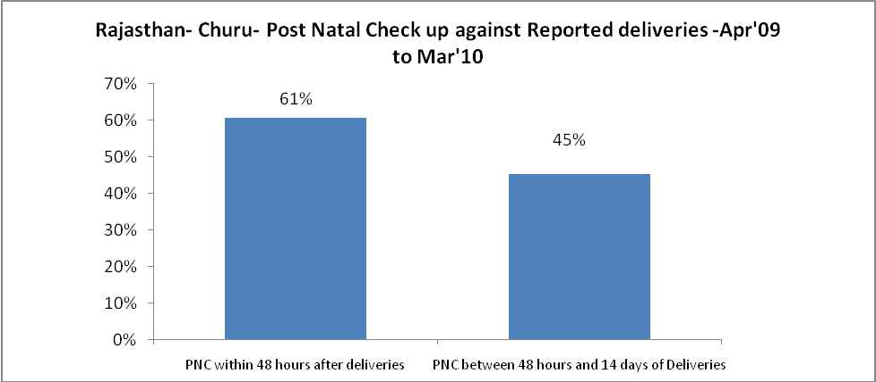

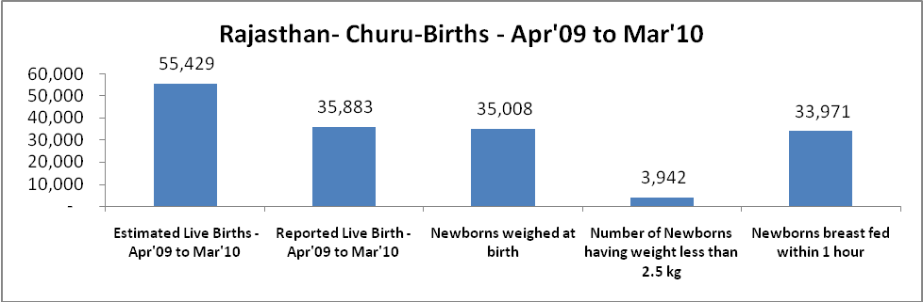

Rajasthan- Churu - Births - Apr'09 to Mar'10
Live Birth - Males | Live Birth - females | Live Birth - Total | Sex Ratio at birth | Still Birth | Abortion( Induced/Spontaneous
19,112 | 16,771 | 35,883 | 878 | 520 | 333

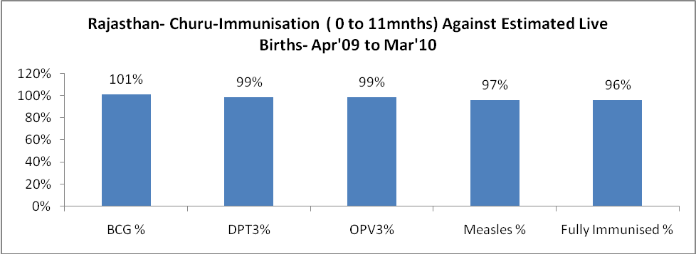

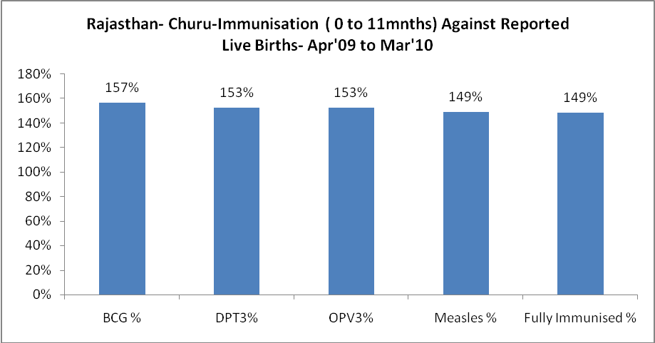

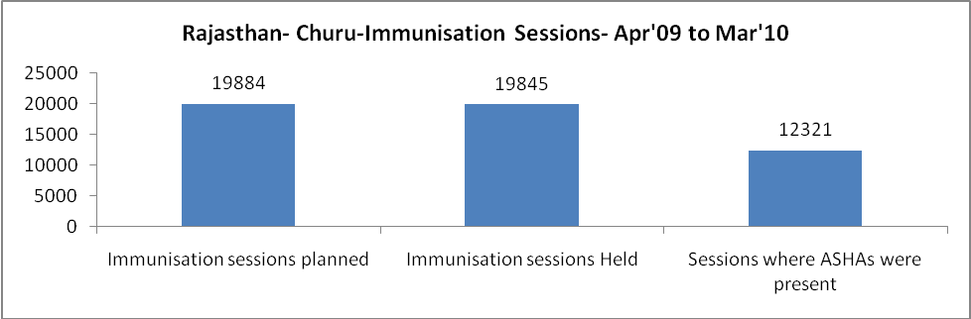

Rajasthan- Churu- Apr'09 to Mar'10
Total Abortions | Abortion Rate
602 | 1.0%

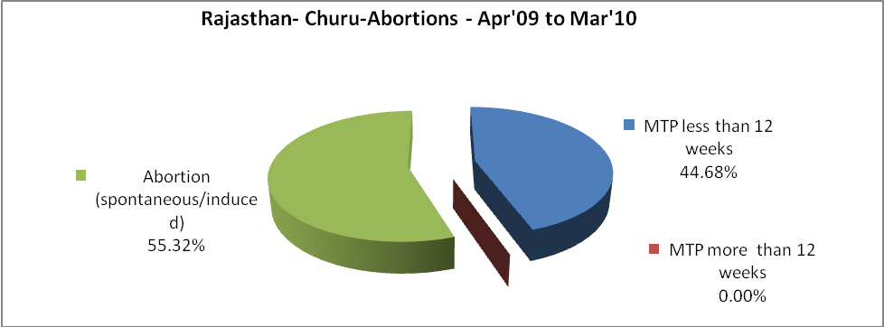

Rajasthan- Churu- Apr'09 to Mar'10
Total OPD | Total RTI/STI cases
1,087,480 | 6,151

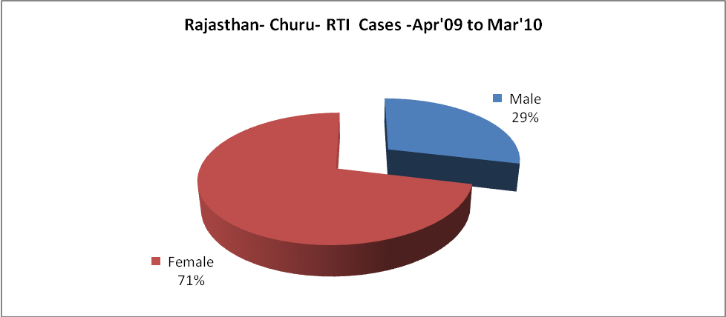

Rajasthan- Churu-Sterilisations - Apr'09 to Mar'10
 | Reported | %age of Reported Sterilisation
Total Sterilisation | 9,199 | -
NSV | 644 | 7%
Laproscopic | 8,358 | 91%
MiniLap | 46 | 1%
Post Partum | 151 | 2%
Male Sterilisation | 644 | 7%
Female Sterilisation | 8,555 | 93%

Rajasthan- Churu-FP Methods - Apr'09 to Mar'10
 | Reported | %age of All Reported FP Methods
Total Reported FP Methodd (All types) Users | 104,246 | -
Sterilisations | 9,199 | 9%
IUD | 12,340 | 12%
Condom Users | 52,383 | 50%
OCP Users | 30,324 | 29%
Limiting Methods | 9,199 | 9%
Spacing Methods | 95,047 | 91%

Rajasthan- Churu- Service Delivery - Apr'09 to Mar'10
Operation major (General and spinal anaesthesia) | Operation minor (No or local anaesthesia) | AYUSH | Dental Procedures | Adolescent counselling services | Total OPD | Total IPD
2,098 | 4,801 | 31,764 | 3,928 | 3,132 | 1,087,480 | 58,927
Operation major (General and spinal anaesthesia) as %ge of OPD | Operation minor (No or local anaesthesia)as %ge of OPD | AYUSH as %ge of OPD | Dental Procedures as %ge of OPD | Adolescent counselling services as %ge of OPD | IPD as percentage of OPD
0.2% | 0.4% | 2.9% | 0.4% | 0.3% | 5%

Rajasthan- Churu- Lab Services - Apr'09 to Mar'10
Total OPD | Total HB tested | Total HIV Tested | Total Population
1,087,480 | 27,322 | 4,525 | 2,015,600
HB test conducted as %age of OPD | HB<7gm as %age of HB tested | HIV test conducted as %age of OPD | HIV positive as %age of HIV tested | Blood Smear Examined as % of Population
2.5% | 6.7% | 0.4% | 0.5% | 6.2%

Rajasthan- Churu- Childhood Disease - Vaccine Preventable -Apr'09 to Mar'10
Diphtheria | Pertussis | Tetanus Neonatorum | Tetanus others | Polio | Measles
0 | 0 | 0 | 0 | 0 | 36
Rajasthan- Churu-Childhood Disease - Others - Apr'09 to Mar'10
Diarrhoea and dehydration | Malaria | Number admitted with Respiratory Infections
1,219 | 217 | 4,745

Rajasthan- Churu- Infant & Child Deaths - Apr'09 to Mar'10
Infant Deaths within 24 hrs of birth | Infant Deaths between 24hrs & under 1 week | Infant Deaths between 1 week & under 1 month | Child Deaths between 1 month & under 1 year | Child Deaths between 1yr under 5years | Total Deaths
26 | 46 | 11 | 30 | 48 | 161

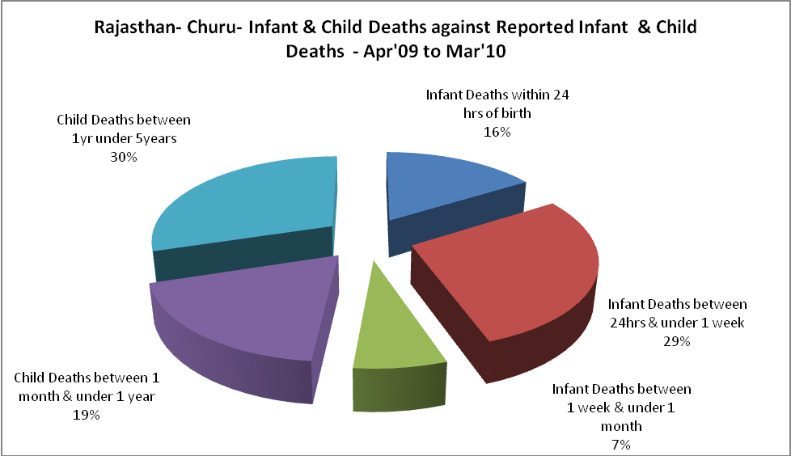

Rajasthan- Churu- Causes of Infant & Child Deaths - Apr'09 to Mar'10
Sepsis |  |  | Asphyxia |  |  | LBW
Up to 1 Weeks of Birth | Between 1 week & 4 weeks of birth | Total | Up to 1 Weeks of Birth | Between 1 week & 4 weeks of birth | Total | Up to 1 Weeks of Birth | Between 1 week & 4 weeks of birth | Total
4 | 1 | 5 | 19 | 0 | 19 | 5 | 4 | 9
Pneumonia |  |  | Diarrhoea |  |  | Fever related
Between 1 month and 11 months | Between 1 year & 5 years | Total | Between 1 month and 11 months | Between 1 year & 5 years | Total | Between 1 month and 11 months | Between 1 year & 5 years | Total
3 | 21 | 24 | 2 | 3 | 5 | 9 | 12 | 21
Others |  |  | Measles |  |  | Others
Up to 1 Weeks of Birth | Between 1 week & 4 weeks of birth | Total | Between 1 month and 11 months | Between 1 year & 5 years | Total | Between 1 month and 11 months | Between 1 year & 5 years | Total
18 | 6 | 24 | 0 | 0 | 0 | 16 | 12 | 28

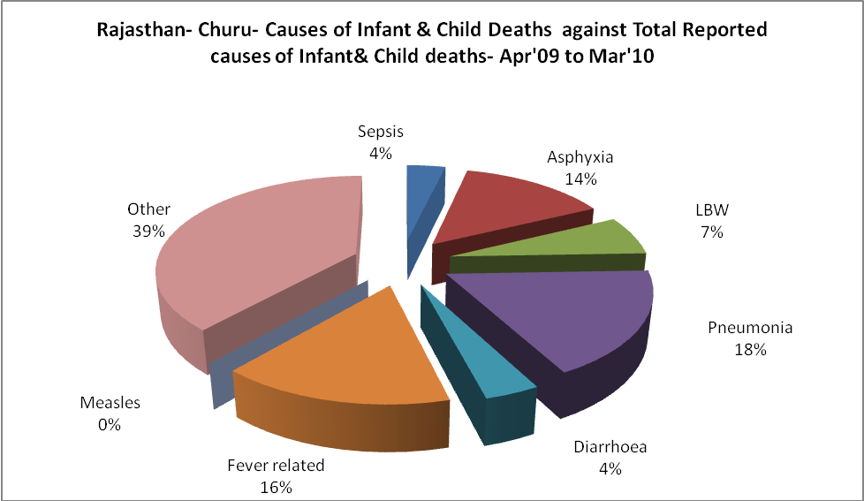

Rajasthan- Churu- Maternal Deaths & Causes - Apr'09 to Mar'10
Abortion |  |  | Obstructed/prolonged labour |  |  | Severe hypertesnion/fits
6-14 yrs | 15-55 yrs. | Total | 6-14 yrs | 15-55 yrs. | Total | 6-14 yrs | 15-55 yrs. | Total
0 | 1 | 1 | 0 | 0 | 0 | 0 | 0 | 0
Bleeding |  |  | High Fever |  |  | Other Causes
6-14 yrs | 15-55 yrs. | Total | 6-14 yrs | 15-55 yrs. | Total | 6-14 yrs | 15-55 yrs. | Total
0 | 0 | 0 | 0 | 0 | 0 | 0 | 1 | 1

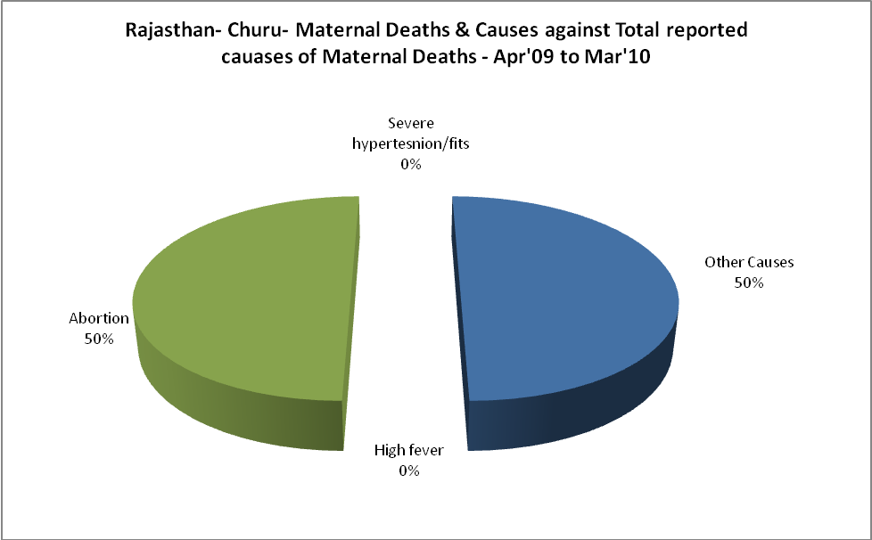

Rajasthan- Churu-Causes of Deaths in 6 to 55yrs age group - Apr'09 to Mar'10
Diarrhoel Diseases |  |  |  | Tuberculosis |  |  |  | Respiratory Diseases( Other than TB)
6-14 yrs | 15-55 yrs. | Above 55yrs | Total | 6-14 yrs | 15-55 yrs. | Above 55yrs | Total | 6-14 yrs | 15-55 yrs. | Above 55yrs | Total
10 | 4 | 1 | 15 | 0 | 7 | 5 | 12 | 1 | 17 | 32 | 50
Malaria |  |  |  | Other fever Related |  |  |  | HIV/Aids
6-14 yrs | 15-55 yrs. | Above 55yrs | Total | 6-14 yrs | 15-55 yrs. | Above 55yrs | Total | 6-14 yrs | 15-55 yrs. | Above 55yrs | Total
0 | 0 | 0 | 0 | 3 | 18 | 17 | 38 | 0 | 0 | 0 | 0
Heart Disease/Hypertenion related |  |  |  | Neurological Disease including strokes |  |  |  | Trauma/Accidents/ Burn Cases
6-14 yrs | 15-55 yrs. | Above 55yrs | Total | 6-14 yrs | 15-55 yrs. | Above 55yrs | Total | 6-14 yrs | 15-55 yrs. | Above 55yrs | Total
0 | 35 | 54 | 89 | 52 | 9 | 14 | 75 | 6 | 19 | 6 | 31
Suicide |  |  |  | Animal Bites & Stings
6-14 yrs | 15-55 yrs. | Above 55yrs | Total | 6-14 yrs | 15-55 yrs. | Above 55yrs | Total
1 | 16 | 1 | 18 | 4 | 6 | 3 | 13

