NHSRC
Rajasthan-Dausa
Analysis: Apr 2009 – Mar 2010

Rajasthan- Dausa- Summary-Apr'09 to Mar'10
ANC
ANC Registration against Expected Pregnancies | 95% | TT1 given to Pregnant women against ANC Registraion | 64%
3 ANC Check ups against ANC Reigtrations | 53% | 100 IFA Tablets given to Pregnant women against ANC Registraion | 111%
Deliveries
Unreported Deliveries against Estimated Deliveries | 29.8% | HOME Deliveries( SBA& Non SBA) against Estimated Deliveries | 6.2%
Institutional Deliveries against Estimated Deliveries | 64.0% | HOME Deliveries( SBA& Non SBA) against Reported Deliveries | 8.8%
Institutional Deliveries against Reported Deliveries | 91.2% | C Section Deliveries against Institutional Deliveries( Pvt & Pub) | 0%
Births & Neonates Care
Live Births Reported against Estimated Live Births | 71% | New borns weighed against Reported Live Births | 88%
Still Births (Reported) | 288 | New borns weighed less than 2.5 kgs against newborns weighed | 14%
Sex Ratio at Birh | 864 | New borns breastfed within one hr of Birth against Reported live Births | 83%
Child Immunisation( 0 to 11 months)
BCG given against Expected Live Births | 96% | Measles given against Expected Live Births | 83%
OPV3 given against Expected Live Births | 88% | Fully Immunised Children against Expected Live Births | 79%
DPT3 given against Expected Live Births | 89%
Family Planning
Family Plannig Methods Users ( Sterilisations(Male &Female)+IUD+ Condom pieces/72 + OCP Cycles/13) | 43,998 | IUD Insertions against reported FP Methods | 14%
Sterilisation against reported FP Methods | 14% | Condom Users against reported FP Methods | 52%
 |  | OCP Users against reported FP Methods | 19%
Other Services
OPD | 606,440 | Major Operations | 254
IPD | 47,866 | Minor Operations | 675

Rajasthan- Dausa- Deliveries Apr'09 to Mar'10
Total Population | 1,571,800 | Expected Deliveries |  | 44,586
Home SBA | Home Non SBA | Institutional | Total Deliveries Reported | Unreported Deliveries
2,185 | 558 | 28,547 | 31,290 | 13,296
Home SBA % | Home Non SBA% | Institutional % | Total Deliveries Reported % | Unreported Deliveries %
5% | 1% | 64% | 70% | 30%
`

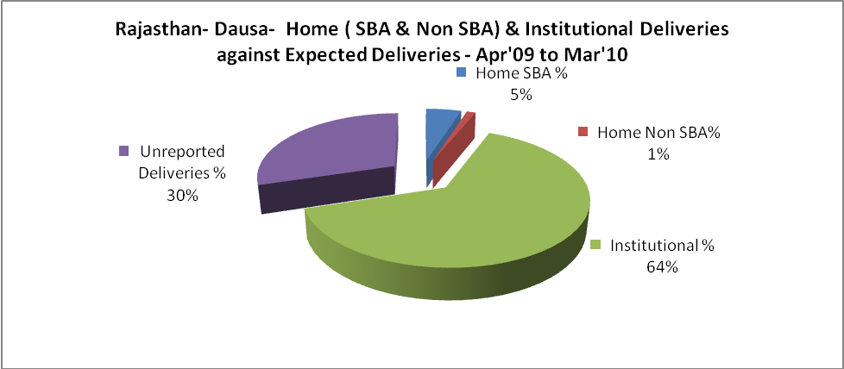

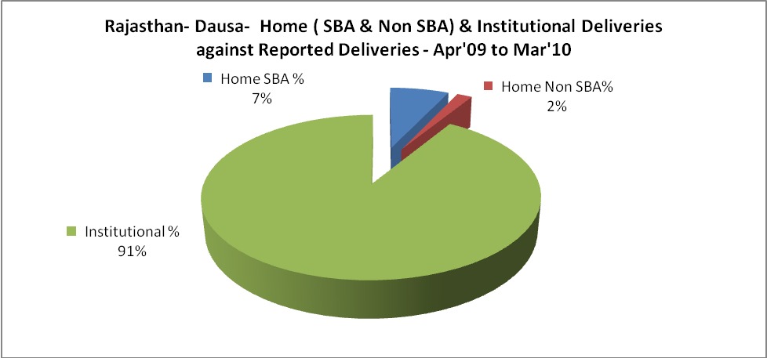

Rajasthan- Dausa- C sections & Complicated Deliveries Apr'09 to Mar'10
 | Institutional Deliveries (Public) | Institutional Deliveries (Pvt)
 | 19,465 | 9,082
C Section | 1 | 1
C Section% | 0% | 0%
Complicated Pregnacies attended | 45 | -
Complicated Pregnacies attended % | 0% | 0%

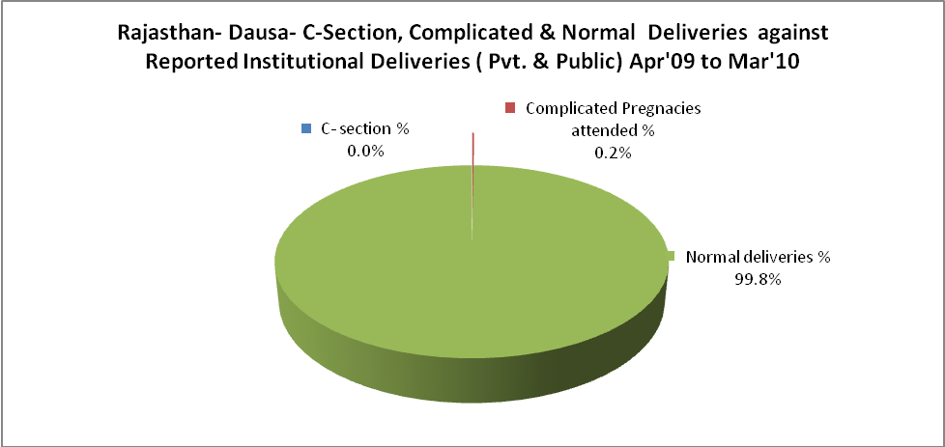

Rajasthan- Dausa- Complicated Pregnancies & Deliveries Treated - Apr'09 to Mar'10
Reported Deliveries |  |  | Reported ANC Reigtration
31,290 |  |  | 44,939
Complicated Pregnancies attended | Complicated Pregnancies Rate | C - Section Deliveries | PNC Maternal Complications | Abortions | Still Births
45 | 0% | 2 | 111 | 261 | 288
Complicated Deliveries Treated with |  |  |  | No Of Eclampsia cases Treated | No Of severe anemia cases treated
IV Antibiotics | IV antihypertensive/Magsulph injection | IV Oxytocis | Blood Transfusion | No Of Eclampsia cases Treated | No Of severe anemia cases treated
248 | 17 | 199 | 21 | 136 | 231

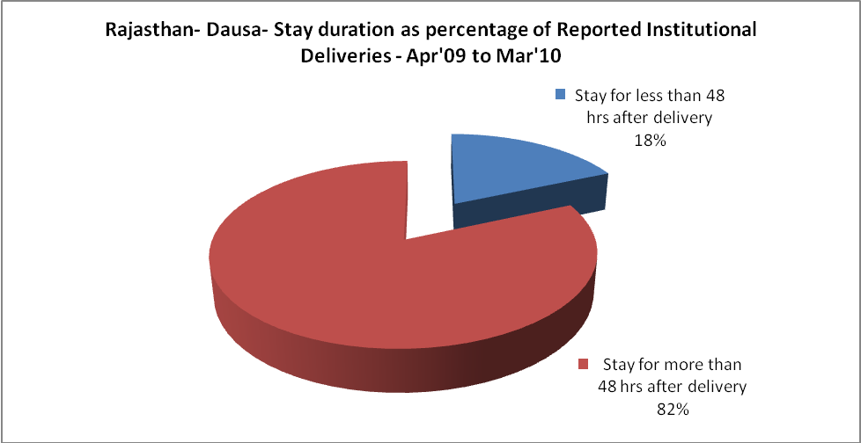

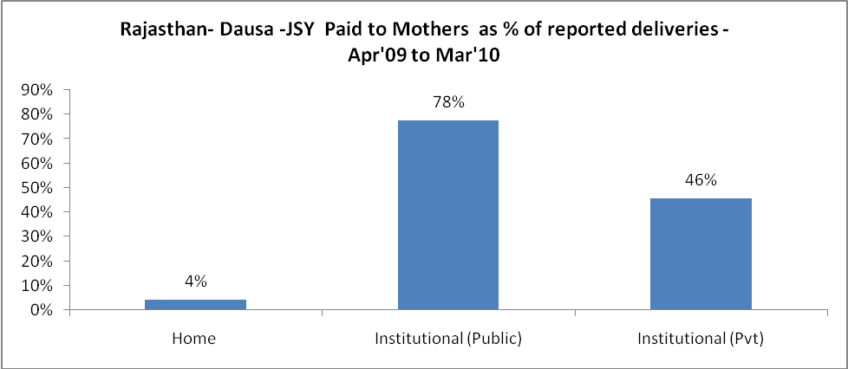

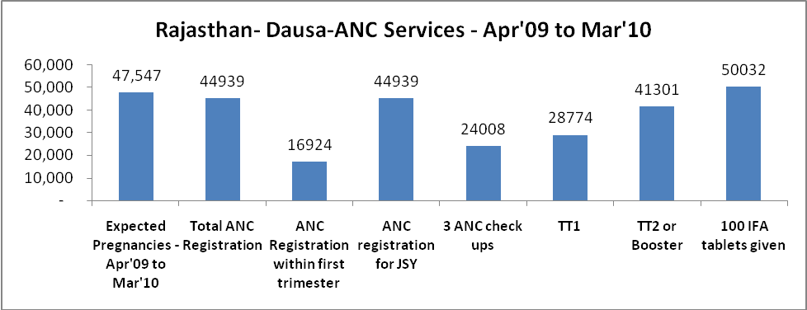
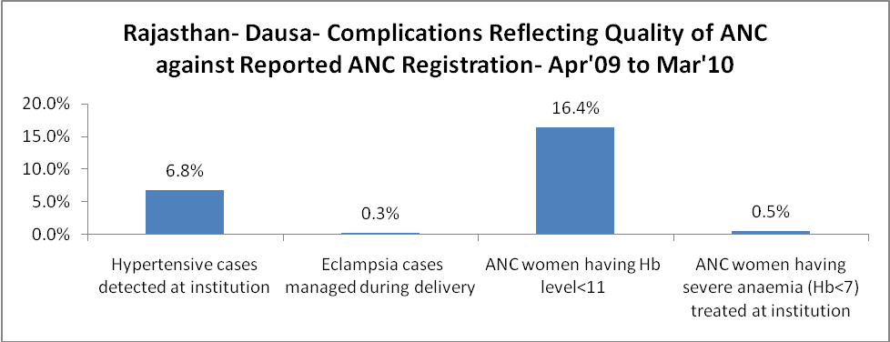

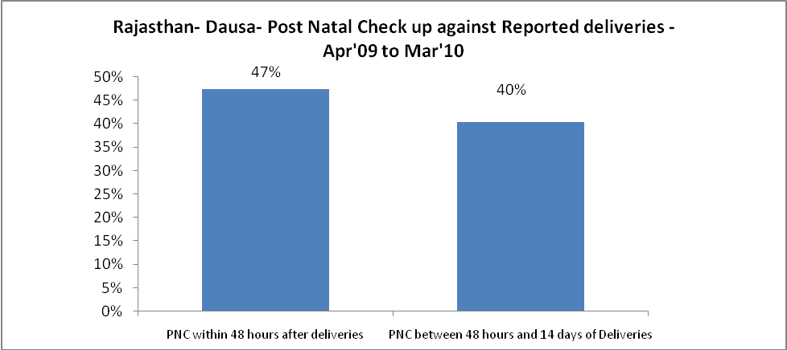

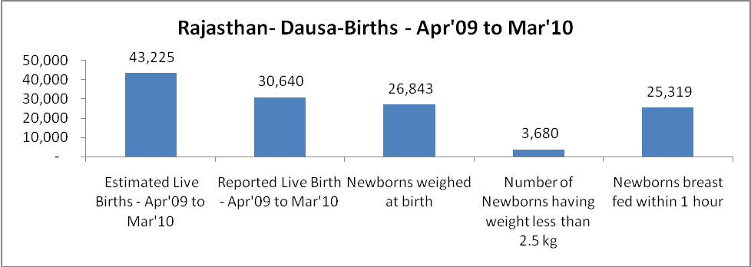

Rajasthan- Dausa - Births - Apr'09 to Mar'10
Live Birth - Males | Live Birth - females | Live Birth - Total | Sex Ratio at birth | Still Birth | Abortion( Induced/Spontaneous
16,440 | 14,200 | 30,640 | 864 | 288 | 261

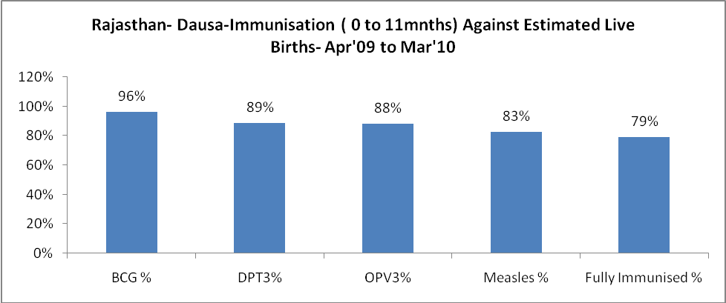

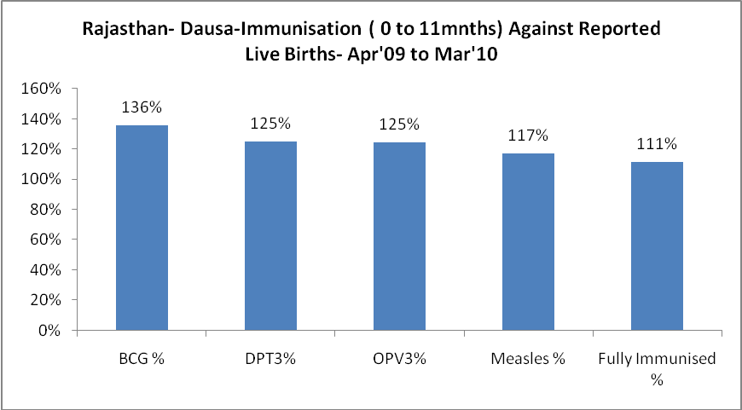

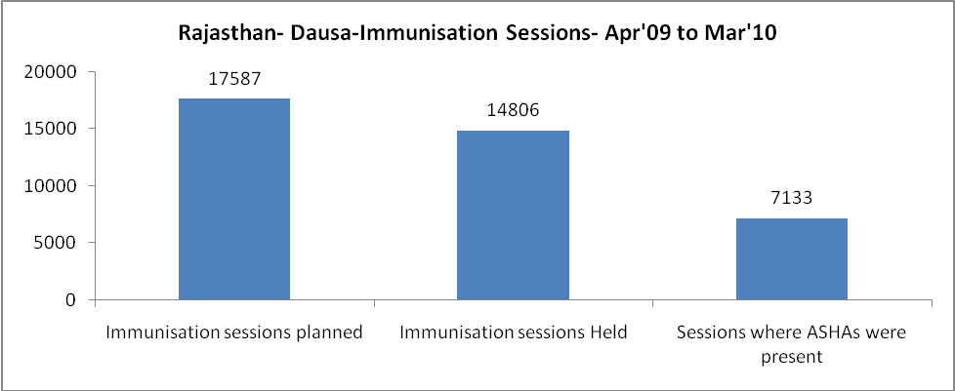

Rajasthan- Dausa- Apr'09 to Mar'10
Total Abortions | Abortion Rate
428 | 0.9%

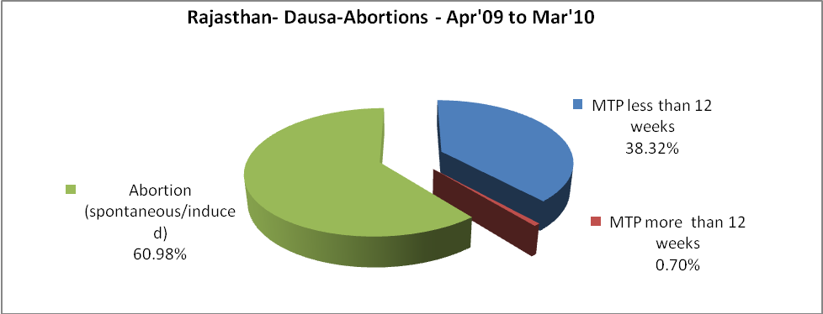

Rajasthan- Dausa- Apr'09 to Mar'10
Total OPD | Total RTI/STI cases
606,440 | 3,175

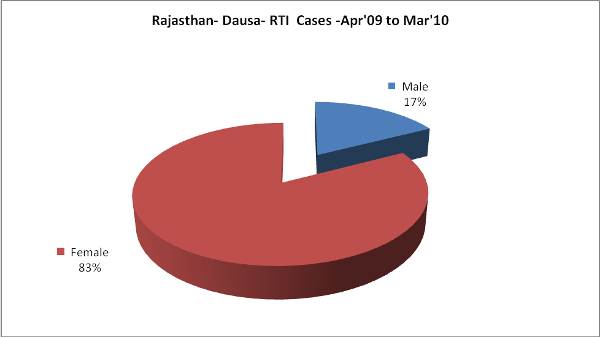
Rajasthan- Dausa-Sterilisations - Apr'09 to Mar'10
 | Reported | %age of Reported Sterilisation
Total Sterilisation | 6,116 | -
NSV | 50 | 1%
Laproscopic | 6,064 | 99%
MiniLap | - | 0%
Post Partum | 2 | 0%
Male Sterilisation | 50 | 1%
Female Sterilisation | 6,066 | 99%

Rajasthan- Dausa-FP Methods - Apr'09 to Mar'10
 | Reported | %age of All Reported FP Methods
Total Reported FP Methodd (All types) Users | 43,998 | -
Sterilisations | 6,116 | 14%
IUD | 6,370 | 14%
Condom Users | 23,079 | 52%
OCP Users | 8,433 | 19%
Limiting Methods | 6,116 | 14%
Spacing Methods | 37,882 | 86%

Rajasthan- Dausa- Lab Services - Apr'09 to Mar'10
Total OPD | Total HB tested | Total HIV Tested | Total Population
606,440 | 17,256 | 2,403 | 1,571,800
HB test conducted as %age of OPD | HB<7gm as %age of HB tested | HIV test conducted as %age of OPD | HIV positive as %age of HIV tested | Blood Smear Examined as % of Population
2.8% | 5.3% | 0.4% | 0.2% | 4.9%

Rajasthan- Dausa- Childhood Disease - Vaccine Preventable -Apr'09 to Mar'10
Diphtheria | Pertussis | Tetanus Neonatorum | Tetanus others | Polio | Measles
0 | 10 | 0 | 0 | 0 | 105
Rajasthan- Dausa-Childhood Disease - Others - Apr'09 to Mar'10
Diarrhoea and dehydration | Malaria | Number admitted with Respiratory Infections
1,811 | 30 | 765

Rajasthan- Dausa- Infant & Child Deaths - Apr'09 to Mar'10
Infant Deaths within 24 hrs of birth | Infant Deaths between 24hrs & under 1 week | Infant Deaths between 1 week & under 1 month | Child Deaths between 1 month & under 1 year | Child Deaths between 1yr under 5years | Total Deaths
58 | 118 | 60 | 238 | 242 | 716

.

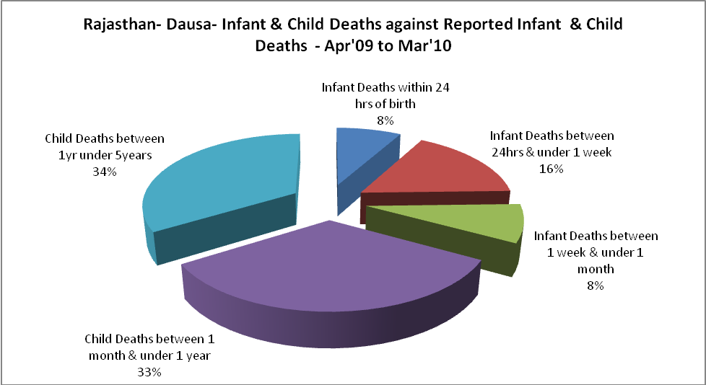

Rajasthan- Dausa- Causes of Infant & Child Deaths - Apr'09 to Mar'10
Sepsis |  |  | Asphyxia |  |  | LBW
Up to 1 Weeks of Birth | Between 1 week & 4 weeks of birth | Total | Up to 1 Weeks of Birth | Between 1 week & 4 weeks of birth | Total | Up to 1 Weeks of Birth | Between 1 week & 4 weeks of birth | Total
22 | 11 | 33 | 10 | 11 | 21 | 26 | 17 | 43
Pneumonia |  |  | Diarrhoea |  |  | Fever related
Between 1 month and 11 months | Between 1 year & 5 years | Total | Between 1 month and 11 months | Between 1 year & 5 years | Total | Between 1 month and 11 months | Between 1 year & 5 years | Total
45 | 26 | 71 | 69 | 74 | 143 | 69 | 106 | 175
Others |  |  | Measles |  |  | Others
Up to 1 Weeks of Birth | Between 1 week & 4 weeks of birth | Total | Between 1 month and 11 months | Between 1 year & 5 years | Total | Between 1 month and 11 months | Between 1 year & 5 years | Total
60 | 21 | 81 | 0 | 2 | 2 | 55 | 34 | 89

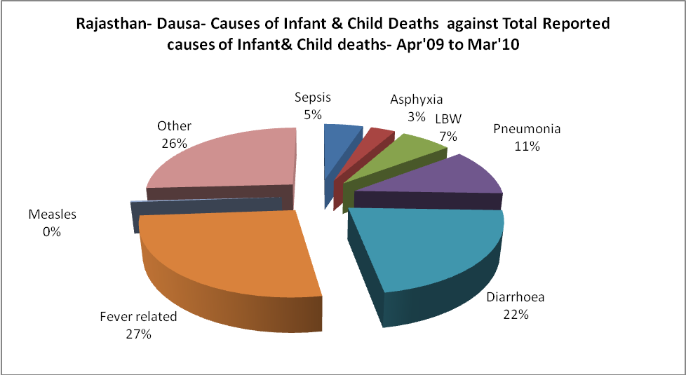

Rajasthan- Dausa- Maternal Deaths & Causes - Apr'09 to Mar'10
Abortion |  |  | Obstructed/prolonged labour |  |  | Severe hypertesnion/fits
6-14 yrs | 15-55 yrs. | Total | 6-14 yrs | 15-55 yrs. | Total | 6-14 yrs | 15-55 yrs. | Total
0 | 6 | 6 | 0 | 1 | 1 | 2 | 5 | 7
Bleeding |  |  | High Fever |  |  | Other Causes
6-14 yrs | 15-55 yrs. | Total | 6-14 yrs | 15-55 yrs. | Total | 6-14 yrs | 15-55 yrs. | Total

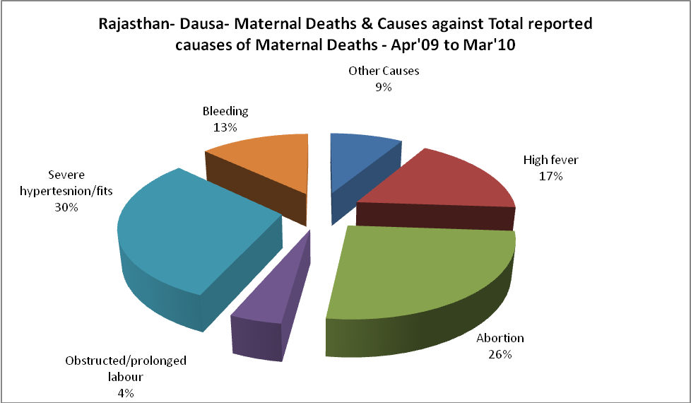

Rajasthan- Dausa-Causes of Deaths in 6 to 55yrs age group - Apr'09 to Mar'10
Diarrhoel Diseases |  |  |  | Tuberculosis |  |  |  | Respiratory Diseases( Other than TB)
6-14 yrs | 15-55 yrs. | Above 55yrs | Total | 6-14 yrs | 15-55 yrs. | Above 55yrs | Total | 6-14 yrs | 15-55 yrs. | Above 55yrs | Total
35 | 31 | 36 | 102 | 3 | 59 | 23 | 85 | 21 | 54 | 71 | 146
Malaria |  |  |  | Other fever Related |  |  |  | HIV/Aids
6-14 yrs | 15-55 yrs. | Above 55yrs | Total | 6-14 yrs | 15-55 yrs. | Above 55yrs | Total | 6-14 yrs | 15-55 yrs. | Above 55yrs | Total
0 | 0 | 0 | 0 | 46 | 82 | 42 | 170 | 0 | 3 | 2 | 5
Heart Disease/Hypertenion related |  |  |  | Neurological Disease including strokes |  |  |  | Trauma/Accidents/ Burn Cases
6-14 yrs | 15-55 yrs. | Above 55yrs | Total | 6-14 yrs | 15-55 yrs. | Above 55yrs | Total | 6-14 yrs | 15-55 yrs. | Above 55yrs | Total
3 | 22 | 30 | 55 | 21 | 17 | 5 | 43 | 7 | 28 | 13 | 48
Suicide |  |  |  | Animal Bites & Stings
6-14 yrs | 15-55 yrs. | Above 55yrs | Total | 6-14 yrs | 15-55 yrs. | Above 55yrs | Total
0 | 5 | 0 | 5 | 2 | 8 | 4 | 14

