NHSRC
Rajasthan-Dhualpur
Analysis: Apr 2009 – Mar 2010

Rajasthan- Dhaulpur- Summary-Apr'09 to Mar'10
ANC
ANC Registration against Expected Pregnancies | 118% | TT1 given to Pregnant women against ANC Registration | 57%
3 ANC Checkups against ANC Registrations | 66% | 100 IFA Tablets given to Pregnant women against ANC Registration | 80%
Deliveries
Unreported Deliveries against Estimated Deliveries | 16.5% | HOME Deliveries( SBA& Non SBA) against Estimated Deliveries | 9.6%
Institutional Deliveries against Estimated Deliveries | 73.9% | HOME Deliveries( SBA& Non SBA) against Reported Deliveries | 11.5%
Institutional Deliveries against Reported Deliveries | 88.5% | C Section Deliveries against Institutional Deliveries( Pvt & Pub) | 1%
Births & Neonates Care
Live Births Reported against Estimated Live Births | 83% | New borns weighed against Reported Live Births | 88%
Still Births (Reported) | 518 | New borns weighed less than 2.5 kgs against newborns weighed | 11%
Sex Ratio at Birth | 880 | New borns breastfed within one hr of Birth against Reported live Births | 95%
Child Immunisation( 0 to 11 months)
BCG given against Expected Live Births | 101% | Measles given against Expected Live Births | 92%
OPV3 given against Expected Live Births | 96% | Fully Immunised Children against Expected Live Births | 90%
DPT3 given against Expected Live Births | 96%
Family Planning
Family Plannig Methods Users ( Sterilisations(Male &Female)+IUD+ Condom pieces/72 + OCP Cycles/13) | 55,187 | IUD Insertions against reported FP Methods | 9%
Sterilisation against reported FP Methods | 9% | Condom Users against reported FP Methods | 58%
 |  | OCP Users against reported FP Methods | 25%
Other Services
OPD | 417,826 | Major Operations | 543
IPD | 54,406 | Minor Operations | 1,365

Rajasthan- Dhaulpur- Deliveries Apr'09 to Mar'10
Total Population | 1,171,000 | Expected Deliveries |  | 33,217
Home SBA | Home Non SBA | Institutional | Total Deliveries Reported | Unreported Deliveries
1,757 | 1,447 | 24,546 | 27,750 | 5,467
Home SBA % | Home Non SBA% | Institutional % | Total Deliveries Reported % | Unreported Deliveries %
5% | 4% | 74% | 84% | 16%

`
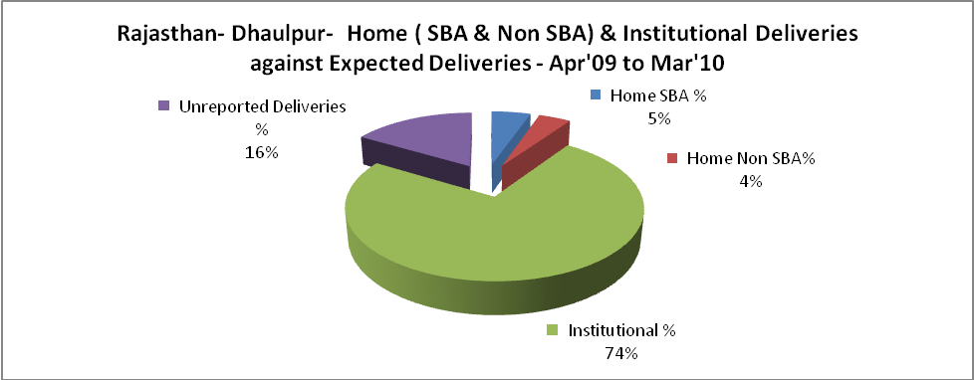

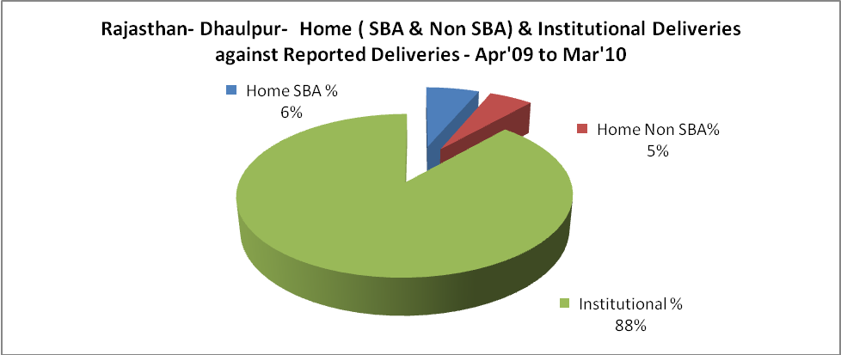

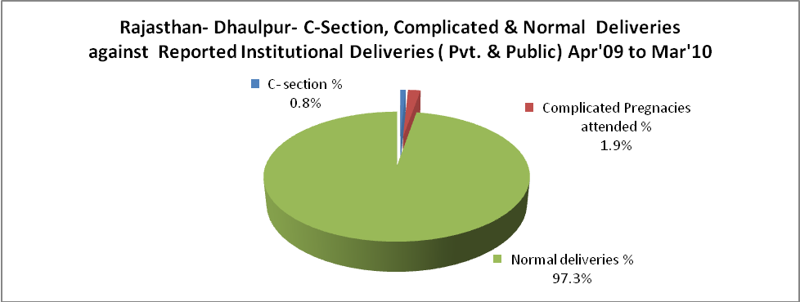

Rajasthan- Dhaulpur- Complicated Pregnancies & Deliveries Treated - Apr'09 to Mar'10
Reported Deliveries |  |  | Reported ANC Reigtration
27,750 |  |  | 41,677
Complicated Pregnancies attended | Complicated Pregnancies Rate | C - Section Deliveries | PNC Maternal Complications | Abortions | Still Births
469 | 1% | 201 | 252 | 358 | 518
Complicated Deliveries Treated with |  |  |  | No Of Eclampsia cases Treated | No Of severe anemia cases treated
IV Antibiotics | IV antihypertensive/Magsulph injection | IV Oxytocis | Blood Transfusion | No Of Eclampsia cases Treated | No Of severe anemia cases treated
2,891 | 182 | 2,791 | 244 | 343 | 1,523

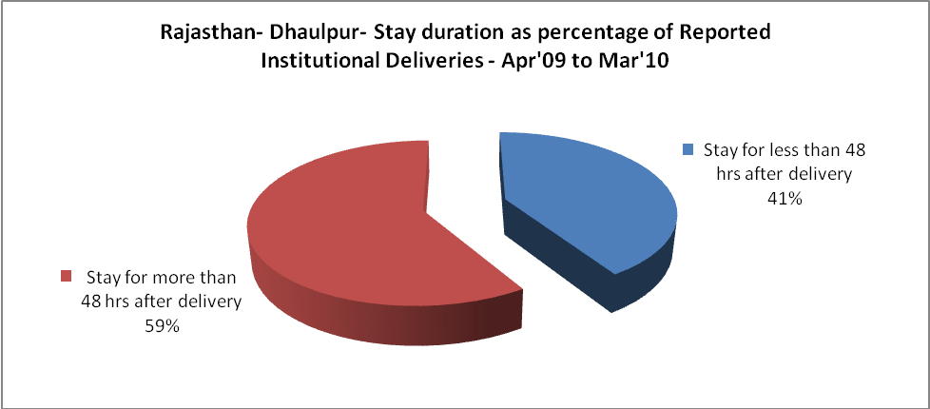

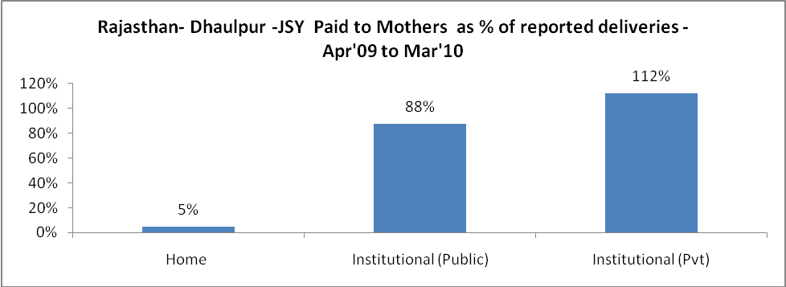

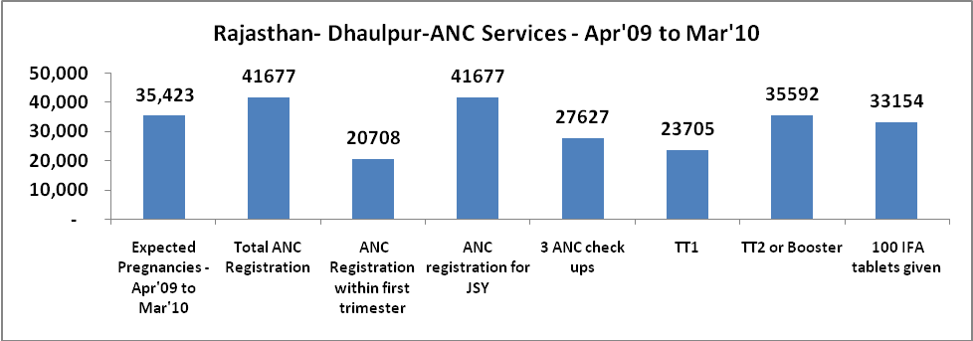
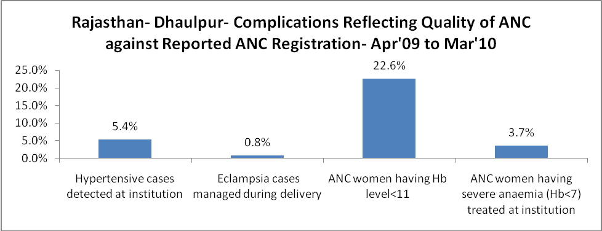

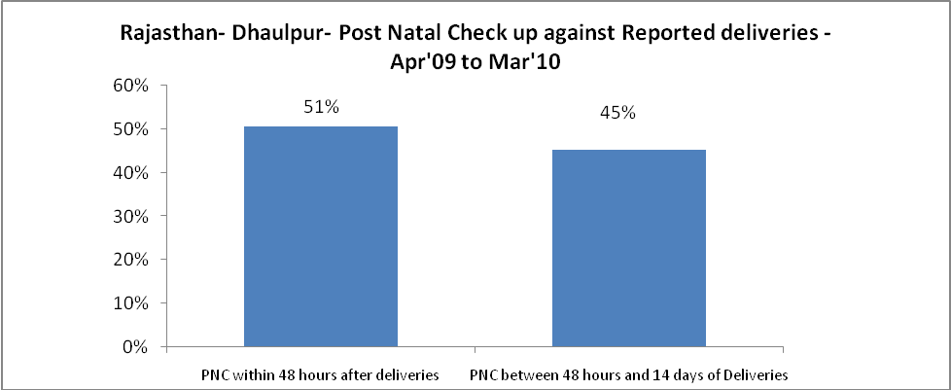

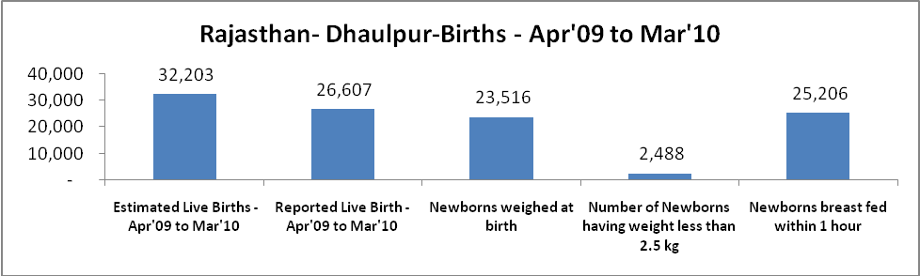

Rajasthan- Dhaulpur - Births - Apr'09 to Mar'10
Live Birth - Males | Live Birth - females | Live Birth - Total | Sex Ratio at birth | Still Birth | Abortion( Induced/Spontaneous
14,154 | 12,453 | 26,607 | 880 | 518 | 358

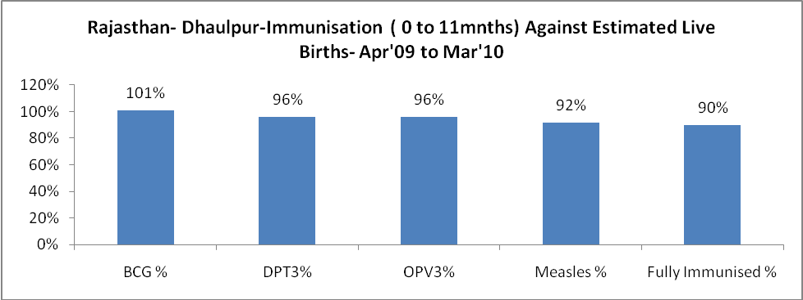

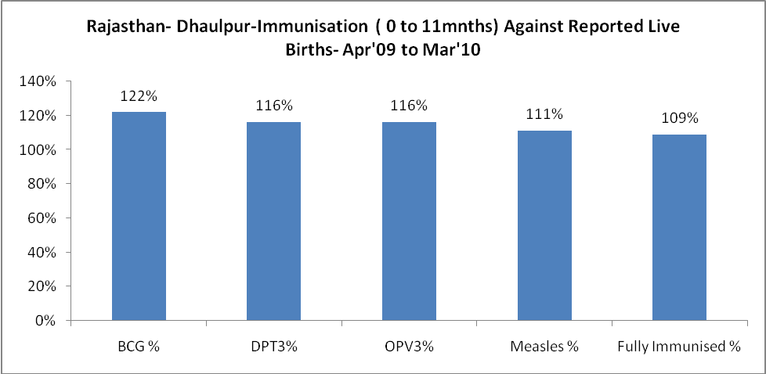

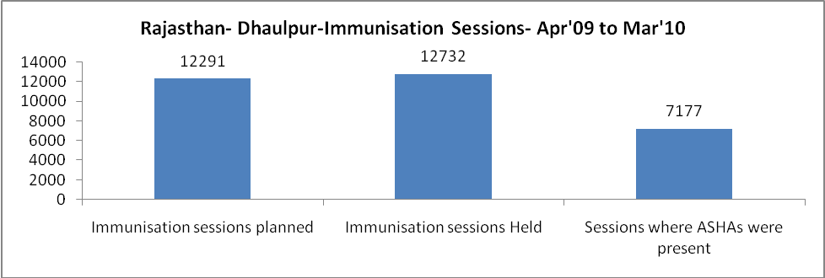

Rajasthan- Dhaulpur- Apr'09 to Mar'10
Total Abortions | Abortion Rate
542 | 1.5%

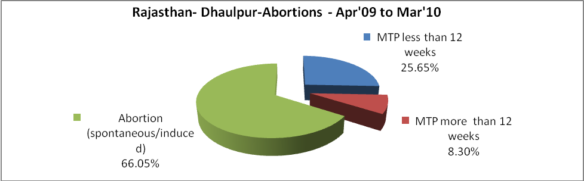

Rajasthan- Dhaulpur- Apr'09 to Mar'10
Total OPD | Total RTI/STI cases
417,826 | 3,289

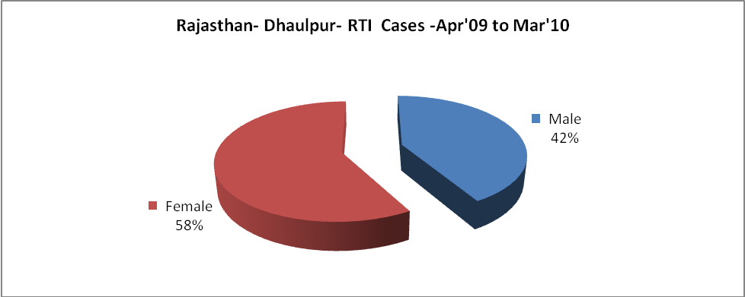

Rajasthan- Dhaulpur-Sterilisations - Apr'09 to Mar'10
 | Reported | %age of Reported Sterilisation
Total Sterilisation | 4,781 | -
NSV | 40 | 1%
Laproscopic | 4,669 | 98%
MiniLap | 6 | 0%
Post Partum | 66 | 1%
Male Sterilisation | 40 | 1%
Female Sterilisation | 4,741 | 99%

Rajasthan- Dhaulpur-FP Methods - Apr'09 to Mar'10
 | Reported | %age of All Reported FP Methods
Total Reported FP Methodd (All types) Users | 55,187 | -
Sterilisations | 4,781 | 9%
IUD | 4,840 | 9%
Condom Users | 31,828 | 58%
OCP Users | 13,739 | 25%
Limiting Methods | 4,781 | 9%
Spacing Methods | 50,406 | 91%

Rajasthan- Dhaulpur- Service Delivery - Apr'09 to Mar'10
Operation major (General and spinal anaesthesia) | Operation minor (No or local anaesthesia) | AYUSH | Dental Procedures | Adolescent counselling services | Total OPD | Total IPD
543 | 1,365 | 14,171 | 793 | 577 | 417,826 | 54,406
Operation major (General and spinal anaesthesia) as %ge of OPD | Operation minor (No or local anaesthesia)as %ge of OPD | AYUSH as %ge of OPD | Dental Procedures as %ge of OPD | Adolescent counselling services as %ge of OPD | IPD as percentage of OPD
0.1% | 0.3% | 3.4% | 0.2% | 0.1% | 13%

Rajasthan- Dhaulpur- Lab Services - Apr'09 to Mar'10
Total OPD | Total HB tested | Total HIV Tested | Total Population
417,826 | 13,253 | 6,344 | 1,171,000
HB test conducted as %age of OPD | HB<7gm as %age of HB tested | HIV test conducted as %age of OPD | HIV positive as %age of HIV tested | Blood Smear Examined as % of Population
3.2% | 6.2% | 1.5% | 1.1% | 3.9%

Rajasthan- Dhaulpur- Childhood Disease - Vaccine Preventable -Apr'09 to Mar'10
Diphtheria | Pertussis | Tetanus Neonatorum | Tetanus others | Polio | Measles
0 | 0 | 0 | 5 | 0 | 12
Rajasthan- Dhaulpur-Childhood Disease - Others - Apr'09 to Mar'10
Diarrhoea and dehydration | Malaria | Number admitted with Respiratory Infections
3,197 | 525 | 4,451

Rajasthan- Dhaulpur- Infant & Child Deaths - Apr'09 to Mar'10
Infant Deaths within 24 hrs of birth | Infant Deaths between 24hrs & under 1 week | Infant Deaths between 1 week & under 1 month | Child Deaths between 1 month & under 1 year | Child Deaths between 1yr under 5years | Total Deaths
162 | 83 | 38 | 103 | 64 | 450

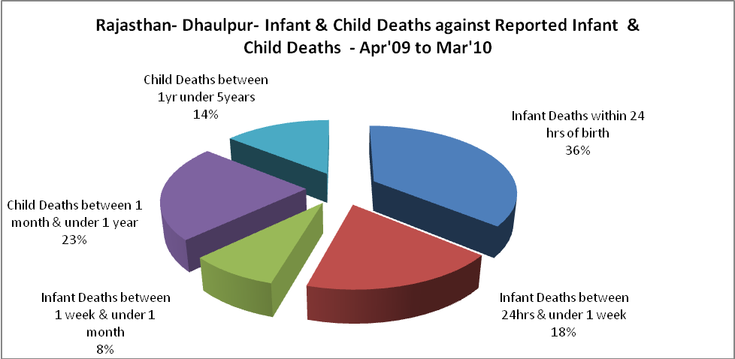

Rajasthan- Dhaulpur- Causes of Infant & Child Deaths - Apr'09 to Mar'10
Sepsis |  |  | Asphyxia |  |  | LBW
Up to 1 Weeks of Birth | Between 1 week & 4 weeks of birth | Total | Up to 1 Weeks of Birth | Between 1 week & 4 weeks of birth | Total | Up to 1 Weeks of Birth | Between 1 week & 4 weeks of birth | Total
10 | 5 | 15 | 10 | 6 | 16 | 26 | 10 | 36
Pneumonia |  |  | Diarrhoea |  |  | Fever related
Between 1 month and 11 months | Between 1 year & 5 years | Total | Between 1 month and 11 months | Between 1 year & 5 years | Total | Between 1 month and 11 months | Between 1 year & 5 years | Total
21 | 9 | 30 | 5 | 3 | 8 | 24 | 16 | 40
Others |  |  | Measles |  |  | Others
Up to 1 Weeks of Birth | Between 1 week & 4 weeks of birth | Total | Between 1 month and 11 months | Between 1 year & 5 years | Total | Between 1 month and 11 months | Between 1 year & 5 years | Total
37 | 17 | 54 | 0 | 0 | 0 | 53 | 36 | 89

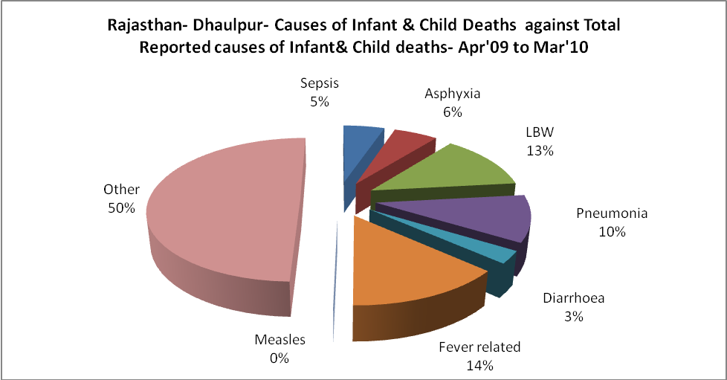

Rajasthan- Dhaulpur- Maternal Deaths & Causes - Apr'09 to Mar'10
Abortion |  |  | Obstructed/prolonged labour |  |  | Severe hypertesnion/fits
6-14 yrs | 15-55 yrs. | Total | 6-14 yrs | 15-55 yrs. | Total | 6-14 yrs | 15-55 yrs. | Total
0 | 5 | 5 | 0 | 0 | 0 | 0 | 0 | 0
Bleeding |  |  | High Fever |  |  | Other Causes
6-14 yrs | 15-55 yrs. | Total | 6-14 yrs | 15-55 yrs. | Total | 6-14 yrs | 15-55 yrs. | Total
1 | 2 | 3 | 0 | 0 | 0 | 1 | 2 | 3

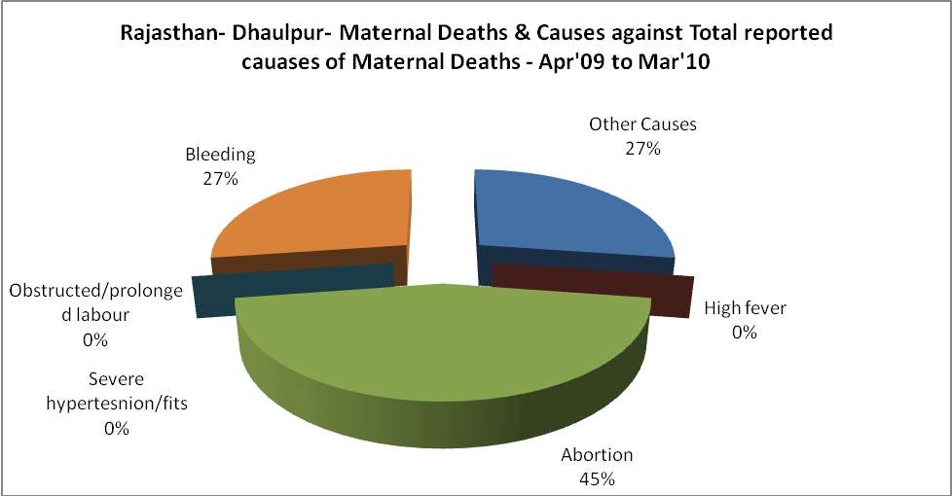

Rajasthan- Dhaulpur-Causes of Deaths in 6 to 55yrs age group - Apr'09 to Mar'10
Diarrhoel Diseases |  |  |  | Tuberculosis |  |  |  | Respiratory Diseases( Other than TB)
6-14 yrs | 15-55 yrs. | Above 55yrs | Total | 6-14 yrs | 15-55 yrs. | Above 55yrs | Total | 6-14 yrs | 15-55 yrs. | Above 55yrs | Total
7 | 0 | 1 | 8 | 1 | 21 | 16 | 38 | 6 | 23 | 29 | 58
Malaria |  |  |  | Other fever Related |  |  |  | HIV/Aids
6-14 yrs | 15-55 yrs. | Above 55yrs | Total | 6-14 yrs | 15-55 yrs. | Above 55yrs | Total | 6-14 yrs | 15-55 yrs. | Above 55yrs | Total
0 | 0 | 0 | 0 | 13 | 14 | 8 | 35 | 0 | 2 | 0 | 2
Heart Disease/Hypertenion related |  |  |  | Neurological Disease including strokes |  |  |  | Trauma/Accidents/ Burn Cases
6-14 yrs | 15-55 yrs. | Above 55yrs | Total | 6-14 yrs | 15-55 yrs. | Above 55yrs | Total | 6-14 yrs | 15-55 yrs. | Above 55yrs | Total
0 | 12 | 15 | 27 | 23 | 2 | 6 | 31 | 1 | 20 | 11 | 32
Suicide |  |  |  | Animal Bites & Stings
6-14 yrs | 15-55 yrs. | Above 55yrs | Total | 6-14 yrs | 15-55 yrs. | Above 55yrs | Total
0 | 4 | 2 | 6 | 0 | 2 | 2 | 4

