NHSRC
Meghalaya-East Garo Hills
Analysis: Apr 2009 – Mar 2010

MEGHALAYA- EAST GARO HILLS- Summary-Apr'09 to Mar'10
ANC
ANC Registration against Expected Pregnancies | 82% | TT1 given to Pregnant women against ANC Registraion | 59%
3 ANC Check ups against ANC Reigtrations | 34% | 100 IFA Tablets given to Pregnant women against ANC Registraion | 38%
Deliveries
Unreported Deliveries against Estimated Deliveries | 63.2% | HOME Deliveries( SBA& Non SBA) against Estimated Deliveries | 23.3%
Institutional Deliveries against Estimated Deliveries | 13.5% | HOME Deliveries( SBA& Non SBA) against Reported Deliveries | 63.3%
Institutional Deliveries against Reported Deliveries | 36.7% | C Section Deliveries against Institutional Deliveries( Pvt & Pub) | 0%
Births & Neonates Care
Live Births Reported against Estimated Live Births | 41% | New borns weighed against Reported Live Births | 44%
Still Births (Reported) | 45 | New borns weighed less than 2.5 kgs against newborns weighed | 13%
Sex Ratio at Birh | 977 | New borns breastfed within one hr of Birth against Reported live Births | 50%
Child Immunisation( 0 to 11 months)
BCG given against Expected Live Births | 68% | Measles given against Expected Live Births | 45%
OPV3 given against Expected Live Births | 51% | Fully Immunised Children against Expected Live Births | 51%
DPT3 given against Expected Live Births | 52%
Family Planning
Family Plannig Methods Users ( Sterilisations(Male &Female)+IUD+ Condom pieces/72 + OCP Cycles/13) | 558 | IUD Insertions against reported FP Methods | 22%
Sterilisation against reported FP Methods | 7% | Condom Users against reported FP Methods | 18%
 |  | OCP Users against reported FP Methods | 53%
Other Services
OPD | 1,22,085 | Major Operations | 11,236
IPD | 10,800 | Minor Operations | 264

MEGHALAYA- EAST GARO HILLS- Deliveries Apr'09 to Mar'10
Total Population | 3,06,777 | Expected Deliveries |  | 7,955
Home SBA | Home Non SBA | Institutional | Total Deliveries Reported | Unreported Deliveries
532 | 1,320 | 1,076 | 2,928 | 5,027
Home SBA % | Home Non SBA% | Institutional % | Total Deliveries Reported % | Unreported Deliveries %
7% | 17% | 14% | 37% | 63%
`

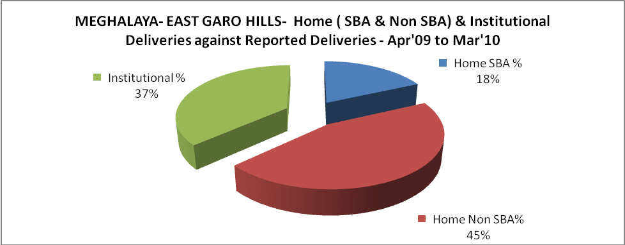

MEGHALAYA- EAST GARO HILLS- C sections & Complicated Deliveries Apr'09 to Mar'10
 | Institutional Deliveries (Public) | Institutional Deliveries (Pvt)
 | 1,076 | -
C Section | 1 | -
C Section% | 0% | 0%
Complicated Pregnacies attended | 53 | -
Complicated Pregnacies attended % | 5% | 0%

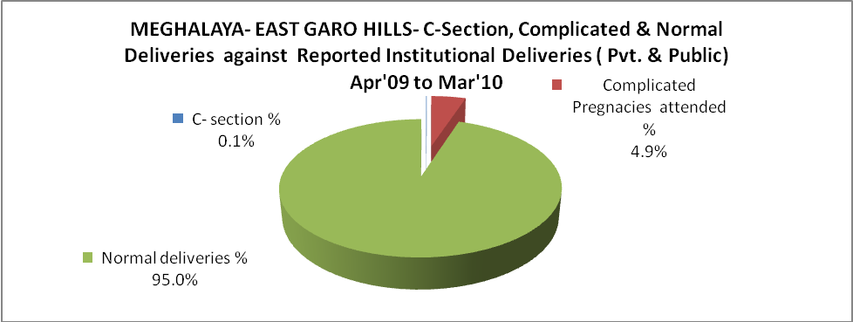

MEGHALAYA- EAST GARO HILLS- Complicated Pregnancies & Deliveries Treated - Apr'09 to Mar'10
Reported Deliveries |  |  | Reported ANC Reigtration
2,928 |  |  | 7,002
Complicated Pregnancies attended | Complicated Pregnancies Rate | C - Section Deliveries | PNC Maternal Complications | Abortions | Still Births
53 | 1% | 1 | 12 | 31 | 45
Complicated Deliveries Treated with |  |  |  | No Of Eclampsia cases Treated | No Of severe anemia cases treated
IV Antibiotics | IV antihypertensive/Magsulph injection | IV Oxytocis | Blood Transfusion | No Of Eclampsia cases Treated | No Of severe anemia cases treated
1,119 | 48 | 62 | - | 22 | 68

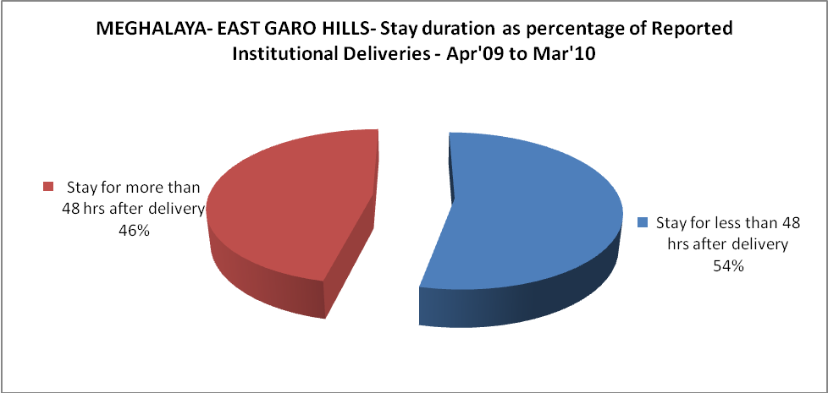

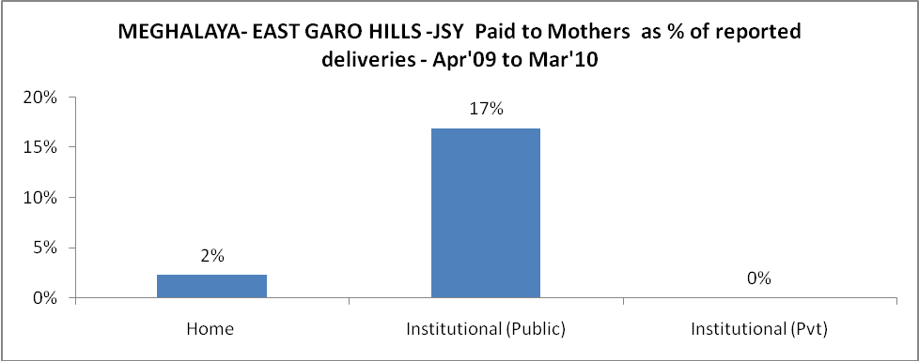

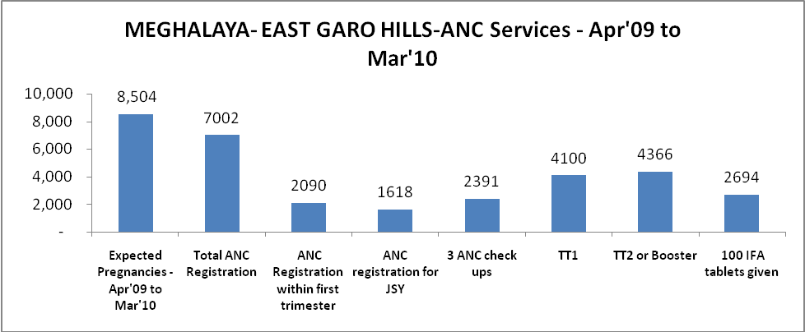

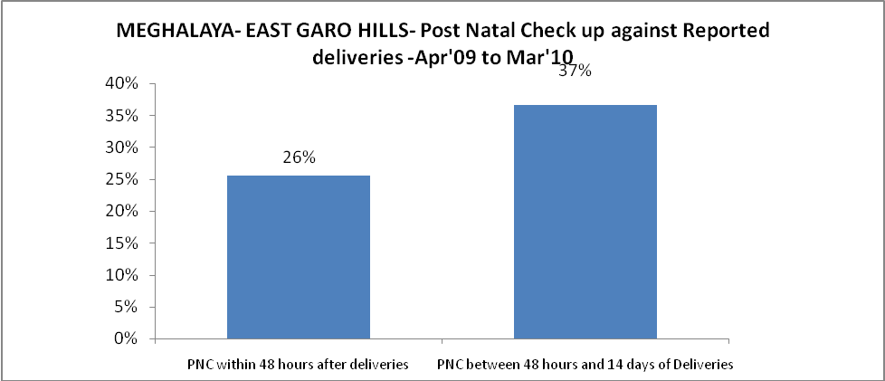

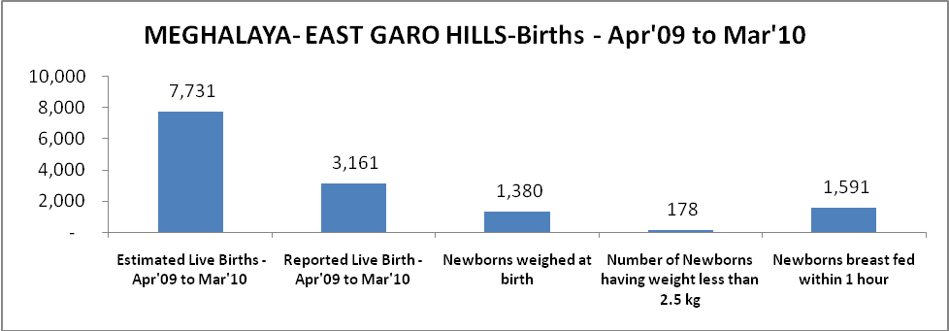

MEGHALAYA- EAST GARO HILLS - Births - Apr'09 to Mar'10
Live Birth - Males | Live Birth - females | Live Birth - Total | Sex Ratio at birth | Still Birth | Abortion( Induced/Spontaneous
1,599 | 1,562 | 3,161 | 977 | 45 | 31

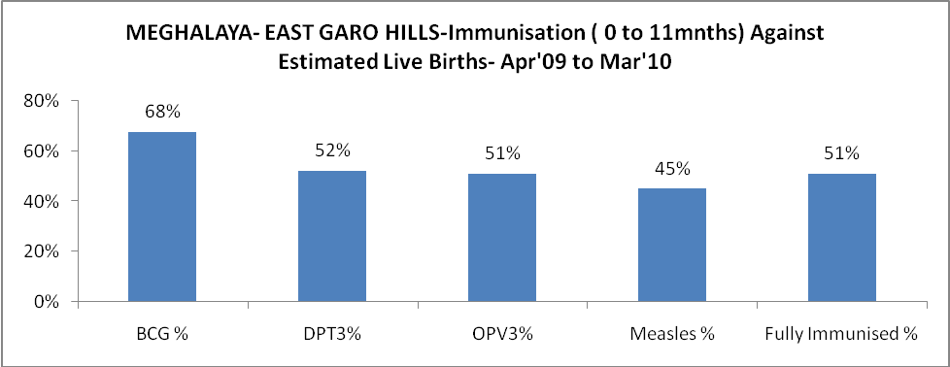

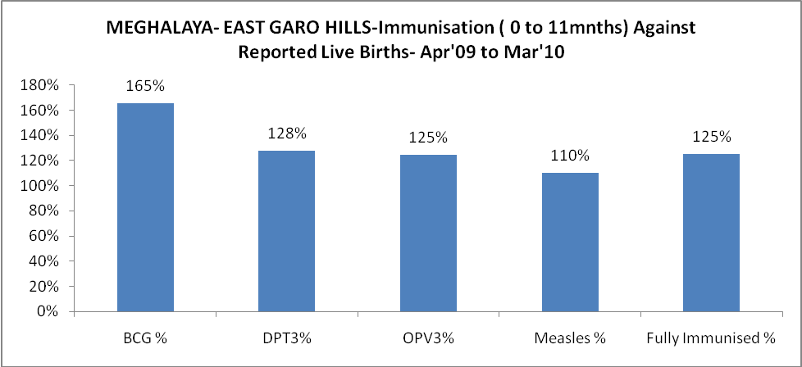

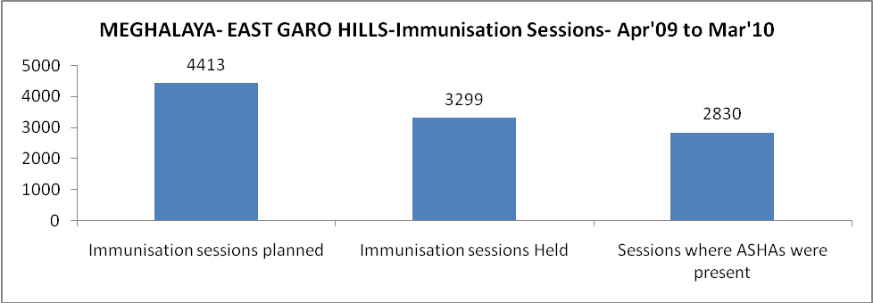

MEGHALAYA- EAST GARO HILLS- Apr'09 to Mar'10
Total Abortions | Abortion Rate
46 | 0.5%

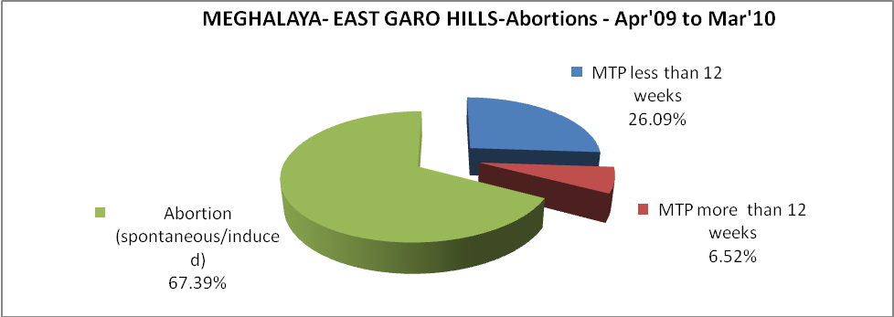

MEGHALAYA- EAST GARO HILLS- Apr'09 to Mar'10
Total OPD | Total RTI/STI cases
1,22,085 | 189

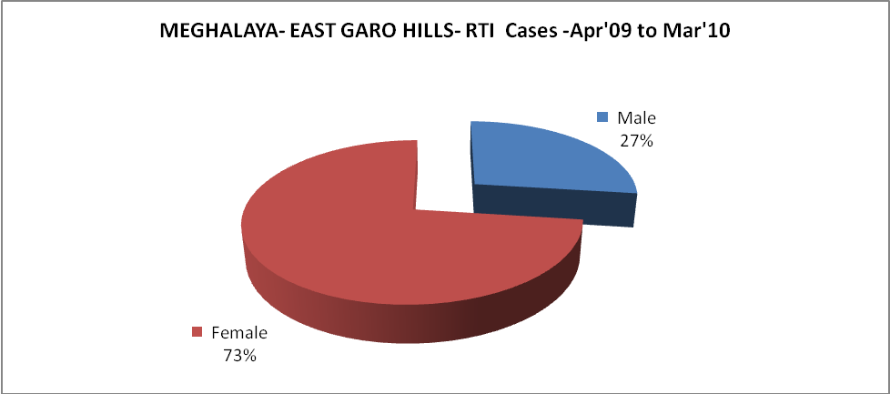

MEGHALAYA- EAST GARO HILLS-Sterilisations - Apr'09 to Mar'10
 | Reported | %age of Reported Sterilisation
Total Sterilisation | 40 | -
NSV | 3 | 8%
Laproscopic | 5 | 13%
MiniLap | 30 | 75%
Post Partum | 2 | 5%
Male Sterilisation | 3 | 8%
Female Sterilisation | 37 | 93%

MEGHALAYA- EAST GARO HILLS-FP Methods - Apr'09 to Mar'10
 | Reported | %age of All Reported FP Methods
Total Reported FP Methodd (All types) Users | 558 | -
Sterilisations | 40 | 7%
IUD | 122 | 22%
Condom Users | 101 | 18%
OCP Users | 295 | 53%
Limiting Methods | 40 | 7%
Spacing Methods | 518 | 93%

MEGHALAYA- EAST GARO HILLS- Service Delivery - Apr'09 to Mar'10
Operation major (General and spinal anaesthesia) | Operation minor (No or local anaesthesia) | AYUSH | Dental Procedures | Adolescent counselling services | Total OPD | Total IPD
11,236 | 264 | 1,117 | 1,727 | 108 | 1,22,085 | 10,800
Operation major (General and spinal anaesthesia) as %ge of OPD | Operation minor (No or local anaesthesia)as %ge of OPD | AYUSH as %ge of OPD | Dental Procedures as %ge of OPD | Adolescent counselling services as %ge of OPD | IPD as percentage of OPD
9.2% | 0.2% | 0.9% | 1.4% | 0.1% | 9%

MEGHALAYA- EAST GARO HILLS- Lab Services - Apr'09 to Mar'10
Total OPD | Total HB tested | Total HIV Tested | Total Population
1,22,085 | 484 | 231 | 3,06,777
HB test conducted as %age of OPD | HB<7gm as %age of HB tested | HIV test conducted as %age of OPD | HIV positive as %age of HIV tested | Blood Smear Examined as % of Population
0.4% | 28.9% | 0.2% | 0.9% | 18.7%

MEGHALAYA- EAST GARO HILLS- Childhood Disease - Vaccine Preventable -Apr'09 to Mar'10
Diphtheria | Pertussis | Tetanus Neonatorum | Tetanus others | Polio | Measles
6 | 0 | 0 | 0 | 0 | 230
MEGHALAYA- EAST GARO HILLS-Childhood Disease - Others - Apr'09 to Mar'10
Diarrhoea and dehydration | Malaria | Number admitted with Respiratory Infections
2,843 | 5,170 | 904

MEGHALAYA- EAST GARO HILLS- Infant & Child Deaths - Apr'09 to Mar'10
Infant Deaths within 24 hrs of birth | Infant Deaths between 24hrs & under 1 week | Infant Deaths between 1 week & under 1 month | Child Deaths between 1 month & under 1 year | Child Deaths between 1yr under 5years | Total Deaths
0 | 14 | 9 | 35 | 47 | 105

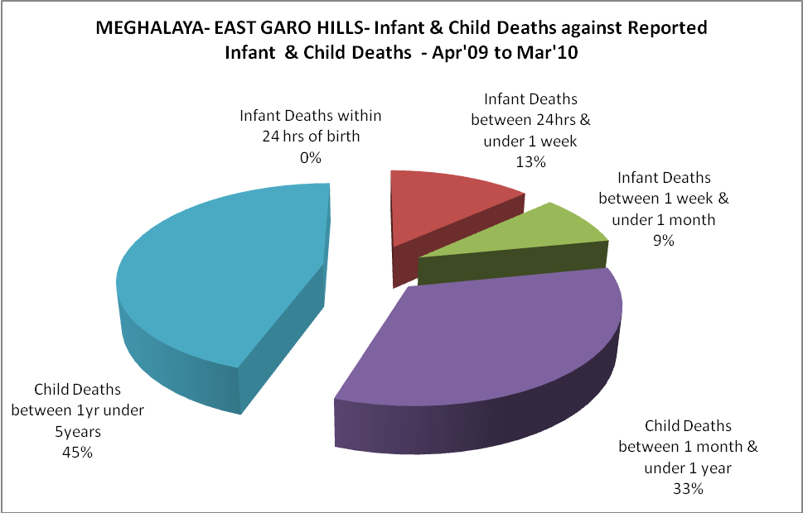

MEGHALAYA- EAST GARO HILLS- Causes of Infant & Child Deaths - Apr'09 to Mar'10
Sepsis |  |  | Asphyxia |  |  | LBW
Up to 1 Weeks of Birth | Between 1 week & 4 weeks of birth | Total | Up to 1 Weeks of Birth | Between 1 week & 4 weeks of birth | Total | Up to 1 Weeks of Birth | Between 1 week & 4 weeks of birth | Total
7 | 0 | 7 | 3 | 3 | 6 | 0 | 1 | 1
Pneumonia |  |  | Diarrhoea |  |  | Fever related
Between 1 month and 11 months | Between 1 year & 5 years | Total | Between 1 month and 11 months | Between 1 year & 5 years | Total | Between 1 month and 11 months | Between 1 year & 5 years | Total
3 | 4 | 7 | 1 | 5 | 6 | 10 | 7 | 17
Others |  |  | Measles |  |  | Others
Up to 1 Weeks of Birth | Between 1 week & 4 weeks of birth | Total | Between 1 month and 11 months | Between 1 year & 5 years | Total | Between 1 month and 11 months | Between 1 year & 5 years | Total
4 | 5 | 9 | 4 | 3 | 7 | 17 | 28 | 45

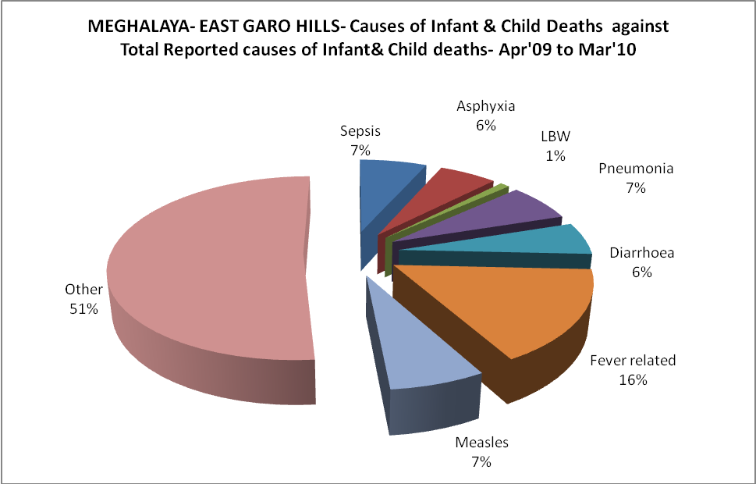

MEGHALAYA- EAST GARO HILLS- Maternal Deaths & Causes - Apr'09 to Mar'10
Abortion |  |  | Obstructed/prolonged labour |  |  | Severe hypertesnion/fits
6-14 yrs | 15-55 yrs. | Total | 6-14 yrs | 15-55 yrs. | Total | 6-14 yrs | 15-55 yrs. | Total
0 | 0 | 0 | 0 | 0 | 0 | 0 | 0 | 0
Bleeding |  |  | High Fever |  |  | Other Causes
6-14 yrs | 15-55 yrs. | Total | 6-14 yrs | 15-55 yrs. | Total | 6-14 yrs | 15-55 yrs. | Total
0 | 1 | 1 | 1 | 1 | 2 | 6 | 4 | 10

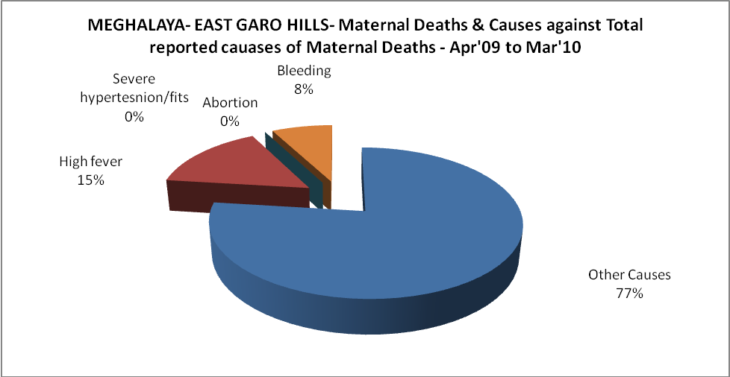
MEGHALAYA- EAST GARO HILLS-Causes of Deaths in 6 to 55yrs age group - Apr'09 to Mar'10
Diarrhoel Diseases |  |  |  | Tuberculosis |  |  |  | Respiratory Diseases( Other than TB)
6-14 yrs | 15-55 yrs. | Above 55yrs | Total | 6-14 yrs | 15-55 yrs. | Above 55yrs | Total | 6-14 yrs | 15-55 yrs. | Above 55yrs | Total
8 | 6 | 2 | 16 | 1 | 0 | 1 | 2 | 9 | 8 | 3 | 20
Malaria |  |  |  | Other fever Related |  |  |  | HIV/Aids
6-14 yrs | 15-55 yrs. | Above 55yrs | Total | 6-14 yrs | 15-55 yrs. | Above 55yrs | Total | 6-14 yrs | 15-55 yrs. | Above 55yrs | Total
21 | 10 | 1 | 32 | 20 | 17 | 17 | 54 | 0 | 0 | 0 | 0
Heart Disease/Hypertenion related |  |  |  | Neurological Disease including strokes |  |  |  | Trauma/Accidents/ Burn Cases
6-14 yrs | 15-55 yrs. | Above 55yrs | Total | 6-14 yrs | 15-55 yrs. | Above 55yrs | Total | 6-14 yrs | 15-55 yrs. | Above 55yrs | Total
1 | 4 | 1 | 6 | 0 | 0 | 0 | 0 | 2 | 11 | 1 | 14
Suicide |  |  |  | Animal Bites & Stings
6-14 yrs | 15-55 yrs. | Above 55yrs | Total | 6-14 yrs | 15-55 yrs. | Above 55yrs | Total
1 | 1 | 0 | 2 | 0 | 1 | 0 | 1

