NHSRC
Maharashtra – Gadchiroli
Analysis: Apr 2009 – Mar 2010

Maharashtra-Gadchiroli- Summary-Apr'09 to Mar'10
ANC
ANC Registration against Expected Pregnancies | 398% | TT1 given to Pregnant women against ANC Registration | 80%
3 ANC Check ups against ANC Registrations | 82% | 100 IFA Tablets given to Pregnant women against ANC Registration | 86%
Deliveries
Unreported Deliveries against Estimated Deliveries | -429.7% | HOME Deliveries( SBA& Non SBA) against Estimated Deliveries | 212.8%
Institutional Deliveries against Estimated Deliveries | 317.0% | HOME Deliveries( SBA& Non SBA) against Reported Deliveries | 40.2%
Institutional Deliveries against Reported Deliveries | 59.8% | C Section Deliveries against Institutional Deliveries( Pvt & Pub) | 7%
Births & Neonates Care
Live Births Reported against Estimated Live Births | 462% | New borns weighed against Reported Live Births | 89%
Still Births (Reported) | 2,953 | New borns weighed less than 2.5 kgs against newborns weighed | 22%
Sex Ratio at Birth | 992 | New borns breastfed within one hr of Birth against Reported live Births | 0%
Child Immunization( 0 to 11 months)
BCG given against Expected Live Births | 865% | Measles given against Expected Live Births | 505%
OPV3 given against Expected Live Births | 440% | Fully Immunized Children against Expected Live Births | 819%
DPT3 given against Expected Live Births | 514%
Family Planning
Family Plannig Methods Users ( Sterilizations(Male &Female)+IUD+ Condom pieces/72 + OCP Cycles/13) | 91,357 | IUD Insertions against reported FP Methods | 10%
Sterilization against reported FP Methods | 20% | Condom Users against reported FP Methods | 47%
 |  | OCP Users against reported FP Methods | 23%
Other Services
OPD | 158,048 | Major Operations | 772
IPD | - | Minor Operations | 544

Maharashtra-Gadchiroli- Deliveries Apr'09 to Mar'10
Total Population | 1,138,781 | Expected Deliveries |  | 20,721
Home SBA | Home Non SBA | Institutional | Total Deliveries Reported | Unreported Deliveries
42,010 | 2,074 | 65,674 | 109,758 | (89,037)
Home SBA % | Home Non SBA% | Institutional % | Total Deliveries Reported % | Unreported Deliveries %
203% | 10% | 317% | 530% | -430%

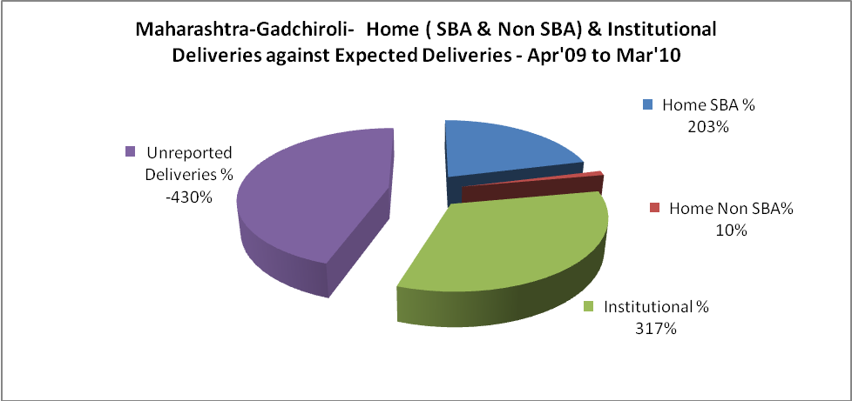

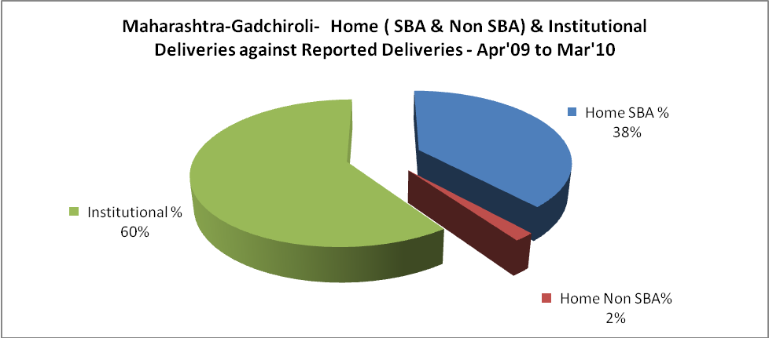

Maharashtra-Gadchiroli- C sections & Complicated Deliveries Apr'09 to Mar'10
 | Institutional Deliveries (Public) | Institutional Deliveries (Pvt)
 | 65,157 | 517
C Section | 4,546 | 376
C Section% | 7% | 73%
Complicated Pregnancies attended | 10,668 | 947
Complicated Pregnancies attended % | 16% | 183%

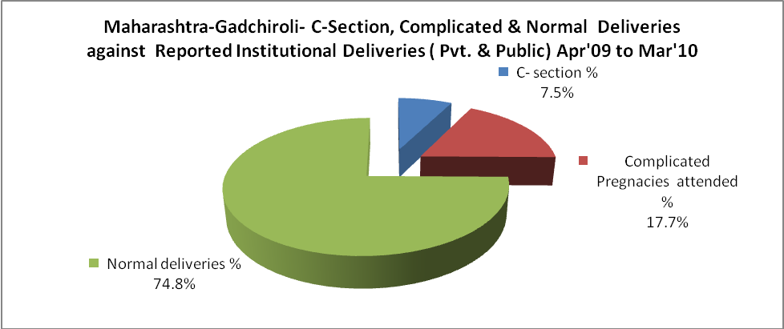

Maharashtra-Gadchiroli- Complicated Pregnancies & Deliveries Treated - Apr'09 to Mar'10
Reported Deliveries |  |  | Reported ANC Reigtration
109,758 |  |  | 89,264
Complicated Pregnancies attended | Complicated Pregnancies Rate | C - Section Deliveries | PNC Maternal Complications | Abortions | Still Births
11,615 | 52% | 4,922 | - | 2,957 | 2,953
Complicated Deliveries Treated with |  |  |  | No Of Eclampsia cases Treated | No Of severe anemia cases treated
IV Antibiotics | IV antihypertensive/Magsulph injection | IV Oxytocis | Blood Transfusion | No Of Eclampsia cases Treated | No Of severe anemia cases treated
- | - | - | - | - | -

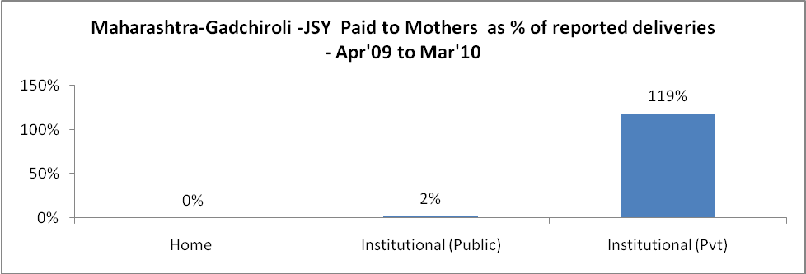

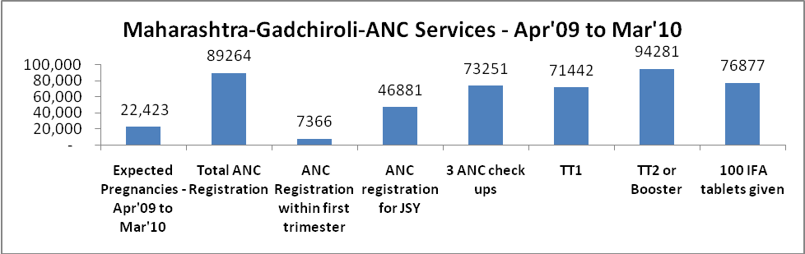

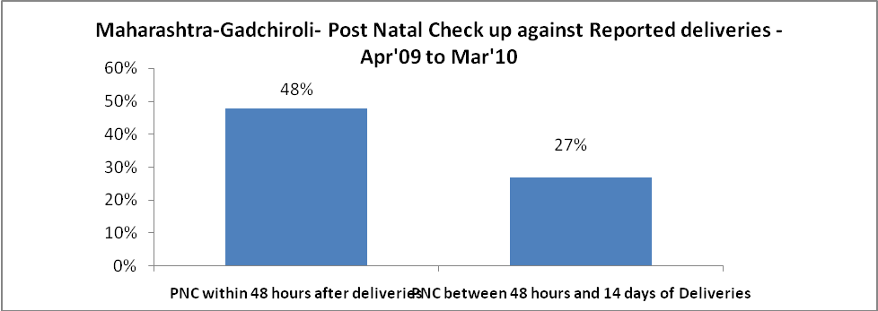

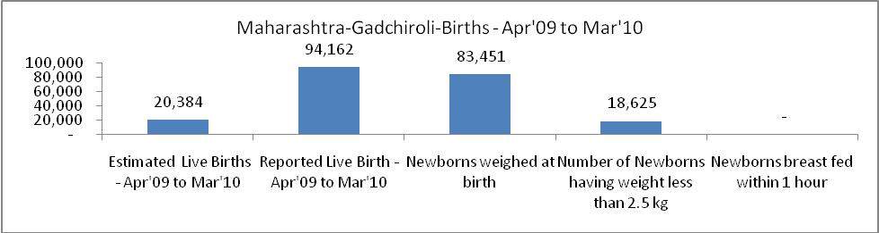

Maharashtra-Gadchiroli - Births - Apr'09 to Mar'10
Live Birth - Males | Live Birth - females | Live Birth - Total | Sex Ratio at birth | Still Birth | Abortion( Induced/Spontaneous
47,273 | 46,889 | 94,162 | 992 | 2,953 | 2,957

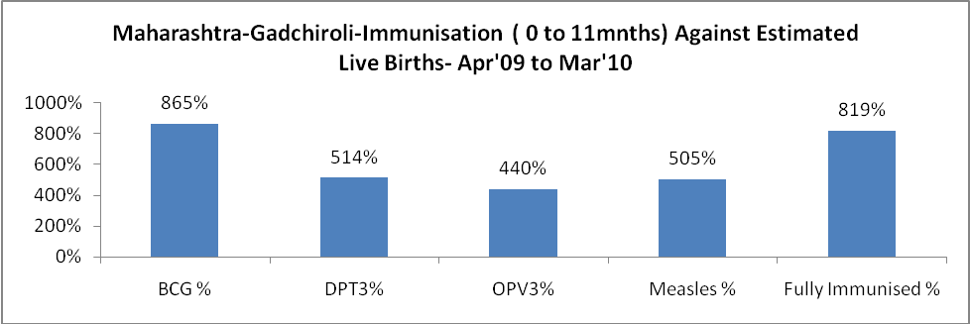

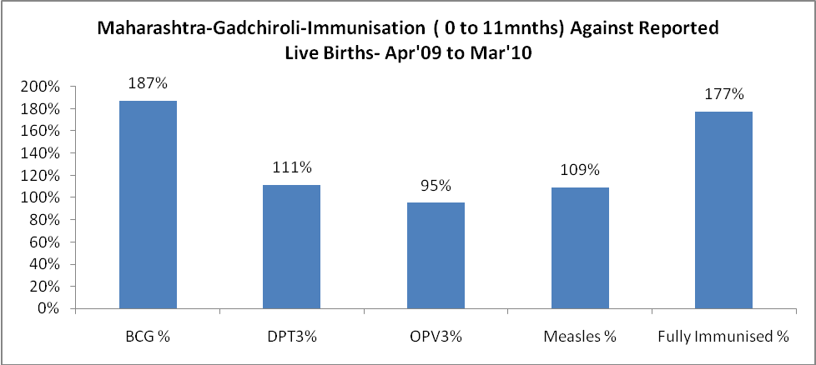

Maharashtra-Gadchiroli- Apr'09 to Mar'10
Total Abortions | Abortion Rate
5,291 | 23.6%

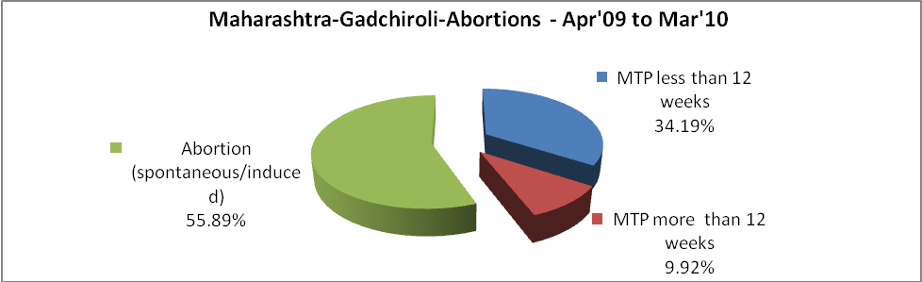

Maharashtra-Gadchiroli- Apr'09 to Mar'10
Total OPD | Total RTI/STI cases
158,048 | 68,838

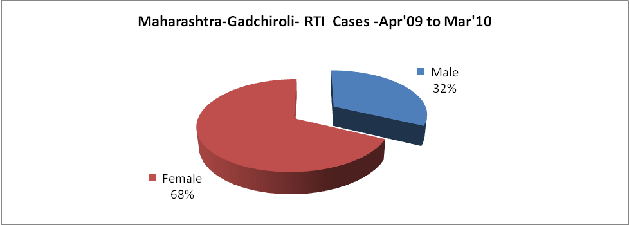

Maharashtra-Gadchiroli-Sterilizations - Apr'09 to Mar'10
 | Reported | %age of Reported Sterilization
Total Sterilization | 18,537 | -
NSV | 3,791 | 20%
Laproscopic | 868 | 5%
MiniLap | 11,500 | 62%
Post Partum | 2,378 | 13%
Male Sterilization | 3,791 | 20%
Female Sterilization | 14,746 | 80%

Maharashtra-Gadchiroli-FP Methods - Apr'09 to Mar'10
 | Reported | %age of All Reported FP Methods
Total Reported FP Methodd (All types) Users | 91,357 | -
Sterilizations | 18,537 | 20%
IUD | 9,106 | 10%
Condom Users | 42,900 | 47%
OCP Users | 20,814 | 23%
Limiting Methods | 18,537 | 20%
Spacing Methods | 72,820 | 80%

Maharashtra-Gadchiroli- Service Delivery - Apr'09 to Mar'10
Operation major (General and spinal anaesthesia) | Operation minor (No or local anaesthesia) | AYUSH | Dental Procedures | Adolescent counselling services | Total OPD | Total IPD
772 | 544 | - | - | - | 158,048 | -
Operation major (General and spinal anaesthesia) as %ge of OPD | Operation minor (No or local anaesthesia)as %ge of OPD | AYUSH as %ge of OPD | Dental Procedures as %ge of OPD | Adolescent counselling services as %ge of OPD | IPD as percentage of OPD
0.5% | 0.3% | 0.0% | 0.0% | 0.0% | 0%

Maharashtra-Gadchiroli- Lab Services - Apr'09 to Mar'10
Total OPD | Total HB tested | Total HIV Tested | Total Population
158,048 | - | - | 1,138,781
HB test conducted as %age of OPD | HB<7gm as %age of HB tested | HIV test conducted as %age of OPD | HIV positive as %age of HIV tested | Blood Smear Examined as % of Population
0.0% | 0.0% | 0.0% | 0.0% | 20.9%

Maharashtra-Gadchiroli- Childhood Disease - Vaccine Preventable -Apr'09 to Mar'10
Diphtheria | Pertussis | Tetanus Neonatorum | Tetanus others | Polio | Measles
0 | 0 | 0 | 0 | 0 | 159
Maharashtra-Gadchiroli-Childhood Disease - Others - Apr'09 to Mar'10
Diarrhoea and dehydration | Malaria | Number admitted with Respiratory Infections
7,291 | 1,074 | 4,981

Maharashtra-Gadchiroli- Infant & Child Deaths - Apr'09 to Mar'10
Infant Deaths within 24 hrs of birth | Infant Deaths between 24hrs & under 1 week | Infant Deaths between 1 week & under 1 month | Child Deaths between 1 month & under 1 year | Child Deaths between 1yr under 5years | Total Deaths
1067 | 0 | 0 | 40 | 49 | 1156

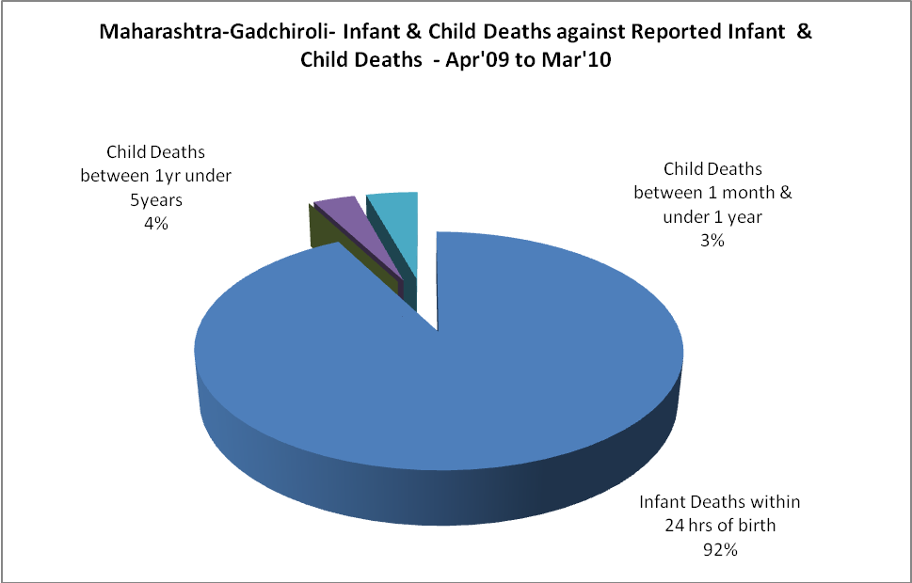

Maharashtra-Gadchiroli- Causes of Infant & Child Deaths - Apr'09 to Mar'10
Sepsis |  |  | Asphyxia |  |  | LBW
Up to 1 Weeks of Birth | Between 1 week & 4 weeks of birth | Total | Up to 1 Weeks of Birth | Between 1 week & 4 weeks of birth | Total | Up to 1 Weeks of Birth | Between 1 week & 4 weeks of birth | Total
0 | 0 | 0 | 0 | 0 | 0 | 0 | 0 | 0
Pneumonia |  |  | Diarrhoea |  |  | Fever related
Between 1 month and 11 months | Between 1 year & 5 years | Total | Between 1 month and 11 months | Between 1 year & 5 years | Total | Between 1 month and 11 months | Between 1 year & 5 years | Total
0 | 0 | 0 | 0 | 0 | 0 | 0 | 0 | 0
Others |  |  | Measles |  |  | Others
Up to 1 Weeks of Birth | Between 1 week & 4 weeks of birth | Total | Between 1 month and 11 months | Between 1 year & 5 years | Total | Between 1 month and 11 months | Between 1 year & 5 years | Total
0 | 0 | 0 | 0 | 0 | 0 | 40 | 49 | 89

Maharashtra-Gadchiroli- Maternal Deaths & Causes - Apr'09 to Mar'10
Abortion |  |  | Obstructed/prolonged labour |  |  | Severe hypertesnion/fits
6-14 yrs | 15-55 yrs. | Total | 6-14 yrs | 15-55 yrs. | Total | 6-14 yrs | 15-55 yrs. | Total
0 | 0 | 0 | 0 | 0 | 0 | 0 | 0 | 0
Bleeding |  |  | High Fever |  |  | Other Causes
6-14 yrs | 15-55 yrs. | Total | 6-14 yrs | 15-55 yrs. | Total | 6-14 yrs | 15-55 yrs. | Total
0 | 0 | 0 | 0 | 0 | 0 | 0 | 0 | 0

Maharashtra-Gadchiroli-Causes of Deaths in 6 to 55yrs age group - Apr'09 to Mar'10
Diarrhoel Diseases |  |  |  | Tuberculosis |  |  |  | Respiratory Diseases( Other than TB)
6-14 yrs | 15-55 yrs. | Above 55yrs | Total | 6-14 yrs | 15-55 yrs. | Above 55yrs | Total | 6-14 yrs | 15-55 yrs. | Above 55yrs | Total
0 | 0 | 0 | 0 | 0 | 0 | 0 | 0 | 0 | 0 | 0 | 0
Malaria |  |  |  | Other fever Related |  |  |  | HIV/Aids
6-14 yrs | 15-55 yrs. | Above 55yrs | Total | 6-14 yrs | 15-55 yrs. | Above 55yrs | Total | 6-14 yrs | 15-55 yrs. | Above 55yrs | Total
0 | 0 | 0 | 0 | 0 | 0 | 0 | 0 | 0 | 0 | 0 | 0
Heart Disease/Hypertension related |  |  |  | Neurological Disease including strokes |  |  |  | Trauma/Accidents/ Burn Cases
6-14 yrs | 15-55 yrs. | Above 55yrs | Total | 6-14 yrs | 15-55 yrs. | Above 55yrs | Total | 6-14 yrs | 15-55 yrs. | Above 55yrs | Total
0 | 0 | 0 | 0 | 0 | 0 | 0 | 0 | 0 | 0 | 0 | 0
Suicide |  |  |  | Animal Bites & Stings
6-14 yrs | 15-55 yrs. | Above 55yrs | Total | 6-14 yrs | 15-55 yrs. | Above 55yrs | Total
0 | 0 | 0 | 0 | 0 | 0 | 0 | 0

