NHSRC
Maharashtra – Gondiya
Analysis: Apr 2009 – Mar 2010

Maharashtra-Gondiya- Summary-Apr'09 to Mar'10
ANC
ANC Registration against Expected Pregnancies | 78% | TT1 given to Pregnant women against ANC Registration | 66%
3 ANC Check ups against ANC Registrations | 90% | 100 IFA Tablets given to Pregnant women against ANC Registration | 109%
Deliveries
Unreported Deliveries against Estimated Deliveries | 43.2% | HOME Deliveries( SBA& Non SBA) against Estimated Deliveries | 13.8%
Institutional Deliveries against Estimated Deliveries | 43.0% | HOME Deliveries( SBA& Non SBA) against Reported Deliveries | 24.3%
Institutional Deliveries against Reported Deliveries | 75.7% | C Section Deliveries against Institutional Deliveries( Pvt & Pub) | 17%
Births & Neonates Care
Live Births Reported against Estimated Live Births | 70% | New borns weighed against Reported Live Births | 95%
Still Births (Reported) | 453 | New borns weighed less than 2.5 kgs against newborns weighed | 11%
Sex Ratio at Birth | 900 | New borns breastfed within one hr of Birth against Reported live Births | 0%
Child Immunization( 0 to 11 months)
BCG given against Expected Live Births | 78% | Measles given against Expected Live Births | 81%
OPV3 given against Expected Live Births | 84% | Fully Immunized Children against Expected Live Births | 126%
DPT3 given against Expected Live Births | 85%
Family Planning
Family Plannig Methods Users ( Sterilizations(Male &Female)+IUD+ Condom pieces/72 + OCP Cycles/13) | 20,549 | IUD Insertions against reported FP Methods | 19%
Sterilization against reported FP Methods | 38% | Condom Users against reported FP Methods | 22%
 |  | OCP Users against reported FP Methods | 22%
Other Services
OPD | 193,907 | Major Operations | 1,417
IPD | - | Minor Operations | 837

Maharashtra-Gondiya- Deliveries Apr'09 to Mar'10
Total Population | 1,409,229 | Expected Deliveries |  | 25,641
Home SBA | Home Non SBA | Institutional | Total Deliveries Reported | Unreported Deliveries
915 | 2,622 | 11,023 | 14,560 | 11,081
Home SBA % | Home Non SBA% | Institutional % | Total Deliveries Reported % | Unreported Deliveries %
4% | 10% | 43% | 57% | 43%

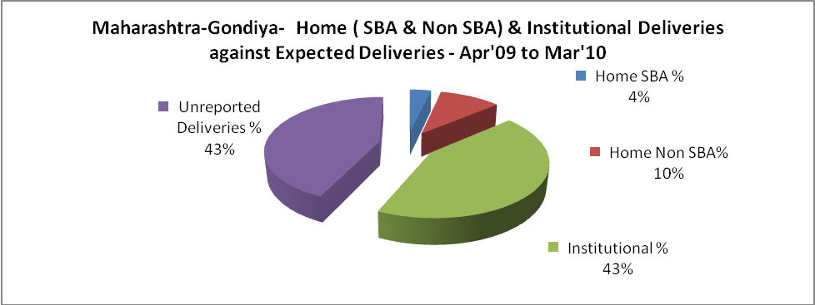

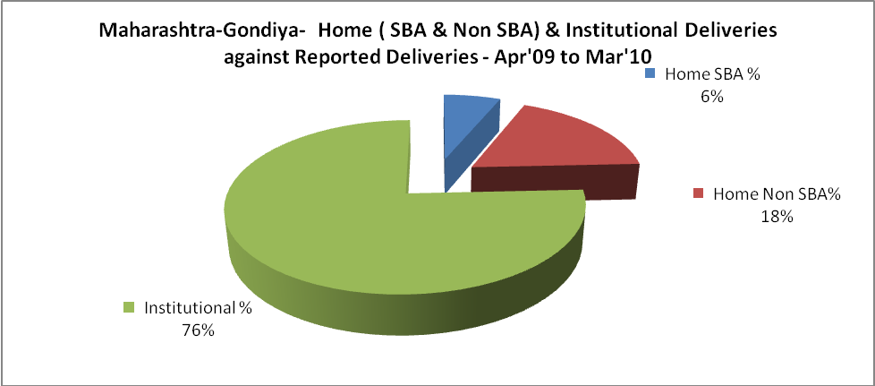

Maharashtra-Gondiya- C sections & Complicated Deliveries Apr'09 to Mar'10
 | Institutional Deliveries (Public) | Institutional Deliveries (Pvt)
 | 10,663 | 360
C Section | 1,338 | 492
C Section% | 13% | 137%
Complicated Pregnancies attended | 732 | 72
Complicated Pregnancies attended % | 7% | 20%

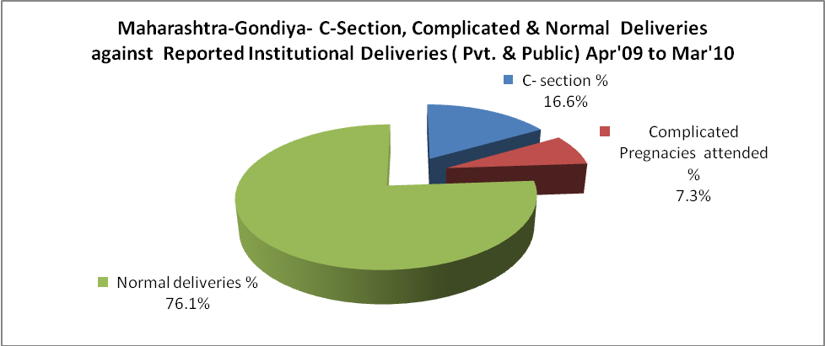

Maharashtra-Gondiya- Complicated Pregnancies & Deliveries Treated - Apr'09 to Mar'10
Reported Deliveries |  |  | Reported ANC Reigtration
14,560 |  |  | 21,581
Complicated Pregnancies attended | Complicated Pregnancies Rate | C - Section Deliveries | PNC Maternal Complications | Abortions | Still Births
804 | 3% | 1,830 | - | 514 | 453
Complicated Deliveries Treated with |  |  |  | No Of Eclampsia cases Treated | No Of severe anemia cases treated
IV Antibiotics | IV antihypertensive/Magsulph injection | IV Oxytocis | Blood Transfusion | No Of Eclampsia cases Treated | No Of severe anemia cases treated
- | - | - | - | - | -

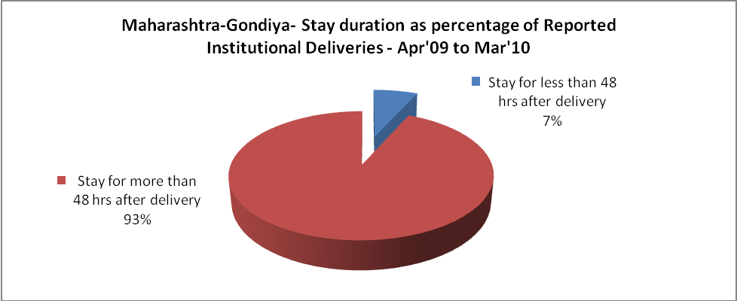

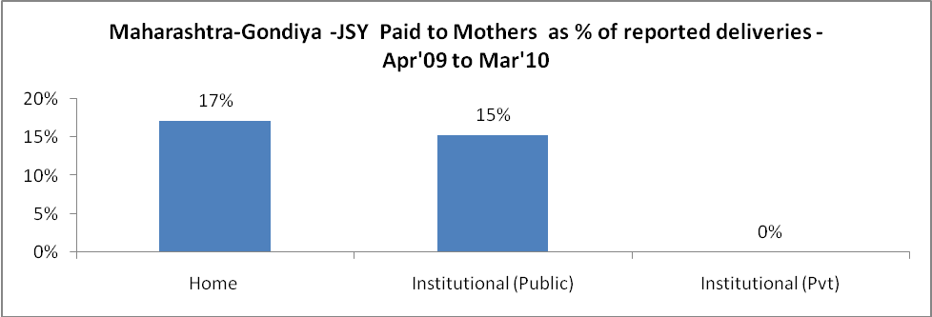

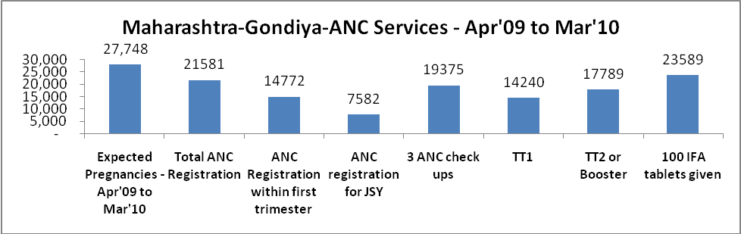

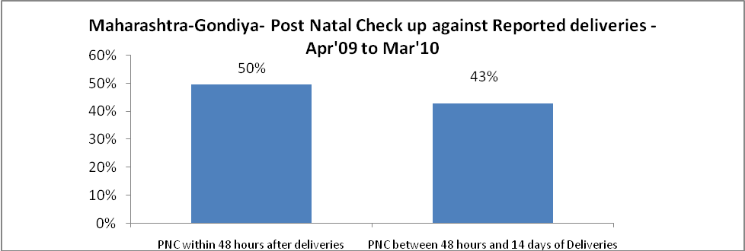

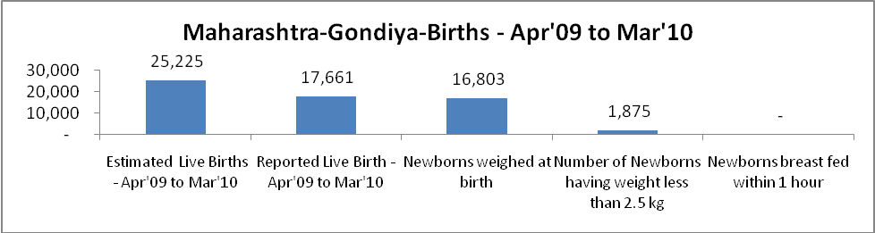

Maharashtra-Gondiya - Births - Apr'09 to Mar'10
Live Birth - Males | Live Birth - females | Live Birth - Total | Sex Ratio at birth | Still Birth | Abortion( Induced/Spontaneous
9,293 | 8,368 | 17,661 | 900 | 453 | 514

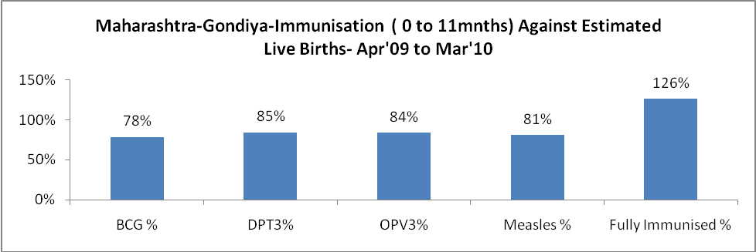

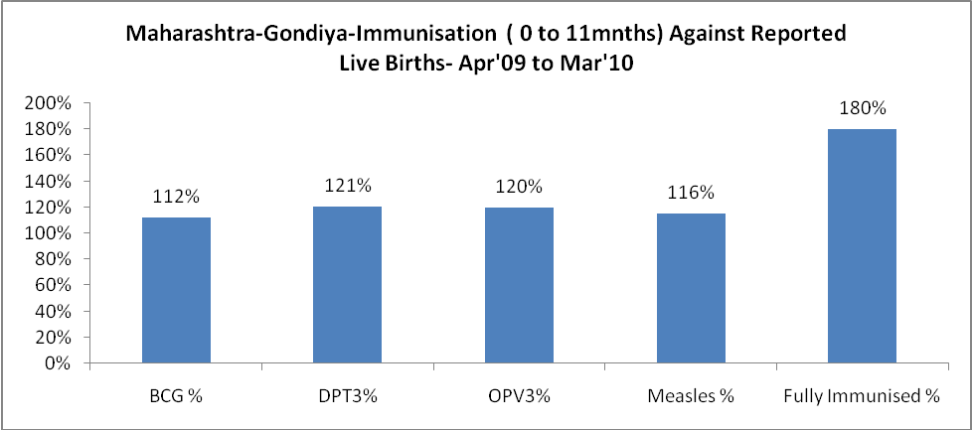

Maharashtra-Gondiya- Apr'09 to Mar'10
Total Abortions | Abortion Rate
678 | 2.4%

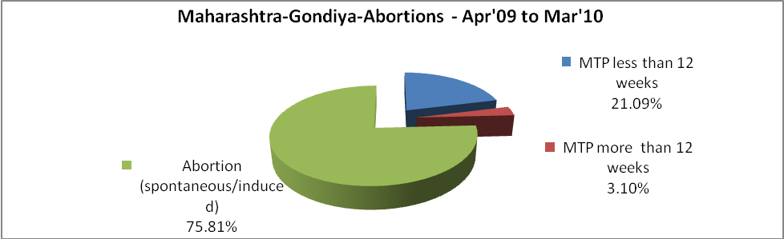

Maharashtra-Gondiya- Apr'09 to Mar'10
Total OPD | Total RTI/STI cases
193,907 | 4,758

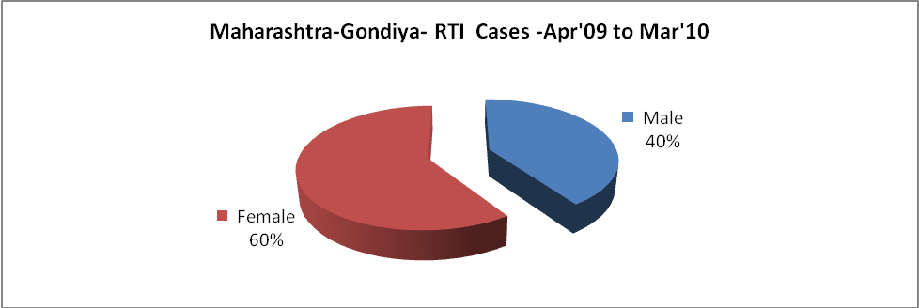

Maharashtra-Gondiya-Sterilizations - Apr'09 to Mar'10
 | Reported | %age of Reported Sterilization
Total Sterilization | 7,711 | -
NSV | 2,091 | 27%
Laproscopic | 59 | 1%
MiniLap | 3,768 | 49%
Post Partum | 1,793 | 23%
Male Sterilization | 2,091 | 27%
Female Sterilization | 5,620 | 73%

Maharashtra-Gondiya-FP Methods - Apr'09 to Mar'10
 | Reported | %age of All Reported FP Methods
Total Reported FP Methodd (All types) Users | 20,549 | -
Sterilizations | 7,711 | 38%
IUD | 3,865 | 19%
Condom Users | 4,526 | 22%
OCP Users | 4,447 | 22%
Limiting Methods | 7,711 | 38%
Spacing Methods | 12,838 | 62%

Maharashtra-Gondiya- Service Delivery - Apr'09 to Mar'10
Operation major (General and spinal anaesthesia) | Operation minor (No or local anaesthesia) | AYUSH | Dental Procedures | Adolescent counselling services | Total OPD | Total IPD
1,417 | 837 | - | - | - | 193,907 | -
Operation major (General and spinal anaesthesia) as %ge of OPD | Operation minor (No or local anaesthesia)as %ge of OPD | AYUSH as %ge of OPD | Dental Procedures as %ge of OPD | Adolescent counselling services as %ge of OPD | IPD as percentage of OPD
0.7% | 0.4% | 0.0% | 0.0% | 0.0% | 0%

Maharashtra-Gondiya- Lab Services - Apr'09 to Mar'10
Total OPD | Total HB tested | Total HIV Tested | Total Population
193,907 | - | - | 1,409,229
HB test conducted as %age of OPD | HB<7gm as %age of HB tested | HIV test conducted as %age of OPD | HIV positive as %age of HIV tested | Blood Smear Examined as % of Population
0.0% | 0.0% | 0.0% | 0.0% | 17.0%

Maharashtra-Gondiya- Childhood Disease - Vaccine Preventable -Apr'09 to Mar'10
Diphtheria | Pertussis | Tetanus Neonatorum | Tetanus others | Polio | Measles
0 | 0 | 0 | 0 | 0 | 12
Maharashtra-Gondiya-Childhood Disease - Others - Apr'09 to Mar'10
Diarrhoea and dehydration | Malaria | Number admitted with Respiratory Infections
103 | - | -

Maharashtra-Gondiya- Infant & Child Deaths - Apr'09 to Mar'10
Infant Deaths within 24 hrs of birth | Infant Deaths between 24hrs & under 1 week | Infant Deaths between 1 week & under 1 month | Child Deaths between 1 month & under 1 year | Child Deaths between 1yr under 5years | Total Deaths
70 | 0 | 0 | 0 | 0 | 70

Maharashtra-Gondiya- Causes of Infant & Child Deaths - Apr'09 to Mar'10
Sepsis |  |  | Asphyxia |  |  | LBW
Up to 1 Weeks of Birth | Between 1 week & 4 weeks of birth | Total | Up to 1 Weeks of Birth | Between 1 week & 4 weeks of birth | Total | Up to 1 Weeks of Birth | Between 1 week & 4 weeks of birth | Total
0 | 0 | 0 | 0 | 0 | 0 | 0 | 0 | 0
Pneumonia |  |  | Diarrhoea |  |  | Fever related
Between 1 month and 11 months | Between 1 year & 5 years | Total | Between 1 month and 11 months | Between 1 year & 5 years | Total | Between 1 month and 11 months | Between 1 year & 5 years | Total
0 | 0 | 0 | 0 | 0 | 0 | 0 | 0 | 0
Others |  |  | Measles |  |  | Others
Up to 1 Weeks of Birth | Between 1 week & 4 weeks of birth | Total | Between 1 month and 11 months | Between 1 year & 5 years | Total | Between 1 month and 11 months | Between 1 year & 5 years | Total
0 | 0 | 0 | 0 | 0 | 0 | 0 | 0 | 0

Maharashtra-Gondiya- Maternal Deaths & Causes - Apr'09 to Mar'10
Abortion |  |  | Obstructed/prolonged labour |  |  | Severe hypertesnion/fits
6-14 yrs | 15-55 yrs. | Total | 6-14 yrs | 15-55 yrs. | Total | 6-14 yrs | 15-55 yrs. | Total
0 | 0 | 0 | 0 | 0 | 0 | 0 | 0 | 0
Bleeding |  |  | High Fever |  |  | Other Causes
6-14 yrs | 15-55 yrs. | Total | 6-14 yrs | 15-55 yrs. | Total | 6-14 yrs | 15-55 yrs. | Total
0 | 0 | 0 | 0 | 0 | 0 | 0 | 0 | 0

Maharashtra-Gondiya-Causes of Deaths in 6 to 55yrs age group - Apr'09 to Mar'10
Diarrhoel Diseases |  |  |  | Tuberculosis |  |  |  | Respiratory Diseases( Other than TB)
6-14 yrs | 15-55 yrs. | Above 55yrs | Total | 6-14 yrs | 15-55 yrs. | Above 55yrs | Total | 6-14 yrs | 15-55 yrs. | Above 55yrs | Total
0 | 0 | 0 | 0 | 0 | 0 | 0 | 0 | 0 | 0 | 0 | 0
Malaria |  |  |  | Other fever Related |  |  |  | HIV/Aids
6-14 yrs | 15-55 yrs. | Above 55yrs | Total | 6-14 yrs | 15-55 yrs. | Above 55yrs | Total | 6-14 yrs | 15-55 yrs. | Above 55yrs | Total
0 | 0 | 0 | 0 | 0 | 0 | 0 | 0 | 0 | 0 | 0 | 0
Heart Disease/Hypertension related |  |  |  | Neurological Disease including strokes |  |  |  | Trauma/Accidents/ Burn Cases
6-14 yrs | 15-55 yrs. | Above 55yrs | Total | 6-14 yrs | 15-55 yrs. | Above 55yrs | Total | 6-14 yrs | 15-55 yrs. | Above 55yrs | Total
0 | 0 | 0 | 0 | 0 | 0 | 0 | 0 | 0 | 0 | 0 | 0
Suicide |  |  |  | Animal Bites & Stings
6-14 yrs | 15-55 yrs. | Above 55yrs | Total | 6-14 yrs | 15-55 yrs. | Above 55yrs | Total
0 | 0 | 0 | 0 | 0 | 0 | 0 | 0

