NHSRC
Maharashtra – Hingoli
Analysis: Apr 2009 – Mar 2010

Maharashtra-Hingoli- Summary-Apr'09 to Mar'10
ANC
ANC Registration against Expected Pregnancies | 82% | TT1 given to Pregnant women against ANC Registration | 72%
3 ANC Check ups against ANC Registrations | 89% | 100 IFA Tablets given to Pregnant women against ANC Registration | 118%
Deliveries
Unreported Deliveries against Estimated Deliveries | 44.2% | HOME Deliveries( SBA& Non SBA) against Estimated Deliveries | 15.3%
Institutional Deliveries against Estimated Deliveries | 40.6% | HOME Deliveries( SBA& Non SBA) against Reported Deliveries | 27.4%
Institutional Deliveries against Reported Deliveries | 72.6% | C Section Deliveries against Institutional Deliveries( Pvt & Pub) | 7%
Births & Neonates Care
Live Births Reported against Estimated Live Births | 86% | New borns weighed against Reported Live Births | 84%
Still Births (Reported) | 335 | New borns weighed less than 2.5 kgs against newborns weighed | 25%
Sex Ratio at Birth | 831 | New borns breastfed within one hr of Birth against Reported live Births | 8%
Child Immunization( 0 to 11 months)
BCG given against Expected Live Births | 91% | Measles given against Expected Live Births | 83%
OPV3 given against Expected Live Births | 88% | Fully Immunized Children against Expected Live Births | 76%
DPT3 given against Expected Live Births | 85%
Family Planning
Family Planning Methods Users ( Sterilizations(Male &Female)+IUD+ Condom pieces/72 + OCP Cycles/13) | 17,848 | IUD Insertions against reported FP Methods | 14%
Sterilization against reported FP Methods | 30% | Condom Users against reported FP Methods | 40%
 |  | OCP Users against reported FP Methods | 16%
Other Services
OPD | 58,116 | Major Operations | 309
IPD | - | Minor Operations | 203

Maharashtra-Hingoli- Deliveries Apr'09 to Mar'10
Total Population | 1,158,594 | Expected Deliveries |  | 21,081
Home SBA | Home Non SBA | Institutional | Total Deliveries Reported | Unreported Deliveries
719 | 2,504 | 8,549 | 11,772 | 9,309
Home SBA % | Home Non SBA% | Institutional % | Total Deliveries Reported % | Unreported Deliveries %
3% | 12% | 41% | 56% | 44%

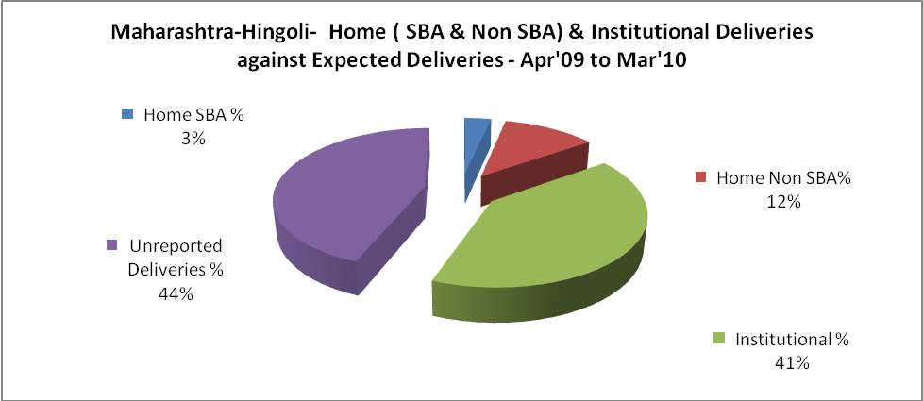

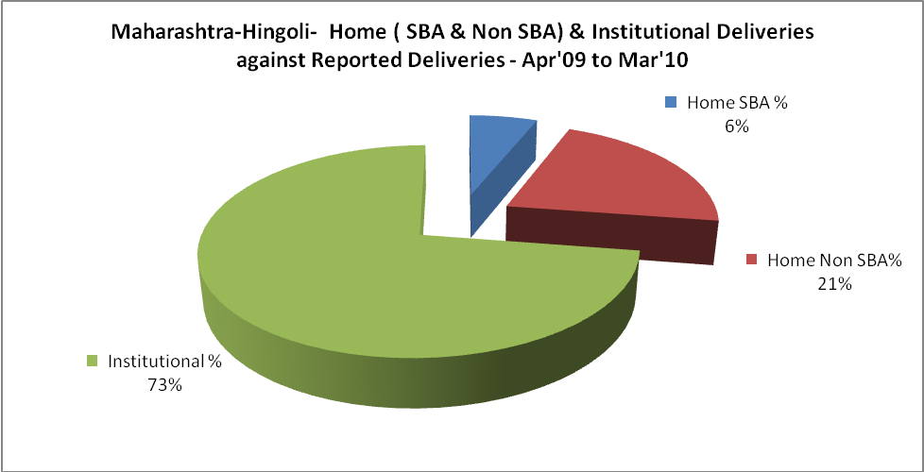

Maharashtra-Hingoli- C sections & Complicated Deliveries Apr'09 to Mar'10
 | Institutional Deliveries (Public) | Institutional Deliveries (Pvt)
 | 7,703 | 846
C Section | 122 | 444
C Section% | 2% | 52%
Complicated Pregnancies attended | 395 | 113
Complicated Pregnancies attended % | 5% | 13%

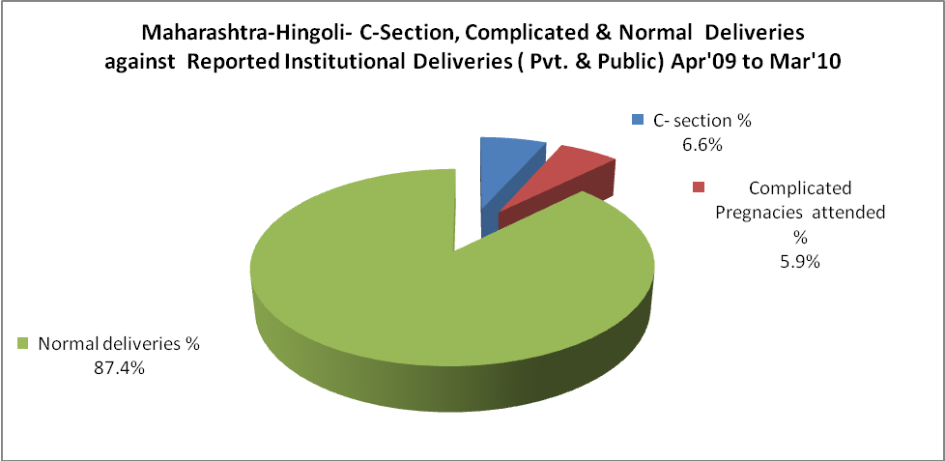

Maharashtra-Hingoli- Complicated Pregnancies & Deliveries Treated - Apr'09 to Mar'10
Reported Deliveries |  |  | Reported ANC Reigtration
11,772 |  |  | 18,676
Complicated Pregnancies attended | Complicated Pregnancies Rate | C - Section Deliveries | PNC Maternal Complications | Abortions | Still Births
508 | 2% | 566 | 885 | 393 | 335
Complicated Deliveries Treated with |  |  |  | No Of Eclampsia cases Treated | No Of severe anemia cases treated
IV Antibiotics | IV antihypertensive/Magsulph injection | IV Oxytocis | Blood Transfusion | No Of Eclampsia cases Treated | No Of severe anemia cases treated
- | - | - | - | - | -

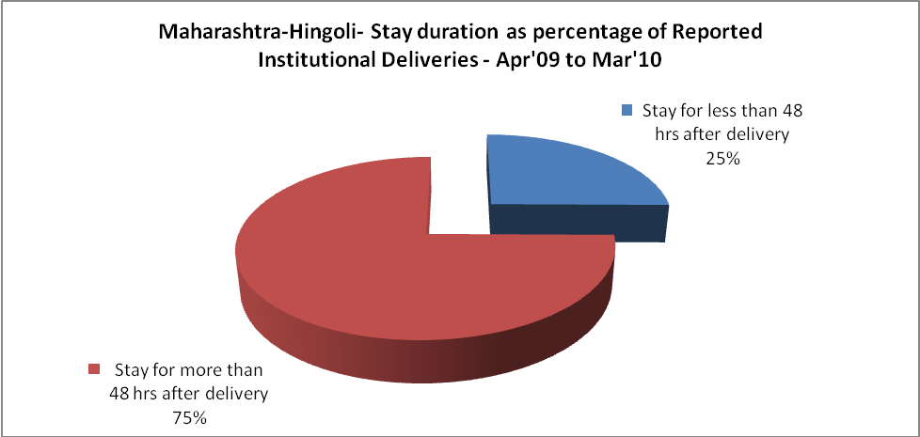

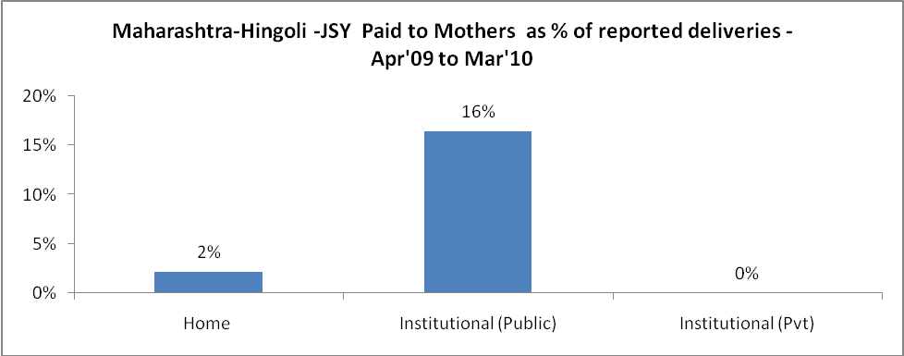

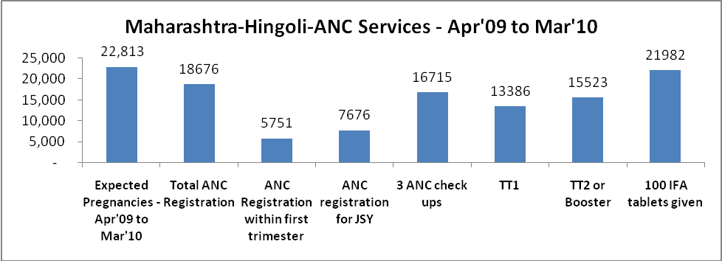

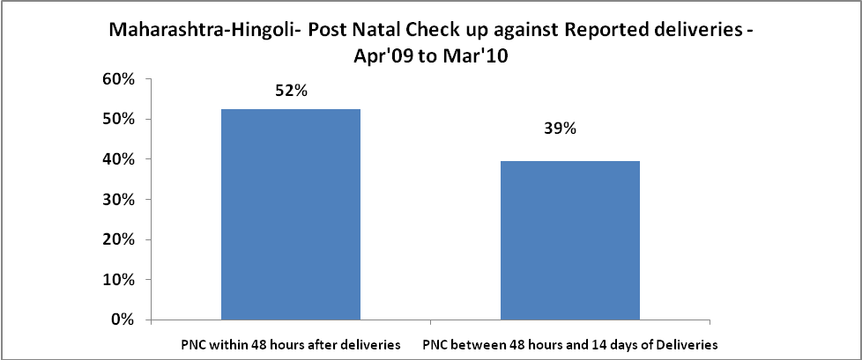

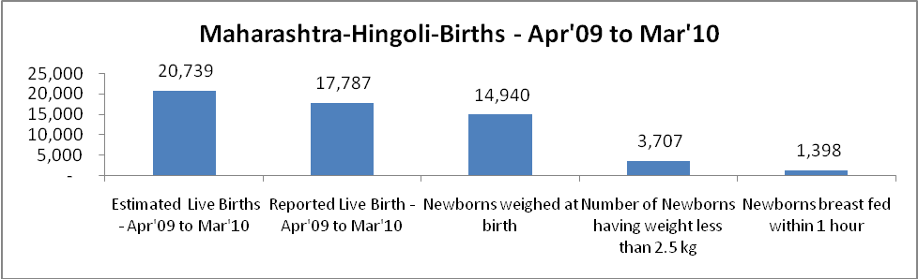

Maharashtra-Hingoli - Births - Apr'09 to Mar'10
Live Birth - Males | Live Birth - females | Live Birth - Total | Sex Ratio at birth | Still Birth | Abortion( Induced/Spontaneous
9,713 | 8,074 | 17,787 | 831 | 335 | 393

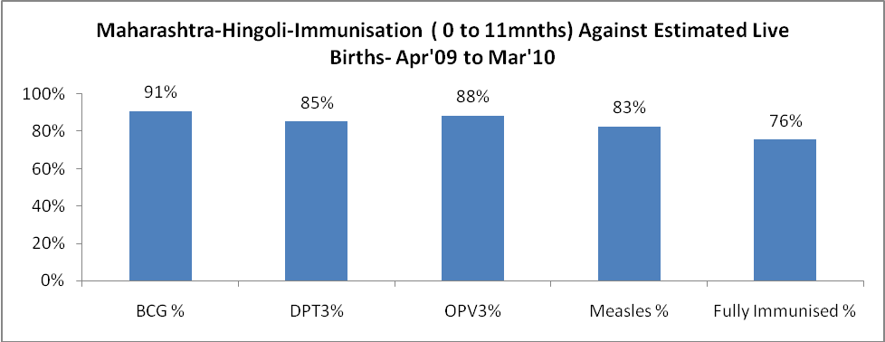

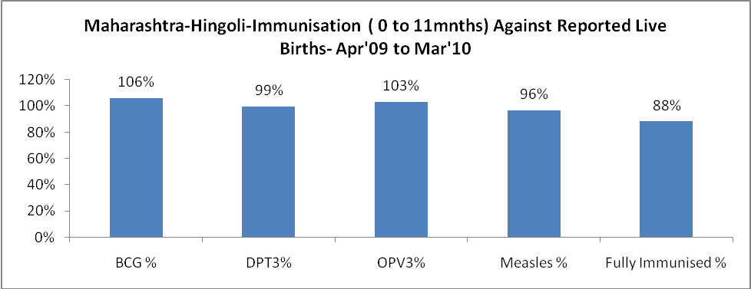

Maharashtra-Hingoli- Apr'09 to Mar'10
Total Abortions | Abortion Rate
561 | 2.5%

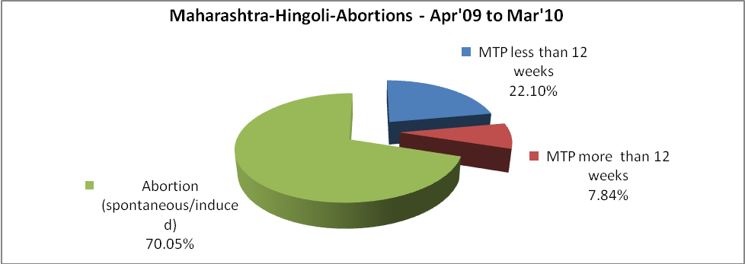

Maharashtra-Hingoli- Apr'09 to Mar'10
Total OPD | Total RTI/STI cases
58,116 | 4,289

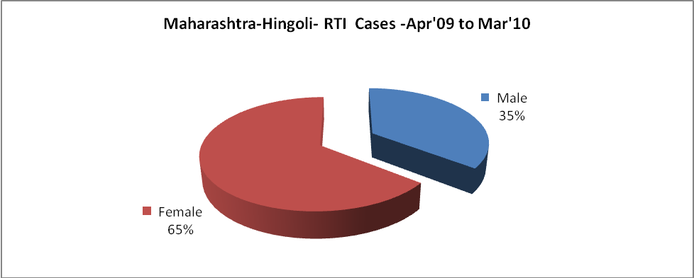

Maharashtra-Hingoli-Sterilizations - Apr'09 to Mar'10
 | Reported | %age of Reported Sterilization
Total Sterilization | 5,343 | -
NSV | 284 | 5%
Laparoscopic | 1,330 | 25%
MiniLap | 2,909 | 54%
Post Partum | 820 | 15%
Male Sterilization | 284 | 5%
Female Sterilization | 5,059 | 95%

Maharashtra-Hingoli-FP Methods - Apr'09 to Mar'10
 | Reported | %age of All Reported FP Methods
Total Reported FP Methodd (All types) Users | 17,848 | -
Sterilizations | 5,343 | 30%
IUD | 2,572 | 14%
Condom Users | 7,136 | 40%
OCP Users | 2,797 | 16%
Limiting Methods | 5,343 | 30%
Spacing Methods | 12,505 | 70%

Maharashtra-Hingoli- Service Delivery - Apr'09 to Mar'10
Operation major (General and spinal anaesthesia) | Operation minor (No or local anaesthesia) | AYUSH | Dental Procedures | Adolescent counselling services | Total OPD | Total IPD
309 | 203 | - | - | - | 58,116 | -
Operation major (General and spinal anaesthesia) as %ge of OPD | Operation minor (No or local anaesthesia)as %ge of OPD | AYUSH as %ge of OPD | Dental Procedures as %ge of OPD | Adolescent counselling services as %ge of OPD | IPD as percentage of OPD
0.5% | 0.3% | 0.0% | 0.0% | 0.0% | 0%

Maharashtra-Hingoli- Lab Services - Apr'09 to Mar'10
Total OPD | Total HB tested | Total HIV Tested | Total Population
58,116 | - | - | 1,158,594
HB test conducted as %age of OPD | HB<7gm as %age of HB tested | HIV test conducted as %age of OPD | HIV positive as %age of HIV tested | Blood Smear Examined as % of Population
0.0% | 0.0% | 0.0% | 0.0% | 5.0%

Maharashtra-Hingoli- Childhood Disease - Vaccine Preventable -Apr'09 to Mar'10
Diphtheria | Pertussis | Tetanus Neonatorum | Tetanus others | Polio | Measles
1 | 0 | 0 | 0 | 0 | 0
Maharashtra-Hingoli-Childhood Disease - Others - Apr'09 to Mar'10
Diarrhoea and dehydration | Malaria | Number admitted with Respiratory Infections
1,143 | 40 | 262

Maharashtra-Hingoli- Infant & Child Deaths - Apr'09 to Mar'10
Infant Deaths within 24 hrs of birth | Infant Deaths between 24hrs & under 1 week | Infant Deaths between 1 week & under 1 month | Child Deaths between 1 month & under 1 year | Child Deaths between 1yr under 5years | Total Deaths
122 | 103 | 23 | 48 | 32 | 328

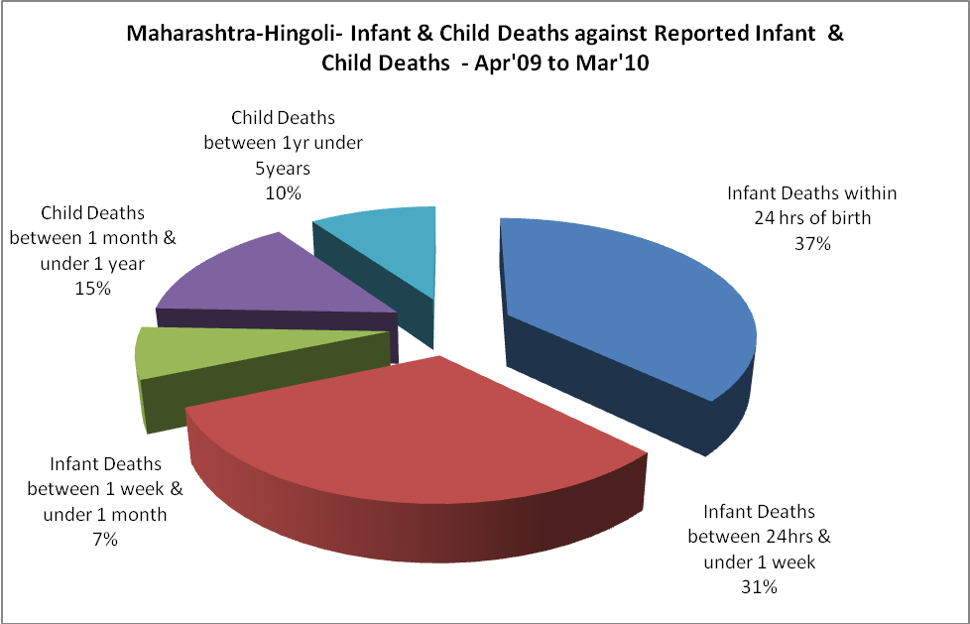

Maharashtra-Hingoli- Causes of Infant & Child Deaths - Apr'09 to Mar'10
Sepsis |  |  | Asphyxia |  |  | LBW
Up to 1 Weeks of Birth | Between 1 week & 4 weeks of birth | Total | Up to 1 Weeks of Birth | Between 1 week & 4 weeks of birth | Total | Up to 1 Weeks of Birth | Between 1 week & 4 weeks of birth | Total
0 | 0 | 0 | 0 | 0 | 0 | 0 | 0 | 0
Pneumonia |  |  | Diarrhoea |  |  | Fever related
Between 1 month and 11 months | Between 1 year & 5 years | Total | Between 1 month and 11 months | Between 1 year & 5 years | Total | Between 1 month and 11 months | Between 1 year & 5 years | Total
0 | 0 | 0 | 0 | 0 | 0 | 0 | 0 | 0
Others |  |  | Measles |  |  | Others
Up to 1 Weeks of Birth | Between 1 week & 4 weeks of birth | Total | Between 1 month and 11 months | Between 1 year & 5 years | Total | Between 1 month and 11 months | Between 1 year & 5 years | Total
103 | 23 | 126 | 0 | 0 | 0 | 48 | 32 | 80

Maharashtra-Hingoli- Maternal Deaths & Causes - Apr'09 to Mar'10
Abortion |  |  | Obstructed/prolonged labour |  |  | Severe hypertesnion/fits
6-14 yrs | 15-55 yrs. | Total | 6-14 yrs | 15-55 yrs. | Total | 6-14 yrs | 15-55 yrs. | Total
0 | 0 | 0 | 0 | 0 | 0 | 0 | 0 | 0
Bleeding |  |  | High Fever |  |  | Other Causes
6-14 yrs | 15-55 yrs. | Total | 6-14 yrs | 15-55 yrs. | Total | 6-14 yrs | 15-55 yrs. | Total
0 | 0 | 0 | 0 | 0 | 0 | 0 | 1 | 1

Maharashtra-Hingoli-Causes of Deaths in 6 to 55yrs age group - Apr'09 to Mar'10
Diarrhoel Diseases |  |  |  | Tuberculosis |  |  |  | Respiratory Diseases( Other than TB)
6-14 yrs | 15-55 yrs. | Above 55yrs | Total | 6-14 yrs | 15-55 yrs. | Above 55yrs | Total | 6-14 yrs | 15-55 yrs. | Above 55yrs | Total
0 | 0 | 0 | 0 | 0 | 0 | 0 | 0 | 0 | 0 | 0 | 0
Malaria |  |  |  | Other fever Related |  |  |  | HIV/Aids
6-14 yrs | 15-55 yrs. | Above 55yrs | Total | 6-14 yrs | 15-55 yrs. | Above 55yrs | Total | 6-14 yrs | 15-55 yrs. | Above 55yrs | Total
0 | 0 | 0 | 0 | 0 | 0 | 0 | 0 | 0 | 0 | 0 | 0
Heart Disease/Hypertension related |  |  |  | Neurological Disease including strokes |  |  |  | Trauma/Accidents/ Burn Cases
6-14 yrs | 15-55 yrs. | Above 55yrs | Total | 6-14 yrs | 15-55 yrs. | Above 55yrs | Total | 6-14 yrs | 15-55 yrs. | Above 55yrs | Total
0 | 0 | 0 | 0 | 0 | 0 | 0 | 0 | 0 | 0 | 0 | 0
Suicide |  |  |  | Animal Bites & Stings
6-14 yrs | 15-55 yrs. | Above 55yrs | Total | 6-14 yrs | 15-55 yrs. | Above 55yrs | Total
0 | 0 | 0 | 0 | 0 | 0 | 0 | 0

