NHSRC
Bihar- Jehanabad
HMIS DATA ANALYSIS 2009-10

KUNAL
25/08/2010
BIHAR-JEHANABAD- Summary-Apr'09 to Mar'10
ANC
ANC Registration against Expected Pregnancies | 318% | TT1 given to Pregnant women against ANC Registraion | 21%
3 ANC Check ups against ANC Reigtrations | 9% | 100 IFA Tablets given to Pregnant women against ANC Registraion | 2%
Deliveries
Unreported Deliveries against Estimated Deliveries | 34.4% | HOME Deliveries( SBA& Non SBA) against Estimated Deliveries | 0.3%
Institutional Deliveries against Estimated Deliveries | 65.3% | HOME Deliveries( SBA& Non SBA) against Reported Deliveries | 0.5%
Institutional Deliveries against Reported Deliveries | 99.5% | C Section Deliveries against Institutional Deliveries( Pvt & Pub) | 0%
Births & Neonates Care
Live Births Reported against Estimated Live Births | 37% | New borns weighed against Reported Live Births | 58%
Still Births (Reported) | 233 | New borns weighed less than 2.5 kgs against newborns weighed | 9%
Sex Ratio at Birh | 1,033 | New borns breastfed within one hr of Birth against Reported live Births | 26%
Child Immunisation( 0 to 11 mnths)
BCG given against Expected Live Births | 92% | Measles given against Expected Live Births | 79%
OPV3 given against Expected Live Births | 87% | Fully Immunised Children against Expected Live Births | 35%
DPT3 given against Expected Live Births | 87%
Family Plannng
Family Plannig Methods Users ( Sterilisations(Male &Female)+IUD+ Condom pieces/72 + OCP Cycles/13) | 8,495 | IUD Insertions against reported FP Methods | 36%
Sterilisation against reported FP Methods | 52% | Condom Users against reported FP Methods | 8%
 |  | OCP Users against reported FP Methods | 4%
Other Services
OPD | 4,84,225 | Major Operations | 50
IPD | 110 | Minor Operations | 11,876

Bihar-Jehanabad- Deliveries Apr'09 to Mar'10
Total Population | 10,37,295 | Expected Deliveries |  | 31,437
Home SBA | Home Non SBA | Institutional | Total Deliveries Reported | Unreported Deliveries
59 | 34 | 20,520 | 20,613 | 10,824
Home SBA % | Home Non SBA% | Institutional % | Total Deliveries Reported % | Unreported Deliveries %
0% | 0% | 65% | 66% | 34%

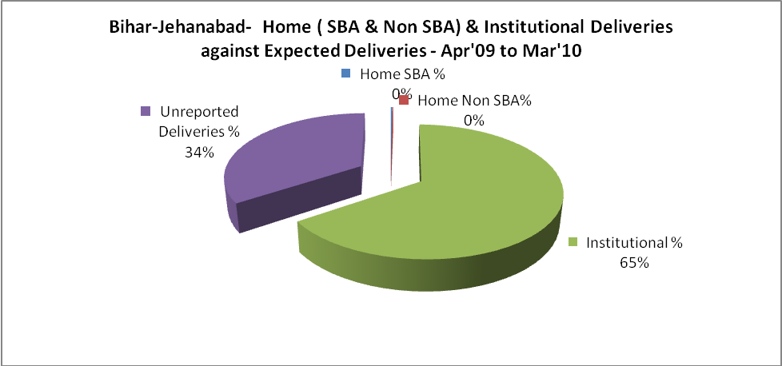
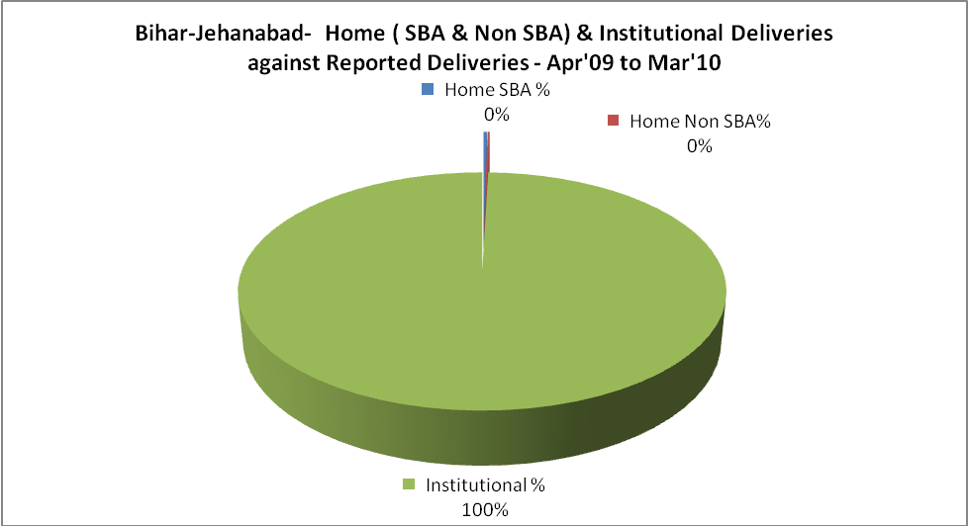
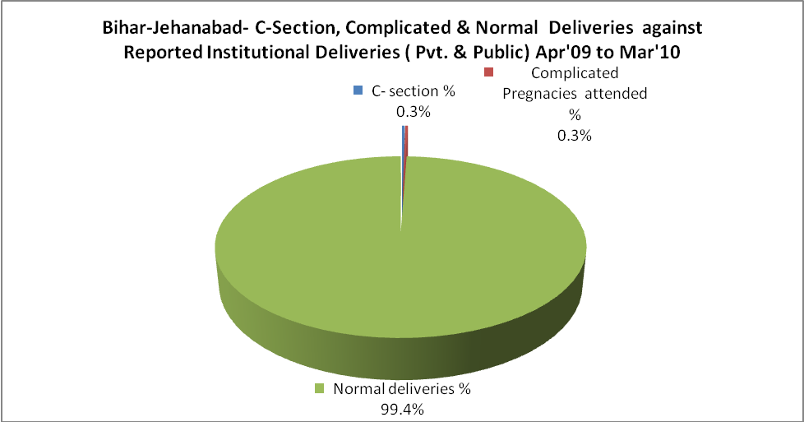
Bihar-Jehanabad- C sections & Complicated Deliveries Apr'09 to Mar'10
 | Institutional Deliveries (Public) | Institutional Deliveries (Pvt)
 | 20,520 | -
C Section | 59 | -
C Section% | 0% | 0
Complicated Pregnancies attended | 61 | -
Complicated Pregnancies attended % | 0% | 0

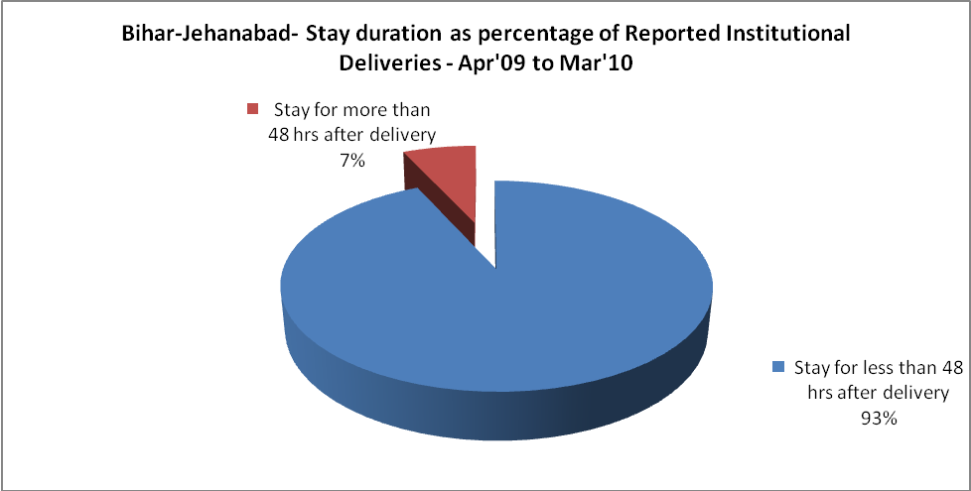

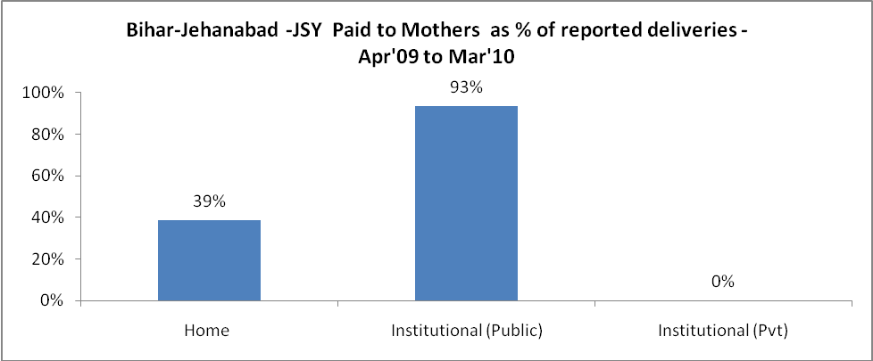

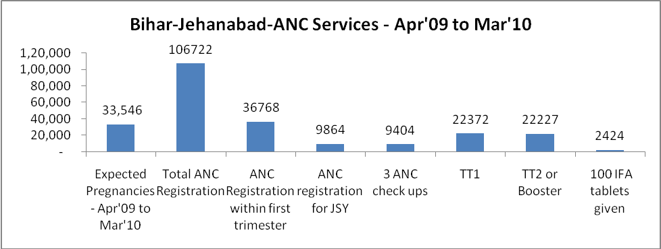
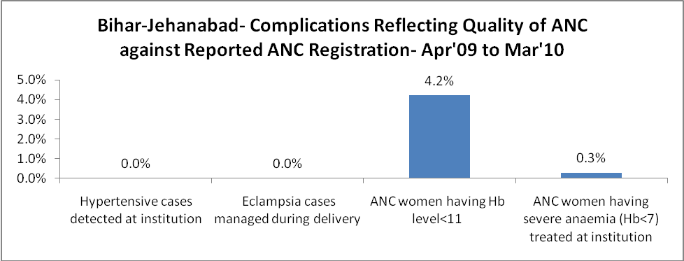
Bihar-Jehanabad - Births - Apr'09 to Mar'10
Live Birth - Males | Live Birth - females | Live Birth - Total | Sex Ratio at birth | Still Birth | Abortion( Induced/Spontaneous
5,607 | 5,792 | 11,399 | 1,033 | 233 | 13

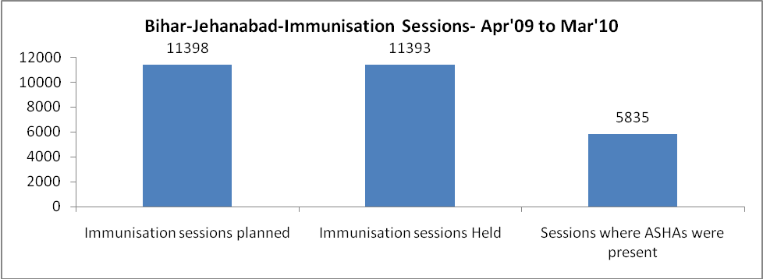
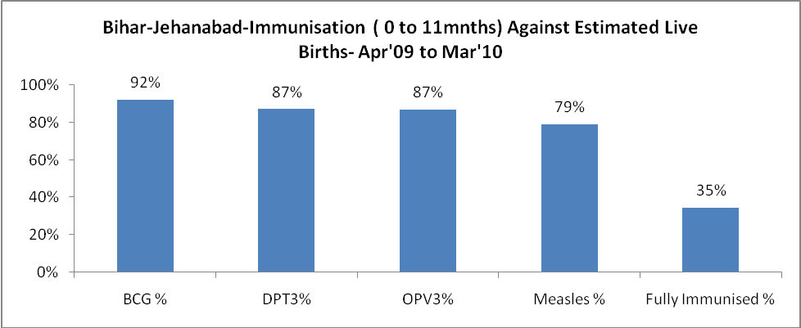

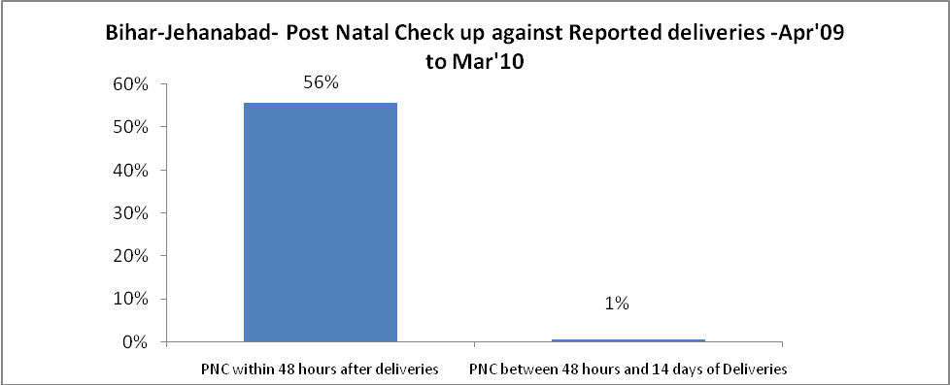
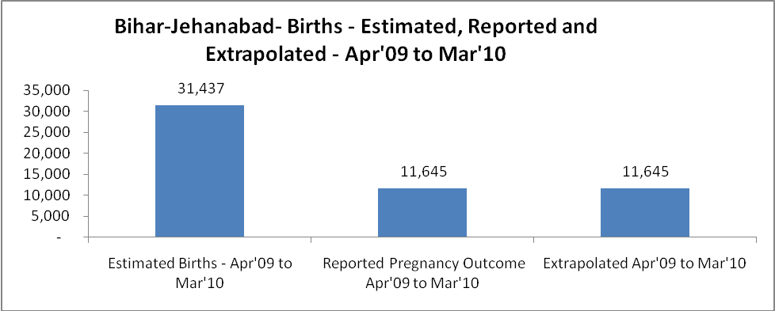
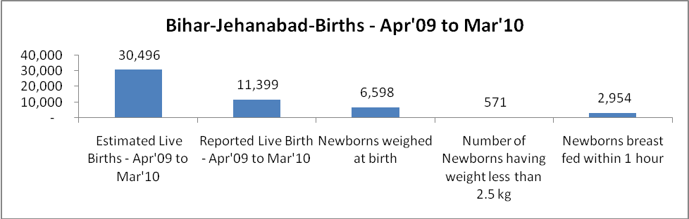
Bihar-Jehanabad- Apr'09 to Mar'10
Total Abortions | Abortion Rate
101 | 0.3%

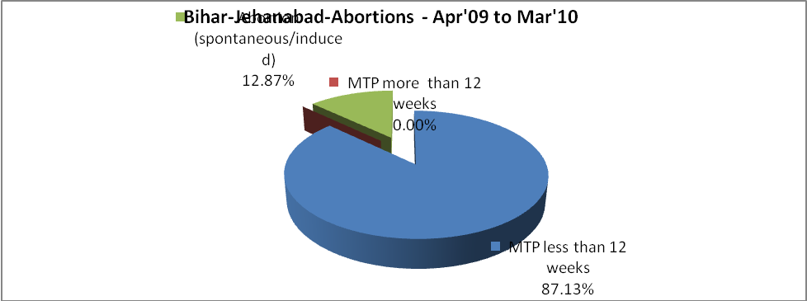
Bihar-Jehanabad- Apr'09 to Mar'10
Total OPD | Total RTI/STI cases
4,84,225 | -

Bihar-Jehanabad-Sterilisations - Apr'09 to Mar'10
 | Reported | %age of Reported Sterilisation
Total Sterilisation | 4,405 | -
NSV | 2,394 | 54%
Laproscopic | - | 0%
MiniLap | 2,011 | 46%
Post Partum | - | 0%
Male Sterilisation | 2,394 | 54%
Female Sterilisation | 2,011 | 46%
Bihar-Jehanabad-FP Methods - Apr'09 to Mar'10
 | Reported | %age of All Reported FP Methods
Total Reported FP Methodd (All types) Users | 8,495 | -
Sterilisations | 4,405 | 52%
IUD | 3,074 | 36%
Condom Users | 684 | 8%
OCP Users | 332 | 4%
Limiting Methods | 4,405 | 52%
Spacing Methods | 4,090 | 48%

Bihar-Jehanabad- Service Delivery - Apr'09 to Mar'10
Operation major (General and spinal anaesthesia) | Operation minor (No or local anaesthesia) | AYUSH | Dental Procedures | Adolescent counselling services | Total OPD | Total IPD
50 | 11,876 | 24 | 24 | - | 4,84,225 | 110
Operation major (General and spinal anaesthesia) as %ge of OPD | Operation minor (No or local anaesthesia)as %ge of OPD | AYUSH as %ge of OPD | Dental Procedures as %ge of OPD | Adolescent counselling services as %ge of OPD | IPD as percentage of OPD
0.0% | 2.5% | 0.0% | 0.0% | 0.0% | 0%

Bihar-Jehanabad- Lab Services - Apr'09 to Mar'10
Total OPD | Total HB tested | Total HIV Tested | Total Population
4,84,225 | 4,672 | 5,457 | 10,37,295
HB test conducted as %age of OPD | HB<7gm as %age of HB tested | HIV test conducted as %age of OPD | HIV positive as %age of HIV tested | Blood Smear Examined as % of Population
1.0% | 5.2% | 1.1% | 0.5% | 0.2%
Bihar-Jehanabad- Childhood Disease - Vaccine Preventable -Apr'09 to Mar'10
Diphtheria | Pertussis | Tetanus Neonatorum | Tetanus others | Polio | Measles
0 | 0 | 0 | 0 | 0 | 0
Bihar-Jehanabad-Childhood Disease - Others - Apr'09 to Mar'10
Diarrhoea and dehydration | Malaria | Number admitted with Respiratory Infections
- | - | -
Bihar-Jehanabad- Infant & Child Deaths - Apr'09 to Mar'10
Infant Deaths within 24 hrs of birth | Infant Deaths between 24hrs & under 1 week | Infant Deaths between 1 week & under 1 month | Child Deaths between 1 month & under 1 year | Child Deaths between 1yr under 5years | Total Deaths
0 | 0 | 0 | 0 | 0 | 0

Bihar-Jehanabad- Causes of Infant & Child Deaths - Apr'09 to Mar'10
Sepsis |  |  | Asphyxia |  |  | LBW
Up to 1 Weeks of Birth | Between 1 week & 4 weeks of birth | Total | Up to 1 Weeks of Birth | Between 1 week & 4 weeks of birth | Total | Up to 1 Weeks of Birth | Between 1 week & 4 weeks of birth | Total
0 | 0 | 0 | 0 | 0 | 0 | 0 | 0 | 0
Pneumonia |  |  | Diarrhoea |  |  | Fever related
Between 1 month and 11 months | Between 1 year & 5 years | Total | Between 1 month and 11 months | Between 1 year & 5 years | Total | Between 1 month and 11 months | Between 1 year & 5 years | Total
0 | 0 | 0 | 0 | 0 | 0 | 0 | 0 | 0
Others |  |  | Measles |  |  | Others
Up to 1 Weeks of Birth | Between 1 week & 4 weeks of birth | Total | Between 1 month and 11 months | Between 1 year & 5 years | Total | Between 1 month and 11 months | Between 1 year & 5 years | Total
0 | 0 | 0 | 0 | 0 | 0 | 0 | 0 | 0

Bihar-Jehanabad- Maternal Deaths & Causes - Apr'09 to Mar'10
Abortion |  |  | Obstructed/prolonged labour |  |  | Severe hypertesnion/fits
6-14 yrs | 15-55 yrs. | Total | 6-14 yrs | 15-55 yrs. | Total | 6-14 yrs | 15-55 yrs. | Total
0 | 0 | 0 | 0 | 0 | 0 | 0 | 0 | 0
Bleeding |  |  | High Fever |  |  | Other Causes
6-14 yrs | 15-55 yrs. | Total | 6-14 yrs | 15-55 yrs. | Total | 6-14 yrs | 15-55 yrs. | Total
0 | 0 | 0 | 0 | 0 | 0 | 0 | 0 | 0

Bihar-Jehanabad-Causes of Deaths in 6 to 55yrs age group - Apr'09 to Mar'10
Diarrhoel Diseases |  |  |  | Tuberculosis |  |  |  | Respiratory Diseases( Other than TB)
6-14 yrs | 15-55 yrs. | Above 55yrs | Total | 6-14 yrs | 15-55 yrs. | Above 55yrs | Total | 6-14 yrs | 15-55 yrs. | Above 55yrs | Total
0 | 0 | 0 | 0 | 0 | 0 | 0 | 0 | 0 | 0 | 0 | 0
Malaria |  |  |  | Other fever Related |  |  |  | HIV/Aids
6-14 yrs | 15-55 yrs. | Above 55yrs | Total | 6-14 yrs | 15-55 yrs. | Above 55yrs | Total | 6-14 yrs | 15-55 yrs. | Above 55yrs | Total
0 | 0 | 0 | 0 | 0 | 0 | 0 | 0 | 0 | 0 | 0 | 0
Heart Disease/Hypertenion related |  |  |  | Neurological Disease including strokes |  |  |  | Trauma/Accidents/ Burn Cases
6-14 yrs | 15-55 yrs. | Above 55yrs | Total | 6-14 yrs | 15-55 yrs. | Above 55yrs | Total | 6-14 yrs | 15-55 yrs. | Above 55yrs | Total
0 | 0 | 0 | 0 | 0 | 0 | 0 | 0 | 0 | 0 | 0 | 0
Suicide |  |  |  | Animal Bites & Stings
6-14 yrs | 15-55 yrs. | Above 55yrs | Total | 6-14 yrs | 15-55 yrs. | Above 55yrs | Total
0 | 0 | 0 | 0 | 0 | 0 | 0 | 0

