NHSRC
Rajasthan-Jaiselmer
Analysis: Apr 2009 – Mar 2010

Rajasthan- Jaiselmer- Summary-Apr'09 to Mar'10
ANC
ANC Registration against Expected Pregnancies | 100% | TT1 given to Pregnant women against ANC Registration | 79%
3 ANC Checkups against ANC Registrations | 58% | 100 IFA Tablets given to Pregnant women against ANC Registration | 95%
Deliveries
Unreported Deliveries against Estimated Deliveries | 24.8% | HOME Deliveries( SBA& Non SBA) against Estimated Deliveries | 28.4%
Institutional Deliveries against Estimated Deliveries | 46.8% | HOME Deliveries( SBA& Non SBA) against Reported Deliveries | 37.8%
Institutional Deliveries against Reported Deliveries | 62.2% | C Section Deliveries against Institutional Deliveries( Pvt & Pub) | 15%
Births & Neonates Care
Live Births Reported against Estimated Live Births | 79% | New borns weighed against Reported Live Births | 81%
Still Births (Reported) | 332 | New borns weighed less than 2.5 kgs against newborns weighed | 35%
Sex Ratio at Birh | 872 | New borns breastfed within one hr of Birth against Reported live Births | 80%
Child Immunisation( 0 to 11 months)
BCG given against Expected Live Births | 102% | Measles given against Expected Live Births | 97%
OPV3 given against Expected Live Births | 97% | Fully Immunised Children against Expected Live Births | 91%
DPT3 given against Expected Live Births | 100%
Family Planning
Family Plannig Methods Users ( Sterilisations(Male &Female)+IUD+ Condom pieces/72 + OCP Cycles/13) | 52,886 | IUD Insertions against reported FP Methods | 9%
Sterilisation against reported FP Methods | 6% | Condom Users against reported FP Methods | 43%
 |  | OCP Users against reported FP Methods | 41%
Other Services
OPD | 354,277 | Major Operations | 419
IPD | 19,516 | Minor Operations | 329

Rajasthan- Jaiselmer- Deliveries Apr'09 to Mar'10
Total Population | 603,400 | Expected Deliveries |  | 17,116
Home SBA | Home Non SBA | Institutional | Total Deliveries Reported | Unreported Deliveries
2,495 | 2,365 | 8,005 | 12,865 | 4,251
Home SBA % | Home Non SBA% | Institutional % | Total Deliveries Reported % | Unreported Deliveries %
15% | 14% | 47% | 75% | 25%
`

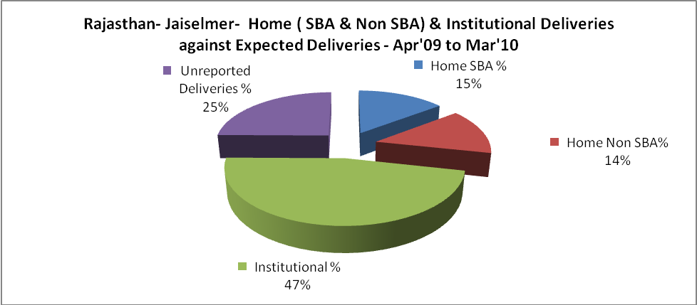

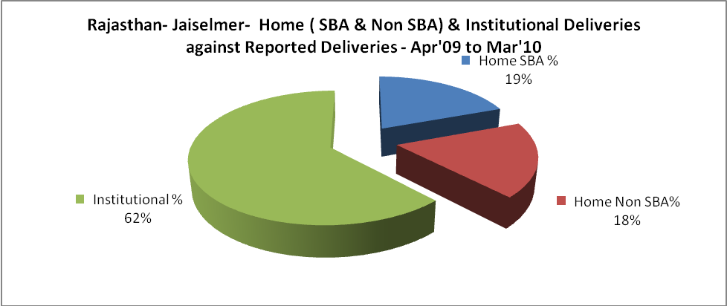

Rajasthan- Jaiselmer- C sections & Complicated Deliveries Apr'09 to Mar'10
 | Institutional Deliveries (Public) | Institutional Deliveries (Pvt)
 | 8,005 | -
C Section | 1,231 | -
C Section% | 15% | #DIV/0!
Complicated Pregnacies attended | 667 | -
Complicated Pregnacies attended % | 8% | #DIV/0!

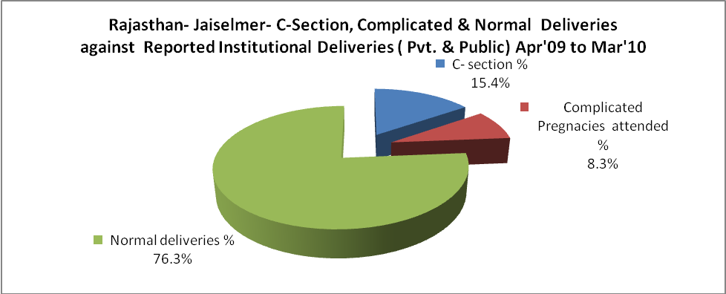

Rajasthan- Jaiselmer- Complicated Pregnancies & Deliveries Treated - Apr'09 to Mar'10
Reported Deliveries |  |  | Reported ANC Reigtration
12,865 |  |  | 18,319
Complicated Pregnancies attended | Complicated Pregnancies Rate | C - Section Deliveries | PNC Maternal Complications | Abortions | Still Births
667 | 4% | 1,231 | 146 | 561 | 332
Complicated Deliveries Treated with |  |  |  | No Of Eclampsia cases Treated | No Of severe anemia cases treated
IV Antibiotics | IV antihypertensive/Magsulph injection | IV Oxytocis | Blood Transfusion | No Of Eclampsia cases Treated | No Of severe anemia cases treated
1,974 | 51 | 1,205 | 92 | 201 | 358

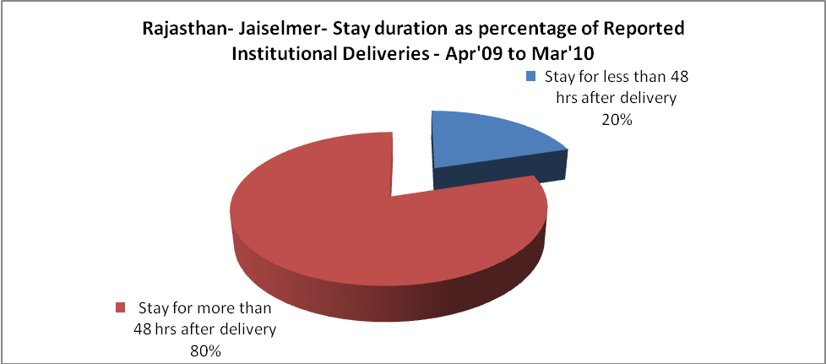

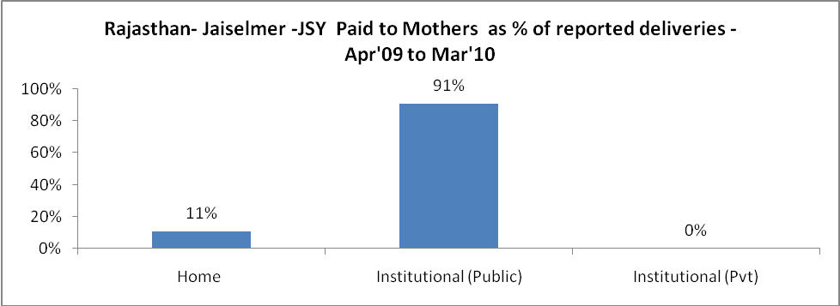

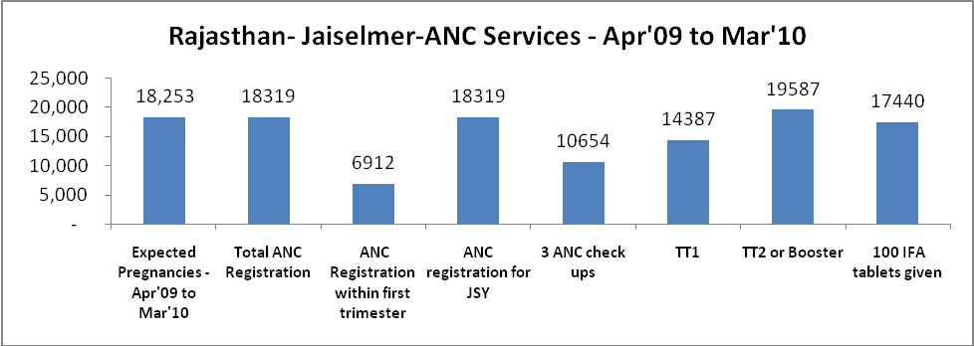

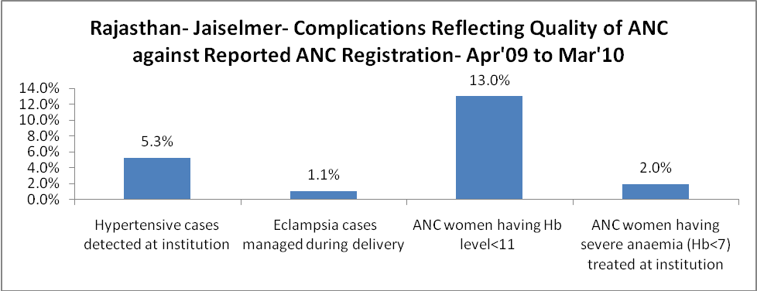
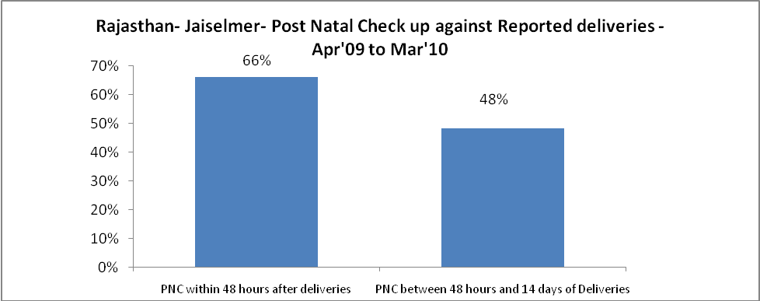

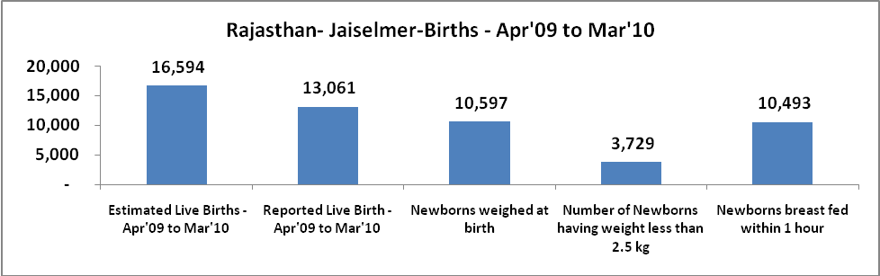

Rajasthan- Jaiselmer - Births - Apr'09 to Mar'10
Live Birth - Males | Live Birth - females | Live Birth - Total | Sex Ratio at birth | Still Birth | Abortion( Induced/Spontaneous
6,976 | 6,085 | 13,061 | 872 | 332 | 561

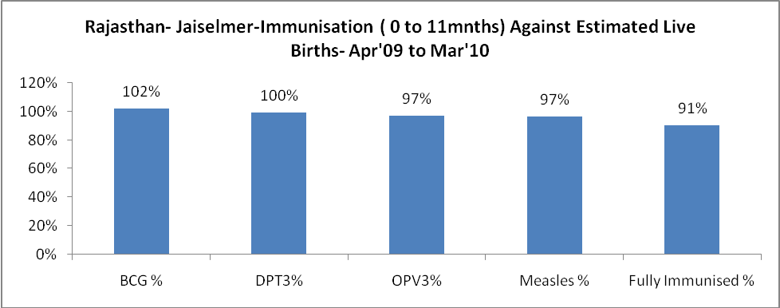

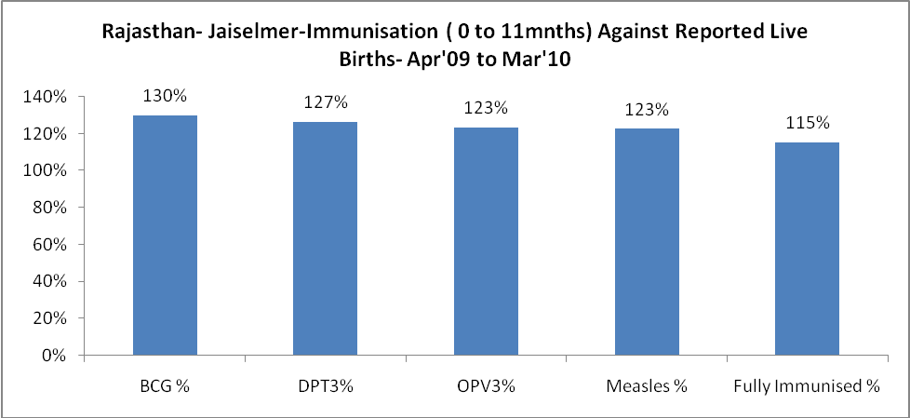

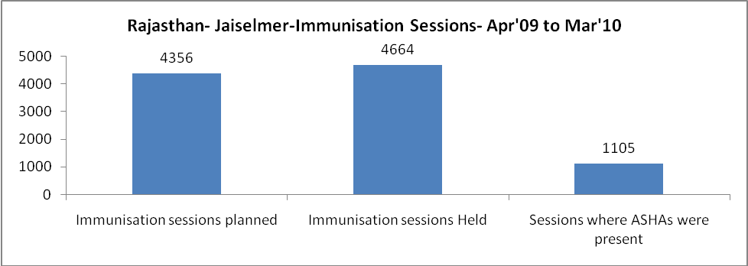

Rajasthan- Jaiselmer- Apr'09 to Mar'10
Total Abortions | Abortion Rate
609 | 3.3%

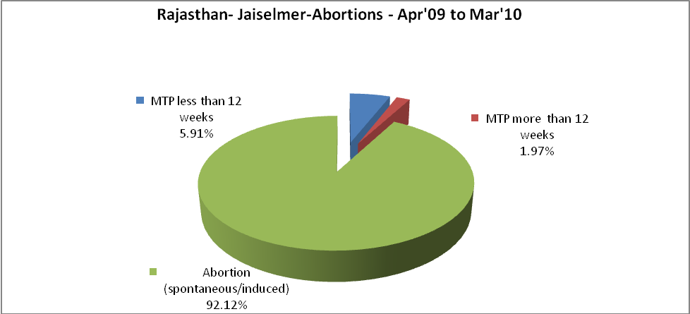

Rajasthan- Jaiselmer- Apr'09 to Mar'10
Total OPD | Total RTI/STI cases
354,277 | 822

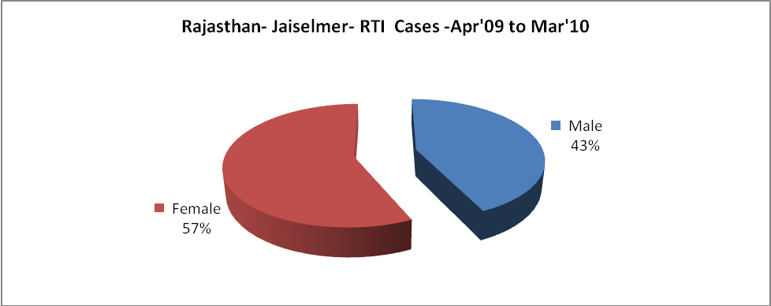

Rajasthan- Jaiselmer-Sterilisations - Apr'09 to Mar'10
 | Reported | %age of Reported Sterilisation
Total Sterilisation | 3,081 | -
NSV | 20 | 1%
Laproscopic | 3,047 | 99%
MiniLap | 13 | 0%
Post Partum | 1 | 0%
Male Sterilisation | 20 | 1%
Female Sterilisation | 3,061 | 99%

Rajasthan- Jaiselmer-FP Methods - Apr'09 to Mar'10
 | Reported | %age of All Reported FP Methods
Total Reported FP Methodd (All types) Users | 52,886 | -
Sterilisations | 3,081 | 6%
IUD | 4,993 | 9%
Condom Users | 22,928 | 43%
OCP Users | 21,884 | 41%
Limiting Methods | 3,081 | 6%
Spacing Methods | 49,805 | 94%

Rajasthan- Jaiselmer- Service Delivery - Apr'09 to Mar'10
Operation major (General and spinal anaesthesia) | Operation minor (No or local anaesthesia) | AYUSH | Dental Procedures | Adolescent counselling services | Total OPD | Total IPD
419 | 329 | 4,777 | 2,381 | 384 | 354,277 | 19,516
Operation major (General and spinal anaesthesia) as %ge of OPD | Operation minor (No or local anaesthesia)as %ge of OPD | AYUSH as %ge of OPD | Dental Procedures as %ge of OPD | Adolescent counselling services as %ge of OPD | IPD as percentage of OPD
0.1% | 0.1% | 1.3% | 0.7% | 0.1% | 6%

Rajasthan- Jaiselmer- Lab Services - Apr'09 to Mar'10
Total OPD | Total HB tested | Total HIV Tested | Total Population
354,277 | 5,941 | 3,556 | 603,400
HB test conducted as %age of OPD | HB<7gm as %age of HB tested | HIV test conducted as %age of OPD | HIV positive as %age of HIV tested | Blood Smear Examined as % of Population
1.7% | 5.8% | 1.0% | 0.9% | 8.1%

Rajasthan- Jaiselmer- Childhood Disease - Vaccine Preventable -Apr'09 to Mar'10
Diphtheria | Pertussis | Tetanus Neonatorum | Tetanus others | Polio | Measles
9 | 0 | 0 | 0 | 0 | 50
Rajasthan- Jaiselmer-Childhood Disease - Others - Apr'09 to Mar'10
Diarrhoea and dehydration | Malaria | Number admitted with Respiratory Infections
475 | 66 | 218

Rajasthan- Jaiselmer- Infant & Child Deaths - Apr'09 to Mar'10
Infant Deaths within 24 hrs of birth | Infant Deaths between 24hrs & under 1 week | Infant Deaths between 1 week & under 1 month | Child Deaths between 1 month & under 1 year | Child Deaths between 1yr under 5years | Total Deaths
9 | 16 | 1 | 1 | 13 | 40

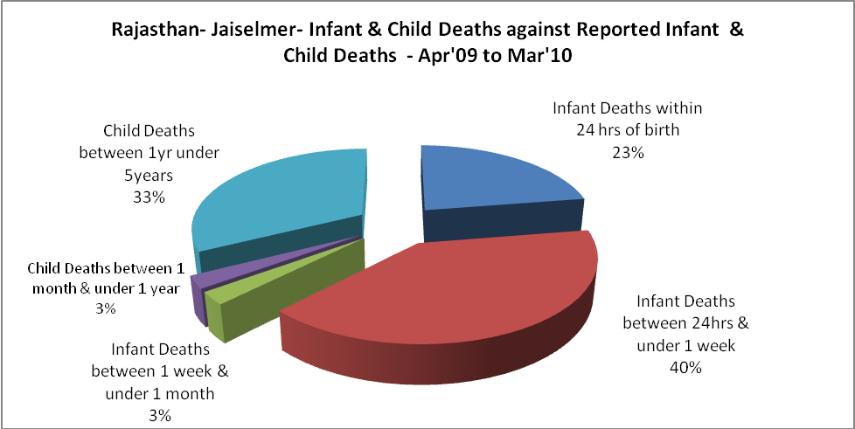

Rajasthan- Jaiselmer- Causes of Infant & Child Deaths - Apr'09 to Mar'10
Sepsis |  |  | Asphyxia |  |  | LBW
Up to 1 Weeks of Birth | Between 1 week & 4 weeks of birth | Total | Up to 1 Weeks of Birth | Between 1 week & 4 weeks of birth | Total | Up to 1 Weeks of Birth | Between 1 week & 4 weeks of birth | Total
0 | 0 | 0 | 6 | 0 | 6 | 0 | 0 | 0
Pneumonia |  |  | Diarrhoea |  |  | Fever related
Between 1 month and 11 months | Between 1 year & 5 years | Total | Between 1 month and 11 months | Between 1 year & 5 years | Total | Between 1 month and 11 months | Between 1 year & 5 years | Total
1 | 0 | 1 | 0 | 0 | 0 | 0 | 12 | 12
Others |  |  | Measles |  |  | Others
Up to 1 Weeks of Birth | Between 1 week & 4 weeks of birth | Total | Between 1 month and 11 months | Between 1 year & 5 years | Total | Between 1 month and 11 months | Between 1 year & 5 years | Total
10 | 1 | 11 | 0 | 0 | 0 | 0 | 1 | 1

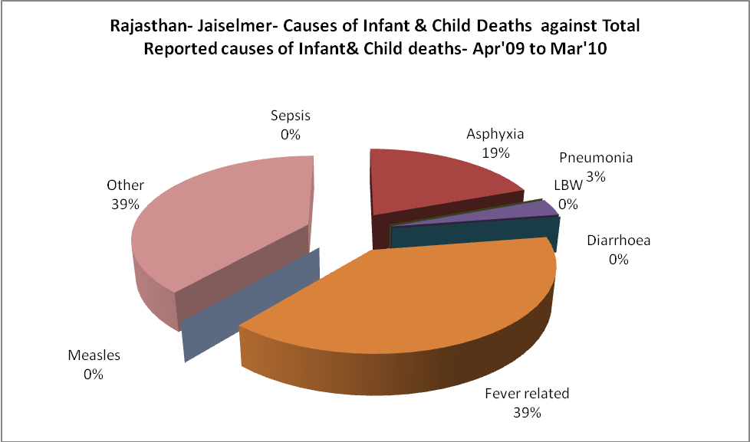

Rajasthan- Jaiselmer- Maternal Deaths & Causes - Apr'09 to Mar'10
Abortion |  |  | Obstructed/prolonged labour |  |  | Severe hypertesnion/fits
6-14 yrs | 15-55 yrs. | Total | 6-14 yrs | 15-55 yrs. | Total | 6-14 yrs | 15-55 yrs. | Total
0 | 0 | 0 | 0 | 0 | 0 | 0 | 0 | 0
Bleeding |  |  | High Fever |  |  | Other Causes
6-14 yrs | 15-55 yrs. | Total | 6-14 yrs | 15-55 yrs. | Total | 6-14 yrs | 15-55 yrs. | Total
0 | 0 | 0 | 0 | 0 | 0 | 0 | 0 | 0

Rajasthan- Jaiselmer-Causes of Deaths in 6 to 55yrs age group - Apr'09 to Mar'10
Diarrhoel Diseases |  |  |  | Tuberculosis |  |  |  | Respiratory Diseases( Other than TB)
6-14 yrs | 15-55 yrs. | Above 55yrs | Total | 6-14 yrs | 15-55 yrs. | Above 55yrs | Total | 6-14 yrs | 15-55 yrs. | Above 55yrs | Total
0 | 1 | 8 | 9 | 0 | 4 | 0 | 4 | 0 | 4 | 1 | 5
Malaria |  |  |  | Other fever Related |  |  |  | HIV/Aids
6-14 yrs | 15-55 yrs. | Above 55yrs | Total | 6-14 yrs | 15-55 yrs. | Above 55yrs | Total | 6-14 yrs | 15-55 yrs. | Above 55yrs | Total
0 | 0 | 0 | 0 | 0 | 0 | 0 | 0 | 0 | 0 | 0 | 0
Heart Disease/Hypertenion related |  |  |  | Neurological Disease including strokes |  |  |  | Trauma/Accidents/ Burn Cases
6-14 yrs | 15-55 yrs. | Above 55yrs | Total | 6-14 yrs | 15-55 yrs. | Above 55yrs | Total | 6-14 yrs | 15-55 yrs. | Above 55yrs | Total
1 | 11 | 10 | 22 | 17 | 3 | 1 | 21 | 3 | 1 | 0 | 4
Suicide |  |  |  | Animal Bites & Stings
6-14 yrs | 15-55 yrs. | Above 55yrs | Total | 6-14 yrs | 15-55 yrs. | Above 55yrs | Total
1 | 2 | 0 | 3 | 0 | 0 | 0 | 0

