NHSRC
Maharashtra – Jalgaon
Analysis: Apr 2009 – Mar 2010

Maharashtra-Jalgaon- Summary-Apr'09 to Mar'10
ANC
ANC Registration against Expected Pregnancies | 109% | TT1 given to Pregnant women against ANC Registration | 63%
3 ANC Check ups against ANC Registrations | 68% | 100 IFA Tablets given to Pregnant women against ANC Registration | 64%
Deliveries
Unreported Deliveries against Estimated Deliveries | 2.7% | HOME Deliveries( SBA& Non SBA) against Estimated Deliveries | 14.4%
Institutional Deliveries against Estimated Deliveries | 82.9% | HOME Deliveries( SBA& Non SBA) against Reported Deliveries | 14.8%
Institutional Deliveries against Reported Deliveries | 85.2% | C Section Deliveries against Institutional Deliveries( Pvt & Pub) | 5%
Births & Neonates Care
Live Births Reported against Estimated Live Births | 88% | New borns weighed against Reported Live Births | 77%
Still Births (Reported) | 926 | New borns weighed less than 2.5 kgs against newborns weighed | 13%
Sex Ratio at Birth | 788 | New borns breastfed within one hr of Birth against Reported live Births | 74%
Child Immunization( 0 to 11 months)
BCG given against Expected Live Births | 107% | Measles given against Expected Live Births | 102%
OPV3 given against Expected Live Births | 103% | Fully Immunized Children against Expected Live Births | 93%
DPT3 given against Expected Live Births | 102%
Family Planning
Family Plannig Methods Users ( Sterilizations(Male &Female)+IUD+ Condom pieces/72 + OCP Cycles/13) | 65,815 | IUD Insertions against reported FP Methods | 24%
Sterilization against reported FP Methods | 35% | Condom Users against reported FP Methods | 24%
 |  | OCP Users against reported FP Methods | 17%
Other Services
OPD | 771,735 | Major Operations | -
IPD | - | Minor Operations | 21

Maharashtra-Jalgaon- Deliveries Apr'09 to Mar'10
Total Population | 4,322,423 | Expected Deliveries |  | 78,648
Home SBA | Home Non SBA | Institutional | Total Deliveries Reported | Unreported Deliveries
7,724 | 3,604 | 65,203 | 76,531 | 2,117
Home SBA % | Home Non SBA% | Institutional % | Total Deliveries Reported % | Unreported Deliveries %
10% | 5% | 83% | 97% | 3%

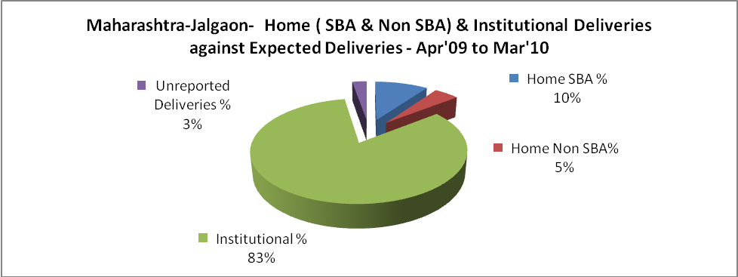

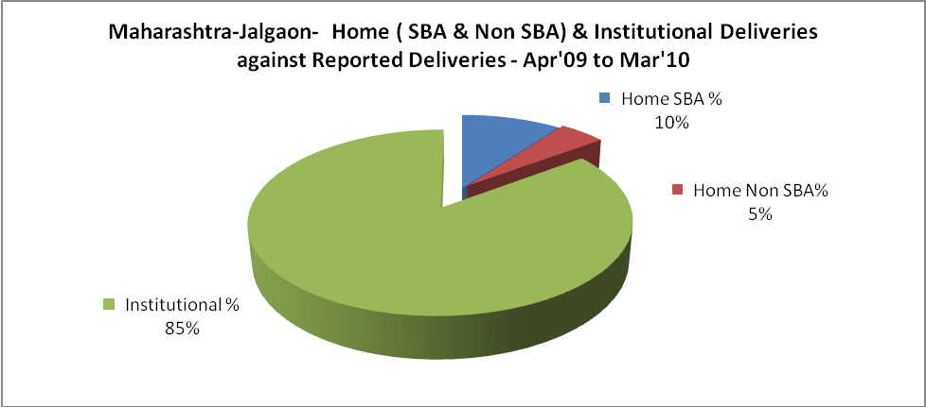

Maharashtra-Jalgaon- C sections & Complicated Deliveries Apr'09 to Mar'10
 | Institutional Deliveries (Public) | Institutional Deliveries (Pvt)
 | 25,763 | 39,440
C Section | 1,455 | 1,582
C Section% | 6% | 4%
Complicated Pregnancies attended | 3,202 | 812
Complicated Pregnancies attended % | 12% | 2%

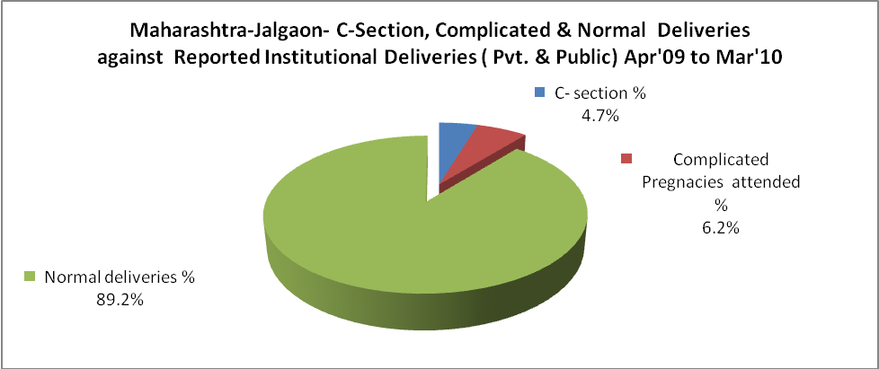

Maharashtra-Jalgaon- Complicated Pregnancies & Deliveries Treated - Apr'09 to Mar'10
Reported Deliveries |  |  | Reported ANC Reigtration
76,531 |  |  | 92,806
Complicated Pregnancies attended | Complicated Pregnancies Rate | C - Section Deliveries | PNC Maternal Complications | Abortions | Still Births
4,014 | 5% | 3,037 | - | 2,632 | 926
Complicated Deliveries Treated with |  |  |  | No Of Eclampsia cases Treated | No Of severe anemia cases treated
IV Antibiotics | IV antihypertensive/Magsulph injection | IV Oxytocis | Blood Transfusion | No Of Eclampsia cases Treated | No Of severe anemia cases treated
276 | - | - | - | - | -

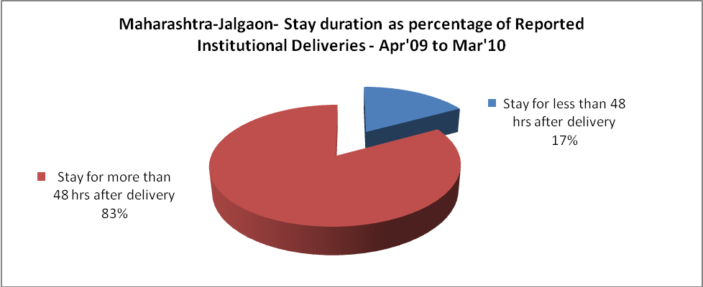

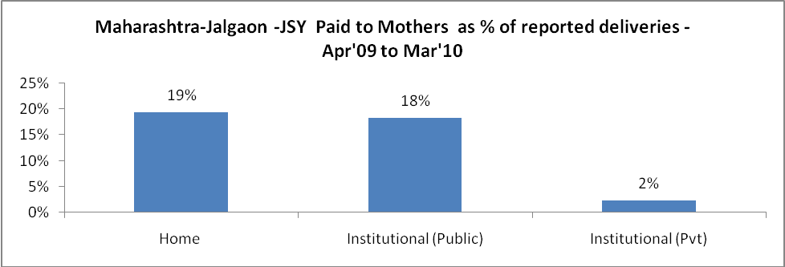

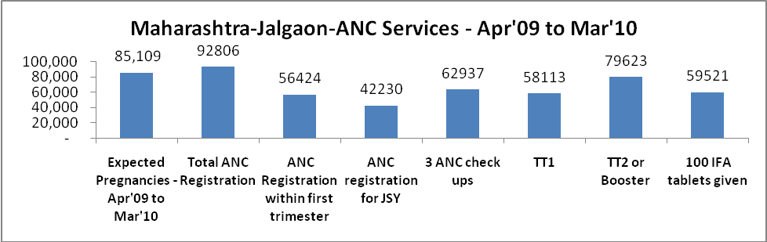

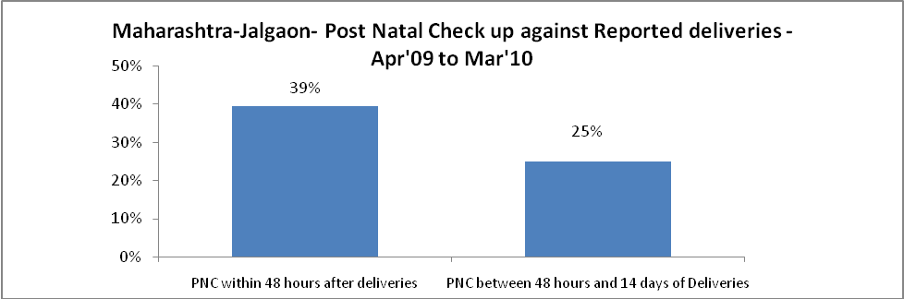

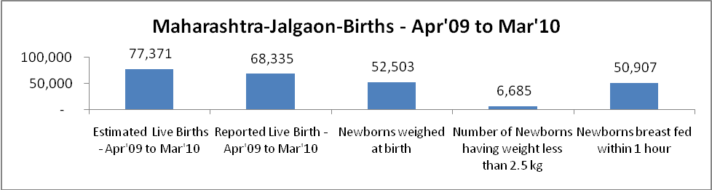

Maharashtra-Jalgaon - Births - Apr'09 to Mar'10
Live Birth - Males | Live Birth - females | Live Birth - Total | Sex Ratio at birth | Still Birth | Abortion( Induced/Spontaneous
38,219 | 30,116 | 68,335 | 788 | 926 | 2,632

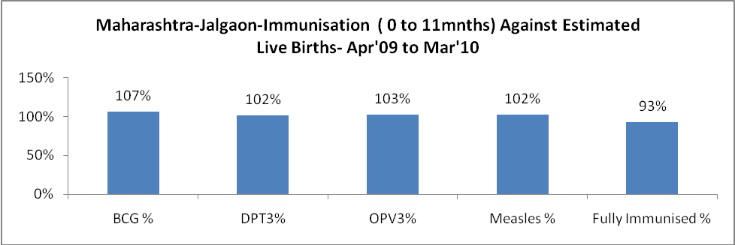

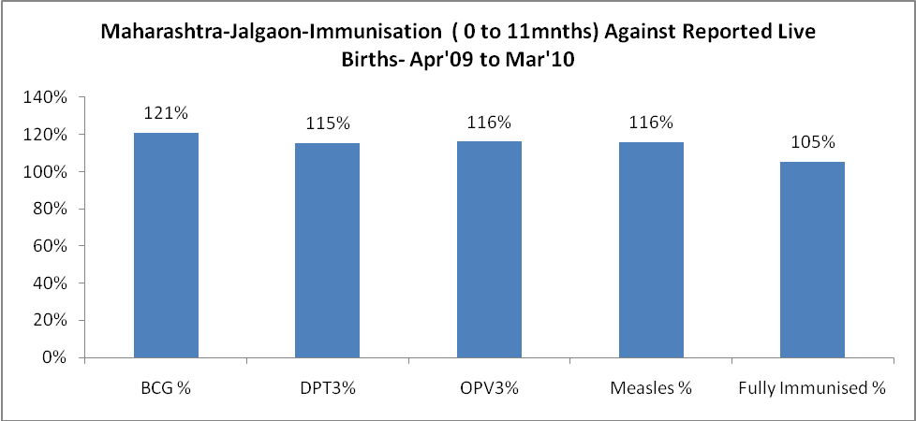

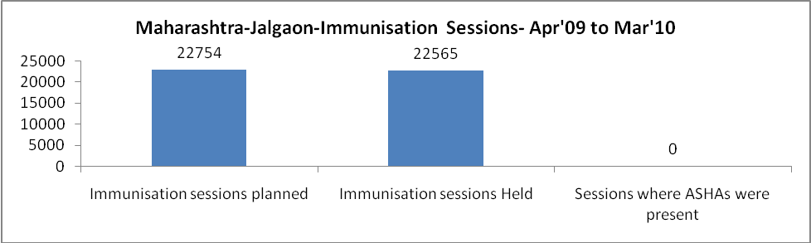

Maharashtra-Jalgaon- Apr'09 to Mar'10
Total Abortions | Abortion Rate
4,952 | 5.8%

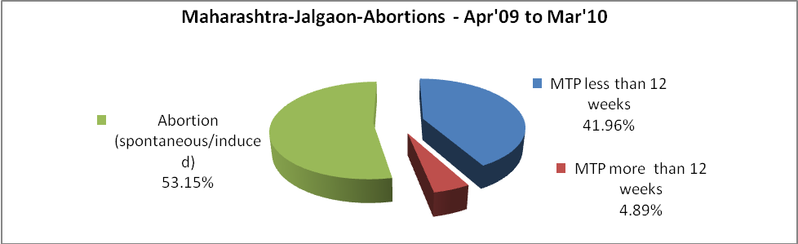

Maharashtra-Jalgaon- Apr'09 to Mar'10
Total OPD | Total RTI/STI cases
771,735 | 6,733

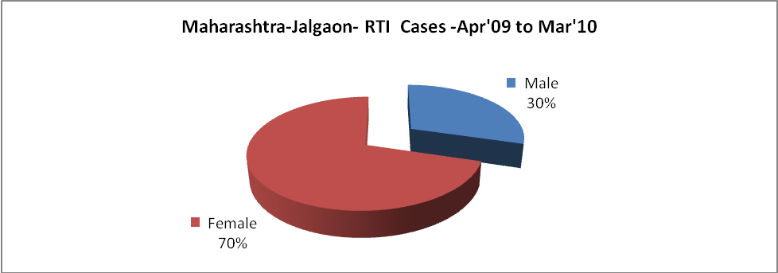

Maharashtra-Jalgaon-Sterilizations - Apr'09 to Mar'10
 | Reported | %age of Reported Sterilization
Total Sterilization | 22,937 | -
NSV | 774 | 3%
Laparoscopic | 1,682 | 7%
MiniLap | 13,357 | 58%
Post Partum | 7,124 | 31%
Male Sterilization | 774 | 3%
Female Sterilization | 22,163 | 97%

Maharashtra-Jalgaon-FP Methods - Apr'09 to Mar'10
 | Reported | %age of All Reported FP Methods
Total Reported FP Methodd (All types) Users | 65,815 | -
Sterilizations | 22,937 | 35%
IUD | 15,705 | 24%
Condom Users | 15,864 | 24%
OCP Users | 11,309 | 17%
Limiting Methods | 22,937 | 35%
Spacing Methods | 42,878 | 65%

Maharashtra-Jalgaon- Service Delivery - Apr'09 to Mar'10
Operation major (General and spinal anaesthesia) | Operation minor (No or local anaesthesia) | AYUSH | Dental Procedures | Adolescent counselling services | Total OPD | Total IPD
- | 21 | - | - | - | 771,735 | -
Operation major (General and spinal anaesthesia) as %ge of OPD | Operation minor (No or local anaesthesia)as %ge of OPD | AYUSH as %ge of OPD | Dental Procedures as %ge of OPD | Adolescent counselling services as %ge of OPD | IPD as percentage of OPD
0.0% | 0.0% | 0.0% | 0.0% | 0.0% | 0%

Maharashtra-Jalgaon- Lab Services - Apr'09 to Mar'10
Total OPD | Total HB tested | Total HIV Tested | Total Population
771,735 | 2,514 | - | 4,322,423
HB test conducted as %age of OPD | HB<7gm as %age of HB tested | HIV test conducted as %age of OPD | HIV positive as %age of HIV tested | Blood Smear Examined as % of Population
0.3% | 6.2% | 0.0% | 0.0% | 1.3%

Maharashtra-Jalgaon- Childhood Disease - Vaccine Preventable -Apr'09 to Mar'10
Diphtheria | Pertussis | Tetanus Neonatorum | Tetanus others | Polio | Measles
0 | 0 | 0 | 0 | 0 | 10
Maharashtra-Jalgaon-Childhood Disease - Others - Apr'09 to Mar'10
Diarrhoea and dehydration | Malaria | Number admitted with Respiratory Infections
798 | 3 | -

Maharashtra-Jalgaon- Infant & Child Deaths - Apr'09 to Mar'10
Infant Deaths within 24 hrs of birth | Infant Deaths between 24hrs & under 1 week | Infant Deaths between 1 week & under 1 month | Child Deaths between 1 month & under 1 year | Child Deaths between 1yr under 5years | Total Deaths
37 | 512 | 257 | 174 | 100 | 1080

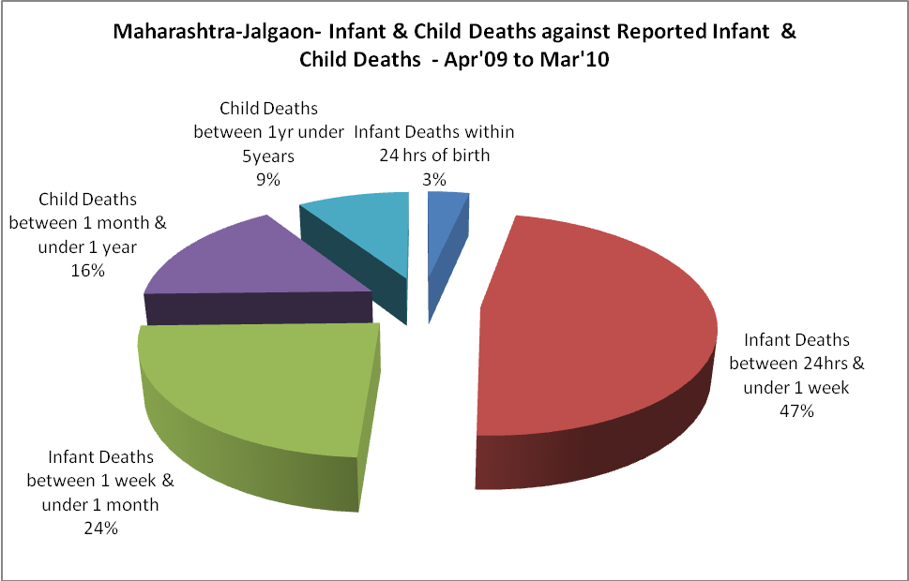

Maharashtra-Jalgaon- Causes of Infant & Child Deaths - Apr'09 to Mar'10
Sepsis |  |  | Asphyxia |  |  | LBW
Up to 1 Weeks of Birth | Between 1 week & 4 weeks of birth | Total | Up to 1 Weeks of Birth | Between 1 week & 4 weeks of birth | Total | Up to 1 Weeks of Birth | Between 1 week & 4 weeks of birth | Total
2 | 3 | 5 | 114 | 66 | 180 | 332 | 138 | 470
Pneumonia |  |  | Diarrhoea |  |  | Fever related
Between 1 month and 11 months | Between 1 year & 5 years | Total | Between 1 month and 11 months | Between 1 year & 5 years | Total | Between 1 month and 11 months | Between 1 year & 5 years | Total
46 | 10 | 56 | 0 | 0 | 0 | 9 | 2 | 11
Others |  |  | Measles |  |  | Others
Up to 1 Weeks of Birth | Between 1 week & 4 weeks of birth | Total | Between 1 month and 11 months | Between 1 year & 5 years | Total | Between 1 month and 11 months | Between 1 year & 5 years | Total
64 | 50 | 114 | 8 | 0 | 8 | 111 | 88 | 199

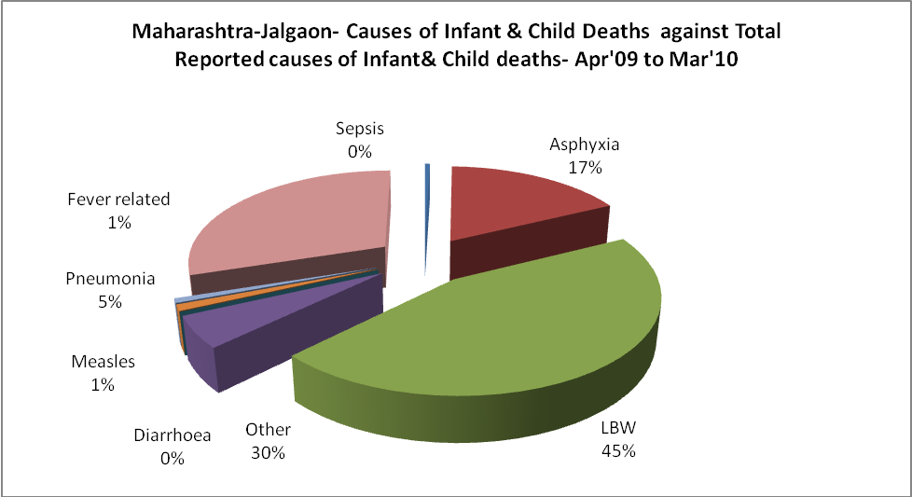

Maharashtra-Jalgaon- Maternal Deaths & Causes - Apr'09 to Mar'10
Abortion |  |  | Obstructed/prolonged labour |  |  | Severe hypertesnion/fits
6-14 yrs | 15-55 yrs. | Total | 6-14 yrs | 15-55 yrs. | Total | 6-14 yrs | 15-55 yrs. | Total
0 | 5 | 5 | 0 | 1 | 1 | 0 | 0 | 0
Bleeding |  |  | High Fever |  |  | Other Causes
6-14 yrs | 15-55 yrs. | Total | 6-14 yrs | 15-55 yrs. | Total | 6-14 yrs | 15-55 yrs. | Total
0 | 3 | 3 | 0 | 1 | 1 | 0 | 0 | 0

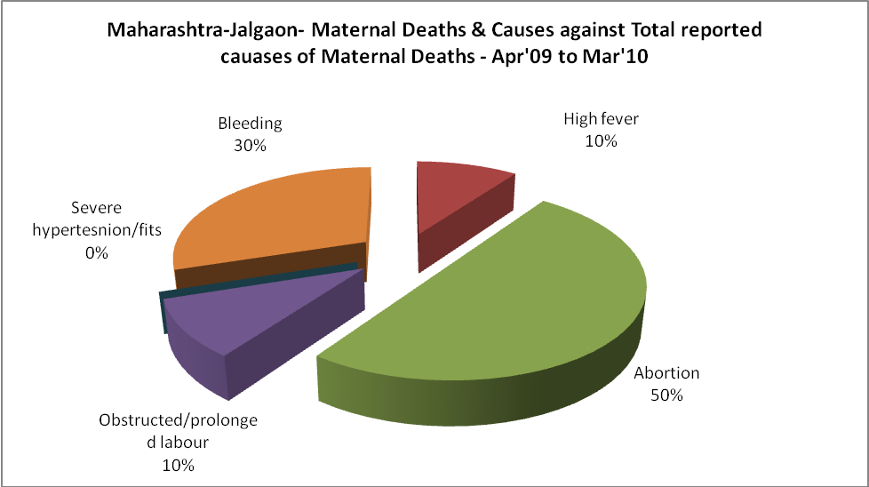

Maharashtra-Jalgaon-Causes of Deaths in 6 to 55yrs age group - Apr'09 to Mar'10
Diarrhoel Diseases |  |  |  | Tuberculosis |  |  |  | Respiratory Diseases( Other than TB)
6-14 yrs | 15-55 yrs. | Above 55yrs | Total | 6-14 yrs | 15-55 yrs. | Above 55yrs | Total | 6-14 yrs | 15-55 yrs. | Above 55yrs | Total
0 | 0 | 0 | 0 | 0 | 0 | 0 | 0 | 0 | 0 | 0 | 0
Malaria |  |  |  | Other fever Related |  |  |  | HIV/Aids
6-14 yrs | 15-55 yrs. | Above 55yrs | Total | 6-14 yrs | 15-55 yrs. | Above 55yrs | Total | 6-14 yrs | 15-55 yrs. | Above 55yrs | Total
0 | 0 | 0 | 0 | 0 | 0 | 0 | 0 | 0 | 0 | 0 | 0
Heart Disease/Hypertension related |  |  |  | Neurological Disease including strokes |  |  |  | Trauma/Accidents/ Burn Cases
6-14 yrs | 15-55 yrs. | Above 55yrs | Total | 6-14 yrs | 15-55 yrs. | Above 55yrs | Total | 6-14 yrs | 15-55 yrs. | Above 55yrs | Total
0 | 0 | 0 | 0 | 0 | 0 | 0 | 0 | 0 | 0 | 0 | 0
Suicide |  |  |  | Animal Bites & Stings
6-14 yrs | 15-55 yrs. | Above 55yrs | Total | 6-14 yrs | 15-55 yrs. | Above 55yrs | Total
0 | 0 | 0 | 0 | 0 | 0 | 0 | 0

