NHSRC
Maharashtra – Jalna
Analysis: Apr 2009 – Mar 2010

Maharashtra-Jalna- Summary-Apr'09 to Mar'10
ANC
ANC Registration against Expected Pregnancies | 123% | TT1 given to Pregnant women against ANC Registration | 43%
3 ANC Check ups against ANC Registrations | 79% | 100 IFA Tablets given to Pregnant women against ANC Registration | 91%
Deliveries
Unreported Deliveries against Estimated Deliveries | -18.0% | HOME Deliveries( SBA& Non SBA) against Estimated Deliveries | 21.2%
Institutional Deliveries against Estimated Deliveries | 96.8% | HOME Deliveries( SBA& Non SBA) against Reported Deliveries | 18.0%
Institutional Deliveries against Reported Deliveries | 82.0% | C Section Deliveries against Institutional Deliveries( Pvt & Pub) | 4%
Births & Neonates Care
Live Births Reported against Estimated Live Births | 118% | New borns weighed against Reported Live Births | 90%
Still Births (Reported) | 506 | New borns weighed less than 2.5 kgs against newborns weighed | 11%
Sex Ratio at Birth | 938 | New borns breastfed within one hr of Birth against Reported live Births | 83%
Child Immunization( 0 to 11 months)
BCG given against Expected Live Births | 124% | Measles given against Expected Live Births | 114%
OPV3 given against Expected Live Births | 116% | Fully Immunized Children against Expected Live Births | 111%
DPT3 given against Expected Live Births | 104%
Family Planning
Family Planning Methods Users ( Sterilizations(Male &Female)+IUD+ Condom pieces/72 + OCP Cycles/13) | 28,615 | IUD Insertions against reported FP Methods | 23%
Sterilization against reported FP Methods | 33% | Condom Users against reported FP Methods | 31%
 |  | OCP Users against reported FP Methods | 13%
Other Services
OPD | 461,838 | Major Operations | 898
IPD | - | Minor Operations | 658
`

Maharashtra-Jalna- Deliveries Apr'09 to Mar'10
Total Population | 1,893,079 | Expected Deliveries |  | 34,445
Home SBA | Home Non SBA | Institutional | Total Deliveries Reported | Unreported Deliveries
6,818 | 482 | 33,332 | 40,632 | (6,187)
Home SBA % | Home Non SBA% | Institutional % | Total Deliveries Reported % | Unreported Deliveries %
20% | 1% | 97% | 118% | -18%

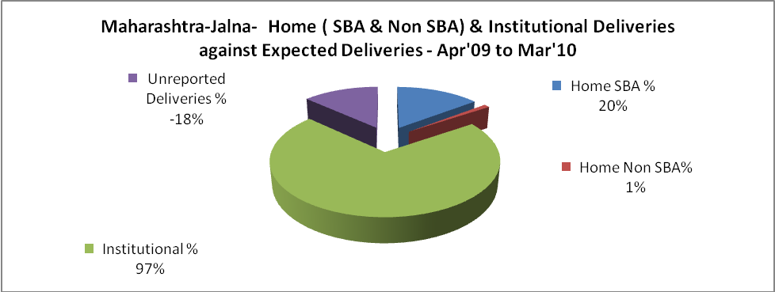

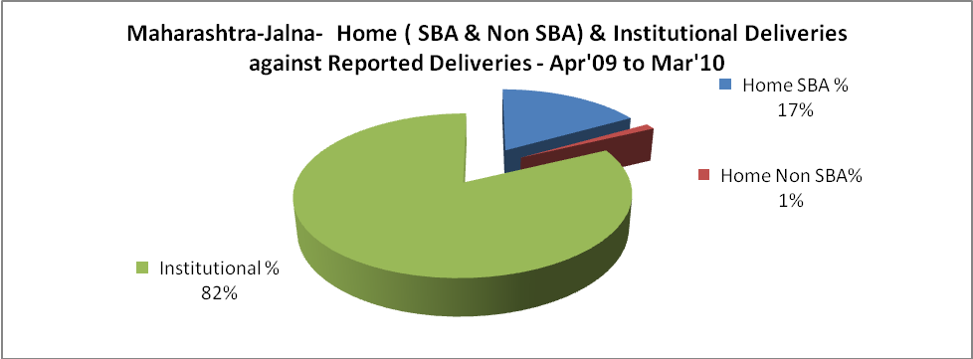

Maharashtra-Jalna- C sections & Complicated Deliveries Apr'09 to Mar'10
 | Institutional Deliveries (Public) | Institutional Deliveries (Pvt)
 | 12,862 | 20,470
C Section | 318 | 1,014
C Section% | 2% | 5%
Complicated Pregnancies attended | 1,526 | 478
Complicated Pregnancies attended % | 12% | 2%

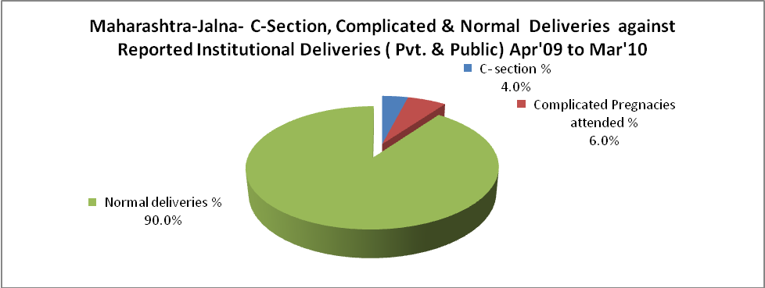

Maharashtra-Jalna- Complicated Pregnancies & Deliveries Treated - Apr'09 to Mar'10
Reported Deliveries |  |  | Reported ANC Registration
40,632 |  |  | 45,992
Complicated Pregnancies attended | Complicated Pregnancies Rate | C - Section Deliveries | PNC Maternal Complications | Abortions | Still Births
2,004 | 5% | 1,332 | 506 | 2,701 | 506
Complicated Deliveries Treated with |  |  |  | No Of Eclampsia cases Treated | No Of severe anemia cases treated
IV Antibiotics | IV antihypertensive/Magsulph injection | IV Oxytocis | Blood Transfusion | No Of Eclampsia cases Treated | No Of severe anemia cases treated
- | - | - | - | 1,112 | 1,252

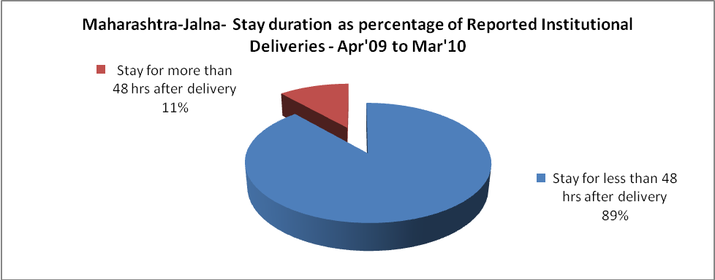

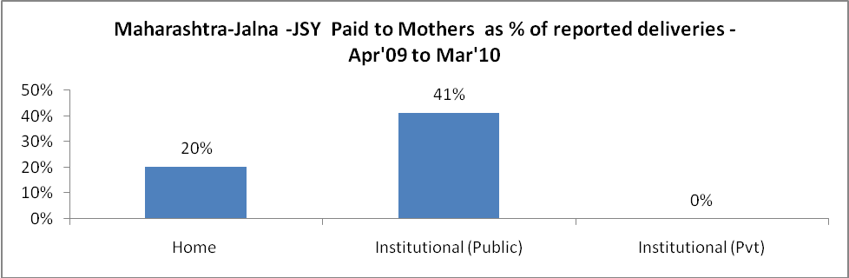

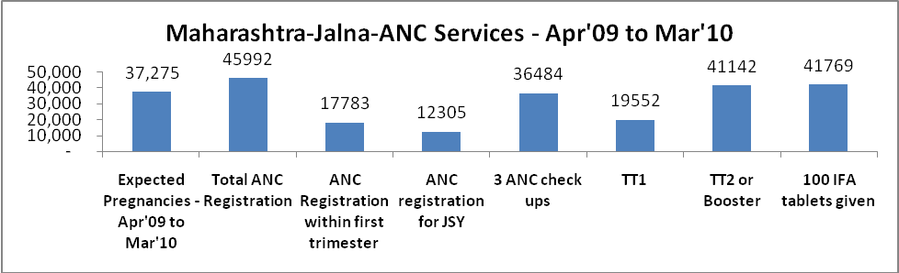

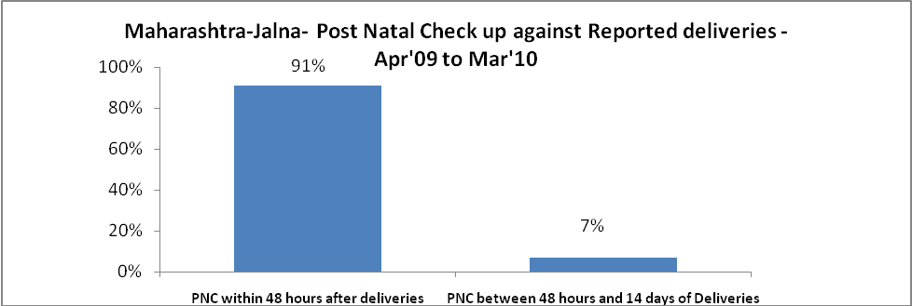

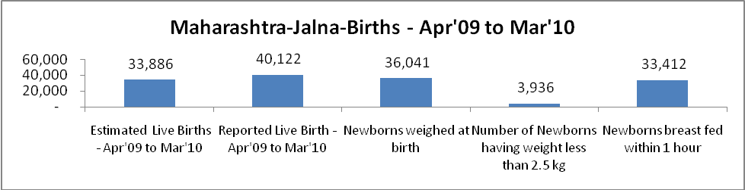

Maharashtra-Jalna - Births - Apr'09 to Mar'10
Live Birth - Males | Live Birth - females | Live Birth - Total | Sex Ratio at birth | Still Birth | Abortion( Induced/Spontaneous
20,699 | 19,423 | 40,122 | 938 | 506 | 2,701

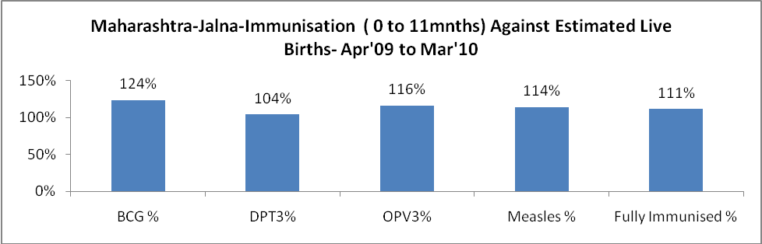

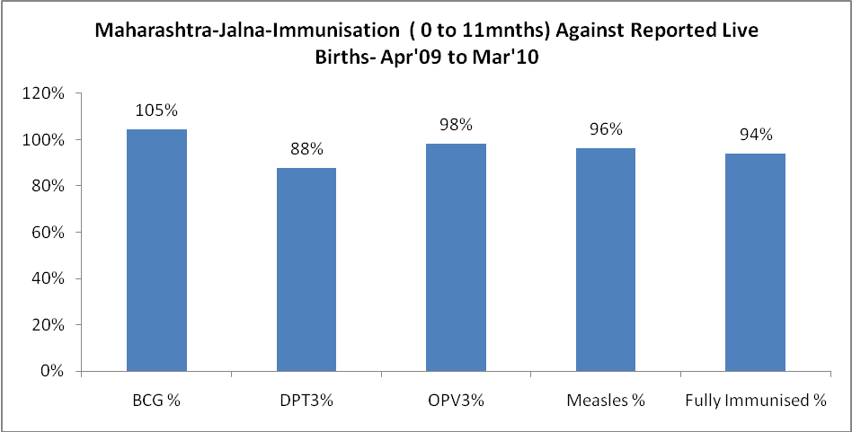

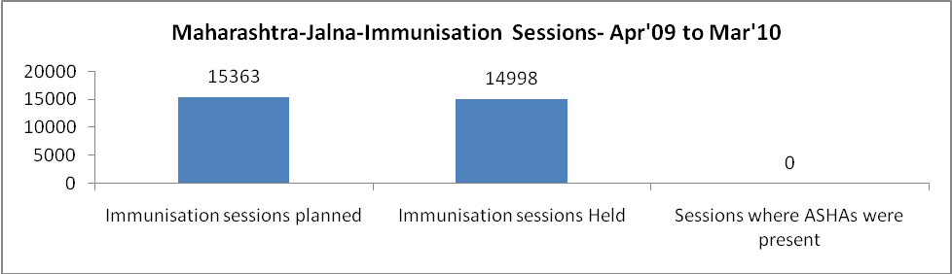

Maharashtra-Jalna- Apr'09 to Mar'10
Total Abortions | Abortion Rate
4,327 | 11.6%

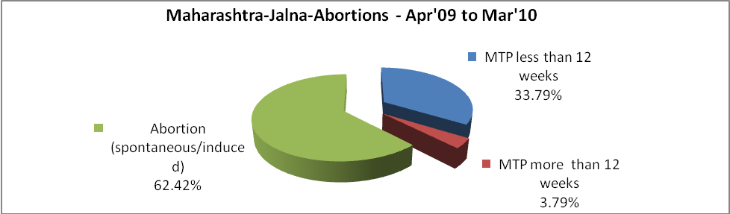

Maharashtra-Jalna- Apr'09 to Mar'10
Total OPD | Total RTI/STI cases
461,838 | 5,847

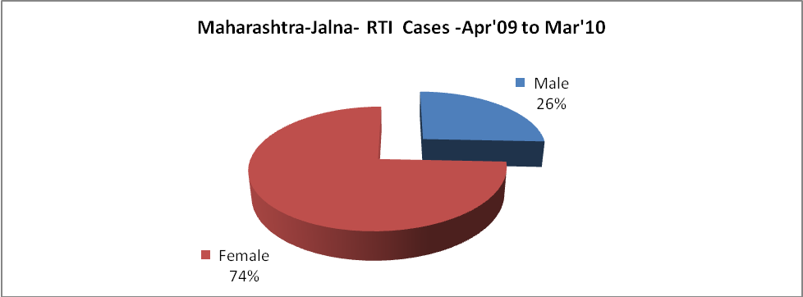

Maharashtra-Jalna-Sterilizations - Apr'09 to Mar'10
 | Reported | %age of Reported Sterilization
Total Sterilization | 9,553 | -
NSV | 20 | 0%
Laparoscopic | 8,431 | 88%
MiniLap | 1,075 | 11%
Post Partum | 27 | 0%
Male Sterilization | 20 | 0%
Female Sterilization | 9,533 | 100%

Maharashtra-Jalna-FP Methods - Apr'09 to Mar'10
 | Reported | %age of All Reported FP Methods
Total Reported FP Methodd (All types) Users | 28,615 | -
Sterilizations | 9,553 | 33%
IUD | 6,462 | 23%
Condom Users | 8,880 | 31%
OCP Users | 3,720 | 13%
Limiting Methods | 9,553 | 33%
Spacing Methods | 19,062 | 67%

Maharashtra-Jalna- Service Delivery - Apr'09 to Mar'10
Operation major (General and spinal anaesthesia) | Operation minor (No or local anaesthesia) | AYUSH | Dental Procedures | Adolescent counselling services | Total OPD | Total IPD
898 | 658 | 63 | - | - | 461,838 | -
Operation major (General and spinal anaesthesia) as %ge of OPD | Operation minor (No or local anaesthesia)as %ge of OPD | AYUSH as %ge of OPD | Dental Procedures as %ge of OPD | Adolescent counselling services as %ge of OPD | IPD as percentage of OPD
0.2% | 0.1% | 0.0% | 0.0% | 0.0% | 0%

Maharashtra-Jalna- Lab Services - Apr'09 to Mar'10
Total OPD | Total HB tested | Total HIV Tested | Total Population
461,838 | 24,196 | - | 1,893,079
HB test conducted as %age of OPD | HB<7gm as %age of HB tested | HIV test conducted as %age of OPD | HIV positive as %age of HIV tested | Blood Smear Examined as % of Population
5.2% | 0.0% | 0.0% | 0.0% | 9.4%

Maharashtra-Jalna- Childhood Disease - Vaccine Preventable -Apr'09 to Mar'10
Diphtheria | Pertussis | Tetanus Neonatorum | Tetanus others | Polio | Measles
0 | 0 | 0 | 0 | 0 | 0
Maharashtra-Jalna-Childhood Disease - Others - Apr'09 to Mar'10
Diarrhoea and dehydration | Malaria | Number admitted with Respiratory Infections
719 | - | 197

Maharashtra-Jalna- Infant & Child Deaths - Apr'09 to Mar'10
Infant Deaths within 24 hrs of birth | Infant Deaths between 24hrs & under 1 week | Infant Deaths between 1 week & under 1 month | Child Deaths between 1 month & under 1 year | Child Deaths between 1yr under 5years | Total Deaths
34 | 25 | 16 | 19 | 15 | 109

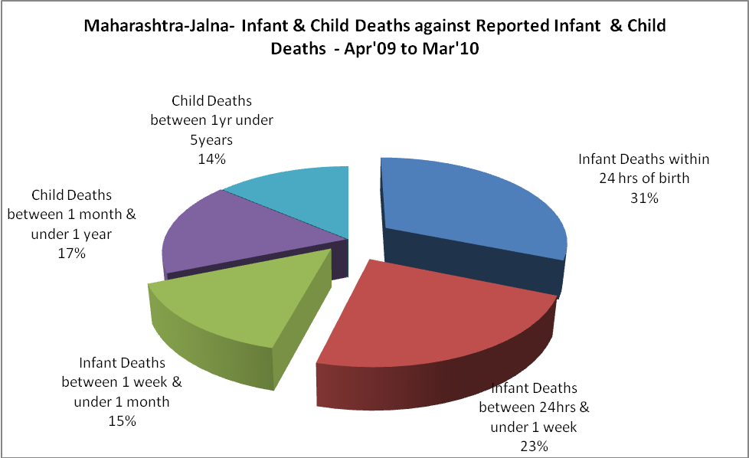

Maharashtra-Jalna- Causes of Infant & Child Deaths - Apr'09 to Mar'10
Sepsis |  |  | Asphyxia |  |  | LBW
Up to 1 Weeks of Birth | Between 1 week & 4 weeks of birth | Total | Up to 1 Weeks of Birth | Between 1 week & 4 weeks of birth | Total | Up to 1 Weeks of Birth | Between 1 week & 4 weeks of birth | Total
0 | 0 | 0 | 0 | 0 | 0 | 0 | 0 | 0
Pneumonia |  |  | Diarrhoea |  |  | Fever related
Between 1 month and 11 months | Between 1 year & 5 years | Total | Between 1 month and 11 months | Between 1 year & 5 years | Total | Between 1 month and 11 months | Between 1 year & 5 years | Total
0 | 0 | 0 | 0 | 0 | 0 | 0 | 0 | 0
Others |  |  | Measles |  |  | Others
Up to 1 Weeks of Birth | Between 1 week & 4 weeks of birth | Total | Between 1 month and 11 months | Between 1 year & 5 years | Total | Between 1 month and 11 months | Between 1 year & 5 years | Total
25 | 16 | 41 | 0 | 0 | 0 | 19 | 15 | 34

Maharashtra-Jalna- Maternal Deaths & Causes - Apr'09 to Mar'10
Abortion |  |  | Obstructed/prolonged labour |  |  | Severe hypertesnion/fits
6-14 yrs | 15-55 yrs. | Total | 6-14 yrs | 15-55 yrs. | Total | 6-14 yrs | 15-55 yrs. | Total
0 | 0 | 0 | 0 | 0 | 0 | 0 | 0 | 0
Bleeding |  |  | High Fever |  |  | Other Causes
6-14 yrs | 15-55 yrs. | Total | 6-14 yrs | 15-55 yrs. | Total | 6-14 yrs | 15-55 yrs. | Total
0 | 0 | 0 | 0 | 0 | 0 | 0 | 0 | 0

Maharashtra-Jalna-Causes of Deaths in 6 to 55yrs age group - Apr'09 to Mar'10
Diarrhoel Diseases |  |  |  | Tuberculosis |  |  |  | Respiratory Diseases( Other than TB)
6-14 yrs | 15-55 yrs. | Above 55yrs | Total | 6-14 yrs | 15-55 yrs. | Above 55yrs | Total | 6-14 yrs | 15-55 yrs. | Above 55yrs | Total
0 | 0 | 0 | 0 | 0 | 0 | 0 | 0 | 0 | 0 | 0 | 0
Malaria |  |  |  | Other fever Related |  |  |  | HIV/Aids
6-14 yrs | 15-55 yrs. | Above 55yrs | Total | 6-14 yrs | 15-55 yrs. | Above 55yrs | Total | 6-14 yrs | 15-55 yrs. | Above 55yrs | Total
0 | 0 | 0 | 0 | 0 | 0 | 0 | 0 | 0 | 0 | 0 | 0
Heart Disease/Hypertension related |  |  |  | Neurological Disease including strokes |  |  |  | Trauma/Accidents/ Burn Cases
6-14 yrs | 15-55 yrs. | Above 55yrs | Total | 6-14 yrs | 15-55 yrs. | Above 55yrs | Total | 6-14 yrs | 15-55 yrs. | Above 55yrs | Total
0 | 0 | 0 | 0 | 0 | 0 | 0 | 0 | 0 | 0 | 0 | 0
Suicide |  |  |  | Animal Bites & Stings
6-14 yrs | 15-55 yrs. | Above 55yrs | Total | 6-14 yrs | 15-55 yrs. | Above 55yrs | Total
0 | 0 | 0 | 0 | 0 | 0 | 0 | 0

