NHSRC
Rajasthan-Jalore
Analysis: Apr 2009 – Mar 2010

Rajasthan- Jalore- Summary-Apr'09 to Mar'10
ANC
ANC Registration against Expected Pregnancies | 96% | TT1 given to Pregnant women against ANC Registration | 67%
3 ANC Checkups against ANC Registrations | 70% | 100 IFA Tablets given to Pregnant women against ANC Registration | 80%
Deliveries
Unreported Deliveries against Estimated Deliveries | 21.4% | HOME Deliveries( SBA& Non SBA) against Estimated Deliveries | 14.0%
Institutional Deliveries against Estimated Deliveries | 64.6% | HOME Deliveries( SBA& Non SBA) against Reported Deliveries | 17.9%
Institutional Deliveries against Reported Deliveries | 82.1% | C Section Deliveries against Institutional Deliveries( Pvt & Pub) | 0%
Births & Neonates Care
Live Births Reported against Estimated Live Births | 80% | New borns weighed against Reported Live Births | 82%
Still Births (Reported) | 501 | New borns weighed less than 2.5 kgs against newborns weighed | 15%
Sex Ratio at Birth | 886 | New borns breastfed within one hr of Birth against Reported live Births | 81%
Child Immunisation( 0 to 11 months)
BCG given against Expected Live Births | 94% | Measles given against Expected Live Births | 93%
OPV3 given against Expected Live Births | 93% | Fully Immunised Children against Expected Live Births | 92%
DPT3 given against Expected Live Births | 93%
Family Planning
Family Plannig Methods Users ( Sterilisations(Male &Female)+IUD+ Condom pieces/72 + OCP Cycles/13) | 121,460 | IUD Insertions against reported FP Methods | 11%
Sterilisation against reported FP Methods | 5% | Condom Users against reported FP Methods | 56%
 |  | OCP Users against reported FP Methods | 27%
Other Services
OPD | 720,162 | Major Operations | 766
IPD | 36,903 | Minor Operations | 1,992

Rajasthan- Jalore- Deliveries Apr'09 to Mar'10
Total Population | 1,730,800 | Expected Deliveries |  | 49,096
Home SBA | Home Non SBA | Institutional | Total Deliveries Reported | Unreported Deliveries
3,723 | 3,166 | 31,704 | 38,593 | 10,503
Home SBA % | Home Non SBA% | Institutional % | Total Deliveries Reported % | Unreported Deliveries %
8% | 6% | 65% | 79% | 21%
`

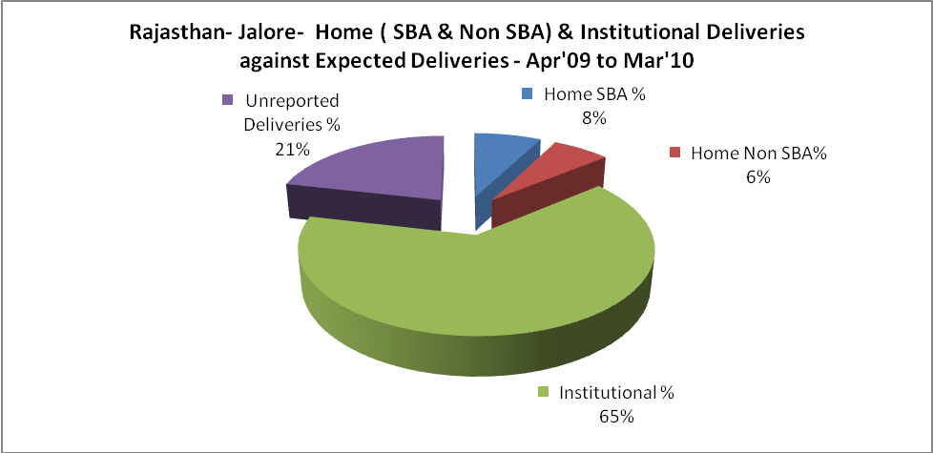

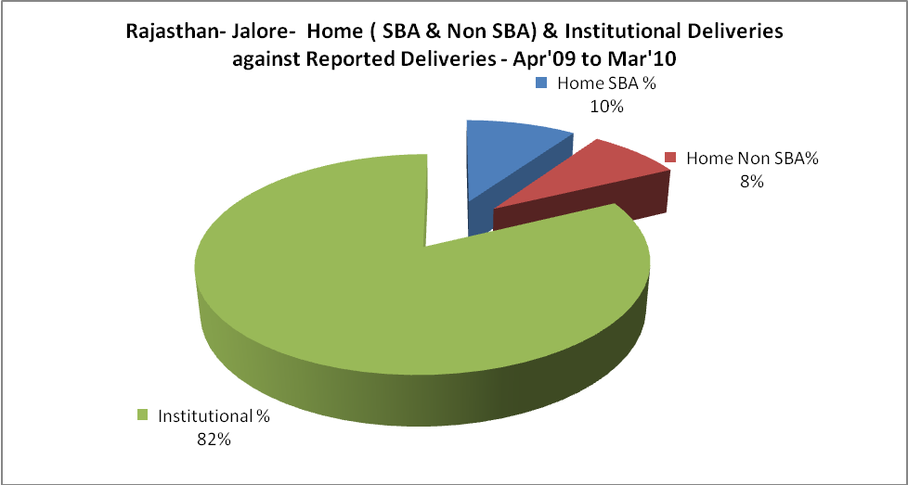

Rajasthan- Jalore- C sections & Complicated Deliveries Apr'09 to Mar'10
 | Institutional Deliveries (Public) | Institutional Deliveries (Pvt)
 | 23,591 | 8,113
C Section | 47 | 12
C Section% | 0% | 0%
Complicated Pregnacies attended | 494 | 75
Complicated Pregnacies attended % | 2% | 1%

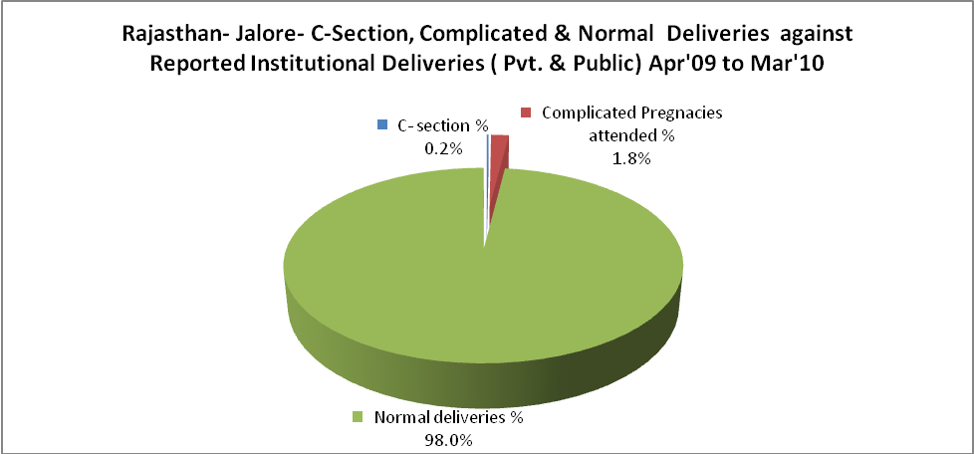

Rajasthan- Jalore- Complicated Pregnancies & Deliveries Treated - Apr'09 to Mar'10
Reported Deliveries |  |  | Reported ANC Reigtration
38,593 |  |  | 50,093
Complicated Pregnancies attended | Complicated Pregnancies Rate | C - Section Deliveries | PNC Maternal Complications | Abortions | Still Births
569 | 1% | 59 | 271 | 433 | 501
Complicated Deliveries Treated with |  |  |  | No Of Eclampsia cases Treated | No Of severe anemia cases treated
IV Antibiotics | IV antihypertensive/Magsulph injection | IV Oxytocis | Blood Transfusion | No Of Eclampsia cases Treated | No Of severe anemia cases treated
1,988 | 52 | 2,172 | 139 | 90 | 501

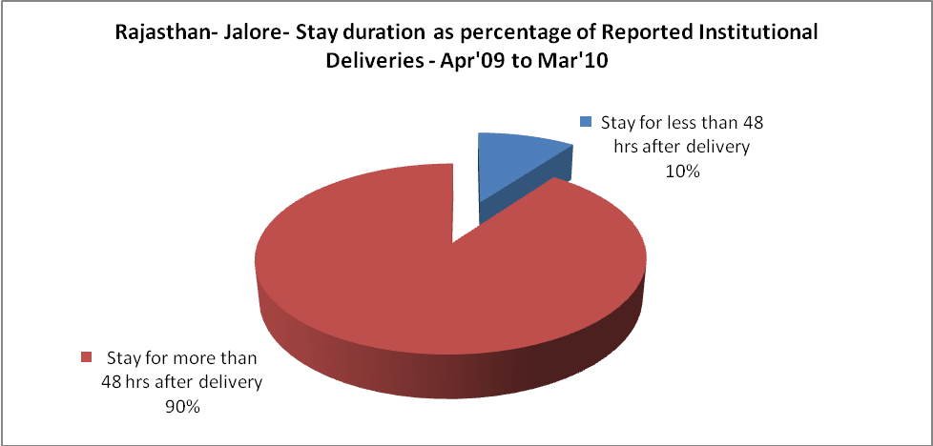

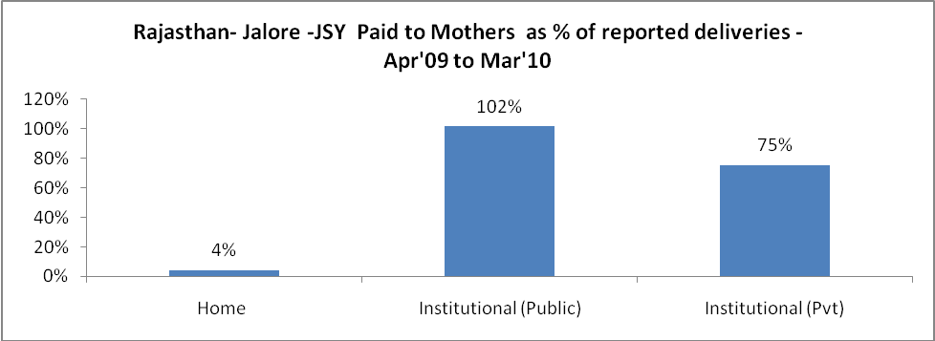

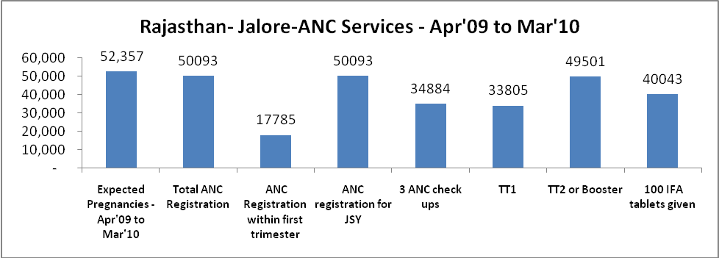

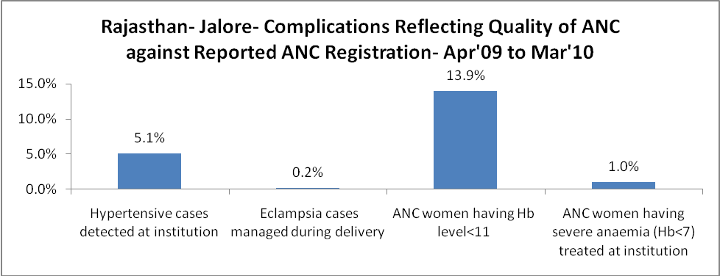

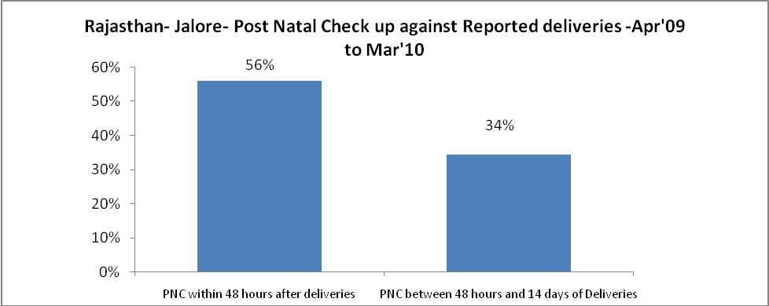

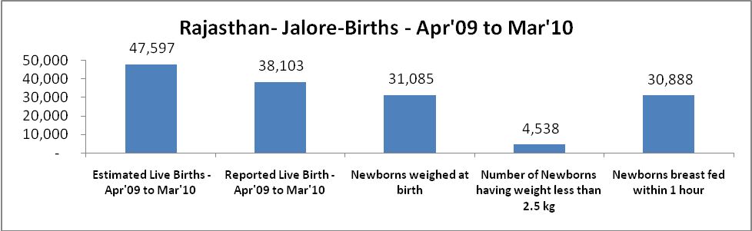

Rajasthan- Jalore - Births - Apr'09 to Mar'10
Live Birth - Males | Live Birth - females | Live Birth - Total | Sex Ratio at birth | Still Birth | Abortion( Induced/Spontaneous
20,200 | 17,903 | 38,103 | 886 | 501 | 433

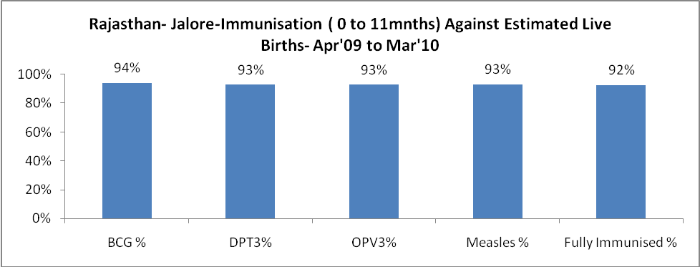

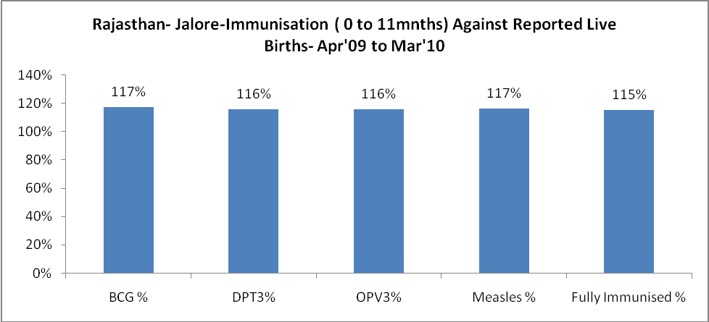

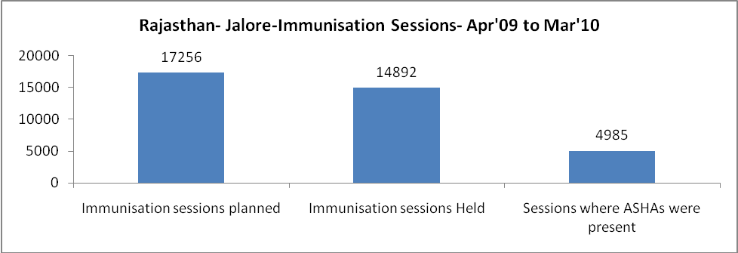

Rajasthan- Jalore- Apr'09 to Mar'10
Total Abortions | Abortion Rate
561 | 1.1%

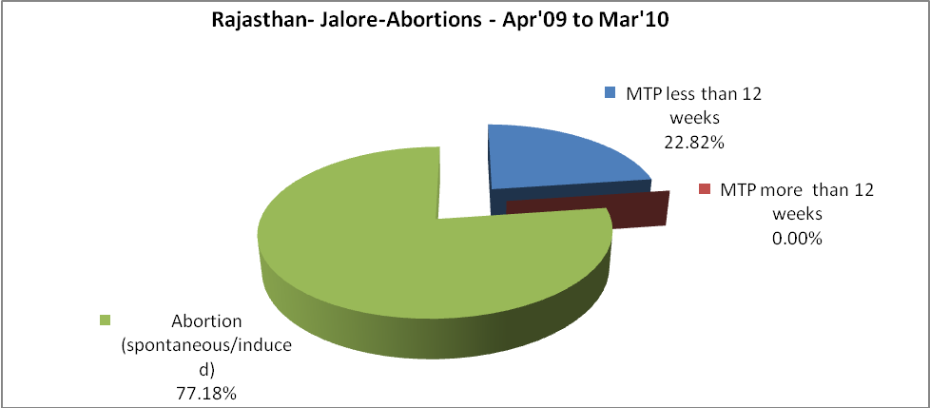

Rajasthan- Jalore- Apr'09 to Mar'10
Total OPD | Total RTI/STI cases
720,162 | 3,470

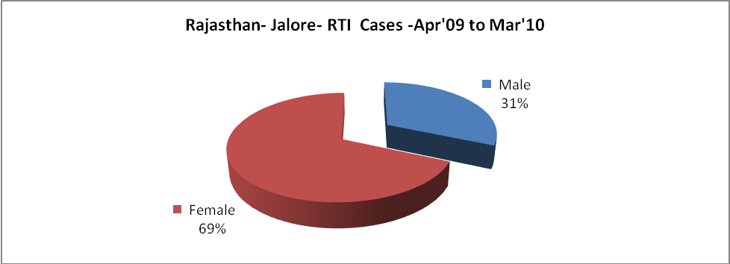

Rajasthan- Jalore-Sterilisations - Apr'09 to Mar'10
 | Reported | %age of Reported Sterilisation
Total Sterilisation | 6,426 | -
NSV | 21 | 0%
Laproscopic | 6,249 | 97%
MiniLap | - | 0%
Post Partum | 156 | 2%
Male Sterilisation | 21 | 0%
Female Sterilisation | 6,405 | 100%

Rajasthan- Jalore-FP Methods - Apr'09 to Mar'10
 | Reported | %age of All Reported FP Methods
Total Reported FP Methodd (All types) Users | 121,460 | -
Sterilisations | 6,426 | 5%
IUD | 13,651 | 11%
Condom Users | 68,583 | 56%
OCP Users | 32,800 | 27%
Limiting Methods | 6,426 | 5%
Spacing Methods | 115,034 | 95%

Rajasthan- Jalore- Lab Services - Apr'09 to Mar'10
Total OPD | Total HB tested | Total HIV Tested | Total Population
720,162 | 17,368 | 3,508 | 1,730,800
HB test conducted as %age of OPD | HB<7gm as %age of HB tested | HIV test conducted as %age of OPD | HIV positive as %age of HIV tested | Blood Smear Examined as % of Population
2.4% | 10.1% | 0.5% | 5.7% | 6.2%

Rajasthan- Jalore- Childhood Disease - Vaccine Preventable -Apr'09 to Mar'10
Diphtheria | Pertussis | Tetanus Neonatorum | Tetanus others | Polio | Measles
0 | 0 | 0 | 0 | 0 | 25
Rajasthan- Jalore-Childhood Disease - Others - Apr'09 to Mar'10
Diarrhoea and dehydration | Malaria | Number admitted with Respiratory Infections
2,268 | 27 | 132

Rajasthan- Jalore- Infant & Child Deaths - Apr'09 to Mar'10
Infant Deaths within 24 hrs of birth | Infant Deaths between 24hrs & under 1 week | Infant Deaths between 1 week & under 1 month | Child Deaths between 1 month & under 1 year | Child Deaths between 1yr under 5years | Total Deaths
54 | 79 | 29 | 63 | 66 | 291

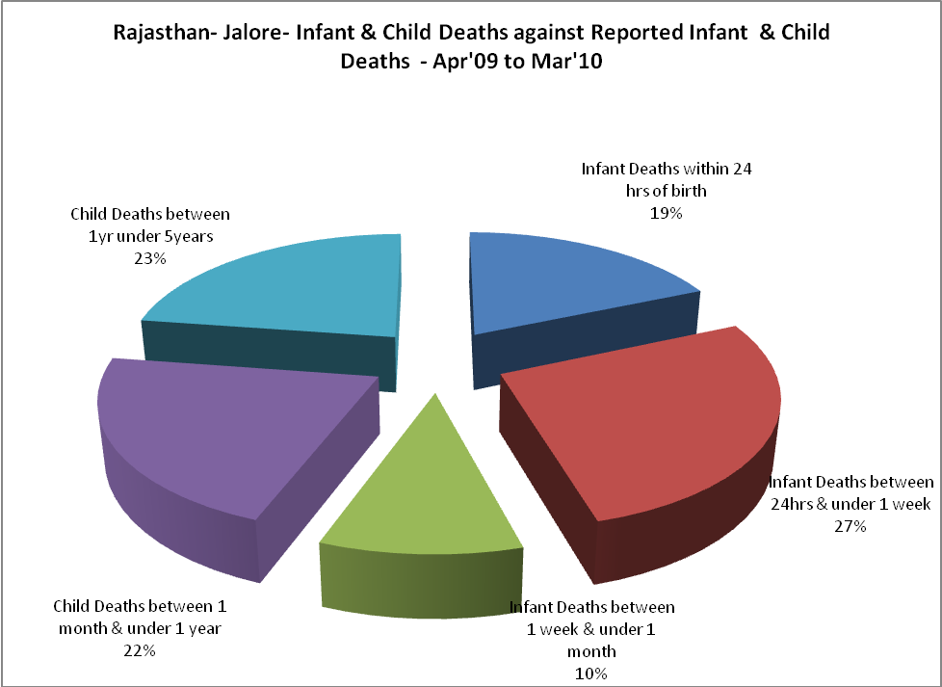

Rajasthan- Jalore- Causes of Infant & Child Deaths - Apr'09 to Mar'10
Sepsis |  |  | Asphyxia |  |  | LBW
Up to 1 Weeks of Birth | Between 1 week & 4 weeks of birth | Total | Up to 1 Weeks of Birth | Between 1 week & 4 weeks of birth | Total | Up to 1 Weeks of Birth | Between 1 week & 4 weeks of birth | Total
5 | 4 | 9 | 27 | 5 | 32 | 15 | 9 | 24
Pneumonia |  |  | Diarrhoea |  |  | Fever related
Between 1 month and 11 months | Between 1 year & 5 years | Total | Between 1 month and 11 months | Between 1 year & 5 years | Total | Between 1 month and 11 months | Between 1 year & 5 years | Total
9 | 4 | 13 | 4 | 7 | 11 | 6 | 14 | 20
Others |  |  | Measles |  |  | Others
Up to 1 Weeks of Birth | Between 1 week & 4 weeks of birth | Total | Between 1 month and 11 months | Between 1 year & 5 years | Total | Between 1 month and 11 months | Between 1 year & 5 years | Total
32 | 11 | 43 | 0 | 0 | 0 | 44 | 41 | 85

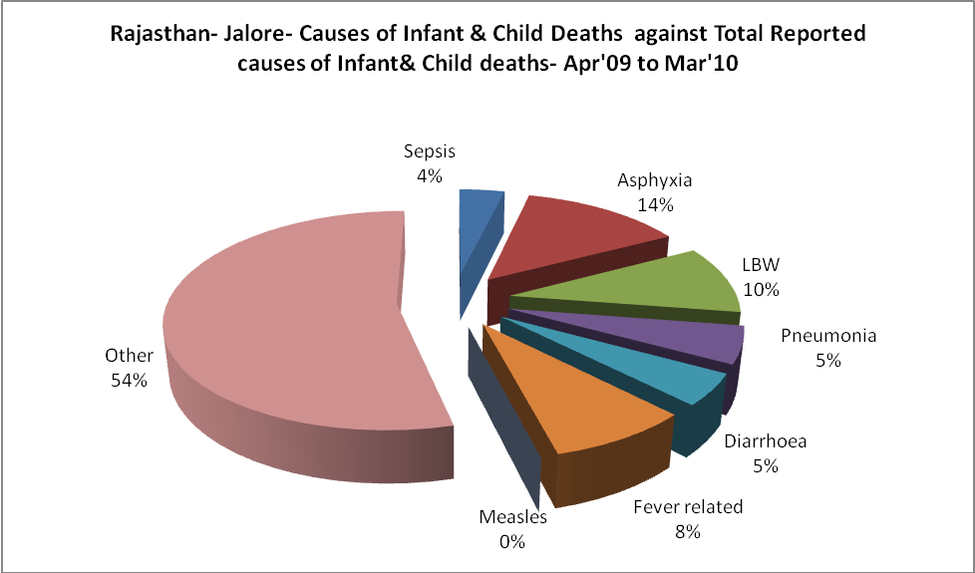
Rajasthan- Jalore- Maternal Deaths & Causes - Apr'09 to Mar'10
Abortion |  |  | Obstructed/prolonged labour |  |  | Severe hypertesnion/fits
6-14 yrs | 15-55 yrs. | Total | 6-14 yrs | 15-55 yrs. | Total | 6-14 yrs | 15-55 yrs. | Total
1 | 0 | 1 | 0 | 1 | 1 | 0 | 0 | 0
Bleeding |  |  | High Fever |  |  | Other Causes
6-14 yrs | 15-55 yrs. | Total | 6-14 yrs | 15-55 yrs. | Total | 6-14 yrs | 15-55 yrs. | Total
0 | 1 | 1 | 0 | 0 | 0 | 0 | 7 | 7

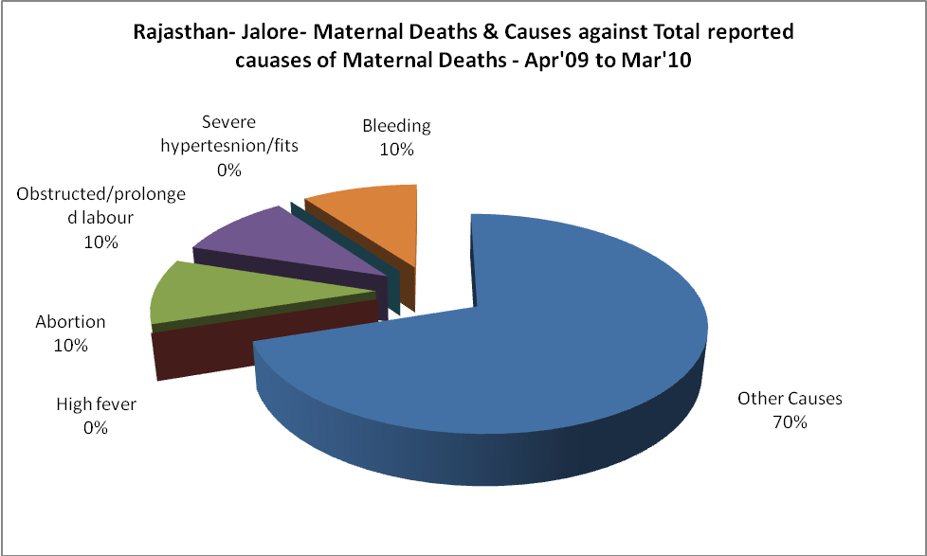

Rajasthan- Jalore-Causes of Deaths in 6 to 55yrs age group - Apr'09 to Mar'10
Diarrhoel Diseases |  |  |  | Tuberculosis |  |  |  | Respiratory Diseases( Other than TB)
6-14 yrs | 15-55 yrs. | Above 55yrs | Total | 6-14 yrs | 15-55 yrs. | Above 55yrs | Total | 6-14 yrs | 15-55 yrs. | Above 55yrs | Total
7 | 6 | 1 | 14 | 0 | 30 | 9 | 39 | 2 | 26 | 47 | 75
Malaria |  |  |  | Other fever Related |  |  |  | HIV/Aids
6-14 yrs | 15-55 yrs. | Above 55yrs | Total | 6-14 yrs | 15-55 yrs. | Above 55yrs | Total | 6-14 yrs | 15-55 yrs. | Above 55yrs | Total
0 | 3 | 0 | 3 | 8 | 10 | 12 | 30 | 0 | 7 | 9 | 16
Heart Disease/Hypertenion related |  |  |  | Neurological Disease including strokes |  |  |  | Trauma/Accidents/ Burn Cases
6-14 yrs | 15-55 yrs. | Above 55yrs | Total | 6-14 yrs | 15-55 yrs. | Above 55yrs | Total | 6-14 yrs | 15-55 yrs. | Above 55yrs | Total
0 | 21 | 13 | 34 | 31 | 21 | 9 | 61 | 3 | 23 | 7 | 33
Suicide |  |  |  | Animal Bites & Stings
6-14 yrs | 15-55 yrs. | Above 55yrs | Total | 6-14 yrs | 15-55 yrs. | Above 55yrs | Total
0 | 10 | 0 | 10 | 2 | 5 | 1 | 8

