NHSRC
Rajasthan-Jhodpur
Analysis: Apr 2009 – Mar 2010

Rajasthan- Jodhpur- Summary-Apr'09 to Mar'10
ANC
ANC Registration against Expected Pregnancies | 104% | TT1 given to Pregnant women against ANC Registration | 80%
3 ANC Checkups against ANC Registrations | 70% | 100 IFA Tablets given to Pregnant women against ANC Registration | 57%
Deliveries
Unreported Deliveries against Estimated Deliveries | 5.7% | HOME Deliveries( SBA& Non SBA) against Estimated Deliveries | 22.1%
Institutional Deliveries against Estimated Deliveries | 72.1% | HOME Deliveries( SBA& Non SBA) against Reported Deliveries | 23.5%
Institutional Deliveries against Reported Deliveries | 76.5% | C Section Deliveries against Institutional Deliveries( Pvt & Pub) | 6%
Births & Neonates Care
Live Births Reported against Estimated Live Births | 78% | New borns weighed against Reported Live Births | 72%
Still Births (Reported) | 412 | New borns weighed less than 2.5 kgs against newborns weighed | 10%
Sex Ratio at Birth | 863 | New borns breastfed within one hr of Birth against Reported live Births | 57%
Child Immunisation( 0 to 11 mnths)
BCG given against Expected Live Births | 96% | Measles given against Expected Live Births | 94%
OPV3 given against Expected Live Births | 95% | Fully Immunised Children against Expected Live Births | 90%
DPT3 given against Expected Live Births | 95%
Family Planning
Family Plannig Methods Users ( Sterilisations(Male &Female)+IUD+ Condom pieces/72 + OCP Cycles/13) | 143,084 | IUD Insertions against reported FP Methods | 16%
Sterilisation against reported FP Methods | 9% | Condom Users against reported FP Methods | 43%
 |  | OCP Users against reported FP Methods | 32%
Other Services
OPD | 1,019,094 | Major Operations | 1,488
IPD | 51,873 | Minor Operations | 8,149

Rajasthan- Jodhpur- Deliveries Apr'09 to Mar'10
Total Population | 3,448,700 | Expected Deliveries |  | 97,827
Home SBA | Home Non SBA | Institutional | Total Deliveries Reported | Unreported Deliveries
8,527 | 13,115 | 70,581 | 92,223 | 5,604
Home SBA % | Home Non SBA% | Institutional % | Total Deliveries Reported % | Unreported Deliveries %
9% | 13% | 72% | 94% | 6%
`

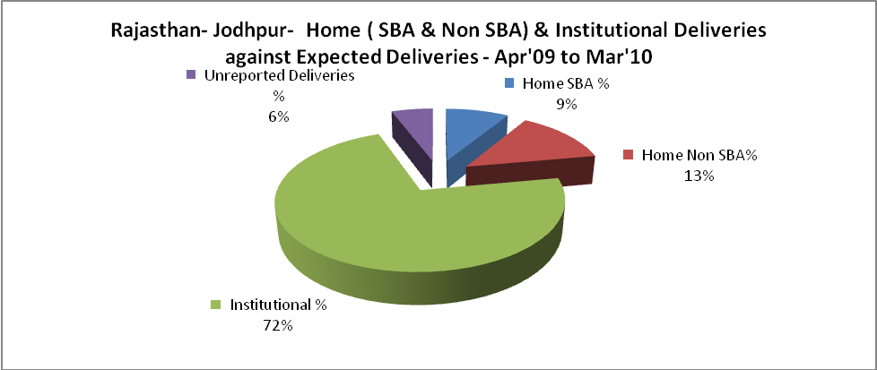

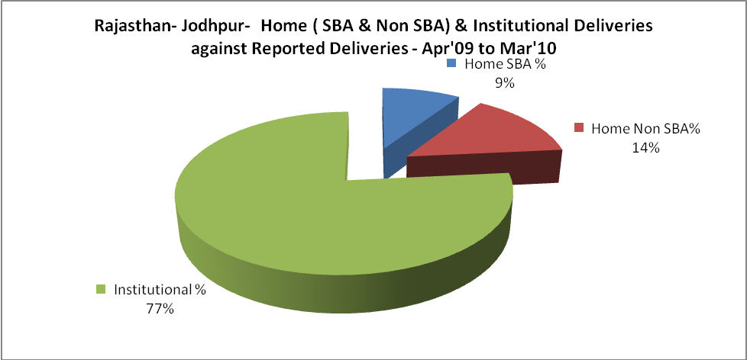

Rajasthan- Jodhpur- C sections & Complicated Deliveries Apr'09 to Mar'10
 | Institutional Deliveries (Public) | Institutional Deliveries (Pvt)
 | 50,523 | 20,058
C Section | 4,438 | -
C Section% | 9% | 0%
Complicated Pregnacies attended | 894 | 95
Complicated Pregnacies attended % | 2% | 0%

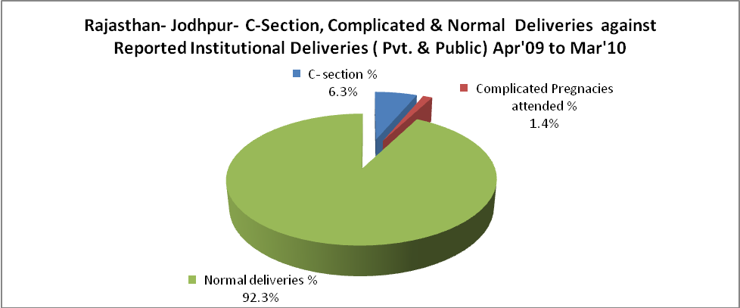

Rajasthan- Jodhpur- Complicated Pregnancies & Deliveries Treated - Apr'09 to Mar'10
Reported Deliveries |  |  | Reported ANC Reigtration
92,223 |  |  | 108,261
Complicated Pregnancies attended | Complicated Pregnancies Rate | C - Section Deliveries | PNC Maternal Complications | Abortions | Still Births
989 | 1% | 4,438 | 287 | 287 | 412
Complicated Deliveries Treated with |  |  |  | No Of Eclampsia cases Treated | No Of severe anemia cases treated
IV Antibiotics | IV antihypertensive/Magsulph injection | IV Oxytocis | Blood Transfusion | No Of Eclampsia cases Treated | No Of severe anemia cases treated
551 | 110 | 1,523 | 6 | 378 | 1,728

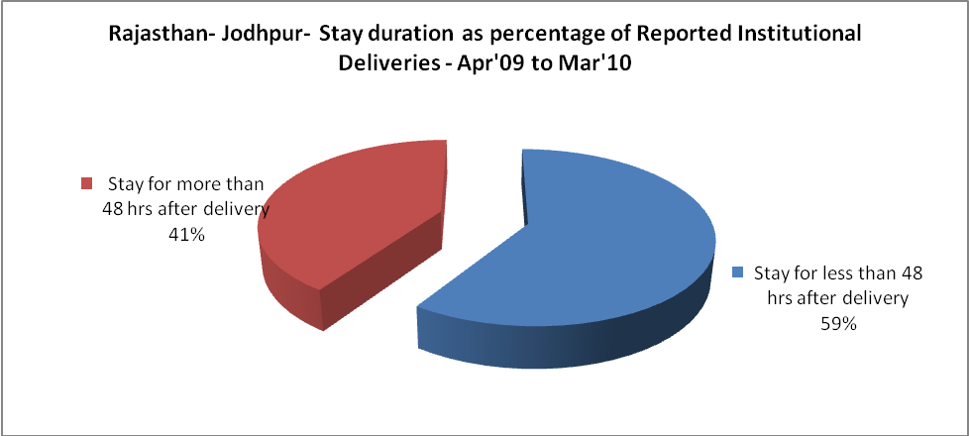

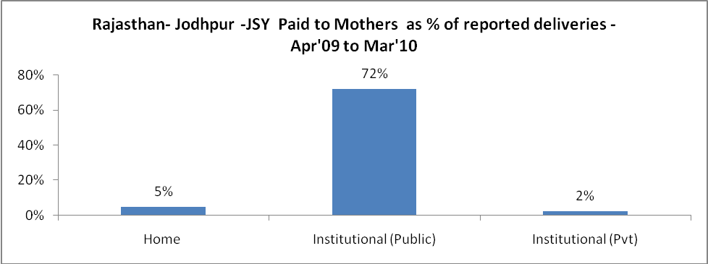

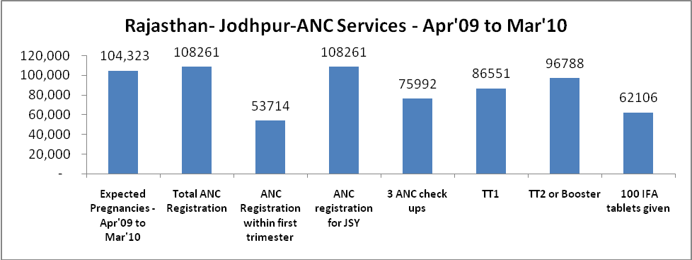

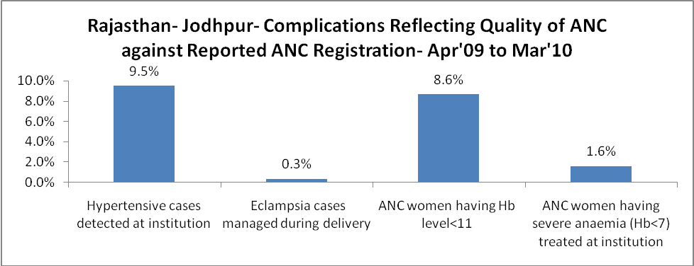

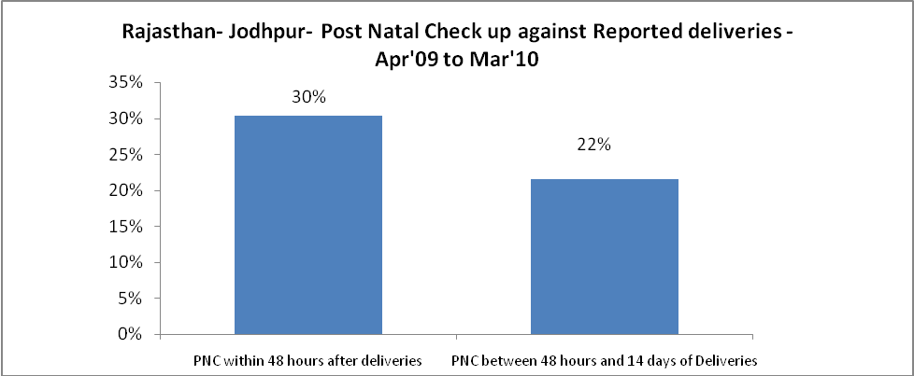

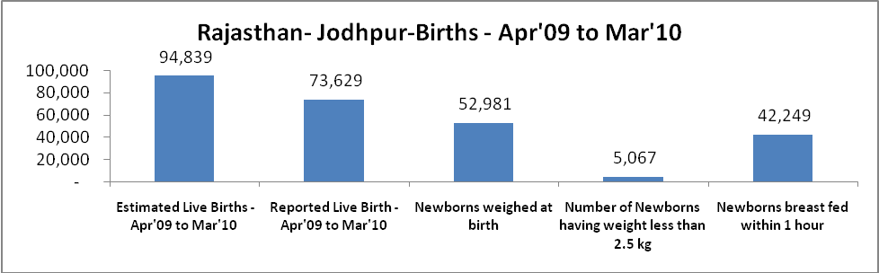

Rajasthan- Jodhpur - Births - Apr'09 to Mar'10
Live Birth - Males | Live Birth - females | Live Birth - Total | Sex Ratio at birth | Still Birth | Abortion( Induced/Spontaneous
39,531 | 34,098 | 73,629 | 863 | 412 | 287

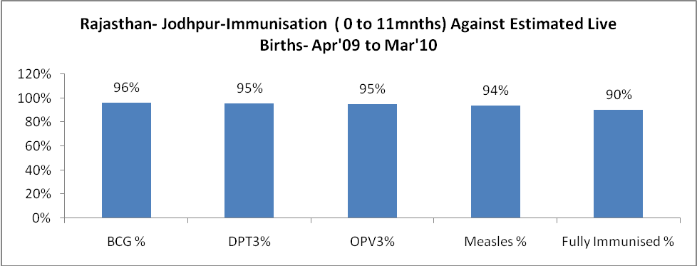

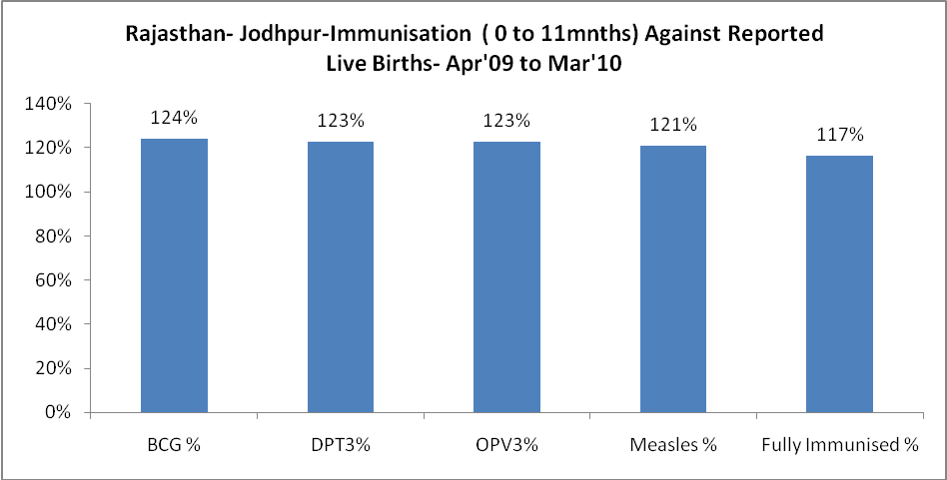

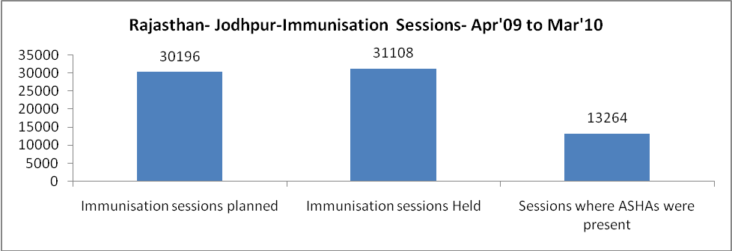

Rajasthan- Jodhpur- Apr'09 to Mar'10
Total Abortions | Abortion Rate
3,491 | 3.3%

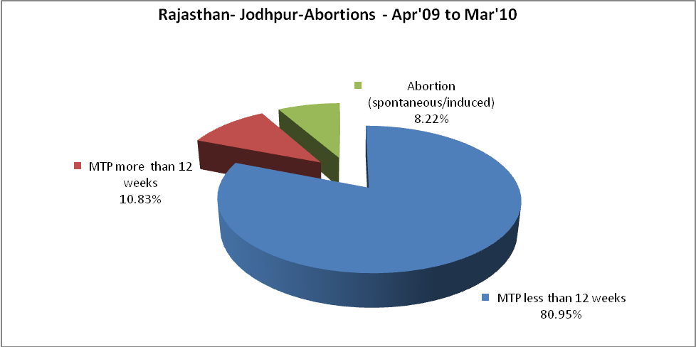

Rajasthan- Jodhpur- Apr'09 to Mar'10
Total OPD | Total RTI/STI cases
1,019,094 | 2,919

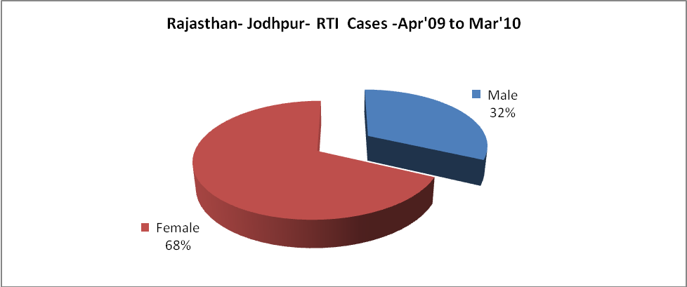

Rajasthan- Jodhpur-Sterilisations - Apr'09 to Mar'10
 | Reported | %age of Reported Sterilisation
Total Sterilisation | 13,387 | -
NSV | 155 | 1%
Laproscopic | 11,943 | 89%
MiniLap | - | 0%
Post Partum | 1,289 | 10%
Male Sterilisation | 155 | 1%
Female Sterilisation | 13,232 | 99%

Rajasthan- Jodhpur-FP Methods - Apr'09 to Mar'10
 | Reported | %age of All Reported FP Methods
Total Reported FP Methodd (All types) Users | 143,084 | -
Sterilisations | 13,387 | 9%
IUD | 22,558 | 16%
Condom Users | 61,989 | 43%
OCP Users | 45,150 | 32%
Limiting Methods | 13,387 | 9%
Spacing Methods | 129,697 | 91%

Rajasthan- Jodhpur- Service Delivery - Apr'09 to Mar'10
Operation major (General and spinal anaesthesia) | Operation minor (No or local anaesthesia) | AYUSH | Dental Procedures | Adolescent counselling services | Total OPD | Total IPD
1,488 | 8,149 | 55,797 | 2,325 | 816 | 1,019,094 | 51,873
Operation major (General and spinal anaesthesia) as %ge of OPD | Operation minor (No or local anaesthesia)as %ge of OPD | AYUSH as %ge of OPD | Dental Procedures as %ge of OPD | Adolescent counselling services as %ge of OPD | IPD as percentage of OPD
0.1% | 0.8% | 5.5% | 0.2% | 0.1% | 5%

Rajasthan- Jodhpur- Lab Services - Apr'09 to Mar'10
Total OPD | Total HB tested | Total HIV Tested | Total Population
1,019,094 | 14,421 | 284 | 3,448,700
HB test conducted as %age of OPD | HB<7gm as %age of HB tested | HIV test conducted as %age of OPD | HIV positive as %age of HIV tested | Blood Smear Examined as % of Population
1.4% | 12.0% | 0.0% | 0.7% | 2.7%

Rajasthan- Jodhpur- Childhood Disease - Vaccine Preventable -Apr'09 to Mar'10
Diphtheria | Pertussis | Tetanus Neonatorum | Tetanus others | Polio | Measles
19 | 38 | 4 | 4 | 0 | 210
Rajasthan- Jodhpur-Childhood Disease - Others - Apr'09 to Mar'10
Diarrhoea and dehydration | Malaria | Number admitted with Respiratory Infections
5,228 | 729 | 2,606

Rajasthan- Jodhpur- Infant & Child Deaths - Apr'09 to Mar'10
Infant Deaths within 24 hrs of birth | Infant Deaths between 24hrs & under 1 week | Infant Deaths between 1 week & under 1 month | Child Deaths between 1 month & under 1 year | Child Deaths between 1yr under 5years | Total Deaths
11 | 35 | 22 | 21 | 44 | 133

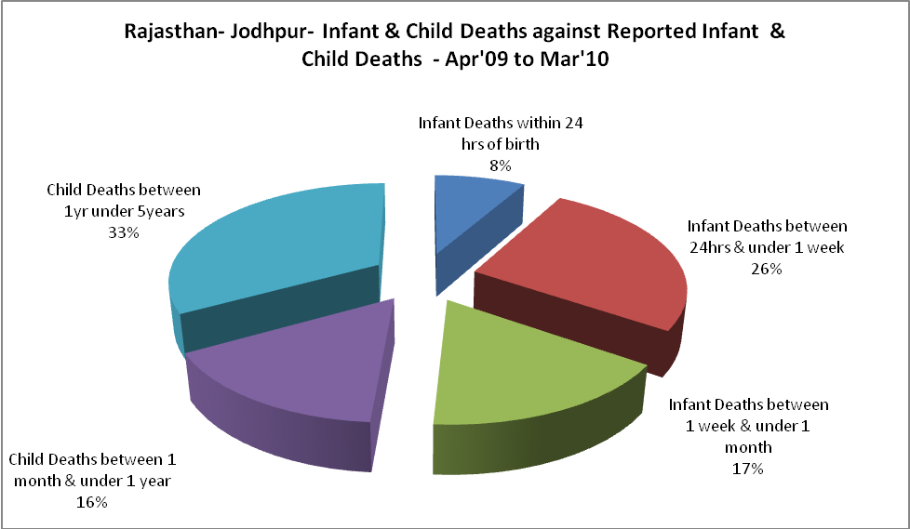

Rajasthan- Jodhpur- Causes of Infant & Child Deaths - Apr'09 to Mar'10
Sepsis |  |  | Asphyxia |  |  | LBW
Up to 1 Weeks of Birth | Between 1 week & 4 weeks of birth | Total | Up to 1 Weeks of Birth | Between 1 week & 4 weeks of birth | Total | Up to 1 Weeks of Birth | Between 1 week & 4 weeks of birth | Total
1 | 2 | 3 | 4 | 3 | 7 | 4 | 2 | 6
Pneumonia |  |  | Diarrhoea |  |  | Fever related
Between 1 month and 11 months | Between 1 year & 5 years | Total | Between 1 month and 11 months | Between 1 year & 5 years | Total | Between 1 month and 11 months | Between 1 year & 5 years | Total
1 | 11 | 12 | 4 | 15 | 19 | 1 | 7 | 8
Others |  |  | Measles |  |  | Others
Up to 1 Weeks of Birth | Between 1 week & 4 weeks of birth | Total | Between 1 month and 11 months | Between 1 year & 5 years | Total | Between 1 month and 11 months | Between 1 year & 5 years | Total
26 | 15 | 41 | 0 | 1 | 1 | 15 | 10 | 25

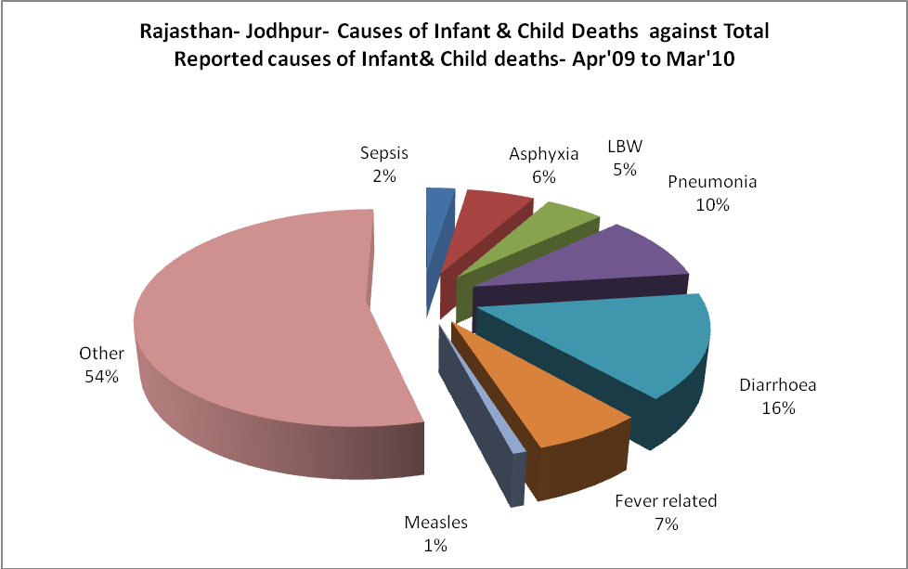
Rajasthan- Jodhpur- Maternal Deaths & Causes - Apr'09 to Mar'10
Abortion |  |  | Obstructed/prolonged labour |  |  | Severe hypertesnion/fits
6-14 yrs | 15-55 yrs. | Total | 6-14 yrs | 15-55 yrs. | Total | 6-14 yrs | 15-55 yrs. | Total
0 | 0 | 0 | 0 | 0 | 0 | 0 | 1 | 1
Bleeding |  |  | High Fever |  |  | Other Causes
6-14 yrs | 15-55 yrs. | Total | 6-14 yrs | 15-55 yrs. | Total | 6-14 yrs | 15-55 yrs. | Total
0 | 1 | 1 | 0 | 0 | 0 | 0 | 23 | 23

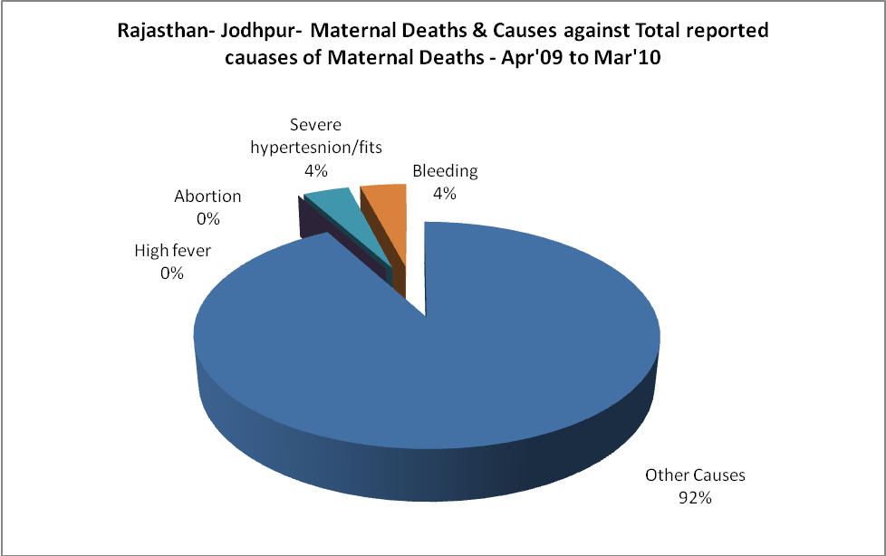

Rajasthan- Jodhpur-Causes of Deaths in 6 to 55yrs age group - Apr'09 to Mar'10
Diarrhoel Diseases |  |  |  | Tuberculosis |  |  |  | Respiratory Diseases( Other than TB)
6-14 yrs | 15-55 yrs. | Above 55yrs | Total | 6-14 yrs | 15-55 yrs. | Above 55yrs | Total | 6-14 yrs | 15-55 yrs. | Above 55yrs | Total
20 | 25 | 9 | 54 | 0 | 15 | 3 | 18 | 3 | 1 | 11 | 15
Malaria |  |  |  | Other fever Related |  |  |  | HIV/Aids
6-14 yrs | 15-55 yrs. | Above 55yrs | Total | 6-14 yrs | 15-55 yrs. | Above 55yrs | Total | 6-14 yrs | 15-55 yrs. | Above 55yrs | Total
17 | 14 | 9 | 40 | 8 | 1 | 3 | 12 | 0 | 0 | 1 | 1
Heart Disease/Hypertenion related |  |  |  | Neurological Disease including strokes |  |  |  | Trauma/Accidents/ Burn Cases
6-14 yrs | 15-55 yrs. | Above 55yrs | Total | 6-14 yrs | 15-55 yrs. | Above 55yrs | Total | 6-14 yrs | 15-55 yrs. | Above 55yrs | Total
1 | 14 | 7 | 22 | 24 | 4 | 3 | 31 | 3 | 11 | 0 | 14
Suicide |  |  |  | Animal Bites & Stings
6-14 yrs | 15-55 yrs. | Above 55yrs | Total | 6-14 yrs | 15-55 yrs. | Above 55yrs | Total
3 | 0 | 0 | 3 | 1 | 0 | 1 | 2

