NHSRC
Rajasthan-Jhunjhunu
Analysis: Apr 2009 – Mar 2010

Rajasthan- Jhunjhunun- Summary-Apr'09 to Mar'10
ANC
ANC Registration against Expected Pregnancies | 78% | TT1 given to Pregnant women against ANC Registration | 64%
3 ANC Checkups against ANC Registrations | 64% | 100 IFA Tablets given to Pregnant women against ANC Registration | 82%
Deliveries
Unreported Deliveries against Estimated Deliveries | 52.1% | HOME Deliveries( SBA& Non SBA) against Estimated Deliveries | 3.2%
Institutional Deliveries against Estimated Deliveries | 44.7% | HOME Deliveries( SBA& Non SBA) against Reported Deliveries | 6.6%
Institutional Deliveries against Reported Deliveries | 93.4% | C Section Deliveries against Institutional Deliveries( Pvt & Pub) | 1%
Births & Neonates Care
Live Births Reported against Estimated Live Births | 52% | New borns weighed against Reported Live Births | 66%
Still Births (Reported) | 226 | New borns weighed less than 2.5 kgs against newborns weighed | 13%
Sex Ratio at Birth | 777 | New borns breastfed within one hr of Birth against Reported live Births | 70%
Child Immunisation( 0 to 11 months)
BCG given against Expected Live Births | 83% | Measles given against Expected Live Births | 76%
OPV3 given against Expected Live Births | 76% | Fully Immunised Children against Expected Live Births | 74%
DPT3 given against Expected Live Births | 76%
Family Planning
Family Plannig Methods Users ( Sterilisations(Male &Female)+IUD+ Condom pieces/72 + OCP Cycles/13) | 99,390 | IUD Insertions against reported FP Methods | 15%
Sterilisation against reported FP Methods | 10% | Condom Users against reported FP Methods | 56%
 |  | OCP Users against reported FP Methods | 19%
Other Services
OPD | 955,147 | Major Operations | 1,460
IPD | 30,161 | Minor Operations | 2,911

`
Rajasthan- Jhunjhunun- Deliveries Apr'09 to Mar'10
Total Population | 2,292,600 | Expected Deliveries |  | 65,032
Home SBA | Home Non SBA | Institutional | Total Deliveries Reported | Unreported Deliveries
1,771 | 301 | 29,102 | 31,174 | 33,858
Home SBA % | Home Non SBA% | Institutional % | Total Deliveries Reported % | Unreported Deliveries %
3% | 0% | 45% | 48% | 52%

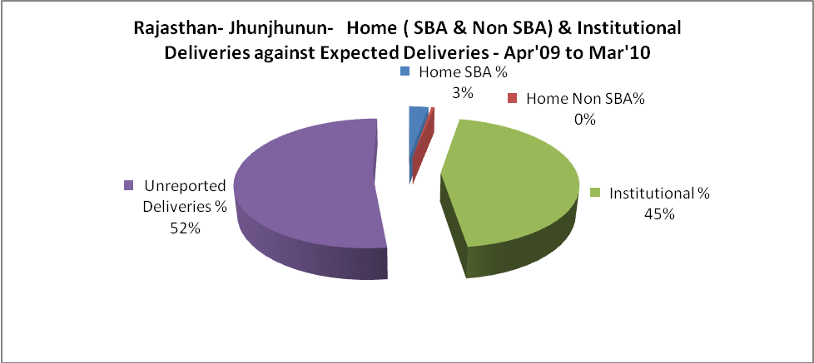

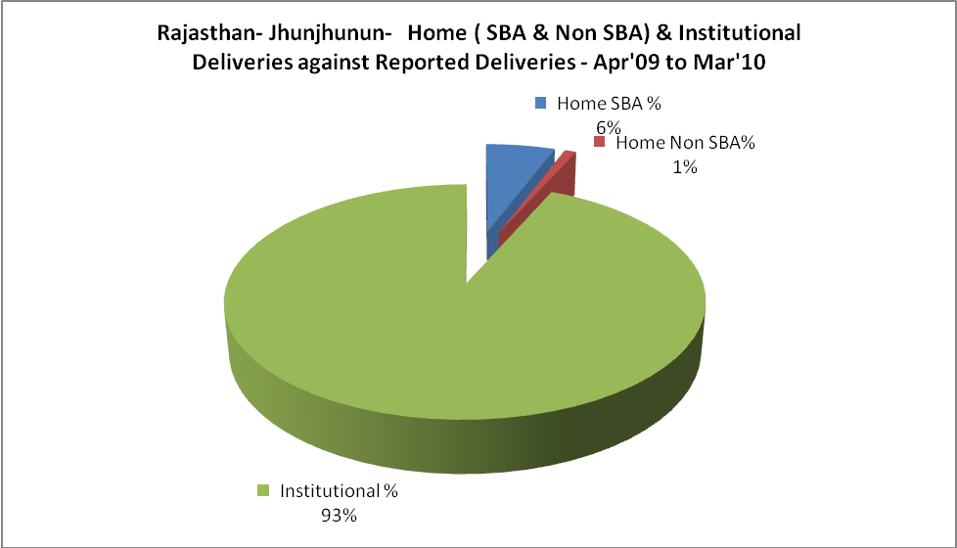

Rajasthan- Jhunjhunun- C sections & Complicated Deliveries Apr'09 to Mar'10
 | Institutional Deliveries (Public) | Institutional Deliveries (Pvt)
 | 15,759 | 13,343
C Section | 22 | 252
C Section% | 0% | 2%
Complicated Pregnacies attended | 5 | 10
Complicated Pregnacies attended % | 0% | 0%

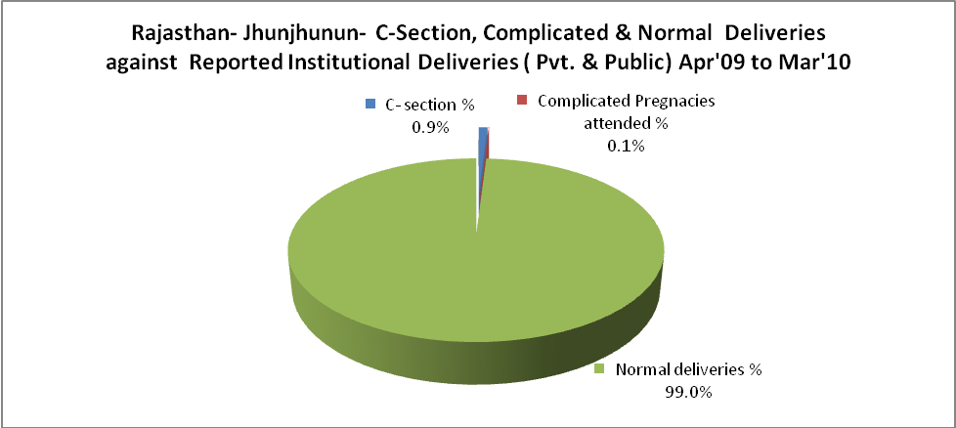

Rajasthan- Jhunjhunun- Complicated Pregnancies & Deliveries Treated - Apr'09 to Mar'10
Reported Deliveries |  |  | Reported ANC Reigtration
31,174 |  |  | 54,015
Complicated Pregnancies attended | Complicated Pregnancies Rate | C - Section Deliveries | PNC Maternal Complications | Abortions | Still Births
15 | 0% | 274 | 54 | 280 | 226
Complicated Deliveries Treated with |  |  |  | No Of Eclampsia cases Treated | No Of severe anemia cases treated
IV Antibiotics | IV antihypertensive/Magsulph injection | IV Oxytocis | Blood Transfusion | No Of Eclampsia cases Treated | No Of severe anemia cases treated
1,029 | 196 | 745 | 53 | 16 | 1,146

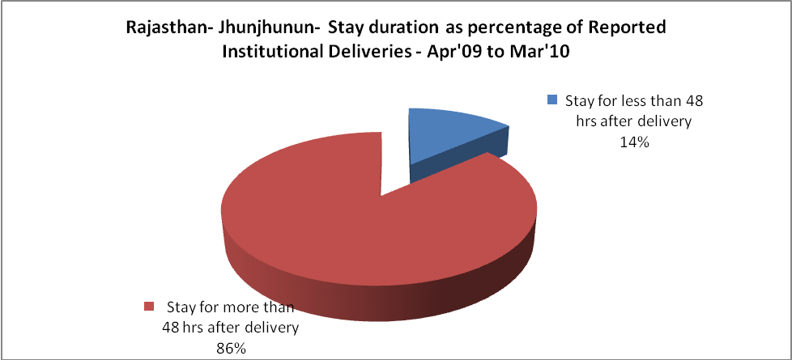

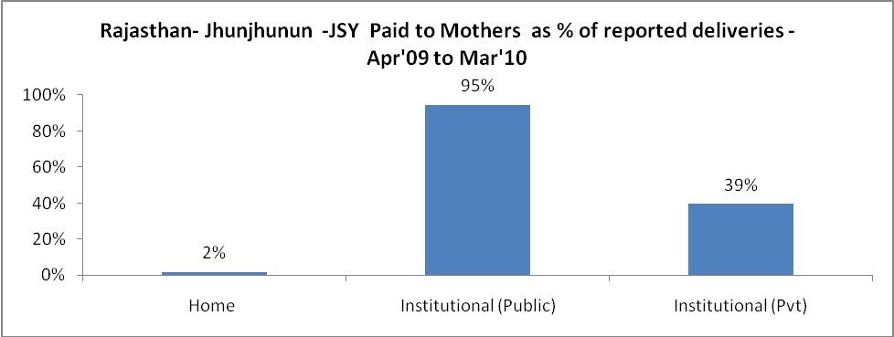

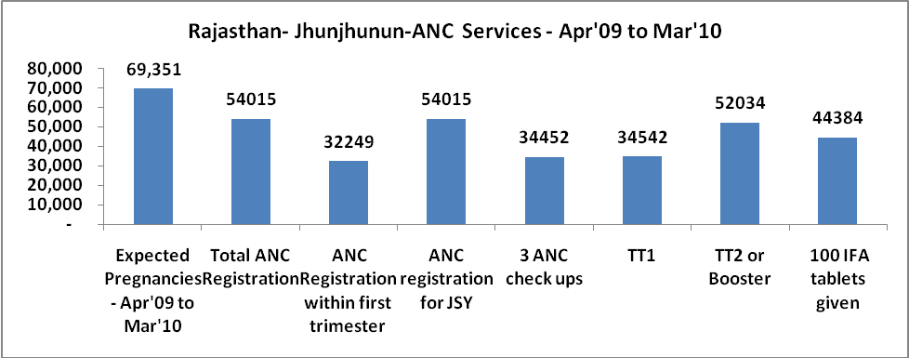
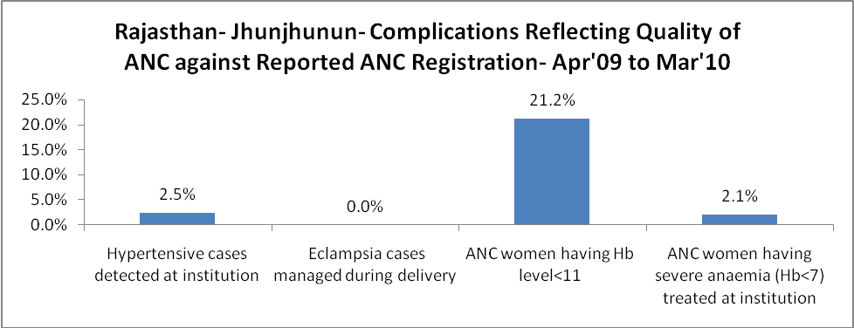
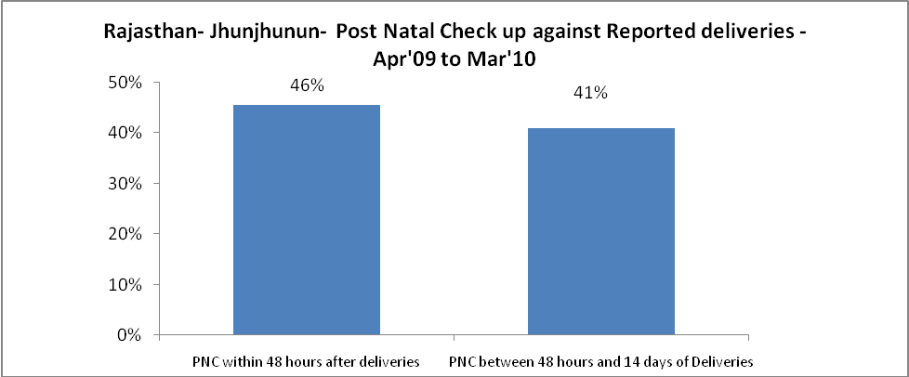

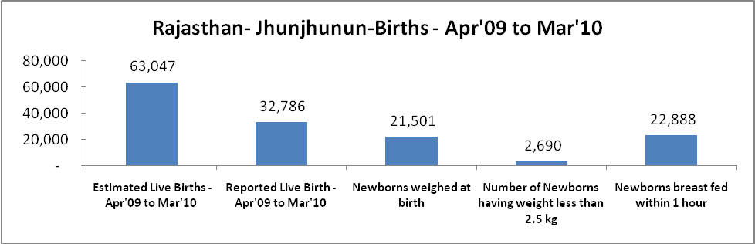

Rajasthan- Jhunjhunun - Births - Apr'09 to Mar'10
Live Birth - Males | Live Birth - females | Live Birth - Total | Sex Ratio at birth | Still Birth | Abortion( Induced/Spontaneous
18,455 | 14,331 | 32,786 | 777 | 226 | 280

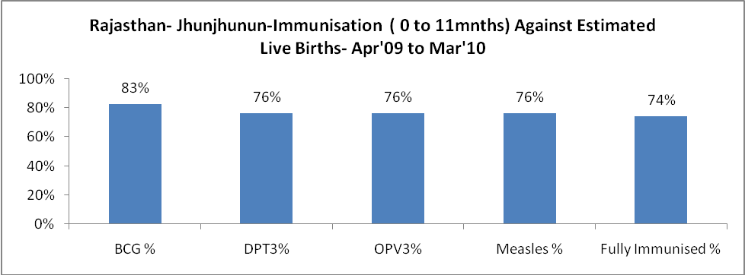

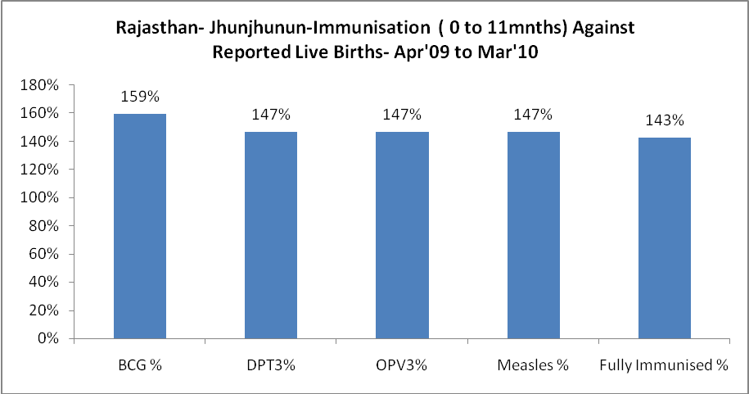

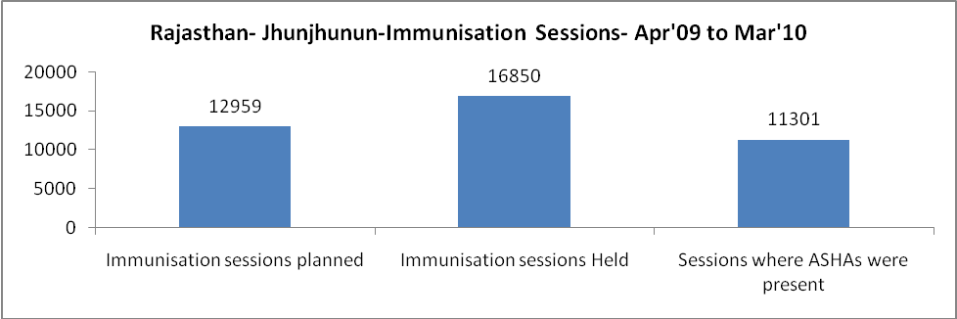

Rajasthan- Jhunjhunun- Apr'09 to Mar'10
Total Abortions | Abortion Rate
545 | 0.8%

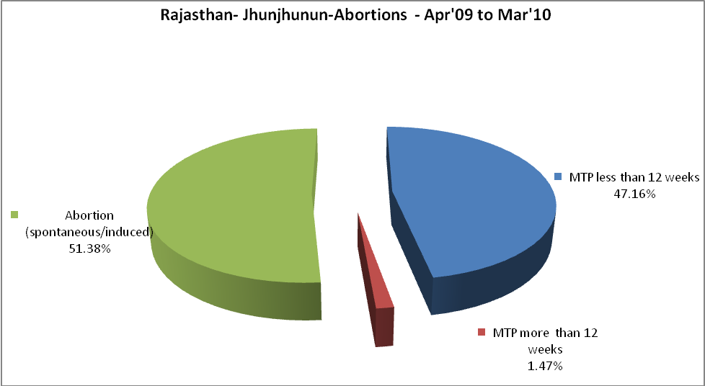

Rajasthan- Jhunjhunun- Apr'09 to Mar'10
Total OPD | Total RTI/STI cases
955,147 | 3,736

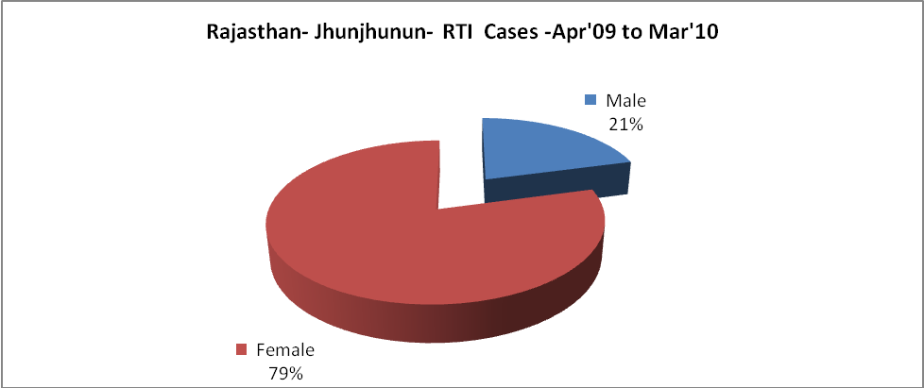

Rajasthan- Jhunjhunun-Sterilisations - Apr'09 to Mar'10
 | Reported | %age of Reported Sterilisation
Total Sterilisation | 10,029 | -
NSV | 376 | 4%
Laproscopic | 9,633 | 96%
MiniLap | 7 | 0%
Post Partum | 13 | 0%
Male Sterilisation | 376 | 4%
Female Sterilisation | 9,653 | 96%

Rajasthan- Jhunjhunun-FP Methods - Apr'09 to Mar'10
 | Reported | %age of All Reported FP Methods
Total Reported FP Methodd (All types) Users | 99,390 | -
Sterilisations | 10,029 | 10%
IUD | 15,114 | 15%
Condom Users | 55,655 | 56%
OCP Users | 18,591 | 19%
Limiting Methods | 10,029 | 10%
Spacing Methods | 89,361 | 90%

Rajasthan- Jhunjhunun- Service Delivery - Apr'09 to Mar'10
Operation major (General and spinal anaesthesia) | Operation minor (No or local anaesthesia) | AYUSH | Dental Procedures | Adolescent counselling services | Total OPD | Total IPD
1,460 | 2,911 | 37,625 | 191 | 1,118 | 955,147 | 30,161
Operation major (General and spinal anaesthesia) as %ge of OPD | Operation minor (No or local anaesthesia)as %ge of OPD | AYUSH as %ge of OPD | Dental Procedures as %ge of OPD | Adolescent counselling services as %ge of OPD | IPD as percentage of OPD
0.2% | 0.3% | 3.9% | 0.0% | 0.1% | 3%

Rajasthan- Jhunjhunun- Lab Services - Apr'09 to Mar'10
Total OPD | Total HB tested | Total HIV Tested | Total Population
955,147 | 26,976 | 2,923 | 2,292,600
HB test conducted as %age of OPD | HB<7gm as %age of HB tested | HIV test conducted as %age of OPD | HIV positive as %age of HIV tested | Blood Smear Examined as % of Population
2.8% | 9.2% | 0.3% | 0.0% | 2.3%

Rajasthan- Jhunjhunun- Childhood Disease - Vaccine Preventable -Apr'09 to Mar'10
Diphtheria | Pertussis | Tetanus Neonatorum | Tetanus others | Polio | Measles
0 | 0 | 0 | 0 | 0 | 1
Rajasthan- Jhunjhunun-Childhood Disease - Others - Apr'09 to Mar'10
Diarrhoea and dehydration | Malaria | Number admitted with Respiratory Infections
1,086 | 110 | 1,909

Rajasthan- Jhunjhunun- Infant & Child Deaths - Apr'09 to Mar'10
Infant Deaths within 24 hrs of birth | Infant Deaths between 24hrs & under 1 week | Infant Deaths between 1 week & under 1 month | Child Deaths between 1 month & under 1 year | Child Deaths between 1yr under 5years | Total Deaths
7 | 35 | 2 | 5 | 8 | 57

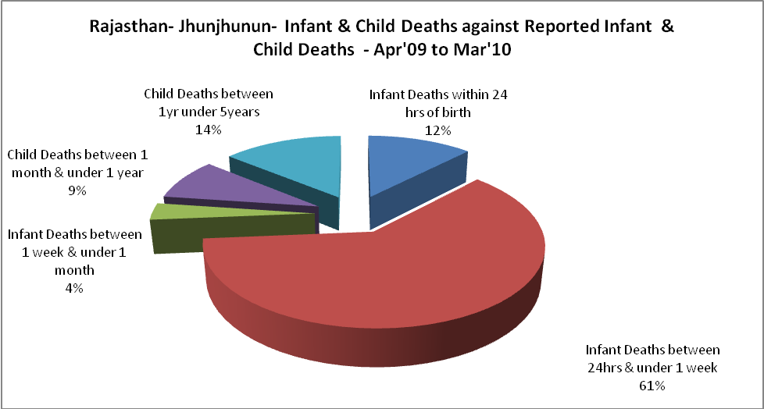

Rajasthan- Jhunjhunun- Causes of Infant & Child Deaths - Apr'09 to Mar'10
Sepsis |  |  | Asphyxia |  |  | LBW
Up to 1 Weeks of Birth | Between 1 week & 4 weeks of birth | Total | Up to 1 Weeks of Birth | Between 1 week & 4 weeks of birth | Total | Up to 1 Weeks of Birth | Between 1 week & 4 weeks of birth | Total
0 | 0 | 0 | 2 | 0 | 2 | 2 | 0 | 2
Pneumonia |  |  | Diarrhoea |  |  | Fever related
Between 1 month and 11 months | Between 1 year & 5 years | Total | Between 1 month and 11 months | Between 1 year & 5 years | Total | Between 1 month and 11 months | Between 1 year & 5 years | Total
0 | 0 | 0 | 2 | 1 | 3 | 0 | 5 | 5
Others |  |  | Measles |  |  | Others
Up to 1 Weeks of Birth | Between 1 week & 4 weeks of birth | Total | Between 1 month and 11 months | Between 1 year & 5 years | Total | Between 1 month and 11 months | Between 1 year & 5 years | Total
31 | 2 | 33 | 0 | 0 | 0 | 3 | 2 | 5

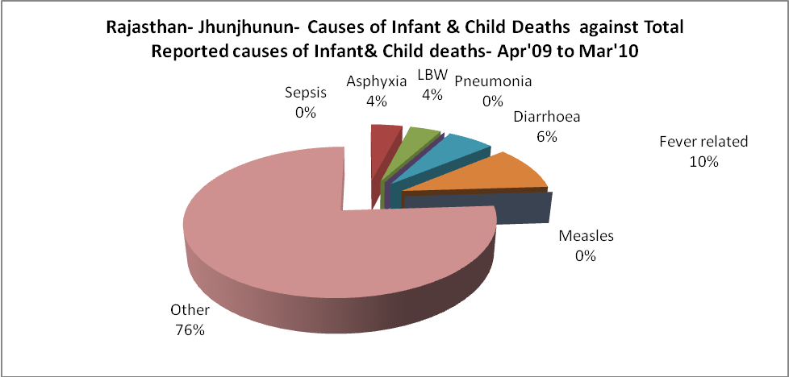

Rajasthan- Jhunjhunun- Maternal Deaths & Causes - Apr'09 to Mar'10
Abortion |  |  | Obstructed/prolonged labour |  |  | Severe hypertesnion/fits
6-14 yrs | 15-55 yrs. | Total | 6-14 yrs | 15-55 yrs. | Total | 6-14 yrs | 15-55 yrs. | Total
0 | 0 | 0 | 0 | 0 | 0 | 0 | 0 | 0
Bleeding |  |  | High Fever |  |  | Other Causes
6-14 yrs | 15-55 yrs. | Total | 6-14 yrs | 15-55 yrs. | Total | 6-14 yrs | 15-55 yrs. | Total
0 | 0 | 0 | 0 | 0 | 0 | 0 | 0 | 0

Rajasthan- Jhunjhunun-Causes of Deaths in 6 to 55yrs age group - Apr'09 to Mar'10
Diarrhoel Diseases |  |  |  | Tuberculosis |  |  |  | Respiratory Diseases( Other than TB)
6-14 yrs | 15-55 yrs. | Above 55yrs | Total | 6-14 yrs | 15-55 yrs. | Above 55yrs | Total | 6-14 yrs | 15-55 yrs. | Above 55yrs | Total
0 | 0 | 0 | 0 | 0 | 2 | 0 | 2 | 0 | 2 | 4 | 6
Malaria |  |  |  | Other fever Related |  |  |  | HIV/Aids
6-14 yrs | 15-55 yrs. | Above 55yrs | Total | 6-14 yrs | 15-55 yrs. | Above 55yrs | Total | 6-14 yrs | 15-55 yrs. | Above 55yrs | Total
0 | 0 | 0 | 0 | 0 | 0 | 1 | 1 | 0 | 0 | 0 | 0
Heart Disease/Hypertenion related |  |  |  | Neurological Disease including strokes |  |  |  | Trauma/Accidents/ Burn Cases
6-14 yrs | 15-55 yrs. | Above 55yrs | Total | 6-14 yrs | 15-55 yrs. | Above 55yrs | Total | 6-14 yrs | 15-55 yrs. | Above 55yrs | Total
0 | 2 | 3 | 5 | 7 | 1 | 8 | 16 | 0 | 0 | 1 | 1
Suicide |  |  |  | Animal Bites & Stings
6-14 yrs | 15-55 yrs. | Above 55yrs | Total | 6-14 yrs | 15-55 yrs. | Above 55yrs | Total
0 | 0 | 0 | 0 | 0 | 0 | 0 | 0

