NHSRC
Bihar- kaimur
HMIS DATA ANALYSIS 2009-10

KUNAL
25/08/2010

Bihar-Kaimur- Summary-Apr'09 to Mar'10
ANC
ANC Registration against Expected Pregnancies | 169% | TT1 given to Pregnant women against ANC Registraion | 31%
3 ANC Check ups against ANC Reigtrations | 26% | 100 IFA Tablets given to Pregnant women against ANC Registraion | 480%
Deliveries
Unreported Deliveries against Estimated Deliveries | 50.2% | HOME Deliveries( SBA& Non SBA) against Estimated Deliveries | 0.0%
Institutional Deliveries against Estimated Deliveries | 49.8% | HOME Deliveries( SBA& Non SBA) against Reported Deliveries | 0.0%
Institutional Deliveries against Reported Deliveries | 100.0% | C Section Deliveries against Institutional Deliveries( Pvt & Pub) | 0%
Births & Neonates Care
Live Births Reported against Estimated Live Births | 39% | New borns weighed against Reported Live Births | 101%
Still Births (Reported) | 182 | New borns weighed less than 2.5 kgs against newborns weighed | 6%
Sex Ratio at Birh | 982 | New borns breastfed within one hr of Birth against Reported live Births | 99%
Child Immunisation( 0 to 11 mnths)
BCG given against Expected Live Births | 77% | Measles given against Expected Live Births | 66%
OPV3 given against Expected Live Births | 81% | Fully Immunised Children against Expected Live Births | 74%
DPT3 given against Expected Live Births | 84%
Family Plannng
Family Plannig Methods Users ( Sterilisations(Male &Female)+IUD+ Condom pieces/72 + OCP Cycles/13) | 12,990 | IUD Insertions against reported FP Methods | 8%
Sterilisation against reported FP Methods | 76% | Condom Users against reported FP Methods | 12%
 |  | OCP Users against reported FP Methods | 4%
Other Services
OPD | 5,77,251 | Major Operations | 71
IPD | 2,615 | Minor Operations | 7,861

Bihar-Kaimur- Deliveries Apr'09 to Mar'10
Total Population | 14,76,802 | Expected Deliveries |  | 44,757
Home SBA | Home Non SBA | Institutional | Total Deliveries Reported | Unreported Deliveries
10 | - | 22,273 | 22,283 | 22,474
Home SBA % | Home Non SBA% | Institutional % | Total Deliveries Reported % | Unreported Deliveries %
0% | 0% | 50% | 50% | 50%

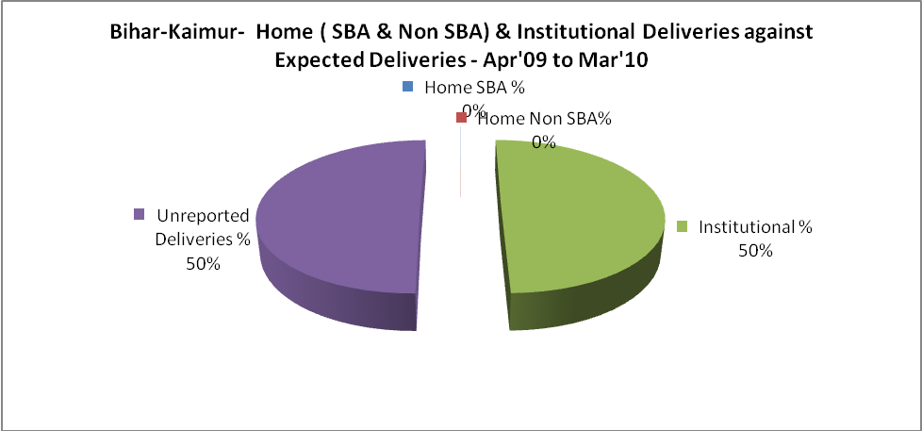
Bihar-Kaimur- C sections & Complicated Deliveries Apr'09 to Mar'10
 | Institutional Deliveries (Public) | Institutional Deliveries (Pvt)
 | 16,490 | 5,783
C Section | 90 | -
C Section% | 1% | 0%
Complicated Pregnacies attended | 148 | -
Complicated Pregnacies attended % | 1% | 0%

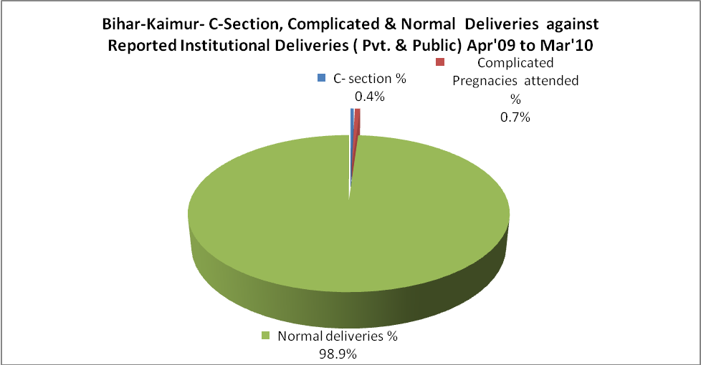
Bihar-Kaimur- Complicated Pregnancies & Deliveries Treated - Apr'09 to Mar'10
Reported Deliveries |  |  | Reported ANC Reigtration
22,283 |  |  | 80,780
Complicated Pregnancies attended | Complicated Pregnancies Rate | C - Section Deliveries | PNC Maternal Complications | Abortions | Still Births
148 | 0% | 90 | - | - | 182
Complicated Deliveries Treated with |  |  |  | No Of Eclampsia cases Treated | No Of severe anemia cases treated
IV Antibiotics | IV antihypertensive/Magsulph injection | IV Oxytocis | Blood Transfusion | No Of Eclampsia cases Treated | No Of severe anemia cases treated
173 | 60 | 113 | - | 1,183 | 186

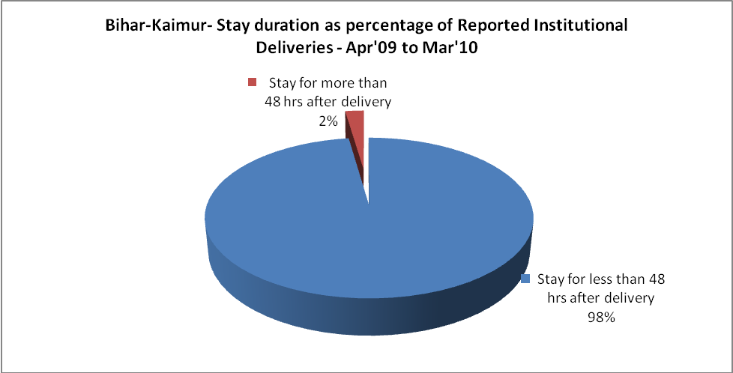

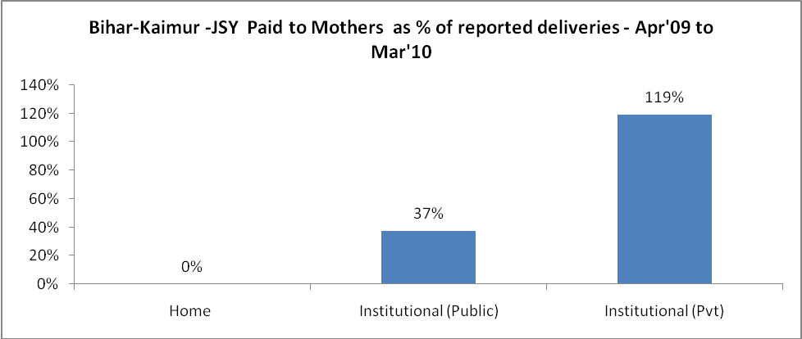
`
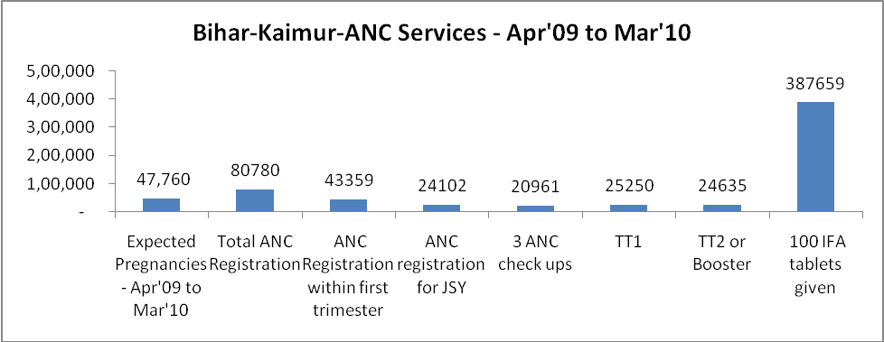
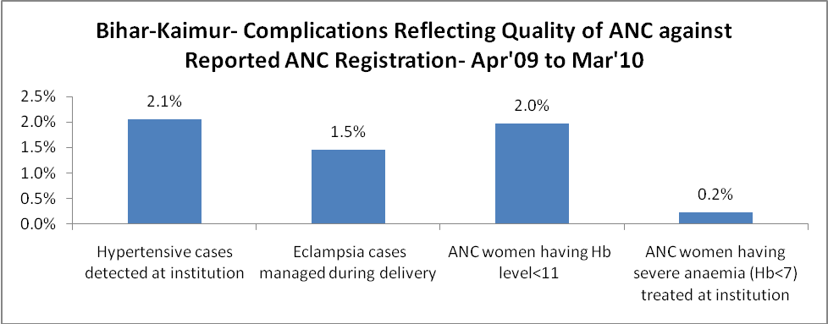
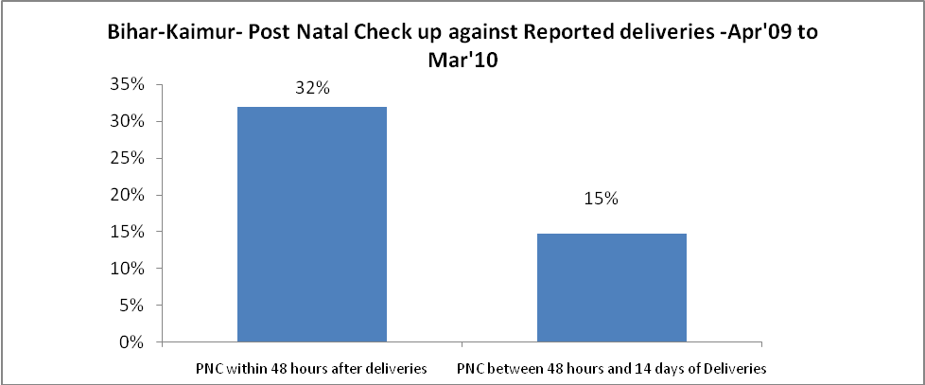

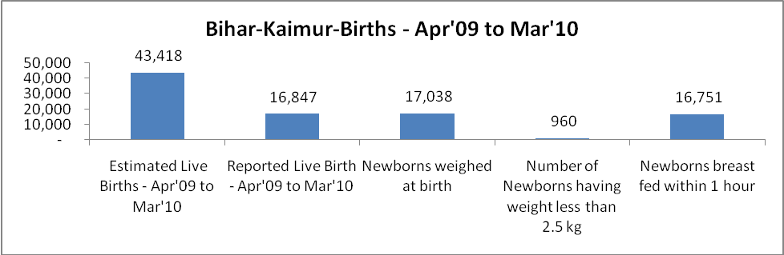
Bihar-Kaimur - Births - Apr'09 to Mar'10
Live Birth - Males | Live Birth - females | Live Birth - Total | Sex Ratio at birth | Still Birth | Abortion( Induced/Spontaneous
8,500 | 8,347 | 16,847 | 982 | 182 | -

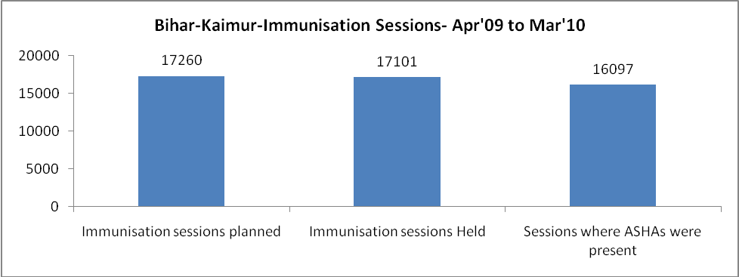
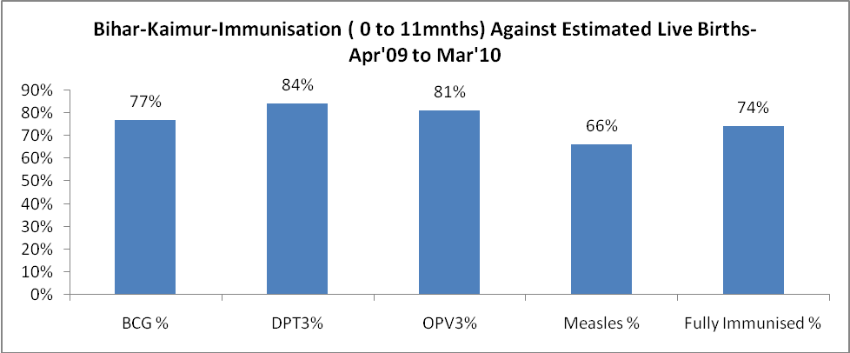
Bihar-Kaimur- Apr'09 to Mar'10
Total Abortions | Abortion Rate
- | 0.0%

Bihar-Kaimur- Apr'09 to Mar'10
Total OPD | Total RTI/STI cases
5,77,251 | 83

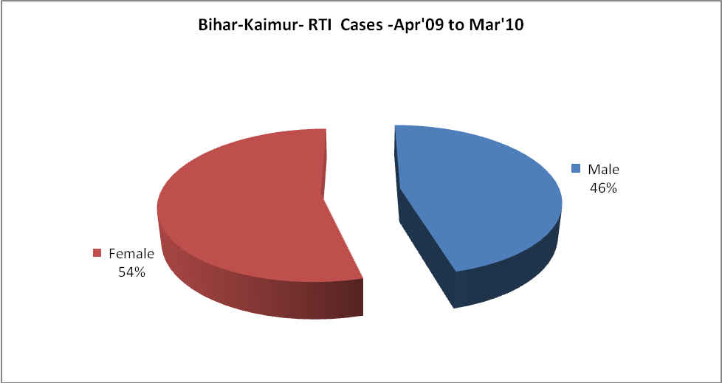

Bihar-Kaimur-Sterilisations - Apr'09 to Mar'10
 | Reported | %age of Reported Sterilisation
Total Sterilisation | 9,861 | -
NSV | 134 | 1%
Laproscopic | - | 0%
MiniLap | 9,677 | 98%
Post Partum | 50 | 1%
Male Sterilisation | 134 | 1%
Female Sterilisation | 9,727 | 99%
Bihar-Kaimur-FP Methods - Apr'09 to Mar'10
 | Reported | %age of All Reported FP Methods
Total Reported FP Methodd (All types) Users | 12,990 | -
Sterilisations | 9,861 | 76%
IUD | 1,026 | 8%
Condom Users | 1,547 | 12%
OCP Users | 556 | 4%
Limiting Methods | 9,861 | 76%
Spacing Methods | 3,129 | 24%

Bihar-Kaimur- Lab Services - Apr'09 to Mar'10
Total OPD | Total HB tested | Total HIV Tested | Total Population
5,77,251 | 4,434 | 495 | 14,76,802
HB test conducted as %age of OPD | HB<7gm as %age of HB tested | HIV test conducted as %age of OPD | HIV positive as %age of HIV tested | Blood Smear Examined as % of Population
0.8% | 9.4% | 0.1% | 7.5% | 0.0%

Bihar-Kaimur- Childhood Disease - Vaccine Preventable -Apr'09 to Mar'10
Diphtheria | Pertussis | Tetanus Neonatorum | Tetanus others | Polio | Measles
0 | 0 | 0 | 0 | 361 | 522
Bihar-Kaimur-Childhood Disease - Others - Apr'09 to Mar'10
Diarrhoea and dehydration | Malaria | Number admitted with Respiratory Infections
65 | 476 | -
Bihar-Kaimur- Infant & Child Deaths - Apr'09 to Mar'10
Infant Deaths within 24 hrs of birth | Infant Deaths between 24hrs & under 1 week | Infant Deaths between 1 week & under 1 month | Child Deaths between 1 month & under 1 year | Child Deaths between 1yr under 5years | Total Deaths
61 | 19 | 0 | 178 | 0 | 258

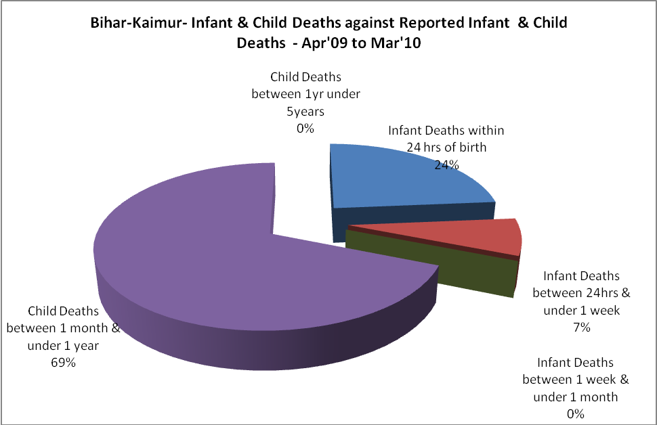
Bihar-Kaimur- Causes of Infant & Child Deaths - Apr'09 to Mar'10
Sepsis |  |  | Asphyxia |  |  | LBW
Up to 1 Weeks of Birth | Between 1 week & 4 weeks of birth | Total | Up to 1 Weeks of Birth | Between 1 week & 4 weeks of birth | Total | Up to 1 Weeks of Birth | Between 1 week & 4 weeks of birth | Total
0 | 0 | 0 | 0 | 0 | 0 | 0 | 0 | 0
Pneumonia |  |  | Diarrhoea |  |  | Fever related
Between 1 month and 11 months | Between 1 year & 5 years | Total | Between 1 month and 11 months | Between 1 year & 5 years | Total | Between 1 month and 11 months | Between 1 year & 5 years | Total
0 | 0 | 0 | 0 | 0 | 0 | 0 | 0 | 0
Others |  |  | Measles |  |  | Others
Up to 1 Weeks of Birth | Between 1 week & 4 weeks of birth | Total | Between 1 month and 11 months | Between 1 year & 5 years | Total | Between 1 month and 11 months | Between 1 year & 5 years | Total
19 | 0 | 19 | 178 | 0 | 178 | 0 | 0 | 0

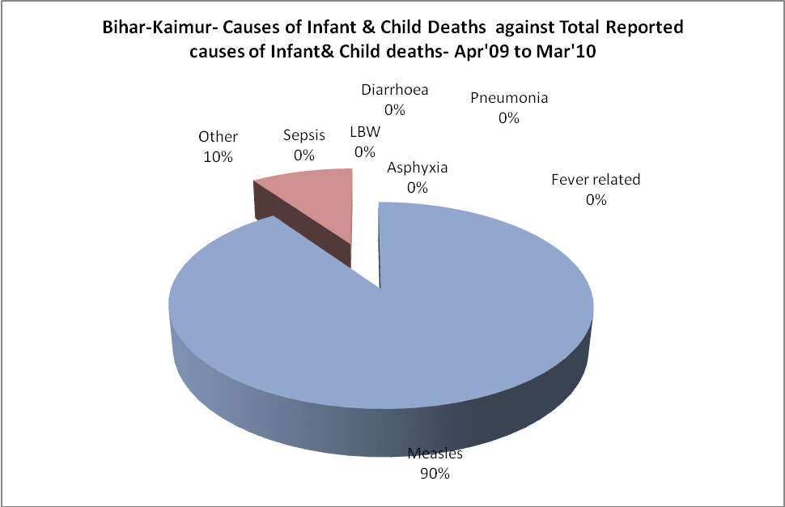

Bihar-Kaimur- Maternal Deaths & Causes - Apr'09 to Mar'10
Abortion |  |  | Obstructed/prolonged labour |  |  | Severe hypertesnion/fits
6-14 yrs | 15-55 yrs. | Total | 6-14 yrs | 15-55 yrs. | Total | 6-14 yrs | 15-55 yrs. | Total
0 | 0 | 0 | 0 | 0 | 0 | 0 | 0 | 0
Bleeding |  |  | High Fever |  |  | Other Causes
6-14 yrs | 15-55 yrs. | Total | 6-14 yrs | 15-55 yrs. | Total | 6-14 yrs | 15-55 yrs. | Total
0 | 40 | 40 | 0 | 69 | 69 | 0 | 0 | 0

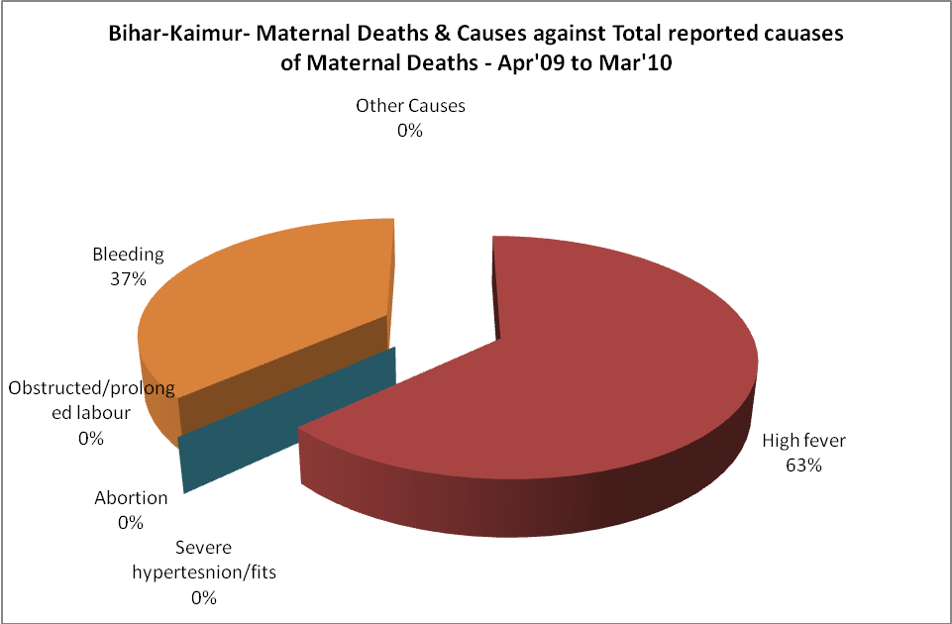
Bihar-Kaimur-Causes of Deaths in 6 to 55yrs age group - Apr'09 to Mar'10
Diarrhoel Diseases |  |  |  | Tuberculosis |  |  |  | Respiratory Diseases( Other than TB)
6-14 yrs | 15-55 yrs. | Above 55yrs | Total | 6-14 yrs | 15-55 yrs. | Above 55yrs | Total | 6-14 yrs | 15-55 yrs. | Above 55yrs | Total
0 | 0 | 0 | 0 | 0 | 0 | 0 | 0 | 0 | 0 | 0 | 0
Malaria |  |  |  | Other fever Related |  |  |  | HIV/Aids
6-14 yrs | 15-55 yrs. | Above 55yrs | Total | 6-14 yrs | 15-55 yrs. | Above 55yrs | Total | 6-14 yrs | 15-55 yrs. | Above 55yrs | Total
0 | 0 | 0 | 0 | 0 | 0 | 0 | 0 | 0 | 0 | 0 | 0
Heart Disease/Hypertenion related |  |  |  | Neurological Disease including strokes |  |  |  | Trauma/Accidents/ Burn Cases
6-14 yrs | 15-55 yrs. | Above 55yrs | Total | 6-14 yrs | 15-55 yrs. | Above 55yrs | Total | 6-14 yrs | 15-55 yrs. | Above 55yrs | Total
0 | 0 | 0 | 0 | 0 | 0 | 0 | 0 | 1 | 3 | 0 | 4
Suicide |  |  |  | Animal Bites & Stings
6-14 yrs | 15-55 yrs. | Above 55yrs | Total | 6-14 yrs | 15-55 yrs. | Above 55yrs | Total
0 | 0 | 0 | 0 | 1 | 3 | 0 | 4

