NHSRC
Maharashtra – Kolhapur
Analysis: Apr 2009 – Mar 2010

Maharashtra-Kolhapur- Summary-Apr'09 to Mar'10
ANC
ANC Registration against Expected Pregnancies | 84% | TT1 given to Pregnant women against ANC Registration | 68%
3 ANC Check ups against ANC Registrations | 83% | 100 IFA Tablets given to Pregnant women against ANC Registration | 77%
Deliveries
Unreported Deliveries against Estimated Deliveries | 21.1% | HOME Deliveries( SBA& Non SBA) against Estimated Deliveries | 2.6%
Institutional Deliveries against Estimated Deliveries | 76.3% | HOME Deliveries( SBA& Non SBA) against Reported Deliveries | 3.3%
Institutional Deliveries against Reported Deliveries | 96.7% | C Section Deliveries against Institutional Deliveries( Pvt & Pub) | 10%
Births & Neonates Care
Live Births Reported against Estimated Live Births | 79% | New borns weighed against Reported Live Births | 88%
Still Births (Reported) | 894 | New borns weighed less than 2.5 kgs against newborns weighed | 19%
Sex Ratio at Birth | 840 | New borns breastfed within one hr of Birth against Reported live Births | 91%
Child Immunization( 0 to 11 months)
BCG given against Expected Live Births | 89% | Measles given against Expected Live Births | 81%
OPV3 given against Expected Live Births | 81% | Fully Immunized Children against Expected Live Births | 76%
DPT3 given against Expected Live Births | 83%
Family Planning
Family Plannig Methods Users ( Sterilizations(Male &Female)+IUD+ Condom pieces/72 + OCP Cycles/13) | 79,719 | IUD Insertions against reported FP Methods | 28%
Sterilization against reported FP Methods | 26% | Condom Users against reported FP Methods | 18%
 |  | OCP Users against reported FP Methods | 29%
Other Services
OPD | 821,609 | Major Operations | 2,516
IPD | - | Minor Operations | 1,683
`

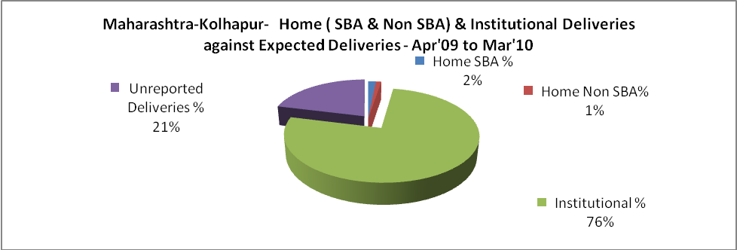

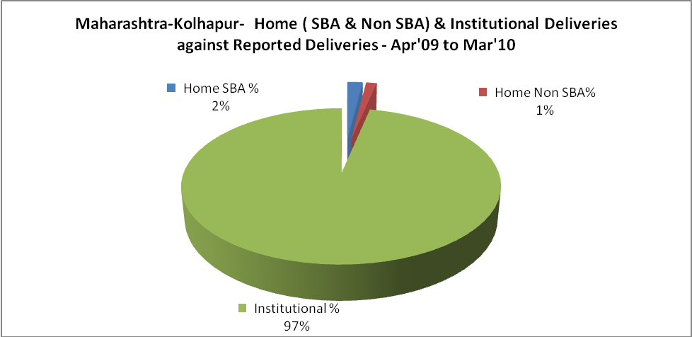

Maharashtra-Kolhapur- C sections & Complicated Deliveries Apr'09 to Mar'10
 | Institutional Deliveries (Public) | Institutional Deliveries (Pvt)
 | 23,652 | 33,755
C Section | 1,749 | 3,783
C Section% | 7% | 11%
Complicated Pregnancies attended | 3,479 | 1,466
Complicated Pregnancies attended % | 15% | 4%

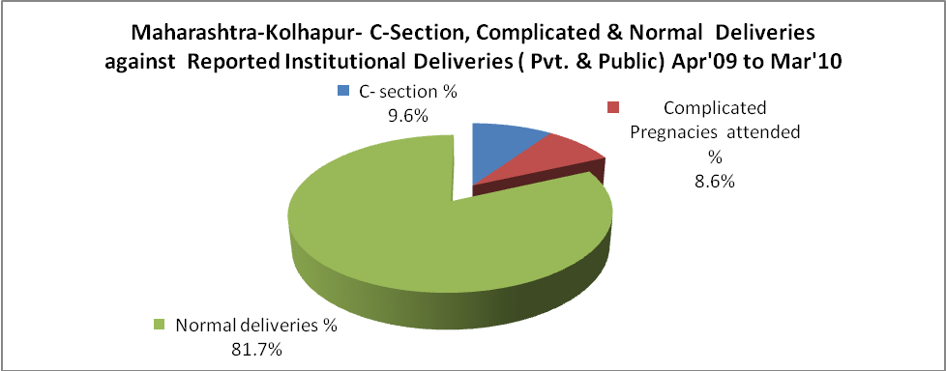

Maharashtra-Kolhapur- Complicated Pregnancies & Deliveries Treated - Apr'09 to Mar'10
Reported Deliveries |  |  | Reported ANC Registration
59,373 |  |  | 68,076
Complicated Pregnancies attended | Complicated Pregnancies Rate | C - Section Deliveries | PNC Maternal Complications | Abortions | Still Births
4,945 | 6% | 5,532 | - | 2,924 | 894
Complicated Deliveries Treated with |  |  |  | No Of Eclampsia cases Treated | No Of severe anemia cases treated
IV Antibiotics | IV antihypertensive/Magsulph injection | IV Oxytocis | Blood Transfusion | No Of Eclampsia cases Treated | No Of severe anemia cases treated
- | - | - | - | - | -

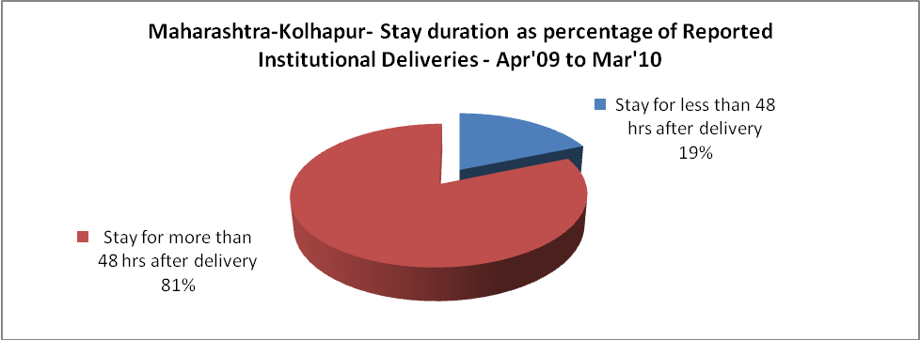

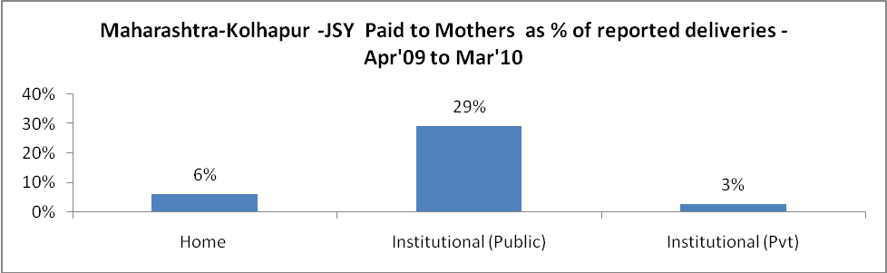

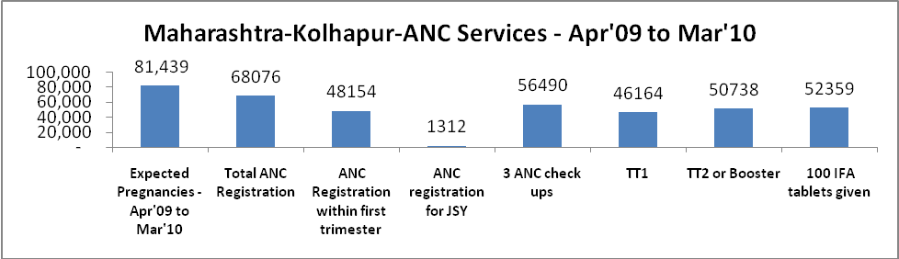

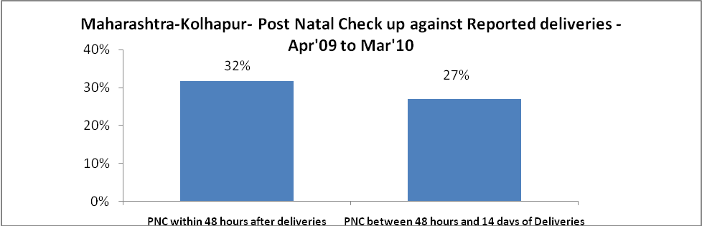

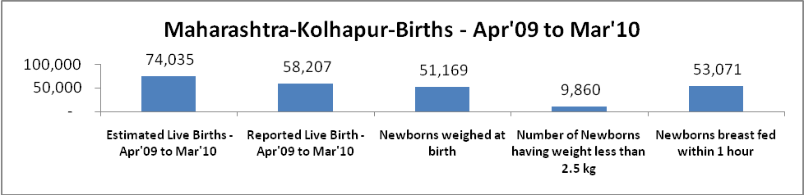

Maharashtra-Kolhapur - Births - Apr'09 to Mar'10
Live Birth - Males | Live Birth - females | Live Birth - Total | Sex Ratio at birth | Still Birth | Abortion( Induced/Spontaneous
31,629 | 26,578 | 58,207 | 840 | 894 | 2,924

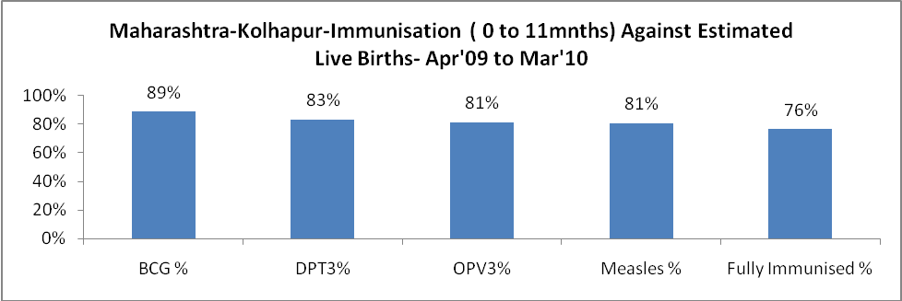

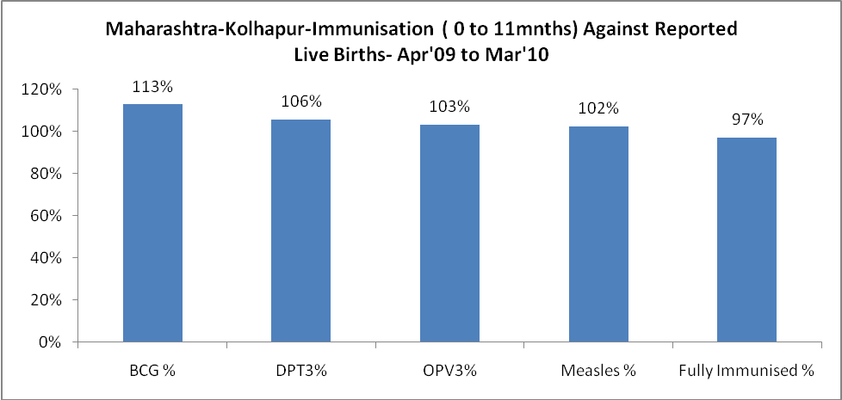

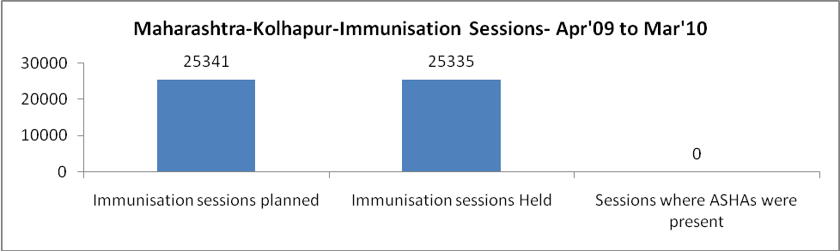

Maharashtra-Kolhapur- Apr'09 to Mar'10
Total Abortions | Abortion Rate
4,385 | 5.4%

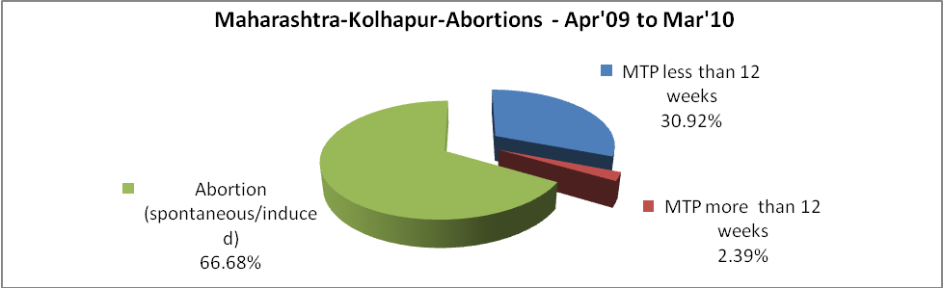

Maharashtra-Kolhapur- Apr'09 to Mar'10
Total OPD | Total RTI/STI cases
821,609 | 9,340

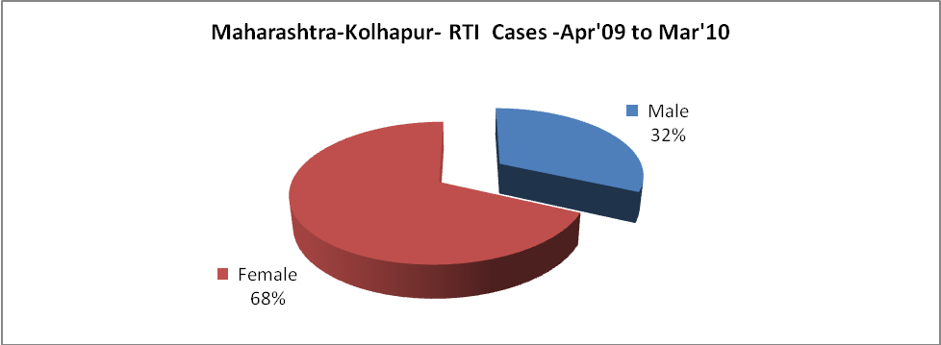

Maharashtra-Kolhapur-Sterilizations - Apr'09 to Mar'10
 | Reported | %age of Reported Sterilization
Total Sterilization | 20,330 | -
NSV | 263 | 1%
Laparoscopic | 11,097 | 55%
MiniLap | 5,322 | 26%
Post Partum | 3,648 | 18%
Male Sterilization | 263 | 1%
Female Sterilization | 20,067 | 99%

Maharashtra-Kolhapur-FP Methods - Apr'09 to Mar'10
 | Reported | %age of All Reported FP Methods
Total Reported FP Method (All types) Users | 79,719 | -
Sterilizations | 20,330 | 26%
IUD | 22,648 | 28%
Condom Users | 13,959 | 18%
OCP Users | 22,782 | 29%
Limiting Methods | 20,330 | 26%
Spacing Methods | 59,389 | 74%

Maharashtra-Kolhapur- Service Delivery - Apr'09 to Mar'10
Operation major (General and spinal anaesthesia) | Operation minor (No or local anaesthesia) | AYUSH | Dental Procedures | Adolescent counselling services | Total OPD | Total IPD
2,516 | 1,683 | - | - | - | 821,609 | -
Operation major (General and spinal anaesthesia) as %ge of OPD | Operation minor (No or local anaesthesia)as %ge of OPD | AYUSH as %ge of OPD | Dental Procedures as %ge of OPD | Adolescent counselling services as %ge of OPD | IPD as percentage of OPD
0.3% | 0.2% | 0.0% | 0.0% | 0.0% | 0%

Maharashtra-Kolhapur- Lab Services - Apr'09 to Mar'10
Total OPD | Total HB tested | Total HIV Tested | Total Population
821,609 | 61,626 | - | 4,136,042
HB test conducted as %age of OPD | HB<7gm as %age of HB tested | HIV test conducted as %age of OPD | HIV positive as %age of HIV tested | Blood Smear Examined as % of Population
7.5% | 0.0% | 0.0% | 0.0% | 6.6%

Maharashtra-Kolhapur- Childhood Disease - Vaccine Preventable -Apr'09 to Mar'10
Diphtheria | Pertussis | Tetanus Neonatorum | Tetanus others | Polio | Measles
0 | 0 | 0 | 0 | 0 | 0
Maharashtra-Kolhapur-Childhood Disease - Others - Apr'09 to Mar'10
Diarrhoea and dehydration | Malaria | Number admitted with Respiratory Infections
1,591 | - | -

Maharashtra-Kolhapur- Infant & Child Deaths - Apr'09 to Mar'10
Infant Deaths within 24 hrs of birth | Infant Deaths between 24hrs & under 1 week | Infant Deaths between 1 week & under 1 month | Child Deaths between 1 month & under 1 year | Child Deaths between 1yr under 5years | Total Deaths
234 | 406 | 145 | 158 | 62 | 1005

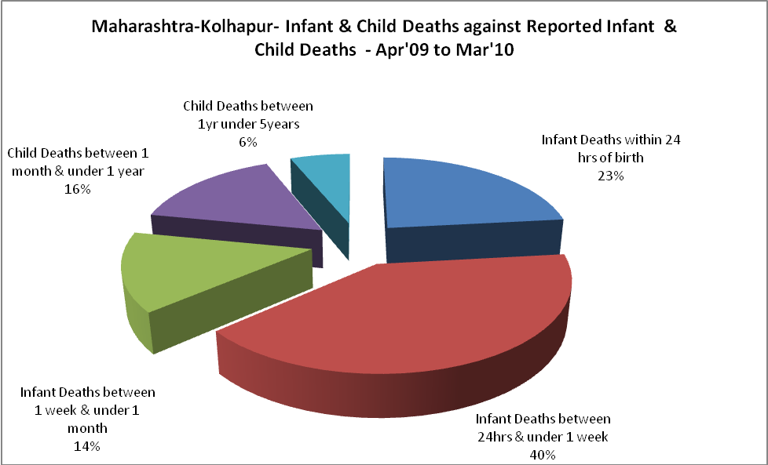

Maharashtra-Kolhapur- Causes of Infant & Child Deaths - Apr'09 to Mar'10
Sepsis |  |  | Asphyxia |  |  | LBW
Up to 1 Weeks of Birth | Between 1 week & 4 weeks of birth | Total | Up to 1 Weeks of Birth | Between 1 week & 4 weeks of birth | Total | Up to 1 Weeks of Birth | Between 1 week & 4 weeks of birth | Total
0 | 0 | 0 | 0 | 0 | 0 | 0 | 0 | 0
Pneumonia |  |  | Diarrhoea |  |  | Fever related
Between 1 month and 11 months | Between 1 year & 5 years | Total | Between 1 month and 11 months | Between 1 year & 5 years | Total | Between 1 month and 11 months | Between 1 year & 5 years | Total
0 | 0 | 0 | 0 | 0 | 0 | 0 | 0 | 0
Others |  |  | Measles |  |  | Others
Up to 1 Weeks of Birth | Between 1 week & 4 weeks of birth | Total | Between 1 month and 11 months | Between 1 year & 5 years | Total | Between 1 month and 11 months | Between 1 year & 5 years | Total
406 | 145 | 551 | 0 | 0 | 0 | 158 | 62 | 220

Maharashtra-Kolhapur- Maternal Deaths & Causes - Apr'09 to Mar'10
Abortion |  |  | Obstructed/prolonged labour |  |  | Severe hypertesnion/fits
6-14 yrs | 15-55 yrs. | Total | 6-14 yrs | 15-55 yrs. | Total | 6-14 yrs | 15-55 yrs. | Total
0 | 0 | 0 | 0 | 0 | 0 | 0 | 0 | 0
Bleeding |  |  | High Fever |  |  | Other Causes
6-14 yrs | 15-55 yrs. | Total | 6-14 yrs | 15-55 yrs. | Total | 6-14 yrs | 15-55 yrs. | Total
0 | 0 | 0 | 0 | 0 | 0 | 0 | 33 | 33

Maharashtra-Kolhapur-Causes of Deaths in 6 to 55yrs age group - Apr'09 to Mar'10
Diarrhoel Diseases |  |  |  | Tuberculosis |  |  |  | Respiratory Diseases( Other than TB)
6-14 yrs | 15-55 yrs. | Above 55yrs | Total | 6-14 yrs | 15-55 yrs. | Above 55yrs | Total | 6-14 yrs | 15-55 yrs. | Above 55yrs | Total
0 | 0 | 0 | 0 | 0 | 0 | 0 | 0 | 0 | 0 | 0 | 0
Malaria |  |  |  | Other fever Related |  |  |  | HIV/Aids
6-14 yrs | 15-55 yrs. | Above 55yrs | Total | 6-14 yrs | 15-55 yrs. | Above 55yrs | Total | 6-14 yrs | 15-55 yrs. | Above 55yrs | Total
0 | 0 | 0 | 0 | 0 | 0 | 0 | 0 | 0 | 0 | 0 | 0
Heart Disease/Hypertension related |  |  |  | Neurological Disease including strokes |  |  |  | Trauma/Accidents/ Burn Cases
6-14 yrs | 15-55 yrs. | Above 55yrs | Total | 6-14 yrs | 15-55 yrs. | Above 55yrs | Total | 6-14 yrs | 15-55 yrs. | Above 55yrs | Total
0 | 0 | 0 | 0 | 0 | 0 | 0 | 0 | 0 | 0 | 0 | 0
Suicide |  |  |  | Animal Bites & Stings
6-14 yrs | 15-55 yrs. | Above 55yrs | Total | 6-14 yrs | 15-55 yrs. | Above 55yrs | Total
0 | 0 | 0 | 0 | 0 | 0 | 0 | 0

