NHSRC
Maharashtra – Latur
Analysis: Apr 2009 – Mar 2010

`
Maharashtra-Latur- Summary-Apr'09 to Mar'10
ANC
ANC Registration against Expected Pregnancies | 108% | TT1 given to Pregnant women against ANC Registration | 48%
3 ANC Check ups against ANC Registrations | 79% | 100 IFA Tablets given to Pregnant women against ANC Registration | 69%
Deliveries
Unreported Deliveries against Estimated Deliveries | -5.1% | HOME Deliveries( SBA& Non SBA) against Estimated Deliveries | 7.9%
Institutional Deliveries against Estimated Deliveries | 97.3% | HOME Deliveries( SBA& Non SBA) against Reported Deliveries | 7.5%
Institutional Deliveries against Reported Deliveries | 92.5% | C Section Deliveries against Institutional Deliveries( Pvt & Pub) | 2%
Births & Neonates Care
Live Births Reported against Estimated Live Births | 106% | New borns weighed against Reported Live Births | 77%
Still Births (Reported) | 355 | New borns weighed less than 2.5 kgs against newborns weighed | 6%
Sex Ratio at Birth | 867 | New borns breastfed within one hr of Birth against Reported live Births | 0%
Child Immunization( 0 to 11 months)
BCG given against Expected Live Births | 114% | Measles given against Expected Live Births | 99%
OPV3 given against Expected Live Births | 104% | Fully Immunized Children against Expected Live Births | 96%
DPT3 given against Expected Live Births | 104%
Family Planning
Family Plannig Methods Users ( Sterilizations(Male &Female)+IUD+ Condom pieces/72 + OCP Cycles/13) | 39,834 | IUD Insertions against reported FP Methods | 21%
Sterilization against reported FP Methods | 38% | Condom Users against reported FP Methods | 26%
 |  | OCP Users against reported FP Methods | 15%
Other Services
OPD | 223,153 | Major Operations | 158
IPD | - | Minor Operations | 535

Maharashtra-Latur- Deliveries Apr'09 to Mar'10
Total Population | 2,441,741 | Expected Deliveries |  | 44,428
Home SBA | Home Non SBA | Institutional | Total Deliveries Reported | Unreported Deliveries
765 | 2,737 | 43,207 | 46,709 | (2,281)
Home SBA % | Home Non SBA% | Institutional % | Total Deliveries Reported % | Unreported Deliveries %
2% | 6% | 97% | 105% | -5%

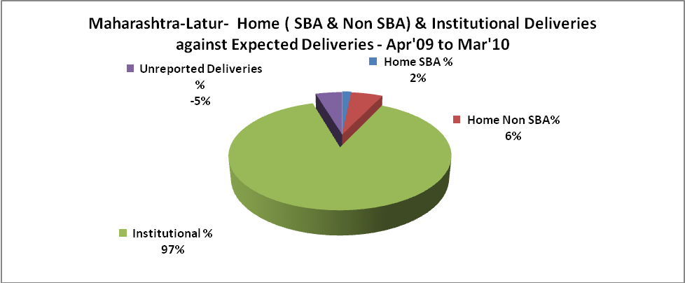

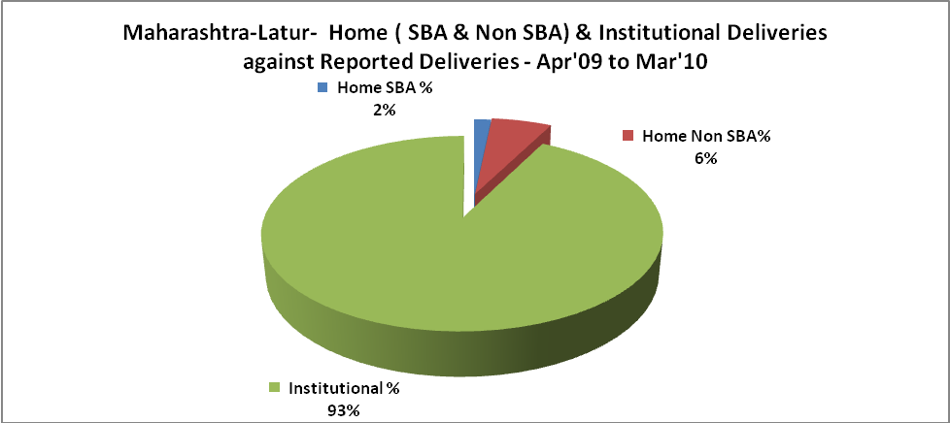

Maharashtra-Latur- C sections & Complicated Deliveries Apr'09 to Mar'10
 | Institutional Deliveries (Public) | Institutional Deliveries (Pvt)
 | 16,142 | 27,065
C Section | 321 | 472
C Section% | 2% | 2%
Complicated Pregnancies attended | 1,604 | 214
Complicated Pregnancies attended % | 10% | 1%

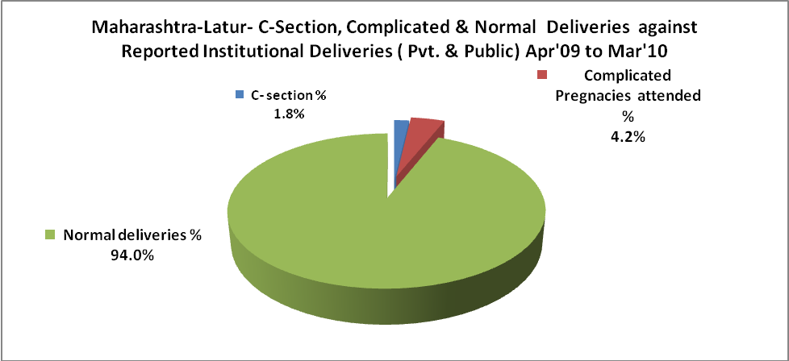

Maharashtra-Latur- Complicated Pregnancies & Deliveries Treated - Apr'09 to Mar'10
Reported Deliveries |  |  | Reported ANC Registration
46,709 |  |  | 52,074
Complicated Pregnancies attended | Complicated Pregnancies Rate | C - Section Deliveries | PNC Maternal Complications | Abortions | Still Births
1,818 | 4% | 793 | - | 1,529 | 355
Complicated Deliveries Treated with |  |  |  | No Of Eclampsia cases Treated | No Of severe anemia cases treated
IV Antibiotics | IV antihypertensive/Magsulph injection | IV Oxytocis | Blood Transfusion | No Of Eclampsia cases Treated | No Of severe anemia cases treated
- | - | - | - | - | -

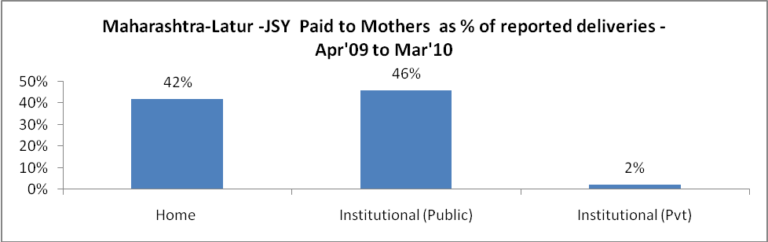

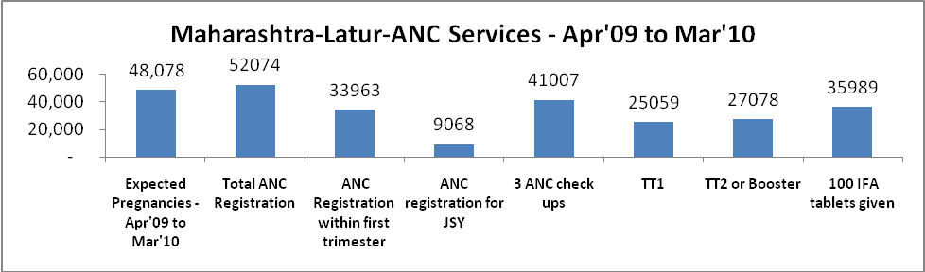

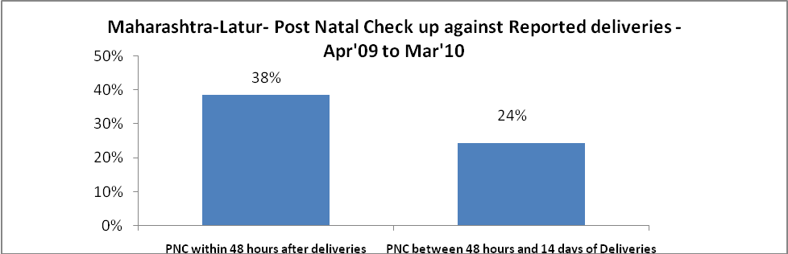

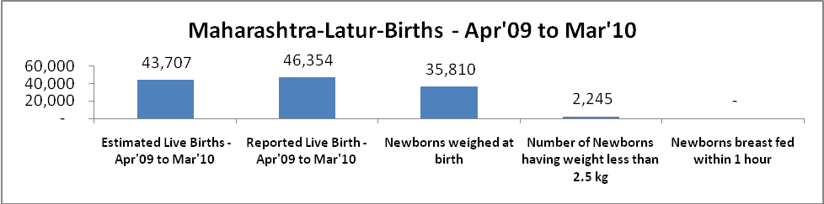

Maharashtra-Latur - Births - Apr'09 to Mar'10
Live Birth - Males | Live Birth - females | Live Birth - Total | Sex Ratio at birth | Still Birth | Abortion( Induced/Spontaneous
24,826 | 21,528 | 46,354 | 867 | 355 | 1,529

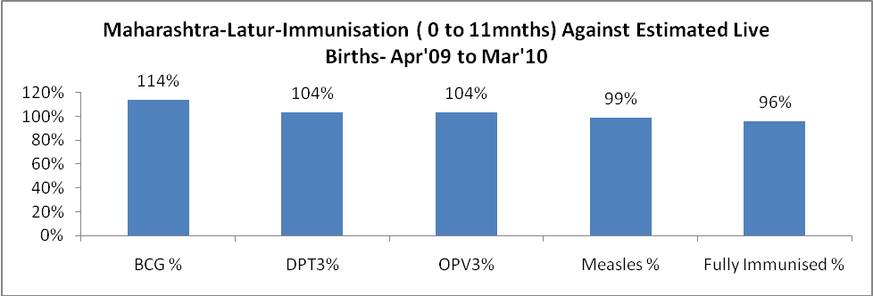

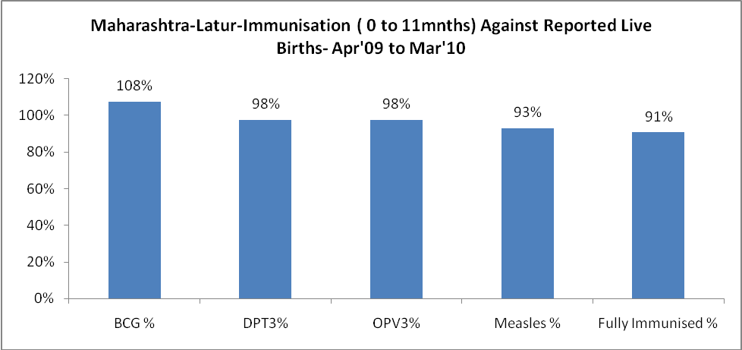

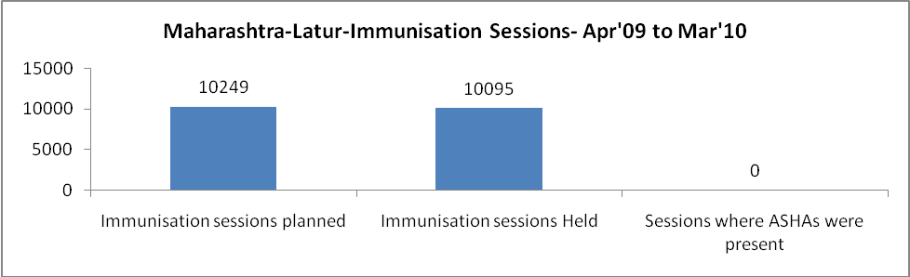

Maharashtra-Latur- Apr'09 to Mar'10
Total Abortions | Abortion Rate
2,068 | 4.3%

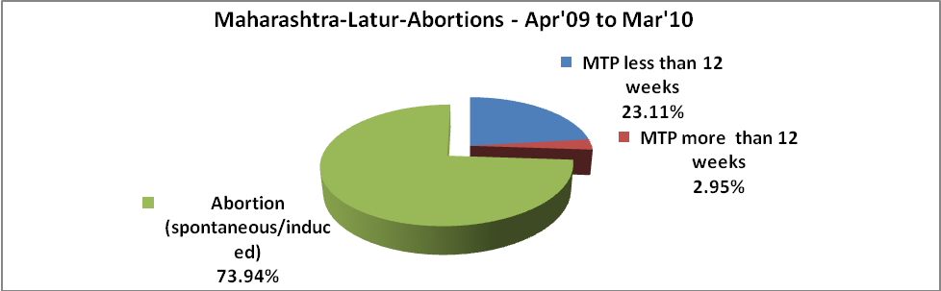

Maharashtra-Latur- Apr'09 to Mar'10
Total OPD | Total RTI/STI cases
223,153 | 5,548

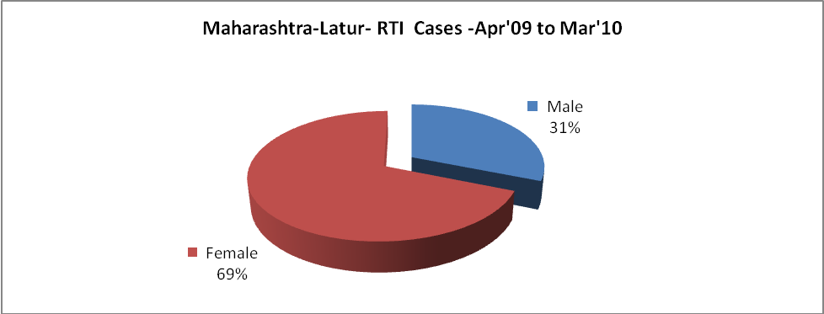

Maharashtra-Latur-Sterilizations - Apr'09 to Mar'10
 | Reported | %age of Reported Sterilization
Total Sterilization | 15,026 | -
NSV | 214 | 1%
Laproscopic | 5,567 | 37%
MiniLap | 8,565 | 57%
Post Partum | 680 | 5%
Male Sterilization | 214 | 1%
Female Sterilization | 14,812 | 99%

Maharashtra-Latur-FP Methods - Apr'09 to Mar'10
 | Reported | %age of All Reported FP Methods
Total Reported FP Methodd (All types) Users | 39,834 | -
Sterilizations | 15,026 | 38%
IUD | 8,431 | 21%
Condom Users | 10,406 | 26%
OCP Users | 5,972 | 15%
Limiting Methods | 15,026 | 38%
Spacing Methods | 24,808 | 62%

Maharashtra-Latur- Service Delivery - Apr'09 to Mar'10
Operation major (General and spinal anaesthesia) | Operation minor (No or local anaesthesia) | AYUSH | Dental Procedures | Adolescent counselling services | Total OPD | Total IPD
158 | 535 | - | - | - | 223,153 | -
Operation major (General and spinal anaesthesia) as %ge of OPD | Operation minor (No or local anaesthesia)as %ge of OPD | AYUSH as %ge of OPD | Dental Procedures as %ge of OPD | Adolescent counselling services as %ge of OPD | IPD as percentage of OPD
0.1% | 0.2% | 0.0% | 0.0% | 0.0% | 0%

Maharashtra-Latur- Lab Services - Apr'09 to Mar'10
Total OPD | Total HB tested | Total HIV Tested | Total Population
223,153 | - | - | 2,441,741
HB test conducted as %age of OPD | HB<7gm as %age of HB tested | HIV test conducted as %age of OPD | HIV positive as %age of HIV tested | Blood Smear Examined as % of Population
0.0% | 0.0% | 0.0% | 0.0% | 6.9%

Maharashtra-Latur- Childhood Disease - Vaccine Preventable -Apr'09 to Mar'10
Diphtheria | Pertussis | Tetanus Neonatorum | Tetanus others | Polio | Measles
0 | 0 | 0 | 0 | 0 | 36
Maharashtra-Latur-Childhood Disease - Others - Apr'09 to Mar'10
Diarrhoea and dehydration | Malaria | Number admitted with Respiratory Infections
1,490 | 7 | 462

Maharashtra-Latur- Infant & Child Deaths - Apr'09 to Mar'10
Infant Deaths within 24 hrs of birth | Infant Deaths between 24hrs & under 1 week | Infant Deaths between 1 week & under 1 month | Child Deaths between 1 month & under 1 year | Child Deaths between 1yr under 5years | Total Deaths
147 | 233 | 82 | 139 | 81 | 682

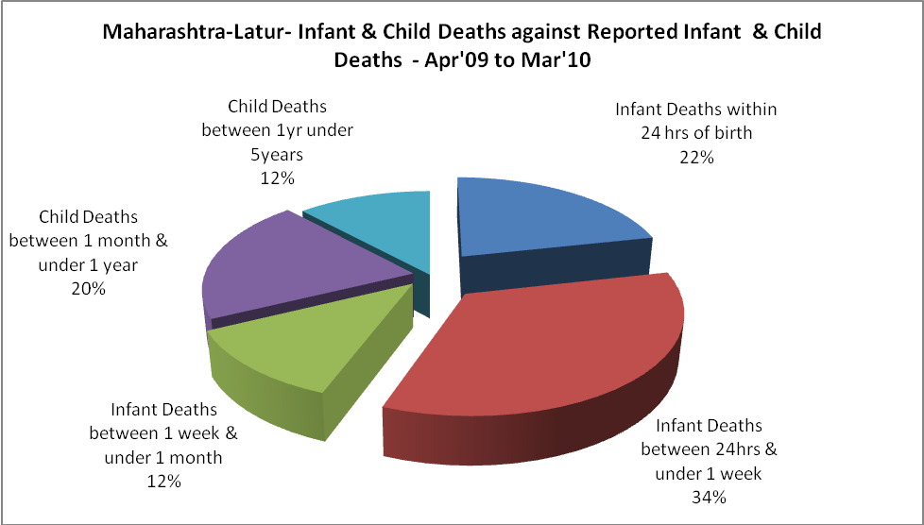

Maharashtra-Latur- Causes of Infant & Child Deaths - Apr'09 to Mar'10
Sepsis |  |  | Asphyxia |  |  | LBW
Up to 1 Weeks of Birth | Between 1 week & 4 weeks of birth | Total | Up to 1 Weeks of Birth | Between 1 week & 4 weeks of birth | Total | Up to 1 Weeks of Birth | Between 1 week & 4 weeks of birth | Total
0 | 0 | 0 | 0 | 0 | 0 | 0 | 0 | 0
Pneumonia |  |  | Diarrhoea |  |  | Fever related
Between 1 month and 11 months | Between 1 year & 5 years | Total | Between 1 month and 11 months | Between 1 year & 5 years | Total | Between 1 month and 11 months | Between 1 year & 5 years | Total
0 | 0 | 0 | 0 | 0 | 0 | 0 | 0 | 0
Others |  |  | Measles |  |  | Others
Up to 1 Weeks of Birth | Between 1 week & 4 weeks of birth | Total | Between 1 month and 11 months | Between 1 year & 5 years | Total | Between 1 month and 11 months | Between 1 year & 5 years | Total
233 | 82 | 315 | 0 | 0 | 0 | 139 | 81 | 220

Maharashtra-Latur- Maternal Deaths & Causes - Apr'09 to Mar'10
Abortion |  |  | Obstructed/prolonged labour |  |  | Severe hypertension/fits
6-14 yrs | 15-55 yrs. | Total | 6-14 yrs | 15-55 yrs. | Total | 6-14 yrs | 15-55 yrs. | Total
0 | 0 | 0 | 0 | 0 | 0 | 0 | 1 | 1
Bleeding |  |  | High Fever |  |  | Other Causes
6-14 yrs | 15-55 yrs. | Total | 6-14 yrs | 15-55 yrs. | Total | 6-14 yrs | 15-55 yrs. | Total
0 | 5 | 5 | 0 | 2 | 2 | 0 | 6 | 6

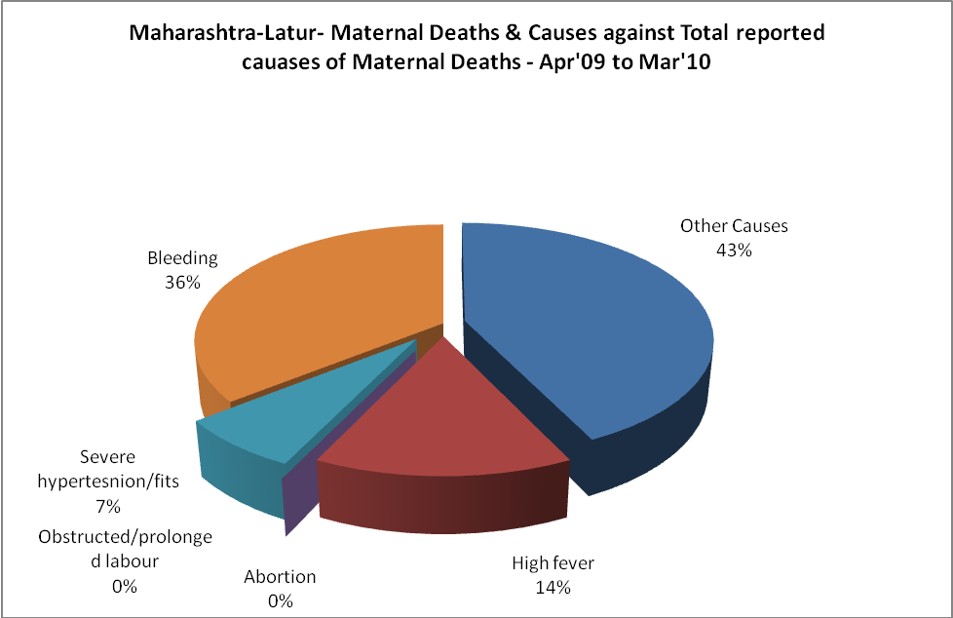

Maharashtra-Latur-Causes of Deaths in 6 to 55yrs age group - Apr'09 to Mar'10
Diarrhoel Diseases |  |  |  | Tuberculosis |  |  |  | Respiratory Diseases( Other than TB)
6-14 yrs | 15-55 yrs. | Above 55yrs | Total | 6-14 yrs | 15-55 yrs. | Above 55yrs | Total | 6-14 yrs | 15-55 yrs. | Above 55yrs | Total
0 | 0 | 0 | 0 | 0 | 0 | 0 | 0 | 0 | 0 | 0 | 0
Malaria |  |  |  | Other fever Related |  |  |  | HIV/Aids
6-14 yrs | 15-55 yrs. | Above 55yrs | Total | 6-14 yrs | 15-55 yrs. | Above 55yrs | Total | 6-14 yrs | 15-55 yrs. | Above 55yrs | Total
0 | 0 | 0 | 0 | 0 | 0 | 0 | 0 | 0 | 0 | 0 | 0
Heart Disease/Hypertension related |  |  |  | Neurological Disease including strokes |  |  |  | Trauma/Accidents/ Burn Cases
6-14 yrs | 15-55 yrs. | Above 55yrs | Total | 6-14 yrs | 15-55 yrs. | Above 55yrs | Total | 6-14 yrs | 15-55 yrs. | Above 55yrs | Total
0 | 0 | 0 | 0 | 0 | 0 | 0 | 0 | 0 | 0 | 0 | 0
Suicide |  |  |  | Animal Bites & Stings
6-14 yrs | 15-55 yrs. | Above 55yrs | Total | 6-14 yrs | 15-55 yrs. | Above 55yrs | Total
0 | 0 | 0 | 0 | 0 | 0 | 0 | 0

