[NHSRC]
Mizoram-Champhai
[ Analysis 2009-10]

MIZORAM- CHAMPHAI DIST.- Summary-Apr'09 to Mar'10
ANC
ANC Registration against Expected Pregnancies | 137% | TT1 given to Pregnant women against ANC Registraion | 51%
3 ANC Check ups against ANC Reigtrations | 91% | 100 IFA Tablets given to Pregnant women against ANC Registraion | 91%
Deliveries
Unreported Deliveries against Estimated Deliveries | -14.0% | HOME Deliveries( SBA& Non SBA) against Estimated Deliveries | 29.6%
Institutional Deliveries against Estimated Deliveries | 84.4% | HOME Deliveries( SBA& Non SBA) against Reported Deliveries | 25.9%
Institutional Deliveries against Reported Deliveries | 74.1% | C Section Deliveries against Institutional Deliveries( Pvt & Pub) | 4%
Births & Neonates Care
Live Births Reported against Estimated Live Births | 119% | New borns weighed against Reported Live Births | 97%
Still Births (Reported) | 21 | New borns weighed less than 2.5 kgs against newborns weighed | 1%
Sex Ratio at Birh | 1,044 | New borns breastfed within one hr of Birth against Reported live Births | 95%
Child Immunisation( 0 to 11 mnths)
BCG given against Expected Live Births | 122% | Measles given against Expected Live Births | 118%
OPV3 given against Expected Live Births | 129% | Fully Immunised Children against Expected Live Births | 115%
DPT3 given against Expected Live Births | 128%
Family Plannng
Family Plannig Methods Users ( Sterilisations(Male &Female)+IUD+ Condom pieces/72 + OCP Cycles/13) | 1,830 | IUD Insertions against reported FP Methods | 18%
Sterilisation against reported FP Methods | 10% | Condom Users against reported FP Methods | 24%
 |  | OCP Users against reported FP Methods | 48%
Other Services
OPD | 72,147 | Major Operations | 411
IPD | 12,034 | Minor Operations | 2,264

MIZORAM- CHAMPHAI DIST.- Deliveries Apr'09 to Mar'10
Total Population | 134,385 | Expected Deliveries |  | 2,436
Home SBA | Home Non SBA | Institutional | Total Deliveries Reported | Unreported Deliveries
402 | 318 | 2,057 | 2,777 | (341)
Home SBA % | Home Non SBA% | Institutional % | Total Deliveries Reported % | Unreported Deliveries %
17% | 13% | 84% | 114% | -14%

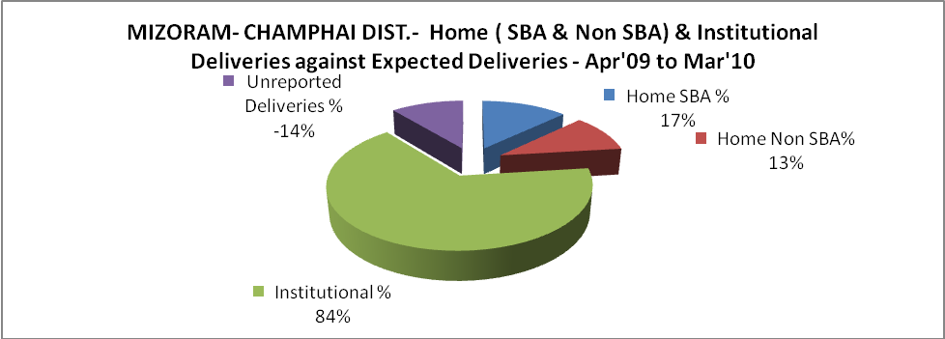

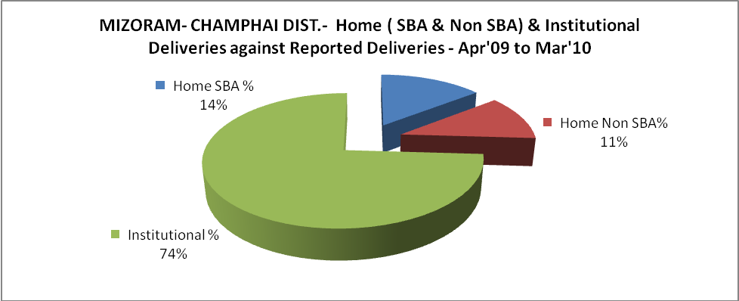

MIZORAM- CHAMPHAI DIST.- C sections & Complicated Deliveries Apr'09 to Mar'10
 | Institutional Deliveries (Public) | Institutional Deliveries (Pvt)
 | 2,057 | -
C Section | 89 | -
C Section% | 4% | #DIV/0!
Complicated Pregnacies attended | 14 | -
Complicated Pregnacies attended % | 1% | #DIV/0!

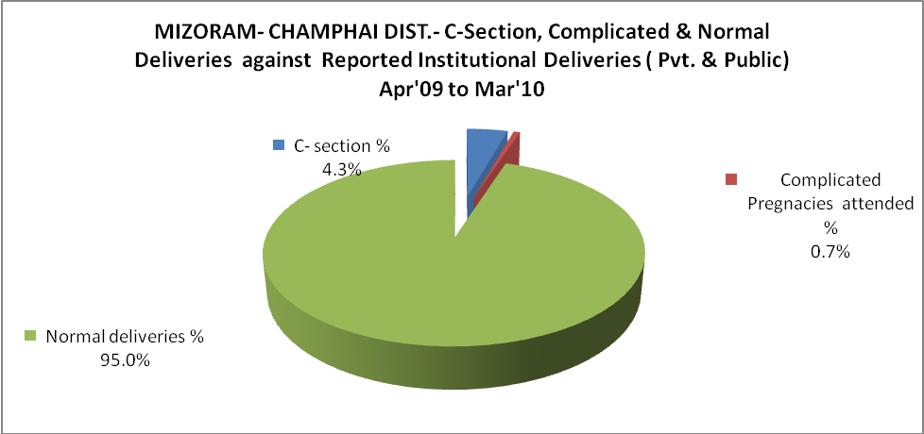

MIZORAM- CHAMPHAI DIST.- Complicated Pregnancies & Deliveries Treated - Apr'09 to Mar'10
Reported Deliveries |  |  | Reported ANC Reigtration
2,777 |  |  | 3,601
Complicated Pregnancies attended | Complicated Pregnancies Rate | C - Section Deliveries | PNC Maternal Complications | Abortions | Still Births
14 | 1% | 89 | 25 | 116 | 21
Complicated Deliveries Treated with |  |  |  | No Of Eclampsia cases Treated | No Of severe anemia cases treated
IV Antibiotics | IV antihypertensive/Magsulph injection | IV Oxytocis | Blood Transfusion | No Of Eclampsia cases Treated | No Of severe anemia cases treated
52 | 9 | 29 | - | - | -

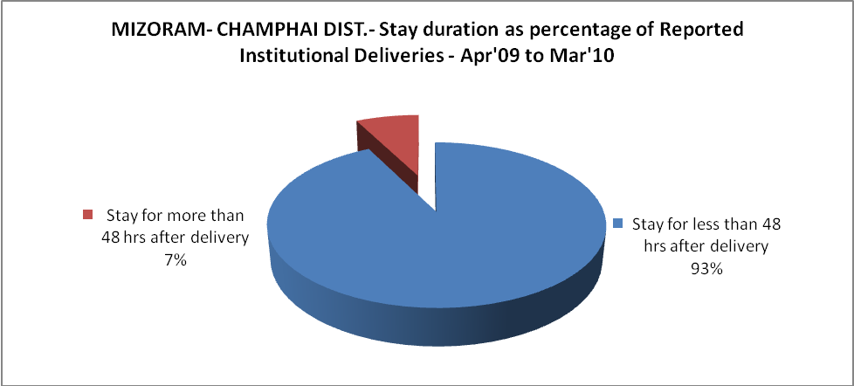

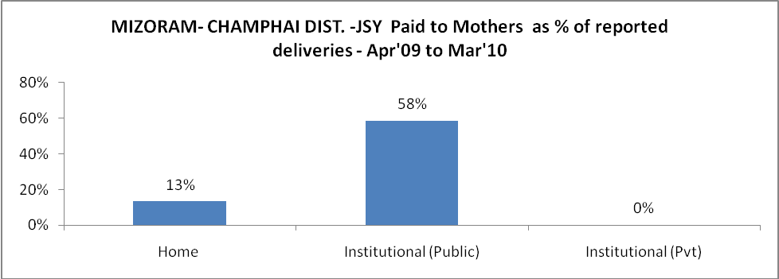

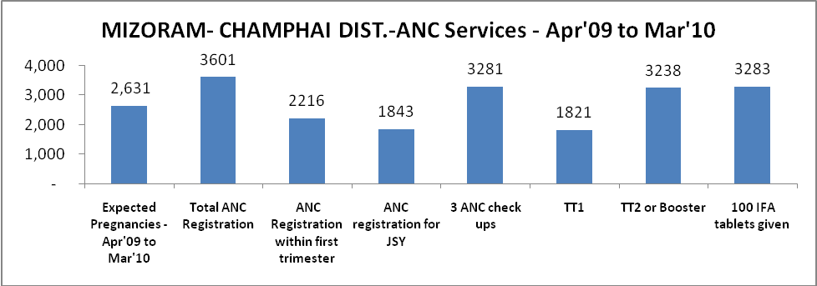

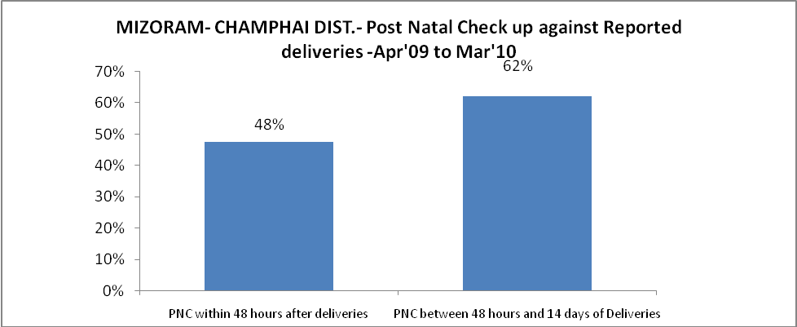

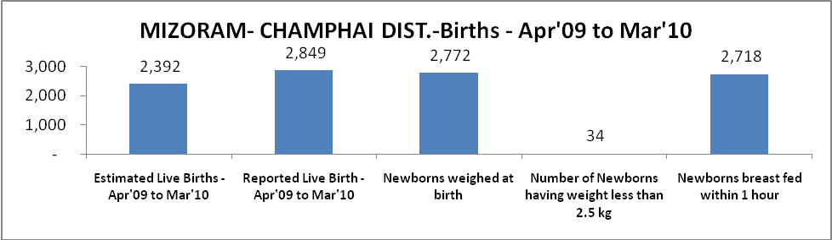

MIZORAM- CHAMPHAI DIST. - Births - Apr'09 to Mar'10
Live Birth - Males | Live Birth - females | Live Birth - Total | Sex Ratio at birth | Still Birth | Abortion( Induced/Spontaneous
1,394 | 1,455 | 2,849 | 1,044 | 21 | 116

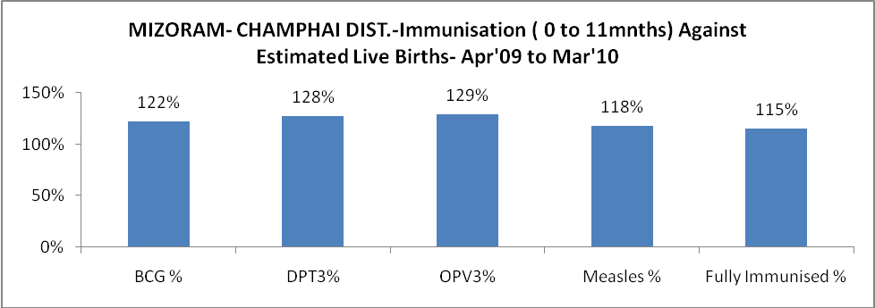

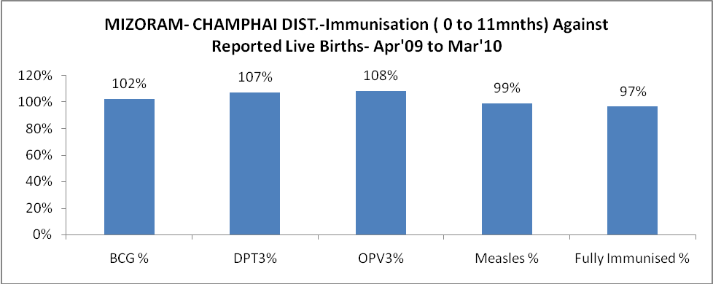

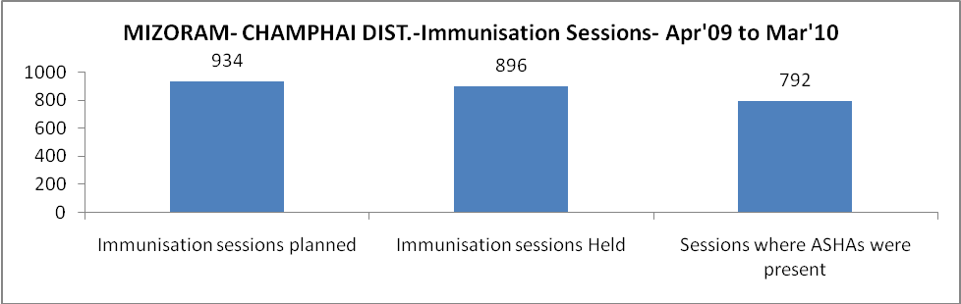

MIZORAM- CHAMPHAI DIST.- Apr'09 to Mar'10
Total Abortions | Abortion Rate
294 | 11.2%

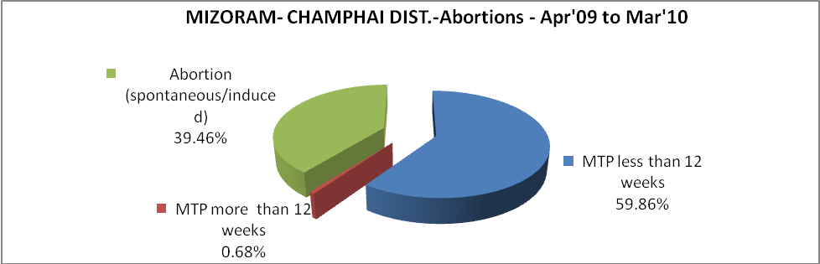

MIZORAM- CHAMPHAI DIST.- Apr'09 to Mar'10
Total OPD | Total RTI/STI cases
72,147 | 229

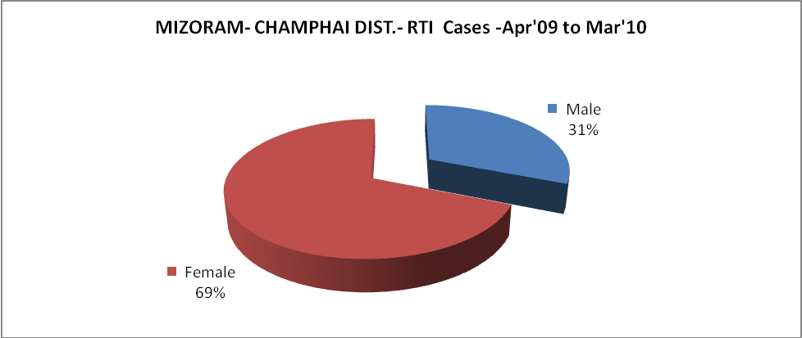

MIZORAM- CHAMPHAI DIST.-Sterilisations - Apr'09 to Mar'10
 | Reported | %age of Reported Sterilisation
Total Sterilisation | 184 | -
NSV | - | 0%
Laproscopic | 6 | 3%
MiniLap | 66 | 36%
Post Partum | 112 | 61%
Male Sterilisation | - | 0%
Female Sterilisation | 184 | 100%

MIZORAM- CHAMPHAI DIST.-FP Methods - Apr'09 to Mar'10
 | Reported | %age of All Reported FP Methods
Total Reported FP Methodd (All types) Users | 1,830 | -
Sterilisations | 184 | 10%
IUD | 321 | 18%
Condom Users | 443 | 24%
OCP Users | 882 | 48%
Limiting Methods | 184 | 10%
Spacing Methods | 1,646 | 90%

MIZORAM- CHAMPHAI DIST.- Service Delivery - Apr'09 to Mar'10
Operation major (General and spinal anaesthesia) | Operation minor (No or local anaesthesia) | AYUSH | Dental Procedures | Adolescent counselling services | Total OPD | Total IPD
411 | 2,264 | 2,704 | 4,734 | 824 | 72,147 | 12,034
Operation major (General and spinal anaesthesia) as %ge of OPD | Operation minor (No or local anaesthesia)as %ge of OPD | AYUSH as %ge of OPD | Dental Procedures as %ge of OPD | Adolescent counselling services as %ge of OPD | IPD as percentage of OPD
0.6% | 3.1% | 3.7% | 6.6% | 1.1% | 17%

MIZORAM- CHAMPHAI DIST.- Lab Services - Apr'09 to Mar'10
Total OPD | Total HB tested | Total HIV Tested | Total Population
72,147 | 3,008 | 5,444 | 134,385
HB test conducted as %age of OPD | HB<7gm as %age of HB tested | HIV test conducted as %age of OPD | HIV positive as %age of HIV tested | Blood Smear Examined as % of Population
4.2% | 3.4% | 7.5% | 2.8% | 9.8%

MIZORAM- CHAMPHAI DIST.- Childhood Disease - Vaccine Preventable -Apr'09 to Mar'10
Diphtheria | Pertussis | Tetanus Neonatorum | Tetanus others | Polio | Measles
0 | 0 | 0 | 0 | 0 | 76
MIZORAM- CHAMPHAI DIST.-Childhood Disease - Others - Apr'09 to Mar'10
Diarrhoea and dehydration | Malaria | Number admitted with Respiratory Infections
1,540 | 407 | 384

MIZORAM- CHAMPHAI DIST.- Infant & Child Deaths - Apr'09 to Mar'10
Infant Deaths within 24 hrs of birth | Infant Deaths between 24hrs & under 1 week | Infant Deaths between 1 week & under 1 month | Child Deaths between 1 month & under 1 year | Child Deaths between 1yr under 5years | Total Deaths
6 | 17 | 2 | 50 | 23 | 98

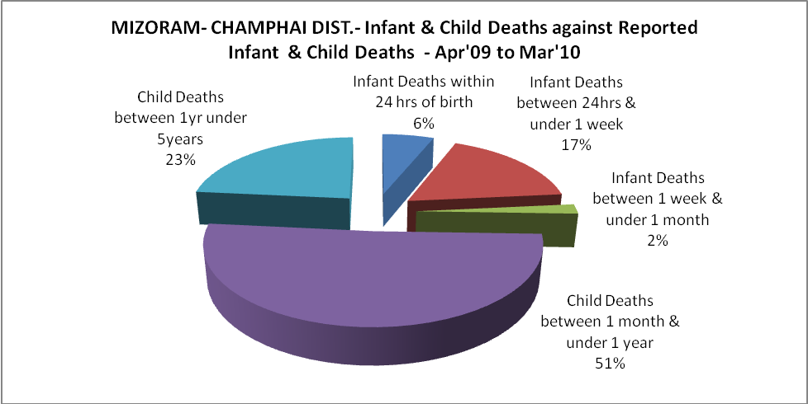

MIZORAM- CHAMPHAI DIST.- Causes of Infant & Child Deaths - Apr'09 to Mar'10
Sepsis |  |  | Asphyxia |  |  | LBW
Up to 1 Weeks of Birth | Between 1 week & 4 weeks of birth | Total | Up to 1 Weeks of Birth | Between 1 week & 4 weeks of birth | Total | Up to 1 Weeks of Birth | Between 1 week & 4 weeks of birth | Total
5 | 0 | 5 | 2 | 0 | 2 | 0 | 0 | 0
Pneumonia |  |  | Diarrhoea |  |  | Fever related
Between 1 month and 11 months | Between 1 year & 5 years | Total | Between 1 month and 11 months | Between 1 year & 5 years | Total | Between 1 month and 11 months | Between 1 year & 5 years | Total
19 | 4 | 23 | 6 | 3 | 9 | 9 | 4 | 13
Others |  |  | Measles |  |  | Others
Up to 1 Weeks of Birth | Between 1 week & 4 weeks of birth | Total | Between 1 month and 11 months | Between 1 year & 5 years | Total | Between 1 month and 11 months | Between 1 year & 5 years | Total
10 | 2 | 12 | 0 | 0 | 0 | 16 | 12 | 28

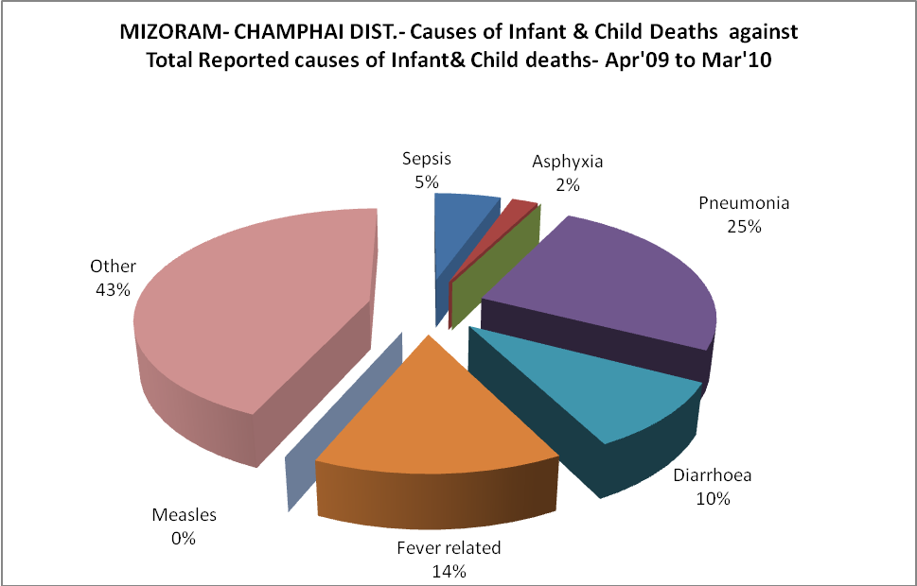

MIZORAM- CHAMPHAI DIST.- Maternal Deaths & Causes - Apr'09 to Mar'10
Abortion |  |  | Obstructed/prolonged labour |  |  | Severe hypertesnion/fits
6-14 yrs | 15-55 yrs. | Total | 6-14 yrs | 15-55 yrs. | Total | 6-14 yrs | 15-55 yrs. | Total
0 | 0 | 0 | 0 | 0 | 0 | 0 | 0 | 0
Bleeding |  |  | High Fever |  |  | Other Causes
6-14 yrs | 15-55 yrs. | Total | 6-14 yrs | 15-55 yrs. | Total | 6-14 yrs | 15-55 yrs. | Total
0 | 0 | 0 | 0 | 0 | 0 | 0 | 0 | 0

MIZORAM- CHAMPHAI DIST.-Causes of Deaths in 6 to 55yrs age group - Apr'09 to Mar'10
Diarrhoel Diseases |  |  |  | Tuberculosis |  |  |  | Respiratory Diseases( Other than TB)
6-14 yrs | 15-55 yrs. | Above 55yrs | Total | 6-14 yrs | 15-55 yrs. | Above 55yrs | Total | 6-14 yrs | 15-55 yrs. | Above 55yrs | Total
0 | 1 | 0 | 1 | 0 | 7 | 5 | 12 | 0 | 5 | 39 | 44
Malaria |  |  |  | Other fever Related |  |  |  | HIV/Aids
6-14 yrs | 15-55 yrs. | Above 55yrs | Total | 6-14 yrs | 15-55 yrs. | Above 55yrs | Total | 6-14 yrs | 15-55 yrs. | Above 55yrs | Total
0 | 4 | 2 | 6 | 2 | 32 | 42 | 76 | 0 | 1 | 0 | 1
Heart Disease/Hypertenion related |  |  |  | Neurological Disease including strokes |  |  |  | Trauma/Accidents/ Burn Cases
6-14 yrs | 15-55 yrs. | Above 55yrs | Total | 6-14 yrs | 15-55 yrs. | Above 55yrs | Total | 6-14 yrs | 15-55 yrs. | Above 55yrs | Total
1 | 11 | 22 | 34 | 0 | 4 | 1 | 5 | 2 | 25 | 2 | 29
Suicide |  |  |  | Animal Bites & Stings
6-14 yrs | 15-55 yrs. | Above 55yrs | Total | 6-14 yrs | 15-55 yrs. | Above 55yrs | Total
0 | 5 | 1 | 6 | 0 | 0 | 0 | 0

