[NHSRC]
MP- Damoh
[ Analysis 2009-10]

MADHYA PRADESH- DAMOH Dist.- Summary-Apr'09 to Mar'10
ANC
ANC Registration against Expected Pregnancies | 98% | TT1 given to Pregnant women against ANC Registraion | 52%
3 ANC Check ups against ANC Reigtrations | 69% | 100 IFA Tablets given to Pregnant women against ANC Registraion | 65%
Deliveries
Unreported Deliveries against Estimated Deliveries | 26.4% | HOME Deliveries( SBA& Non SBA) against Estimated Deliveries | 23.7%
Institutional Deliveries against Estimated Deliveries | 49.9% | HOME Deliveries( SBA& Non SBA) against Reported Deliveries | 32.2%
Institutional Deliveries against Reported Deliveries | 67.8% | C Section Deliveries against Institutional Deliveries( Pvt & Pub) | 2%
Births & Neonates Care
Live Births Reported against Estimated Live Births | 76% | New borns weighed against Reported Live Births | 80%
Still Births (Reported) | 588 | New borns weighed less than 2.5 kgs against newborns weighed | 19%
Sex Ratio at Birh | 929 | New borns breastfed within one hr of Birth against Reported live Births | 61%
Child Immunisation( 0 to 11 mnths)
BCG given against Expected Live Births | 92% | Measles given against Expected Live Births | 89%
OPV3 given against Expected Live Births | 84% | Fully Immunised Children against Expected Live Births | 84%
DPT3 given against Expected Live Births | 84%
Family Planning
Family Plannig Methods Users ( Sterilisations(Male &Female)+IUD+ Condom pieces/72 + OCP Cycles/13) | 25,524 | IUD Insertions against reported FP Methods | 39%
Sterilisation against reported FP Methods | 33% | Condom Users against reported FP Methods | 25%
 |  | OCP Users against reported FP Methods | 3%
Other Services
OPD | 230,863 | Major Operations | 144
IPD | 44,989 | Minor Operations | 2,830

MADHYA PRADESH- DAMOH Dist.- Deliveries Apr'09 to Mar'10
Total Population | 1,288,407 | Expected Deliveries |  | 37,338
Home SBA | Home Non SBA | Institutional | Total Deliveries Reported | Unreported Deliveries
1,365 | 7,488 | 18,621 | 27,474 | 9,864
Home SBA % | Home Non SBA% | Institutional % | Total Deliveries Reported % | Unreported Deliveries %
4% | 20% | 50% | 74% | 26%

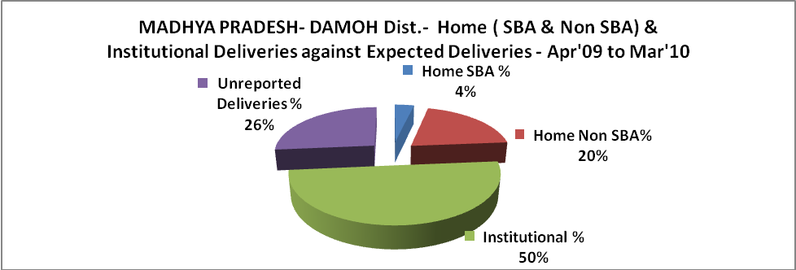

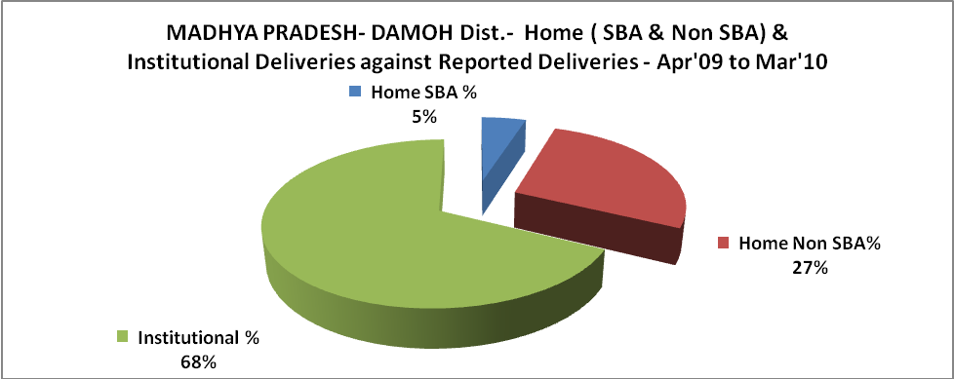

MADHYA PRADESH- DAMOH Dist.- C sections & Complicated Deliveries Apr'09 to Mar'10
 | Institutional Deliveries (Public) | Institutional Deliveries (Pvt)
 | 18,271 | 350
C Section | 348 | -
C Section% | 2% | 0%
Complicated Pregnacies attended | 720 | 14
Complicated Pregnacies attended % | 4% | 4%

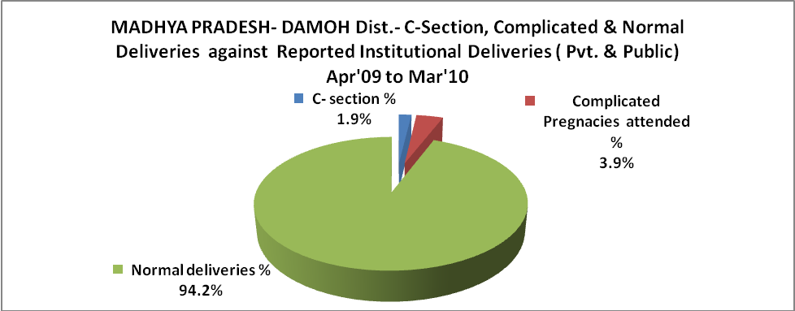

MADHYA PRADESH- DAMOH Dist.- Complicated Pregnancies & Deliveries Treated - Apr'09 to Mar'10
Reported Deliveries |  |  | Reported ANC Reigtration
27,474 |  |  | 38,788
Complicated Pregnancies attended | Complicated Pregnancies Rate | C - Section Deliveries | PNC Maternal Complications | Abortions | Still Births
734 | 2% | 348 | 814 | 252 | 588
Complicated Deliveries Treated with |  |  |  | No Of Eclampsia cases Treated | No Of severe anemia cases treated
IV Antibiotics | IV antihypertensive/Magsulph injection | IV Oxytocis | Blood Transfusion | No Of Eclampsia cases Treated | No Of severe anemia cases treated
382 | 282 | 300 | - | 12 | 870

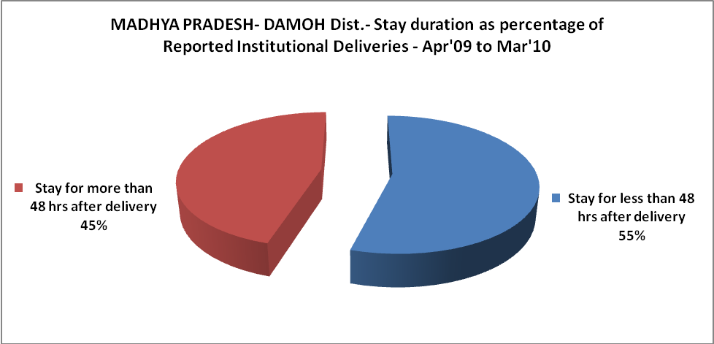

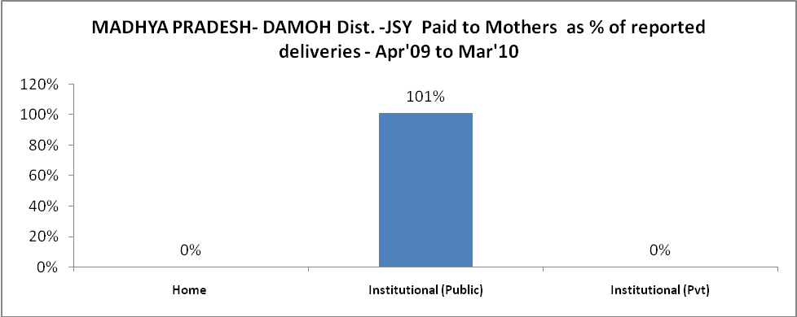

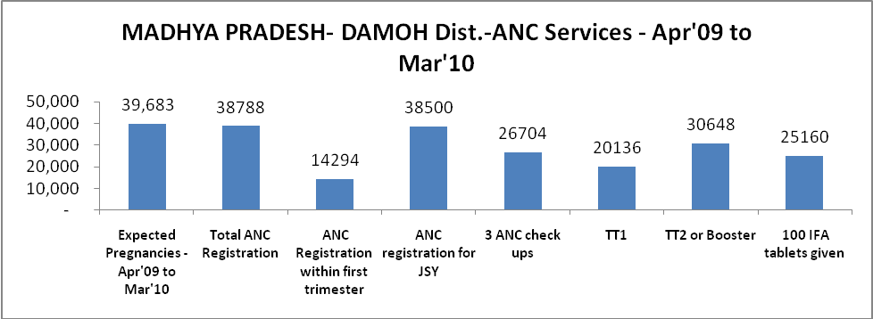

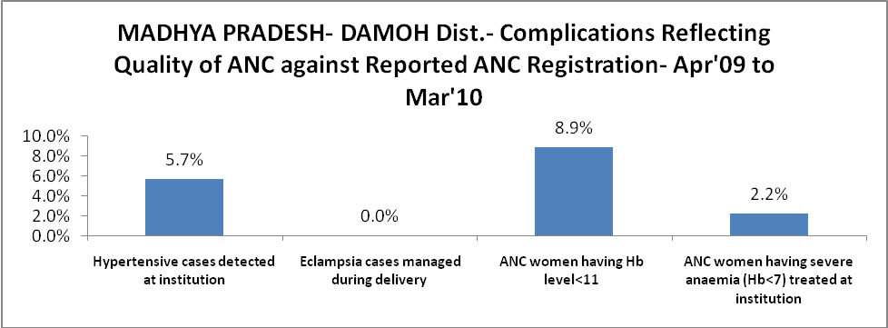

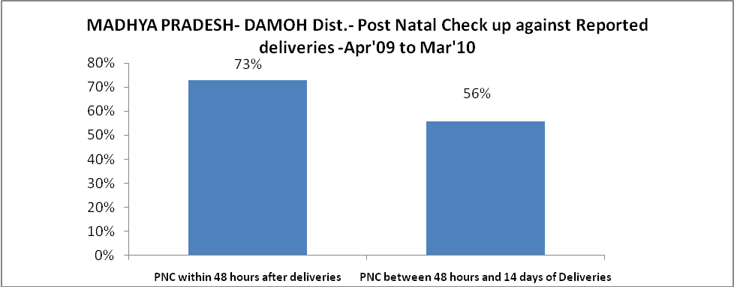

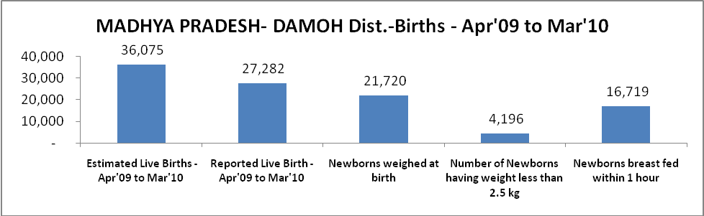

MADHYA PRADESH- DAMOH Dist. - Births - Apr'09 to Mar'10
Live Birth - Males | Live Birth - females | Live Birth - Total | Sex Ratio at birth | Still Birth | Abortion( Induced/Spontaneous
14,141 | 13,141 | 27,282 | 929 | 588 | 252

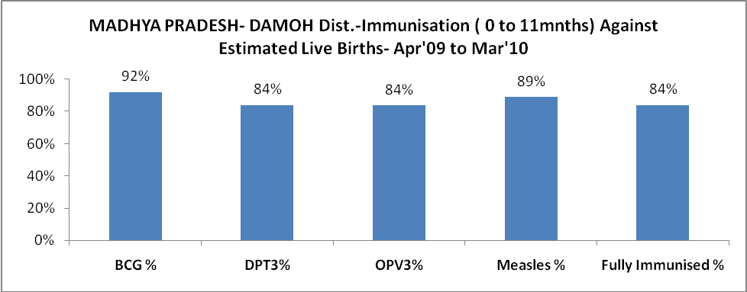

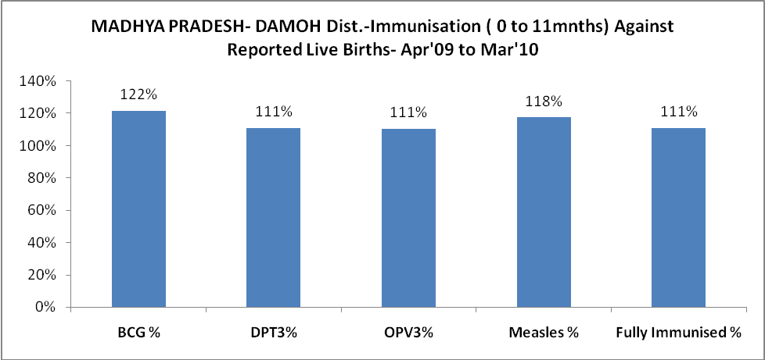

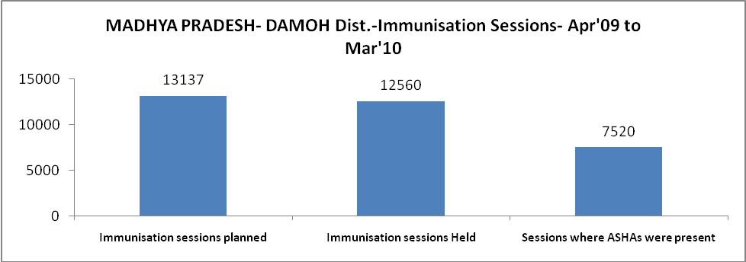

MADHYA PRADESH- DAMOH Dist.- Apr'09 to Mar'10
Total Abortions | Abortion Rate
513 | 1.3%

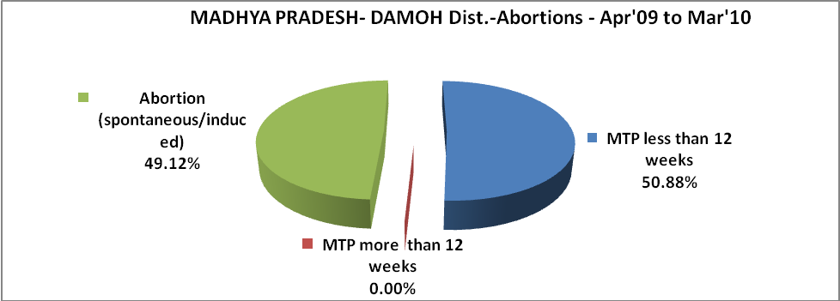

MADHYA PRADESH- DAMOH Dist.- Apr'09 to Mar'10
Total OPD | Total RTI/STI cases
230,863 | 4,201

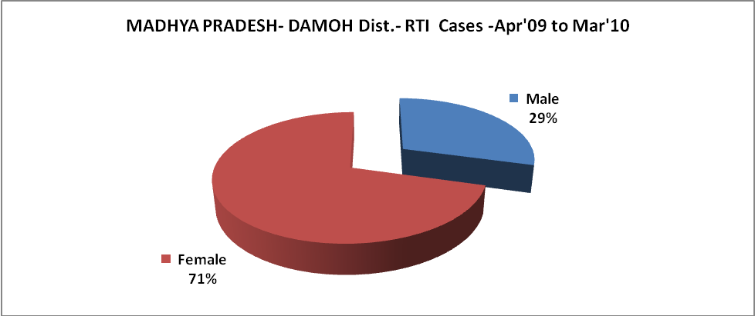

MADHYA PRADESH- DAMOH Dist.-Sterilisations - Apr'09 to Mar'10
 | Reported | %age of Reported Sterilisation
Total Sterilisation | 8,438 | -
NSV | 92 | 1%
Laproscopic | 8,116 | 96%
MiniLap | - | 0%
Post Partum | 230 | 3%
Male Sterilisation | 92 | 1%
Female Sterilisation | 8,346 | 99%

MADHYA PRADESH- DAMOH Dist.-FP Methods - Apr'09 to Mar'10
 | Reported | %age of All Reported FP Methods
Total Reported FP Methodd (All types) Users | 25,524 | -
Sterilisations | 8,438 | 33%
IUD | 10,007 | 39%
Condom Users | 6,411 | 25%
OCP Users | 668 | 3%
Limiting Methods | 8,438 | 33%
Spacing Methods | 17,086 | 67%

MADHYA PRADESH- DAMOH Dist.- Service Delivery - Apr'09 to Mar'10
Operation major (General and spinal anaesthesia) | Operation minor (No or local anaesthesia) | AYUSH | Dental Procedures | Adolescent counselling services | Total OPD | Total IPD
144 | 2,830 | - | 26 | - | 230,863 | 44,989
Operation major (General and spinal anaesthesia) as %ge of OPD | Operation minor (No or local anaesthesia)as %ge of OPD | AYUSH as %ge of OPD | Dental Procedures as %ge of OPD | Adolescent counselling services as %ge of OPD | IPD as percentage of OPD
0.1% | 1.2% | 0.0% | 0.0% | 0.0% | 19%

MADHYA PRADESH- DAMOH Dist.- Lab Services - Apr'09 to Mar'10
Total OPD | Total HB tested | Total HIV Tested | Total Population
230,863 | 7,258 | 2,355 | 1,288,407
HB test conducted as %age of OPD | HB<7gm as %age of HB tested | HIV test conducted as %age of OPD | HIV positive as %age of HIV tested | Blood Smear Examined as % of Population
3.1% | 5.1% | 1.0% | 0.0% | 4.3%

MADHYA PRADESH- DAMOH Dist.- Childhood Disease - Vaccine Preventable -Apr'09 to Mar'10
Diphtheria | Pertussis | Tetanus Neonatorum | Tetanus others | Polio | Measles
1 | 0 | 51 | 0 | 0 | 198
MADHYA PRADESH- DAMOH Dist.-Childhood Disease - Others - Apr'09 to Mar'10
Diarrhoea and dehydration | Malaria | Number admitted with Respiratory Infections
1,303 | 513 | 8

MADHYA PRADESH- DAMOH Dist.- Infant & Child Deaths - Apr'09 to Mar'10
Infant Deaths within 24 hrs of birth | Infant Deaths between 24hrs & under 1 week | Infant Deaths between 1 week & under 1 month | Child Deaths between 1 month & under 1 year | Child Deaths between 1yr under 5years | Total Deaths
0 | 144 | 62 | 58 | 91 | 355

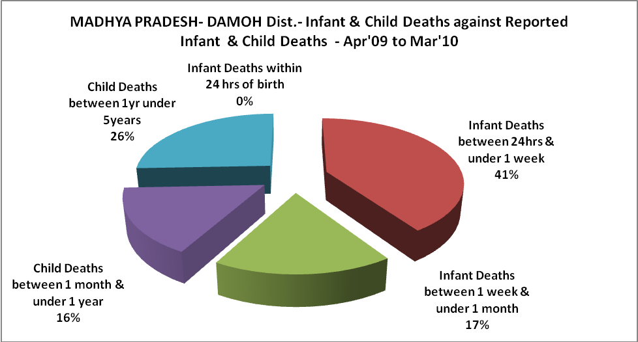

MADHYA PRADESH- DAMOH Dist.- Causes of Infant & Child Deaths - Apr'09 to Mar'10
Sepsis |  |  | Asphyxia |  |  | LBW
Up to 1 Weeks of Birth | Between 1 week & 4 weeks of birth | Total | Up to 1 Weeks of Birth | Between 1 week & 4 weeks of birth | Total | Up to 1 Weeks of Birth | Between 1 week & 4 weeks of birth | Total
21 | 13 | 34 | 15 | 7 | 22 | 33 | 14 | 47
Pneumonia |  |  | Diarrhoea |  |  | Fever related
Between 1 month and 11 months | Between 1 year & 5 years | Total | Between 1 month and 11 months | Between 1 year & 5 years | Total | Between 1 month and 11 months | Between 1 year & 5 years | Total
4 | 3 | 7 | 5 | 5 | 10 | 12 | 13 | 25
Others |  |  | Measles |  |  | Others
Up to 1 Weeks of Birth | Between 1 week & 4 weeks of birth | Total | Between 1 month and 11 months | Between 1 year & 5 years | Total | Between 1 month and 11 months | Between 1 year & 5 years | Total
75 | 28 | 103 | 0 | 1 | 1 | 37 | 69 | 106

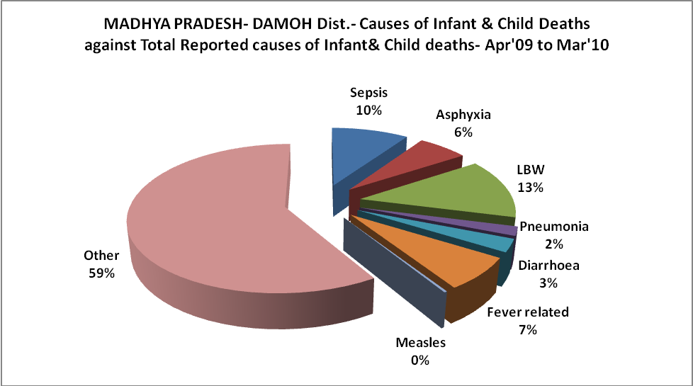

MADHYA PRADESH- DAMOH Dist.-Causes of Deaths in 6 to 55yrs age group - Apr'09 to Mar'10
Diarrhoel Diseases |  |  |  | Tuberculosis |  |  |  | Respiratory Diseases( Other than TB)
6-14 yrs | 15-55 yrs. | Above 55yrs | Total | 6-14 yrs | 15-55 yrs. | Above 55yrs | Total | 6-14 yrs | 15-55 yrs. | Above 55yrs | Total
0 | 16 | 9 | 25 | 9 | 80 | 103 | 192 | 3 | 20 | 21 | 44
Malaria |  |  |  | Other fever Related |  |  |  | HIV/Aids
6-14 yrs | 15-55 yrs. | Above 55yrs | Total | 6-14 yrs | 15-55 yrs. | Above 55yrs | Total | 6-14 yrs | 15-55 yrs. | Above 55yrs | Total
11 | 1 | 13 | 25 | 27 | 70 | 138 | 235 | 0 | 0 | 0 | 0
Heart Disease/Hypertenion related |  |  |  | Neurological Disease including strokes |  |  |  | Trauma/Accidents/ Burn Cases
6-14 yrs | 15-55 yrs. | Above 55yrs | Total | 6-14 yrs | 15-55 yrs. | Above 55yrs | Total | 6-14 yrs | 15-55 yrs. | Above 55yrs | Total
3 | 34 | 39 | 76 | 2 | 10 | 21 | 33 | 8 | 26 | 25 | 59
Suicide |  |  |  | Animal Bites & Stings
6-14 yrs | 15-55 yrs. | Above 55yrs | Total | 6-14 yrs | 15-55 yrs. | Above 55yrs | Total
1 | 44 | 8 | 53 | 1 | 10 | 1 | 12

