[NHSRC]
MP- Balaghat
[ Analysis 2009-10]

MADHYA PRADESH- BALAGHAT Dist.- Summary-Apr'09 to Mar'10
ANC
ANC Registration against Expected Pregnancies |  |  | 61% | TT1 given to Pregnant women against ANC Registraion |  |  |  | 85%
3 ANC Check ups against ANC Reigtrations |  |  | 84% | 100 IFA Tablets given to Pregnant women against ANC Registraion |  |  |  | 84%
Deliveries
Unreported Deliveries against Estimated Deliveries |  |  | 48.0% | HOME Deliveries( SBA& Non SBA) against Estimated Deliveries |  |  |  | 12.1%
Institutional Deliveries against Estimated Deliveries |  |  | 39.9% | HOME Deliveries( SBA& Non SBA) against Reported Deliveries |  |  |  | 23.2%
Institutional Deliveries against Reported Deliveries |  |  | 76.8% | C Section Deliveries against Institutional Deliveries( Pvt & Pub) |  |  |  | 13%
Births & Neonates Care
Live Births Reported against Estimated Live Births |  |  | 57% | New borns weighed against Reported Live Births |  |  |  | 99%
Still Births (Reported) |  |  | 858 | New borns weighed less than 2.5 kgs against newborns weighed |  |  |  | 9%
Sex Ratio at Birh |  |  | 973 | New borns breastfed within one hr of Birth against Reported live Births |  |  |  | 91%
Child Immunisation( 0 to 11 months)
BCG given against Expected Live Births |  |  | 62% | Measles given against Expected Live Births |  |  |  | 59%
OPV3 given against Expected Live Births |  |  | 62% | Fully Immunised Children against Expected Live Births |  |  |  | 59%
DPT3 given against Expected Live Births |  |  | 62%
Family Planning
Family Plannig Methods Users ( Sterilisations(Male &Female)+IUD+ Condom pieces/72 + OCP Cycles/13) |  |  | 30,704 | IUD Insertions against reported FP Methods |  |  |  | 6%
Sterilisation against reported FP Methods |  |  | 35% | Condom Users against reported FP Methods |  |  |  | 36%
 |  |  |  | OCP Users against reported FP Methods |  |  |  | 22%
Other Services
OPD |  |  | 204,737 | Major Operations |  |  |  | 1,829
IPD |  |  | 29,018 | Minor Operations |  |  |  | 5,857
MADHYA PRADESH- BALAGHAT Dist.- Deliveries Apr'09 to Mar'10
Total Population | 1,789,084 | Expected Deliveries |  |  |  | 51,848
Home SBA | Home Non SBA | Institutional |  |  | Total Deliveries Reported | Unreported Deliveries
- | 6,248 | 20,694 |  |  | 26,942 | 24,906
Home SBA % | Home Non SBA% | Institutional % |  |  | Total Deliveries Reported % | Unreported Deliveries %
0% | 12% | 40% |  |  | 52% | 48%

MADHYA PRADESH- BALAGHAT Dist.- C sections & Complicated Deliveries Apr'09 to Mar'10
 | Institutional Deliveries (Public) | Institutional Deliveries (Pvt)
 | 20,634 | 60
C Section | 1,796 | 791
C Section% | 9% | 1318%
Complicated Pregnacies attended | 1,915 | 9
Complicated Pregnacies attended % | 9% | 15%

MADHYA PRADESH- BALAGHAT Dist.- Complicated Pregnancies & Deliveries Treated - Apr'09 to Mar'10
Reported Deliveries |  |  | Reported ANC Reigtration
26,942 |  |  | 33,835
Complicated Pregnancies attended | Complicated Pregnancies Rate | C - Section Deliveries | PNC Maternal Complications | Abortions | Still Births
1,924 | 3% | 2,587 | 212 | 361 | 858
Complicated Deliveries Treated with |  |  |  | No Of Eclampsia cases Treated | No Of severe anemia cases treated
IV Antibiotics | IV antihypertensive/Magsulph injection | IV Oxytocis | Blood Transfusion | No Of Eclampsia cases Treated | No Of severe anemia cases treated
408 | 14 | 61 | 450 | 51 | 80

MADHYA PRADESH- BALAGHAT Dist. - Births - Apr'09 to Mar'10
Live Birth - Males | Live Birth - females | Live Birth - Total | Sex Ratio at birth | Still Birth | Abortion( Induced/Spontaneous
14,394 | 14,003 | 28,397 | 973 | 858 | 361

MADHYA PRADESH- BALAGHAT Dist.- Apr'09 to Mar'10
Total Abortions | Abortion Rate
498 | 0.9%

MADHYA PRADESH- BALAGHAT Dist.- Apr'09 to Mar'10
Total OPD | Total RTI/STI cases
204,737 | 1,910

MADHYA PRADESH- BALAGHAT Dist.-Sterilisations - Apr'09 to Mar'10
 | Reported | %age of Reported Sterilisation
Total Sterilisation | 10,860 | -
NSV | 970 | 9%
Laproscopic | 8,983 | 83%
MiniLap | 740 | 7%
Post Partum | 167 | 2%
Male Sterilisation | 970 | 9%
Female Sterilisation | 9,890 | 91%

MADHYA PRADESH- BALAGHAT Dist.-FP Methods - Apr'09 to Mar'10
 | Reported | %age of All Reported FP Methods
Total Reported FP Methodd (All types) Users | 30,704 | -
Sterilisations | 10,860 | 35%
IUD | 1,876 | 6%
Condom Users | 11,091 | 36%
OCP Users | 6,878 | 22%
Limiting Methods | 10,860 | 35%
Spacing Methods | 19,844 | 65%

MADHYA PRADESH- BALAGHAT Dist.- Service Delivery - Apr'09 to Mar'10
Operation major (General and spinal anaesthesia) | Operation minor (No or local anaesthesia) | AYUSH | Dental Procedures | Adolescent counselling services | Total OPD | Total IPD
1,829 | 5,857 | 6,747 | - | 294 | 204,737 | 29,018
Operation major (General and spinal anaesthesia) as %ge of OPD | Operation minor (No or local anaesthesia)as %ge of OPD | AYUSH as %ge of OPD | Dental Procedures as %ge of OPD | Adolescent counselling services as %ge of OPD | IPD as percentage of OPD
0.9% | 2.9% | 3.3% | 0.0% | 0.1% | 14%

MADHYA PRADESH- BALAGHAT Dist.- Lab Services - Apr'09 to Mar'10
Total OPD | Total HB tested | Total HIV Tested | Total Population
204,737 | 6,808 | 2,077 | 1,789,084
HB test conducted as %age of OPD | HB<7gm as %age of HB tested | HIV test conducted as %age of OPD | HIV positive as %age of HIV tested | Blood Smear Examined as % of Population
3.3% | 10.4% | 1.0% | 0.5% | 5.8%

MADHYA PRADESH- BALAGHAT Dist.- Childhood Disease - Vaccine Preventable -Apr'09 to Mar'10
Diphtheria | Pertussis | Tetanus Neonatorum | Tetanus others | Polio | Measles
0 | 0 | 0 | 0 | 0 | 140
MADHYA PRADESH- BALAGHAT Dist.-Childhood Disease - Others - Apr'09 to Mar'10
Diarrhoea and dehydration | Malaria | Number admitted with Respiratory Infections
3,988 | 686 | 941

MADHYA PRADESH- BALAGHAT Dist.- Infant & Child Deaths - Apr'09 to Mar'10
Infant Deaths within 24 hrs of birth | Infant Deaths between 24hrs & under 1 week | Infant Deaths between 1 week & under 1 month | Child Deaths between 1 month & under 1 year | Child Deaths between 1yr under 5years | Total Deaths
92 | 422 | 150 | 175 | 228 | 1067

MADHYA PRADESH- BALAGHAT Dist.- Causes of Infant & Child Deaths - Apr'09 to Mar'10
Sepsis |  |  | Asphyxia |  |  | LBW
Up to 1 Weeks of Birth | Between 1 week & 4 weeks of birth | Total | Up to 1 Weeks of Birth | Between 1 week & 4 weeks of birth | Total | Up to 1 Weeks of Birth | Between 1 week & 4 weeks of birth | Total
17 | 5 | 22 | 9 | 1 | 10 | 95 | 15 | 110
Pneumonia |  |  | Diarrhoea |  |  | Fever related
Between 1 month and 11 months | Between 1 year & 5 years | Total | Between 1 month and 11 months | Between 1 year & 5 years | Total | Between 1 month and 11 months | Between 1 year & 5 years | Total
5 | 4 | 9 | 0 | 4 | 4 | 10 | 8 | 18
Others |  |  | Measles |  |  | Others
Up to 1 Weeks of Birth | Between 1 week & 4 weeks of birth | Total | Between 1 month and 11 months | Between 1 year & 5 years | Total | Between 1 month and 11 months | Between 1 year & 5 years | Total
301 | 129 | 430 | 0 | 0 | 0 | 160 | 212 | 372

MADHYA PRADESH- BALAGHAT Dist.- Maternal Deaths & Causes - Apr'09 to Mar'10
Abortion |  |  | Obstructed/prolonged labour |  |  | Severe hypertesnion/fits
6-14 yrs | 15-55 yrs. | Total | 6-14 yrs | 15-55 yrs. | Total | 6-14 yrs | 15-55 yrs. | Total
0 | 0 | 0 | 0 | 4 | 4 | 0 | 2 | 2
Bleeding |  |  | High Fever |  |  | Other Causes
6-14 yrs | 15-55 yrs. | Total | 6-14 yrs | 15-55 yrs. | Total | 6-14 yrs | 15-55 yrs. | Total
0 | 0 | 0 | 0 | 0 | 0 | 0 | 3 | 3

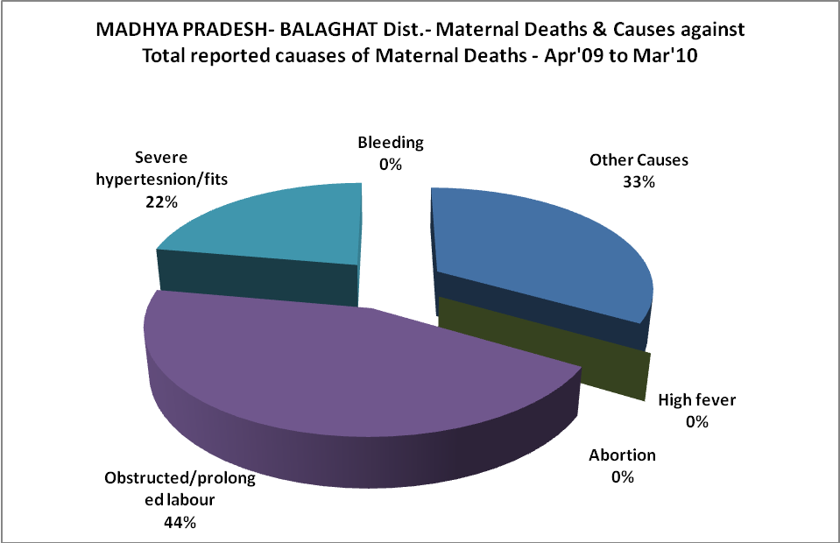

MADHYA PRADESH- BALAGHAT Dist.-Causes of Deaths in 6 to 55yrs age group - Apr'09 to Mar'10
Diarrhoel Diseases |  |  |  | Tuberculosis |  |  |  | Respiratory Diseases( Other than TB)
6-14 yrs | 15-55 yrs. | Above 55yrs | Total | 6-14 yrs | 15-55 yrs. | Above 55yrs | Total | 6-14 yrs | 15-55 yrs. | Above 55yrs | Total
4 | 12 | 3 | 19 | 1 | 1 | 2 | 4 | 0 | 1 | 1 | 2
Malaria |  |  |  | Other fever Related |  |  |  | HIV/Aids
6-14 yrs | 15-55 yrs. | Above 55yrs | Total | 6-14 yrs | 15-55 yrs. | Above 55yrs | Total | 6-14 yrs | 15-55 yrs. | Above 55yrs | Total
0 | 3 | 10 | 13 | 44 | 175 | 242 | 461 | 0 | 0 | 0 | 0
Heart Disease/Hypertenion related |  |  |  | Neurological Disease including strokes |  |  |  | Trauma/Accidents/ Burn Cases
6-14 yrs | 15-55 yrs. | Above 55yrs | Total | 6-14 yrs | 15-55 yrs. | Above 55yrs | Total | 6-14 yrs | 15-55 yrs. | Above 55yrs | Total
3 | 38 | 56 | 97 | 2 | 16 | 29 | 47 | 0 | 6 | 3 | 9
Suicide |  |  |  | Animal Bites & Stings
6-14 yrs | 15-55 yrs. | Above 55yrs | Total | 6-14 yrs | 15-55 yrs. | Above 55yrs | Total
0 | 6 | 2 | 8 | 0 | 5 | 6 | 11

