[NHSRC]
MP- Chhindwara
[ Analysis 2009-10]

MADHYA PRADESH- CHHINDWARA Dist.- Summary-Apr'09 to Mar'10
ANC
ANC Registration against Expected Pregnancies | 82% | TT1 given to Pregnant women against ANC Registraion | 65%
3 ANC Check ups against ANC Reigtrations | 71% | 100 IFA Tablets given to Pregnant women against ANC Registraion | 71%
Deliveries
Unreported Deliveries against Estimated Deliveries | 36.0% | HOME Deliveries( SBA& Non SBA) against Estimated Deliveries | 3.9%
Institutional Deliveries against Estimated Deliveries | 60.1% | HOME Deliveries( SBA& Non SBA) against Reported Deliveries | 6.1%
Institutional Deliveries against Reported Deliveries | 93.9% | C Section Deliveries against Institutional Deliveries( Pvt & Pub) | 4%
Births & Neonates Care
Live Births Reported against Estimated Live Births | 62% | New borns weighed against Reported Live Births | 62%
Still Births (Reported) | 2,372 | New borns weighed less than 2.5 kgs against newborns weighed | 45%
Sex Ratio at Birh | 934 | New borns breastfed within one hr of Birth against Reported live Births | 64%
Child Immunisation( 0 to 11 mnths)
BCG given against Expected Live Births | 62% | Measles given against Expected Live Births | 74%
OPV3 given against Expected Live Births | 59% | Fully Immunised Children against Expected Live Births | 72%
DPT3 given against Expected Live Births | 61%
Family Planning
Family Plannig Methods Users ( Sterilisations(Male &Female)+IUD+ Condom pieces/72 + OCP Cycles/13) | 55,601 | IUD Insertions against reported FP Methods | 16%
Sterilisation against reported FP Methods | 18% | Condom Users against reported FP Methods | 37%
 |  | OCP Users against reported FP Methods | 30%
Other Services
OPD | 1,112,970 | Major Operations | 1,345
IPD | 80,515 | Minor Operations | 1,166

MADHYA PRADESH- CHHINDWARA Dist.- Deliveries Apr'09 to Mar'10
Total Population | 2,197,577 | Expected Deliveries |  | 63,686
Home SBA | Home Non SBA | Institutional | Total Deliveries Reported | Unreported Deliveries
770 | 1,706 | 38,272 | 40,748 | 22,938
Home SBA % | Home Non SBA% | Institutional % | Total Deliveries Reported % | Unreported Deliveries %
1% | 3% | 60% | 64% | 36%

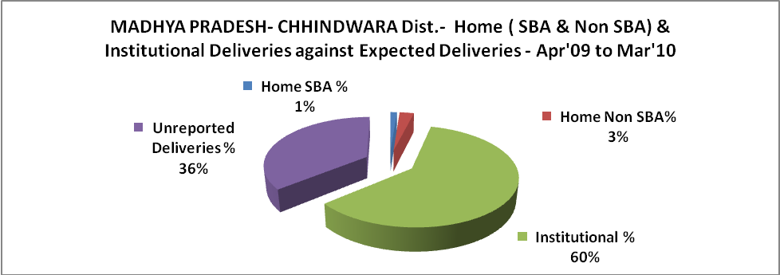

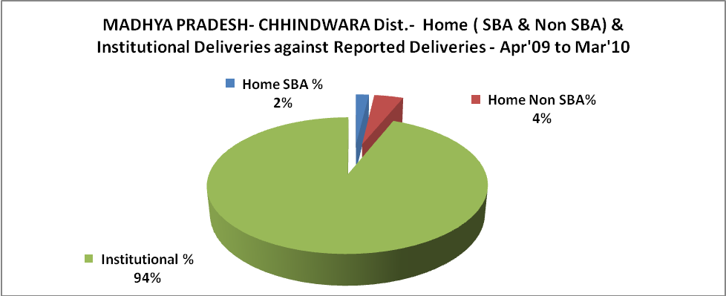

MADHYA PRADESH- CHHINDWARA Dist.- C sections & Complicated Deliveries Apr'09 to Mar'10
 | Institutional Deliveries (Public) | Institutional Deliveries (Pvt)
 | 38,272 | -
C Section | 1,395 | -
C Section% | 4% | -
Complicated Pregnacies attended | 463 | -
Complicated Pregnacies attended % | 1% | -

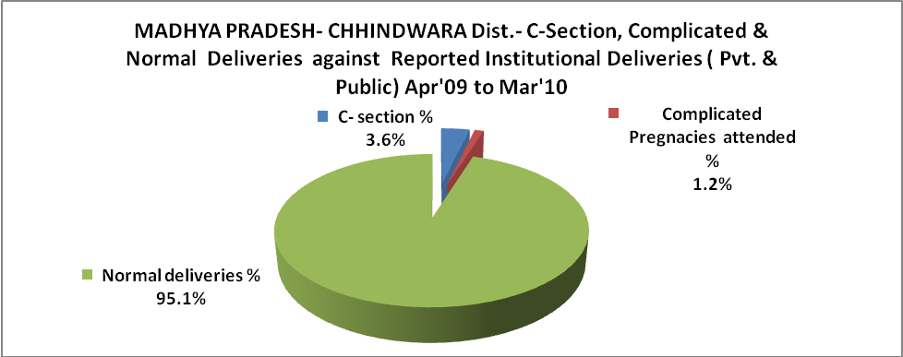

MADHYA PRADESH- CHHINDWARA Dist.- Complicated Pregnancies & Deliveries Treated - Apr'09 to Mar'10
Reported Deliveries |  |  | Reported ANC Reigtration
40,748 |  |  | 55,616
Complicated Pregnancies attended | Complicated Pregnancies Rate | C - Section Deliveries | PNC Maternal Complications | Abortions | Still Births
463 | 1% | 1,395 | 409 | 379 | 2,372
Complicated Deliveries Treated with |  |  |  | No Of Eclampsia cases Treated | No Of severe anemia cases treated
IV Antibiotics | IV antihypertensive/Magsulph injection | IV Oxytocis | Blood Transfusion | No Of Eclampsia cases Treated | No Of severe anemia cases treated
109 | 29 | 92 | 282 | 190 | 4,218

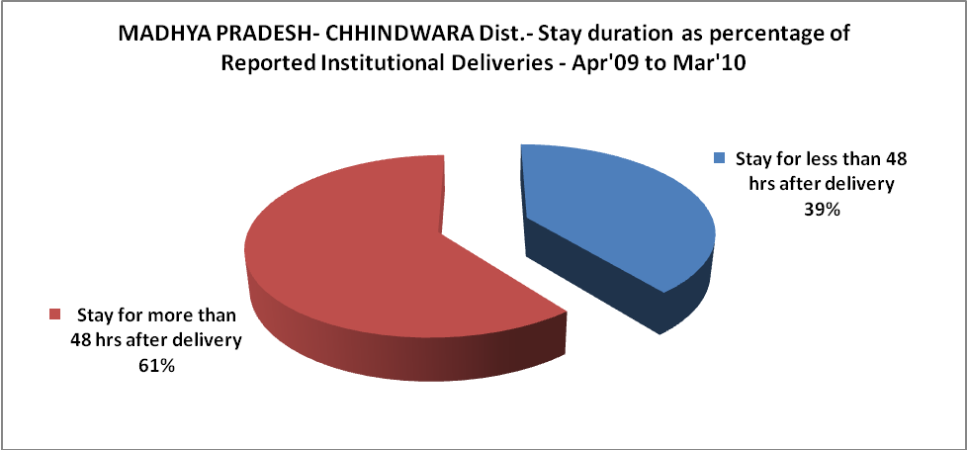

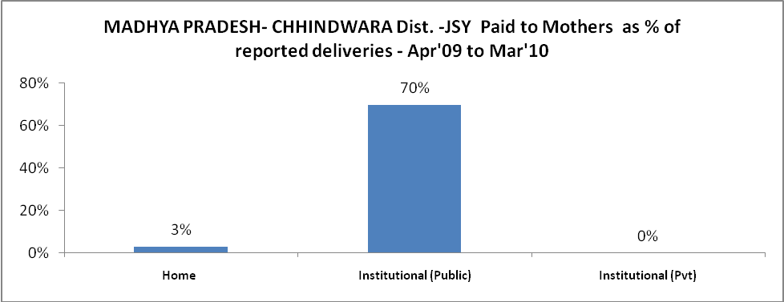

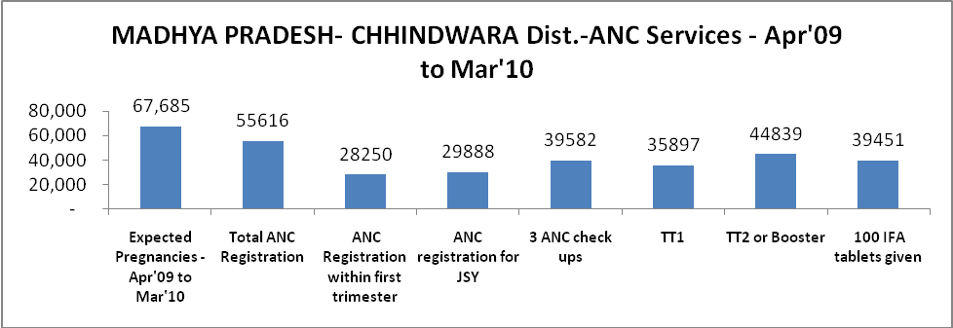

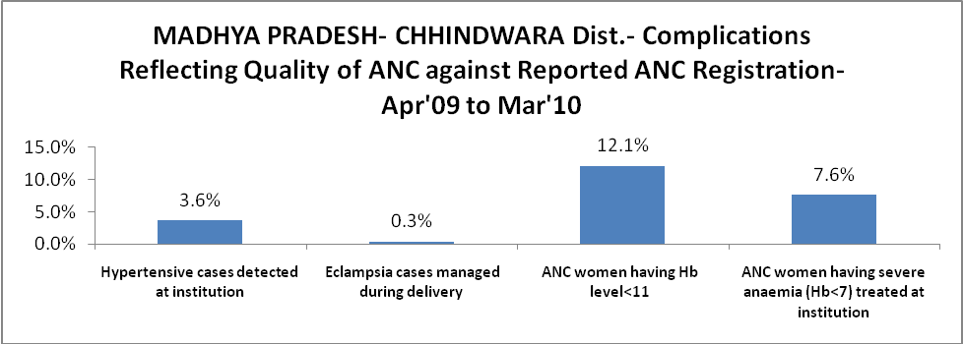

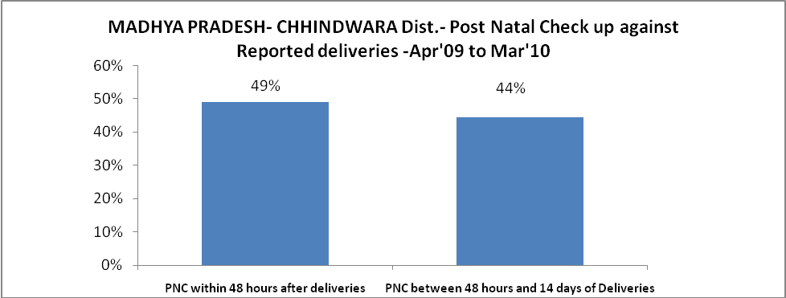

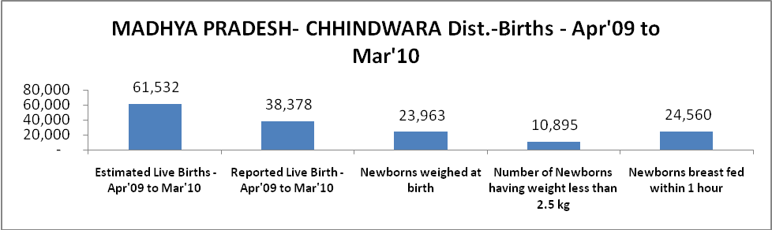

MADHYA PRADESH- CHHINDWARA Dist. - Births - Apr'09 to Mar'10
Live Birth - Males | Live Birth - females | Live Birth - Total | Sex Ratio at birth | Still Birth | Abortion( Induced/Spontaneous
19,848 | 18,530 | 38,378 | 934 | 2,372 | 379

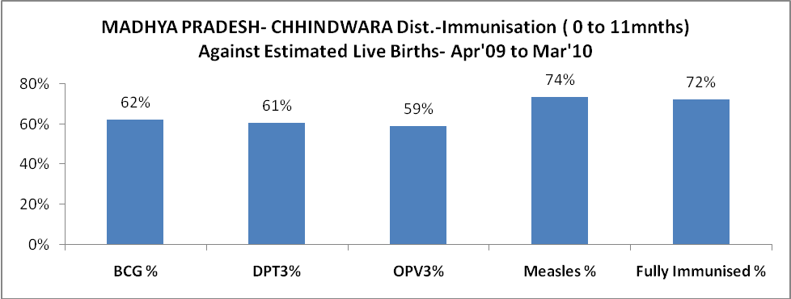

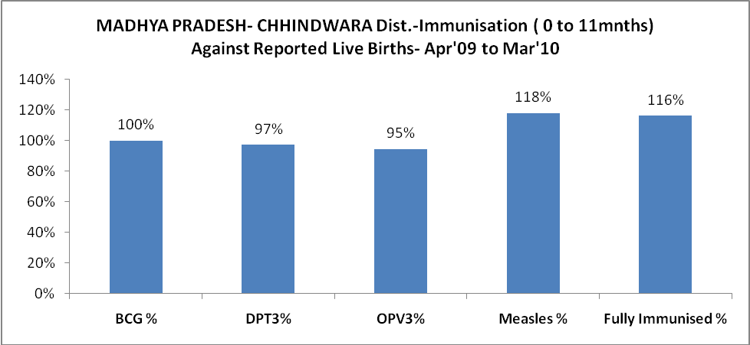

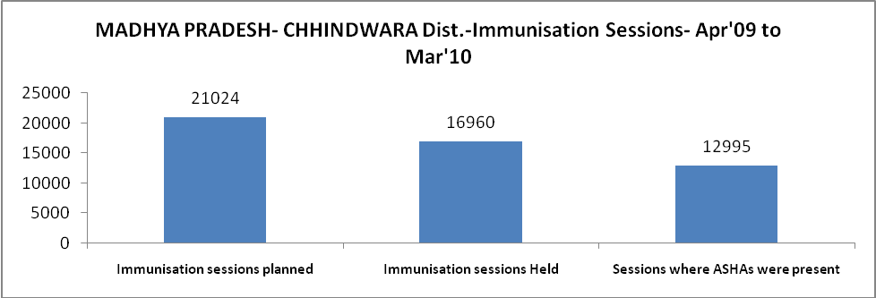

MADHYA PRADESH- CHHINDWARA Dist.- Apr'09 to Mar'10
Total Abortions | Abortion Rate
626 | 0.9%

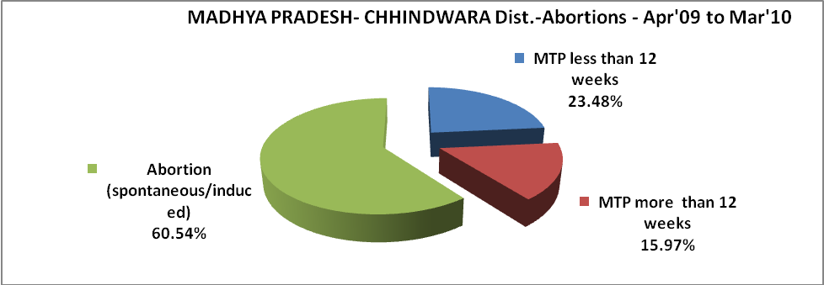

MADHYA PRADESH- CHHINDWARA Dist.- Apr'09 to Mar'10
Total OPD | Total RTI/STI cases
1,112,970 | 8,464

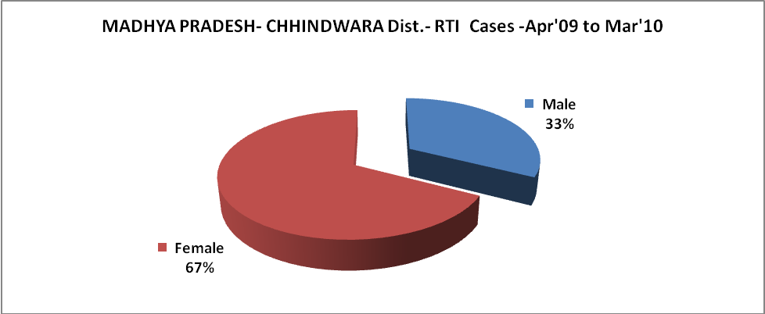

MADHYA PRADESH- CHHINDWARA Dist.-Sterilisations - Apr'09 to Mar'10
 | Reported | %age of Reported Sterilisation
Total Sterilisation | 9,792 | -
NSV | 1,103 | 11%
Laproscopic | 7,395 | 76%
MiniLap | 294 | 3%
Post Partum | 1,000 | 10%
Male Sterilisation | 1,103 | 11%
Female Sterilisation | 8,689 | 89%

MADHYA PRADESH- CHHINDWARA Dist.-FP Methods - Apr'09 to Mar'10
 | Reported | %age of All Reported FP Methods
Total Reported FP Methodd (All types) Users | 55,601 | -
Sterilisations | 9,792 | 18%
IUD | 8,793 | 16%
Condom Users | 20,357 | 37%
OCP Users | 16,659 | 30%
Limiting Methods | 9,792 | 18%
Spacing Methods | 45,809 | 82%

MADHYA PRADESH- CHHINDWARA Dist.- Service Delivery - Apr'09 to Mar'10
Operation major (General and spinal anaesthesia) | Operation minor (No or local anaesthesia) | AYUSH | Dental Procedures | Adolescent counselling services | Total OPD | Total IPD
1,345 | 1,166 | 13,862 | 269 | 156 | 1,112,970 | 80,515
Operation major (General and spinal anaesthesia) as %ge of OPD | Operation minor (No or local anaesthesia)as %ge of OPD | AYUSH as %ge of OPD | Dental Procedures as %ge of OPD | Adolescent counselling services as %ge of OPD | IPD as percentage of OPD
0.1% | 0.1% | 1.2% | 0.0% | 0.0% | 7%

MADHYA PRADESH- CHHINDWARA Dist.- Lab Services - Apr'09 to Mar'10
Total OPD | Total HB tested | Total HIV Tested | Total Population
1,112,970 | 11,062 | 5,027 | 2,197,577
HB test conducted as %age of OPD | HB<7gm as %age of HB tested | HIV test conducted as %age of OPD | HIV positive as %age of HIV tested | Blood Smear Examined as % of Population
1.0% | 11.2% | 0.5% | 0.5% | 4.1%

MADHYA PRADESH- CHHINDWARA Dist.- Childhood Disease - Vaccine Preventable -Apr'09 to Mar'10
Diphtheria | Pertussis | Tetanus Neonatorum | Tetanus others | Polio | Measles
0 | 2 | 13 | 0 | 0 | 17
MADHYA PRADESH- CHHINDWARA Dist.-Childhood Disease - Others - Apr'09 to Mar'10
Diarrhoea and dehydration | Malaria | Number admitted with Respiratory Infections
2,364 | 2,338 | 632

MADHYA PRADESH- CHHINDWARA Dist.- Infant & Child Deaths - Apr'09 to Mar'10
Infant Deaths within 24 hrs of birth | Infant Deaths between 24hrs & under 1 week | Infant Deaths between 1 week & under 1 month | Child Deaths between 1 month & under 1 year | Child Deaths between 1yr under 5years | Total Deaths
25 | 96 | 44 | 41 | 183 | 389

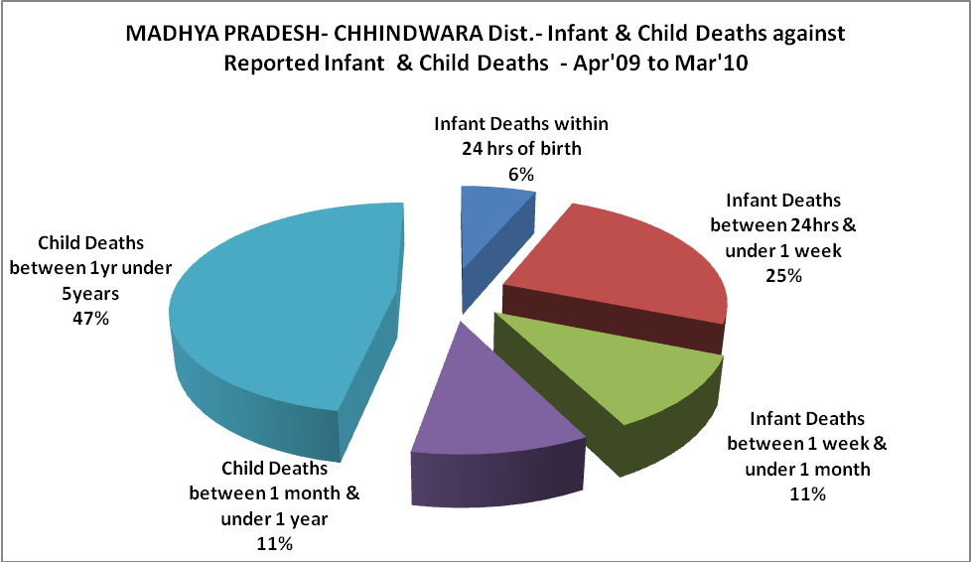

MADHYA PRADESH- CHHINDWARA Dist.- Causes of Infant & Child Deaths - Apr'09 to Mar'10
Sepsis |  |  | Asphyxia |  |  | LBW
Up to 1 Weeks of Birth | Between 1 week & 4 weeks of birth | Total | Up to 1 Weeks of Birth | Between 1 week & 4 weeks of birth | Total | Up to 1 Weeks of Birth | Between 1 week & 4 weeks of birth | Total
3 | 1 | 4 | 3 | 5 | 8 | 15 | 2 | 17
Pneumonia |  |  | Diarrhoea |  |  | Fever related
Between 1 month and 11 months | Between 1 year & 5 years | Total | Between 1 month and 11 months | Between 1 year & 5 years | Total | Between 1 month and 11 months | Between 1 year & 5 years | Total
0 | 20 | 20 | 0 | 95 | 95 | 5 | 4 | 9
Others |  |  | Measles |  |  | Others
Up to 1 Weeks of Birth | Between 1 week & 4 weeks of birth | Total | Between 1 month and 11 months | Between 1 year & 5 years | Total | Between 1 month and 11 months | Between 1 year & 5 years | Total
75 | 36 | 111 | 0 | 0 | 0 | 36 | 64 | 100

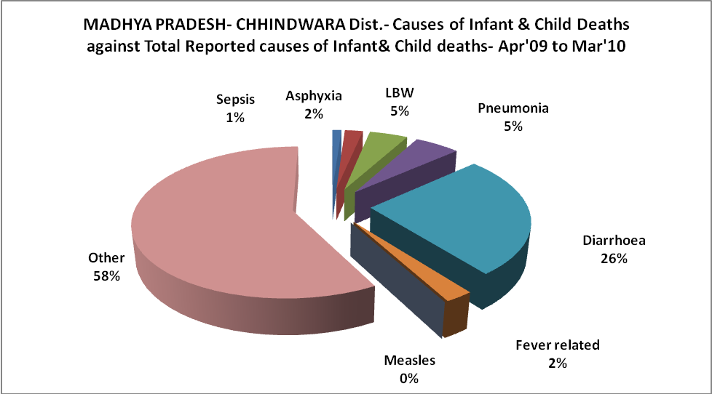

MADHYA PRADESH- CHHINDWARA Dist.- Maternal Deaths & Causes - Apr'09 to Mar'10
Abortion |  |  | Obstructed/prolonged labour |  |  | Severe hypertesnion/fits
6-14 yrs | 15-55 yrs. | Total | 6-14 yrs | 15-55 yrs. | Total | 6-14 yrs | 15-55 yrs. | Total
0 | 9 | 9 | 0 | 0 | 0 | 0 | 0 | 0
Bleeding |  |  | High Fever |  |  | Other Causes
6-14 yrs | 15-55 yrs. | Total | 6-14 yrs | 15-55 yrs. | Total | 6-14 yrs | 15-55 yrs. | Total
0 | 1 | 1 | 0 | 0 | 0 | 0 | 25 | 25

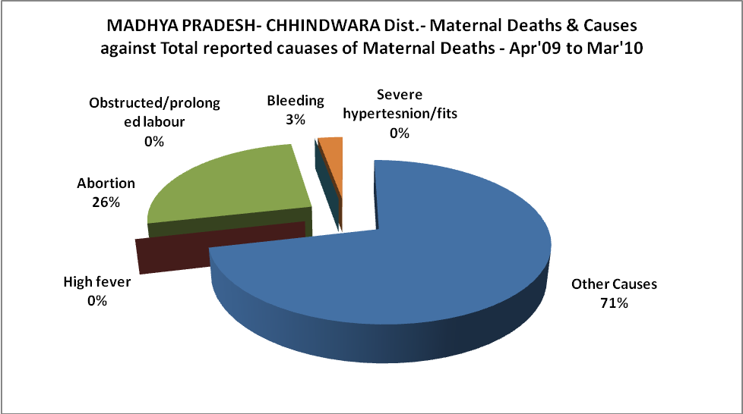

MADHYA PRADESH- CHHINDWARA Dist.-Causes of Deaths in 6 to 55yrs age group - Apr'09 to Mar'10
Diarrhoel Diseases |  |  |  | Tuberculosis |  |  |  | Respiratory Diseases( Other than TB)
6-14 yrs | 15-55 yrs. | Above 55yrs | Total | 6-14 yrs | 15-55 yrs. | Above 55yrs | Total | 6-14 yrs | 15-55 yrs. | Above 55yrs | Total
1 | 6 | 3 | 10 | 0 | 1 | 0 | 1 | 1 | 5 | 21 | 27
Malaria |  |  |  | Other fever Related |  |  |  | HIV/Aids
6-14 yrs | 15-55 yrs. | Above 55yrs | Total | 6-14 yrs | 15-55 yrs. | Above 55yrs | Total | 6-14 yrs | 15-55 yrs. | Above 55yrs | Total
0 | 0 | 2 | 2 | 11 | 61 | 72 | 144 | 0 | 0 | 0 | 0
Heart Disease/Hypertenion related |  |  |  | Neurological Disease including strokes |  |  |  | Trauma/Accidents/ Burn Cases
6-14 yrs | 15-55 yrs. | Above 55yrs | Total | 6-14 yrs | 15-55 yrs. | Above 55yrs | Total | 6-14 yrs | 15-55 yrs. | Above 55yrs | Total
0 | 18 | 24 | 42 | 0 | 1 | 2 | 3 | 1 | 13 | 13 | 27
Suicide |  |  |  | Animal Bites & Stings
6-14 yrs | 15-55 yrs. | Above 55yrs | Total | 6-14 yrs | 15-55 yrs. | Above 55yrs | Total
1 | 7 | 1 | 9 | 2 | 8 | 4 | 14

