[NHSRC]
MP-Datia
[ Analysis 2009-10]

MADHYA PRADESH- DATIA Dist.- Summary-Apr'09 to Mar'10
ANC
ANC Registration against Expected Pregnancies | 79% | TT1 given to Pregnant women against ANC Registraion | 99%
3 ANC Check ups against ANC Reigtrations | 73% | 100 IFA Tablets given to Pregnant women against ANC Registraion | 108%
Deliveries
Unreported Deliveries against Estimated Deliveries | 25.4% | HOME Deliveries( SBA& Non SBA) against Estimated Deliveries | 9.6%
Institutional Deliveries against Estimated Deliveries | 65.0% | HOME Deliveries( SBA& Non SBA) against Reported Deliveries | 12.8%
Institutional Deliveries against Reported Deliveries | 87.2% | C Section Deliveries against Institutional Deliveries( Pvt & Pub) | 0%
Births & Neonates Care
Live Births Reported against Estimated Live Births | 76% | New borns weighed against Reported Live Births | 81%
Still Births (Reported) | 199 | New borns weighed less than 2.5 kgs against newborns weighed | 23%
Sex Ratio at Birh | 911 | New borns breastfed within one hr of Birth against Reported live Births | 75%
Child Immunisation( 0 to 11 months)
BCG given against Expected Live Births | 79% | Measles given against Expected Live Births | 83%
OPV3 given against Expected Live Births | 77% | Fully Immunised Children against Expected Live Births | 83%
DPT3 given against Expected Live Births | 86%
Family Planning
Family Plannig Methods Users ( Sterilisations(Male &Female)+IUD+ Condom pieces/72 + OCP Cycles/13) | 20,678 | IUD Insertions against reported FP Methods | 25%
Sterilisation against reported FP Methods | 17% | Condom Users against reported FP Methods | 39%
 |  | OCP Users against reported FP Methods | 19%
Other Services
OPD | 111,824 | Major Operations | 58
IPD | 5,916 | Minor Operations | 1,148

MADHYA PRADESH- DATIA Dist.- Deliveries Apr'09 to Mar'10
Total Population | 746,611 | Expected Deliveries |  | 21,637
Home SBA | Home Non SBA | Institutional | Total Deliveries Reported | Unreported Deliveries
1,391 | 680 | 14,072 | 16,143 | 5,494
Home SBA % | Home Non SBA% | Institutional % | Total Deliveries Reported % | Unreported Deliveries %
6% | 3% | 65% | 75% | 25%

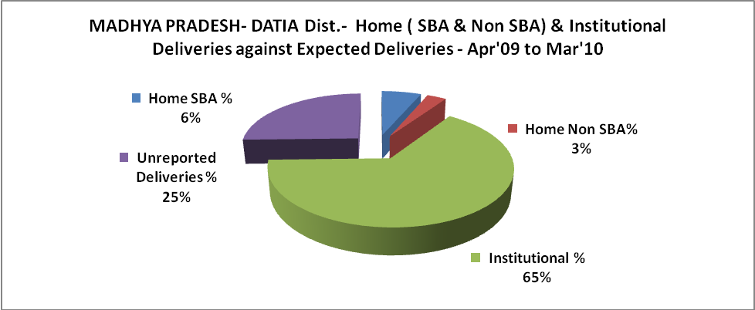

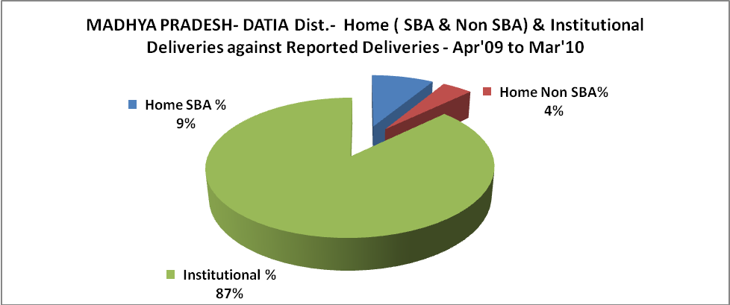

MADHYA PRADESH- DATIA Dist.- C sections & Complicated Deliveries Apr'09 to Mar'10
 | Institutional Deliveries (Public) | Institutional Deliveries (Pvt)
 | 14,072 | -
C Section | 14 | -
C Section% | 0% | 0%
Complicated Pregnacies attended | 255 | -
Complicated Pregnacies attended % | 2% | 0%

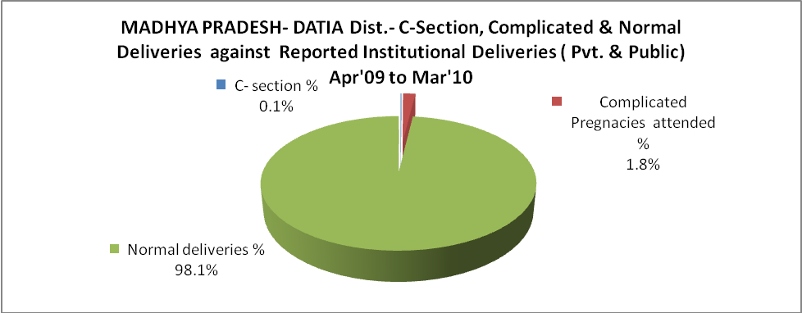

MADHYA PRADESH- DATIA Dist.- Complicated Pregnancies & Deliveries Treated - Apr'09 to Mar'10
Reported Deliveries |  |  | Reported ANC Reigtration
16,143 |  |  | 18,242
Complicated Pregnancies attended | Complicated Pregnancies Rate | C - Section Deliveries | PNC Maternal Complications | Abortions | Still Births
255 | 1% | 14 | 936 | 110 | 199
Complicated Deliveries Treated with |  |  |  | No Of Eclampsia cases Treated | No Of severe anemia cases treated
IV Antibiotics | IV antihypertensive/Magsulph injection | IV Oxytocis | Blood Transfusion | No Of Eclampsia cases Treated | No Of severe anemia cases treated
2,103 | 2 | 1,573 | 7 | 18 | 144

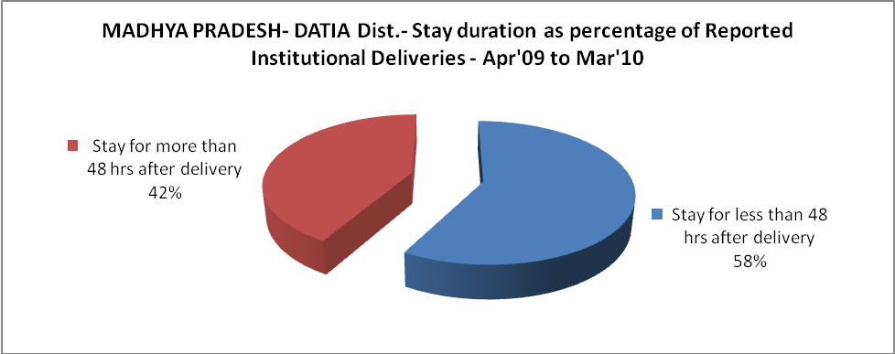

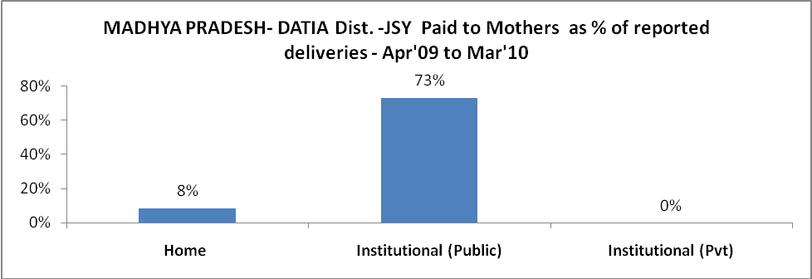

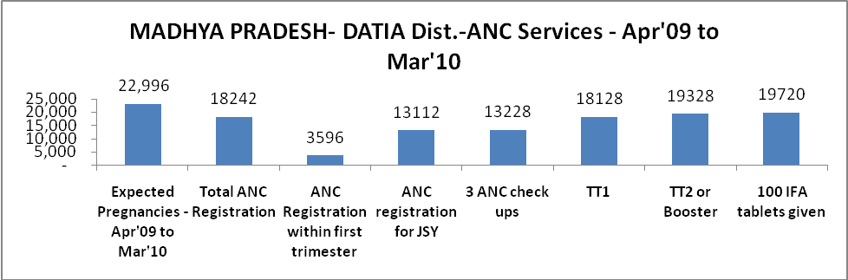

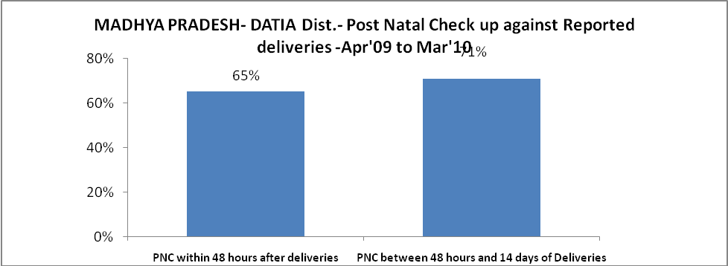

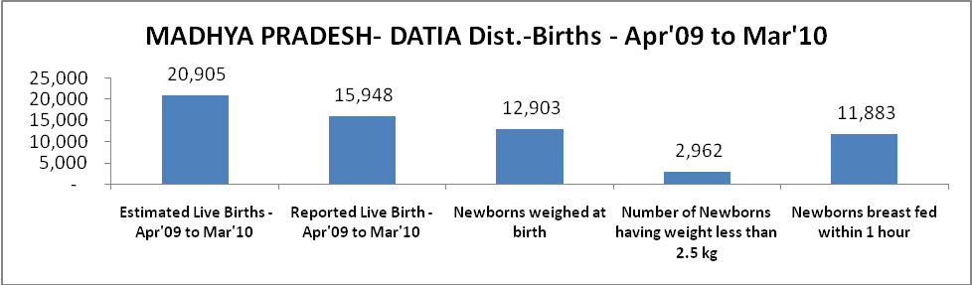

MADHYA PRADESH- DATIA Dist. - Births - Apr'09 to Mar'10
Live Birth - Males | Live Birth - females | Live Birth - Total | Sex Ratio at birth | Still Birth | Abortion( Induced/Spontaneous
8,346 | 7,602 | 15,948 | 911 | 199 | 110

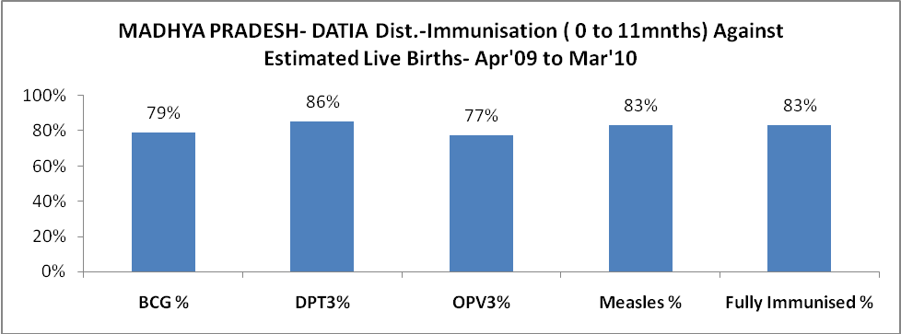

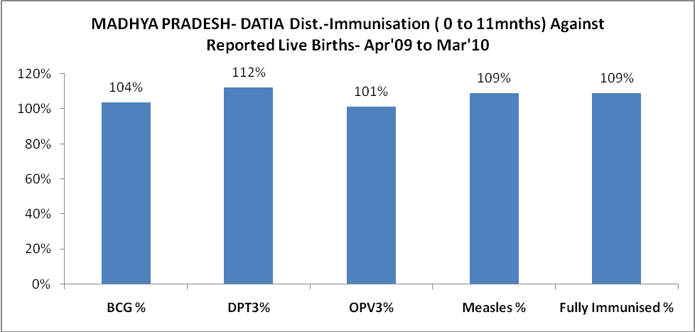

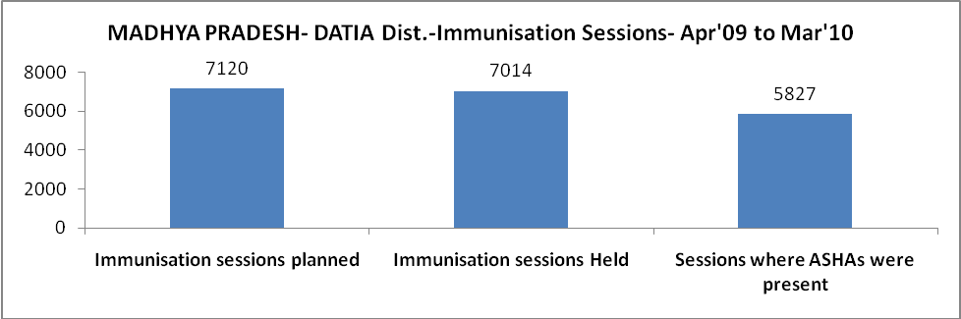
MADHYA PRADESH- DATIA Dist.- Apr'09 to Mar'10
Total Abortions | Abortion Rate
156 | 0.7%

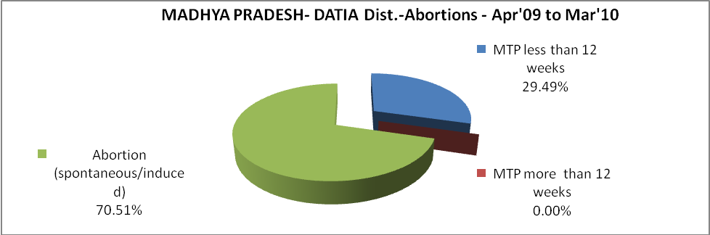

MADHYA PRADESH- DATIA Dist.- Apr'09 to Mar'10
Total OPD | Total RTI/STI cases
111,824 | 603

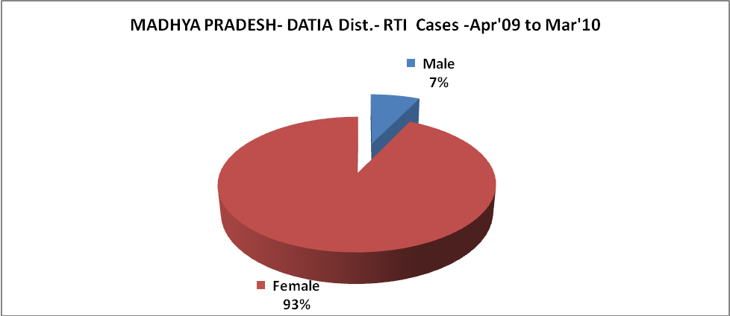
MADHYA PRADESH- DATIA Dist.-Sterilisations - Apr'09 to Mar'10
 | Reported | %age of Reported Sterilisation
Total Sterilisation | 3,613 | -
NSV | 103 | 3%
Laproscopic | 3,304 | 91%
MiniLap | 206 | 6%
Post Partum | - | 0%
Male Sterilisation | 103 | 3%
Female Sterilisation | 3,510 | 97%
MADHYA PRADESH- DATIA Dist.-FP Methods - Apr'09 to Mar'10
 | Reported | %age of All Reported FP Methods
Total Reported FP Methodd (All types) Users | 20,678 | -
Sterilisations | 3,613 | 17%
IUD | 5,189 | 25%
Condom Users | 8,015 | 39%
OCP Users | 3,862 | 19%
Limiting Methods | 3,613 | 17%
Spacing Methods | 17,065 | 83%

MADHYA PRADESH- DATIA Dist.- Service Delivery - Apr'09 to Mar'10
Operation major (General and spinal anaesthesia) | Operation minor (No or local anaesthesia) | AYUSH | Dental Procedures | Adolescent counselling services | Total OPD | Total IPD
58 | 1,148 | 8,533 | 622 | - | 111,824 | 5,916
Operation major (General and spinal anaesthesia) as %ge of OPD | Operation minor (No or local anaesthesia)as %ge of OPD | AYUSH as %ge of OPD | Dental Procedures as %ge of OPD | Adolescent counselling services as %ge of OPD | IPD as percentage of OPD
0.1% | 1.0% | 7.6% | 0.6% | 0.0% | 5%

l
MADHYA PRADESH- DATIA Dist.- Lab Services - Apr'09 to Mar'10
Total OPD | Total HB tested | Total HIV Tested | Total Population
111,824 | 4,592 | 1,978 | 746,611
HB test conducted as %age of OPD | HB<7gm as %age of HB tested | HIV test conducted as %age of OPD | HIV positive as %age of HIV tested | Blood Smear Examined as % of Population
4.1% | 4.8% | 1.8% | 0.0% | 9.0%

MADHYA PRADESH- DATIA Dist.- Childhood Disease - Vaccine Preventable -Apr'09 to Mar'10
Diphtheria | Pertussis | Tetanus Neonatorum | Tetanus others | Polio | Measles
0 | 0 | 0 | 0 | 0 | 24
MADHYA PRADESH- DATIA Dist.-Childhood Disease - Others - Apr'09 to Mar'10
Diarrhoea and dehydration | Malaria | Number admitted with Respiratory Infections
3,207 | 1,226 | 109
MADHYA PRADESH- DATIA Dist.- Infant & Child Deaths - Apr'09 to Mar'10
Infant Deaths within 24 hrs of birth | Infant Deaths between 24hrs & under 1 week | Infant Deaths between 1 week & under 1 month | Child Deaths between 1 month & under 1 year | Child Deaths between 1yr under 5years | Total Deaths
122 | 279 | 77 | 68 | 65 | 611

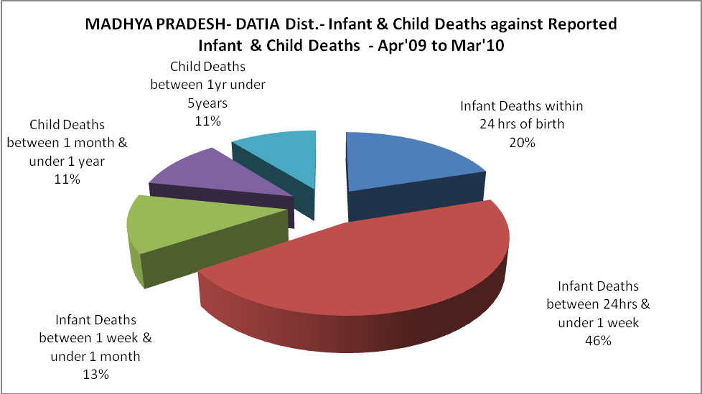

MADHYA PRADESH- DATIA Dist.- Causes of Infant & Child Deaths - Apr'09 to Mar'10
Sepsis |  |  | Asphyxia |  |  | LBW
Up to 1 Weeks of Birth | Between 1 week & 4 weeks of birth | Total | Up to 1 Weeks of Birth | Between 1 week & 4 weeks of birth | Total | Up to 1 Weeks of Birth | Between 1 week & 4 weeks of birth | Total
0 | 0 | 0 | 0 | 0 | 0 | 73 | 31 | 104
Pneumonia |  |  | Diarrhoea |  |  | Fever related
Between 1 month and 11 months | Between 1 year & 5 years | Total | Between 1 month and 11 months | Between 1 year & 5 years | Total | Between 1 month and 11 months | Between 1 year & 5 years | Total
0 | 0 | 0 | 0 | 0 | 0 | 0 | 0 | 0
Others |  |  | Measles |  |  | Others
Up to 1 Weeks of Birth | Between 1 week & 4 weeks of birth | Total | Between 1 month and 11 months | Between 1 year & 5 years | Total | Between 1 month and 11 months | Between 1 year & 5 years | Total
206 | 46 | 252 | 0 | 0 | 0 | 68 | 65 | 133

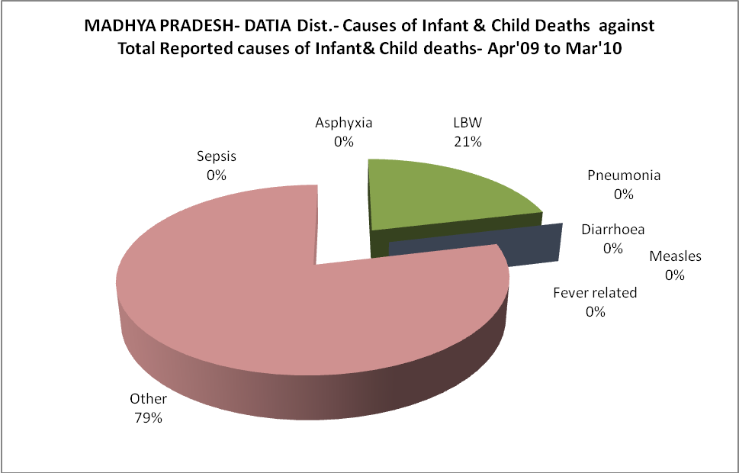

MADHYA PRADESH- DATIA Dist.- Maternal Deaths & Causes - Apr'09 to Mar'10
Abortion |  |  | Obstructed/prolonged labour |  |  | Severe hypertesnion/fits
6-14 yrs | 15-55 yrs. | Total | 6-14 yrs | 15-55 yrs. | Total | 6-14 yrs | 15-55 yrs. | Total
0 | 0 | 0 | 0 | 0 | 0 | 0 | 0 | 0
Bleeding |  |  | High Fever |  |  | Other Causes
6-14 yrs | 15-55 yrs. | Total | 6-14 yrs | 15-55 yrs. | Total | 6-14 yrs | 15-55 yrs. | Total
0 | 0 | 0 | 0 | 0 | 0 | 0 | 0 | 0

MADHYA PRADESH- DATIA Dist.-Causes of Deaths in 6 to 55yrs age group - Apr'09 to Mar'10
Diarrhoel Diseases |  |  |  | Tuberculosis |  |  |  | Respiratory Diseases( Other than TB)
6-14 yrs | 15-55 yrs. | Above 55yrs | Total | 6-14 yrs | 15-55 yrs. | Above 55yrs | Total | 6-14 yrs | 15-55 yrs. | Above 55yrs | Total
0 | 0 | 0 | 0 | 0 | 0 | 0 | 0 | 0 | 0 | 0 | 0
Malaria |  |  |  | Other fever Related |  |  |  | HIV/Aids
6-14 yrs | 15-55 yrs. | Above 55yrs | Total | 6-14 yrs | 15-55 yrs. | Above 55yrs | Total | 6-14 yrs | 15-55 yrs. | Above 55yrs | Total
0 | 0 | 0 | 0 | 0 | 0 | 0 | 0 | 0 | 0 | 0 | 0
Heart Disease/Hypertenion related |  |  |  | Neurological Disease including strokes |  |  |  | Trauma/Accidents/ Burn Cases
6-14 yrs | 15-55 yrs. | Above 55yrs | Total | 6-14 yrs | 15-55 yrs. | Above 55yrs | Total | 6-14 yrs | 15-55 yrs. | Above 55yrs | Total
0 | 0 | 3 | 3 | 0 | 0 | 0 | 0 | 0 | 0 | 4 | 4
Suicide |  |  |  | Animal Bites & Stings
6-14 yrs | 15-55 yrs. | Above 55yrs | Total | 6-14 yrs | 15-55 yrs. | Above 55yrs | Total
0 | 0 | 0 | 0 | 0 | 0 | 53 | 53

