[NHSRC]
MP-Dewas
[ Analysis 2009-10]

MADHYA PRADESH- DEWAS Dist.- Summary-Apr'09 to Mar'10
ANC
ANC Registration against Expected Pregnancies | 88% | TT1 given to Pregnant women against ANC Registraion | 90%
3 ANC Check ups against ANC Reigtrations | 90% | 100 IFA Tablets given to Pregnant women against ANC Registraion | 95%
Deliveries
Unreported Deliveries against Estimated Deliveries | 36.8% | HOME Deliveries( SBA& Non SBA) against Estimated Deliveries | 2.7%
Institutional Deliveries against Estimated Deliveries | 60.5% | HOME Deliveries( SBA& Non SBA) against Reported Deliveries | 4.3%
Institutional Deliveries against Reported Deliveries | 95.7% | C Section Deliveries against Institutional Deliveries( Pvt & Pub) | 0%
Births & Neonates Care
Live Births Reported against Estimated Live Births | 65% | New borns weighed against Reported Live Births | 94%
Still Births (Reported) | 335 | New borns weighed less than 2.5 kgs against newborns weighed | 5%
Sex Ratio at Birh | 936 | New borns breastfed within one hr of Birth against Reported live Births | 88%
Child Immunisation( 0 to 11 mnths)
BCG given against Expected Live Births | 70% | Measles given against Expected Live Births | 86%
OPV3 given against Expected Live Births | 92% | Fully Immunised Children against Expected Live Births | 84%
DPT3 given against Expected Live Births | 92%
Family Planning
Family Plannig Methods Users ( Sterilisations(Male &Female)+IUD+ Condom pieces/72 + OCP Cycles/13) | 52,192 | IUD Insertions against reported FP Methods | 14%
Sterilisation against reported FP Methods | 16% | Condom Users against reported FP Methods | 51%
 |  | OCP Users against reported FP Methods | 19%
Other Services
OPD | 180,235 | Major Operations | 45
IPD | 37,228 | Minor Operations | 3,074

MADHYA PRADESH- DEWAS Dist.- Deliveries Apr'09 to Mar'10
Total Population | 1,554,838 | Expected Deliveries |  | 45,059
Home SBA | Home Non SBA | Institutional | Total Deliveries Reported | Unreported Deliveries
- | 1,222 | 27,276 | 28,498 | 16,561
Home SBA % | Home Non SBA% | Institutional % | Total Deliveries Reported % | Unreported Deliveries %
0% | 3% | 61% | 63% | 37%

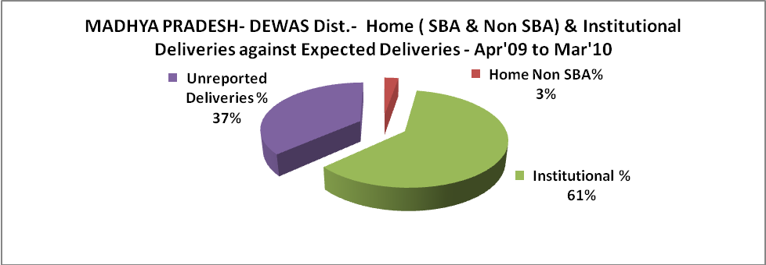

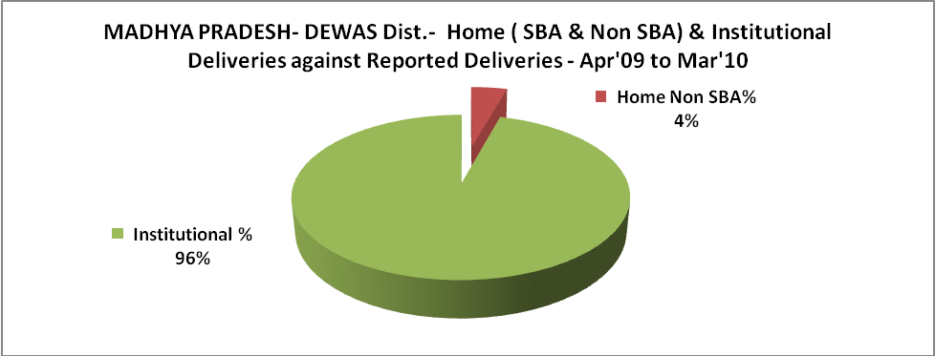

MADHYA PRADESH- DEWAS Dist.- C sections & Complicated Deliveries Apr'09 to Mar'10
 | Institutional Deliveries (Public) | Institutional Deliveries (Pvt)
 | 23,518 | 3,758
C Section | 23 | 41
C Section% | 0% | 1%
Complicated Pregnacies attended | 1,434 | 78
Complicated Pregnacies attended % | 6% | 2%

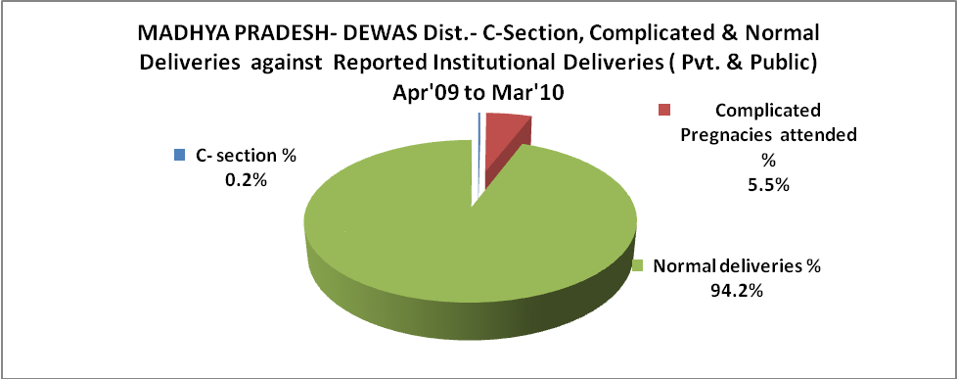

MADHYA PRADESH- DEWAS Dist.- Complicated Pregnancies & Deliveries Treated - Apr'09 to Mar'10
Reported Deliveries |  |  | Reported ANC Reigtration
28,498 |  |  | 42,091
Complicated Pregnancies attended | Complicated Pregnancies Rate | C - Section Deliveries | PNC Maternal Complications | Abortions | Still Births
1,512 | 3% | 64 | 170 | 102 | 335
Complicated Deliveries Treated with |  |  |  | No Of Eclampsia cases Treated | No Of severe anemia cases treated
IV Antibiotics | IV antihypertensive/Magsulph injection | IV Oxytocis | Blood Transfusion | No Of Eclampsia cases Treated | No Of severe anemia cases treated
459 | 260 | 297 | 98 | 58 | 519

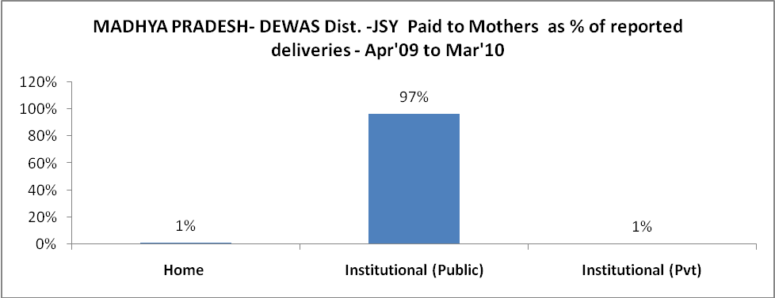

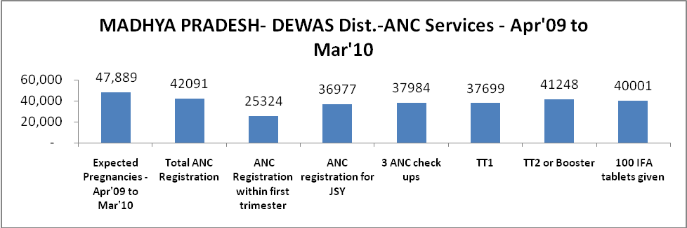

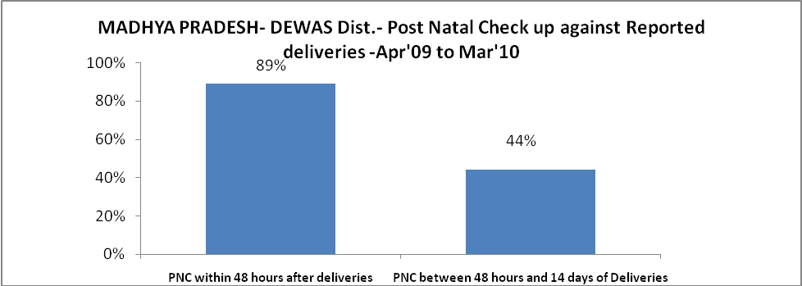
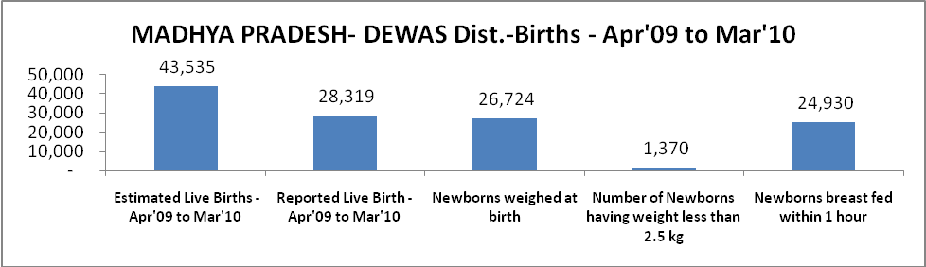

MADHYA PRADESH- DEWAS Dist. - Births - Apr'09 to Mar'10
Live Birth - Males | Live Birth - females | Live Birth - Total | Sex Ratio at birth | Still Birth | Abortion( Induced/Spontaneous
14,624 | 13,695 | 28,319 | 936 | 335 | 102

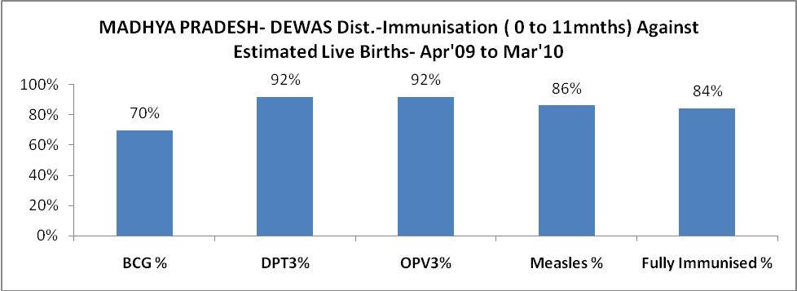

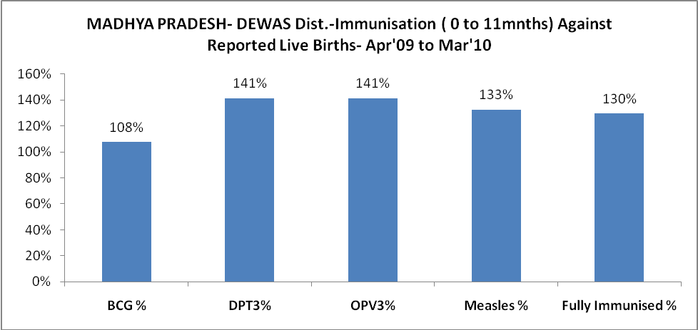

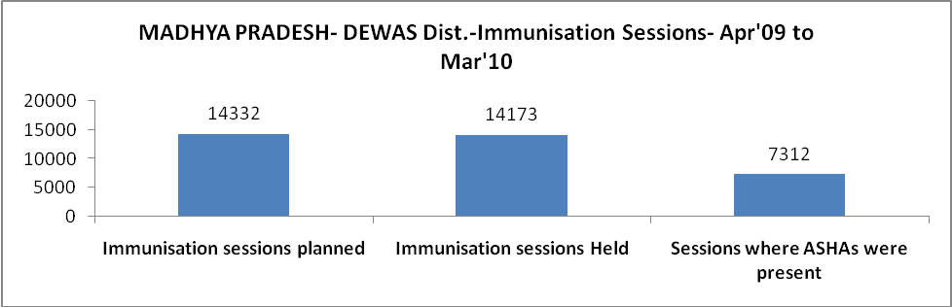

MADHYA PRADESH- DEWAS Dist.- Apr'09 to Mar'10
Total Abortions | Abortion Rate
176 | 0.4%

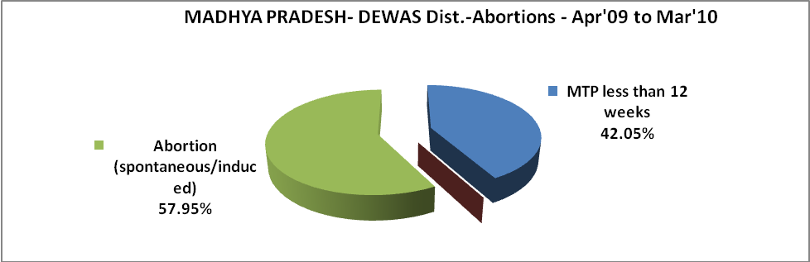

MADHYA PRADESH- DEWAS Dist.- Apr'09 to Mar'10
Total OPD | Total RTI/STI cases
180,235 | 15,302

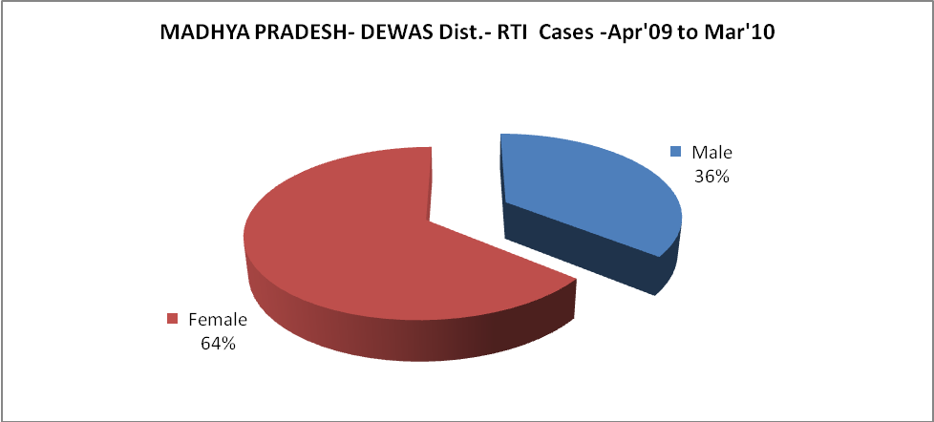

MADHYA PRADESH- DEWAS Dist.-Sterilisations - Apr'09 to Mar'10
 | Reported | %age of Reported Sterilisation
Total Sterilisation | 8,522 | -
NSV | 187 | 2%
Laproscopic | 5,856 | 69%
MiniLap | 1,773 | 21%
Post Partum | 706 | 8%
Male Sterilisation | 187 | 2%
Female Sterilisation | 8,335 | 98%
MADHYA PRADESH- DEWAS Dist.-FP Methods - Apr'09 to Mar'10
 | Reported | %age of All Reported FP Methods
Total Reported FP Methodd (All types) Users | 52,192 | -
Sterilisations | 8,522 | 16%
IUD | 7,406 | 14%
Condom Users | 26,361 | 51%
OCP Users | 9,903 | 19%
Limiting Methods | 8,522 | 16%
Spacing Methods | 43,670 | 84%

MADHYA PRADESH- DEWAS Dist.- Service Delivery - Apr'09 to Mar'10
Operation major (General and spinal anaesthesia) | Operation minor (No or local anaesthesia) | AYUSH | Dental Procedures | Adolescent counselling services | Total OPD | Total IPD
45 | 3,074 | 3,410 | 589 | 116 | 180,235 | 37,228
Operation major (General and spinal anaesthesia) as %ge of OPD | Operation minor (No or local anaesthesia)as %ge of OPD | AYUSH as %ge of OPD | Dental Procedures as %ge of OPD | Adolescent counselling services as %ge of OPD | IPD as percentage of OPD
0.0% | 1.7% | 1.9% | 0.3% | 0.1% | 21%

MADHYA PRADESH- DEWAS Dist.- Lab Services - Apr'09 to Mar'10
Total OPD | Total HB tested | Total HIV Tested | Total Population
180,235 | 19,437 | 8,884 | 1,554,838
HB test conducted as %age of OPD | HB<7gm as %age of HB tested | HIV test conducted as %age of OPD | HIV positive as %age of HIV tested | Blood Smear Examined as % of Population
10.8% | 4.9% | 4.9% | 0.2% | 6.9%
MADHYA PRADESH- DEWAS Dist.- Childhood Disease - Vaccine Preventable -Apr'09 to Mar'10
Diphtheria | Pertussis | Tetanus Neonatorum | Tetanus others | Polio | Measles
1269 | 0 | 0 | 0 | 0 | 0
MADHYA PRADESH- DEWAS Dist.-Childhood Disease - Others - Apr'09 to Mar'10
Diarrhoea and dehydration | Malaria | Number admitted with Respiratory Infections
22,608 | 3,446 | 7,472
MADHYA PRADESH- DEWAS Dist.- Infant & Child Deaths - Apr'09 to Mar'10
Infant Deaths within 24 hrs of birth | Infant Deaths between 24hrs & under 1 week | Infant Deaths between 1 week & under 1 month | Child Deaths between 1 month & under 1 year | Child Deaths between 1yr under 5years | Total Deaths
97 | 78 | 72 | 62 | 76 | 385

l

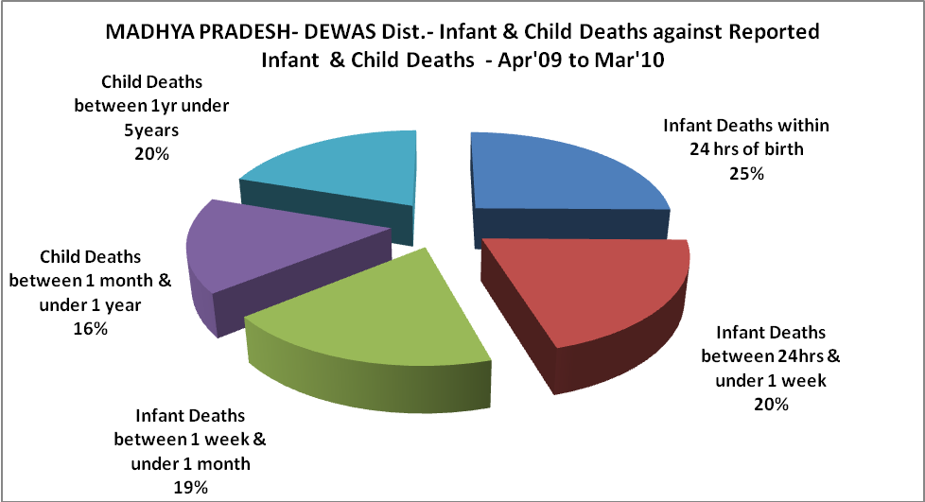

MADHYA PRADESH- DEWAS Dist.- Causes of Infant & Child Deaths - Apr'09 to Mar'10
Sepsis |  |  | Asphyxia |  |  | LBW
Up to 1 Weeks of Birth | Between 1 week & 4 weeks of birth | Total | Up to 1 Weeks of Birth | Between 1 week & 4 weeks of birth | Total | Up to 1 Weeks of Birth | Between 1 week & 4 weeks of birth | Total
11 | 9 | 20 | 3 | 3 | 6 | 33 | 18 | 51
Pneumonia |  |  | Diarrhoea |  |  | Fever related
Between 1 month and 11 months | Between 1 year & 5 years | Total | Between 1 month and 11 months | Between 1 year & 5 years | Total | Between 1 month and 11 months | Between 1 year & 5 years | Total
5 | 5 | 10 | 0 | 0 | 0 | 0 | 0 | 0
Others |  |  | Measles |  |  | Others
Up to 1 Weeks of Birth | Between 1 week & 4 weeks of birth | Total | Between 1 month and 11 months | Between 1 year & 5 years | Total | Between 1 month and 11 months | Between 1 year & 5 years | Total
31 | 42 | 73 | 0 | 0 | 0 | 57 | 71 | 128

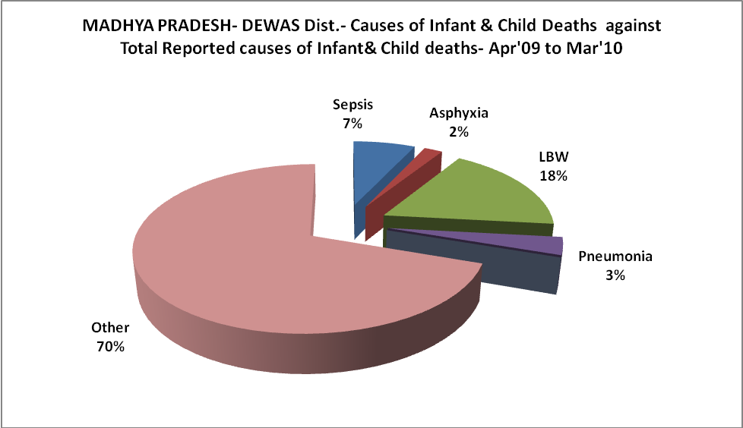
MADHYA PRADESH- DEWAS Dist.- Maternal Deaths & Causes - Apr'09 to Mar'10
Abortion |  |  | Obstructed/prolonged labour |  |  | Severe hypertesnion/fits
6-14 yrs | 15-55 yrs. | Total | 6-14 yrs | 15-55 yrs. | Total | 6-14 yrs | 15-55 yrs. | Total
0 | 0 | 0 | 0 | 1 | 1 | 0 | 0 | 0
Bleeding |  |  | High Fever |  |  | Other Causes
6-14 yrs | 15-55 yrs. | Total | 6-14 yrs | 15-55 yrs. | Total | 6-14 yrs | 15-55 yrs. | Total
0 | 0 | 0 | 0 | 0 | 0 | 0 | 2 | 2

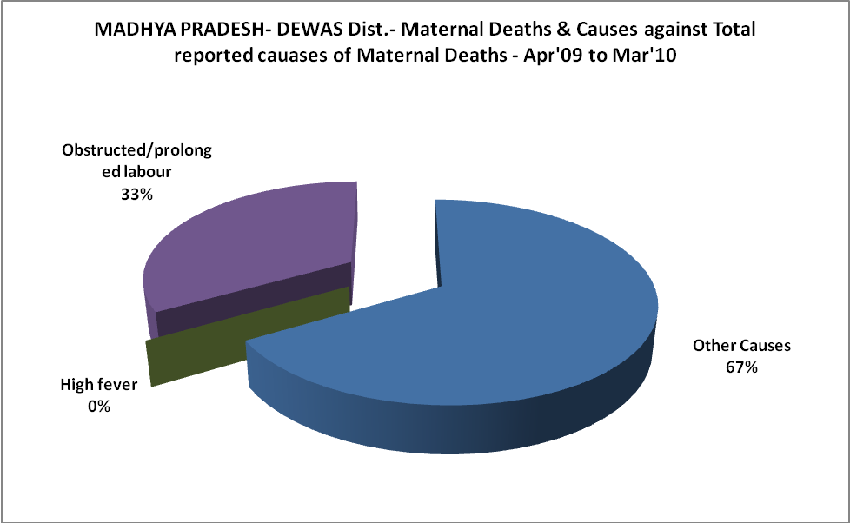

MADHYA PRADESH- DEWAS Dist.-Causes of Deaths in 6 to 55yrs age group - Apr'09 to Mar'10
Diarrhoel Diseases |  |  |  | Tuberculosis |  |  |  | Respiratory Diseases( Other than TB)
6-14 yrs | 15-55 yrs. | Above 55yrs | Total | 6-14 yrs | 15-55 yrs. | Above 55yrs | Total | 6-14 yrs | 15-55 yrs. | Above 55yrs | Total
0 | 3 | 7 | 10 | 0 | 2 | 0 | 2 | 0 | 0 | 4 | 4
Malaria |  |  |  | Other fever Related |  |  |  | HIV/Aids
6-14 yrs | 15-55 yrs. | Above 55yrs | Total | 6-14 yrs | 15-55 yrs. | Above 55yrs | Total | 6-14 yrs | 15-55 yrs. | Above 55yrs | Total
0 | 0 | 0 | 0 | 6 | 27 | 67 | 100 | 0 | 0 | 0 | 0
Heart Disease/Hypertenion related |  |  |  | Neurological Disease including strokes |  |  |  | Trauma/Accidents/ Burn Cases
6-14 yrs | 15-55 yrs. | Above 55yrs | Total | 6-14 yrs | 15-55 yrs. | Above 55yrs | Total | 6-14 yrs | 15-55 yrs. | Above 55yrs | Total
3 | 79 | 216 | 298 | 0 | 0 | 0 | 0 | 4 | 7 | 4 | 15
Suicide |  |  |  | Animal Bites & Stings
6-14 yrs | 15-55 yrs. | Above 55yrs | Total | 6-14 yrs | 15-55 yrs. | Above 55yrs | Total
0 | 0 | 0 | 0 | 0 | 0 | 0 | 0

