[NHSRC]
MP-Dhar
[ Analysis 2009-10]

MADHYA PRADESH- DHAR Dist.- Summary-Apr'09 to Mar'10
ANC
ANC Registration against Expected Pregnancies | 97% | TT1 given to Pregnant women against ANC Registraion | 52%
3 ANC Check ups against ANC Reigtrations | 80% | 100 IFA Tablets given to Pregnant women against ANC Registraion | 93%
Deliveries
Unreported Deliveries against Estimated Deliveries | 20.6% | HOME Deliveries( SBA& Non SBA) against Estimated Deliveries | 17.0%
Institutional Deliveries against Estimated Deliveries | 62.4% | HOME Deliveries( SBA& Non SBA) against Reported Deliveries | 21.4%
Institutional Deliveries against Reported Deliveries | 78.6% | C Section Deliveries against Institutional Deliveries( Pvt & Pub) | 3%
Births & Neonates Care
Live Births Reported against Estimated Live Births | 81% | New borns weighed against Reported Live Births | 92%
Still Births (Reported) | 717 | New borns weighed less than 2.5 kgs against newborns weighed | 42%
Sex Ratio at Birh | 952 | New borns breastfed within one hr of Birth against Reported live Births | 92%
Child Immunisation( 0 to 11 mnths)
BCG given against Expected Live Births | 75% | Measles given against Expected Live Births | 106%
OPV3 given against Expected Live Births | 103% | Fully Immunised Children against Expected Live Births | 106%
DPT3 given against Expected Live Births | 103%
Family Planning
Family Plannig Methods Users ( Sterilisations(Male &Female)+IUD+ Condom pieces/72 + OCP Cycles/13) | 64,489 | IUD Insertions against reported FP Methods | 24%
Sterilisation against reported FP Methods | 21% | Condom Users against reported FP Methods | 34%
 |  | OCP Users against reported FP Methods | 21%
Other Services
OPD | 293,913 | Major Operations | 218
IPD | 61,951 | Minor Operations | 7,564

MADHYA PRADESH- DHAR Dist.- Deliveries Apr'09 to Mar'10
Total Population | 2,067,996 | Expected Deliveries |  | 59,931
Home SBA | Home Non SBA | Institutional | Total Deliveries Reported | Unreported Deliveries
6,441 | 3,736 | 37,409 | 47,586 | 12,345
Home SBA % | Home Non SBA% | Institutional % | Total Deliveries Reported % | Unreported Deliveries %
11% | 6% | 62% | 79% | 21%

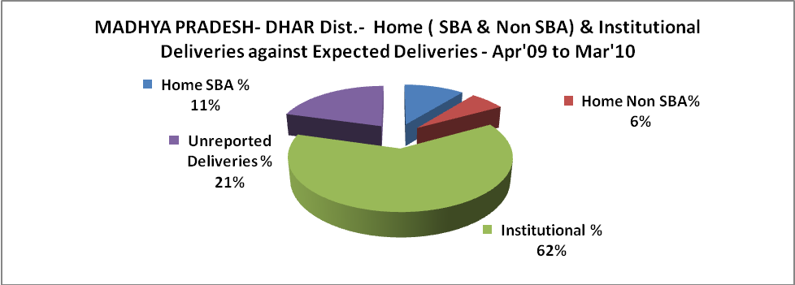

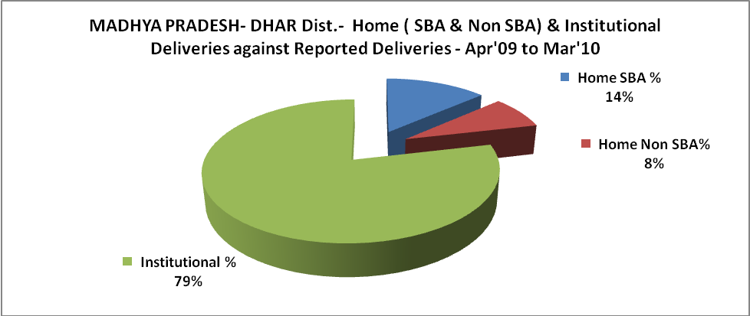

MADHYA PRADESH- DHAR Dist.- C sections & Complicated Deliveries Apr'09 to Mar'10
 | Institutional Deliveries (Public) | Institutional Deliveries (Pvt)
 | 32,986 | 4,423
C Section | 160 | 890
C Section% | 0% | 20%
Complicated Pregnacies attended | 2,734 | 48
Complicated Pregnacies attended % | 8% | 1%

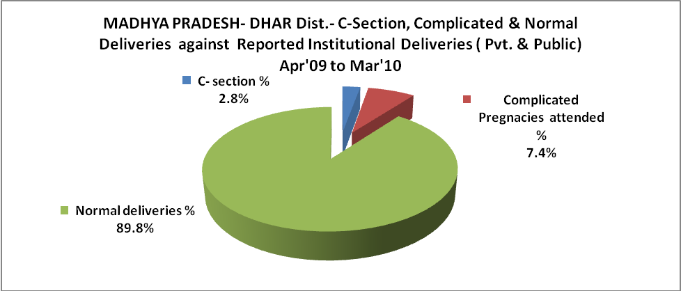

MADHYA PRADESH- DHAR Dist.- Complicated Pregnancies & Deliveries Treated - Apr'09 to Mar'10
Reported Deliveries |  |  | Reported ANC Reigtration
47,586 |  |  | 61,649
Complicated Pregnancies attended | Complicated Pregnancies Rate | C - Section Deliveries | PNC Maternal Complications | Abortions | Still Births
2,782 | 4% | 1,050 | 1,240 | 2,097 | 717
Complicated Deliveries Treated with |  |  |  | No Of Eclampsia cases Treated | No Of severe anemia cases treated
IV Antibiotics | IV antihypertensive/Magsulph injection | IV Oxytocis | Blood Transfusion | No Of Eclampsia cases Treated | No Of severe anemia cases treated
354 | 152 | 123 | 17 | 108 | 1,373

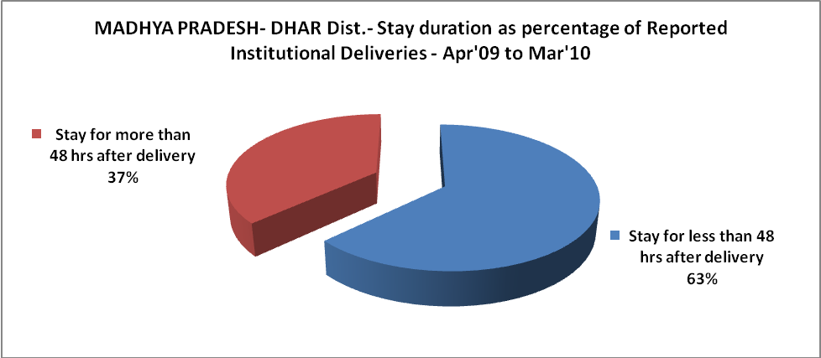

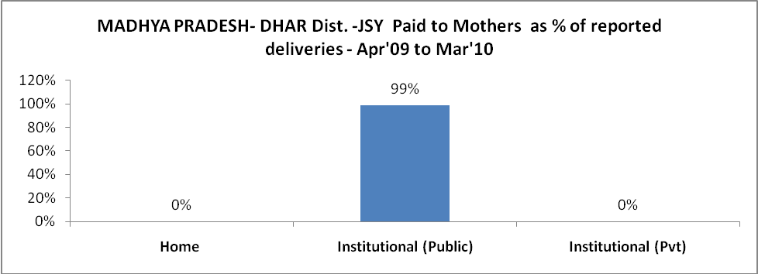

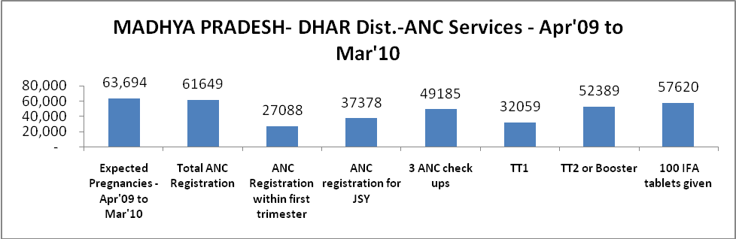

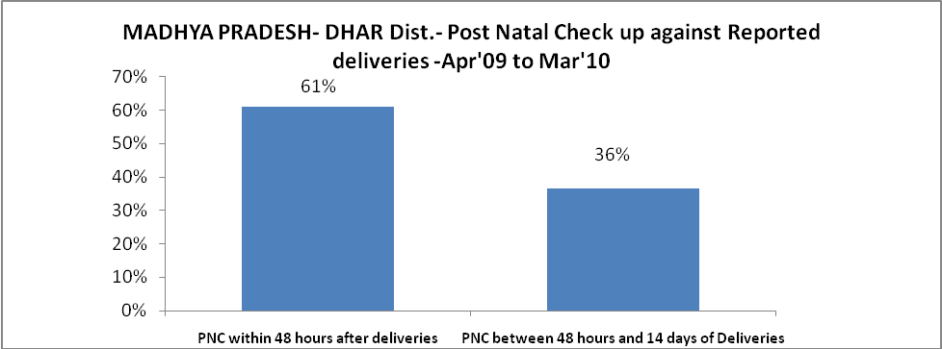

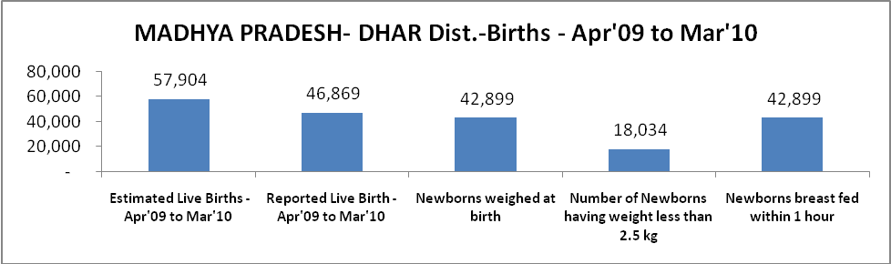

MADHYA PRADESH- DHAR Dist. - Births - Apr'09 to Mar'10
Live Birth - Males | Live Birth - females | Live Birth - Total | Sex Ratio at birth | Still Birth | Abortion( Induced/Spontaneous
24,015 | 22,854 | 46,869 | 952 | 717 | 2,097

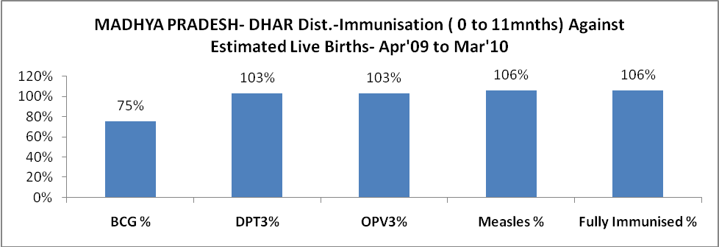

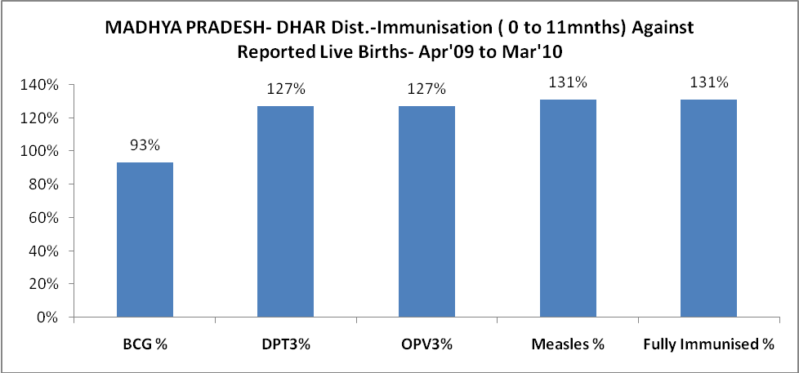

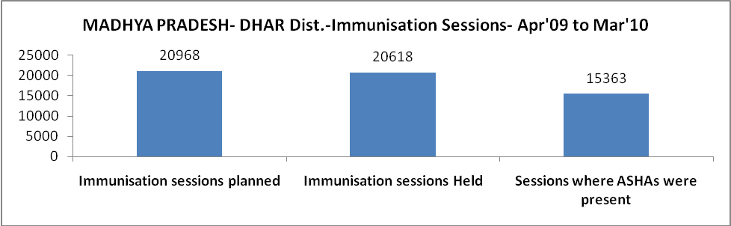

MADHYA PRADESH- DHAR Dist.- Apr'09 to Mar'10
Total Abortions | Abortion Rate
3,849 | 6.0%

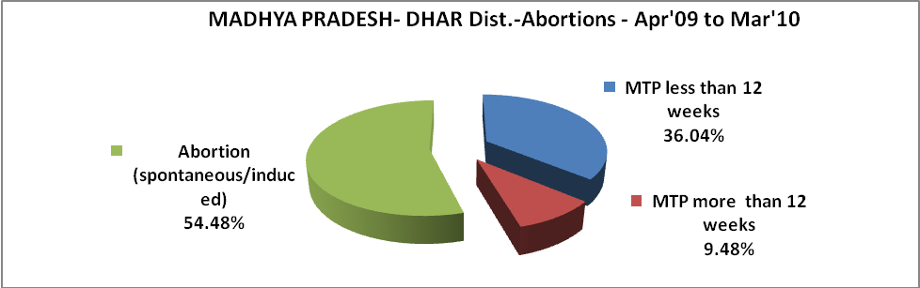

l

MADHYA PRADESH- DHAR Dist.- Apr'09 to Mar'10
Total OPD | Total RTI/STI cases
293,913 | 8,448

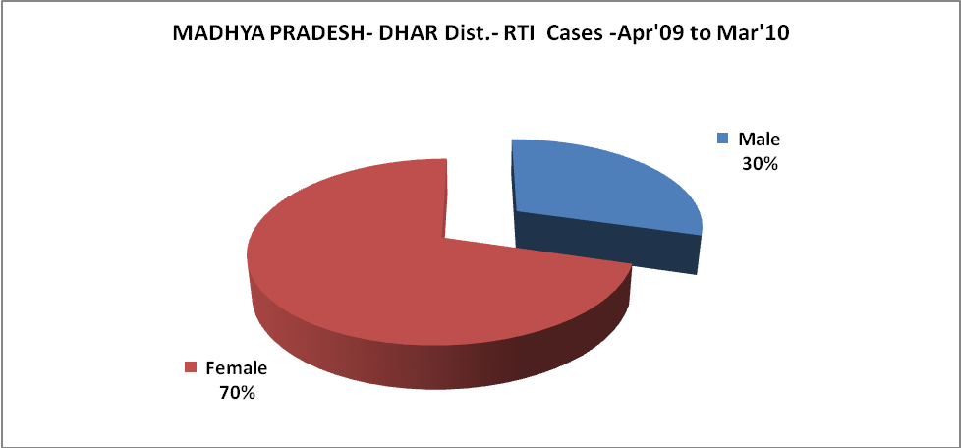

MADHYA PRADESH- DHAR Dist.-Sterilisations - Apr'09 to Mar'10
 | Reported | %age of Reported Sterilisation
Total Sterilisation | 13,607 | -
NSV | 129 | 1%
Laproscopic | 12,461 | 92%
MiniLap | 853 | 6%
Post Partum | 164 | 1%
Male Sterilisation | 129 | 1%
Female Sterilisation | 13,478 | 99%
MADHYA PRADESH- DHAR Dist.-FP Methods - Apr'09 to Mar'10
 | Reported | %age of All Reported FP Methods
Total Reported FP Methodd (All types) Users | 64,489 | -
Sterilisations | 13,607 | 21%
IUD | 15,180 | 24%
Condom Users | 22,008 | 34%
OCP Users | 13,694 | 21%
Limiting Methods | 13,607 | 21%
Spacing Methods | 50,882 | 79%

MADHYA PRADESH- DHAR Dist.- Service Delivery - Apr'09 to Mar'10
Operation major (General and spinal anaesthesia) | Operation minor (No or local anaesthesia) | AYUSH | Dental Procedures | Adolescent counselling services | Total OPD | Total IPD
218 | 7,564 | 1,200 | - | 1,991 | 293,913 | 61,951
Operation major (General and spinal anaesthesia) as %ge of OPD | Operation minor (No or local anaesthesia)as %ge of OPD | AYUSH as %ge of OPD | Dental Procedures as %ge of OPD | Adolescent counselling services as %ge of OPD | IPD as percentage of OPD
0.1% | 2.6% | 0.4% | 0.0% | 0.7% | 21%

MADHYA PRADESH- DHAR Dist.- Lab Services - Apr'09 to Mar'10
Total OPD | Total HB tested | Total HIV Tested | Total Population
293,913 | 20,254 | 13 | 2,067,996
HB test conducted as %age of OPD | HB<7gm as %age of HB tested | HIV test conducted as %age of OPD | HIV positive as %age of HIV tested | Blood Smear Examined as % of Population
6.9% | 3.9% | 0.0% | 0.0% | 8.1%
MADHYA PRADESH- DHAR Dist.- Childhood Disease - Vaccine Preventable -Apr'09 to Mar'10
Diphtheria | Pertussis | Tetanus Neonatorum | Tetanus others | Polio | Measles
123 | 0 | 0 | 0 | 0 | 158
MADHYA PRADESH- DHAR Dist.-Childhood Disease - Others - Apr'09 to Mar'10
Diarrhoea and dehydration | Malaria | Number admitted with Respiratory Infections
7,989 | 5,276 | 781
MADHYA PRADESH- DHAR Dist.- Infant & Child Deaths - Apr'09 to Mar'10
Infant Deaths within 24 hrs of birth | Infant Deaths between 24hrs & under 1 week | Infant Deaths between 1 week & under 1 month | Child Deaths between 1 month & under 1 year | Child Deaths between 1yr under 5years | Total Deaths
66 | 212 | 104 | 163 | 106 | 651

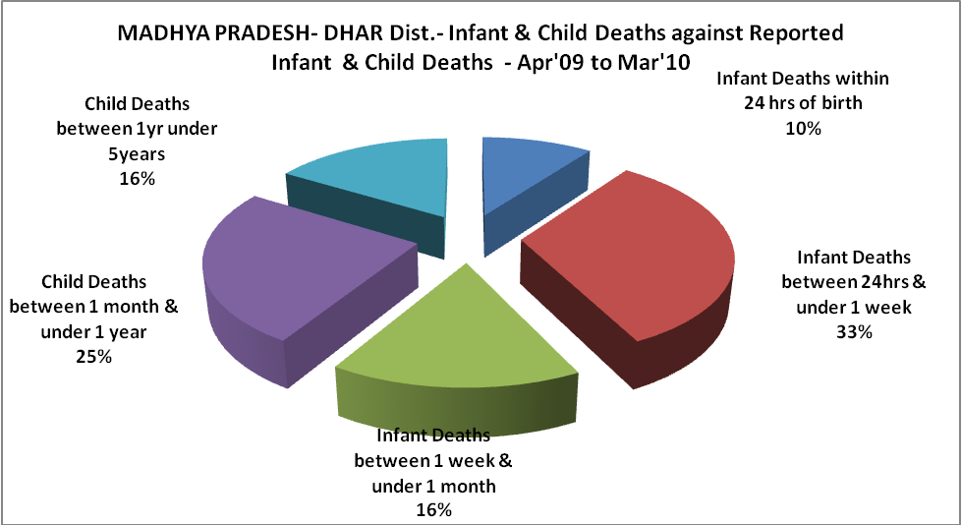

MADHYA PRADESH- DHAR Dist.- Causes of Infant & Child Deaths - Apr'09 to Mar'10
Sepsis |  |  | Asphyxia |  |  | LBW
Up to 1 Weeks of Birth | Between 1 week & 4 weeks of birth | Total | Up to 1 Weeks of Birth | Between 1 week & 4 weeks of birth | Total | Up to 1 Weeks of Birth | Between 1 week & 4 weeks of birth | Total
9 | 0 | 9 | 24 | 10 | 34 | 69 | 30 | 99
Pneumonia |  |  | Diarrhoea |  |  | Fever related
Between 1 month and 11 months | Between 1 year & 5 years | Total | Between 1 month and 11 months | Between 1 year & 5 years | Total | Between 1 month and 11 months | Between 1 year & 5 years | Total
50 | 17 | 67 | 1 | 0 | 1 | 3 | 1 | 4
Others |  |  | Measles |  |  | Others
Up to 1 Weeks of Birth | Between 1 week & 4 weeks of birth | Total | Between 1 month and 11 months | Between 1 year & 5 years | Total | Between 1 month and 11 months | Between 1 year & 5 years | Total
110 | 64 | 174 | 0 | 0 | 0 | 109 | 88 | 197

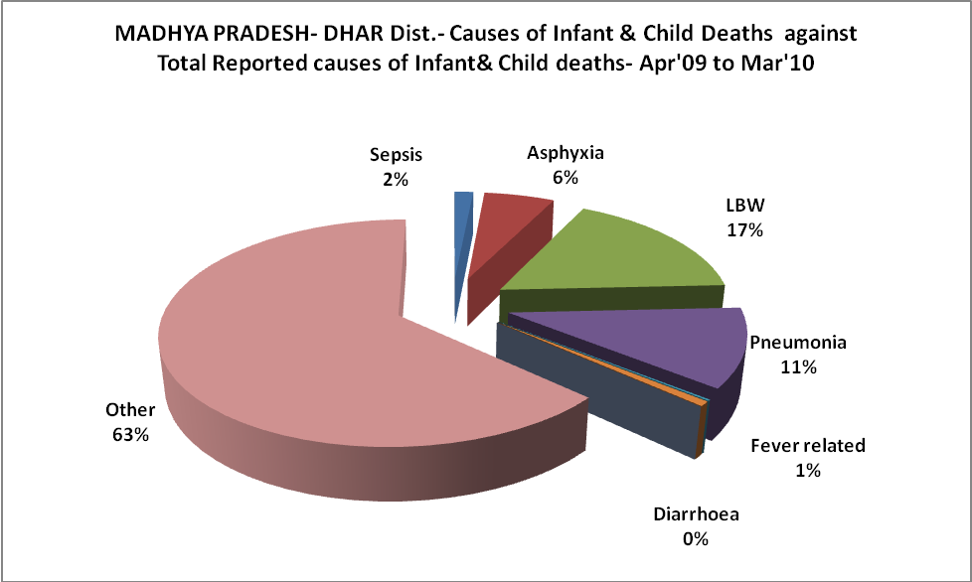

MADHYA PRADESH- DHAR Dist.- Maternal Deaths & Causes - Apr'09 to Mar'10
Abortion |  |  | Obstructed/prolonged labour |  |  | Severe hypertesnion/fits
6-14 yrs | 15-55 yrs. | Total | 6-14 yrs | 15-55 yrs. | Total | 6-14 yrs | 15-55 yrs. | Total
0 | 0 | 0 | 0 | 0 | 0 | 0 | 0 | 0
Bleeding |  |  | High Fever |  |  | Other Causes
6-14 yrs | 15-55 yrs. | Total | 6-14 yrs | 15-55 yrs. | Total | 6-14 yrs | 15-55 yrs. | Total
0 | 2 | 2 | 0 | 1 | 1 | 0 | 25 | 25

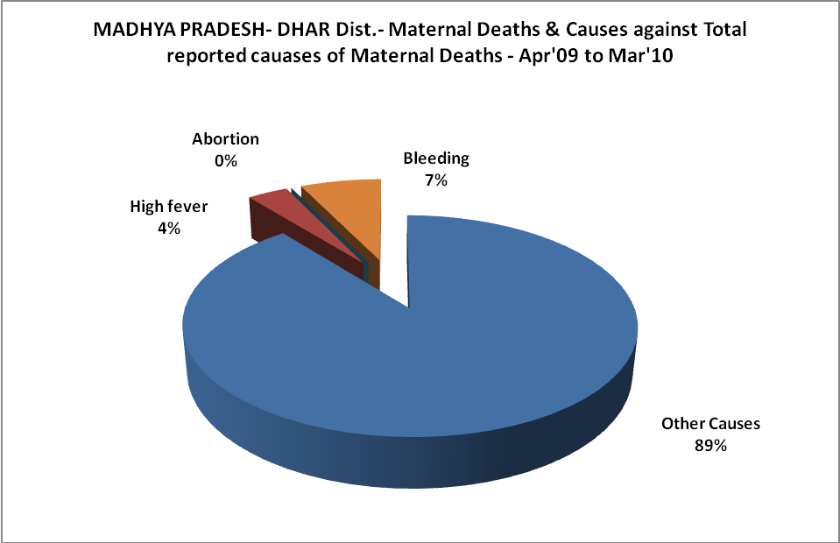

MADHYA PRADESH- DHAR Dist.-Causes of Deaths in 6 to 55yrs age group - Apr'09 to Mar'10
Diarrhoel Diseases |  |  |  | Tuberculosis |  |  |  | Respiratory Diseases( Other than TB)
6-14 yrs | 15-55 yrs. | Above 55yrs | Total | 6-14 yrs | 15-55 yrs. | Above 55yrs | Total | 6-14 yrs | 15-55 yrs. | Above 55yrs | Total
22 | 50 | 41 | 113 | 0 | 11 | 36 | 47 | 2 | 4 | 5 | 11
Malaria |  |  |  | Other fever Related |  |  |  | HIV/Aids
6-14 yrs | 15-55 yrs. | Above 55yrs | Total | 6-14 yrs | 15-55 yrs. | Above 55yrs | Total | 6-14 yrs | 15-55 yrs. | Above 55yrs | Total
1 | 4 | 8 | 13 | 17 | 46 | 49 | 112 | 0 | 0 | 0 | 0
Heart Disease/Hypertenion related |  |  |  | Neurological Disease including strokes |  |  |  | Trauma/Accidents/ Burn Cases
6-14 yrs | 15-55 yrs. | Above 55yrs | Total | 6-14 yrs | 15-55 yrs. | Above 55yrs | Total | 6-14 yrs | 15-55 yrs. | Above 55yrs | Total
0 | 18 | 24 | 42 | 0 | 2 | 3 | 5 | 0 | 17 | 4 | 21
Suicide |  |  |  | Animal Bites & Stings
6-14 yrs | 15-55 yrs. | Above 55yrs | Total | 6-14 yrs | 15-55 yrs. | Above 55yrs | Total
0 | 2 | 0 | 2 | 3 | 2 | 0 | 5

