[NHSRC]
MP-Dindori
[ Analysis 2009-10]

MADHYA PRADESH- DINDORI Dist.- Summary-Apr'09 to Mar'10
ANC
ANC Registration against Expected Pregnancies | 86% | TT1 given to Pregnant women against ANC Registraion | 99%
3 ANC Check ups against ANC Reigtrations | 86% | 100 IFA Tablets given to Pregnant women against ANC Registraion | 85%
Deliveries
Unreported Deliveries against Estimated Deliveries | 14.4% | HOME Deliveries( SBA& Non SBA) against Estimated Deliveries | 51.7%
Institutional Deliveries against Estimated Deliveries | 34.0% | HOME Deliveries( SBA& Non SBA) against Reported Deliveries | 60.3%
Institutional Deliveries against Reported Deliveries | 39.7% | C Section Deliveries against Institutional Deliveries( Pvt & Pub) | 0%
Births & Neonates Care
Live Births Reported against Estimated Live Births | 88% | New borns weighed against Reported Live Births | 86%
Still Births (Reported) | 238 | New borns weighed less than 2.5 kgs against newborns weighed | 8%
Sex Ratio at Birh | 932 | New borns breastfed within one hr of Birth against Reported live Births | 34%
Child Immunisation( 0 to 11 mnths)
BCG given against Expected Live Births | 83% | Measles given against Expected Live Births | 82%
OPV3 given against Expected Live Births | 82% | Fully Immunised Children against Expected Live Births | 82%
DPT3 given against Expected Live Births | 86%
Family Planning
Family Plannig Methods Users ( Sterilisations(Male &Female)+IUD+ Condom pieces/72 + OCP Cycles/13) | 26,942 | IUD Insertions against reported FP Methods | 8%
Sterilisation against reported FP Methods | 23% | Condom Users against reported FP Methods | 46%
 |  | OCP Users against reported FP Methods | 23%
Other Services
OPD | 240,313 | Major Operations | -
IPD | 24,205 | Minor Operations | -

MADHYA PRADESH- DINDORI Dist.- Deliveries Apr'09 to Mar'10
Total Population | 690,324 | Expected Deliveries |  | 20,006
Home SBA | Home Non SBA | Institutional | Total Deliveries Reported | Unreported Deliveries
708 | 9,628 | 6,794 | 17,130 | 2,876
Home SBA % | Home Non SBA% | Institutional % | Total Deliveries Reported % | Unreported Deliveries %
4% | 48% | 34% | 86% | 14%

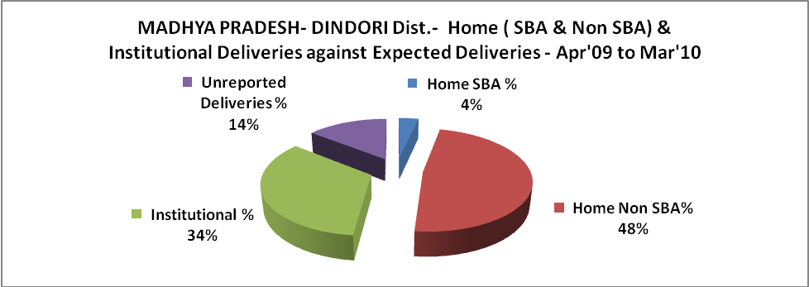

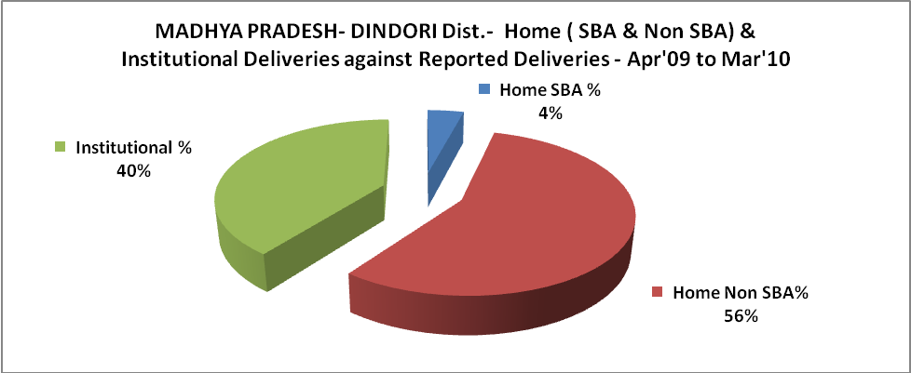

MADHYA PRADESH- DINDORI Dist.- C sections & Complicated Deliveries Apr'09 to Mar'10
 | Institutional Deliveries (Public) | Institutional Deliveries (Pvt)
 | 6,794 | -
C Section | - | -
C Section% | 0% | 0%
Complicated Pregnacies attended | 473 | -
Complicated Pregnacies attended % | 7% | 0%

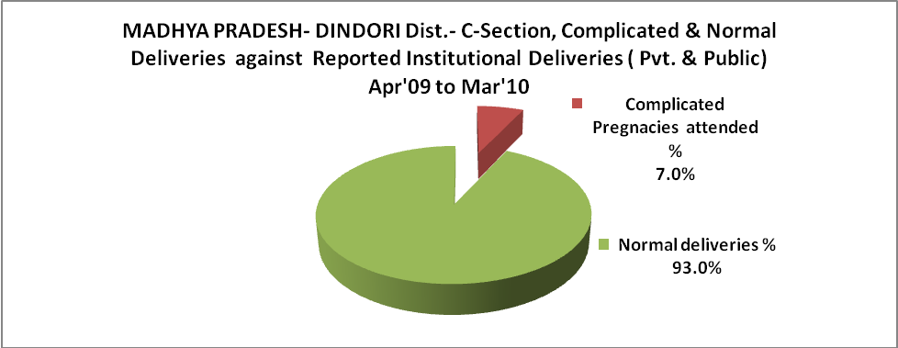

MADHYA PRADESH- DINDORI Dist.- Complicated Pregnancies & Deliveries Treated - Apr'09 to Mar'10
Reported Deliveries |  |  | Reported ANC Reigtration
17,130 |  |  | 18,228
Complicated Pregnancies attended | Complicated Pregnancies Rate | C - Section Deliveries | PNC Maternal Complications | Abortions | Still Births
473 | 2% | - | 71 | 113 | 238
Complicated Deliveries Treated with |  |  |  | No Of Eclampsia cases Treated | No Of severe anemia cases treated
IV Antibiotics | IV antihypertensive/Magsulph injection | IV Oxytocis | Blood Transfusion | No Of Eclampsia cases Treated | No Of severe anemia cases treated
582 | 5 | 268 | - | 19 | 104

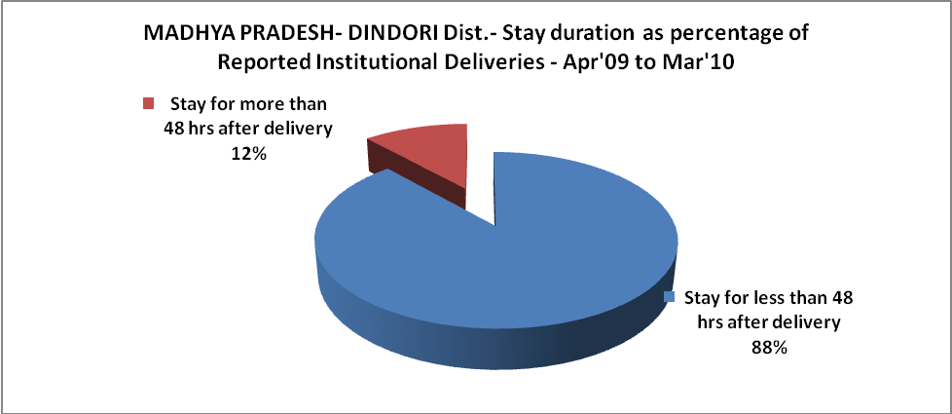

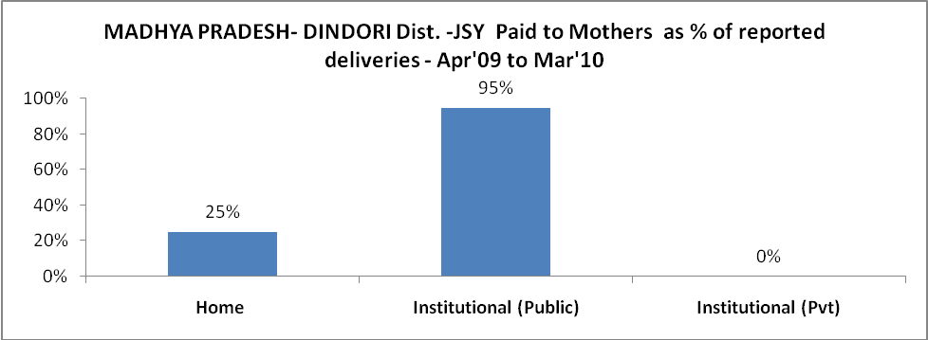

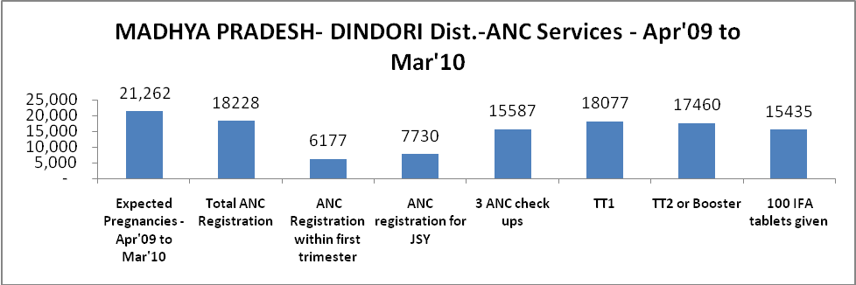

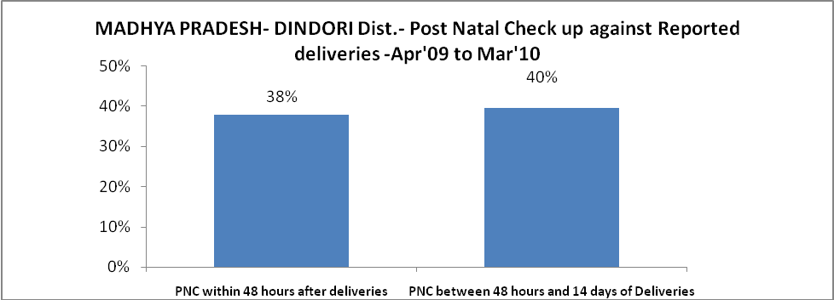

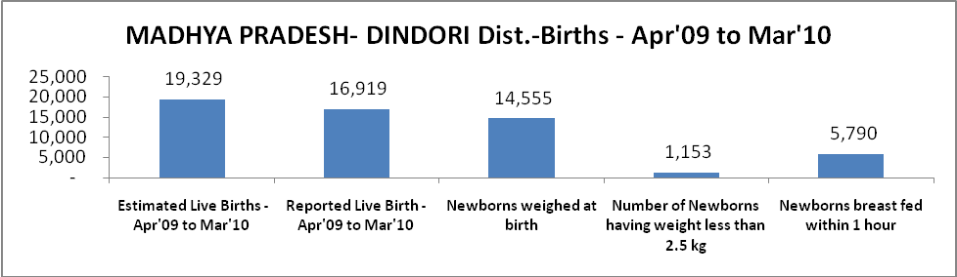

MADHYA PRADESH- DINDORI Dist. - Births - Apr'09 to Mar'10
Live Birth - Males | Live Birth - females | Live Birth - Total | Sex Ratio at birth | Still Birth | Abortion( Induced/Spontaneous
8,759 | 8,160 | 16,919 | 932 | 238 | 113

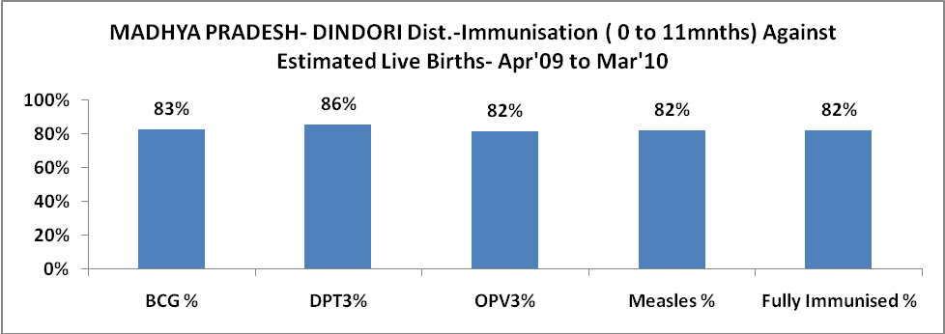

l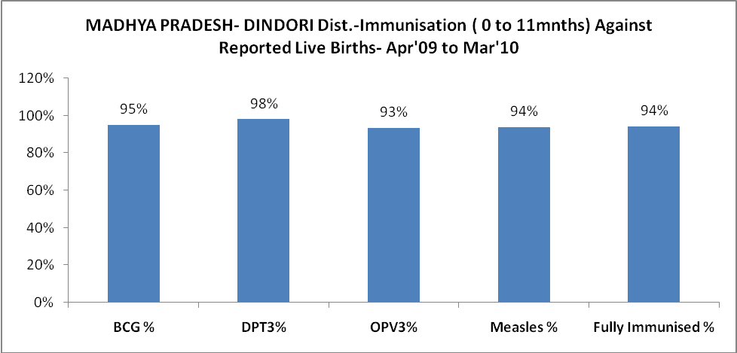

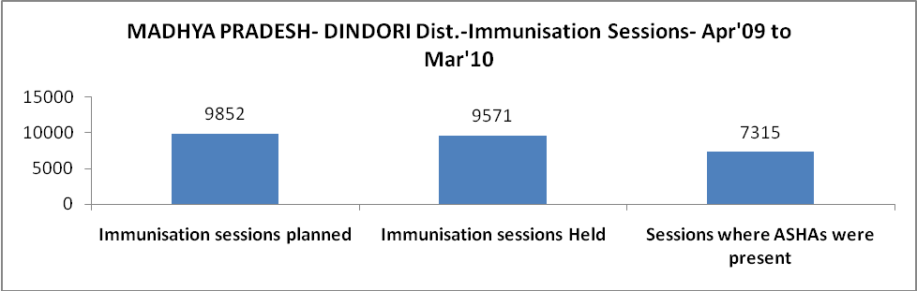

MADHYA PRADESH- DINDORI Dist.- Apr'09 to Mar'10
Total Abortions | Abortion Rate
196 | 0.9%

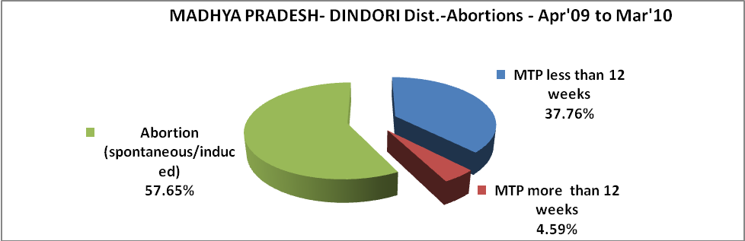

MADHYA PRADESH- DINDORI Dist.- Apr'09 to Mar'10
Total OPD | Total RTI/STI cases
240,313 | 2,285

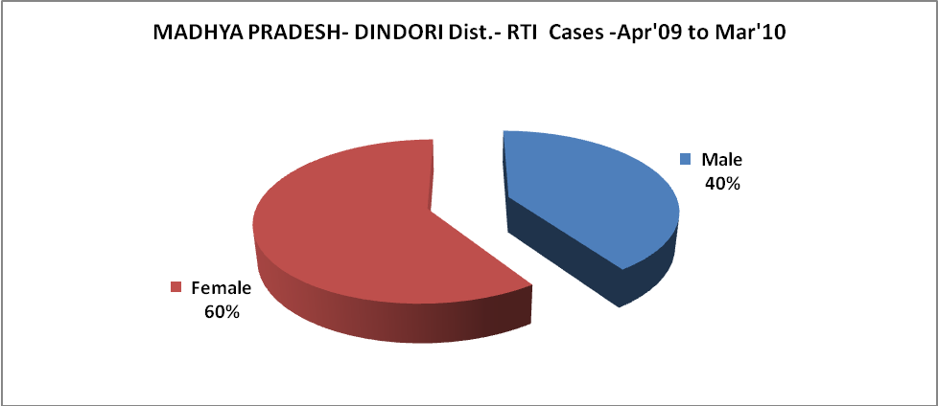

MADHYA PRADESH- DINDORI Dist.-Sterilisations - Apr'09 to Mar'10
 | Reported | %age of Reported Sterilisation
Total Sterilisation | 6,101 | -
NSV | 55 | 1%
Laproscopic | 6,045 | 99%
MiniLap | - | 0%
Post Partum | 1 | 0%
Male Sterilisation | 55 | 1%
Female Sterilisation | 6,046 | 99%
MADHYA PRADESH- DINDORI Dist.-FP Methods - Apr'09 to Mar'10
 | Reported | %age of All Reported FP Methods
Total Reported FP Methodd (All types) Users | 26,942 | -
Sterilisations | 6,101 | 23%
IUD | 2,126 | 8%
Condom Users | 12,486 | 46%
OCP Users | 6,230 | 23%
Limiting Methods | 6,101 | 23%
Spacing Methods | 20,841 | 77%

MADHYA PRADESH- DINDORI Dist.- Service Delivery - Apr'09 to Mar'10
Operation major (General and spinal anaesthesia) | Operation minor (No or local anaesthesia) | AYUSH | Dental Procedures | Adolescent counselling services | Total OPD | Total IPD
- | - | - | - | 93 | 240,313 | 24,205
Operation major (General and spinal anaesthesia) as %ge of OPD | Operation minor (No or local anaesthesia)as %ge of OPD | AYUSH as %ge of OPD | Dental Procedures as %ge of OPD | Adolescent counselling services as %ge of OPD | IPD as percentage of OPD
0.0% | 0.0% | 0.0% | 0.0% | 0.0% | 10%

MADHYA PRADESH- DINDORI Dist.- Lab Services - Apr'09 to Mar'10
Total OPD | Total HB tested | Total HIV Tested | Total Population
240,313 | 6,924 | 2,828 | 690,324
HB test conducted as %age of OPD | HB<7gm as %age of HB tested | HIV test conducted as %age of OPD | HIV positive as %age of HIV tested | Blood Smear Examined as % of Population
2.9% | 4.6% | 1.2% | 0.1% | 18.7%

MADHYA PRADESH- DINDORI Dist.- Childhood Disease - Vaccine Preventable -Apr'09 to Mar'10
Diphtheria | Pertussis | Tetanus Neonatorum | Tetanus others | Polio | Measles
0 | 0 | 0 | 0 | 0 | 26
MADHYA PRADESH- DINDORI Dist.-Childhood Disease - Others - Apr'09 to Mar'10
Diarrhoea and dehydration | Malaria | Number admitted with Respiratory Infections
11,660 | 233 | 9,422
MADHYA PRADESH- DINDORI Dist.- Infant & Child Deaths - Apr'09 to Mar'10
Infant Deaths within 24 hrs of birth | Infant Deaths between 24hrs & under 1 week | Infant Deaths between 1 week & under 1 month | Child Deaths between 1 month & under 1 year | Child Deaths between 1yr under 5years | Total Deaths
91 | 105 | 59 | 92 | 148 | 495

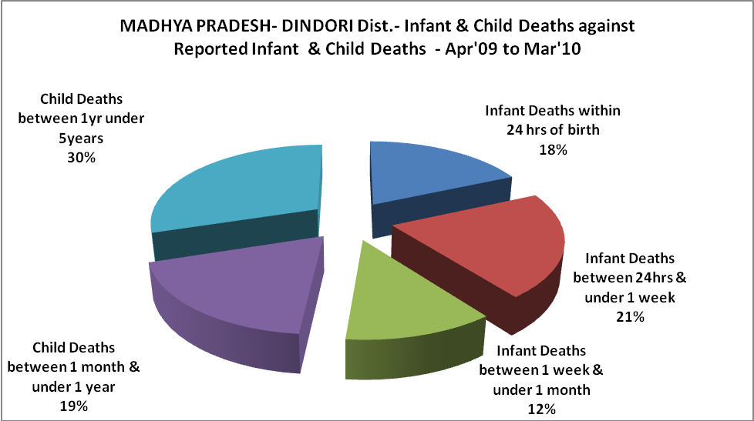

MADHYA PRADESH- DINDORI Dist.- Causes of Infant & Child Deaths - Apr'09 to Mar'10
Sepsis |  |  | Asphyxia |  |  | LBW
Up to 1 Weeks of Birth | Between 1 week & 4 weeks of birth | Total | Up to 1 Weeks of Birth | Between 1 week & 4 weeks of birth | Total | Up to 1 Weeks of Birth | Between 1 week & 4 weeks of birth | Total
6 | 1 | 7 | 10 | 9 | 19 | 17 | 2 | 19
Pneumonia |  |  | Diarrhoea |  |  | Fever related
Between 1 month and 11 months | Between 1 year & 5 years | Total | Between 1 month and 11 months | Between 1 year & 5 years | Total | Between 1 month and 11 months | Between 1 year & 5 years | Total
22 | 33 | 55 | 2 | 5 | 7 | 5 | 17 | 22
Others |  |  | Measles |  |  | Others
Up to 1 Weeks of Birth | Between 1 week & 4 weeks of birth | Total | Between 1 month and 11 months | Between 1 year & 5 years | Total | Between 1 month and 11 months | Between 1 year & 5 years | Total
72 | 47 | 119 | 0 | 0 | 0 | 63 | 93 | 156

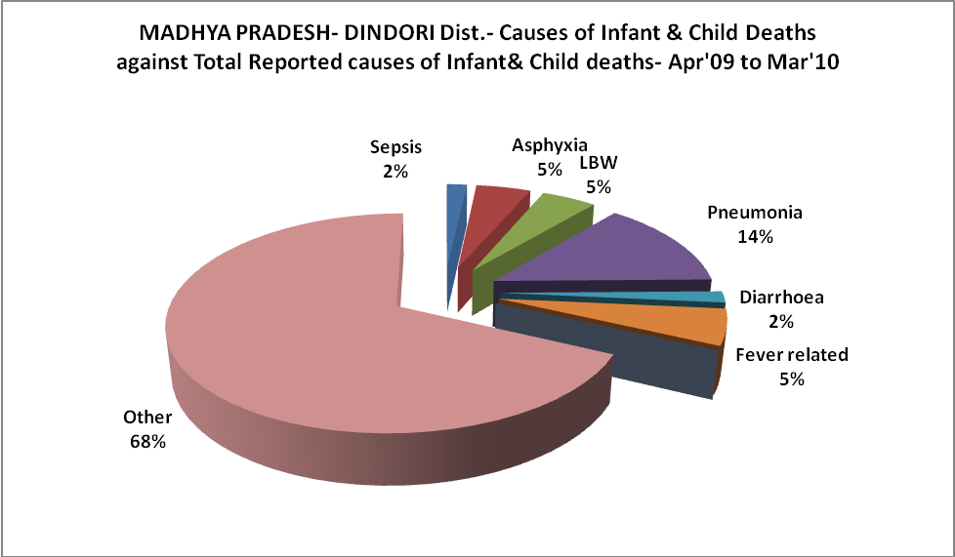

MADHYA PRADESH- DINDORI Dist.- Maternal Deaths & Causes - Apr'09 to Mar'10
Abortion |  |  | Obstructed/prolonged labour |  |  | Severe hypertesnion/fits
6-14 yrs | 15-55 yrs. | Total | 6-14 yrs | 15-55 yrs. | Total | 6-14 yrs | 15-55 yrs. | Total
0 | 0 | 0 | 0 | 2 | 2 | 0 | 3 | 3
Bleeding |  |  | High Fever |  |  | Other Causes
6-14 yrs | 15-55 yrs. | Total | 6-14 yrs | 15-55 yrs. | Total | 6-14 yrs | 15-55 yrs. | Total
0 | 1 | 1 | 0 | 0 | 0 | 0 | 12 | 12

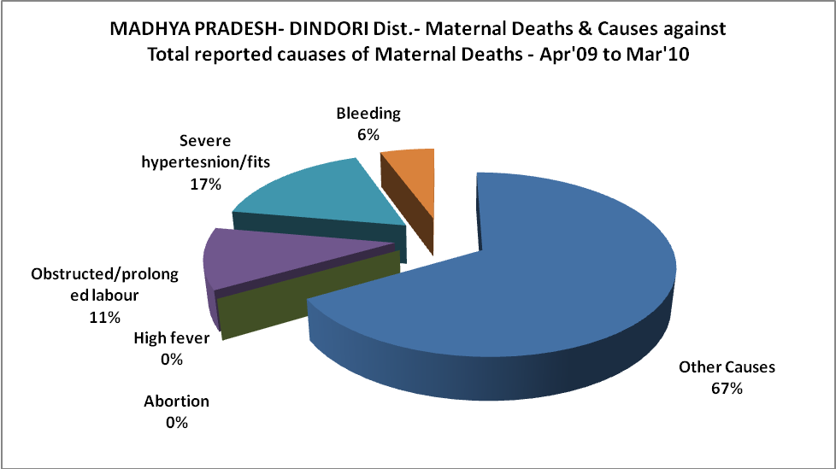

MADHYA PRADESH- DINDORI Dist.-Causes of Deaths in 6 to 55yrs age group - Apr'09 to Mar'10
Diarrhoel Diseases |  |  |  | Tuberculosis |  |  |  | Respiratory Diseases( Other than TB)
6-14 yrs | 15-55 yrs. | Above 55yrs | Total | 6-14 yrs | 15-55 yrs. | Above 55yrs | Total | 6-14 yrs | 15-55 yrs. | Above 55yrs | Total
14 | 59 | 21 | 94 | 1 | 6 | 6 | 13 | 3 | 18 | 36 | 57
Malaria |  |  |  | Other fever Related |  |  |  | HIV/Aids
6-14 yrs | 15-55 yrs. | Above 55yrs | Total | 6-14 yrs | 15-55 yrs. | Above 55yrs | Total | 6-14 yrs | 15-55 yrs. | Above 55yrs | Total
3 | 9 | 1 | 13 | 35 | 325 | 474 | 834 | 1 | 0 | 1 | 2
Heart Disease/Hypertenion related |  |  |  | Neurological Disease including strokes |  |  |  | Trauma/Accidents/ Burn Cases
6-14 yrs | 15-55 yrs. | Above 55yrs | Total | 6-14 yrs | 15-55 yrs. | Above 55yrs | Total | 6-14 yrs | 15-55 yrs. | Above 55yrs | Total
1 | 19 | 40 | 60 | 4 | 10 | 36 | 50 | 7 | 16 | 2 | 25
Suicide |  |  |  | Animal Bites & Stings
6-14 yrs | 15-55 yrs. | Above 55yrs | Total | 6-14 yrs | 15-55 yrs. | Above 55yrs | Total
1 | 6 | 2 | 9 | 7 | 4 | 0 | 11

