[NHSRC]
MP-Guna
[ Analysis 2009-10]

MADHYA PRADESH- GUNA Dist.- Summary-Apr'09 to Mar'10
ANC
ANC Registration against Expected Pregnancies | 61% | TT1 given to Pregnant women against ANC Registraion | 95%
3 ANC Check ups against ANC Reigtrations | 79% | 100 IFA Tablets given to Pregnant women against ANC Registraion | 90%
Deliveries
Unreported Deliveries against Estimated Deliveries | 43.3% | HOME Deliveries( SBA& Non SBA) against Estimated Deliveries | 1.5%
Institutional Deliveries against Estimated Deliveries | 55.2% | HOME Deliveries( SBA& Non SBA) against Reported Deliveries | 2.6%
Institutional Deliveries against Reported Deliveries | 97.4% | C Section Deliveries against Institutional Deliveries( Pvt & Pub) | 2%
Births & Neonates Care
Live Births Reported against Estimated Live Births | 58% | New borns weighed against Reported Live Births | 93%
Still Births (Reported) | 490 | New borns weighed less than 2.5 kgs against newborns weighed | 9%
Sex Ratio at Birh | 892 | New borns breastfed within one hr of Birth against Reported live Births | 72%
Child Immunisation( 0 to 11 mnths)
BCG given against Expected Live Births | 56% | Measles given against Expected Live Births | 60%
OPV3 given against Expected Live Births | 59% | Fully Immunised Children against Expected Live Births | 54%
DPT3 given against Expected Live Births | 59%
Family Planning
Family Plannig Methods Users ( Sterilisations(Male &Female)+IUD+ Condom pieces/72 + OCP Cycles/13) | 30,314 | IUD Insertions against reported FP Methods | 40%
Sterilisation against reported FP Methods | 25% | Condom Users against reported FP Methods | 16%
 |  | OCP Users against reported FP Methods | 20%
Other Services
OPD | 245,326 | Major Operations | 1,066
IPD | 45,484 | Minor Operations | 2,719

MADHYA PRADESH- GUNA Dist.- Deliveries Apr'09 to Mar'10
Total Population | 1,980,839 | Expected Deliveries |  | 57,405
Home SBA | Home Non SBA | Institutional | Total Deliveries Reported | Unreported Deliveries
- | 843 | 31,715 | 32,558 | 24,847
Home SBA % | Home Non SBA% | Institutional % | Total Deliveries Reported % | Unreported Deliveries %
0% | 1% | 55% | 57% | 43%

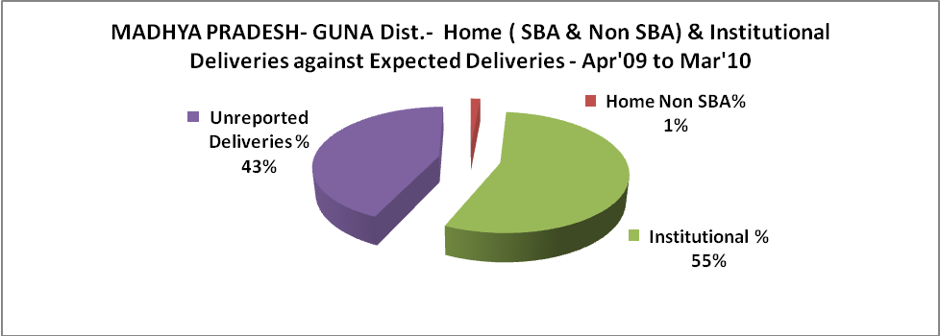

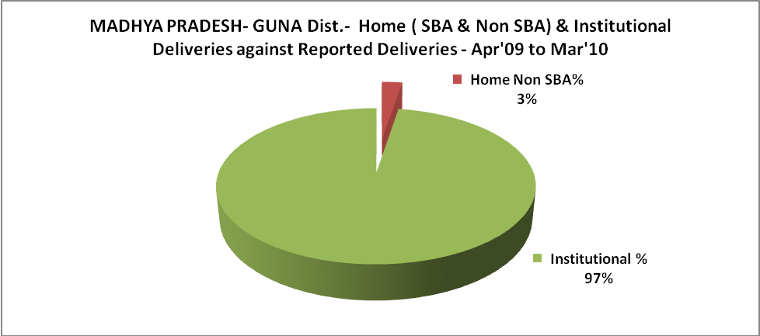

MADHYA PRADESH- GUNA Dist.- C sections & Complicated Deliveries Apr'09 to Mar'10
 | Institutional Deliveries (Public) | Institutional Deliveries (Pvt)
 | 30,045 | 1,670
C Section | 374 | 133
C Section% | 1% | 8%
Complicated Pregnacies attended | 1,468 | -
Complicated Pregnacies attended % | 5% | 0%

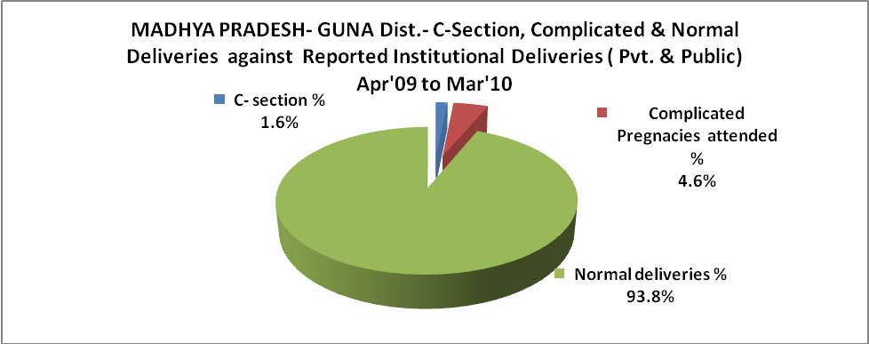

MADHYA PRADESH- GUNA Dist.- Complicated Pregnancies & Deliveries Treated - Apr'09 to Mar'10
Reported Deliveries |  |  | Reported ANC Reigtration
32,558 |  |  | 37,020
Complicated Pregnancies attended | Complicated Pregnancies Rate | C - Section Deliveries | PNC Maternal Complications | Abortions | Still Births
1,468 | 2% | 507 | 495 | 495 | 490
Complicated Deliveries Treated with |  |  |  | No Of Eclampsia cases Treated | No Of severe anemia cases treated
IV Antibiotics | IV antihypertensive/Magsulph injection | IV Oxytocis | Blood Transfusion | No Of Eclampsia cases Treated | No Of severe anemia cases treated
1,059 | 63 | 435 | 604 | 33 | 276

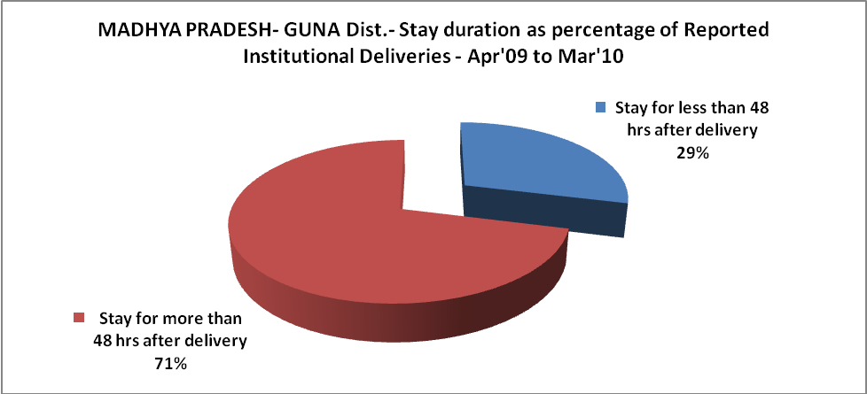

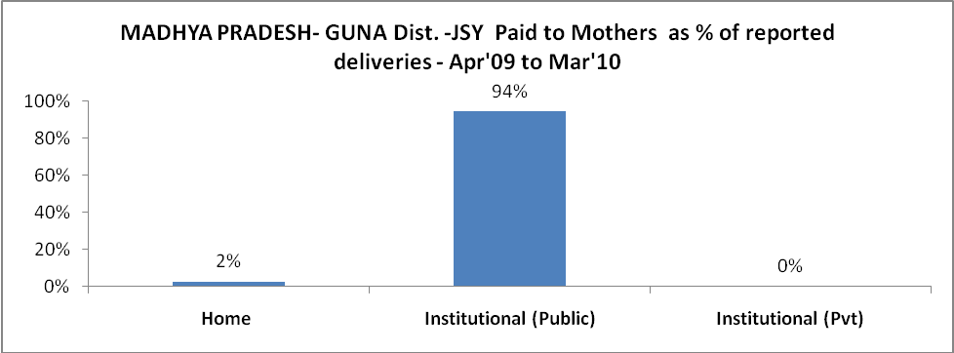

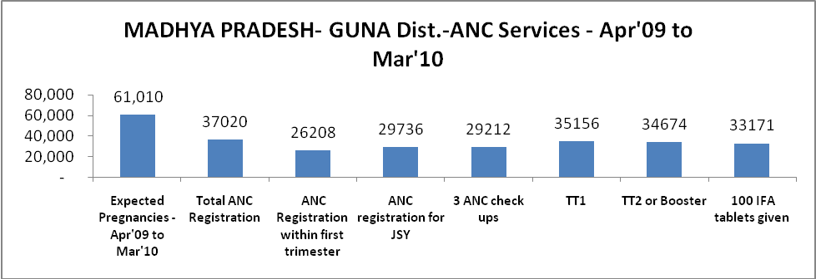

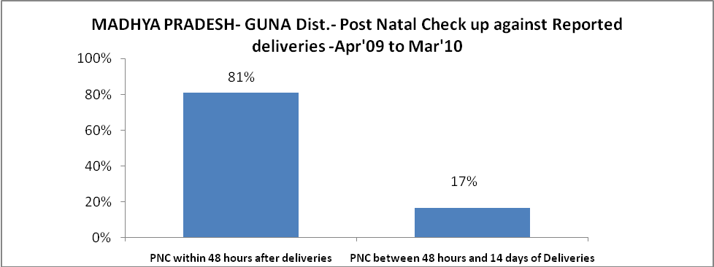

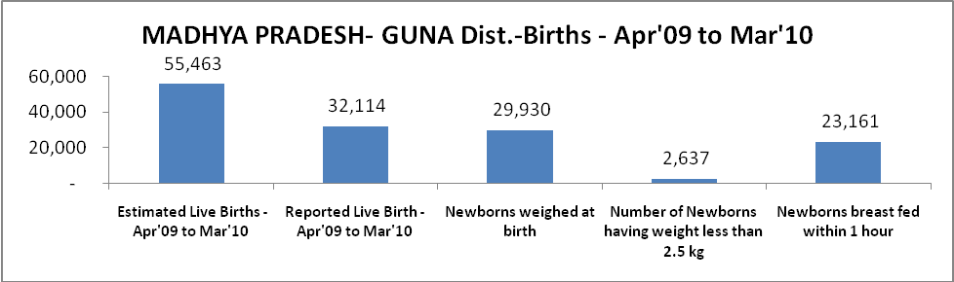

MADHYA PRADESH- GUNA Dist. - Births - Apr'09 to Mar'10
Live Birth - Males | Live Birth - females | Live Birth - Total | Sex Ratio at birth | Still Birth | Abortion( Induced/Spontaneous
16,973 | 15,141 | 32,114 | 892 | 490 | 495

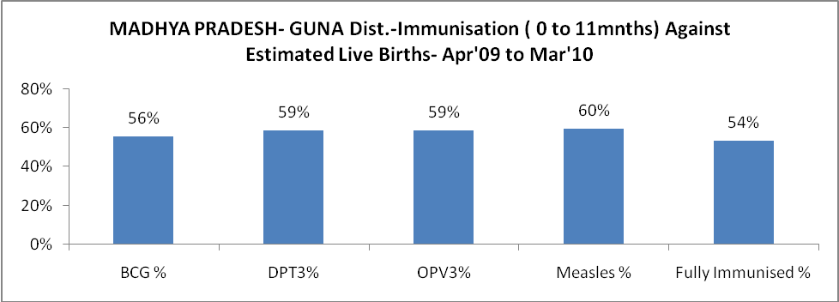

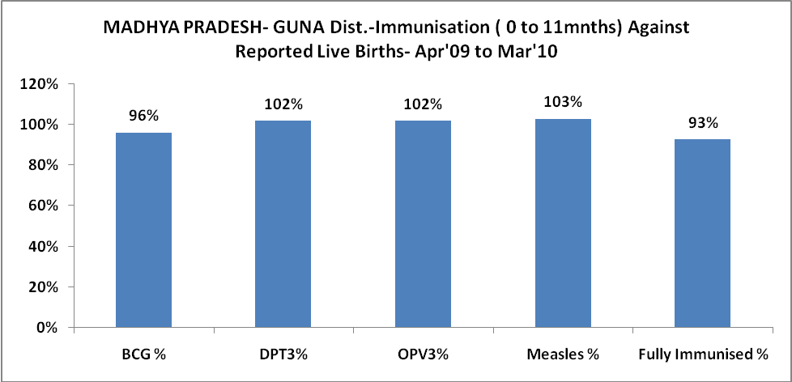

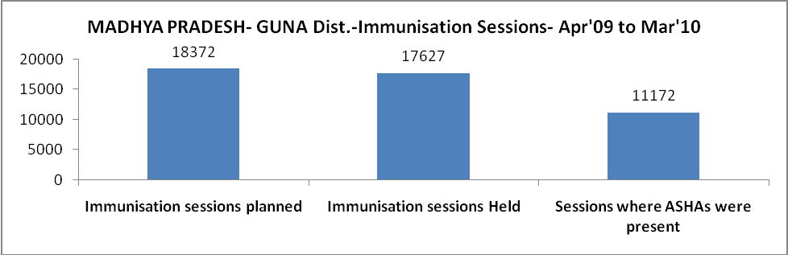

l

MADHYA PRADESH- GUNA Dist.- Apr'09 to Mar'10
Total Abortions | Abortion Rate
975 | 1.6%

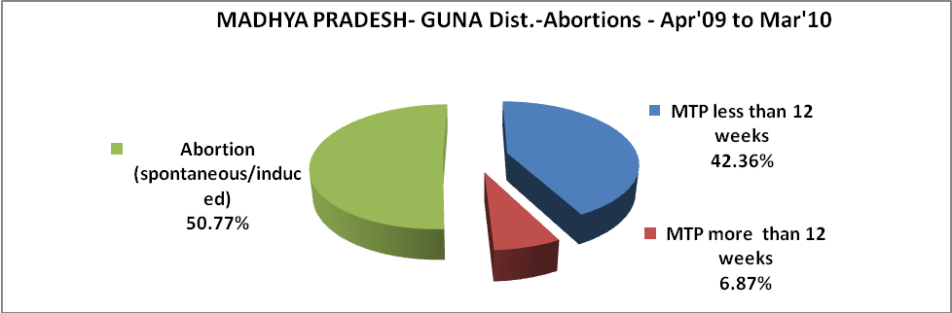

MADHYA PRADESH- GUNA Dist.- Apr'09 to Mar'10
Total OPD | Total RTI/STI cases
245,326 | 8,135

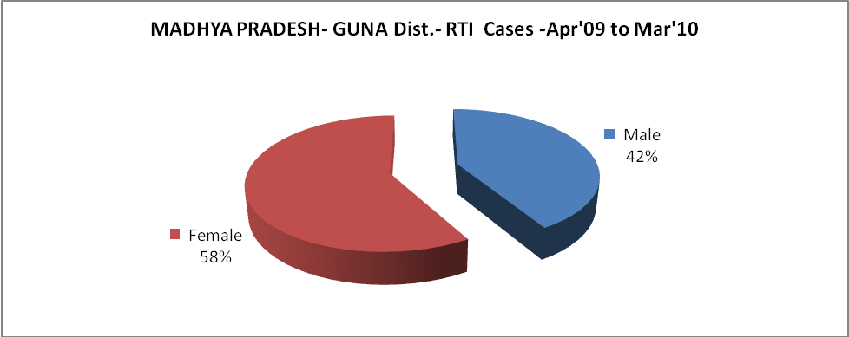

MADHYA PRADESH- GUNA Dist.-Sterilisations - Apr'09 to Mar'10
 | Reported | %age of Reported Sterilisation
Total Sterilisation | 7,481 | -
NSV | 158 | 2%
Laproscopic | 6,515 | 87%
MiniLap | 33 | 0%
Post Partum | 775 | 10%
Male Sterilisation | 158 | 2%
Female Sterilisation | 7,323 | 98%
MADHYA PRADESH- GUNA Dist.-FP Methods - Apr'09 to Mar'10
 | Reported | %age of All Reported FP Methods
Total Reported FP Methodd (All types) Users | 30,314 | -
Sterilisations | 7,481 | 25%
IUD | 11,997 | 40%
Condom Users | 4,712 | 16%
OCP Users | 6,125 | 20%
Limiting Methods | 7,481 | 25%
Spacing Methods | 22,833 | 75%

MADHYA PRADESH- GUNA Dist.- Service Delivery - Apr'09 to Mar'10
Operation major (General and spinal anaesthesia) | Operation minor (No or local anaesthesia) | AYUSH | Dental Procedures | Adolescent counselling services | Total OPD | Total IPD
1,066 | 2,719 | - | 60 | 215 | 245,326 | 45,484
Operation major (General and spinal anaesthesia) as %ge of OPD | Operation minor (No or local anaesthesia)as %ge of OPD | AYUSH as %ge of OPD | Dental Procedures as %ge of OPD | Adolescent counselling services as %ge of OPD | IPD as percentage of OPD
0.4% | 1.1% | 0.0% | 0.0% | 0.1% | 19%

MADHYA PRADESH- GUNA Dist.- Lab Services - Apr'09 to Mar'10
Total OPD | Total HB tested | Total HIV Tested | Total Population
245,326 | 21,279 | 6,889 | 1,980,839
HB test conducted as %age of OPD | HB<7gm as %age of HB tested | HIV test conducted as %age of OPD | HIV positive as %age of HIV tested | Blood Smear Examined as % of Population
8.7% | 6.7% | 2.8% | 0.5% | 9.1%
MADHYA PRADESH- GUNA Dist.- Childhood Disease - Vaccine Preventable -Apr'09 to Mar'10
Diphtheria | Pertussis | Tetanus Neonatorum | Tetanus others | Polio | Measles
0 | 0 | 0 | 0 | 0 | 5
MADHYA PRADESH- GUNA Dist.-Childhood Disease - Others - Apr'09 to Mar'10
Diarrhoea and dehydration | Malaria | Number admitted with Respiratory Infections
721 | 447 | 3
MADHYA PRADESH- GUNA Dist.- Infant & Child Deaths - Apr'09 to Mar'10
Infant Deaths within 24 hrs of birth | Infant Deaths between 24hrs & under 1 week | Infant Deaths between 1 week & under 1 month | Child Deaths between 1 month & under 1 year | Child Deaths between 1yr under 5years | Total Deaths
35 | 181 | 272 | 241 | 146 | 875

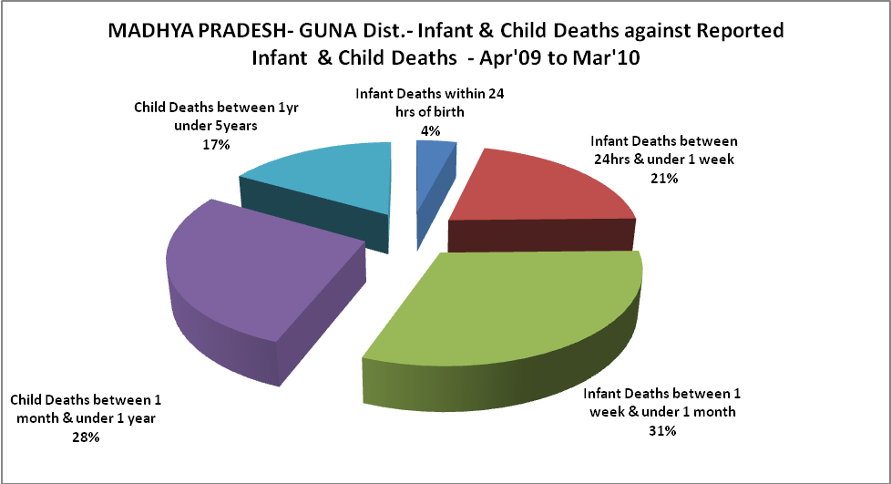

MADHYA PRADESH- GUNA Dist.- Causes of Infant & Child Deaths - Apr'09 to Mar'10
Sepsis |  |  | Asphyxia |  |  | LBW
Up to 1 Weeks of Birth | Between 1 week & 4 weeks of birth | Total | Up to 1 Weeks of Birth | Between 1 week & 4 weeks of birth | Total | Up to 1 Weeks of Birth | Between 1 week & 4 weeks of birth | Total
10 | 18 | 28 | 9 | 6 | 15 | 49 | 63 | 112
Pneumonia |  |  | Diarrhoea |  |  | Fever related
Between 1 month and 11 months | Between 1 year & 5 years | Total | Between 1 month and 11 months | Between 1 year & 5 years | Total | Between 1 month and 11 months | Between 1 year & 5 years | Total
13 | 2 | 15 | 8 | 2 | 10 | 33 | 18 | 51
Others |  |  | Measles |  |  | Others
Up to 1 Weeks of Birth | Between 1 week & 4 weeks of birth | Total | Between 1 month and 11 months | Between 1 year & 5 years | Total | Between 1 month and 11 months | Between 1 year & 5 years | Total
113 | 185 | 298 | 0 | 2 | 2 | 187 | 122 | 309

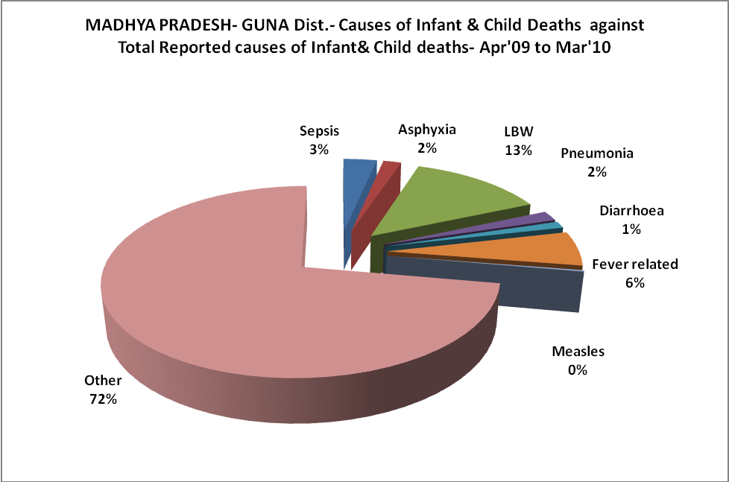

MADHYA PRADESH- GUNA Dist.- Maternal Deaths & Causes - Apr'09 to Mar'10
Abortion |  |  | Obstructed/prolonged labour |  |  | Severe hypertesnion/fits
6-14 yrs | 15-55 yrs. | Total | 6-14 yrs | 15-55 yrs. | Total | 6-14 yrs | 15-55 yrs. | Total
0 | 0 | 0 | 0 | 0 | 0 | 0 | 4 | 4
Bleeding |  |  | High Fever |  |  | Other Causes
6-14 yrs | 15-55 yrs. | Total | 6-14 yrs | 15-55 yrs. | Total | 6-14 yrs | 15-55 yrs. | Total
0 | 10 | 10 | 0 | 0 | 0 | 0 | 14 | 14

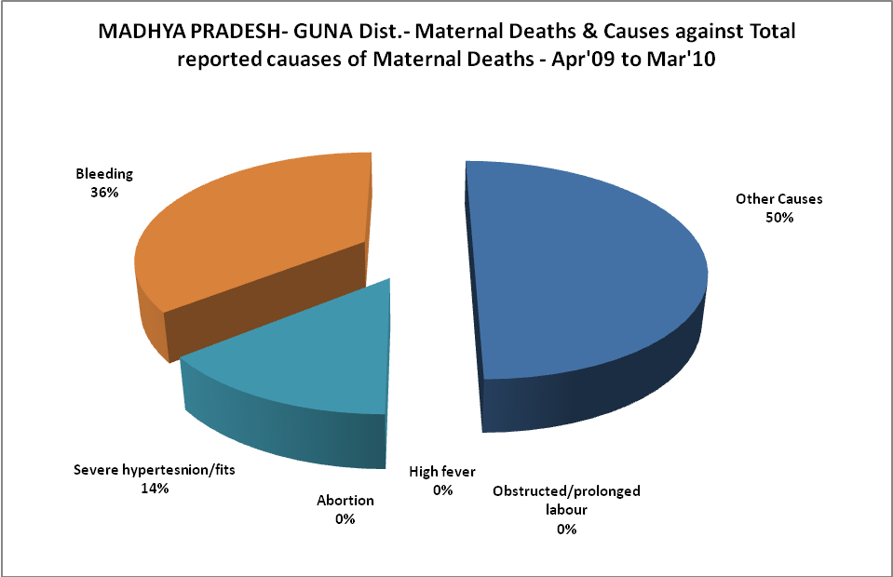

MADHYA PRADESH- GUNA Dist.-Causes of Deaths in 6 to 55yrs age group - Apr'09 to Mar'10
Diarrhoel Diseases |  |  |  | Tuberculosis |  |  |  | Respiratory Diseases( Other than TB)
6-14 yrs | 15-55 yrs. | Above 55yrs | Total | 6-14 yrs | 15-55 yrs. | Above 55yrs | Total | 6-14 yrs | 15-55 yrs. | Above 55yrs | Total
0 | 0 | 0 | 0 | 0 | 0 | 2 | 2 | 0 | 0 | 0 | 0
Malaria |  |  |  | Other fever Related |  |  |  | HIV/Aids
6-14 yrs | 15-55 yrs. | Above 55yrs | Total | 6-14 yrs | 15-55 yrs. | Above 55yrs | Total | 6-14 yrs | 15-55 yrs. | Above 55yrs | Total
0 | 0 | 0 | 0 | 0 | 0 | 0 | 0 | 0 | 0 | 0 | 0
Heart Disease/Hypertenion related |  |  |  | Neurological Disease including strokes |  |  |  | Trauma/Accidents/ Burn Cases
6-14 yrs | 15-55 yrs. | Above 55yrs | Total | 6-14 yrs | 15-55 yrs. | Above 55yrs | Total | 6-14 yrs | 15-55 yrs. | Above 55yrs | Total
0 | 0 | 0 | 0 | 0 | 0 | 0 | 0 | 0 | 0 | 0 | 0
Suicide |  |  |  | Animal Bites & Stings
6-14 yrs | 15-55 yrs. | Above 55yrs | Total | 6-14 yrs | 15-55 yrs. | Above 55yrs | Total
0 | 0 | 0 | 0 | 0 | 0 | 0 | 0

