[NHSRC]
MP-Indore
[ Analysis 2009-10]

MADHYA PRADESH- INDORE Dist.- Summary-Apr'09 to Mar'10
ANC
ANC Registration against Expected Pregnancies | 123% | TT1 given to Pregnant women against ANC Registraion | 81%
3 ANC Check ups against ANC Reigtrations | 83% | 100 IFA Tablets given to Pregnant women against ANC Registraion | 81%
Deliveries
Unreported Deliveries against Estimated Deliveries | -5.0% | HOME Deliveries( SBA& Non SBA) against Estimated Deliveries | 3.0%
Institutional Deliveries against Estimated Deliveries | 102.1% | HOME Deliveries( SBA& Non SBA) against Reported Deliveries | 2.8%
Institutional Deliveries against Reported Deliveries | 97.2% | C Section Deliveries against Institutional Deliveries( Pvt & Pub) | 9%
Births & Neonates Care
Live Births Reported against Estimated Live Births | 108% | New borns weighed against Reported Live Births | 95%
Still Births (Reported) | 203 | New borns weighed less than 2.5 kgs against newborns weighed | 13%
Sex Ratio at Birh | 988 | New borns breastfed within one hr of Birth against Reported live Births | 95%
Child Immunisation( 0 to 11 mnths)
BCG given against Expected Live Births | 112% | Measles given against Expected Live Births | 105%
OPV3 given against Expected Live Births | 108% | Fully Immunised Children against Expected Live Births | 1%
DPT3 given against Expected Live Births | 108%
Family Planning
Family Plannig Methods Users ( Sterilisations(Male &Female)+IUD+ Condom pieces/72 + OCP Cycles/13) | 137,315 | IUD Insertions against reported FP Methods | 17%
Sterilisation against reported FP Methods | 25% | Condom Users against reported FP Methods | 28%
 |  | OCP Users against reported FP Methods | 29%
Other Services
OPD | 587,864 | Major Operations | 9,449
IPD | 108,000 | Minor Operations | 46,785

MADHYA PRADESH- INDORE Dist.- Deliveries Apr'09 to Mar'10
Total Population | 2,910,408 | Expected Deliveries |  | 84,344
Home SBA | Home Non SBA | Institutional | Total Deliveries Reported | Unreported Deliveries
1,695 | 794 | 86,090 | 88,579 | (4,235)
Home SBA % | Home Non SBA% | Institutional % | Total Deliveries Reported % | Unreported Deliveries %
2% | 1% | 102% | 105% | -5%

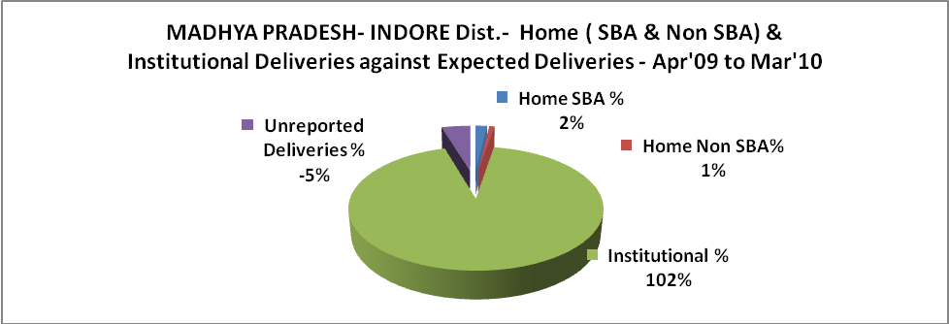

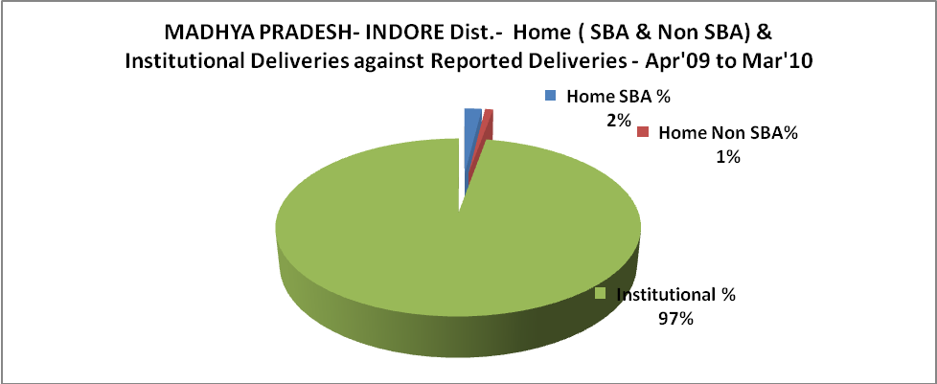
MADHYA PRADESH- INDORE Dist.- C sections & Complicated Deliveries Apr'09 to Mar'10
 | Institutional Deliveries (Public) | Institutional Deliveries (Pvt)
 | 33,353 | 52,737
C Section | 2,379 | 5,265
C Section% | 7% | 10%
Complicated Pregnacies attended | 3,756 | 6,502
Complicated Pregnacies attended % | 11% | 12%

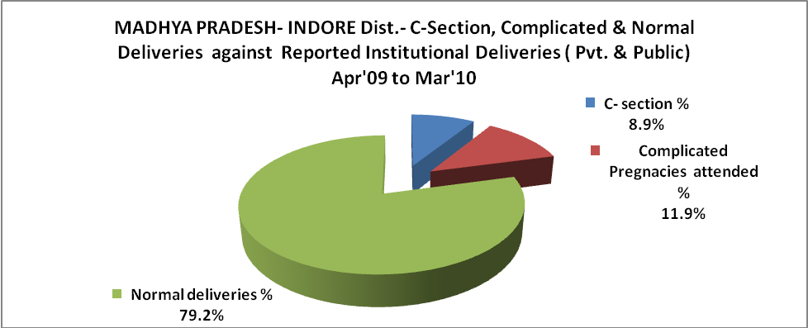

MADHYA PRADESH- INDORE Dist.- Complicated Pregnancies & Deliveries Treated - Apr'09 to Mar'10
Reported Deliveries |  |  | Reported ANC Reigtration
88,579 |  |  | 110,630
Complicated Pregnancies attended | Complicated Pregnancies Rate | C - Section Deliveries | PNC Maternal Complications | Abortions | Still Births
10,258 | 11% | 7,644 | 280 | 6,925 | 203
Complicated Deliveries Treated with |  |  |  | No Of Eclampsia cases Treated | No Of severe anemia cases treated
IV Antibiotics | IV antihypertensive/Magsulph injection | IV Oxytocis | Blood Transfusion | No Of Eclampsia cases Treated | No Of severe anemia cases treated
7,747 | 2,732 | 629 | 1,764 | 282 | 6,570

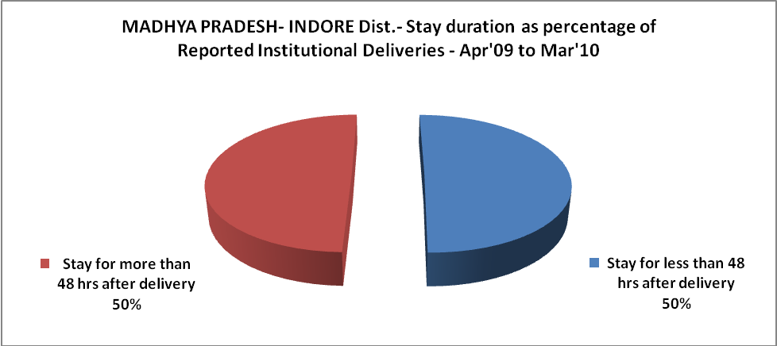

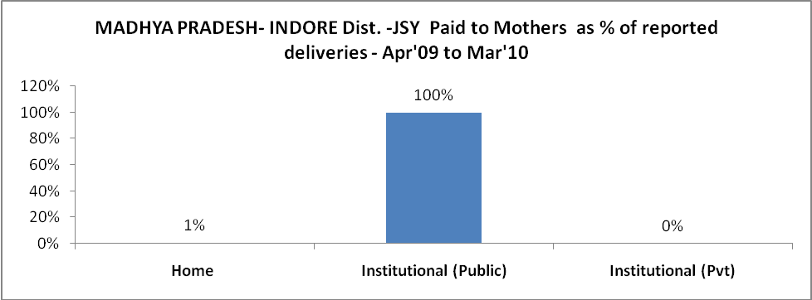

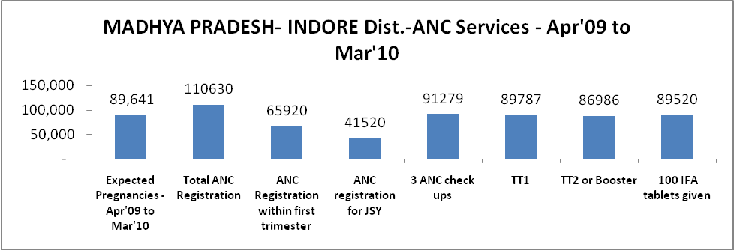

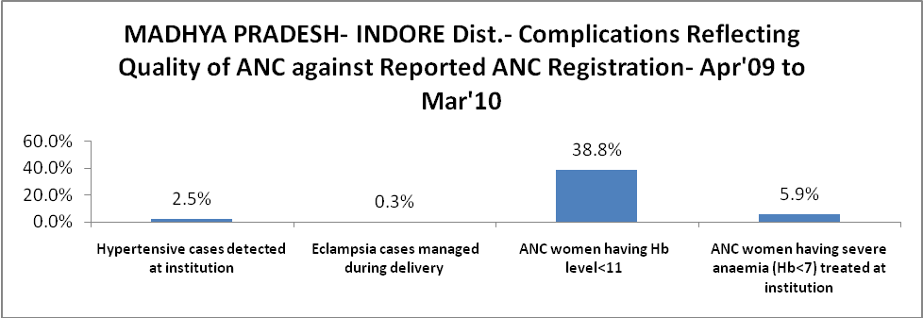

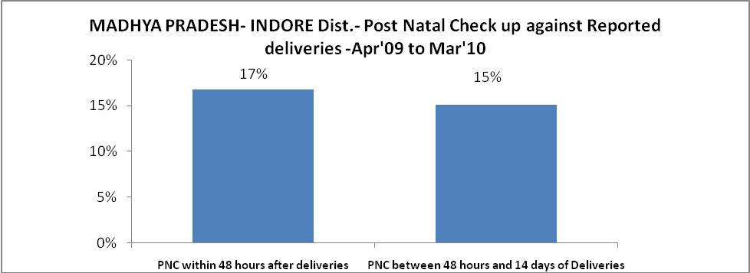

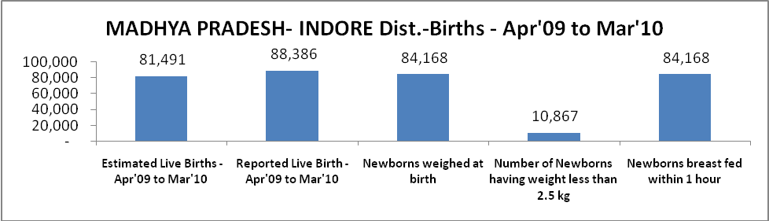

MADHYA PRADESH- INDORE Dist. - Births - Apr'09 to Mar'10
Live Birth - Males | Live Birth - females | Live Birth - Total | Sex Ratio at birth | Still Birth | Abortion( Induced/Spontaneous
44,455 | 43,931 | 88,386 | 988 | 203 | 6,925

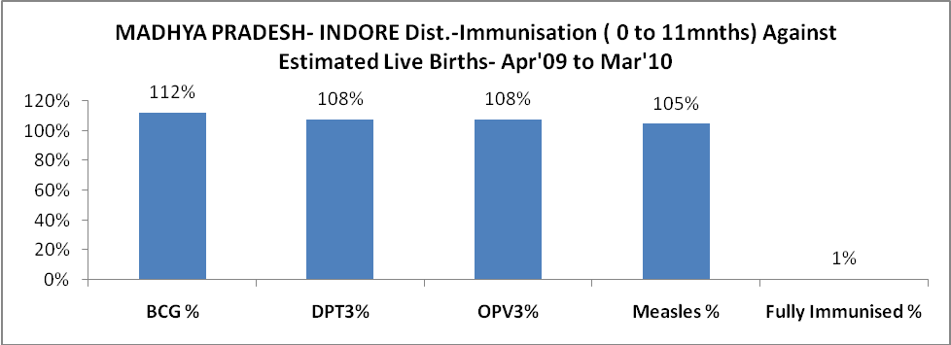

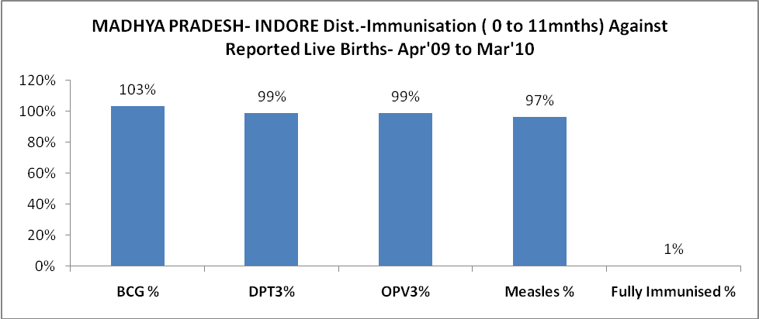

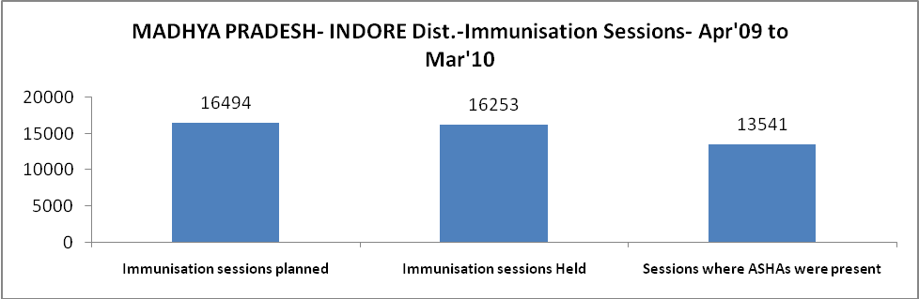
MADHYA PRADESH- INDORE Dist.- Apr'09 to Mar'10
Total Abortions | Abortion Rate
7,221 | 8.1%

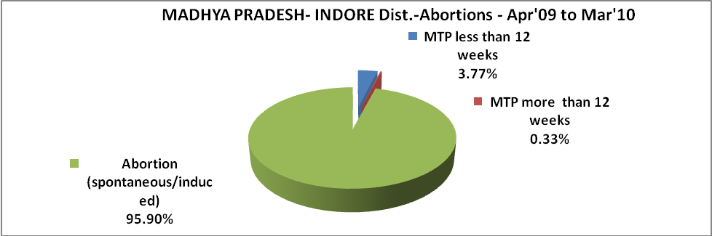

MADHYA PRADESH- INDORE Dist.- Apr'09 to Mar'10
Total OPD | Total RTI/STI cases
587,864 | 15,642

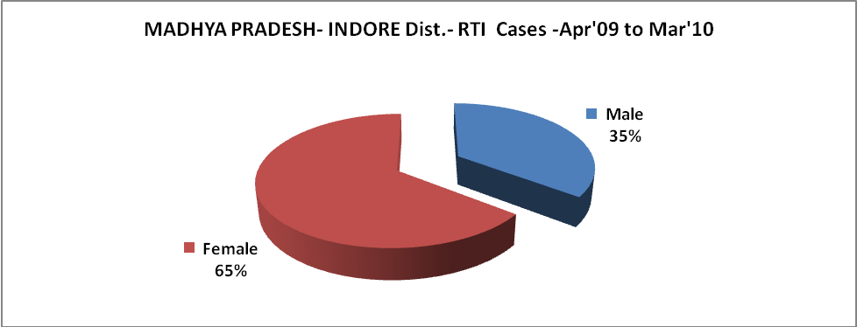

MADHYA PRADESH- INDORE Dist.-Sterilisations - Apr'09 to Mar'10
 | Reported | %age of Reported Sterilisation
Total Sterilisation | 34,385 | -
NSV | 1,529 | 4%
Laproscopic | 13,763 | 40%
MiniLap | 7,959 | 23%
Post Partum | 11,134 | 32%
Male Sterilisation | 1,529 | 4%
Female Sterilisation | 32,856 | 96%

MADHYA PRADESH- INDORE Dist.-FP Methods - Apr'09 to Mar'10
 | Reported | %age of All Reported FP Methods
Total Reported FP Methodd (All types) Users | 137,315 | -
Sterilisations | 34,385 | 25%
IUD | 23,967 | 17%
Condom Users | 38,585 | 28%
OCP Users | 40,378 | 29%
Limiting Methods | 34,385 | 25%
Spacing Methods | 102,930 | 75%

MADHYA PRADESH- INDORE Dist.- Service Delivery - Apr'09 to Mar'10
Operation major (General and spinal anaesthesia) | Operation minor (No or local anaesthesia) | AYUSH | Dental Procedures | Adolescent counselling services | Total OPD | Total IPD
9,449 | 46,785 | 24 | 5,524 | 1,553 | 587,864 | 108,000
Operation major (General and spinal anaesthesia) as %ge of OPD | Operation minor (No or local anaesthesia)as %ge of OPD | AYUSH as %ge of OPD | Dental Procedures as %ge of OPD | Adolescent counselling services as %ge of OPD | IPD as percentage of OPD
1.6% | 8.0% | 0.0% | 0.9% | 0.3% | 18%

MADHYA PRADESH- INDORE Dist.- Lab Services - Apr'09 to Mar'10
Total OPD | Total HB tested | Total HIV Tested | Total Population
587,864 | 92,158 | 26,557 | 2,910,408
HB test conducted as %age of OPD | HB<7gm as %age of HB tested | HIV test conducted as %age of OPD | HIV positive as %age of HIV tested | Blood Smear Examined as % of Population
15.7% | 7.1% | 4.5% | 3.6% | 13.1%

MADHYA PRADESH- INDORE Dist.- Childhood Disease - Vaccine Preventable -Apr'09 to Mar'10
Diphtheria | Pertussis | Tetanus Neonatorum | Tetanus others | Polio | Measles
0 | 0 | 0 | 1 | 0 | 579
MADHYA PRADESH- INDORE Dist.-Childhood Disease - Others - Apr'09 to Mar'10
Diarrhoea and dehydration | Malaria | Number admitted with Respiratory Infections
3,558 | 687 | 320

MADHYA PRADESH- INDORE Dist.- Infant & Child Deaths - Apr'09 to Mar'10
Infant Deaths within 24 hrs of birth | Infant Deaths between 24hrs & under 1 week | Infant Deaths between 1 week & under 1 month | Child Deaths between 1 month & under 1 year | Child Deaths between 1yr under 5years | Total Deaths
7 | 7 | 3 | 4 | 0 | 21

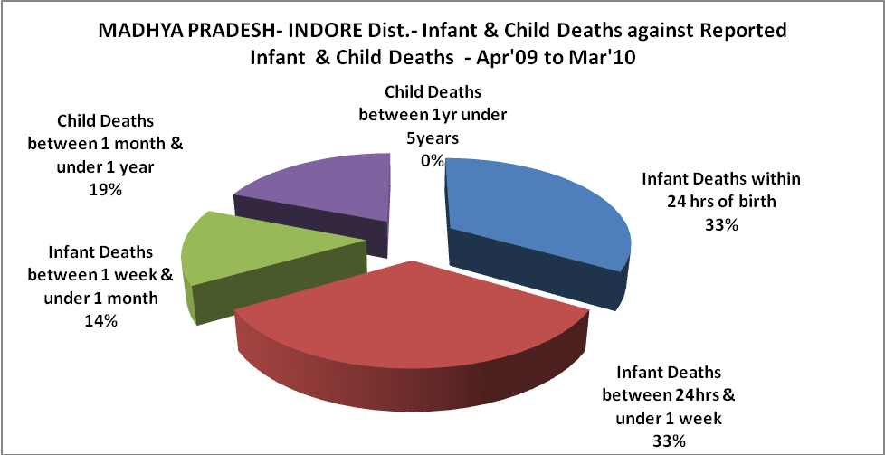

MADHYA PRADESH- INDORE Dist.- Causes of Infant & Child Deaths - Apr'09 to Mar'10
Sepsis |  |  | Asphyxia |  |  | LBW
Up to 1 Weeks of Birth | Between 1 week & 4 weeks of birth | Total | Up to 1 Weeks of Birth | Between 1 week & 4 weeks of birth | Total | Up to 1 Weeks of Birth | Between 1 week & 4 weeks of birth | Total
0 | 0 | 0 | 0 | 3 | 3 | 5 | 0 | 5
Pneumonia |  |  | Diarrhoea |  |  | Fever related
Between 1 month and 11 months | Between 1 year & 5 years | Total | Between 1 month and 11 months | Between 1 year & 5 years | Total | Between 1 month and 11 months | Between 1 year & 5 years | Total
1 | 0 | 1 | 0 | 0 | 0 | 0 | 0 | 0
Others |  |  | Measles |  |  | Others
Up to 1 Weeks of Birth | Between 1 week & 4 weeks of birth | Total | Between 1 month and 11 months | Between 1 year & 5 years | Total | Between 1 month and 11 months | Between 1 year & 5 years | Total
2 | 0 | 2 | 0 | 0 | 0 | 3 | 0 | 3

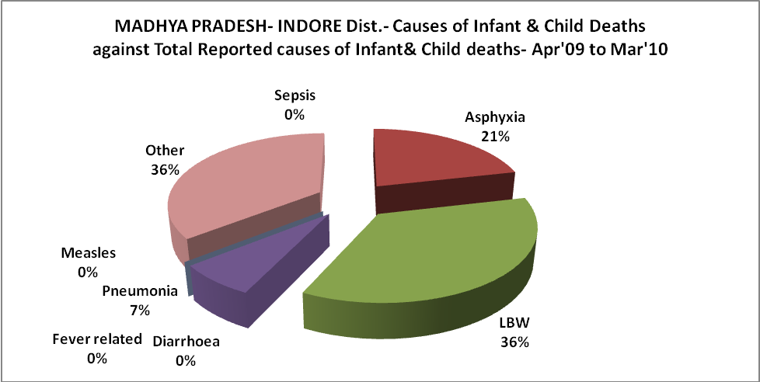

MADHYA PRADESH- INDORE Dist.- Maternal Deaths & Causes - Apr'09 to Mar'10
Abortion |  |  | Obstructed/prolonged labour |  |  | Severe hypertesnion/fits
6-14 yrs | 15-55 yrs. | Total | 6-14 yrs | 15-55 yrs. | Total | 6-14 yrs | 15-55 yrs. | Total
0 | 1 | 1 | 0 | 26 | 26 | 0 | 0 | 0
Bleeding |  |  | High Fever |  |  | Other Causes
6-14 yrs | 15-55 yrs. | Total | 6-14 yrs | 15-55 yrs. | Total | 6-14 yrs | 15-55 yrs. | Total
0 | 20 | 20 | 0 | 2 | 2 | 0 | 0 | 0

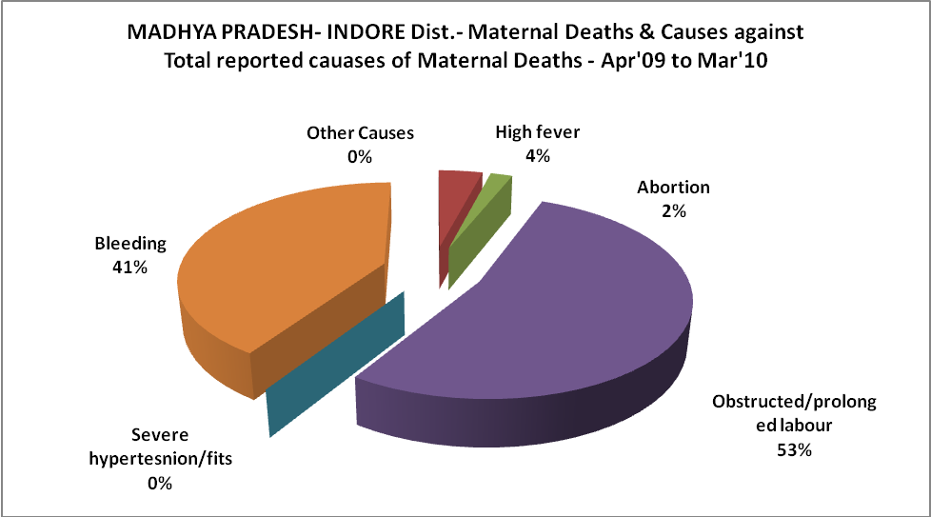

MADHYA PRADESH- INDORE Dist.-Causes of Deaths in 6 to 55yrs age group - Apr'09 to Mar'10
Diarrhoel Diseases |  |  |  | Tuberculosis |  |  |  | Respiratory Diseases( Other than TB)
6-14 yrs | 15-55 yrs. | Above 55yrs | Total | 6-14 yrs | 15-55 yrs. | Above 55yrs | Total | 6-14 yrs | 15-55 yrs. | Above 55yrs | Total
0 | 1 | 0 | 1 | 1 | 0 | 0 | 1 | 0 | 0 | 0 | 0
Malaria |  |  |  | Other fever Related |  |  |  | HIV/Aids
6-14 yrs | 15-55 yrs. | Above 55yrs | Total | 6-14 yrs | 15-55 yrs. | Above 55yrs | Total | 6-14 yrs | 15-55 yrs. | Above 55yrs | Total
0 | 0 | 0 | 0 | 0 | 0 | 0 | 0 | 0 | 0 | 2 | 2
Heart Disease/Hypertenion related |  |  |  | Neurological Disease including strokes |  |  |  | Trauma/Accidents/ Burn Cases
6-14 yrs | 15-55 yrs. | Above 55yrs | Total | 6-14 yrs | 15-55 yrs. | Above 55yrs | Total | 6-14 yrs | 15-55 yrs. | Above 55yrs | Total
0 | 0 | 0 | 0 | 0 | 0 | 0 | 0 | 0 | 2 | 0 | 2
Suicide |  |  |  | Animal Bites & Stings
6-14 yrs | 15-55 yrs. | Above 55yrs | Total | 6-14 yrs | 15-55 yrs. | Above 55yrs | Total
0 | 0 | 0 | 0 | 0 | 0 | 0 | 0

