[NHSRC]
MP-Jhabua
[ Analysis 2009-10]

MADHYA PRADESH- JHABUA Dist.- Summary-Apr'09 to Mar'10
ANC
ANC Registration against Expected Pregnancies | 77% | TT1 given to Pregnant women against ANC Registraion | 40%
3 ANC Check ups against ANC Reigtrations | 75% | 100 IFA Tablets given to Pregnant women against ANC Registraion | 93%
Deliveries
Unreported Deliveries against Estimated Deliveries | 28.6% | HOME Deliveries( SBA& Non SBA) against Estimated Deliveries | 17.4%
Institutional Deliveries against Estimated Deliveries | 54.0% | HOME Deliveries( SBA& Non SBA) against Reported Deliveries | 24.4%
Institutional Deliveries against Reported Deliveries | 75.6% | C Section Deliveries against Institutional Deliveries( Pvt & Pub) | 3%
Births & Neonates Care
Live Births Reported against Estimated Live Births | 73% | New borns weighed against Reported Live Births | 93%
Still Births (Reported) | 463 | New borns weighed less than 2.5 kgs against newborns weighed | 16%
Sex Ratio at Birh | 971 | New borns breastfed within one hr of Birth against Reported live Births | 100%
Child Immunisation( 0 to 11 mnths)
BCG given against Expected Live Births | 73% | Measles given against Expected Live Births | 67%
OPV3 given against Expected Live Births | 65% | Fully Immunised Children against Expected Live Births | 67%
DPT3 given against Expected Live Births | 65%
Family Planning
Family Plannig Methods Users ( Sterilisations(Male &Female)+IUD+ Condom pieces/72 + OCP Cycles/13) | 32,420 | IUD Insertions against reported FP Methods | 32%
Sterilisation against reported FP Methods | 20% | Condom Users against reported FP Methods | 27%
 |  | OCP Users against reported FP Methods | 20%
Other Services
OPD | 219,993 | Major Operations | 5,255
IPD | 19,597 | Minor Operations | 371

MADHYA PRADESH- JHABUA Dist.- Deliveries Apr'09 to Mar'10
Total Population | 1,656,802 | Expected Deliveries |  | 48,014
Home SBA | Home Non SBA | Institutional | Total Deliveries Reported | Unreported Deliveries
26 | 8,348 | 25,907 | 34,281 | 13,733
Home SBA % | Home Non SBA% | Institutional % | Total Deliveries Reported % | Unreported Deliveries %
0% | 17% | 54% | 71% | 29%

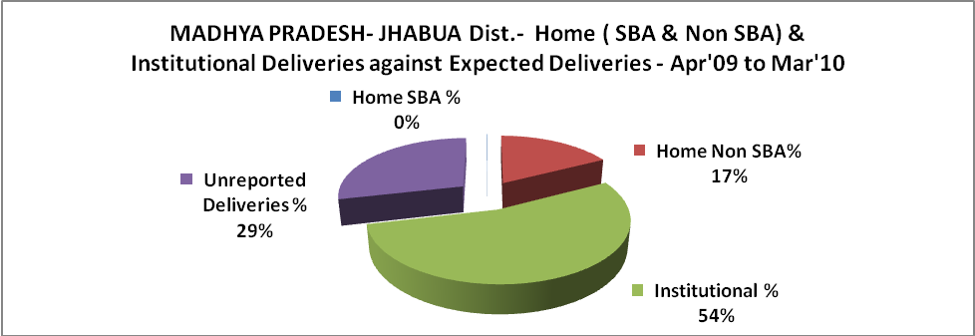

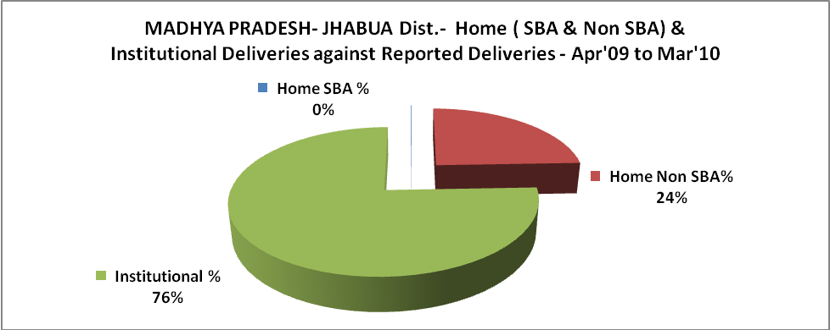
MADHYA PRADESH- JHABUA Dist.- C sections & Complicated Deliveries Apr'09 to Mar'10
 | Institutional Deliveries (Public) | Institutional Deliveries (Pvt)
 | 19,942 | 5,965
C Section | 107 | 706
C Section% | 1% | 12%
Complicated Pregnacies attended | 940 | -
Complicated Pregnacies attended % | 5% | 0%

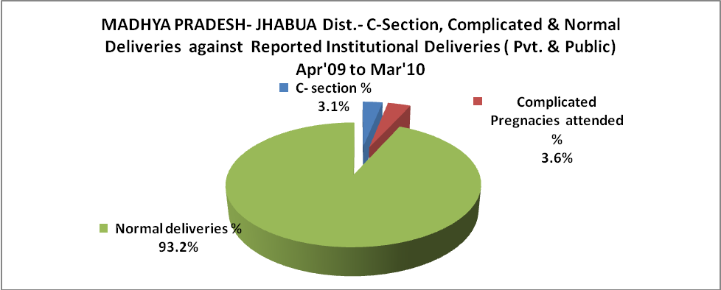

MADHYA PRADESH- JHABUA Dist.- Complicated Pregnancies & Deliveries Treated - Apr'09 to Mar'10
Reported Deliveries |  |  | Reported ANC Reigtration
34,281 |  |  | 39,490
Complicated Pregnancies attended | Complicated Pregnancies Rate | C - Section Deliveries | PNC Maternal Complications | Abortions | Still Births
940 | 2% | 813 | - | 617 | 463
Complicated Deliveries Treated with |  |  |  | No Of Eclampsia cases Treated | No Of severe anemia cases treated
IV Antibiotics | IV antihypertensive/Magsulph injection | IV Oxytocis | Blood Transfusion | No Of Eclampsia cases Treated | No Of severe anemia cases treated
351 | 39 | 296 | 438 | 39 | 811

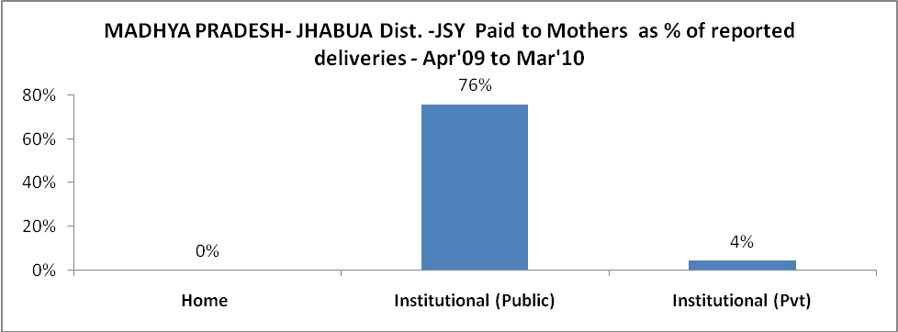

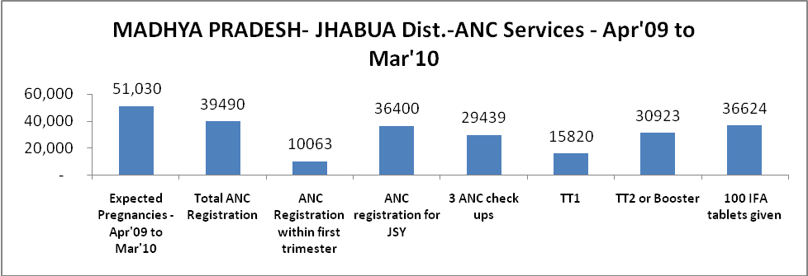

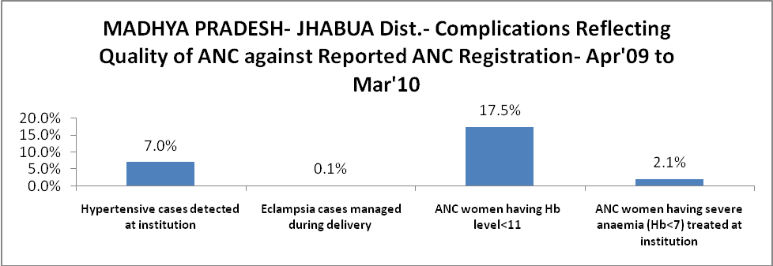

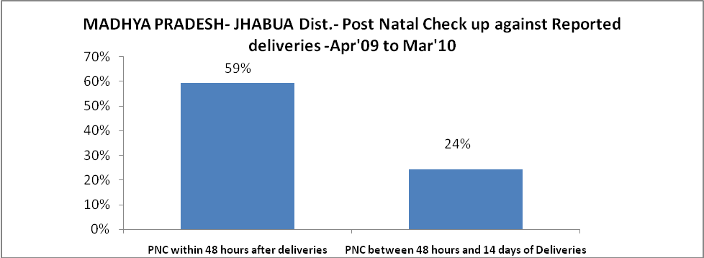

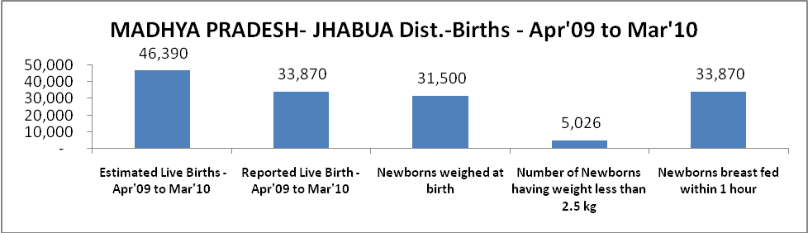

MADHYA PRADESH- JHABUA Dist. - Births - Apr'09 to Mar'10
Live Birth - Males | Live Birth - females | Live Birth - Total | Sex Ratio at birth | Still Birth | Abortion( Induced/Spontaneous
17,180 | 16,690 | 33,870 | 971 | 463 | 617

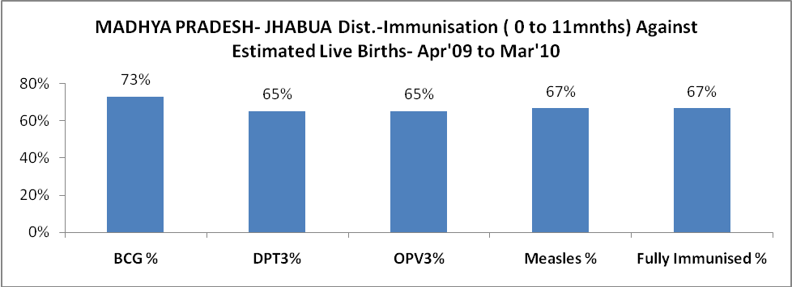

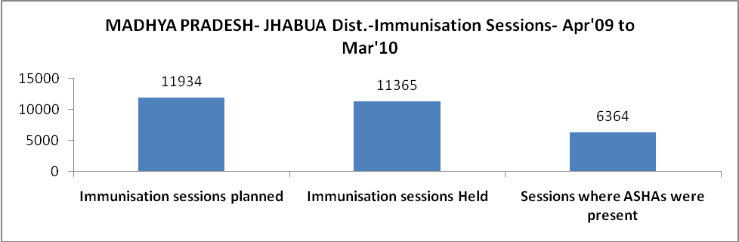

MADHYA PRADESH- JHABUA Dist.- Apr'09 to Mar'10
Total Abortions | Abortion Rate
1,156 | 2.3%

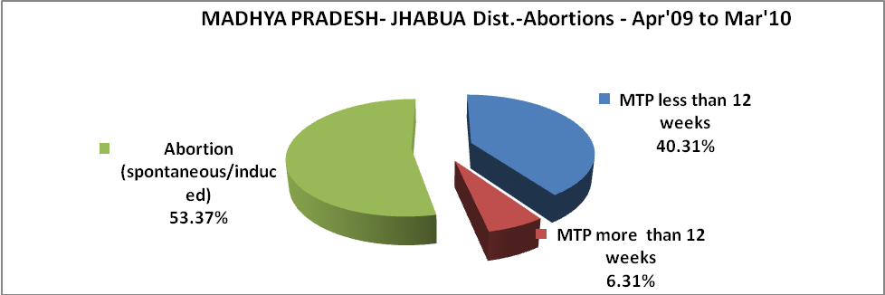

MADHYA PRADESH- JHABUA Dist.- Apr'09 to Mar'10
Total OPD | Total RTI/STI cases
219,993 | 2,130

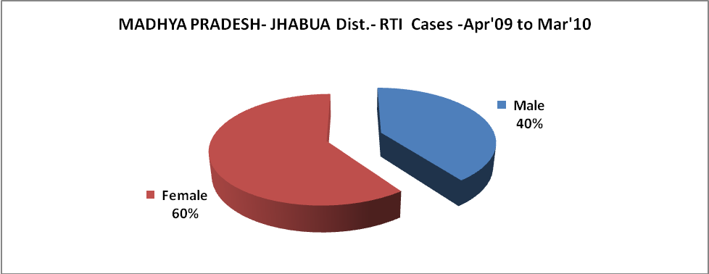

MADHYA PRADESH- JHABUA Dist.-Sterilisations - Apr'09 to Mar'10
 | Reported | %age of Reported Sterilisation
Total Sterilisation | 6,581 | -
NSV | 100 | 2%
Laproscopic | 6,003 | 91%
MiniLap | 239 | 4%
Post Partum | 239 | 4%
Male Sterilisation | 100 | 2%
Female Sterilisation | 6,481 | 98%

MADHYA PRADESH- JHABUA Dist.-FP Methods - Apr'09 to Mar'10
 | Reported | %age of All Reported FP Methods
Total Reported FP Methodd (All types) Users | 32,420 | -
Sterilisations | 6,581 | 20%
IUD | 10,384 | 32%
Condom Users | 8,880 | 27%
OCP Users | 6,574 | 20%
Limiting Methods | 6,581 | 20%
Spacing Methods | 25,839 | 80%

MADHYA PRADESH- JHABUA Dist.- Service Delivery - Apr'09 to Mar'10
Operation major (General and spinal anaesthesia) | Operation minor (No or local anaesthesia) | AYUSH | Dental Procedures | Adolescent counselling services | Total OPD | Total IPD
5,255 | 371 | 1 | - | 67 | 219,993 | 19,597
Operation major (General and spinal anaesthesia) as %ge of OPD | Operation minor (No or local anaesthesia)as %ge of OPD | AYUSH as %ge of OPD | Dental Procedures as %ge of OPD | Adolescent counselling services as %ge of OPD | IPD as percentage of OPD
2.4% | 0.2% | 0.0% | 0.0% | 0.0% | 9%

MADHYA PRADESH- JHABUA Dist.- Lab Services - Apr'09 to Mar'10
Total OPD | Total HB tested | Total HIV Tested | Total Population
219,993 | 31,882 | 1,024 | 1,656,802
HB test conducted as %age of OPD | HB<7gm as %age of HB tested | HIV test conducted as %age of OPD | HIV positive as %age of HIV tested | Blood Smear Examined as % of Population
14.5% | 9.2% | 0.5% | 0.8% | 6.2%

MADHYA PRADESH- JHABUA Dist.- Childhood Disease - Vaccine Preventable -Apr'09 to Mar'10
Diphtheria | Pertussis | Tetanus Neonatorum | Tetanus others | Polio | Measles
0 | 0 | 0 | 3 | 0 | 12
MADHYA PRADESH- JHABUA Dist.-Childhood Disease - Others - Apr'09 to Mar'10
Diarrhoea and dehydration | Malaria | Number admitted with Respiratory Infections
3,471 | 14,017 | 1,095

MADHYA PRADESH- JHABUA Dist.- Infant & Child Deaths - Apr'09 to Mar'10
Infant Deaths within 24 hrs of birth | Infant Deaths between 24hrs & under 1 week | Infant Deaths between 1 week & under 1 month | Child Deaths between 1 month & under 1 year | Child Deaths between 1yr under 5years | Total Deaths
328 | 95 | 41 | 47 | 105 | 616

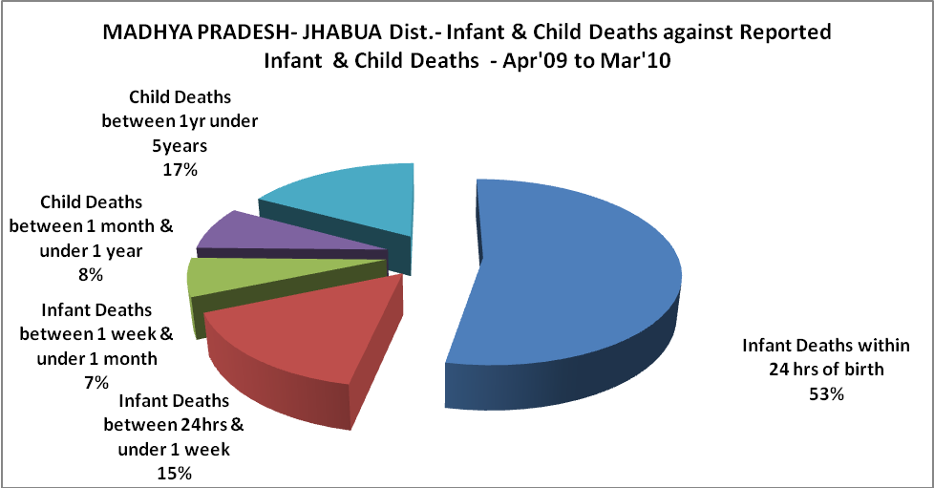

MADHYA PRADESH- JHABUA Dist.- Causes of Infant & Child Deaths - Apr'09 to Mar'10
Sepsis |  |  | Asphyxia |  |  | LBW
Up to 1 Weeks of Birth | Between 1 week & 4 weeks of birth | Total | Up to 1 Weeks of Birth | Between 1 week & 4 weeks of birth | Total | Up to 1 Weeks of Birth | Between 1 week & 4 weeks of birth | Total
18 | 6 | 24 | 11 | 2 | 13 | 28 | 14 | 42
Pneumonia |  |  | Diarrhoea |  |  | Fever related
Between 1 month and 11 months | Between 1 year & 5 years | Total | Between 1 month and 11 months | Between 1 year & 5 years | Total | Between 1 month and 11 months | Between 1 year & 5 years | Total
7 | 15 | 22 | 3 | 2 | 5 | 0 | 2 | 2
Others |  |  | Measles |  |  | Others
Up to 1 Weeks of Birth | Between 1 week & 4 weeks of birth | Total | Between 1 month and 11 months | Between 1 year & 5 years | Total | Between 1 month and 11 months | Between 1 year & 5 years | Total
38 | 19 | 57 | 0 | 0 | 0 | 37 | 86 | 123

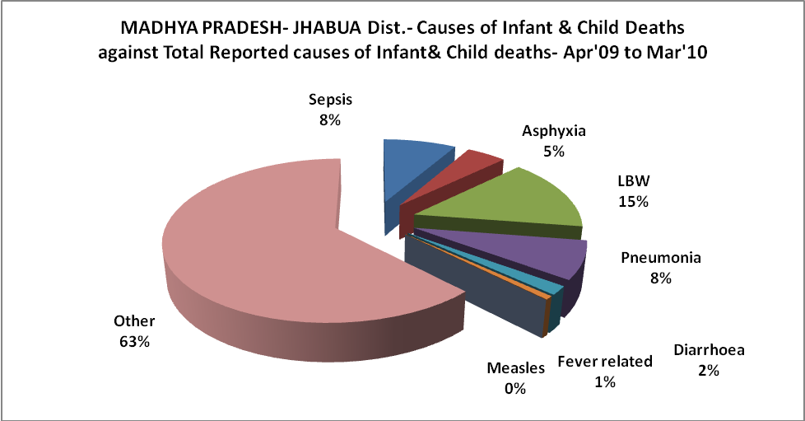

MADHYA PRADESH- JHABUA Dist.- Maternal Deaths & Causes - Apr'09 to Mar'10
Abortion |  |  | Obstructed/prolonged labour |  |  | Severe hypertesnion/fits
6-14 yrs | 15-55 yrs. | Total | 6-14 yrs | 15-55 yrs. | Total | 6-14 yrs | 15-55 yrs. | Total
0 | 0 | 0 | 0 | 0 | 0 | 0 | 0 | 0
Bleeding |  |  | High Fever |  |  | Other Causes
6-14 yrs | 15-55 yrs. | Total | 6-14 yrs | 15-55 yrs. | Total | 6-14 yrs | 15-55 yrs. | Total
0 | 0 | 0 | 0 | 0 | 0 | 0 | 0 | 0

MADHYA PRADESH- JHABUA Dist.-Causes of Deaths in 6 to 55yrs age group - Apr'09 to Mar'10
Diarrhoel Diseases |  |  |  | Tuberculosis |  |  |  | Respiratory Diseases( Other than TB)
6-14 yrs | 15-55 yrs. | Above 55yrs | Total | 6-14 yrs | 15-55 yrs. | Above 55yrs | Total | 6-14 yrs | 15-55 yrs. | Above 55yrs | Total
0 | 4 | 11 | 15 | 0 | 2 | 1 | 3 | 0 | 1 | 2 | 3
Malaria |  |  |  | Other fever Related |  |  |  | HIV/Aids
6-14 yrs | 15-55 yrs. | Above 55yrs | Total | 6-14 yrs | 15-55 yrs. | Above 55yrs | Total | 6-14 yrs | 15-55 yrs. | Above 55yrs | Total
0 | 2 | 0 | 2 | 67 | 26 | 86 | 179 | 0 | 0 | 0 | 0
Heart Disease/Hypertenion related |  |  |  | Neurological Disease including strokes |  |  |  | Trauma/Accidents/ Burn Cases
6-14 yrs | 15-55 yrs. | Above 55yrs | Total | 6-14 yrs | 15-55 yrs. | Above 55yrs | Total | 6-14 yrs | 15-55 yrs. | Above 55yrs | Total
0 | 4 | 1 | 5 | 4 | 1 | 0 | 5 | 1 | 2 | 0 | 3
Suicide |  |  |  | Animal Bites & Stings
6-14 yrs | 15-55 yrs. | Above 55yrs | Total | 6-14 yrs | 15-55 yrs. | Above 55yrs | Total
1 | 4 | 1 | 6 | 0 | 2 | 0 | 2

