[NHSRC]
MP-Katni
[ Analysis 2009-10]

MADHYA PRADESH- KATNI Dist.- Summary-Apr'09 to Mar'10
ANC
ANC Registration against Expected Pregnancies | 82% | TT1 given to Pregnant women against ANC Registraion | 76%
3 ANC Check ups against ANC Reigtrations | 80% | 100 IFA Tablets given to Pregnant women against ANC Registraion | 79%
Deliveries
Unreported Deliveries against Estimated Deliveries | 25.3% | HOME Deliveries( SBA& Non SBA) against Estimated Deliveries | 6.4%
Institutional Deliveries against Estimated Deliveries | 68.3% | HOME Deliveries( SBA& Non SBA) against Reported Deliveries | 8.6%
Institutional Deliveries against Reported Deliveries | 91.4% | C Section Deliveries against Institutional Deliveries( Pvt & Pub) | 4%
Births & Neonates Care
Live Births Reported against Estimated Live Births | 76% | New borns weighed against Reported Live Births | 99%
Still Births (Reported) | 660 | New borns weighed less than 2.5 kgs against newborns weighed | 13%
Sex Ratio at Birh | 953 | New borns breastfed within one hr of Birth against Reported live Births | 96%
Child Immunisation( 0 to 11 mnths)
BCG given against Expected Live Births | 73% | Measles given against Expected Live Births | 73%
OPV3 given against Expected Live Births | 75% | Fully Immunised Children against Expected Live Births | 71%
DPT3 given against Expected Live Births | 76%
Family Planning
Family Plannig Methods Users ( Sterilisations(Male &Female)+IUD+ Condom pieces/72 + OCP Cycles/13) | 46,531 | IUD Insertions against reported FP Methods | 15%
Sterilisation against reported FP Methods | 17% | Condom Users against reported FP Methods | 40%
 |  | OCP Users against reported FP Methods | 28%
Other Services
OPD | 367,221 | Major Operations | 1,555
IPD | 43,335 | Minor Operations | 525

MADHYA PRADESH- KATNI Dist.- Deliveries Apr'09 to Mar'10
Total Population | 1,264,634 | Expected Deliveries |  | 36,649
Home SBA | Home Non SBA | Institutional | Total Deliveries Reported | Unreported Deliveries
501 | 1,858 | 25,023 | 27,382 | 9,267
Home SBA % | Home Non SBA% | Institutional % | Total Deliveries Reported % | Unreported Deliveries %
1% | 5% | 68% | 75% | 25%

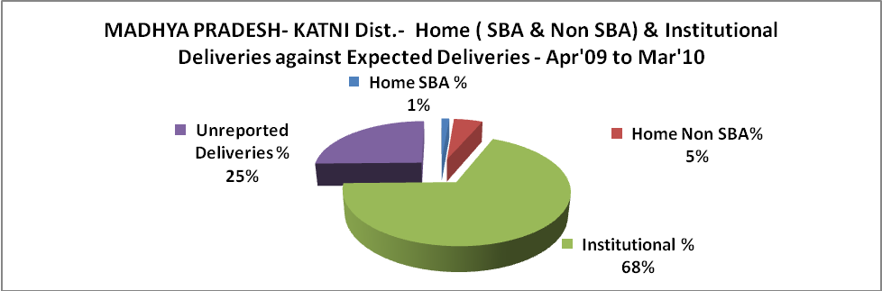

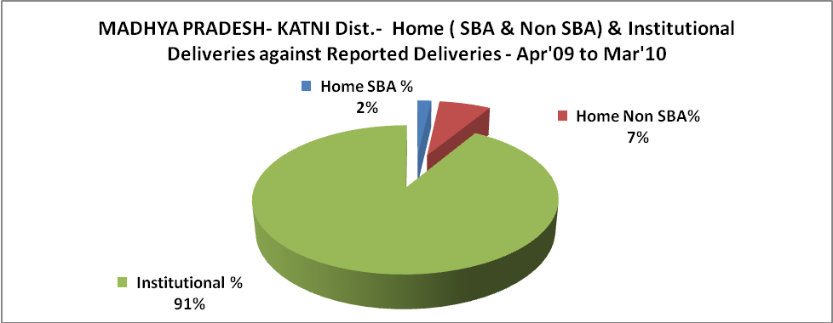
MADHYA PRADESH- KATNI Dist.- C sections & Complicated Deliveries Apr'09 to Mar'10
 | Institutional Deliveries (Public) | Institutional Deliveries (Pvt)
 | 23,625 | 1,398
C Section | 267 | 831
C Section% | 1% | 59%
Complicated Pregnacies attended | 629 | 136
Complicated Pregnacies attended % | 3% | 10%

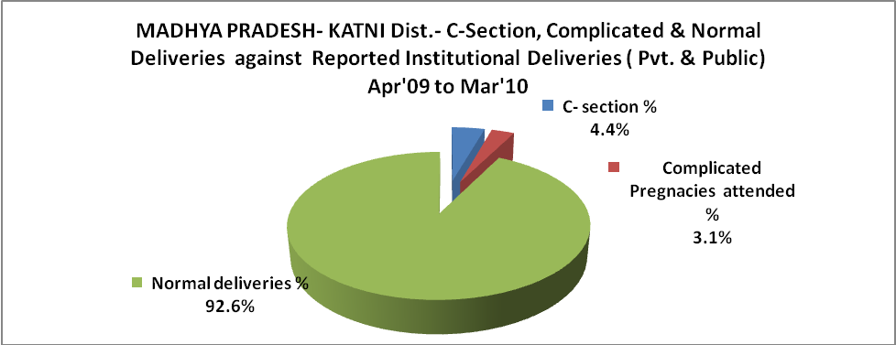

MADHYA PRADESH- KATNI Dist.- Complicated Pregnancies & Deliveries Treated - Apr'09 to Mar'10
Reported Deliveries |  |  | Reported ANC Reigtration
27,382 |  |  | 32,114
Complicated Pregnancies attended | Complicated Pregnancies Rate | C - Section Deliveries | PNC Maternal Complications | Abortions | Still Births
765 | 2% | 1,098 | 198 | 607 | 660
Complicated Deliveries Treated with |  |  |  | No Of Eclampsia cases Treated | No Of severe anemia cases treated
IV Antibiotics | IV antihypertensive/Magsulph injection | IV Oxytocis | Blood Transfusion | No Of Eclampsia cases Treated | No Of severe anemia cases treated
1,297 | 119 | 1,090 | 181 | 23 | 152

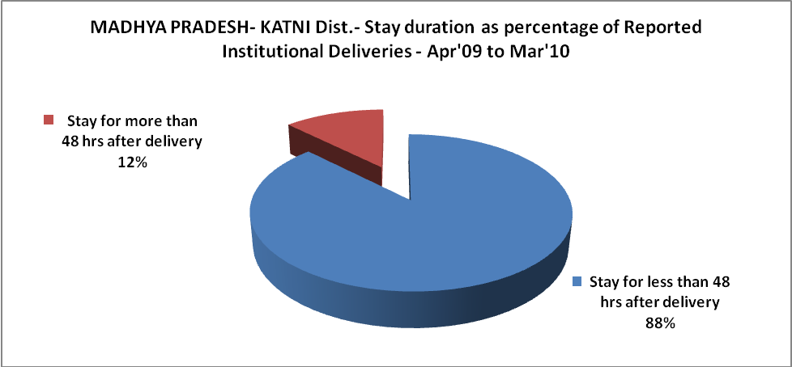

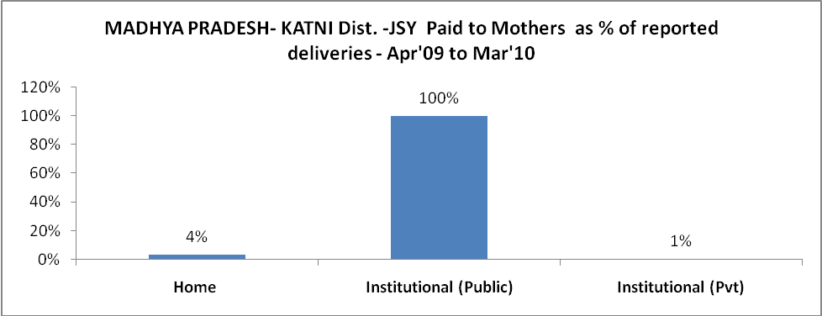

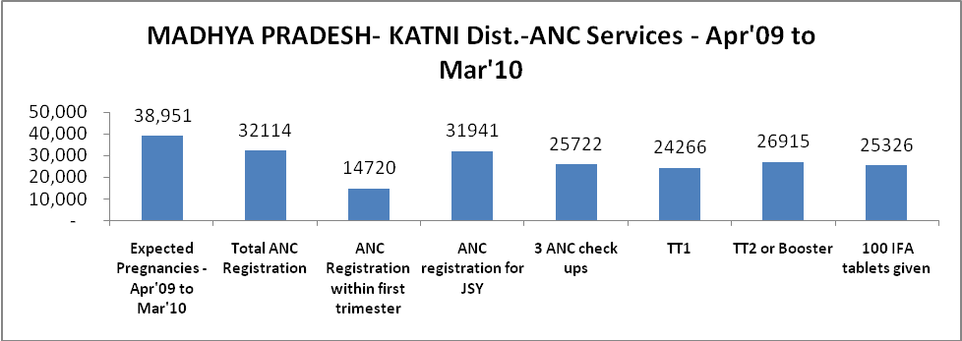

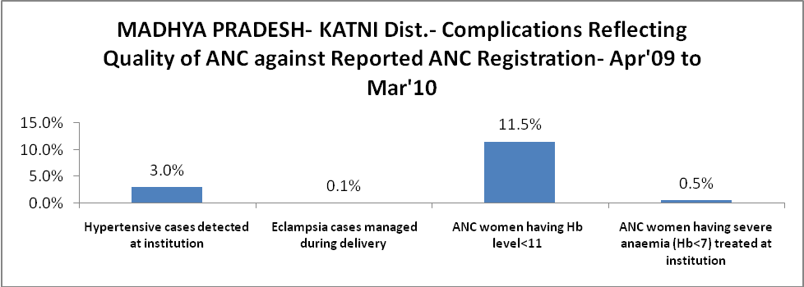
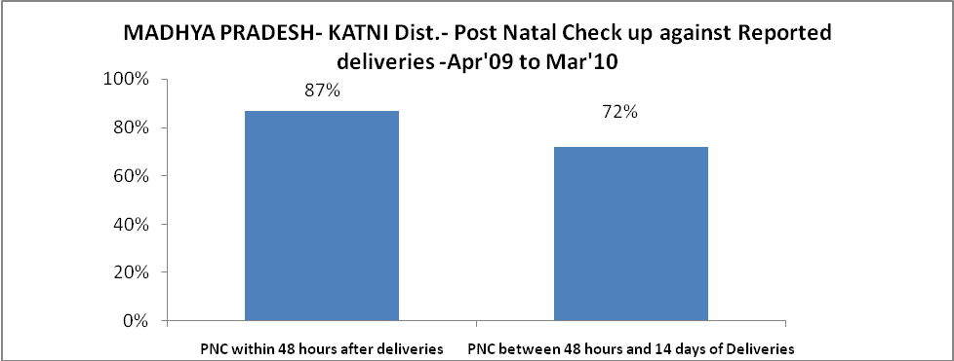

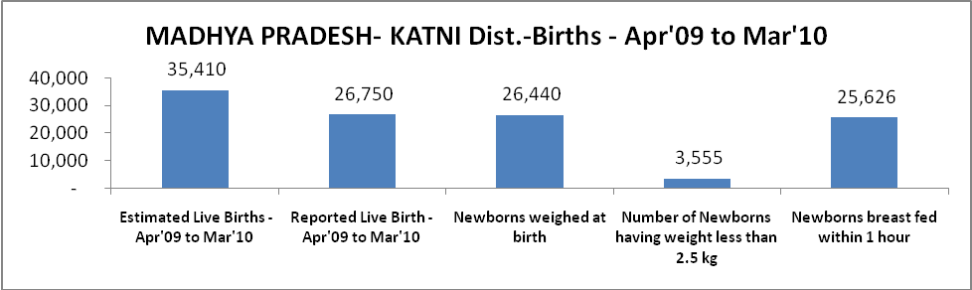

MADHYA PRADESH- KATNI Dist. - Births - Apr'09 to Mar'10
Live Birth - Males | Live Birth - females | Live Birth - Total | Sex Ratio at birth | Still Birth | Abortion( Induced/Spontaneous
13,696 | 13,054 | 26,750 | 953 | 660 | 607

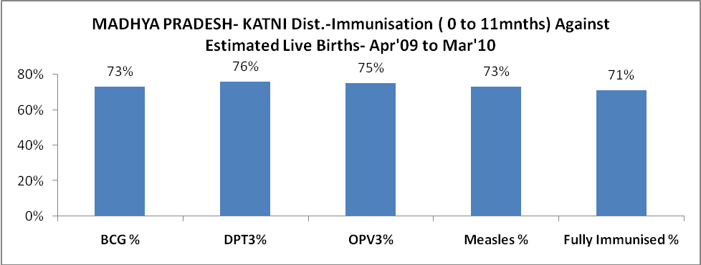

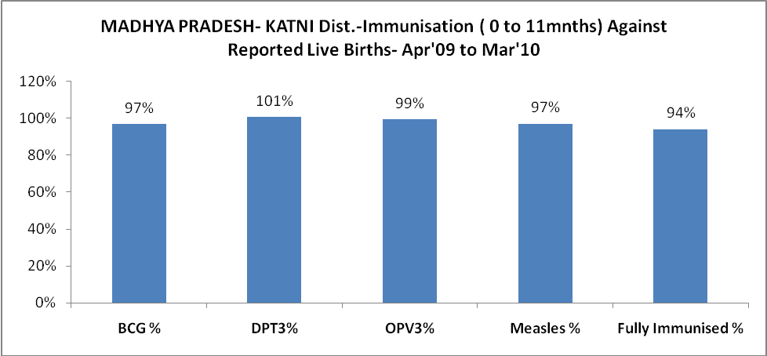

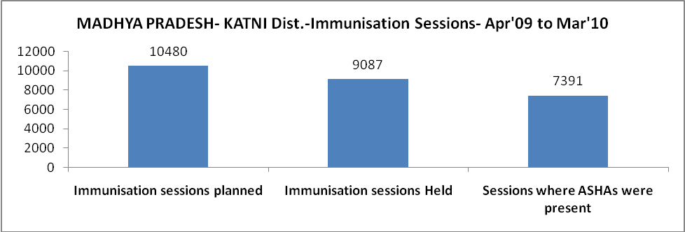

MADHYA PRADESH- KATNI Dist.- Apr'09 to Mar'10
Total Abortions | Abortion Rate
804 | 2.1%

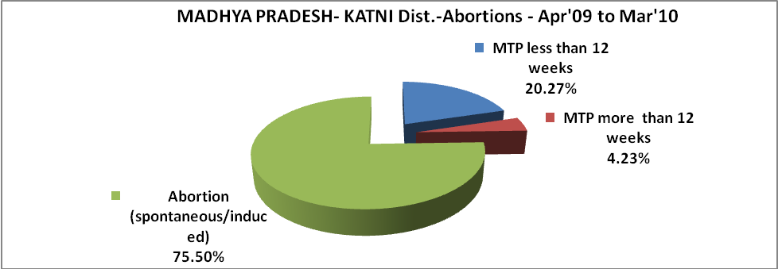

MADHYA PRADESH- KATNI Dist.- Apr'09 to Mar'10
Total OPD | Total RTI/STI cases
367,221 | 2,331

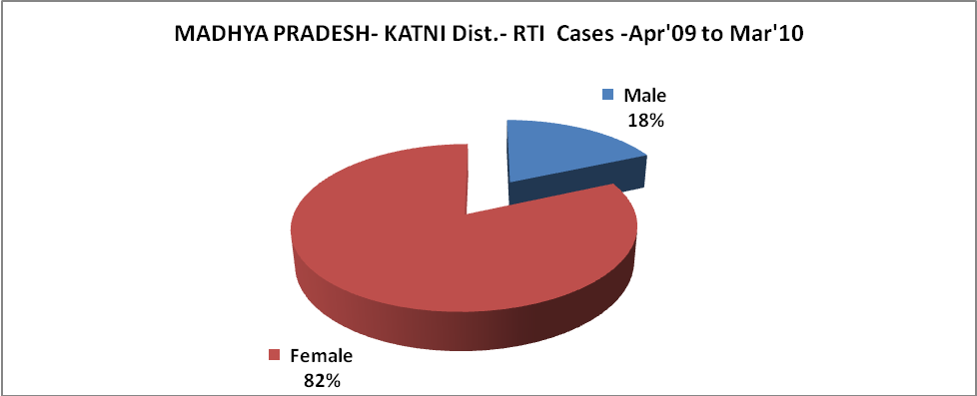

MADHYA PRADESH- KATNI Dist.-Sterilisations - Apr'09 to Mar'10
 | Reported | %age of Reported Sterilisation
Total Sterilisation | 7,712 | -
NSV | 476 | 6%
Laproscopic | 6,984 | 91%
MiniLap | 101 | 1%
Post Partum | 151 | 2%
Male Sterilisation | 476 | 6%
Female Sterilisation | 7,236 | 94%

MADHYA PRADESH- KATNI Dist.-FP Methods - Apr'09 to Mar'10
 | Reported | %age of All Reported FP Methods
Total Reported FP Methodd (All types) Users | 46,531 | -
Sterilisations | 7,712 | 17%
IUD | 7,017 | 15%
Condom Users | 18,786 | 40%
OCP Users | 13,016 | 28%
Limiting Methods | 7,712 | 17%
Spacing Methods | 38,819 | 83%

MADHYA PRADESH- KATNI Dist.- Service Delivery - Apr'09 to Mar'10
Operation major (General and spinal anaesthesia) | Operation minor (No or local anaesthesia) | AYUSH | Dental Procedures | Adolescent counselling services | Total OPD | Total IPD
1,555 | 525 | 27 | 2,016 | 2,035 | 367,221 | 43,335
Operation major (General and spinal anaesthesia) as %ge of OPD | Operation minor (No or local anaesthesia)as %ge of OPD | AYUSH as %ge of OPD | Dental Procedures as %ge of OPD | Adolescent counselling services as %ge of OPD | IPD as percentage of OPD
0.4% | 0.1% | 0.0% | 0.5% | 0.6% | 12%

MADHYA PRADESH- KATNI Dist.- Lab Services - Apr'09 to Mar'10
Total OPD | Total HB tested | Total HIV Tested | Total Population
367,221 | 16,451 | 9,249 | 1,264,634
HB test conducted as %age of OPD | HB<7gm as %age of HB tested | HIV test conducted as %age of OPD | HIV positive as %age of HIV tested | Blood Smear Examined as % of Population
4.5% | 5.6% | 2.5% | 0.2% | 8.4%

MADHYA PRADESH- KATNI Dist.- Childhood Disease - Vaccine Preventable -Apr'09 to Mar'10
Diphtheria | Pertussis | Tetanus Neonatorum | Tetanus others | Polio | Measles
1 | 0 | 0 | 3 | 0 | 49
MADHYA PRADESH- KATNI Dist.-Childhood Disease - Others - Apr'09 to Mar'10
Diarrhoea and dehydration | Malaria | Number admitted with Respiratory Infections
1,147 | 299 | 101

MADHYA PRADESH- KATNI Dist.- Infant & Child Deaths - Apr'09 to Mar'10
Infant Deaths within 24 hrs of birth | Infant Deaths between 24hrs & under 1 week | Infant Deaths between 1 week & under 1 month | Child Deaths between 1 month & under 1 year | Child Deaths between 1yr under 5years | Total Deaths
170 | 257 | 128 | 153 | 239 | 947

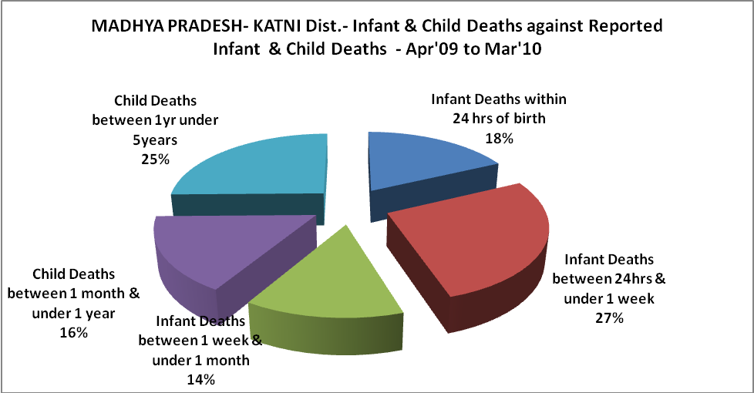

MADHYA PRADESH- KATNI Dist.- Causes of Infant & Child Deaths - Apr'09 to Mar'10
Sepsis |  |  | Asphyxia |  |  | LBW
Up to 1 Weeks of Birth | Between 1 week & 4 weeks of birth | Total | Up to 1 Weeks of Birth | Between 1 week & 4 weeks of birth | Total | Up to 1 Weeks of Birth | Between 1 week & 4 weeks of birth | Total
38 | 21 | 59 | 41 | 23 | 64 | 71 | 17 | 88
Pneumonia |  |  | Diarrhoea |  |  | Fever related
Between 1 month and 11 months | Between 1 year & 5 years | Total | Between 1 month and 11 months | Between 1 year & 5 years | Total | Between 1 month and 11 months | Between 1 year & 5 years | Total
34 | 29 | 63 | 7 | 17 | 24 | 27 | 49 | 76
Others |  |  | Measles |  |  | Others
Up to 1 Weeks of Birth | Between 1 week & 4 weeks of birth | Total | Between 1 month and 11 months | Between 1 year & 5 years | Total | Between 1 month and 11 months | Between 1 year & 5 years | Total
107 | 67 | 174 | 0 | 2 | 2 | 85 | 142 | 227

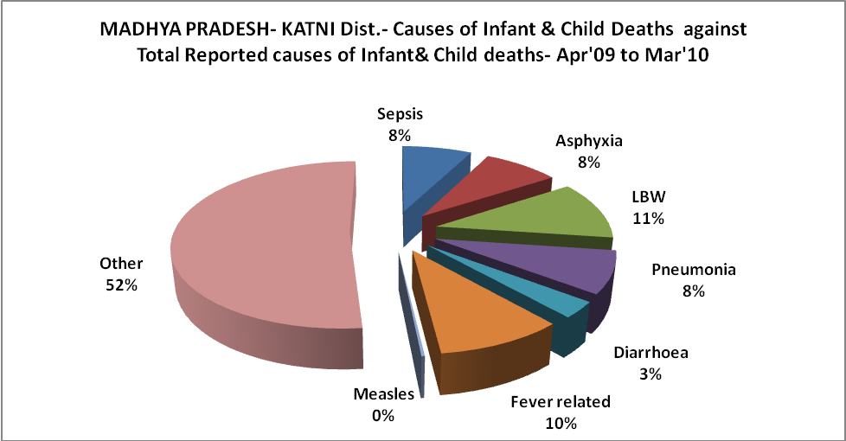

MADHYA PRADESH- KATNI Dist.- Maternal Deaths & Causes - Apr'09 to Mar'10
Abortion |  |  | Obstructed/prolonged labour |  |  | Severe hypertesnion/fits
6-14 yrs | 15-55 yrs. | Total | 6-14 yrs | 15-55 yrs. | Total | 6-14 yrs | 15-55 yrs. | Total
0 | 1 | 1 | 0 | 1 | 1 | 0 | 12 | 12
Bleeding |  |  | High Fever |  |  | Other Causes
6-14 yrs | 15-55 yrs. | Total | 6-14 yrs | 15-55 yrs. | Total | 6-14 yrs | 15-55 yrs. | Total
0 | 16 | 16 | 0 | 4 | 4 | 0 | 8 | 8

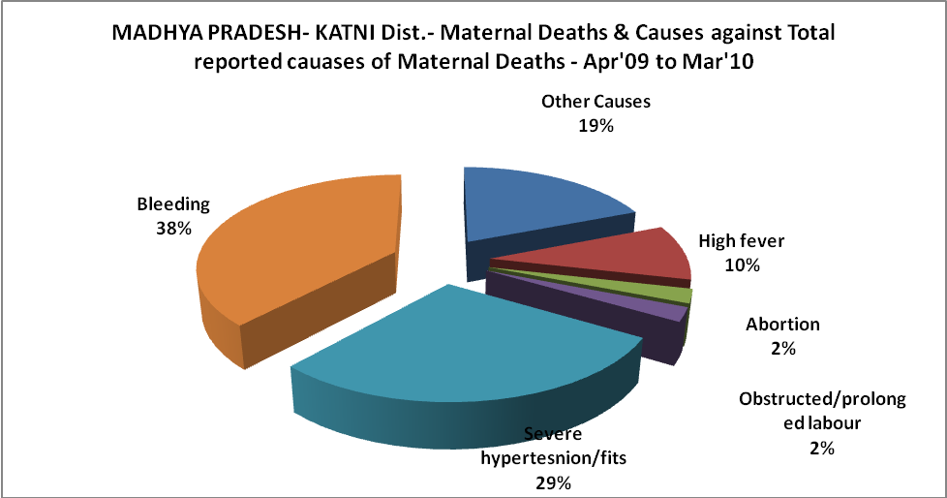

MADHYA PRADESH- KATNI Dist.-Causes of Deaths in 6 to 55yrs age group - Apr'09 to Mar'10
Diarrhoel Diseases |  |  |  | Tuberculosis |  |  |  | Respiratory Diseases( Other than TB)
6-14 yrs | 15-55 yrs. | Above 55yrs | Total | 6-14 yrs | 15-55 yrs. | Above 55yrs | Total | 6-14 yrs | 15-55 yrs. | Above 55yrs | Total
23 | 21 | 21 | 65 | 1 | 26 | 37 | 64 | 17 | 53 | 48 | 118
Malaria |  |  |  | Other fever Related |  |  |  | HIV/Aids
6-14 yrs | 15-55 yrs. | Above 55yrs | Total | 6-14 yrs | 15-55 yrs. | Above 55yrs | Total | 6-14 yrs | 15-55 yrs. | Above 55yrs | Total
1 | 6 | 12 | 19 | 110 | 387 | 756 | 1253 | 0 | 3 | 2 | 5
Heart Disease/Hypertenion related |  |  |  | Neurological Disease including strokes |  |  |  | Trauma/Accidents/ Burn Cases
6-14 yrs | 15-55 yrs. | Above 55yrs | Total | 6-14 yrs | 15-55 yrs. | Above 55yrs | Total | 6-14 yrs | 15-55 yrs. | Above 55yrs | Total
1 | 54 | 84 | 139 | 0 | 19 | 36 | 55 | 7 | 91 | 12 | 110
Suicide |  |  |  | Animal Bites & Stings
6-14 yrs | 15-55 yrs. | Above 55yrs | Total | 6-14 yrs | 15-55 yrs. | Above 55yrs | Total
3 | 28 | 6 | 37 | 3 | 7 | 0 | 10

