[NHSRC]
MP-Khandwa
[ Analysis 2009-10]

MADHYA PRADESH- KHANDWA Dist.- Summary-Apr'09 to Mar'10
ANC
ANC Registration against Expected Pregnancies | 62% | TT1 given to Pregnant women against ANC Registraion | 98%
3 ANC Check ups against ANC Reigtrations | 89% | 100 IFA Tablets given to Pregnant women against ANC Registraion | 81%
Deliveries
Unreported Deliveries against Estimated Deliveries | 41.9% | HOME Deliveries( SBA& Non SBA) against Estimated Deliveries | 17.4%
Institutional Deliveries against Estimated Deliveries | 40.7% | HOME Deliveries( SBA& Non SBA) against Reported Deliveries | 30.0%
Institutional Deliveries against Reported Deliveries | 70.0% | C Section Deliveries against Institutional Deliveries( Pvt & Pub) | 2%
Births & Neonates Care
Live Births Reported against Estimated Live Births | 60% | New borns weighed against Reported Live Births | 100%
Still Births (Reported) | 291 | New borns weighed less than 2.5 kgs against newborns weighed | 10%
Sex Ratio at Birh | 916 | New borns breastfed within one hr of Birth against Reported live Births | 67%
Child Immunisation( 0 to 11 mnths)
BCG given against Expected Live Births | 60% | Measles given against Expected Live Births | 60%
OPV3 given against Expected Live Births | 61% | Fully Immunised Children against Expected Live Births | 60%
DPT3 given against Expected Live Births | 61%
Family Planning
Family Plannig Methods Users ( Sterilisations(Male &Female)+IUD+ Condom pieces/72 + OCP Cycles/13) | 48,721 | IUD Insertions against reported FP Methods | 15%
Sterilisation against reported FP Methods | 19% | Condom Users against reported FP Methods | 47%
 |  | OCP Users against reported FP Methods | 19%
Other Services
OPD | 167,990 | Major Operations | 287
IPD | 37,304 | Minor Operations | 446

MADHYA PRADESH- KHANDWA Dist.- Deliveries Apr'09 to Mar'10
Total Population | 2,036,566 | Expected Deliveries |  | 59,020
Home SBA | Home Non SBA | Institutional | Total Deliveries Reported | Unreported Deliveries
19 | 10,259 | 24,015 | 34,293 | 24,727
Home SBA % | Home Non SBA% | Institutional % | Total Deliveries Reported % | Unreported Deliveries %
0% | 17% | 41% | 58% | 42%

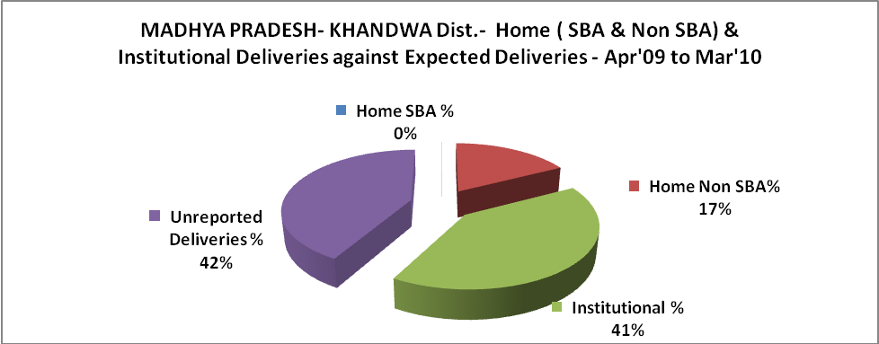

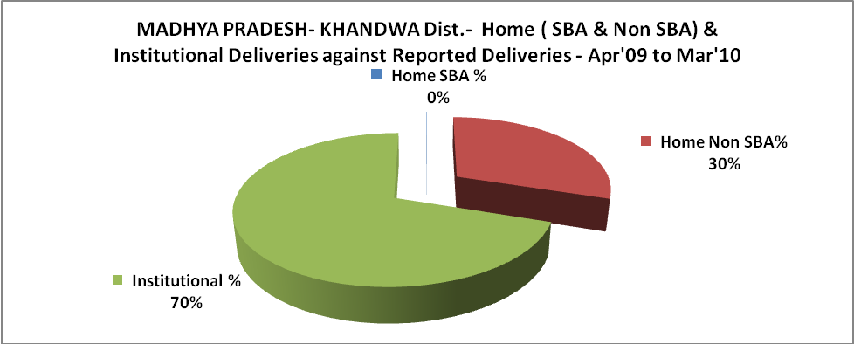

MADHYA PRADESH- KHANDWA Dist.- C sections & Complicated Deliveries Apr'09 to Mar'10
 | Institutional Deliveries (Public) | Institutional Deliveries (Pvt)
 | 22,227 | 1,788
C Section | 415 | -
C Section% | 2% | 0%
Complicated Pregnacies attended | 289 | 27
Complicated Pregnacies attended % | 1% | 2%

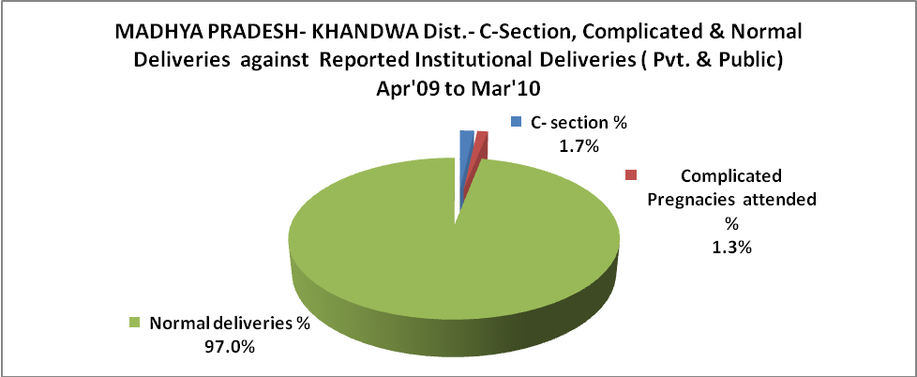

MADHYA PRADESH- KHANDWA Dist.- Complicated Pregnancies & Deliveries Treated - Apr'09 to Mar'10
Reported Deliveries |  |  | Reported ANC Reigtration
34,293 |  |  | 38,599
Complicated Pregnancies attended | Complicated Pregnancies Rate | C - Section Deliveries | PNC Maternal Complications | Abortions | Still Births
316 | 1% | 415 | 108 | 187 | 291
Complicated Deliveries Treated with |  |  |  | No Of Eclampsia cases Treated | No Of severe anemia cases treated
IV Antibiotics | IV antihypertensive/Magsulph injection | IV Oxytocis | Blood Transfusion | No Of Eclampsia cases Treated | No Of severe anemia cases treated
224 | 34 | 91 | 255 | 43 | 413

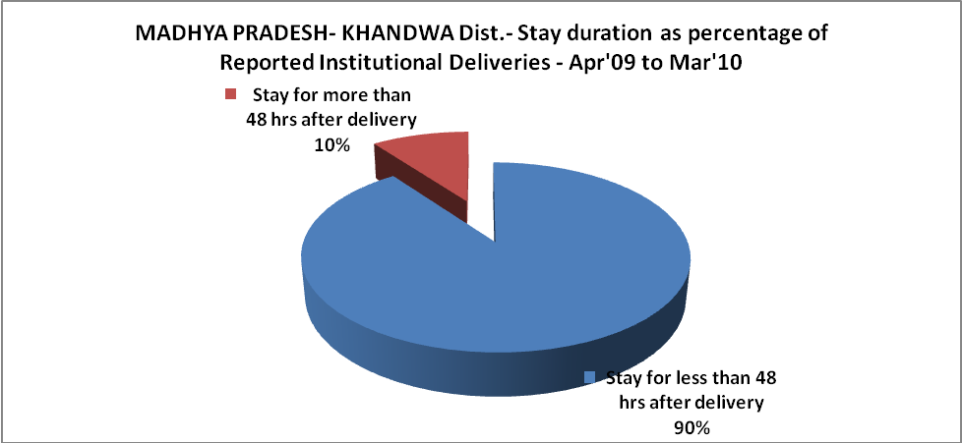

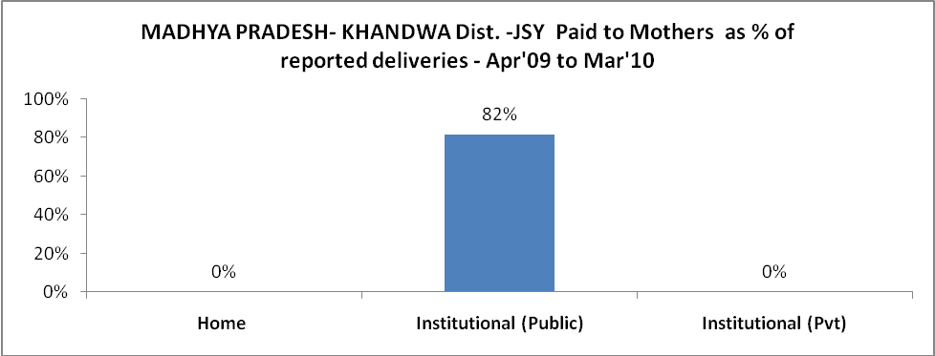

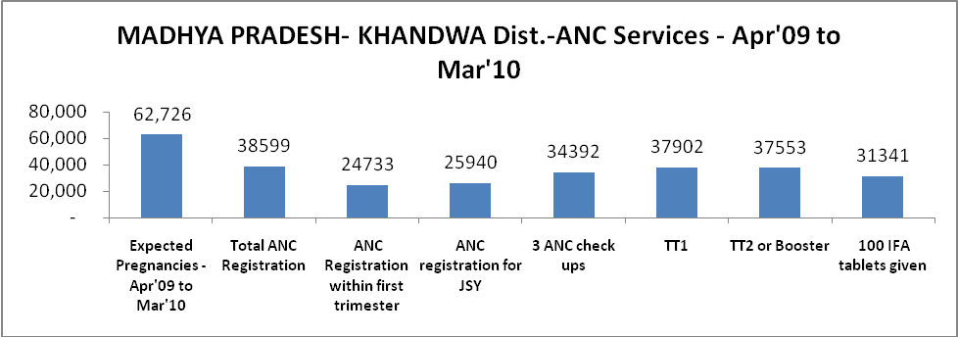

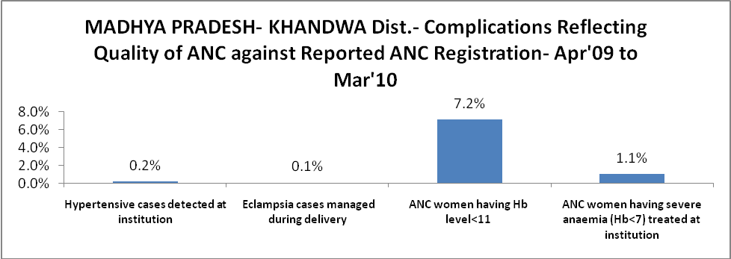

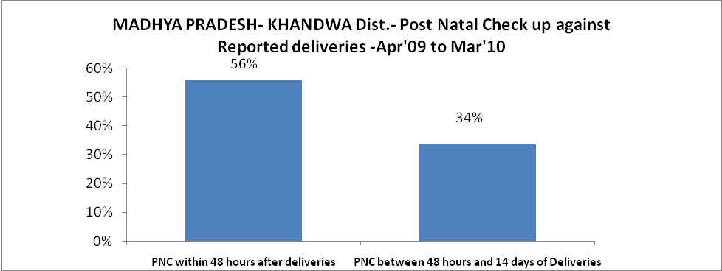

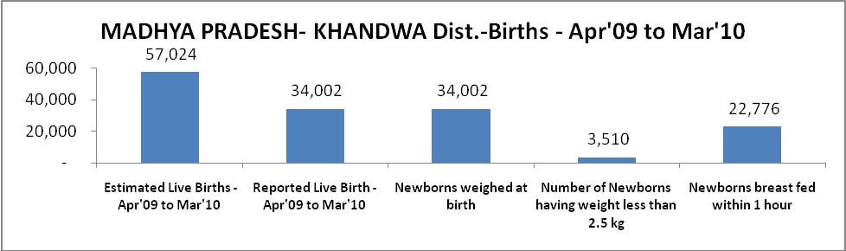

MADHYA PRADESH- KHANDWA Dist. - Births - Apr'09 to Mar'10
Live Birth - Males | Live Birth - females | Live Birth - Total | Sex Ratio at birth | Still Birth | Abortion( Induced/Spontaneous
17,746 | 16,256 | 34,002 | 916 | 291 | 187

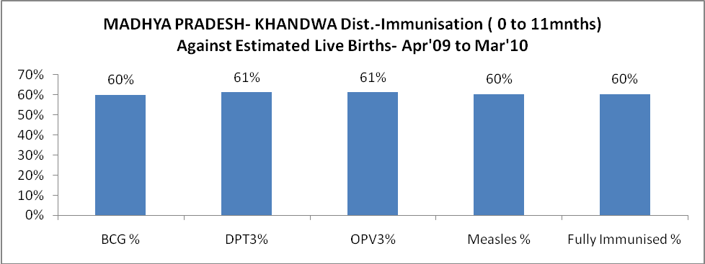

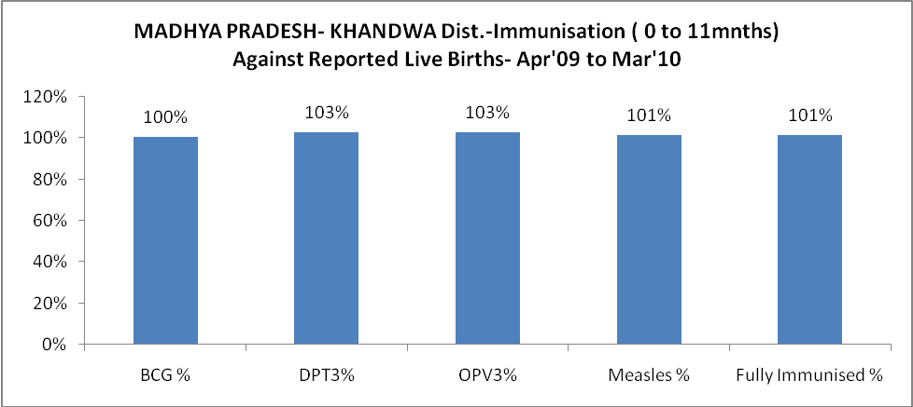

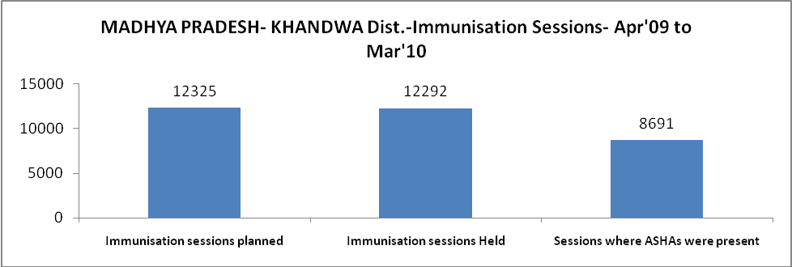

MADHYA PRADESH- KHANDWA Dist.- Apr'09 to Mar'10
Total Abortions | Abortion Rate
305 | 0.5%

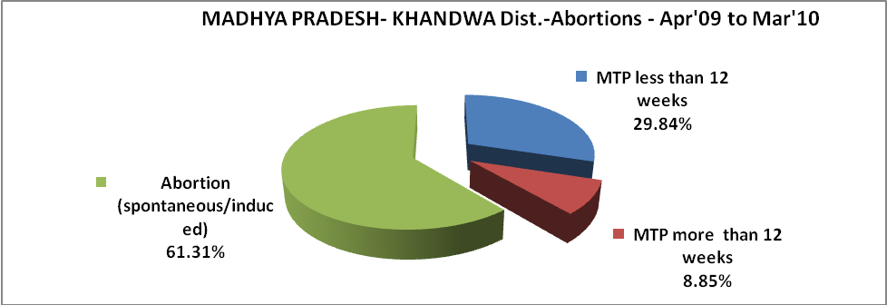

MADHYA PRADESH- KHANDWA Dist.- Apr'09 to Mar'10
Total OPD | Total RTI/STI cases
167,990 | 2,863

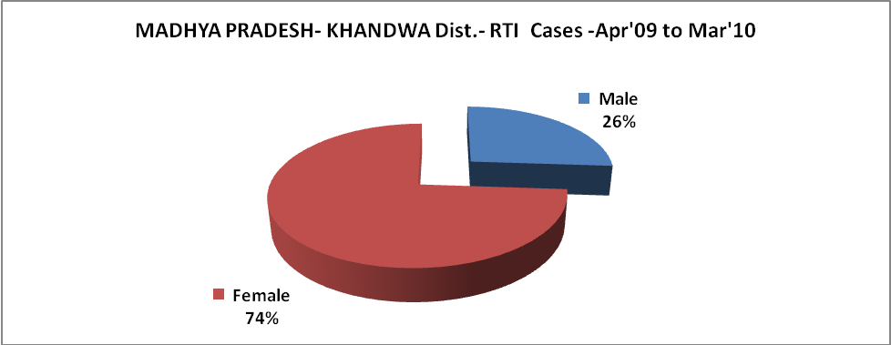

MADHYA PRADESH- KHANDWA Dist.-Sterilisations - Apr'09 to Mar'10
 | Reported | %age of Reported Sterilisation
Total Sterilisation | 9,396 | -
NSV | 300 | 3%
Laproscopic | 8,459 | 90%
MiniLap | 637 | 7%
Post Partum | - | 0%
Male Sterilisation | 300 | 3%
Female Sterilisation | 9,096 | 97%

MADHYA PRADESH- KHANDWA Dist.-FP Methods - Apr'09 to Mar'10
 |  |  |  | Reported |  |  | %age of All Reported FP Methods
Total Reported FP Methodd (All types) Users |  |  |  | 48,721 |  |  | -
Sterilisations |  |  |  | 9,396 |  |  | 19%
IUD |  |  |  | 7,312 |  |  | 15%
Condom Users |  |  |  | 22,792 |  |  | 47%
OCP Users |  |  |  | 9,221 |  |  | 19%
Limiting Methods |  |  |  | 9,396 |  |  | 19%
Spacing Methods |  |  |  | 39,325 |  |  | 81%
MADHYA PRADESH- KHANDWA Dist.- Service Delivery - Apr'09 to Mar'10
Operation major (General and spinal anaesthesia) | Operation minor (No or local anaesthesia) | AYUSH | Dental Procedures |  | Adolescent counselling services | Total OPD |  | Total IPD
287 | 446 | - | 1,344 |  | - | 167,990 |  | 37,304
Operation major (General and spinal anaesthesia) as %ge of OPD | Operation minor (No or local anaesthesia)as %ge of OPD | AYUSH as %ge of OPD | Dental Procedures as %ge of OPD |  | Adolescent counselling services as %ge of OPD | IPD as percentage of OPD
0.2% | 0.3% | 0.0% | 0.8% |  | 0.0% | 22%

MADHYA PRADESH- KHANDWA Dist.- Lab Services - Apr'09 to Mar'10
Total OPD | Total HB tested | Total HIV Tested | Total Population
167,990 | 18,485 | 453 | 2,036,566
HB test conducted as %age of OPD | HB<7gm as %age of HB tested | HIV test conducted as %age of OPD | HIV positive as %age of HIV tested | Blood Smear Examined as % of Population
11.0% | 12.8% | 0.3% | 4.6% | 4.3%

MADHYA PRADESH- KHANDWA Dist.- Childhood Disease - Vaccine Preventable -Apr'09 to Mar'10
Diphtheria | Pertussis | Tetanus Neonatorum | Tetanus others | Polio | Measles
0 | 0 | 0 | 0 | 0 | 0
MADHYA PRADESH- KHANDWA Dist.-Childhood Disease - Others - Apr'09 to Mar'10
Diarrhoea and dehydration | Malaria | Number admitted with Respiratory Infections
9,224 | 70 | 7,005

MADHYA PRADESH- KHANDWA Dist.- Infant & Child Deaths - Apr'09 to Mar'10
Infant Deaths within 24 hrs of birth | Infant Deaths between 24hrs & under 1 week | Infant Deaths between 1 week & under 1 month | Child Deaths between 1 month & under 1 year | Child Deaths between 1yr under 5years | Total Deaths
13 | 255 | 142 | 239 | 188 | 837

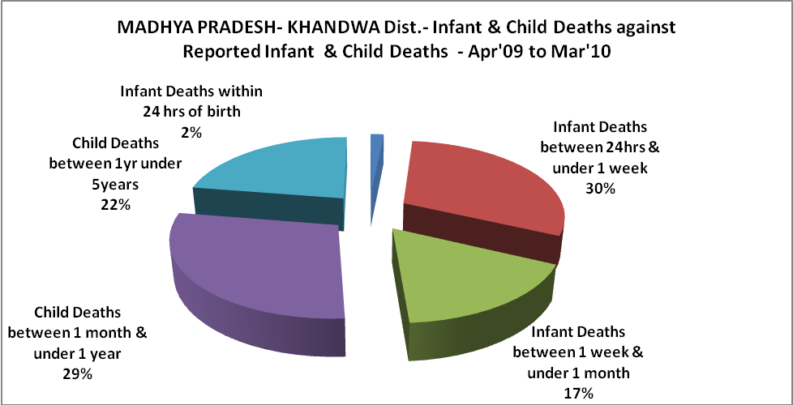

MADHYA PRADESH- KHANDWA Dist.- Causes of Infant & Child Deaths - Apr'09 to Mar'10
Sepsis |  |  | Asphyxia |  |  | LBW
Up to 1 Weeks of Birth | Between 1 week & 4 weeks of birth | Total | Up to 1 Weeks of Birth | Between 1 week & 4 weeks of birth | Total | Up to 1 Weeks of Birth | Between 1 week & 4 weeks of birth | Total
0 | 0 | 0 | 0 | 0 | 0 | 0 | 0 | 0
Pneumonia |  |  | Diarrhoea |  |  | Fever related
Between 1 month and 11 months | Between 1 year & 5 years | Total | Between 1 month and 11 months | Between 1 year & 5 years | Total | Between 1 month and 11 months | Between 1 year & 5 years | Total
2 | 0 | 2 | 0 | 0 | 0 | 0 | 0 | 0
Others |  |  | Measles |  |  | Others
Up to 1 Weeks of Birth | Between 1 week & 4 weeks of birth | Total | Between 1 month and 11 months | Between 1 year & 5 years | Total | Between 1 month and 11 months | Between 1 year & 5 years | Total
255 | 142 | 397 | 0 | 0 | 0 | 237 | 188 | 425

MADHYA PRADESH- KHANDWA Dist.- Maternal Deaths & Causes - Apr'09 to Mar'10
Abortion |  |  | Obstructed/prolonged labour |  |  | Severe hypertesnion/fits
6-14 yrs | 15-55 yrs. | Total | 6-14 yrs | 15-55 yrs. | Total | 6-14 yrs | 15-55 yrs. | Total
0 | 0 | 0 | 0 | 0 | 0 | 0 | 3 | 3
Bleeding |  |  | High Fever |  |  | Other Causes
6-14 yrs | 15-55 yrs. | Total | 6-14 yrs | 15-55 yrs. | Total | 6-14 yrs | 15-55 yrs. | Total
0 | 0 | 0 | 0 | 0 | 0 | 0 | 16 | 16

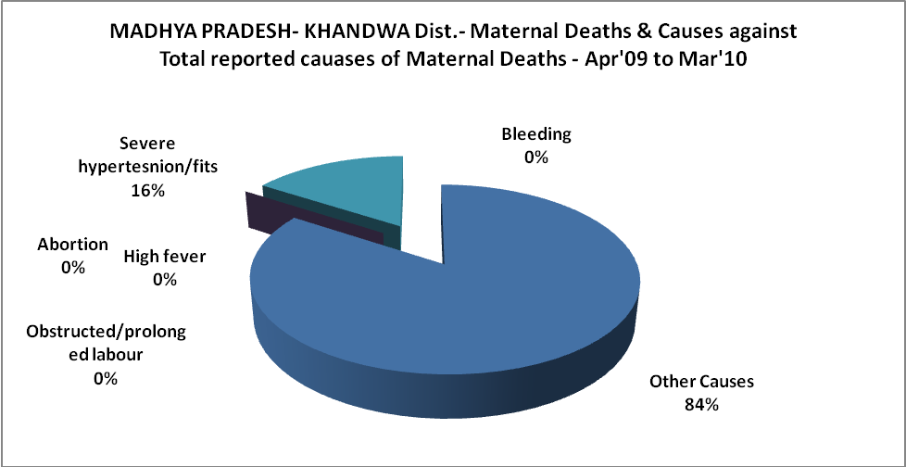

Diarrhoel Diseases |  |  |  | Tuberculosis |  |  |  | Respiratory Diseases( Other than TB)
6-14 yrs | 15-55 yrs. | Above 55yrs | Total | 6-14 yrs | 15-55 yrs. | Above 55yrs | Total | 6-14 yrs | 15-55 yrs. | Above 55yrs | Total
0 | 0 | 0 | 0 | 0 | 0 | 0 | 0 | 0 | 0 | 0 | 0
Malaria |  |  |  | Other fever Related |  |  |  | HIV/Aids
6-14 yrs | 15-55 yrs. | Above 55yrs | Total | 6-14 yrs | 15-55 yrs. | Above 55yrs | Total | 6-14 yrs | 15-55 yrs. | Above 55yrs | Total
0 | 0 | 0 | 0 | 0 | 0 | 0 | 0 | 0 | 0 | 0 | 0
Heart Disease/Hypertenion related |  |  |  | Neurological Disease including strokes |  |  |  | Trauma/Accidents/ Burn Cases
6-14 yrs | 15-55 yrs. | Above 55yrs | Total | 6-14 yrs | 15-55 yrs. | Above 55yrs | Total | 6-14 yrs | 15-55 yrs. | Above 55yrs | Total
0 | 0 | 0 | 0 | 0 | 0 | 0 | 0 | 0 | 0 | 0 | 0
Suicide |  |  |  | Animal Bites & Stings
6-14 yrs | 15-55 yrs. | Above 55yrs | Total | 6-14 yrs | 15-55 yrs. | Above 55yrs | Total
0 | 0 | 0 | 0 | 1 | 0 | 0 | 1

