[NHSRC]
MP-Khargone
[ Analysis 2009-10]

MADHYA PRADESH- KHARGONE Dist.- Summary-Apr'09 to Mar'10
ANC
ANC Registration against Expected Pregnancies | 99% | TT1 given to Pregnant women against ANC Registraion | 55%
3 ANC Check ups against ANC Reigtrations | 76% | 100 IFA Tablets given to Pregnant women against ANC Registraion | 91%
Deliveries
Unreported Deliveries against Estimated Deliveries | 21.3% | HOME Deliveries( SBA& Non SBA) against Estimated Deliveries | 15.9%
Institutional Deliveries against Estimated Deliveries | 62.8% | HOME Deliveries( SBA& Non SBA) against Reported Deliveries | 20.2%
Institutional Deliveries against Reported Deliveries | 79.8% | C Section Deliveries against Institutional Deliveries( Pvt & Pub) | 4%
Births & Neonates Care
Live Births Reported against Estimated Live Births | 80% | New borns weighed against Reported Live Births | 94%
Still Births (Reported) | 527 | New borns weighed less than 2.5 kgs against newborns weighed | 35%
Sex Ratio at Birh | 946 | New borns breastfed within one hr of Birth against Reported live Births | 91%
Child Immunisation( 0 to 11 mnths)
BCG given against Expected Live Births | 79% | Measles given against Expected Live Births | 98%
OPV3 given against Expected Live Births | 98% | Fully Immunised Children against Expected Live Births | 95%
DPT3 given against Expected Live Births | 98%
Family Planning
Family Plannig Methods Users ( Sterilisations(Male &Female)+IUD+ Condom pieces/72 + OCP Cycles/13) | 78,218 | IUD Insertions against reported FP Methods | 9%
Sterilisation against reported FP Methods | 15% | Condom Users against reported FP Methods | 57%
 |  | OCP Users against reported FP Methods | 19%
Other Services
OPD | 627,493 | Major Operations | 9,694
IPD | 70,150 | Minor Operations | 3,274

MADHYA PRADESH- KHARGONE Dist.- Deliveries Apr'09 to Mar'10
Total Population | 1,817,517 | Expected Deliveries |  | 52,672
Home SBA | Home Non SBA | Institutional | Total Deliveries Reported | Unreported Deliveries
4,423 | 3,946 | 33,081 | 41,450 | 11,222
Home SBA % | Home Non SBA% | Institutional % | Total Deliveries Reported % | Unreported Deliveries %
8% | 7% | 63% | 79% | 21%

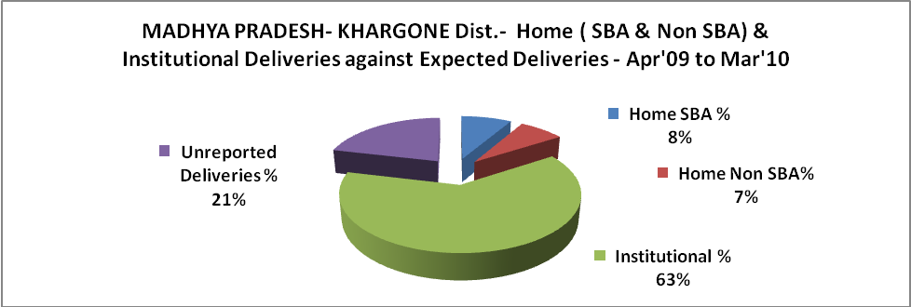

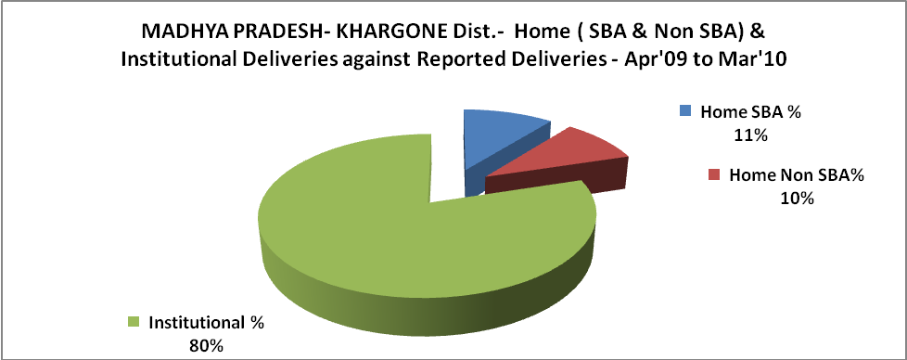
MADHYA PRADESH- KHARGONE Dist.- C sections & Complicated Deliveries Apr'09 to Mar'10
 | Institutional Deliveries (Public) | Institutional Deliveries (Pvt)
 | 28,422 | 4,659
C Section | 1,159 | 282
C Section% | 4% | 6%
Complicated Pregnacies attended | 2,505 | -
Complicated Pregnacies attended % | 9% | 0%

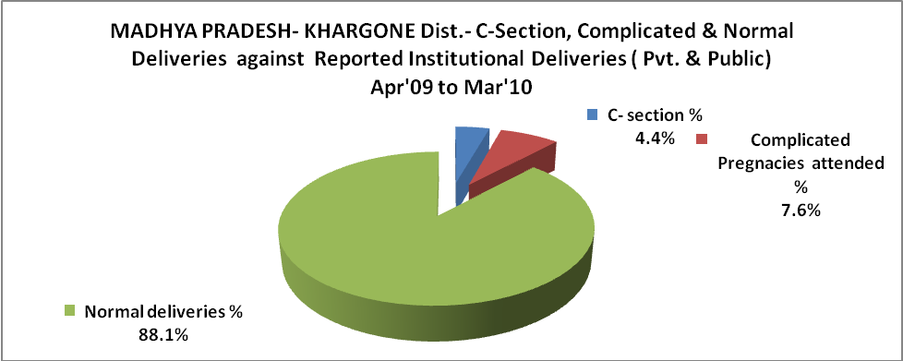

MADHYA PRADESH- KHARGONE Dist.- Complicated Pregnancies & Deliveries Treated - Apr'09 to Mar'10
Reported Deliveries |  |  | Reported ANC Reigtration
41,450 |  |  | 55,637
Complicated Pregnancies attended | Complicated Pregnancies Rate | C - Section Deliveries | PNC Maternal Complications | Abortions | Still Births
2,505 | 4% | 1,441 | 682 | 207 | 527
Complicated Deliveries Treated with |  |  |  | No Of Eclampsia cases Treated | No Of severe anemia cases treated
IV Antibiotics | IV antihypertensive/Magsulph injection | IV Oxytocis | Blood Transfusion | No Of Eclampsia cases Treated | No Of severe anemia cases treated
2,582 | 1,700 | 1,983 | 369 | 780 | 1,161

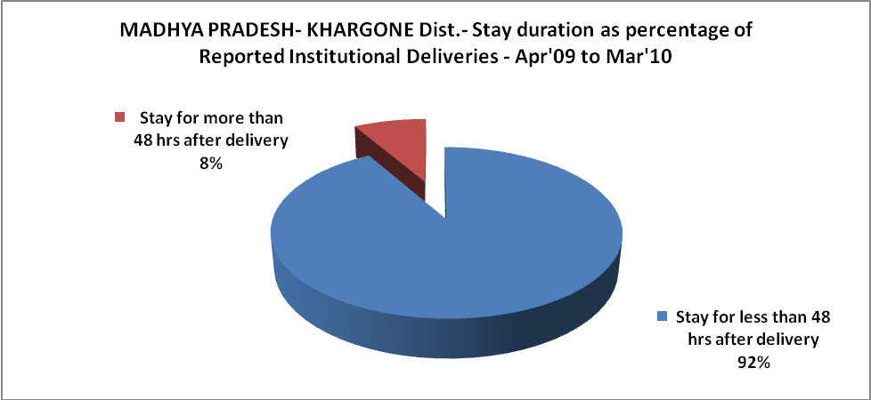

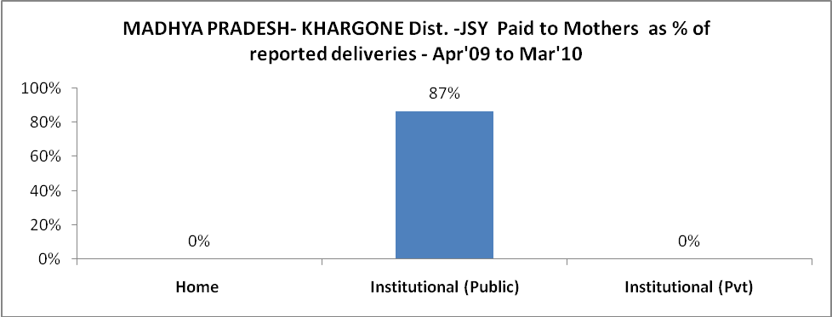

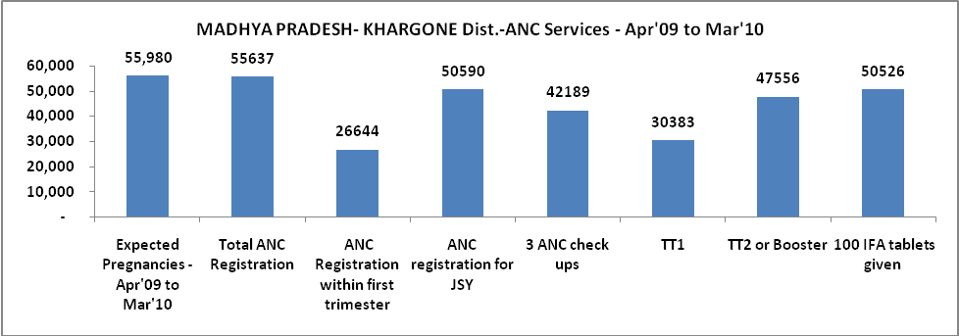

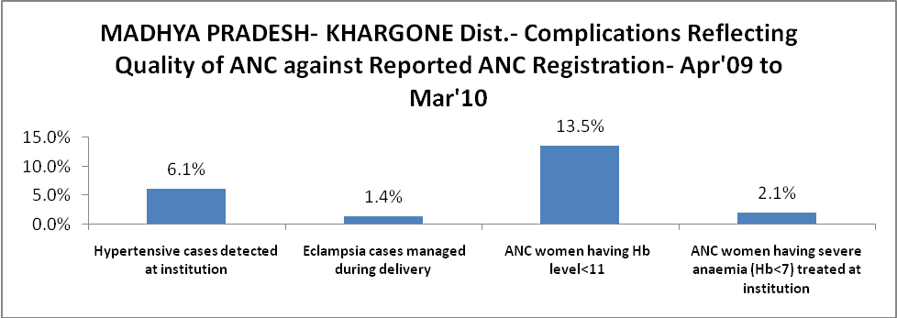

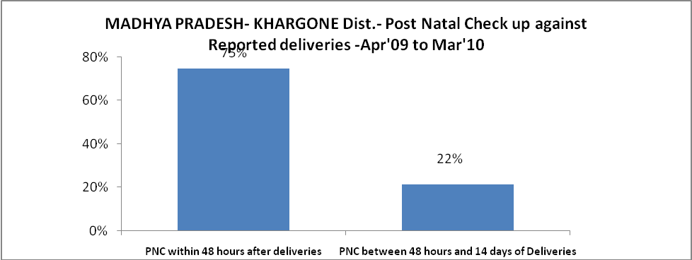

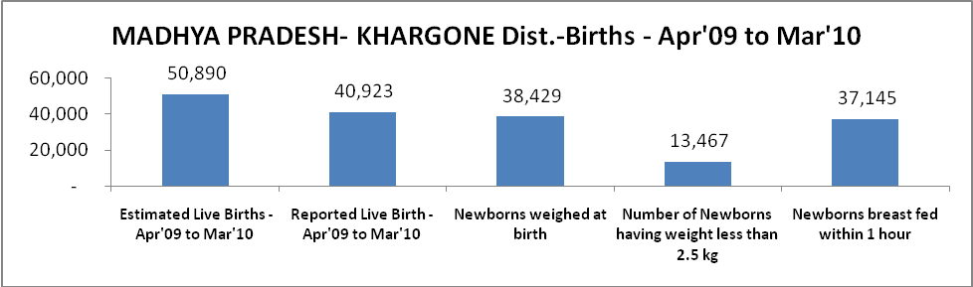

MADHYA PRADESH- KHARGONE Dist. - Births - Apr'09 to Mar'10
Live Birth - Males | Live Birth - females | Live Birth - Total | Sex Ratio at birth | Still Birth | Abortion( Induced/Spontaneous
21,030 | 19,893 | 40,923 | 946 | 527 | 207

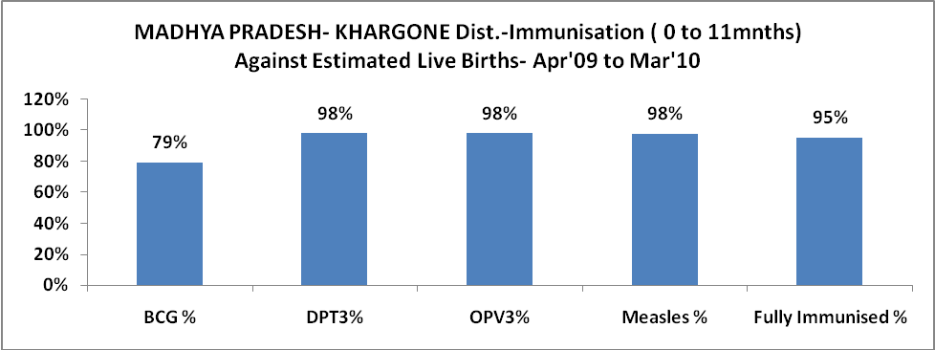

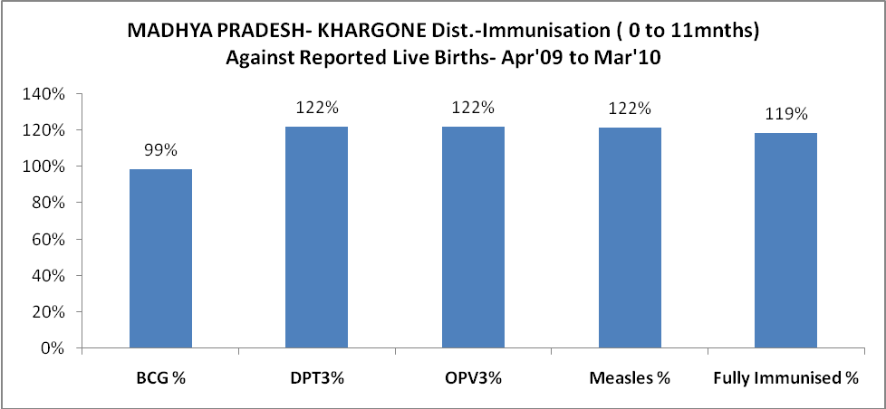

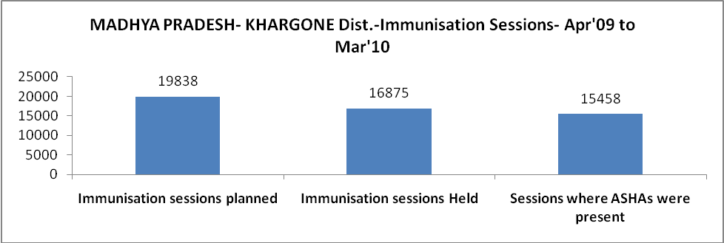

MADHYA PRADESH- KHARGONE Dist.- Apr'09 to Mar'10
Total Abortions | Abortion Rate
375 | 0.7%

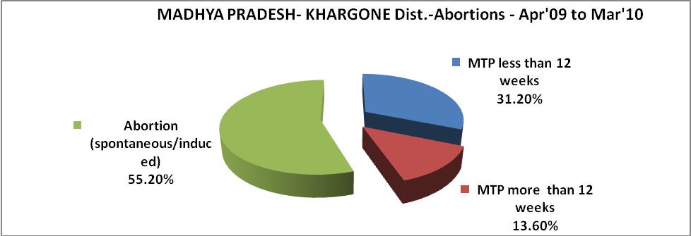

MADHYA PRADESH- KHARGONE Dist.- Apr'09 to Mar'10
Total OPD | Total RTI/STI cases
627,493 | 2,976

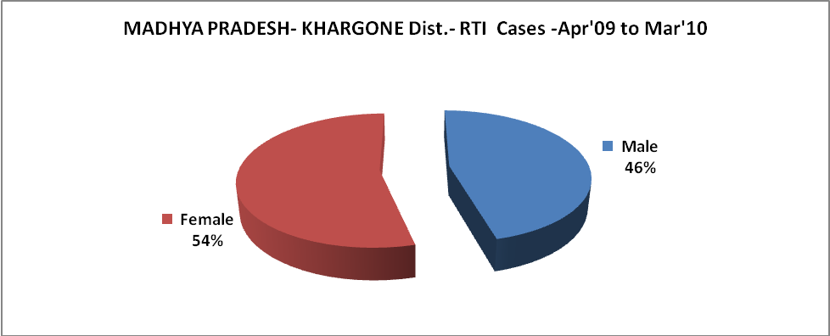

MADHYA PRADESH- KHARGONE Dist.-Sterilisations - Apr'09 to Mar'10
 | Reported | %age of Reported Sterilisation
Total Sterilisation | 12,005 | -
NSV | 339 | 3%
Laproscopic | 9,560 | 80%
MiniLap | 1,772 | 15%
Post Partum | 334 | 3%
Male Sterilisation | 339 | 3%
Female Sterilisation | 11,666 | 97%

MADHYA PRADESH- KHARGONE Dist.-FP Methods - Apr'09 to Mar'10
 |  |  |  |  | Reported |  | %age of All Reported FP Methods
Total Reported FP Methodd (All types) Users |  |  |  |  | 78,218 |  | -
Sterilisations |  |  |  |  | 12,005 |  | 15%
IUD |  |  |  |  | 7,296 |  | 9%
Condom Users |  |  |  |  | 44,201 |  | 57%
OCP Users |  |  |  |  | 14,716 |  | 19%
Limiting Methods |  |  |  |  | 12,005 |  | 15%
Spacing Methods |  |  |  |  | 66,213 |  | 85%
MADHYA PRADESH- KHARGONE Dist.- Service Delivery - Apr'09 to Mar'10
Operation major (General and spinal anaesthesia) | Operation minor (No or local anaesthesia) | AYUSH | Dental Procedures | Adolescent counselling services |  | Total OPD |  | Total IPD
9,694 | 3,274 | 4,052 | 9,407 | 2,331 |  | 627,493 |  | 70,150
Operation major (General and spinal anaesthesia) as %ge of OPD | Operation minor (No or local anaesthesia)as %ge of OPD | AYUSH as %ge of OPD | Dental Procedures as %ge of OPD | Adolescent counselling services as %ge of OPD |  | IPD as percentage of OPD
1.5% | 0.5% | 0.6% | 1.5% | 0.4% |  | 11%

MADHYA PRADESH- KHARGONE Dist.- Lab Services - Apr'09 to Mar'10
Total OPD | Total HB tested | Total HIV Tested | Total Population
627,493 | 38,142 | 2,178 | 1,817,517
HB test conducted as %age of OPD | HB<7gm as %age of HB tested | HIV test conducted as %age of OPD | HIV positive as %age of HIV tested | Blood Smear Examined as % of Population
6.1% | 5.8% | 0.3% | 2.4% | 17.6%

MADHYA PRADESH- KHARGONE Dist.- Childhood Disease - Vaccine Preventable -Apr'09 to Mar'10
Diphtheria | Pertussis | Tetanus Neonatorum | Tetanus others | Polio | Measles
0 | 0 | 1 | 15 | 0 | 14
MADHYA PRADESH- KHARGONE Dist.-Childhood Disease - Others - Apr'09 to Mar'10
Diarrhoea and dehydration | Malaria | Number admitted with Respiratory Infections
4,198 | 1,360 | 1,332

MADHYA PRADESH- KHARGONE Dist.- Infant & Child Deaths - Apr'09 to Mar'10
Infant Deaths within 24 hrs of birth | Infant Deaths between 24hrs & under 1 week | Infant Deaths between 1 week & under 1 month | Child Deaths between 1 month & under 1 year | Child Deaths between 1yr under 5years | Total Deaths
30 | 261 | 216 | 136 | 151 | 794

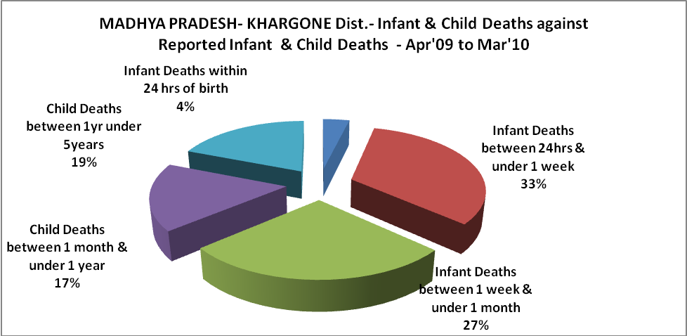

MADHYA PRADESH- KHARGONE Dist.- Causes of Infant & Child Deaths - Apr'09 to Mar'10
Sepsis |  |  | Asphyxia |  |  | LBW
Up to 1 Weeks of Birth | Between 1 week & 4 weeks of birth | Total | Up to 1 Weeks of Birth | Between 1 week & 4 weeks of birth | Total | Up to 1 Weeks of Birth | Between 1 week & 4 weeks of birth | Total
22 | 53 | 75 | 37 | 52 | 89 | 83 | 7 | 90
Pneumonia |  |  | Diarrhoea |  |  | Fever related
Between 1 month and 11 months | Between 1 year & 5 years | Total | Between 1 month and 11 months | Between 1 year & 5 years | Total | Between 1 month and 11 months | Between 1 year & 5 years | Total
12 | 18 | 30 | 6 | 14 | 20 | 0 | 1 | 1
Others |  |  | Measles |  |  | Others
Up to 1 Weeks of Birth | Between 1 week & 4 weeks of birth | Total | Between 1 month and 11 months | Between 1 year & 5 years | Total | Between 1 month and 11 months | Between 1 year & 5 years | Total
119 | 104 | 223 | 0 | 0 | 0 | 118 | 118 | 236

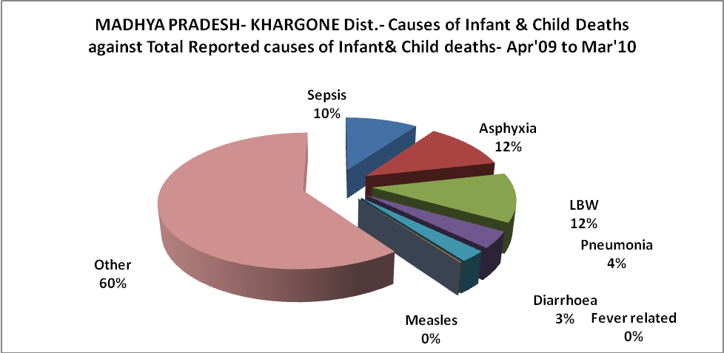

MADHYA PRADESH- KHARGONE Dist.- Maternal Deaths & Causes - Apr'09 to Mar'10
Abortion |  |  | Obstructed/prolonged labour |  |  | Severe hypertesnion/fits
6-14 yrs | 15-55 yrs. | Total | 6-14 yrs | 15-55 yrs. | Total | 6-14 yrs | 15-55 yrs. | Total
0 | 0 | 0 | 0 | 0 | 0 | 0 | 1 | 1
Bleeding |  |  | High Fever |  |  | Other Causes
6-14 yrs | 15-55 yrs. | Total | 6-14 yrs | 15-55 yrs. | Total | 6-14 yrs | 15-55 yrs. | Total
0 | 8 | 8 | 0 | 0 | 0 | 0 | 3 | 3

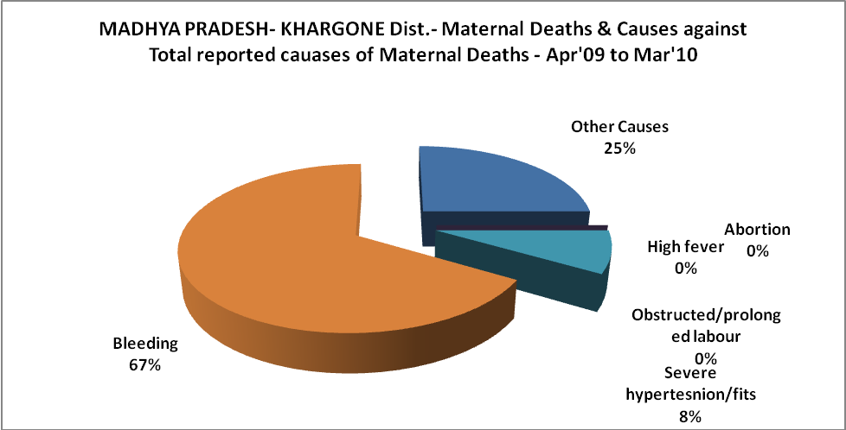

MADHYA PRADESH- KHARGONE Dist.-Causes of Deaths in 6 to 55yrs age group - Apr'09 to Mar'10
Diarrhoel Diseases |  |  |  | Tuberculosis |  |  |  | Respiratory Diseases( Other than TB)
6-14 yrs | 15-55 yrs. | Above 55yrs | Total | 6-14 yrs | 15-55 yrs. | Above 55yrs | Total | 6-14 yrs | 15-55 yrs. | Above 55yrs | Total
14 | 24 | 28 | 66 | 3 | 21 | 6 | 30 | 4 | 13 | 33 | 50
Malaria |  |  |  | Other fever Related |  |  |  | HIV/Aids
6-14 yrs | 15-55 yrs. | Above 55yrs | Total | 6-14 yrs | 15-55 yrs. | Above 55yrs | Total | 6-14 yrs | 15-55 yrs. | Above 55yrs | Total
6 | 7 | 1 | 14 | 10 | 14 | 42 | 66 | 0 | 0 | 0 | 0
Heart Disease/Hypertenion related |  |  |  | Neurological Disease including strokes |  |  |  | Trauma/Accidents/ Burn Cases
6-14 yrs | 15-55 yrs. | Above 55yrs | Total | 6-14 yrs | 15-55 yrs. | Above 55yrs | Total | 6-14 yrs | 15-55 yrs. | Above 55yrs | Total
0 | 4 | 67 | 71 | 10 | 18 | 85 | 113 | 6 | 32 | 18 | 56
Suicide |  |  |  | Animal Bites & Stings
6-14 yrs | 15-55 yrs. | Above 55yrs | Total | 6-14 yrs | 15-55 yrs. | Above 55yrs | Total
3 | 13 | 4 | 20 | 2 | 6 | 1 | 9

